NoSQL Databases Seminar Report
  - Redis Cassandra MongoDB and Neo4j
Bharat Yadav | BT24GCS397
NIIT University | Semester 5
Dimensional and NoSQL Databases | CS 3102
Prepared 5 November 2026 | Submission deadline 10 November 2026

Abstract
This project compares four NoSQL database models through a shared university example. Redis stores student fields in a hash, Cassandra stores a row identified by a partition key, MongoDB stores a nested document, and Neo4j connects a student to a course. Each database runs in a separate Linux container managed from Windows with Docker Compose. CLI scripts and Python drivers perform create, read, update and delete operations. Original screenshots record the setup and demonstrations.
The verified result is a working local environment with persistent volumes, successful database queries and a retained student sample. The exercise shows how data models and query patterns influence database choice. It does not establish a universal performance winner, production availability or distributed fault tolerance.

Objectives and scope
The report explains installation, architecture, core concepts, advantages, disadvantages and the industrial scenarios requested in the seminar brief. The implementation uses one instance of each database on one computer. Cassandra uses one replica, and MongoDB is a standalone server. These choices keep the demonstration reproducible while limiting what can be concluded about clusters. The original screenshots were captured on 29 October 2026; the moved project and Python CRUD were verified on 5 November 2026.
Database | Version | Interface
Redis | 7.4.12 Alpine | redis-cli and redis-py
Cassandra | 5.0.9 | cqlsh and cassandra-driver
MongoDB | 8.0.34 | mongosh and PyMongo
Neo4j | 5.26.32 Community | Browser Cypher and Python driver

NoSQL foundations and comparison
NoSQL refers to a family of databases that use models beyond conventional relational tables. Key–value stores retrieve values by key; wide column stores organize distributed partitions and rows; document stores retain nested records; graph databases represent entities and their relationships. The model should follow the application’s access patterns rather than the size or popularity of a product.

NoSQL and RDBMS
A relational database uses tables, declared keys, constraints and SQL. Normalization reduces duplication, while joins combine related records. NoSQL systems often model an aggregate, partition or graph around common queries. Flexible records can simplify evolving applications, but inconsistent field names or duplicated data still require design and validation. Relational databases can store JSON and scale horizontally in suitable architectures; NoSQL is not automatically faster or more scalable.
Database | Data model | Main strength | Main limitation | Typical use
Redis | Key–value with rich types | Fast memory access; TTL | RAM cost; durability needs configuration | Cache; session state
Cassandra | Wide column | Distributed writes and replication | Query driven schema; cluster operations | Events; time series
MongoDB | BSON documents | Nested data and flexible fields | Indexes and duplication add cost | Content; product catalogs
Neo4j | Property graph | Relationship traversal and patterns | Memory and graph modeling costs | Fraud; knowledge graphs

Transactions consistency and availability
ACID means atomicity, consistency, isolation and durability. Transaction consistency concerns valid database states; it is different from the visibility guarantees of distributed reads. BASE describes systems that may be basically available with soft state and eventual consistency. These are design descriptions, not a rule that every NoSQL database lacks transactions.
The CAP result applies when a distributed system experiences a network partition: it cannot guarantee both linearizable consistency and availability for every request. Configuration and operation matter. Cassandra exposes consistency levels; Neo4j supports ACID transactions; MongoDB supports atomic document updates and, in suitable deployments, transactions. The local single-instance setup cannot test CAP behavior. [4, 7, 9]

Selection for the university example
A cache of a student profile fits Redis. Large event histories can fit Cassandra when partitioned by the expected query. A profile with optional nested attributes fits MongoDB. Enrollment and recommendation traversals fit Neo4j. A relational database remains a strong choice for constrained student administration and reporting across many entities.

Windows installation and Docker architecture
Docker Desktop runs the database images using its Linux engine through the WSL 2 backend. Compose declares services, credentials, ports, volumes, resource limits and health checks. An image is a packaged filesystem and startup definition; a container is a running instance. A custom database Dockerfile is unnecessary because the project uses official database images. The optional Python client has its own Dockerfile.

Reproduce the setup
Install Docker Desktop with WSL 2 support, enable virtualization if needed, and start the Linux engine. Open PowerShell in the repository. Initial setup creates the private environment file, obtains images, starts the services and initializes sample student 101. Later starts reuse the existing volumes. The setup applies to the chosen Windows platform, as permitted by the brief.
docker version
docker compose version
docker info
.\scripts\setup.ps1 # first installation
.\scripts\start.ps1 # subsequent starts
.\scripts\verify.ps1 -CheckSample
.\scripts\cli.ps1 -Database redis
Substitute cassandra, mongodb or neo4j for the CLI database argument. Redis uses port 6379, Cassandra 9042, MongoDB 27017, and Neo4j 7474 for HTTP and 7687 for Bolt. Host ports bind to 127.0.0.1. Compose services communicate through the project network using service names.
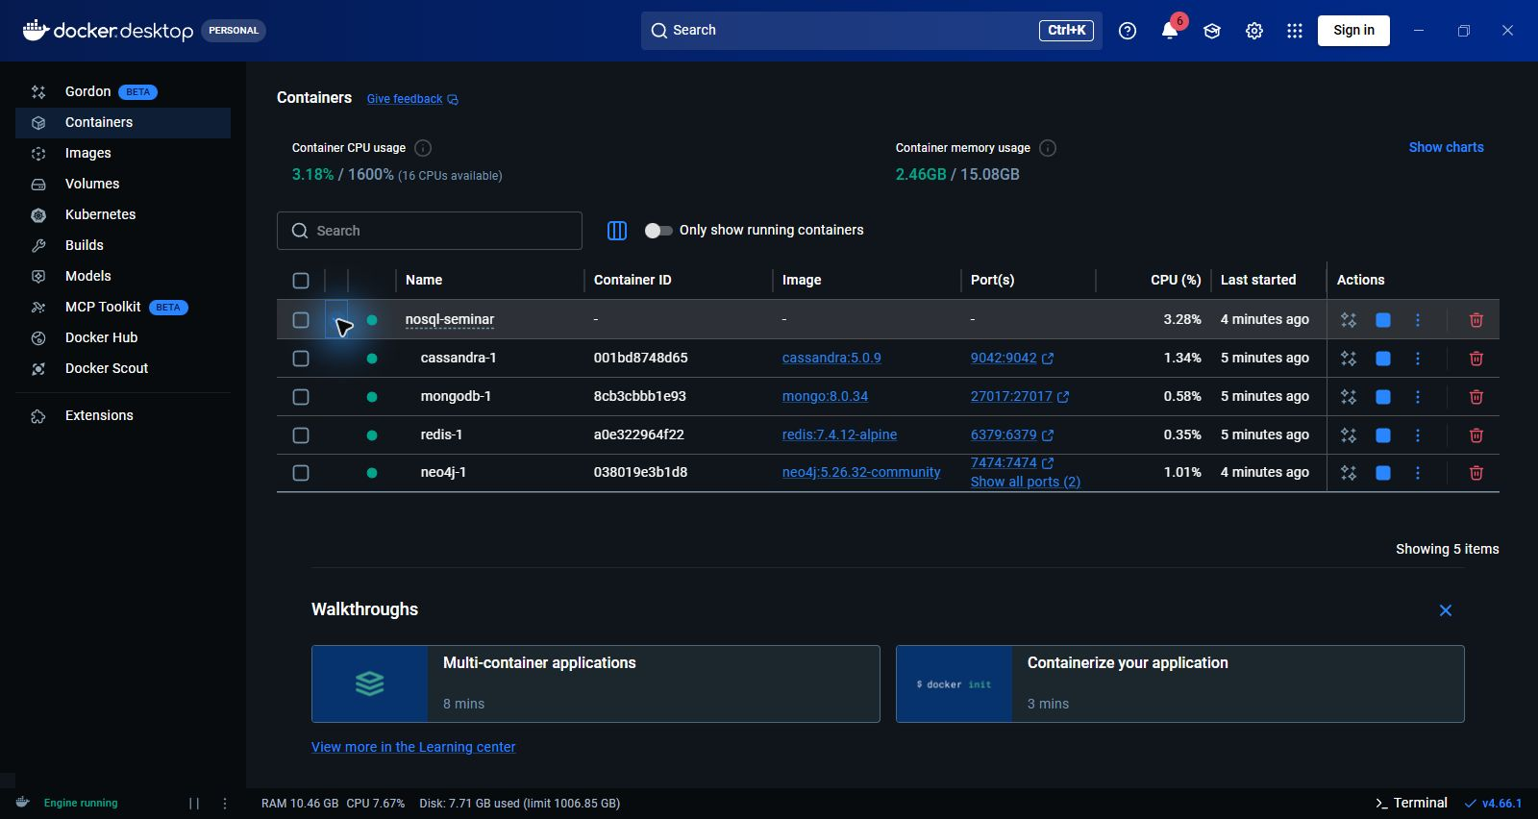
Figure 1 Four database services in Docker Desktop
Named volumes retain database files independently of container replacement. Bind mounts provide command scripts and configuration from this repository. Moving the folder requires Compose to recreate containers with updated bind paths, while the explicit project name preserves the volume names. Stop with scripts/stop.ps1. Removing volumes would remove the stored data. [1]

Redis implementation and core concepts
Redis is an in-memory key–value database with structured value types. Strings suit scalar values and counters; hashes group fields; lists preserve order; sets provide unique membership; sorted sets order members by scores. The permanent student sample is a hash at seminar:student:101. Tests use separate keys so deleting a demonstration record does not remove the sample.

CLI CRUD example
HSET seminar:test:profile:9101 name "Bharat Yadav" semester 5
HGETALL seminar:test:profile:9101
HSET seminar:test:profile:9101 semester 6
HGET seminar:test:profile:9101 semester
DEL seminar:test:profile:9101
EXISTS seminar:test:profile:9101
HSET creates or updates fields, HGETALL reads a hash, and DEL deletes its key. HSET returns the number of new fields, so zero can mean a successful update of an existing field. The expected update value is 6; the deletion check returns zero.
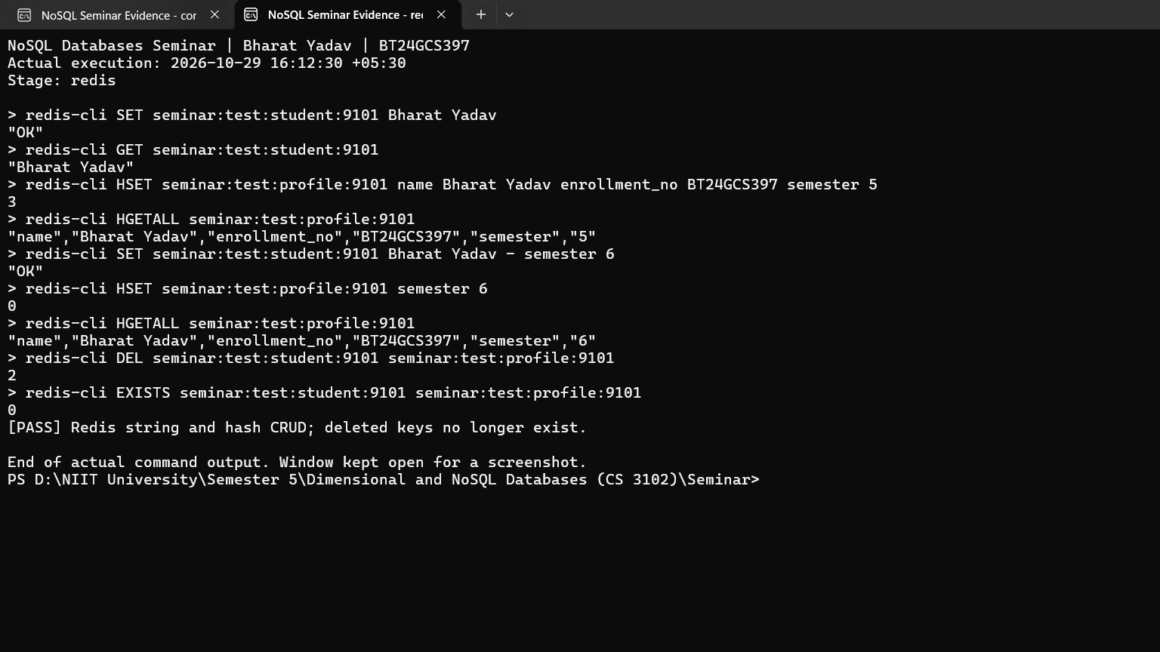
Figure 2 Redis string and hash CRUD evidence

Caching persistence and messaging
A cache avoids repeatedly computing or fetching an expensive result. SET cache:key value EX 2 gives a two-second TTL; the key becomes absent after expiry. The project enables AOF with everysec synchronization and RDB snapshotting. AOF records writes, while RDB stores snapshots. A crash can lose recent writes with everysec, so enabling persistence is not a zero-loss guarantee. [2]
Pub/Sub broadcasts messages to connected subscribers. The captured subscriber receives the publisher’s message, but Pub/Sub has at-most-once delivery and no replay for a disconnected subscriber. Redis offers fast access and convenient data structures, but RAM costs, memory limits and durability settings constrain its use. The demo chooses noeviction to avoid silently evicting student records. [3]

Cassandra implementation and core concepts
Cassandra is a distributed wide column database. Its peer architecture allows a node to coordinate a request and communicate with the replicas responsible for that data. The keyspace controls replication. The partition key is hashed for placement, and clustering columns, when present, order rows within a partition. Here student_id alone is the primary and partition key. [4, 5]

CQL CRUD example
INSERT INTO university.students (student_id,name,semester)
VALUES (9101,'Bharat Yadav',5);
SELECT * FROM university.students WHERE student_id=9101;
UPDATE university.students SET semester=6 WHERE student_id=9101;
DELETE FROM university.students WHERE student_id=9101;
CQL resembles SQL, but this does not imply relational joins or arbitrary efficient filtering. Tables should be designed from known queries. Inserts and updates can act as upserts. Deletes leave tombstones until eligible compaction; they do not imply immediate removal of every on-disk copy.
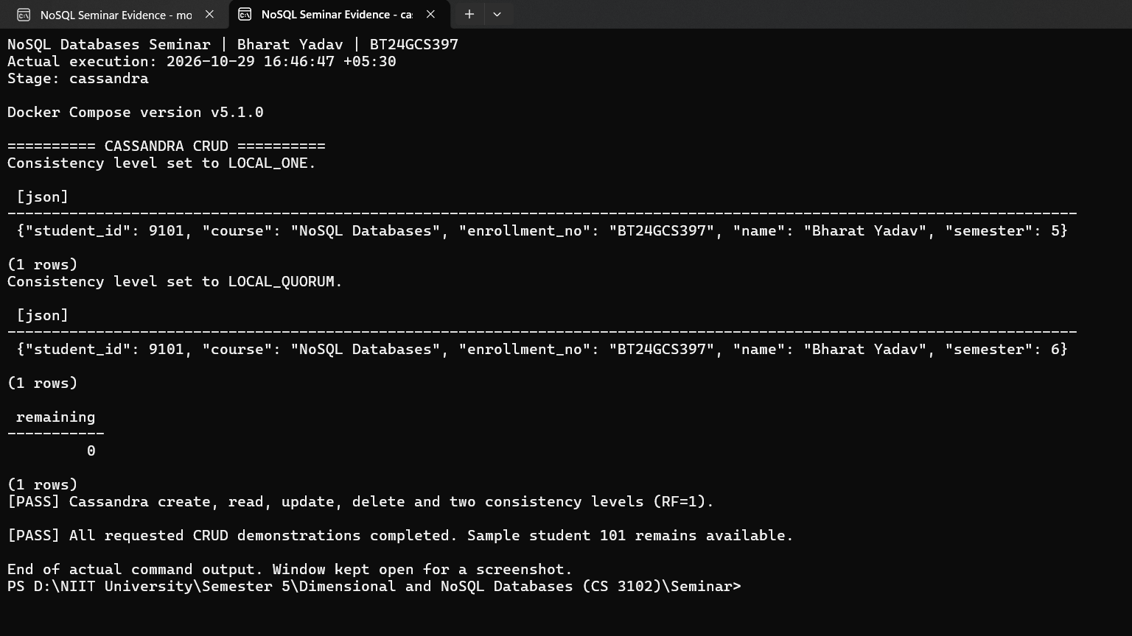
Figure 3 Cassandra CRUD and consistency level output

Replication and tunable consistency
NetworkTopologyStrategy is configured with datacenter1 replication factor 1. Replication factor specifies stored copies; a consistency level specifies the replica responses needed to acknowledge an operation. LOCAL_ONE requires one local replica; LOCAL_QUORUM requires a local majority. Both require one response when RF is 1. With RF 3, a local quorum needs two. [4]
Cassandra suits sustained distributed writes and replicated event data. Its costs include operational complexity, repairs, compaction and query-specific duplication. Low acknowledgment levels may expose stale reads. Stronger overlapping read and write levels improve visibility guarantees at an availability and latency cost; ordinary quorum operations should not be described as full serializable transactions. A single replica provides no replica failover.

MongoDB implementation and core concepts
MongoDB stores BSON documents in collections. BSON is a binary format supporting nested objects, arrays and types such as ObjectId and dates. A student document can include contact.university and an interests array. Schema flexibility means records may differ in optional fields; it does not remove the need for a consistent model. Validation rules can enforce required properties and types. [6]

Mongo shell CRUD example
db.students.insertOne({student_id:9101,name:"Bharat Yadav",semester:5})
db.students.findOne({student_id:9101})
db.students.updateOne({student_id:9101},{$set:{semester:6}})
db.students.findOne({student_id:9101})
db.students.deleteOne({student_id:9101})
db.students.find({student_id:9101}).toArray()
The update uses $set to change a field. The final query returns an empty array. The project creates a unique ascending index on student_id, separate from MongoDB’s built-in unique _id index. Adding a project field in the demonstration illustrates a flexible document shape.
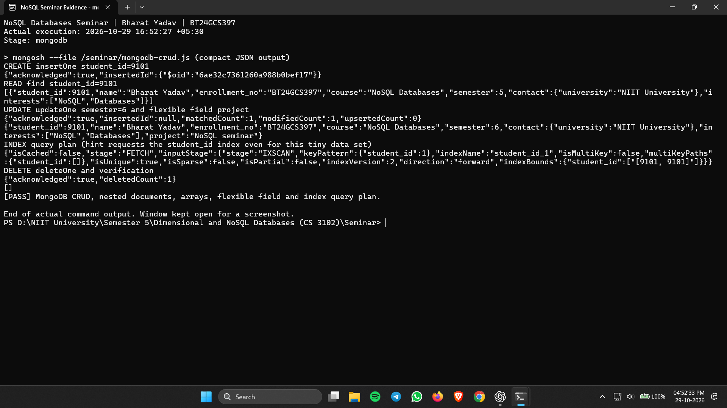
Figure 4 MongoDB document operations and index plan

Indexes and transaction boundaries
An index can reduce the records examined for a suitable query, but consumes storage and adds write-maintenance work. The screenshot shows IXSCAN after an explicit hint requests the student_id index. For a tiny collection, the optimizer might otherwise choose a collection scan; the screenshot is not a performance benchmark. [8]
Single-document updates are atomic. Multi-document transactions require a replica set or sharded deployment and are unavailable on this standalone server. MongoDB’s document model fits content and catalogs, but embedding can duplicate information and grow documents. Applications must manage duplicated values and choose read and write guarantees appropriate to the deployment. [7]

Neo4j implementation and core concepts
Neo4j stores a property graph. Nodes represent entities, labels classify nodes, properties hold attributes, and directed relationships have types and may hold properties. The project uses a Student node and a Course node joined by ENROLLED_IN. Uniqueness constraints protect student_id and course code. Neo4j supports ACID transactions. [9]

Cypher CRUD and traversal
CREATE (:Student {student_id:9101,name:'Bharat Yadav',semester:5});
MATCH (s:Student {student_id:9101}), (c:Course {code:'CS3102'})
CREATE (s)-[:ENROLLED_IN]->(c);
MATCH (s:Student {student_id:9101})-[:ENROLLED_IN]->(c) RETURN s,c;
MATCH (s:Student {student_id:9101}) SET s.semester=6;
MATCH (s:Student {student_id:9101}) DETACH DELETE s;
MATCH describes a pattern to retrieve. SET updates properties. DETACH DELETE removes the selected student and incident relationships while retaining the shared course. The initialization script uses MERGE to match or create the sample pattern, making repeated setup safe with the uniqueness constraints. [10]
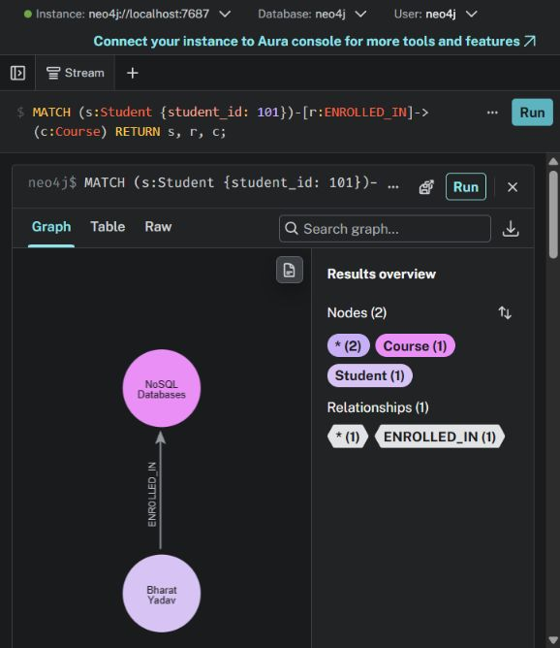
Figure 5 Student 101 connected to Course CS3102
Relationship traversal is useful when the application repeatedly asks how entities are connected. Fraud rings and product knowledge graphs are natural examples. A graph database introduces modeling, memory and query-planning costs, and does not automatically improve simple independent key lookups or every large aggregate query. The captured graph returns two nodes and one relationship. This visual demonstrates the model, not a graph algorithm or a production recommendation engine.

Python integration and reproducible execution
The project includes a Python 3.12 client container with redis-py, cassandra-driver, PyMongo and the Neo4j Python driver. Compose provides credentials through environment variables and addresses the databases by service name. Dependencies are pinned in python/requirements.txt. The client image runs as a non-root user with a read-only filesystem and a temporary writable directory.
.\scripts\python-demo.ps1 # build and run
.\scripts\python-demo.ps1 -NoBuild # reuse the built client image

Representative driver calls
# Redis hash operations
r.hset(key, mapping={"semester": 5}); r.hgetall(key)
r.hset(key, "semester", 6); r.delete(key)
# Cassandra prepared CQL
q = session.prepare("UPDATE students SET semester=? WHERE student_id=?")
session.execute(q, [6, student_id])
# MongoDB document update
students.update_one({"student_id": student_id}, {"$set": {"semester": 6}})
# Neo4j parameterized Cypher
session.run("MATCH (s:Student {student_id:$id}) SET s.semester=6",
id=student_id).consume()
The complete executable program is python/demo.py. It selects a fresh temporary numeric student ID, creates a record, verifies semester 5, updates and verifies semester 6, deletes the record, and checks absence. Neo4j additionally creates and traverses ENROLLED_IN to the existing course. Cleanup runs in finally blocks, and the permanent sample 101 is preserved. Assertions raise errors if observed values differ from the expected results.

Observed result on 5 November 2026
Database | Checks | Outcome
Redis | Create read update delete hash | PASS
Cassandra | Prepared CQL and deletion check | PASS at LOCAL_ONE
MongoDB | Nested document and atomic field update | PASS
Neo4j | Create relationship traverse update delete | PASS

The run log is logs/python-driver-crud.txt. The separate scripts/verify.ps1 -CheckSample check confirms all four services are healthy and the shared enrollment record remains available. Existing CLI command files under commands provide installation and CRUD snippets independently of Python. The program verifies functionality; it does not measure throughput or compare latency.

Industrial applications and design tradeoffs
The following scenarios explain why a database model fits a workload. Company reports describe the systems at their publication dates; they are not claims that each company still uses the same architecture in 2026.

Redis caching at Twitter and session storage
A timeline cache stores already prepared identifiers or results so repeated feed requests avoid the full reconstruction cost. Twitter engineering presentations describe real-time timeline infrastructure. Expiring Redis keys also fit shared session state: a session identifier retrieves login context and TTL removes stale state. [11] The brief’s GitHub session example is treated as a design scenario. GitHub’s 2013 session article describes an ActiveRecord model and lists Redis as an alternative; it does not establish that GitHub sessions were implemented in Redis. [12]

Cassandra messaging at Netflix and time series at Uber
Netflix’s 2022 RENO article explicitly describes Cassandra as the persistent store for notifications, allowing individual devices to poll later. Partitioned notification records help separate devices and support continued message retrieval. [13] Uber’s 2018 M3 article reports that early M3 used Cassandra for time-series storage before adopting M3DB. A suitable Cassandra model partitions by metric and bounded time window, with timestamps ordering observations; this proposed schema explains the fit and is not an asserted copy of Uber’s schema. [14]

MongoDB content at Forbes and data storage at eBay
Forbes’ customer case identifies MongoDB Atlas as part of its content-management solution. Documents accommodate article text, authors, tags and evolving metadata. [15] The 2017 eBay case describes MongoDB across customer-facing applications and resilient deployments. A document model can accommodate varied application records, while replication and operational procedures address availability. These industrial capabilities are broader than this project’s standalone demonstration. [16]

Neo4j financial fraud and e commerce knowledge graphs
A financial fraud graph can connect accounts, transactions, devices and addresses. Shared identifiers, cycles and paths to known suspicious accounts give investigators context that isolated transaction rows may hide. A detected connection is a lead rather than proof of fraud. [17] An e-commerce knowledge graph connects products, categories, brands and customer interests. Traversal supports product discovery and explanations for suggestions; quality depends on the data and recommendation logic. [18]

Choosing the system
Redis trades RAM and durability configuration for convenient fast access. Cassandra trades operational simplicity and arbitrary querying for distributed write scale. MongoDB trades some normalization for flexible aggregate documents. Neo4j invests in relationships at the cost of graph modeling and memory. Select from workload requirements, then measure with representative data rather than transferring a company’s choice without its context.

Results conclusions and references
All four database instances were healthy after starting from the moved repository. Live queries returned Redis PONG, Cassandra version 5.0.9, MongoDB ok 1 and a successful Neo4j result. Student 101 with enrollment BT24GCS397 and the enrollment relationship were verified. The Python demonstration passed CRUD checks in every database. The evidence captures and command files provide a reproducible record of the work.
The main conclusion is that each model fits a different access pattern. Persistence was retained through named volumes and Redis persistence settings. The laptop setup does not test high availability, network partitions or production throughput. Improvements would include a multi-node Cassandra test with RF 3, a MongoDB replica set, backup restoration, transport encryption and workload-specific measurement. No performance ranking is claimed.

References
[1] Docker documentation on volumes
[2] Redis persistence documentation
[3] Redis Pub Sub delivery semantics
[4] Apache Cassandra Dynamo architecture
[5] Apache Cassandra logical data modeling
[6] MongoDB BSON types
[7] MongoDB 8 transaction deployment requirements
[8] MongoDB write performance and indexes
[9] Neo4j property graph and transactions
[10] Neo4j Cypher tutorial
[11] Twitter engineering presentation at InfoQ 2014
[12] GitHub Modeling Your Apps User Session 2013
[13] Netflix Rapid Event Notification System 2022
[14] Uber M3 engineering article 2018
[15] MongoDB Forbes customer case
[16] MongoDB eBay resilient applications case 2017
[17] Neo4j fraud detection use case
[18] Neo4j knowledge graph use case
[19] Seminar work assignment brief supplied with the project. Web references checked 5 November 2026. Original captures and hashes are listed in screenshots/manifest.json. All 12 original images are included in the PowerPoint.

