

**Subject :-** INT 404 – ARTIFICIAL INTELLIGENCE

**Project Title :-** Your Personal Analysis Using

Fat Secret API

**Project submitted to:**

**Faculty: Jasleen Kaur**

**Project submitted by:**

**Name** :V. Bharath, K. Ravi Teja, M. Raja

**Section**: K18MS

**Roll No**: 49, 50, 51

**Student Declaration**

This is to declare that this report has been written by me/us. No part of the report is copied from other sources. All information included from other sources have been duly acknowledged. I/We aver that if any part of the report is found to be copied, I/we are shall take full responsibility for it.

Name: Veerla Bharath

Roll No: 49

Name: K. Ravi Teja Roll No: 50

Name: Mohamad Raja Roll No: 51

**Introduction:**

Personal Nutritionist as the name, the system can act as your personal nutritionist while this system can be used also by nutritionist gaining a lot of information and help in many ways. FatSecret API helps the System to get the information in many ways. The user can get details about a number of nutrients, vitamins etc of a fruit or vegetable. The user can add his recipes or get recopies using the API.  
The System basically helps the user in what to eat and which is good, what will help him and etc, the system will help him filter things easily.  
The System also allows the user to make a diet plan and remind him his food timings.

Your Personal Nutritionist Using FatSecret API brings out an Application Programming Interface to act as personal nutritionist for users. This System uses the API called FatSecret in order to provide various health tips which makes the user to lead a healthy life.

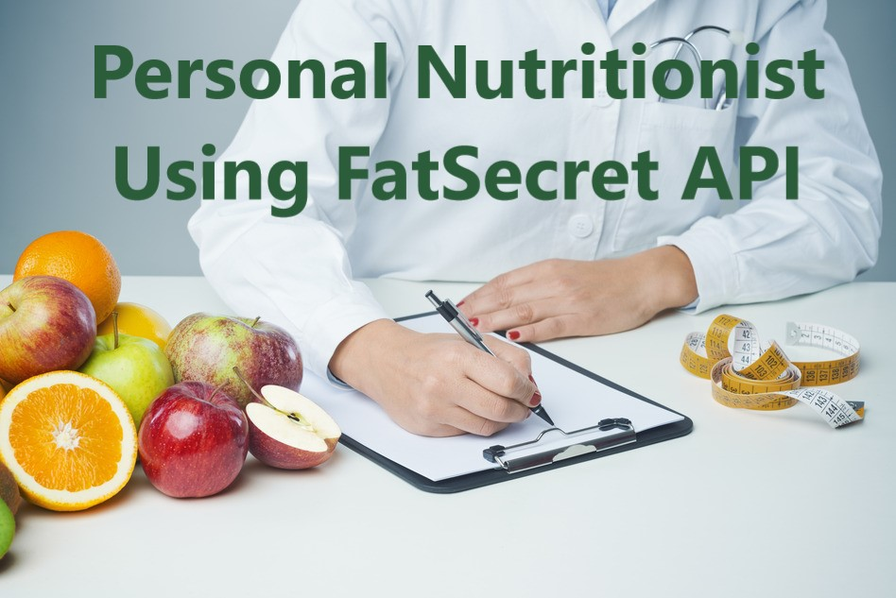

**Project Overview:**

Many technologies are emerging in each and every seconds of human life. In addition people are depending on those technologies to do their daily activities in easy manner. Because now this world is purely depends on digital works. Digital data has been used in all areas of world and no one depend on any paper works as possible. This emerging digital world changes the life of humans in high manner. Thus it reduces the manual work and errors which helps to acquire effective works. Even though this digital works helps the people to minimize their rate of work, it has serious disadvantages. Physical fitness is very important for everyone to lead a healthy life. But everyone who wants to be fit is not succeeding while it comes to maintenance. Maintenance in the sense to have a healthy eating based on nutrition, enough weight etc… Then Stress management also be important to get a good life. Due to stress, people are spoiling their health. Now a day’s everyone needs the presence of nutritionist in order to maintain a better life. Thus Fat Secret API has been developed to act as nutritionist for a particular user. This application programming interface will provide guidance for human about the foods to be taken and which is not. It also brings out the necessity in drinking of water and the impact on children because of parent irregular diet habits. This personal nutritionist api will paves a way for human to interact with application regarding their diet and healthiness.  This Personal Nutritionist application may be of android or windows based. It also includes, getting information about the object entered by user. That object may be fruits, vegetables, raw foods; etc…With the help of this application user can able to get the details of the particular object that have entered.

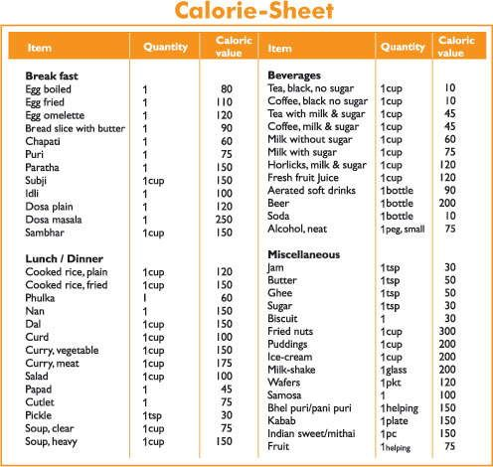

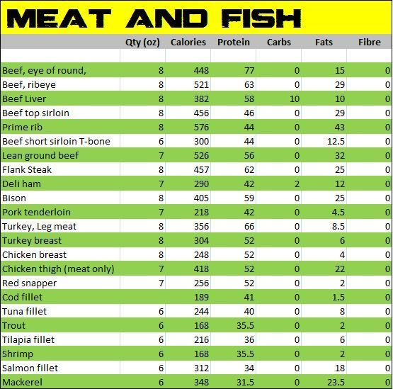

**Proposed System:**

**Personal Nutritionist**API has been developed to behave as a nutritionist for the users. API stands for Application Programming Interface. Everyone is looking for good nutritionist in order to take care of their health status. The reason for this needy is humans are not conscious about their health status in this speedy moving world. It is found that most of the death that occurred was because of imbalance in their health. Due to the imbalance in behavior of food taken, people will suffer more and more. On the other hand, availability of nutritionist is not possible in wherever the humans want. So it is difficult to consult with nutritionist as per their wish in any time. This issue brings out the emerging of mechanism named Fat Secret Application Programming Interface.  With the help of this mechanism, one can able to update their status of health and enhance their health. This would give the knowledge of food that should take and one should not. It also gives out the awareness among the children and adults about the food items and snacks which seems to be healthy. This Personal Nutritionist api also helps the user to schedule their diet plan and remaining based on that schedule. In addition it provides the recipes to be added and which is not. This Personal Nutritionist application makes the interface based on registration of user. Firstly the user will register in the API and they are allowed to provide their details. Then as per the schedule made by the user, the remainder will work to behave as nutritionist to take of user body.

**Programme output:**

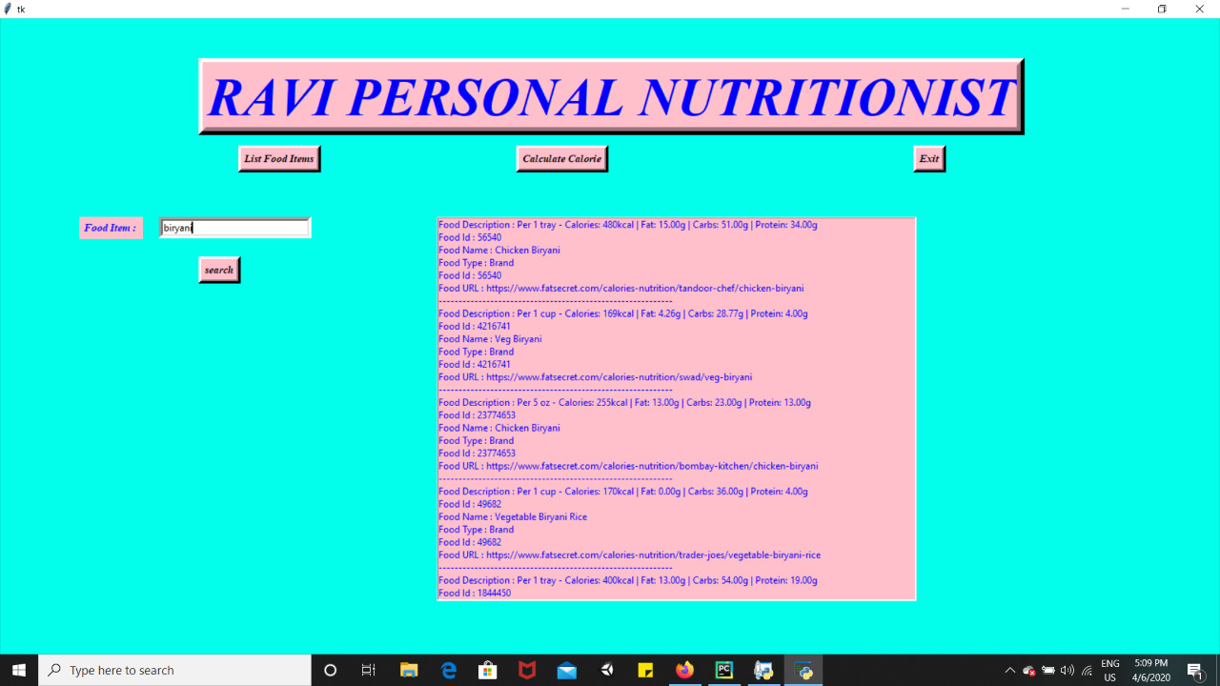

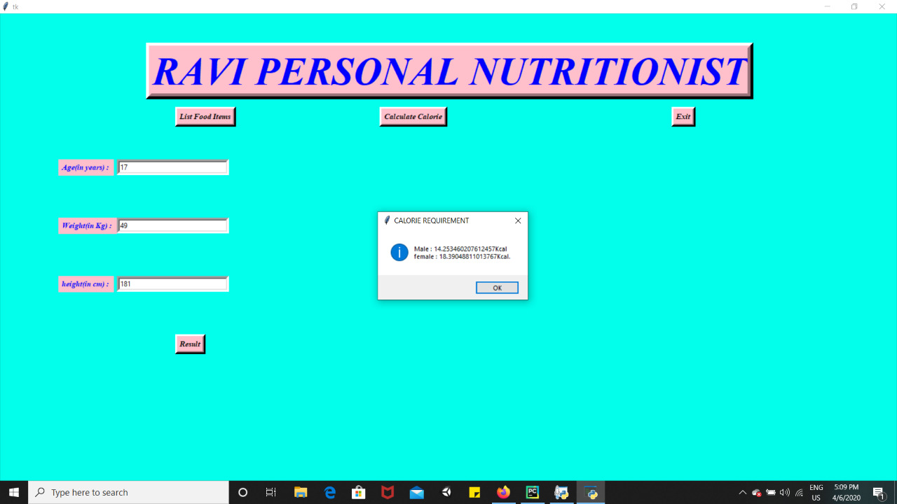

BONAFIDE CERTIFICATE

Certified that this project report “Your Personal Analysis Using Fat Secret API” is the bonafide work of “ K. Ravi Teja,

V. Bharath, M. Raja” who carried out the project work under my supervision.

**Jasleen Kaur**