**Topic 1: Java.lang package:**

**Assignment 1:**

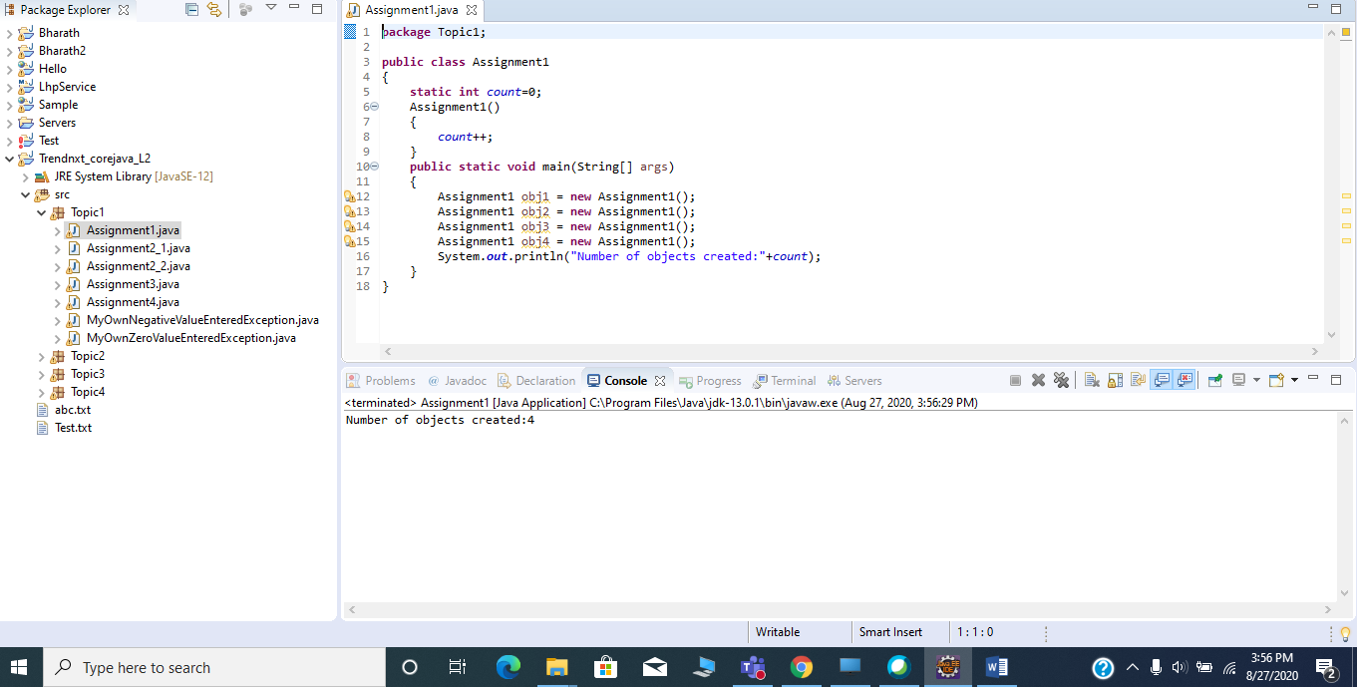

**Assignment 2:**

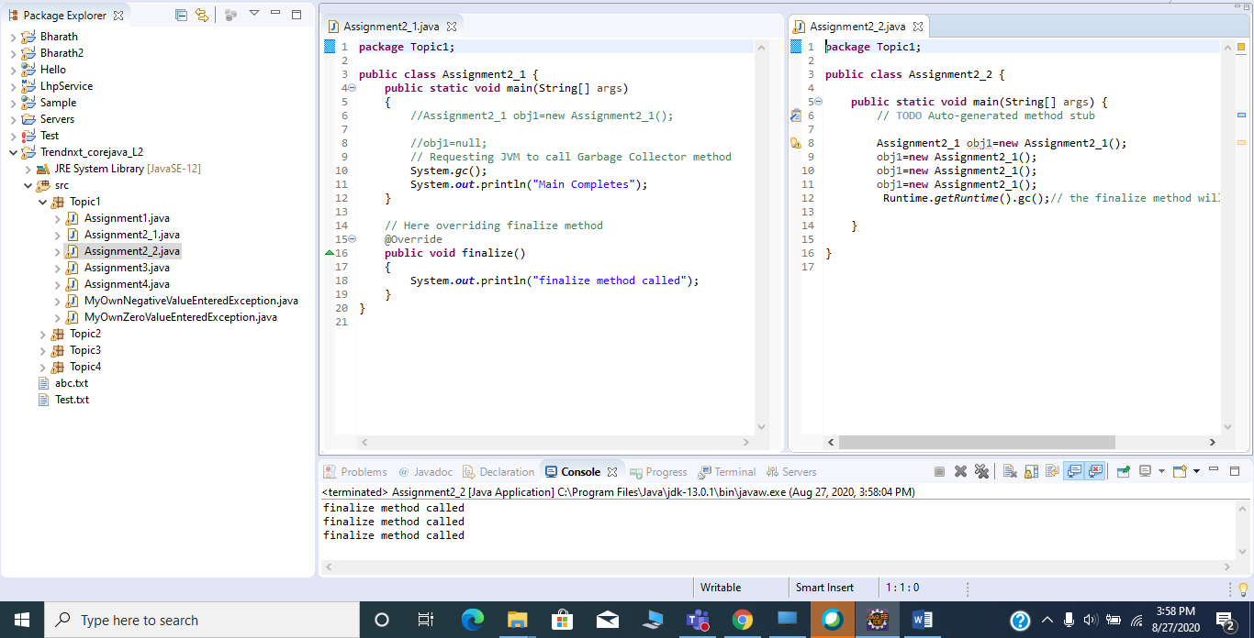

**Assignment 3:**

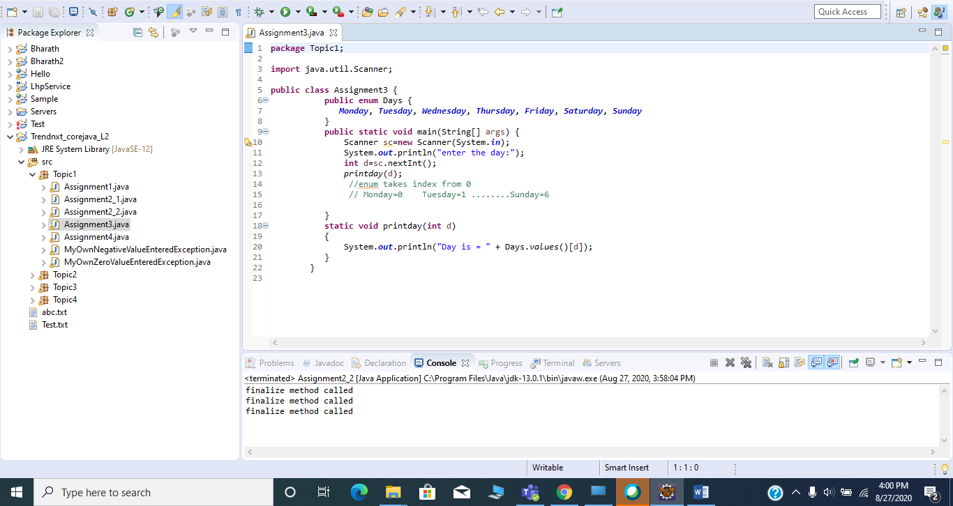

**Assignment 4:**

**Using assertion:**

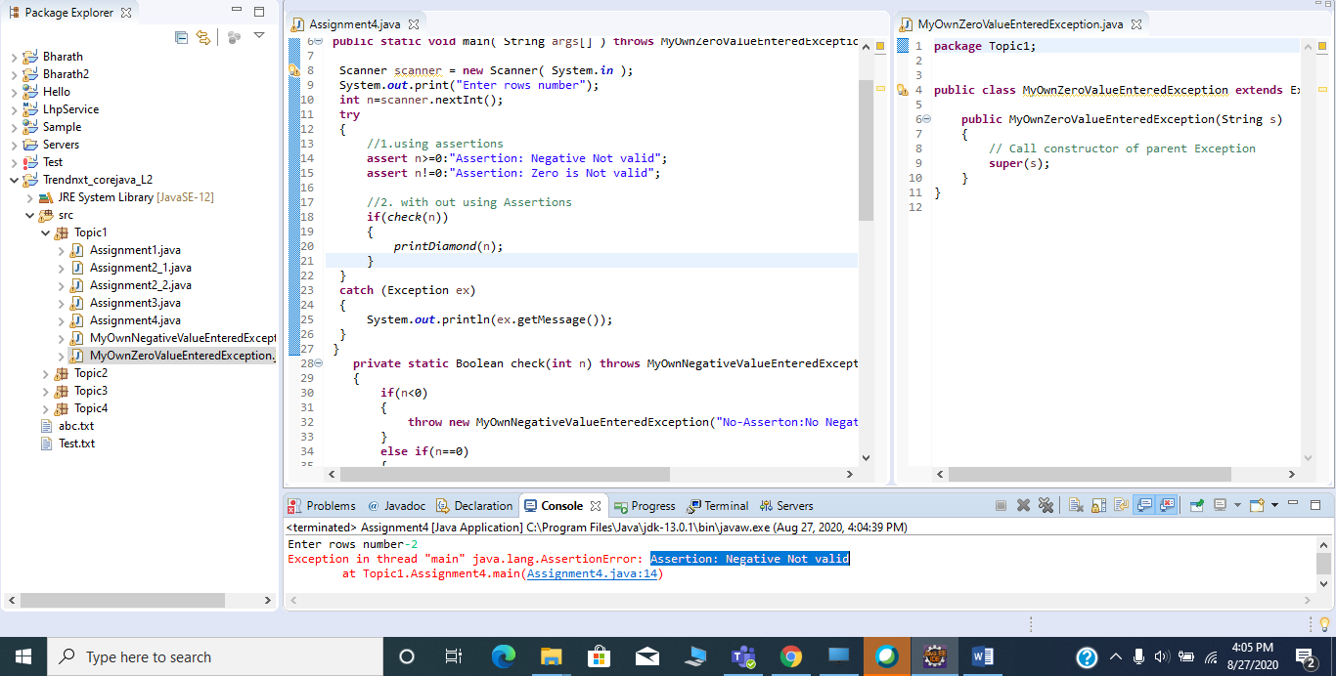

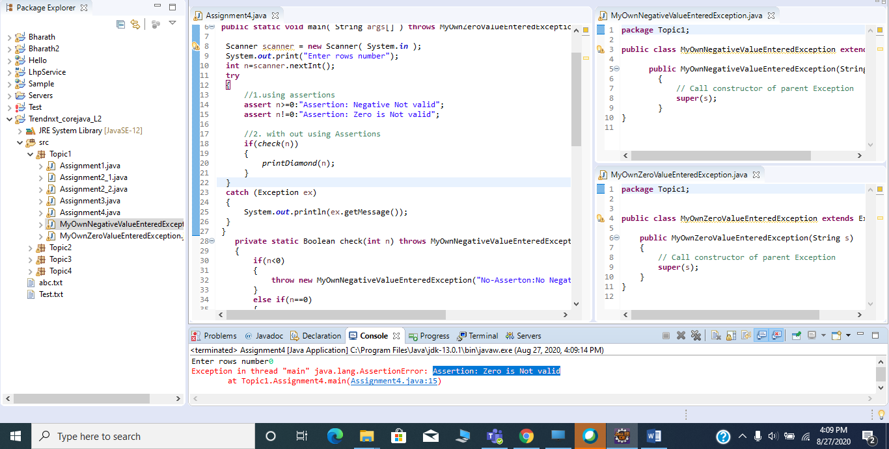

**Without using assertion:**

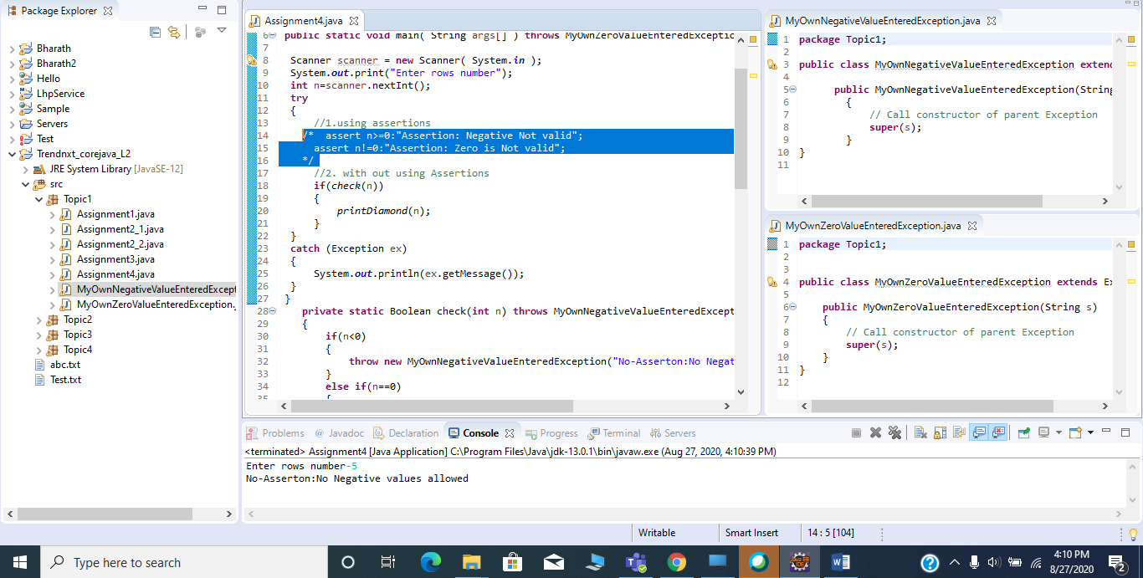

**If we give correct value(value>0)**

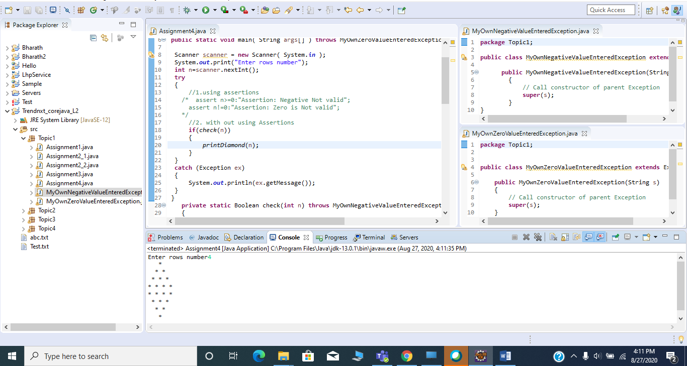

**Topic 2: Java.util package:**

**Assignment 1:**

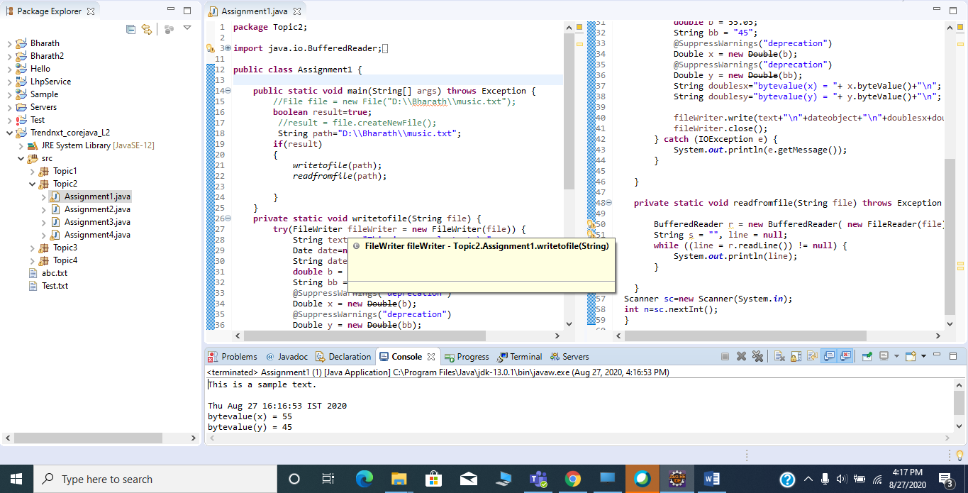

**Assignment 2:**

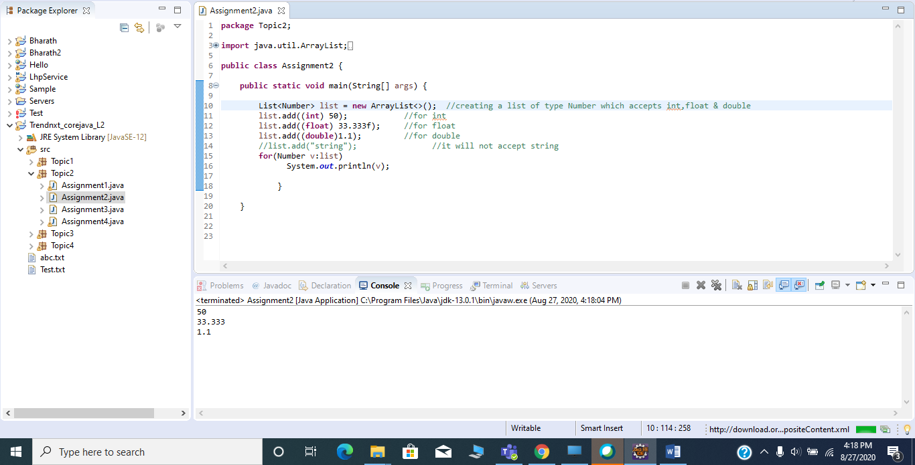

**Assignment 3:**

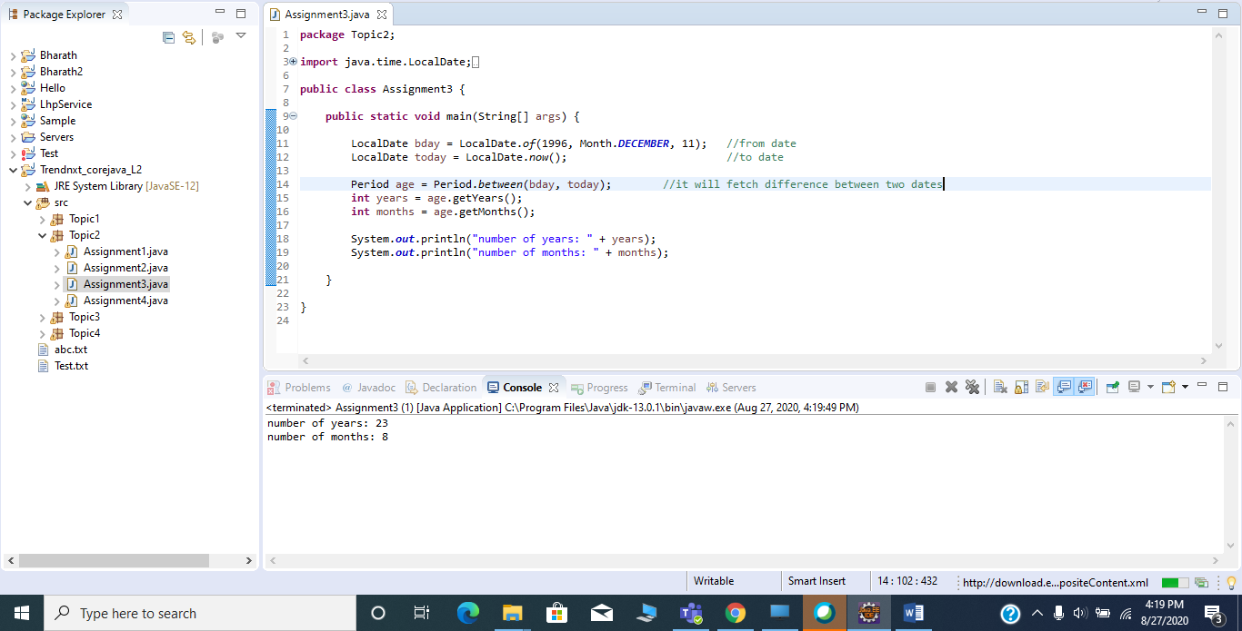

**Assignment 4:**

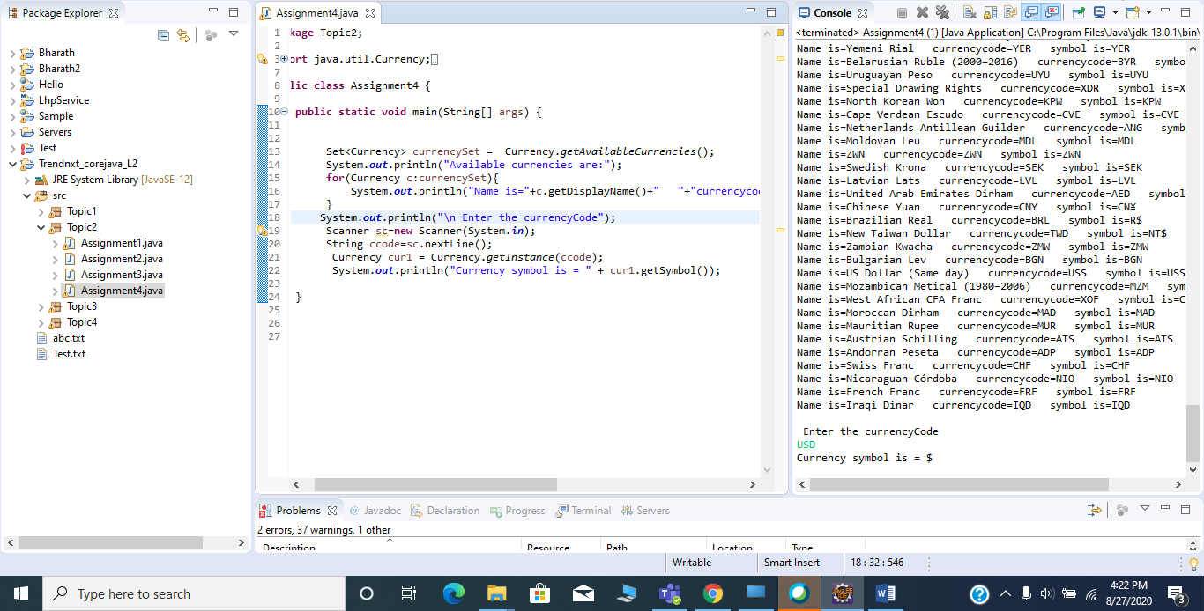

**Topic 3 : Java.io package:**

**Assignment 1:**

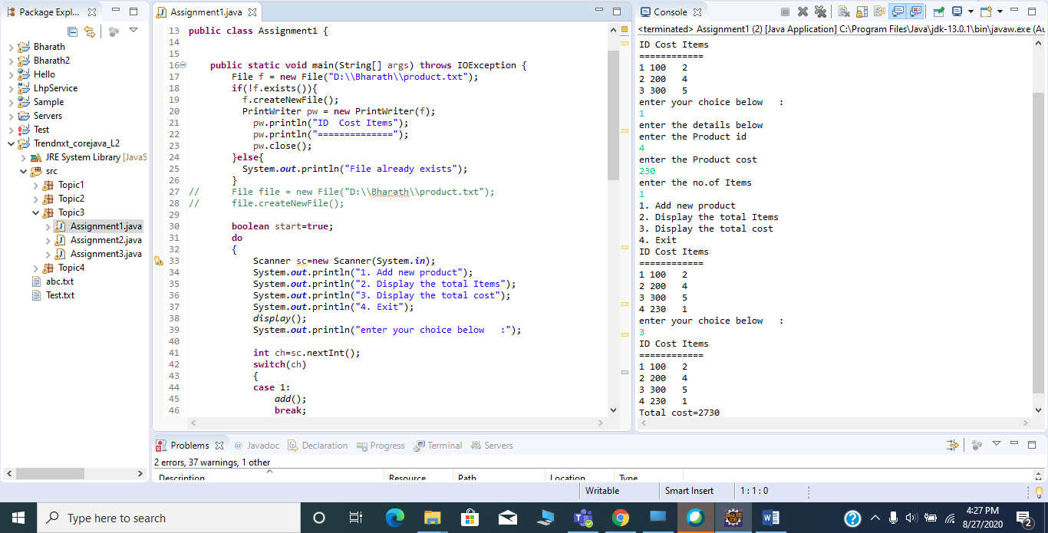

**Assignment 2:**

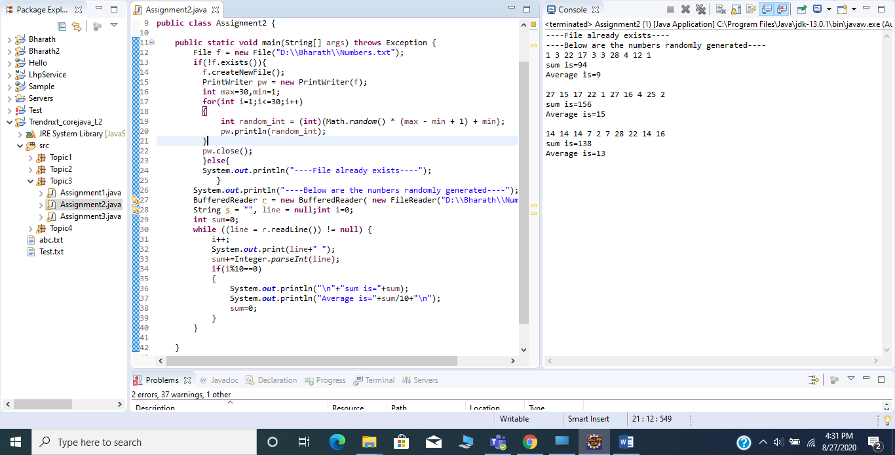

**Assignment 3:**

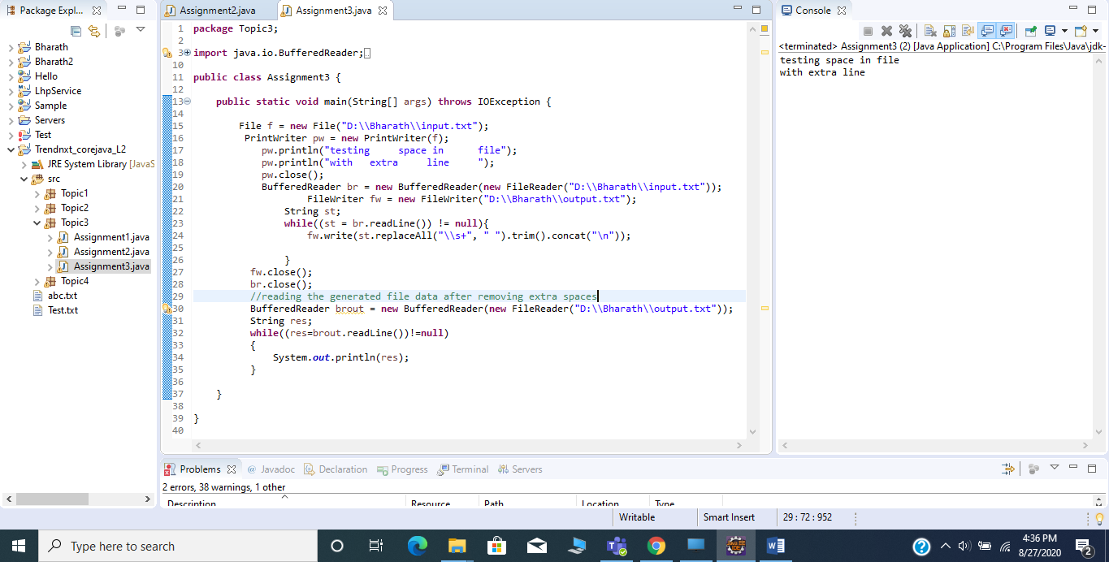

**Topic 4 : Lambda Expressions:**

**Assignment 1:**

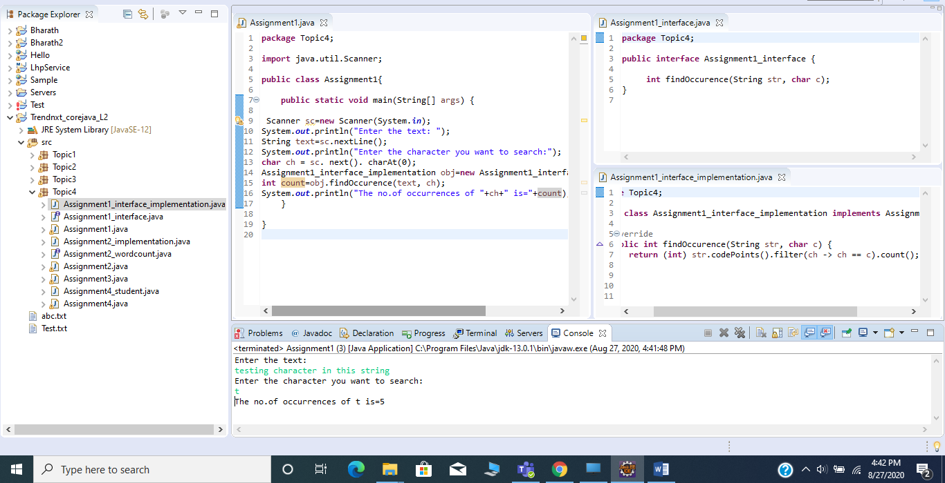

**Assignment 2:**

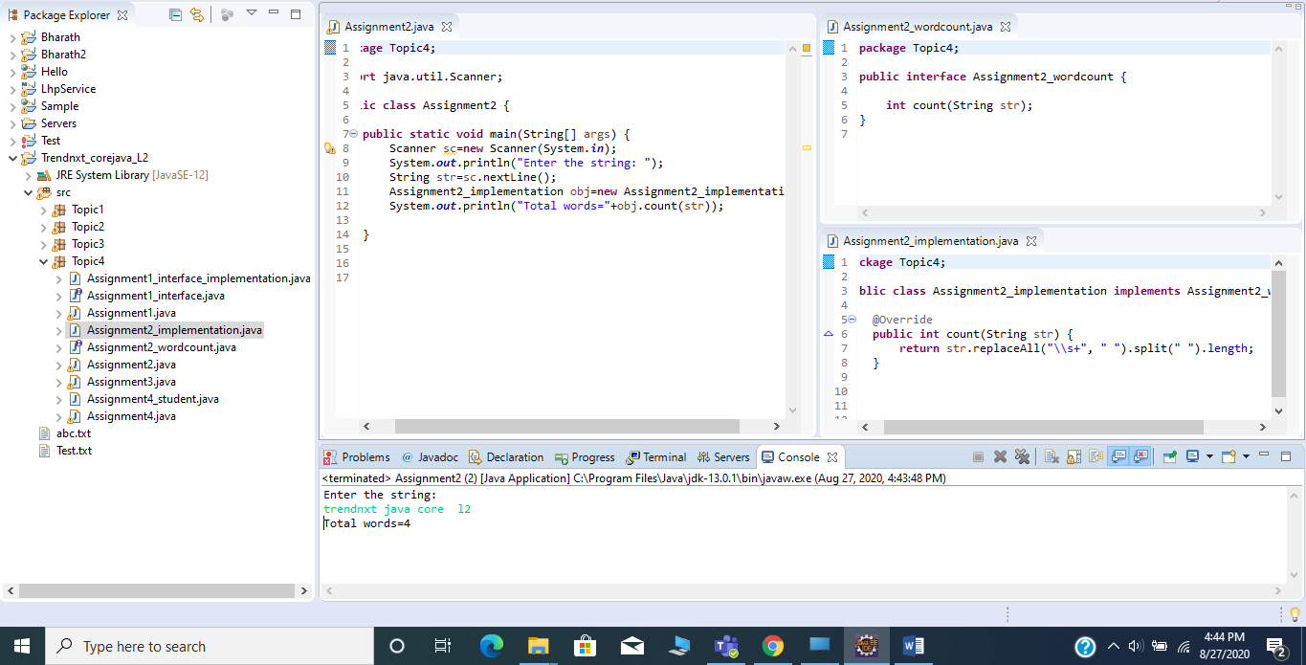

**Assignment 3:**

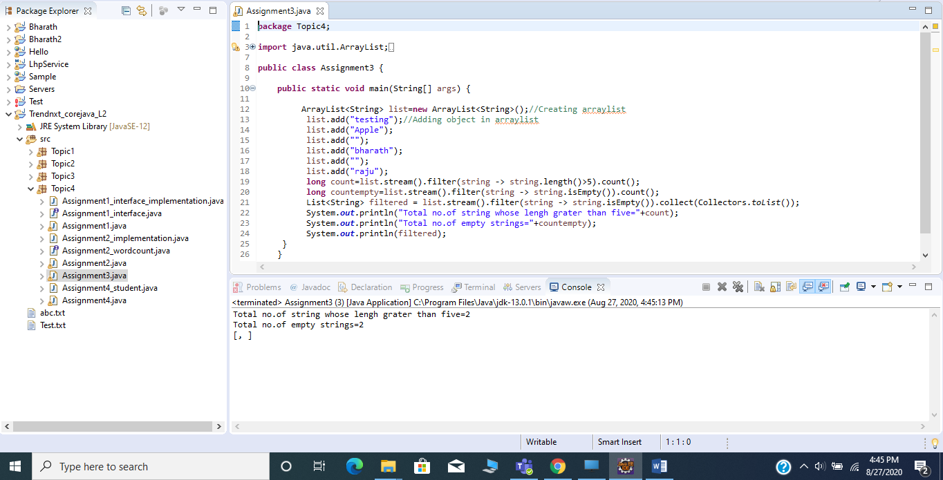

**Assignment 4:**

