ENGINEERING REPORT | COMPLEX ENGINEERING TASK
Machine Temperature Anomaly Detection
Task 3D - Unsupervised Industrial IoT Fault Warning Using Autoencoders
Course: CM701PC Deep Learning and CM751PC Deep Learning Lab | Program: B.Tech CSE (AI&ML), VII Semester, Regulation MR-22
Team 15 | Variant 3D: Machine Temperature | Assigned Faculty: Dr. M. Rudra Kumar, Professor, Department of Emerging Technologies

1. Team Allotment and Contribution Breakdown
Roll number | Member name | Role | Primary work | Viva focus
24265A6604 | [Add member name] | Data Lead | Dataset retrieval, inspection, cleaning, labels and split audit. | Data lineage, NAB labels, leakage controls.
23261A6665 | [Add member name] | Model Lead | Dense and LSTM autoencoder implementation, training and tuning. | Bottleneck capacity, sequence modelling, training.
23261A6616 | [Add member name] | Evaluation & Report Lead | Metric calculation, threshold analysis, target checks and report compilation. | PR curve, event evaluation, cost reasoning.

All members are expected to contribute to code, experiments and the report. Replace the contribution summaries with the work actually completed by each member before submission.

2. Executive Summary
This project develops an unsupervised warning pipeline for temperature readings from an industrial machine. The system learns normal operating behaviour using autoencoders and assigns an anomaly score from reconstruction error. Three models are compared: a dense baseline autoencoder, a more compressed dense autoencoder and an LSTM autoencoder. The series is split chronologically into training, validation and test partitions. Fault labels are excluded from model fitting and are reserved for validation threshold selection and held-out evaluation. The final operating point must balance event recall, false alarms and detection delay. Numerical model results are left as entry fields until the executed Colab outputs are checked.

3. Problem Understanding and Engineering Trade-offs
The machine produces a continuous, mostly normal temperature stream. Faults are rare, so a supervised classifier trained on a small labelled fault set is not the intended solution. The autoencoder is fitted on normal windows and should reconstruct familiar behaviour with low error. A window that differs from learned normal patterns should produce higher reconstruction error and may be flagged.
- Recall versus nuisance alarms: lowering the threshold may catch more faults but increases false alarms; raising it can reduce inspections while missing faults.
- Capacity versus generalisation: a wide bottleneck can learn an identity mapping; an overly narrow bottleneck can fail to reconstruct normal operating variation.
- Temporal structure versus simplicity: dense models flatten the 12 readings; the LSTM processes their order and can represent ramps, oscillations and transitions.

3.1 Required operating constraints
Requirement | Assignment target | Evaluation basis
Fault-event recall | At least 0.85 | Event-level match to labelled fault intervals
False alarms | Fewer than 2 per 24 h | Count distinct false alarm episodes per monitored day
Detection delay | Under 5 min, or within 3 readings when sampling is slower than 1/min | Time from event-window start to first matched alarm
Label use | No labelled fault data in training | Labels only for validation threshold tuning and testing

DATA AND METHODOLOGY
4. Dataset, Exploratory Analysis and Preparation
Dataset description and anomaly intervals are based on the NAB machine-temperature file and its published combined anomaly-window labels.

4.1 Dataset profile
Field | Description
Dataset | Numenta Anomaly Benchmark (NAB), realKnownCause / machine_temperature_system_failure.csv
Signal | Temperature reading of an internal component of a large industrial machine
Records | 22,695 observations
Time span | 2 Dec 2013, 21:15 to 19 Feb 2014, 15:25
Sampling cadence | 5 minutes per reading
Columns | timestamp and value
Ground truth | Four labelled anomaly windows in NAB combined_windows.json

The NAB dataset description notes that the first anomaly is a planned shutdown and that a later difficult-to-detect anomaly is directly related to a subsequent catastrophic machine failure. The label file defines the four evaluation windows listed below [1], [2].

4.2 Ground-truth anomaly windows
Window | Start timestamp | End timestamp
1 | 2013-12-10 06:25 | 2013-12-12 05:35
2 | 2013-12-15 17:50 | 2013-12-17 17:00
3 | 2014-01-27 14:20 | 2014-01-29 13:30
4 | 2014-02-07 14:55 | 2014-02-09 14:05

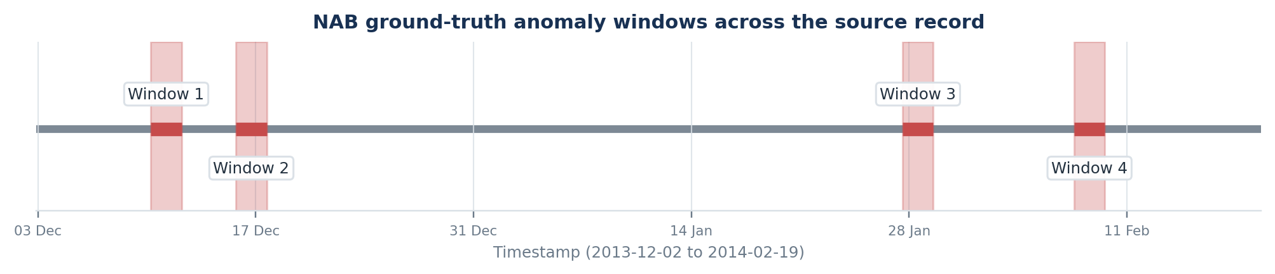
Fig. 1. Four NAB ground-truth anomaly windows mapped across the source time span. These are reference labels, not model detections.

4.3 Preprocessing and split
Timestamps are parsed and the records are kept in chronological order. The notebook uses a 60% / 20% / 20% chronological partition: 13,617 training observations, 4,539 validation observations and 4,539 test observations. The Min-Max scaler is fitted only on normal training observations and then applied unchanged to validation and test data. A sliding window of 12 consecutive readings is used; at five-minute cadence, each window spans one hour.
Only normal training windows are used to fit the autoencoders. Validation labels are used to select thresholds; test labels are held back for final evaluation. Before submission, verify that windows preserve consecutive timestamps and that no training window crosses a removed anomaly gap. Report the exact number of retained normal training windows from Colab.
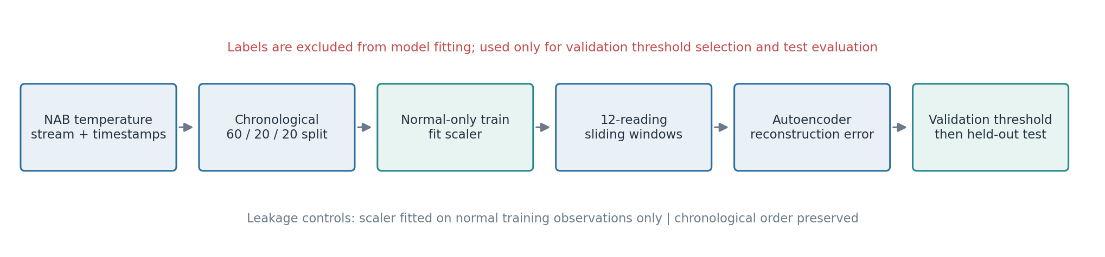
Fig. 2. Experimental pipeline and label-use boundary. The model-fitting path contains normal training data only.
Reproducibility fields to complete: Random seed [____] | Python [____] | TensorFlow/Keras [____] | Colab run date [____] | Normal train windows [____].

MODEL DESIGN AND PROTOCOL
5. Autoencoder Architectures and Experimental Method
The compared models use reconstruction loss to learn patterns from normal data. Their differences are compression capacity and whether input order is represented explicitly.

5.1 Architecture comparison
Model | Input and bottleneck | Architecture | Purpose
Dense baseline AE | 12 values; 2-unit bottleneck | 12 → 8 → 4 → 2 → 4 → 8 → 12 | Reference dense reconstruction model.
Improved dense AE | 12 values; 1-unit bottleneck | 12 → 6 → 3 → 1 → 3 → 6 → 12 | Tests stronger compression and reduced capacity.
LSTM AE | 12 time steps × 1 feature | LSTM(32) → Dense(16) → Repeat(12) → LSTM(32, seq.) → TimeDistributed Dense(1) | Models temporal order and local dynamics.

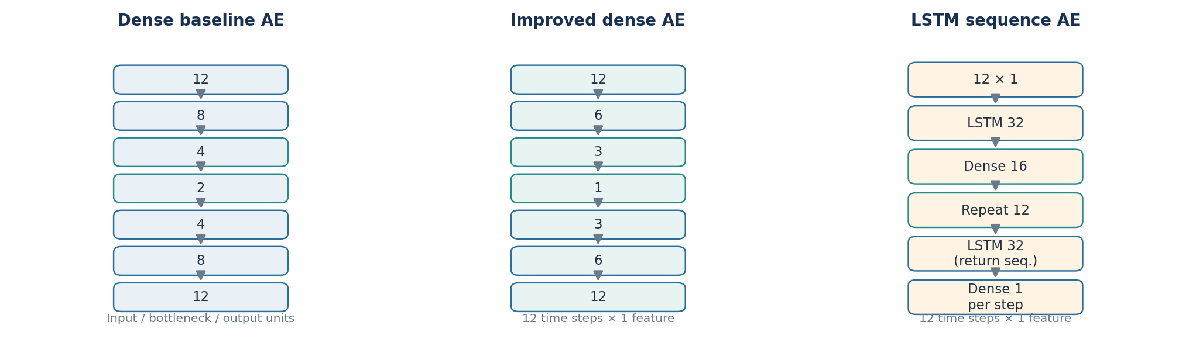
Fig. 3. Model architecture summary reconstructed from the implemented Colab configurations.

5.2 Training configuration
Setting | Implemented configuration
Objective / loss | Input reconstruction; mean squared error (MSE)
Optimizer | Adam
Epochs / batch size | Maximum 50 epochs; batch size 32
Early stopping | Monitor validation loss; patience 5; restore best weights
Window size | 12 readings per sample
Scaling | Min-Max scaler fitted only on normal training data
Threshold selection | Validation reconstruction errors; best-F1 and cost-minimising operating points

5.3 Anomaly score and operating threshold
For a 12-reading input window x and reconstruction x-hat, the score is the mean squared reconstruction error: E(x) = (1/12) × Σ[t=1..12] (xₜ − x-hatₜ)². A window is flagged when E(x) ≥ threshold. The threshold is selected on validation data and then frozen for test evaluation; test labels must not be used to tune it.

5.4 Metrics and event-level interpretation
Precision = TP/(TP+FP); recall = TP/(TP+FN); F1 = 2 × precision × recall/(precision+recall). These are window-level classification measures if the unit is a sliding window. For operational evaluation, consecutive positive windows must be merged into alarm episodes, then matched to the four labelled fault intervals. False alarms per day = unmatched alarm episodes / monitored test duration in days. Detection delay is the elapsed time from a labelled event start to the first matched alarm.
Evaluation caution: Overlapping windows are not independent plant alarms. Do not report window-level FP/FN counts as event-level false alarms or as actual plant cost. The final report must state the exact event matching and alarm-merging rule.

EVALUATION AND INTERPRETATION
6. Experimental Results, Cost Analysis and Discussion
All bracketed fields on this page must be populated from the final Colab run. Do not infer target achievement from successful code execution.

6.1 Test-set model comparison
Model | Precision | Recall | F1 | TP | FP | FN
Dense baseline AE | [____] | [____] | [____] | [____] | [____] | [____]
Improved dense AE | [____] | [____] | [____] | [____] | [____] | [____]
LSTM AE | [____] | [____] | [____] | [____] | [____] | [____]

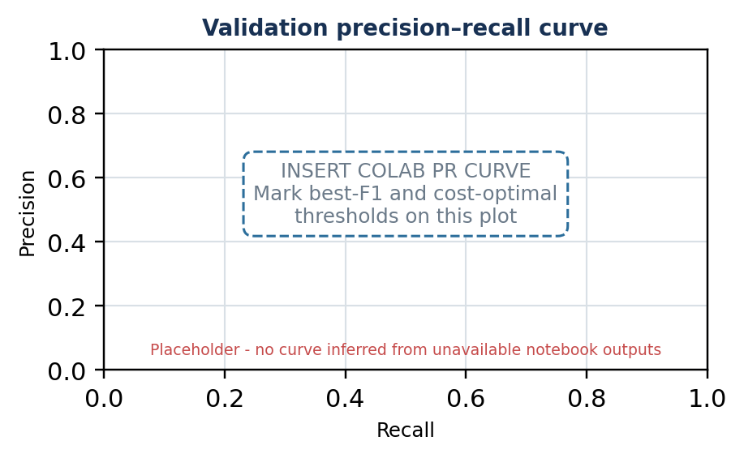  Fig. 4. Required validation precision–recall curve with both operating thresholds marked. | 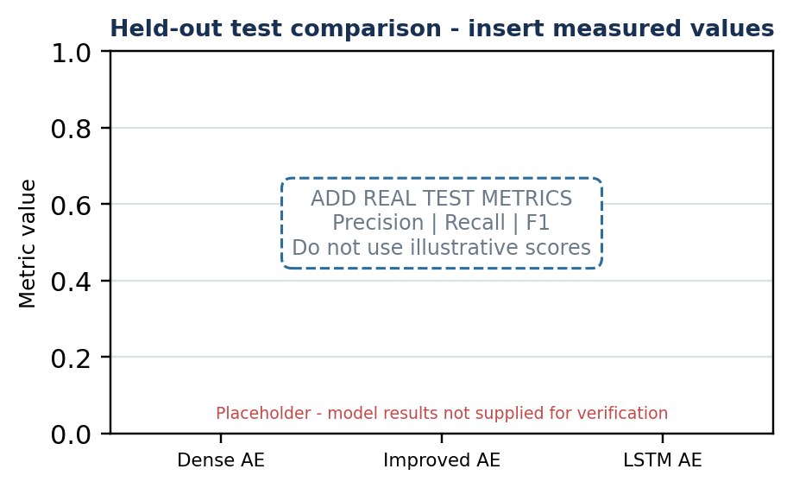  Fig. 5. Test-set model comparison. Replace this placeholder with measured precision, recall and F1 values.
Replace both placeholders with exported figures from the executed notebook before final submission.

6.2 Threshold and operational cost analysis
The task assigns ₹400,000 to a missed fault and ₹2,000 to a false alarm. Thus one missed fault has the same stated cost as 200 false alarms. The notebook cost formula is Cost = ₹400,000 × FN + ₹2,000 × FP. Record whether FP and FN are counted per window or per event; only event-level values support an operational cost interpretation.
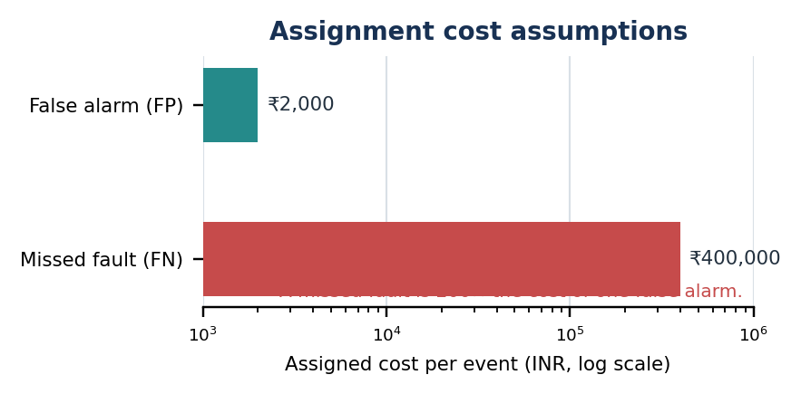
  Model | F1 thr. | Cost thr. | Val. cost ₹
  Dense AE | [____] | [____] | [____]
  Improved AE | [____] | [____] | [____]
  LSTM AE | [____] | [____] | [____]
Fig. 6. Cost ratio from the assignment; adjoining table is for actual validation thresholds and cost results.

6.3 Target verification
Target | Required | Observed result | Status
Fault-event recall | ≥ 0.85 | [____] | [Met / Not met]
False alarms | < 2 per 24 h | [____] per 24 h | [Met / Not met]
Detection delay | < 5 min OR within 3 readings at this cadence | [____] | [Met / Not met]
Labels in model training | None | [Confirm 0 labelled training windows] | [Met / Not met]

6.4 Answers to the prescribed questions
Q1. Why can a wide-bottleneck autoencoder fail? An input-width bottleneck can permit near-identity reconstruction, shrinking the error gap between normal and abnormal patterns. Excess capacity can overfit; an excessively small bottleneck can underfit normal behaviour. Here, the 12-value baseline uses 2 latent units and the improved model uses 1, so both are compressed; the experiment does not directly test an input-width bottleneck. Evidence: baseline F1/recall [____]; improved F1/recall [____]; error separation [____].
Q2. Did the improved model beat the baseline? Dense models reconstruct flattened windows; the LSTM also represents reading order. A smaller bottleneck may suppress unusual patterns but can also remove normal variation. Name the winner only after comparing test recall, F1, false alarms/day and detection delay: [evidence-based conclusion].
Q3. Which threshold should be recommended? A missed fault is costed at 200 false alarms, so the cost threshold may favour recall more than the best-F1 threshold. Recommend [model / threshold] only after confirming its validation cost and test false-alarm and delay limits. Best-F1 [____]; cost-optimal [____]; recommendation [____].

7. Limitations, Conclusion and Repository
The study uses one univariate machine-temperature series and may not generalise to other machines. Verify event-level alarm merging, anomaly-boundary windows and chronological continuity. A pilot also needs drift monitoring, sensor checks, alarm suppression and external-machine validation.
GitHub repository: [Paste repository URL here] | Notebook: [Filename / path] | Deliverables: notebook, README, source/label references, plots and report.
References: [1] Numenta, NAB data corpus and labels/combined_windows.json. [2] Numenta, machine_temperature_system_failure.csv, realKnownCause. [3] S. Ahmad et al., “Unsupervised real-time anomaly detection for streaming data,” Neurocomputing, vol. 262, pp. 134–147, 2017. [4] I. Goodfellow et al., Deep Learning, MIT Press, 2016, ch. 14. [5] MGIT, CM701PC/CM751PC Complex Engineering Task, Oct. 29, 2026.
AI-use declaration: [Name the AI tools actually used and describe their contribution. The team must verify all code, figures and results and remains responsible for the submission.]

OPERATIONAL BRIEF
Plant Engineer Note
Machine Temperature Warning Prototype | Team 15 | Task 3D

Purpose
The prototype analyses a machine temperature sensor stream and looks for patterns that differ from the normal behaviour represented in its training data. It groups recent readings into short sequences, reconstructs those sequences with an autoencoder and uses reconstruction error as a warning score.

What an alert means
An alert means that the recent temperature sequence is unusual compared with the normal patterns learned by the model. It is not proof that a machine has failed. An alert may reflect a developing fault, a machine operating change, a sensor problem or a condition not represented in the training data.

Suggested operator response
- Review the alert timestamp and the temperature trend immediately before and after it.
- Check sensor condition, machine load, operating mode, recent maintenance and any independent alarms.
- Inspect the machine according to the plant procedure; record whether the alert was confirmed, a sensor issue or a normal operating change.
- Do not automatically shut down equipment or disable the monitoring system solely because this prototype raised an alert.

How the threshold affects operations
A lower threshold generally identifies more unusual windows but can increase the number of unnecessary inspections. A higher threshold can reduce unnecessary inspections but may miss developing faults. The assignment uses an estimated cost of ₹4,00,000 for a missed fault and ₹2,000 for a false alarm. The final threshold recommendation must account for both this cost difference and the plant limit on false alarms.
Fig. 7. Assignment cost assumptions: one missed fault is valued at 200 false-alarm inspections.

Deployment gate
Do not treat the prototype as production-ready until: The final test report confirms fault-event recall ≥ 0.85, fewer than 2 false alarm episodes per 24 hours, and the required detection delay. Validate the model on additional time periods and machines, and review all false alarms and missed events with maintenance engineers. If any target is missed, document the measured result and the operational consequence.

Final verification item | Value after test evaluation
Selected model | [________________________]
Recommended threshold | [________________________]
Fault-event recall | [________________________]
False alarms per 24 h | [________________________]
Detection delay | [________________________]
GitHub / notebook location | [Paste URL / path here]

