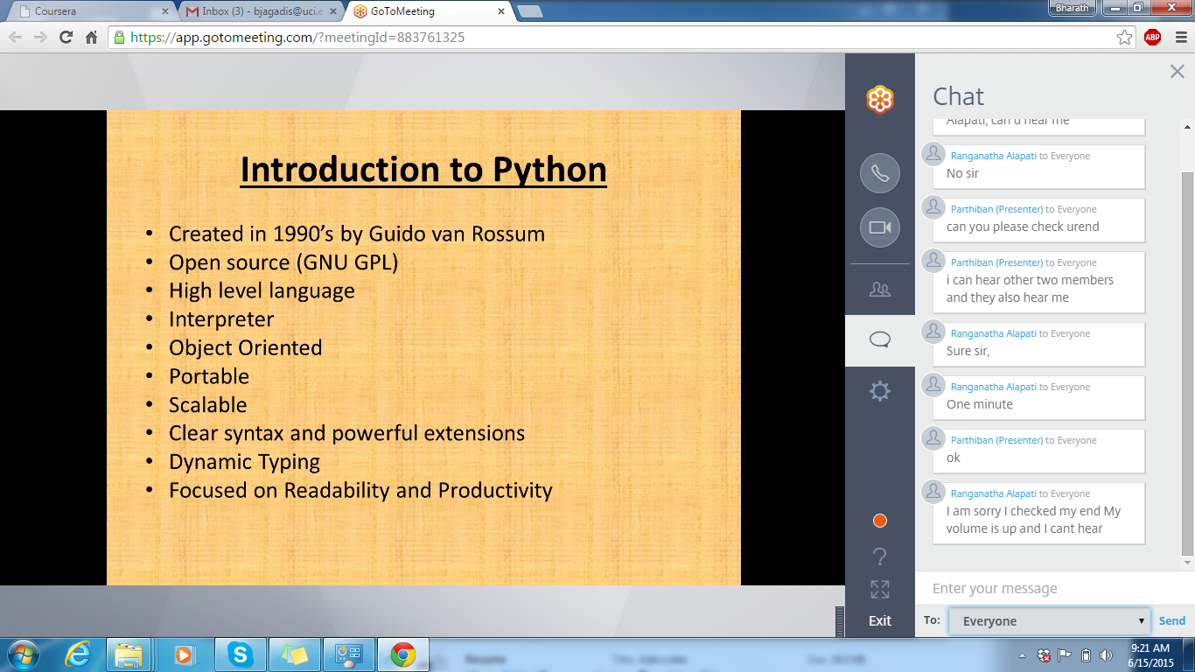

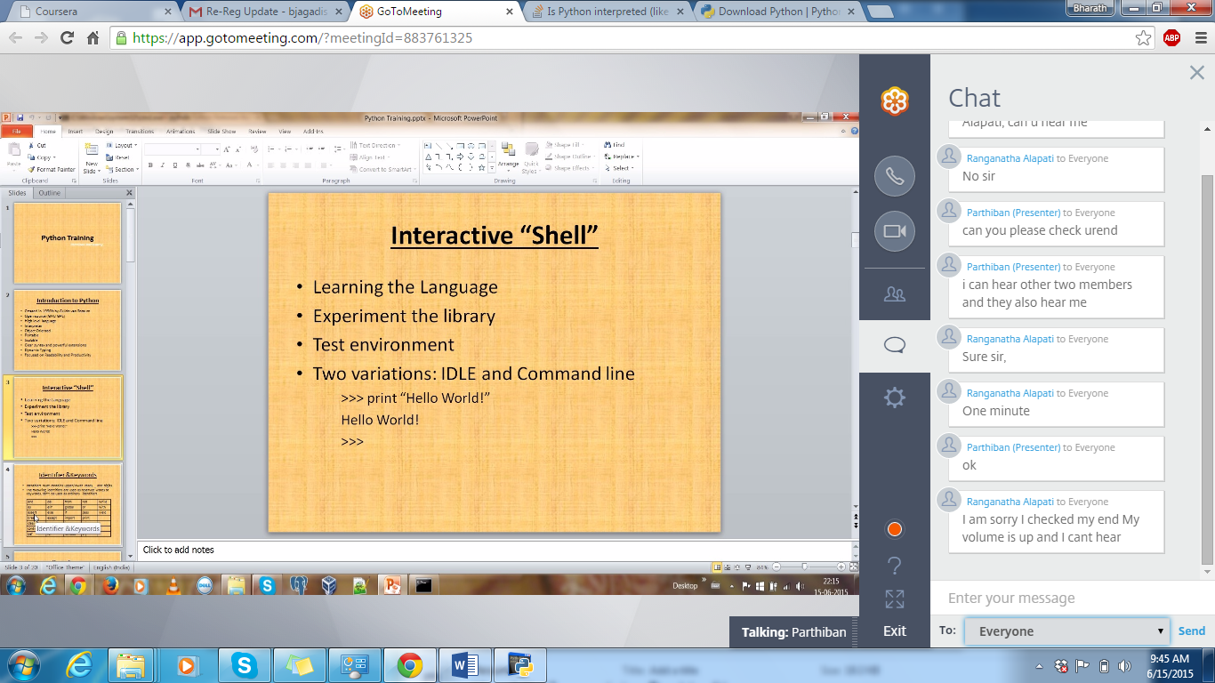

* Identifier

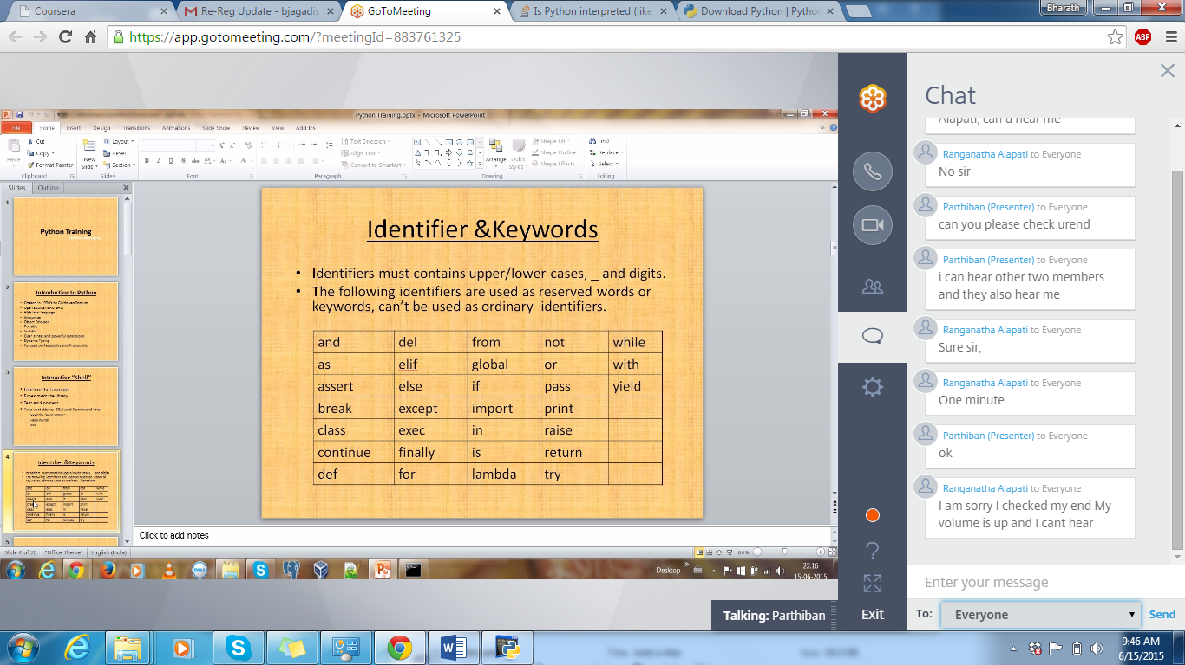

a = 10

id(a) – displays the memory location of “a”

When program terminates, everything will be deleted. Reference counter will be decrements one by one. Reference counter depends on the number of variables.

Python: a = “parthi” or b = 1

But in C: int a = 10, char b = “anteater”

Data types: integer, float, string, complex