**O REVIEW**

**Cloud Realtime Interface Architecture for Accident Detection System on Roads**

**Motivation: -**

This projects motivation to find accident detection system on roads for save human life. Today, it’s terribly tough to search out that an accident has occurred and to search out the position wherever it the accident occurred. Such serious automobile usage has augmented traffic and so leading to an increase in road accidents. Whenever I am seen the roads or while travel road I am seen so many accidents on road. surround person make some delay inform hospital and police So, I am try to implement projects to detected the accident place and give first aid immediately for accident person to save life. And also reducing delay of pass information to hospital and police station. small analysis for accident on road.

About 1.24 million people die each year as a result of road traffic crashes. Without action, road traffic crashes are predicted to result in the deaths of around 1.9 million people annually by 2020. Decade of Action for Road Safety (2011–2020) with the aim of saving millions of lives by improving the safety of roads, vehicles and improving emergency services.

**Problem statement: -**

Now-a-days lots of accidents happen on highways due to increase in traffic. In many situations the family members or the ambulance and police authority are not informed in time. The advent of technology has also increased the traffic hazards and the road accidents take place frequently which causes huge loss of life and property because of the poor emergency facilities.

**Architecture: -**

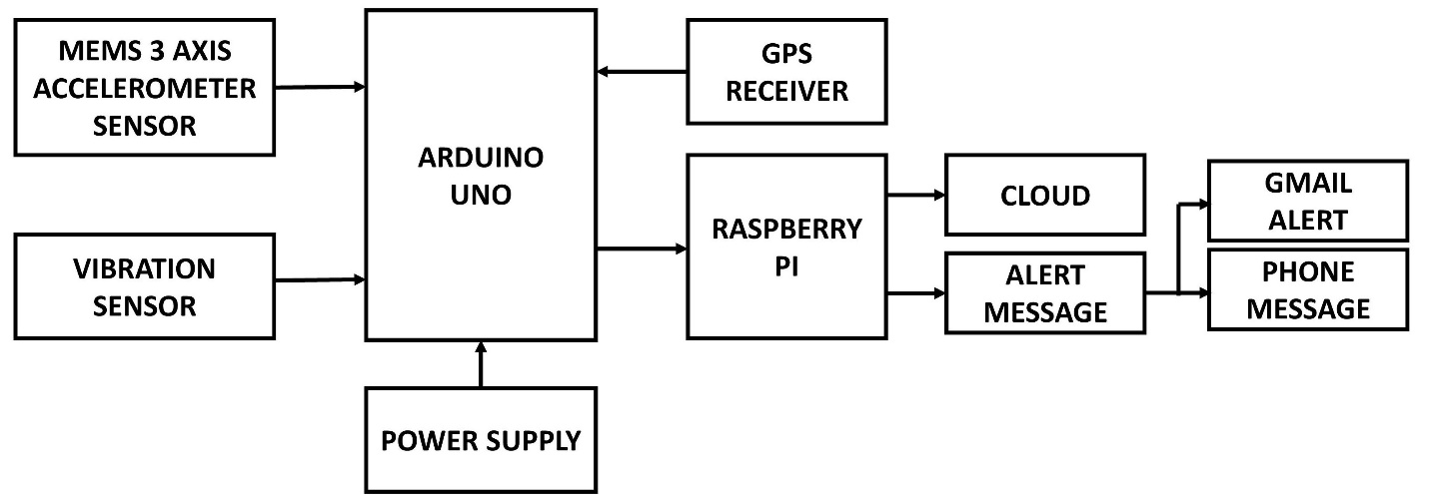

**References: -**

[1].Intelligent System for Vehicular Accident Detection and Notification

Bankar Sanket Anil, Kale Aniket Vilas, Prof. S. R. Jagta-International Conference on Communication and Signal Processing, April 3-5,2014, India.

[2]. An IoT based Fire Alarming and Authentication System for Workhouse using Raspberry Pi 3 Ahmed Imteaj1,2, Tanveer Rahman1, Muhammad Kamrul Hossain2, Mohammed Shamsul Alam1 and Saad Ahmad Rahat1 1Department of Computer Science and Engineering,1International Islamic University Chittagong 2Department of Computer Science and Engineering, 2Chittagong University of Engineering&TechnologyChittagong,BangladeshEmail:imtu_1992@yahoo.com,shakil10vr@hotmail.com,muhammadkamrulhossain@gmail.com, alam_cse@yahoo.com, rahatcse37@gmail.com-International Conference on Electrical, Computer and Communication Engineering (ECCE), February 16-18, 2017, Cox’s Bazar, Bangladesh.

[3]. An IoT Approach to Vehicle Accident Detection, Reporting, and Navigation Elie Nasr, Elie Kfoury, David Khoury Computer Science Department American University of Science and Technology Beirut, Lebanon enasr@aust.edu.lb, [ekfoury@aust.edu.lb,dkhoury@aust.edu.lb-2016IEEEInternational](mailto:ekfoury@aust.edu.lb,dkhoury@aust.edu.lb-2016IEEEInternational) Multidisciplinary Conference on Engineering Technology (IMCET)

[4] John Whipple., William Arensman., Marian Starr Boler.(2009) “A Public Safety Application of GPS-Enabled Smartphones and the Android Operating System”, Proceedings of the 2009 IEEE International Conference on Systems, pp.2059-2061.

[5] KoteswaraRao.P., Haneef Babu.SK.MD.(2013) “Scening of an Accidental Alarm System of Vehicles With a Heartbeat Sensor”, International Journal of Emerging Trends & Technology in Computer Science (IJETTCS) Vol. 2, Issue 2, pp. 191-194.

[6]Matsubara.A., Tanka.S.( 2002) “Unconstrained and Noninvasive Measurement of Heartbeat and Respiration for Drivers Using a Strain” ,SICE 2002, pp.1067-1069.

[7] Mohamed Fazeen., Brandon Gozick., Ram Dantu.,MoizBhukhiya., and Marta C.González.(2012) “Safe Driving Using Mobile Phones”, IEEE transactions on intelligent transportation systems, vol. 13, No. 3, pp. 1462-1468.

[8] Prabakar S., Porkumaran K.,Samson Isaac J and GunaSundari J.(2008) “An Enhanced Accident Detection and Victim Status Indicating System”,Indian Journal ofNeurotrauma(IJNT), pp. 351-356.

[9] Rahul Tiwari., Atul Kumar Singh.(2013) “Using Android Platform to Detect Free Fall”, International Conference on Information Systems and Computer Networks, pp. 161-165.

[10] Salas K Jose., X. Anitha Mary., Namitha Mathew.(2013) “Arm 7 Based Accident Alert and Vehicle Tracking System”, International Journal of Innovative Technology and Exploring Engineering (IJITEE) ISSN: 2278-3075, Vol.2, Issue-4, pp. 93-96.