**0 REVIEW**

**Medical Image Retrieval using Deep Convolutional Neural Network**

**Motivation: -**

This projects motivation for image retrieval processing using deep learning. Due to the increase of online users on the Internet, the amount of collections of digital images have grown continuously during this period.

For example, In web applications that allows adding images and digital albums. Images are increasingly used to convey information, whether one local information, weather, advertising, etc. In this context, it is necessary the development of appropriate systems to manage effectively these collections. Another problem was the complexity of image data, and these data can be interpreted in various ways, thus raising the question of how to work in order to manipulate these data and represent or establish policies to its content. This motivated the birth of the image retrieval area which can be find similarity images whose goal is try to solve those problems.

**Problem statement: -**

To identify the best low level features that meet the requirement of a robust, efficient, computationally simple and suitable for image retrieval. In order to retrieve the desired images from a large database, the development of an effective and efficient algorithm has been proposed for image indexing and retrieval to classification various type of images. With a widespread use of digital imaging data in hospitals, the size of medical image repositories is increasing rapidly. This causes difficulty in managing and querying these large databases leading to the need of content based medical image retrieval (CBMIR) systems. A major challenge in CBMIR systems is the semantic gap that exists between the low level visual information captured by imaging devices and high level semantic information perceived by human. The efficacy of such systems is more crucial in terms of feature representations that can characterize the high-level information completely. In this paper, we propose a framework of deep learning for CBMIR system by using deep Convolutional Neural Network (CNN) that is trained for classification of medical images

**Architecture: -**

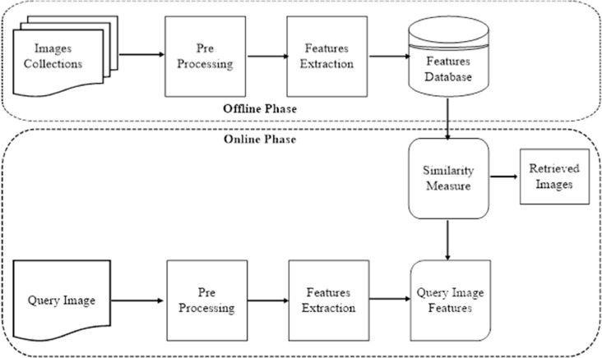

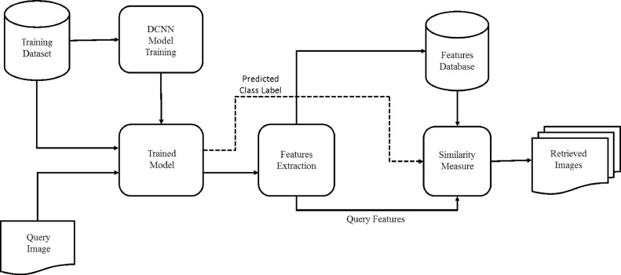

**References: -**

[1]. Medical Image Retrieval using Deep Convolutional Neural Network 1Adnan Qayyum, 2a*Syed Muhammad Anwar, 3bMuhammad Awais, 1aMuhammad Majid 1Department of Computer Engineering, University of Engineering and Technology Taxila, Pakistan 2Department of Software Engineering, University of Engineering and Technology Taxila, Pakistan 3Center for Vision, Speech and Signal Processing, University of Surrey, Surrey, UK aSignal, Image, Multimedia Processing and Learning (SIMPLe) Group, University of Engineering and Technology, Taxila, Pakistan bCerebrai Artificial Intelligence, Surrey, UK *s.anwar@uettaxila.edu.pk -28 March 2017.

[2] G. W. Jiji and P. S. J. D. Raj, “Content-based image retrieval in dermatology using intelligent technique,” IET Image Processing, vol. 9, no. 4, pp. 306-317, 2015.

[3] M. Ponciano-Silva et al., "Does a CBIR system really impact decisions of physicians in a clinical environment?," in Proceedings of the 26th IEEE International Symposium on Computer-Based Medical Systems, 2013, pp. 41-46.

[4] G. Quellec, M. Lamard, G. Cazuguel, B. Cochener, and C. Roux, “Fast wavelet-based image characterization for highly adaptive image retrieval,” IEEE Transactions on Image Processing, vol. 21, no. 4, pp. 1613-1623, 2012.

[5] M. M. Rahman, S. K. Antani, and G. R. Thoma, “A learning-based similarity fusion and filtering approach for biomedical image retrieval using SVM classification and relevance feedback,” IEEE Transactions on Information Technology in Biomedicine, vol. 15, no. 4, pp. 640-646, 2011.

[6] H.-C. Shin et al., “Deep convolutional neural networks for computer-aided detection: CNN architectures, dataset characteristics and transfer learning,” IEEE transactions on medical imaging, vol. 35, no. 5, pp. 1285-1298, 2016.

[7] G. E. Hinton, N. Srivastava, A. Krizhevsky, I. Sutskever, and R. R. Salakhutdinov, “Improving neural networks by preventing co-adaptation of feature detectors,” arXiv preprint arXiv:1207.0580, 2012.

[8] Z. Camlica, H. Tizhoosh, and F. Khalvati, "Autoencoding the retrieval relevance of medical images," in Image Processing Theory, Tools and Applications (IPTA), 2015 International Conference on, 2015, pp. 550-555.

[9] K. Seetharaman and S. Sathiamoorthy, “A unified learning framework for content based medical image retrieval using a statistical model,” Journal of King Saud University-Computer and Information Sciences, vol. 28, no. 1, pp. 110-124, 2016.

[10] R. Arandjelovi´c and A. Zisserman. Three things everyone should know to improve object retrieval. In CVPR, pages 2911–2918, 2012.