A
MINI PROJECT REPORT
on

VEHICLE ACCIDENT DETECTION AND ALERT SYSTEM
Submitted in partial fulfilment of the Requirements for the award of Degree of
Bachelor of Technology
in
Electronics and Communication Engineering
By
S.BHARATH 21681A0465

Under the Esteemed Guidance of

ALLANKI SANYASI RAO

Associate Professor & HOD

Department of Electronics and Communication Engineering

CHRISTU JYOTHI INSTITUTE OF TECHNOLOGY AND SCIENCE
Colombo Nagar, Yeshwanthpur, Jangaon, TS 506167, Telangana
(Accredited by National Board of Accreditation)
2024-2025

CHRISTU JYOTHI INSTITUTE OF TECHNOLOGY & SCIENCE
Colombo Nagar, Yeshwanthapur, Jangaon. 506167, Telangana

Dept. of Electronics & Communication Engg.



Certificate

This is to certify that the work which is being presented in the B.Tech. Mini Project Report entitled ―VEHICLE ACCIDENT DETECTION AND ALERT SYSTEM USING ARDUINO” being submitted by S Bharath (21681A0465), in partial fulfilment of the requirements for the award of the Bachelor of Technology in Electronics & Communication Engineering and submitted to the Department of Electronics & Communication Engineering of Christu Jyothi Institute of Technology & Science, Jangaon.
This is to certify that the above statement made by the candidates is correct to the best of our knowledge.

Signature of Guide Signature of HOD
(Allanki Sanyasi Rao) (Allanki Sanyasi Rao)

Signature of External Examiner

CHRISTU JYOTHI INSTITUTE OF TECHNOLOGY & SCIENCE
Colombo Nagar, Yeshwanthapur, Jangaon. 506167, Telangana

Institution Vision and Mission

VISION
To admit and groom students from rural background and be a truly rural technical institution, benefiting society and nation as a whole institute.
MISSION
- The mission of the institution is to create, deliver and refine knowledge. Being a rural technical institute, our mission is to.
- Enhance our position to one of the best technical institutions and to measure our performance against the highest defined standards.
- Provide highest quality learning environment to our students for their greater well- being so as to equip them with highest technical and professional ethics.
- Produce engineering graduates fully equipped to meet the ever-growing needs of industry and society.



CHRISTU JYOTHI INSTITUTE OF TECHNOLOGY & SCIENCE
Colombo Nagar, Yeshwanthapur, Jangaon. 506167, Telangana
Department Of Electronics & Communication Engineering

Department Vision & Mission

Vision

To achieve excellence in Electronics and Communication engineering through quality education, research contributing to the emerging technologies and innovation to serve industry and society.

Mission

- To enhance the teaching-learning process by implementing innovative practices to create globally competent engineers.
- To strengthen research culture providing sustainable solutions in the domain of Communication, Signal Processing and VLSI for the benefit to industry.
- To be a center of excellence for technological education, training & research and to produce world class Electronics and Communication Engineers to serve the nation and the society.

HOD

DECLARATION
The project entitled “VEHCILE ACCIDENT DETECTION AND ALERT SYSTEM”‖ is a record of the bonafide work undertaken by us towards partial fulfillment of the award of Degree of Bachelor of Technology in Electronics and Communication Engineering, to Christu Jyothi Institute of Technology and Science, Jangaon, affiliated to JNTU, Hyderabad is an authentic work and has not been submitted to any other university or institution for award of the degree.

PROJECT BY
S.BHARATH - 21681A0465

ACKNOWLEDGEMENT

We hereby express our sincere gratitude to the Management of Christu Jyothi Institute of Technology & Science for their kind encouragement bestowed up on us to do this Mini project.
We earnestly take the responsibility to acknowledge the following distinguished personalities who graciously allowed our project work successfully.
We express our sincere thanks to our Director Rev. Fr. D. Vijaya Paul Reddy, Principal Dr. S. Chandrashekhar Reddy for their encouragement, which has motivated us to strive hard to excel in our discipline of Engineering.
We are greatly indebted to the Guide and Head of the Department Mr. Allanki Sanyasi Rao, Associate Professor for his motivation and guidance through the course of this project work. He has been responsible for providing us with lot of splendid opportunities, which has shaped our career. His advices, ideas and constant support has engaged us and helped us to get through in difficult times. His excellent guidance has made the timely completion of this Mini Project.
We express our profound sense of appreciation and gratitude to our Coordinator, Mr. D. JAGAN, Assistant Professor for providing generous assistance, and spending many hours of valuable time with us.
Last but not the least, we express our gratitude to the Teaching and Non- Teaching Staff of the Department of Electronics and Communication Engineering for their needy and continuous support in technical assistance.

ABSTRACT
The increasing number of vehicles on roads worldwide, the occurrence of accidents remains a significant concern. Rapid response to accidents is crucial for minimizing casualties and property damage. The "Vehicle Accident Detection and Alert System" (VAAS) presented in this project aims to enhance the efficiency and effectiveness of accident detection. The Vehicle Accident Detection and Alert System utilizes a combination of advanced sensors, communication technologies, and intelligent algorithms to promptly detect and analyze potential accidents in real-time.Sensors integrated into vehicles continuously monitor parameters such as acceleration, orientation, and impact forces.
These data points are processed locally within the vehicle and transmitted to a central monitoring system via wireless communication protocols. Upon receiving data indicative of an accident, the central system employs machine learning algorithms to analyze the severity and type of collision. Location data from GPS and mapping systems help pinpoint the accident's exact location, aiding emergency responders in reaching the location quickly.

CONTENTS

Chapter No. | Topic | Page No.
1 | INTRODUCTION | 1-4
 | 1.1 Project outline | 1
 | 1.2 Project Objective | 1
 | 1.3 Literature Survey | 2
 | 1.4 Existing System | 3
2 | EMBEDDED SYSTEM | 5-6
 | 2.1 Introduction to Embedded System | 5
 | 2.2 Characteristics of Embedded System | 6
 | 2.3 Applications of Embedded System | 6
3 | MICROCONTROLLERS | 7-8
 | 3.1 Micro Controller Versus Micro Processor | 7
 | 3.2 Micro Controller For Embedded System | 8
4 | HARDWARE COMPONENTS | 9-26
 | 4.1 Arduino Uno | 9-12
 | 4.1.1 Different Memories of Arduino Uno | 9
 | 4.1.2 Technical Specifications | 10
 | 4.1.4 Input and Output Pins of Arduino Uno | 10
 | 4.1.5 Communication Interfaces are Available on Arduino Uno | 11
 | 4.2 GPS NEO 6M | 12-14
 | 4.2.1 NEO-6MV2 GPS Module PIN Configuration | 13
 | 4.2.3 Features and Electrical Characteristics | 13
 | 4.2.4 GPS Application | 14
 | 4.3 LCD | 14-16
 | 4.3.1 Introduction to LCD | 14
 | 4.3.2 LCD Uses | 15
 | 4.3.4 LCD Control Lines | 16
 | 4.3.5 Logic Status on Control Lines | 16
 | 4.4 I2C | 16-18
 | 4.4.2 Message Protocols | 18
 | 4.5 MEMS Sensor | 18-20
 | 4.5.1 MEMS Sensor | 18
 | 4.5.2 MEMS Sensor Technology | 19
 | 4.5.3 Final Thoughts on MEMS Sensor | 19
 | 4.6 12 Volts Power Supply | 20-21
 | 4.6.1 Working Principle | 21
 | 4.7 Capacitor 1000 μF | 21
 | 4.8 DC Jack | 21-22
 | 4.8.1 Features/Specifications | 22
 | 4.9 1N4007 | 22-23
 | 4.9.1 1N4007 Diode PINOUT | 23
 | 4.9.2 Applications of 1N4007 Diode | 23
 | 4.10 GSM Module | 24-25
 | 4.10.1 Features and Specifications | 24
 | 4.11 Potentiometer | 25
 | 4.12 Buzzer | 25-26
 | 4.12.1 Features of Buzzer | 26
 | 4.12.2 Applications of Buzzers | 26
5 | WORKING & BLOCK DIAGRAM | 27-28
 | 5.1 Working | 27
 | 5.2 Block Diagram | 28
6 | SOFTWARE AND CODINGS | 29-37
 | 6.1 Introduction to Arduino Uno | 29
 | 6.2 Arduino Data Types | 29
7 | RESULT AND DISCUSSIONS | 38-39
8 | ADVANTAGES & APPLICATIONS | 40
9 | CONCLUSION AND FUTURE SCOPE | 41
 | REFERENCES | 42
 | APPENDIX | 43-56

LIST OF FIGURES

Figure No. | Title of the Figure | Page No.
Figure 1 | MICROCONTROLLER | 7
Figure 2 | ARDUINO UNO | 9
Figure 3 | ARDUINO UNO PIN DIAGRAM | 11
Figure 4 | GPS NEO 6M | 12
Figure 5 | LCD DISPLAY | 15
Figure 6 | LCD PIN DIAGRAM | 15
Figure 7 | I2C PROTOCOL | 17
Figure 8 | MEMS SENSOR | 19
Figure 9 | CAPACITOR | 21
Figure 10 | DC JACK | 22
Figure 11 | 1N4007 | 23
Figure 12 | GSM | 24
Figure 13 | GSM PIN DIAGRAM | 24
Figure 14 | POTENTIOMETER SYMBOL | 25
Figure 15 | BUZZER | 25
Figure 16 | BLOCK DIAGRAM | 26
Figure 17 | PROJECT KIT | 38
Figure 18 | PROJECT KIT | 38
Figure 19 | RESULT | 39

LIST OF TABLES

Table No. | Title of the Table | Page No.
Table 1 | ARDUINO UNO SPECIFICATIONS | 10
Table 2 | GPS MODULE PIN CONFIGURATION | 13
Table 3 | I2C MODES | 17

ACRONYMS
GPS : Global Positioning System
GSM : Global System for Mobile Communications
MEMS Sensor : Micro-Electro-Mechanical Systems Sensor
SMS : Short Message Service PCB : Printed Circuit Board LCD : Liquid Crystal Display MCU : Microcontroller Unit RAM : Random Access Memory I2C : Inter-Integrated Circuit ICs : Integrated Circuits
LED : Light Emitting Diode RAM : Random Access Memory ROM : Read-Only Memory CPU : Central Processing Unit
CD-ROM : Compact Disc Read-Only Memory

CHAPTER-1

INTRODUCTION

PROJECT OUTLINE

The project aim of "Accident Detection and Alert System Using Arduino" is to design and implement a security system that utilizes emergency message service and alert system technology and the technology is to detect the vehicle condition and pass the emergency alert to emergency services with the location of vehicle and the sensors detect the axis angle and pressure of the vehicle. It monitors the vehicle in every condition.

PROJECT OBJECTIVE

The Vehicle Accident Detection and Alert System using Arduino aims to develop a reliable and efficient mechanism to enhance road safety by promptly detecting vehicle accidents and notifying emergency services and concerned individuals. The system utilizes an Arduino microcontroller along with sensors such as the MEMS Sensor and GPS module to accurately detect sudden changes in vehicle motion that may indicate potential accidents, such as collisions or rollovers.
The primary objectives include designing a compact and cost-effective device suitable for installation in various types of vehicles. This device will continuously monitor vehicle movements and environmental conditions, ensuring real-time accident detection. Upon detection, the system will automatically trigger alerts through SMS notifications to emergency contacts and relevant authorities, providing crucial location information via GPS coordinates.
User-friendliness is prioritized, with an easy-to-use interface for configuring emergency contacts and settings. The system will also feature a backup power source to ensure continuous operation in case of vehicle battery failure or damage.
Overall, the Vehicle Accident and Alert System using Arduino seeks to improve road safety by reducing response times in critical situations, potentially saving lives and minimizing the severity of injuries from vehicle accidents. Through continuous testing,

refinement, and adherence to safety standards, the goal is to deliver a reliable and effective solution that can be widely adopted to enhance road safety.

LITERATURE SURVEY

The Arduino-Based Vehicle Accident Alert System uses GPS, GSM, and MEMS sensor technologies to detect and respond to vehicle accidents promptly. The MEMS sensor monitors the vehicle's axes for sudden variations, which may indicate potential accidents. When such an event is detected, the system activates the GSM module to send an alert message with the precise location of the accident to predefined emergency contacts.
Technology plays a critical role in enhancing convenience and safety in today‘s interconnected world. However, this rapid technological advancement has coincided with a rise in road accidents, leading to significant loss of life and property. The inadequate emergency response infrastructure in many regions worsens the consequences of such accidents.
This project addresses these issues by leveraging cutting-edge technology to improve emergency response times and outcomes. By detecting accidents quickly and automatically alerting emergency services and designated contacts, the system aims to minimize response delays and ensure timely medical assistance. This proactive approach enhances individual safety and contributes to overall road safety by reducing fatalities and injuries related to accidents.
The Arduino-based system offers a scalable and cost-effective solution for various types of vehicles. GPS technology provides accurate location data, vital for emergency responders to reach accident sites swiftly. The GSM module ensures reliable communication of critical information, even in areas with limited cellular coverage. These features collectively enhance the system‘s effectiveness in real-world scenarios, making it a viable tool for improving road safety across diverse geographic and infrastructural settings.
As advocates for technological innovation, it is essential to mitigate the negative impacts associated with advancements. While technology has accelerated the pace of life, proactive measures are necessary to address unintended consequences, such as the

rise in road accidents. This project demonstrates a commitment to using technology for positive social impact, particularly in enhancing emergency response capabilities and reducing road accident fatalities.
In conclusion, the Arduino-based Vehicle Accident Alert System is a significant step towards mitigating the adverse effects of technological proliferation on road safety. By utilizing advanced sensor and communication technologies, the system allows vehicles to respond autonomously to accidents, reducing human error and improving emergency response outcomes. Continued refinement and deployment of this technology envision a future where road accidents are minimized, and lives are safeguarded through proactive and efficient emergency interventions.

EXISTING SYSTEM

The idea for this project originated during the early days of mobile phone technology when GPS sensors were first integrated into mobile devices. Initially, security applications based on GPS were proposed, followed by the suggestion of using specialized hardware devices that could connect to mobile phones. However, this approach had drawbacks, primarily the need to purchase additional hardware at an added cost.
Over the past decade, mobile phone technology has evolved tremendously, with the addition of new sensors and functionalities. This development has eliminated the need for extra hardware. Today, the proposed application remains relatively uncommon, existing in only a few countries. By providing real-time information to emergency services and notifying relatives and friends during critical situations, the goal is to significantly enhance the application‘s efficiency.
The system utilizes GPS technology within the mobile phone itself to accurately pinpoint the location of a vehicle in the event of an accident. When sudden variations in the vehicle's movement are detected by MEMS sensors, the system automatically triggers an alert. This alert includes precise location details, which are essential for emergency responders to quickly reach the accident site.
By leveraging the widespread adoption of mobile phones and their built-in capabilities, this project offers a cost-effective and accessible solution to improve road

safety. This approach not only reduces the financial burden on users but also enhances the overall effectiveness of emergency response efforts. As the technology continues to be refined and expanded, broader global adoption is envisioned, contributing to a safer and more connected society where technology serves to protect and support individuals in times of need.

CHAPTER - 2

EMBEDDED SYSTEM

INTRODUCTION TO EMBEDDED SYSTEM

An embedded system is a special-purpose computer system designed to perform specific functions, often with real-time computing constraints. It is typically embedded within a complete device that includes both hardware and mechanical components. In contrast, a general-purpose computer, such as a personal computer, can perform a wide range of tasks depending on the programming. Embedded systems have become essential in modern technology, as they control many common devices.
Embedded systems vary in size, from portable devices like digital watches and MP3 players to large stationary installations such as traffic lights, factory controllers, or systems that manage nuclear power plants. The complexity can range from simple, with a single microcontroller chip, to highly complex, with multiple units, peripherals, and networks housed in a large chassis or enclosure.
The term "embedded system" is not precisely defined, as many systems contain some degree of programmability. For example, handheld computers share features with embedded systems—such as operating systems and microprocessors—but are not considered true embedded systems because they allow the loading of different applications and connection of peripherals.
An embedded system combines computer hardware and software, either fixed or programmable, specifically designed for a particular application device. Industrial machines, automobiles, medical equipment, cameras, household appliances, airplanes, vending machines, and toys are just a few examples of devices that host embedded systems. Programmable embedded systems include a programming interface, and embedded systems programming is a specialized field. Certain operating systems or programming platforms, such as Embedded Java and Windows XP Embedded, are tailored for embedded systems. In some low-end consumer products, inexpensive microprocessors with limited storage are used, and both the application and operating system are integrated into a single program. In these cases, the program is permanently

written into the system's memory rather than being loaded into RAM as with personal computer programs.

CHARACTERISTICS OF EMBEDDED SYSTEM

    - Speed (bytes/sec): Should be high speed.

    - Power (watts): Low power dissipation.

    - Size and weight: As far as possible small in size and low weight

    - Accuracy (%error): Must be very accurate.

    - Adaptability: High adaptability and accessibility.

    - Reliability: Must be reliable over a long period of time

APPLICATIONS OF EMBEDDED SYSTEMS

We are living in the Embedded World. You are surrounded with many embedded products and your daily life largely depends on the proper functioning of these gadgets. Television, Radio, CD player of your living room, Washing Machine or Microwave Oven in your kitchen, Card readers, Access Controllers, Palm devices of your work space enable you to do many of your tasks very effectively. Apart from all these, many controllers embedded in your car take care of car operations between the bumpers and most of the times you tend to ignore all these controllers.
    - ROBOTICS: industrial robots, machine tools

    - AUTOMOTIVE: cars, trucks, trains

    - AVIATION: airplanes, helicopters

    - HOME: Building Automation

    - AEROSPACE: rockets, satellites

    - ENERGY SYSTEMS: windmills, nuclear plants

    - MEDICAL SYSTEMS: prostheses, revalidation machine

CHAPTER – 3

MICROCONTROLLERS

MICROCONTROLLER VERSUS MICROPROCESSOR

What is the difference between a Microprocessor and Microcontroller? By microprocessor is meant the general purpose Microprocessors such as Intel's X86 family (8086, 80286, 80386, 80486, and the Pentium) or Motorola's 680X0 family (68000,
68010, 68020, 68030, 68040, etc). These microprocessors contain no RAM, no ROM, and no I/O ports on the chip itself. For this reason, they are commonly referred to as general-purpose Microprocessors.
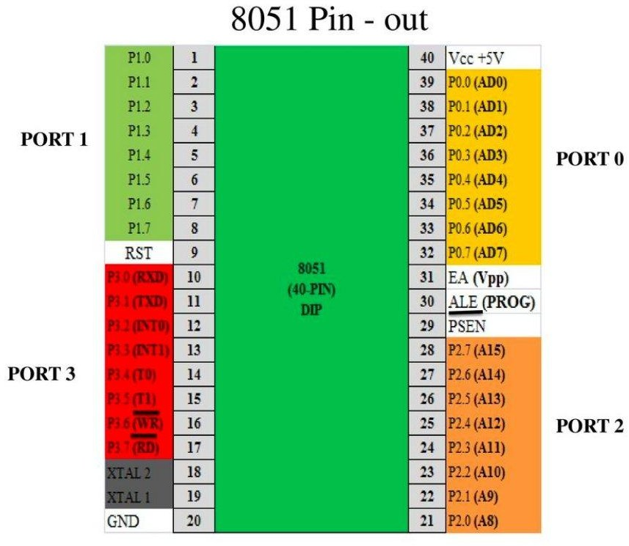
Figure 3.1.1: Microcontroller

A system designer using a general-purpose microprocessor such as the Pentium or the 68040 must add RAM, ROM, I/O ports, and timers externally to make them functional. Although the addition of external RAM, ROM, and I/O ports makes these systems bulkier and much more expensive, they have the advantage of versatility such that the designer can decide on the amount of RAM, ROM and I/O ports needed to fit the task at hand. This is not the case with Microcontrollers.

A Microcontroller has a CPU (a microprocessor) in addition to a fixed amount of RAM, ROM, I/O ports, and a timer all on a single chip. In other words, the processor, the RAM, ROM, I/O ports and the timer are all embedded together on one chip; therefore, the designer cannot add any external memory, I/O ports, or timer to it. The fixed amount of on-chip ROM, RAM, and number of I/O ports in Microcontrollers makes them ideal for many applications in which cost and space are critical.
In many applications, for example a TV remote control, there is no need for the computing power of a 486 or even an 8086 microprocessor. These applications most often require some I/O operations to read signals and turn on and off certain bits.

MICROCONTROLLERS FOR EMBEDDED SYSTEMS

In literature discussing microprocessors, the term "Embedded System" is commonly encountered. Microprocessors and microcontrollers are widely used in embedded system products. An embedded system product uses a microprocessor or microcontroller to perform a single task. For example, a printer is an embedded system, as the processor inside it performs one task: receiving data and printing it. In contrast, a Pentium-based PC can be used for a variety of applications, such as word processing, print-serving, bank teller terminals, video games, network servers, or internet terminals. Software for different applications can be loaded and executed. The ability of a PC to perform many tasks is due to the presence of RAM memory and an operating system that loads application software into RAM, allowing the CPU to run it. In a robot, for example, when a fire sensor detects fire, it sends the signal to the microcontroller. In an embedded system, only one application software is typically burned into ROM. An x86 PC is connected to various embedded products, such as keyboards, printers, modems, disk controllers, sound cards, CD-ROM drives, and mice. Each of these peripherals contains a microcontroller that performs a single task.

CHAPTER – 4

HARDWARE COMPONENTS

ARDUINO UNO
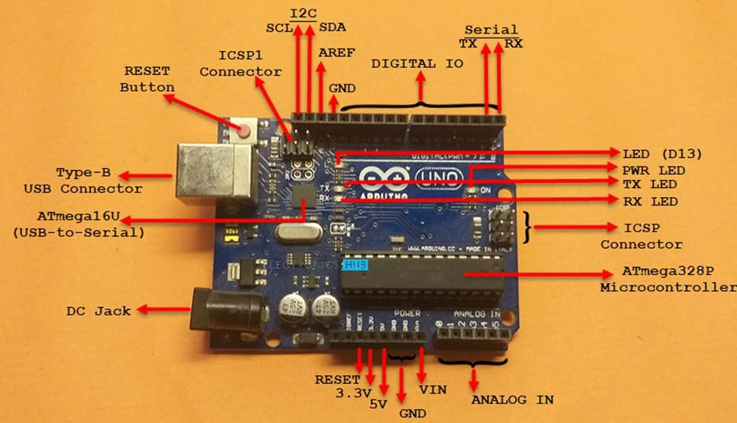
Figure 4.1 : Arduino UNO

Arduino UNO is based on ATmega328P Microcontroller, an 8-bit AVR Architecture based MCU from ATMEL. Arduino UNO comes in two variants: one consists of a 28-pin DIP Microcontroller while the other consists of 32 lead Quad Flat Package Microcontroller.

DIFFERENT MEMORIES OF ARDUINO UNO

Strictly speaking, this is specific to the MCU i.e., ATmega328P, used on the Arduino UNO Board. There are three different memories available in ATmega328P. They are:
      - 32 KB of Flash Memory
      - 2 KB of SRAM
      - 1 KB of EEPROM
      - 0.5 KB of the Flash Memory is used by the bootloader code.

TECHNICAL SPECIFICATIONS OF ARDUINO UNO

Arduino UNO is based on ATmega328P Microcontroller, the technical specifications of Arduino UNO are mostly related to the ATmega328P MCU. But none the less, let me give you a brief overview about some important specifications of Arduino UNO.

Architecture | AVR
Operating Voltage | 5V
Input Voltage | 6V – 20V (limit), 7V – 12V (recommended)
Clock Speed | 16 MHz
Flash Memory | 32 KB (2 KB of this used by boot loader)
SRAM | 2 KB
EEPROM | 1 KB
Digital IO Pins | 24 (of which 6 can produce PWM)
Analog Input Pins | 6

Table 4.1.2.1 : Arduino UNO Specifications

INPUT AND OUTPUT PINS OF ARDUINO UNO

The 32 pins available on the UNO board, 22 pins are associated with input and output. In that 14 pins (D0 to D13) are true digital IO pins, which can be configured as per you application using pinMode(), digitalWrite() and digitalRead() functions.
All these Digital IO pins are capable of sourcing or sinking 20mA of current (maximum 40mA is allowed). An additional feature of the Digital IO pins is the availability of internal pull-up resistor (which is not connected by default).

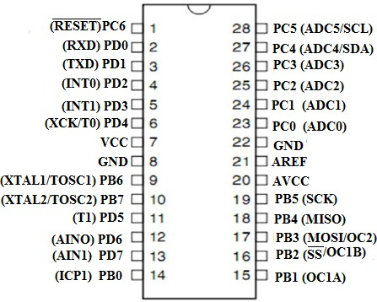
Figure 4.1.4.1 : Pin Diagram

The value of the internal pull-up resistor will be in the range of 20KΩ to 50KΩ. There are also 6 Analog Input Pins (A0 to A5). All the analog input pins provide a 10- bit resolution ADC feature, which can be read using analogRead() function.
An important point about Analog Input pins is that they can be configured as Digital IO pins, if required.
Digital IO pins 3, 5, 6, 9, 10 and 11 are capable of producing 8-bit PWM Signals. You can use analogWrite() function for this.

COMMUNICATION INTERFACES AVAILABLE ON ARDUINO UNO

Arduino UNO supports three different types of communication interfaces. They are:

      - Serial • I2C • SPI

Perhaps the most common communication interface in the Arduino universe is the Serial Communication. In fact, the Arduino boards (UNO or Nano or Mega) are programmed using the serial communication.

Digital IO pins 0 and 1 are used as Serial RX and TX pins to receive and transmit serial data. These pins are connected to the serial pins of the on-board USB to Serial Converter IC.
Analog Input Pins A4 and A5 have alternative functions. They can be configured as SDA (A4) and SCL (A5) to support I2C or I2C or Two Wire Interface (TWI) communication.
The final communication interface is the SPI. Digital IO Pins 10, 11 12 and 13 can be configured as SPI pins SS, MOSI, MISO and SCK respectively.

GPS NEO 6M
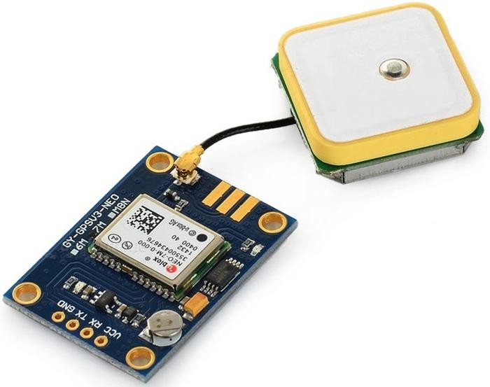
Figure 4.2.1: GPS NEO 6M

The NEO-6MV2 is a GPS (Global Positioning System) module and is used for navigation. The module simply checks its location on earth and provides output data which is longitude and latitude of its position. It is from a family of stand-alone GPS receivers featuring the high performance u-blox 6 positioning engine. These flexible and cost effective receivers offer numerous connectivity options in a miniature (16 x 12.2 x 2.4 mm) package. The compact architecture, power and memory options make NEO-6 modules ideal for battery operated mobile devices with very strict cost and space constraints. Its Innovative design gives NEO-6MV2 excellent navigation performance even in the most challenging environments.

NEO-6MV2 GPS MODULE PIN CONFIGURATION

The module has four output pins and we will describe the function each pin of them below. The powering of module and communication interface is done through these four pins.

Pin Name | Description
VCC | Positive power pin
RX | UART receive pin
TX | UART transmit pin
GND | Ground

Table 4.2.1.1: GPS Module Pins Configuration

4.2.3 FEATURES AND ELECTRICAL CHARACTERISTICS
- Standalone GPS receiver
- Anti-jamming technology
- UART Interface at the output pins (Can use SPI ,I2C and USB by soldering pins to the chip core)
- Under 1 second time-to-first-fix for hot and aided starts
- Receiver type: 50 Channels - GPS L1 frequency - SBAS (WAAS, EGNOS, MSAS, GAGAN)
- Time-To-First-fix: For Cold Start 32s, For Warm Start 23s, For Hot Start <1s
- Maximum navigation update rate: 5Hz
- Default baud rate: 9600bps
- EEPROM with battery backup
- Sensitivity: -160dBm
- Supply voltage: 3.6V
- Maximum DC current at any output: 10mA
- Operation limits: Gravity-4g, Altitude-50000m, Velocity-500m/s
- Operating temperature range: -40ºC TO 85°C

4.2.4 APPLICATIONS
- GPS application
- Smart phone and tablets
- Navigation systems
- Drones
- Hobby projects

LIQUID CRYSTAL DISPLAY

INTRODUCTION TO LCD

A liquid crystal display (LCD) is a thin, flat display device made up of any number of color or monochrome pixels arrayed in front of a light source or reflector. Each pixel consists of a column of liquid crystal molecules suspended between two transparent electrodes, and two polarizing filters, the axes of polarity of which are perpendicular to each other.
Without the liquid crystals between them, light passing through one would be blocked by the other. The liquid crystal twists the polarization of light entering one filter to allow it to pass through the other.
A program must interact with the outside world using input and output devices that communicate directly with a human being. One of the most common devices attached to a controller is an LCD display. Some of the most common LCDs connected to the controllers are 16X1, 16x2 and 20x2 displays. This means 16 characters per line by 1 line 16 characters per line by 2 lines and 20 characters per line by 2 lines, respectively.
Many microcontroller devices use ‗smart LCD‘ displays to output visual information. LCD displays designed around LCD NT-C1611 module, are inexpensive, easy to use, and it is even possible to produce a readout using the 5X7 dots plus cursor of the display.
They have a standard ASCII set of characters and mathematical symbols. For an

8-bit data bus, the display requires a +5V supply plus 10 I/O lines (RS,RW,D7, D6,D5,D4,D3,D2,D1,D0).
For a 4-bit data bus it only requires the supply lines plus 6 extra lines(RS,RW,D7,D6,D5,D4)
When the LCD display is not enabled, data lines are tri-state and they do not interfere with the operation of the microcontroller.
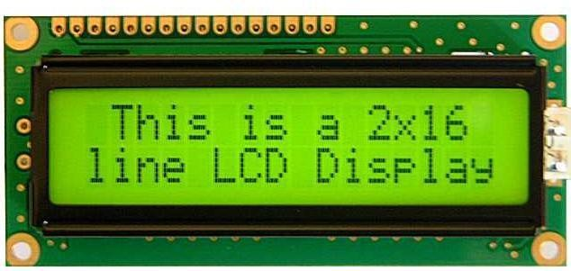

Figure 4.3.1.1: LCD Display

USES

The LCD s used exclusively in watches, calculators and measuring instruments is the simple seven-segment displays, having a limited amount of numeric data. The recent advances in technology have resulted in better legibility, more information displaying capability and a wider temperature range. These have resulted in the LCD s being extensively used in telecommunications and entertainment electronics. The LCD s has even started replacing the cathode ray tubes (CRTs) used for the display of text and graphics, and also in small TV applications.

LCD PIN DIAGRAM
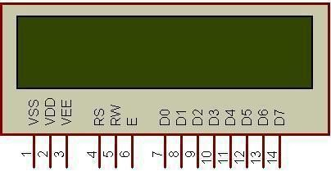
Figure 4.3.3.1: Pin Diagram

CONTROL LINES

EN: Line is called "Enable." This control line is used to tell the LCD that you are sending it data. To send data to the LCD, your program should make sure this line is low (0) and then set the other two control lines and/or put data on the data bus. When the other lines are completely ready, bring EN high (1) and wait for the minimum amount of time required by the LCD datasheet (this varies from LCD to LCD), and end by bringing it low (0) again.
RS: Line is the "Register Select" line. When RS is low (0), the data is to be treated as a command or special instruction (such as clear screen, position cursor, etc.).When RS is high (1), the data being sent is text data which should be displayed on the screen.
RW: Line is the "Read/Write" control line. When RW is low (0), the information on the data bus is being written to the LCD. When RW is high (1), the program is effectively querying (or reading) the LCD. Only one instruction ("Get LCD status") is a read command. All others are write commands, so RW will almost always be low.

LOGIC STATUS ON CONTROL LINES

- E - 0 Access to LCD disabled.
1 Access to LCD enabled.
- R/W- 0 Writing data to LCD.
1 Reading data from LCD
- RS- 0 Instructions.
1 Character

I2C

Communication between microcontrollers and different peripheral devices require some sort of digital protocol. I 2C is a common communication protocol that is used in a variety of devices from many different product families produced by TI. This application note begins with a basic overview of the I2C protocol, describing the history of the protocol, different I2C speed modes, the physical layer of the digital

communication, and the structure of the data. Several examples of the communication protocol are shown with different data converters.
Finally, this application note covers some uncommon aspects of the protocol, including reserved addresses, clock arbitration and stretching, electrical timing and voltage specifications, and pull-up resistor calculation.
The I2C protocol is used to establish communication between two or more ICs (Integrated Circuits), hence why it's known as Inter-Integrated Circuit (I2C) communication. However, it should be noted that I2C could also be used as a communication protocol between two ICs that are located on the same PCB.
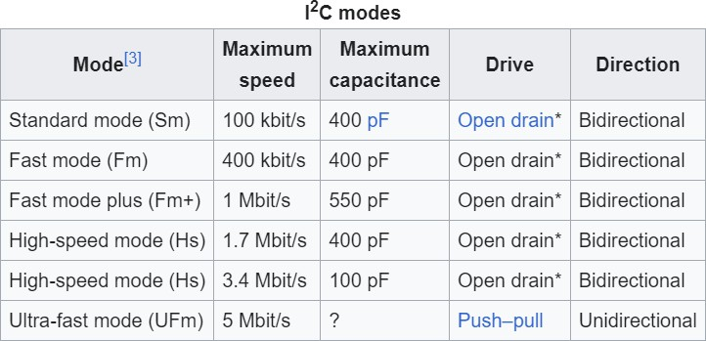

Table 4.4.1.1: I2C Modes

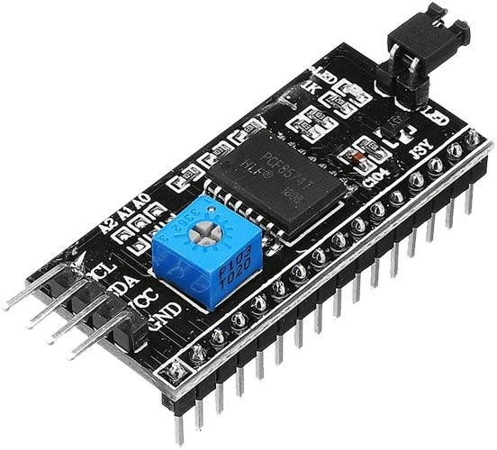

Figure 4.4.1.2: I2C Protocol

4.4.2 MESSAGE PROTOCOLS

I²C defines basic types of transactions, each of which begins with a START and ends with a STOP:
- Single message where a controller (master) writes data to a target (slave).
- Single message where a controller (master) reads data from a target (slave).
- Combined format, where a controller (master) issues at least two reads or writes to one or more targets (slaves).
In a combined transaction, each read or write begins with a START and the target address. The START conditions after the first are also called repeated START bits. Repeated STARTs are not preceded by STOP conditions, which is how targets know that the next message is part of the same transaction.

MEMS SENSOR

MEMS sensors are made up of both electronic and mechanical components. Microelectronic components handle sensing and processing of data while mechanical parts provide physical feedback – this combination makes MEMS sensors small, reliable, and cost-effective
    - MEMS SENSOR

MEMS sensors are miniature devices used to measure physical quantities such as pressure, temperature, acceleration and magnetic fields.
Micro-Electro-Mechanical Systems (MEMS) sensors are widely utilized across a wide variety of applications, from medical to automotive systems and with ruggedized mechanical envelopes they are built to withstand harsh environmental conditions.
The ESCP-MIS2 sensor incorporates ES Systems capacitive MEMS sensor that is built using ES Systems exclusive SOI micro-fabrication TM30 process for absolute capacitive pressure sensors, withstanding temperatures ranging from -20oC to +85oC.

    - MEMS TECHNOLOGY

MEMS technology has transformed manufacturing and design practices significantly over recent years.
Micro fabrication and nanotechnology come together to form an approach that creates small devices with both mechanical and electrical components that can be utilized across industries ranging from medical applications to consumer electronics, allowing us to make more efficient products by exploiting their small size and high precision.
MEMS fabrication uses tools such as lithography, etching, deposition and bonding to fabricate structures on the micron scale for use across various industries. Engineers now have access to MEMS fabrication technology which offers endless opportunities for innovation and advancement across several fields of endeavour.
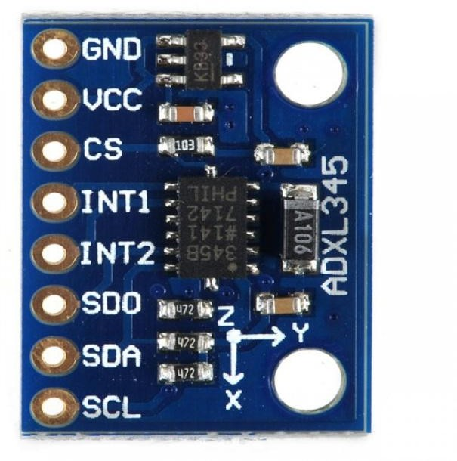
Figure 4.5.2.1: MEMS Sensor

    - FINAL THOUGHTS ON MEMS SENSORS

As engineering and technology continue to advance, MEMS sensors have proven themselves as transformative tools, offering industries precision and efficiency.
MEMS devices have revolutionized industries with their compact size and extraordinary accuracy, leading to further innovations, advancements, breakthroughs,

and breakthroughs that drive highly integrated systems that monitor, control, optimize industrial processes and enable real-time insights and informed decision-making.
Accept the challenge of pushing boundaries, exploring uncharted waters, and using MEMS sensors to build smarter, more efficient systems with the assistance of ES Systems. Our wide range of products will allow industries to reach greater heights together.

POWER SUPPLY 12 VOLTS

In practical terms, a 12-volt power supply works by converting higher voltage alternating current (AC) from a wall outlet or another power source into 12-volt direct current (DC). This conversion process is crucial because most electronic devices operate on DC power, which is more stable and easier to regulate than AC power. The power supply ensures that the output voltage remains steady at 12 volts, regardless of fluctuations in the input voltage or changes in the load (the devices being powered).
The 12-volt power supply typically consists of several key components, including transformers, rectifiers, capacitors, and voltage regulators. These components work together to transform, filter, and regulate the electricity, ensuring that it meets the specific requirements of the devices it powers. Some power supplies also include additional features such as overload protection, short circuit protection, and thermal management to safeguard both the power supply itself and the connected devices from damage.
Applications for 12-volt power supplies are diverse and widespread. In homes, they are often used to power electronic gadgets, LED lighting systems, and small appliances. In vehicles, such as cars, trucks, and boats, 12-volt power supplies are essential for operating navigation systems, audio equipment, and lighting. They are also commonly found in industrial settings to power control systems, sensors, and other machinery.
When using a 12-volt power supply, it's important to match the voltage and current ratings to the requirements of the device being powered. Using an incompatible power supply can damage the device or cause it to malfunction. Therefore,

manufacturers provide specifications detailing the voltage and current requirements for each device to ensure proper compatibility with the power supply.

WORKING PRINCIPLE

Like other lithium-ion cells, LiPos work on the intercalation and de-intercalation of lithium ions from a positive electrode material and a negative electrode material, with the liquid electrolyte providing a conductive medium. To prevent the electrodes from touching each other directly, a micro porous separator is in between, which allows only the ions and not the electrode particles to migrate from one side to the other.

CAPACITOR

Applications of 1000uf/25v electrolytic capacitor: noise filtration. As a coupling capacitor. Charge storage. This is a 25V 1000uF Electrolytic Capacitor from Keltron. It has diameter of 10 mm with an length of 21mm. A capacitor (originally known as a condenser) is a passive two-terminal electrical component used to store energy electrostatically in an electric field.
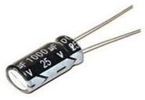
Figure 4.7.1: Capacitor

DC JACK

DC Jack, also known as a power jack, DC power jack, male jack, male plug, etc, is used to give external DC power to any device or board. It has a cylindrical miniature size. It is a perfect option to give direct external power to the board or any device. If you need to connect a DC power wall wart to a board that doesn‘t have a DC jack – this adapter will come in very handy! There is a 2.1mm DC jack on one end, and two normal terminal wires on the other. The red wire is positive and the black/white wire is negative. This product is known as CCTV Devices DC 5.5×2.1mm Female 2-Wire Lead

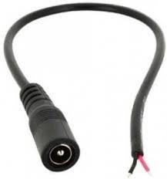
Jack Power Cable Connector, 2.1mm Female to 30cm Cable, 5.5X2.1mm 12V DC Power Plug Female Jack Plug Cable, 5.5mm x

.

Figure 4.8.1: DC Jack

FEATURES/SPECIFICATIONS

- Material: PVC
- DC power jack: Female
- Voltage Rating: 3.3V to 24V
- Current Rating: 2A
- Great for short distance connection
- Simply & Professional appearance for cabling
- Easier for installation save time and money
- Connector Type: 5.5mm X 2.1mm
- 2.1mm inner diameter
- 5.5mm outer diameter
- Weight: 5gm

1N4007

The 1N4007 belongs to a sort of 1 A general-purpose silicon rectifier diode, commonly used in AC adapters for common household appliances. It is fairly low-speed rectifier diode, being inefficient for square waves of more than 15 kHz. The 1N4007 diode is a standard recovery rectifier with a moulded plastic case. The maximum current carrying capacity is 1A and it withstands peak up to 30A. So we can use this diode in circuits that are designed for less than 1A. The reverse current is 5uA which is negligible but it can withstand reverse voltage peak up to 1000V.

1N4007 DIODE PINOUT

1N4007 rectifier diode has in total 2 pins. However, you need to know functions of every pins before it can work better for you.
1N4007 owns a cathode (-) and anode (+). In the schematic symbol, the tip of the triangle with the line on top of it is the cathode. The cathode is marked on the body of a diode by a band. It allows current flow through only one direction that means current can flow from the anode to the cathode only and never from the cathode to the anode – it likes a one way valve.
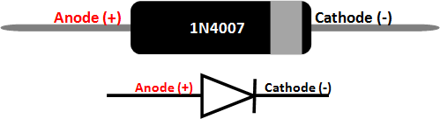

Figure 4.9.1.1: 1N4007

Pin configurations of 1N4007 are list as following:
- Pin 1, Anode, Current always Enters through Anode
- Pin 2, Cathode, Current always Exits through Cathode
The 1N4007 is the most commonly used rectifier diode. It is commonly used in rectifier circuits, protection circuits and regulator circuits. The lead near to the silver line is the cathode and the other lead is anode, current is allowed to flow only form anode to cathode. The specifications of the 1N4007 diode are:
- Reverse Voltage: 1000V (peak)
- Forward Current: 1A
- Peak Forward Current: 30A
- Reverse leakage current: 5uA

APPLICATIONS OF 1N4007 DIODE

- Prevent reverse polarity problem
- Current flow regulators
- Half Wave and Full Wave rectifiers

GSM
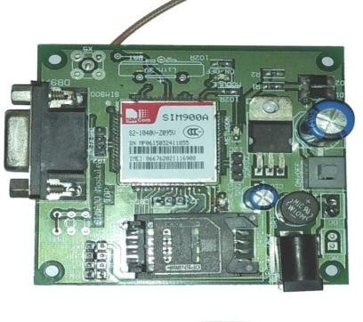
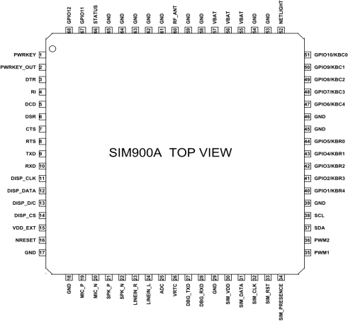
Figure 4.10.1: GSM Figure 4.10.2: GSM Pin Diagram

The SIM900A is a readily available GSM/GPRS module used in many mobile phones and PDA. The module can also be used for developing IOT (Internet of Things) and Embedded Applications. SIM900A is a dual-band GSM/GPRS engine that works on frequencies EGSM 900MHz and DCS 1800MHz. SIM900A features GPRS multi- slot class 10/ class 8 (optional) and supports the GPRS coding schemes CS-1, CS-2, CS- 3 and CS-4.

FEATURES AND SPECIFICATIONS
- Single supply voltage: 3.4V – 4.5V
- Power saving mode: Typical power consumption in SLEEP mode is 1.5mA
- Frequency bands:SIM900A Dual-band: EGSM900, DCS1800. The SIM900A can search the two frequency bands automatically. The frequency bands also can be set by AT command.
- GSM class: Small MS
- GPRS connectivity: GPRS multi-slot class 10 (default) , GPRS multi-slot class 8 (option)
- Transmitting power: Class 4 (2W) at EGSM 900, Class 1 (1W) at DCS 1800
- Operating Temperature: -30ºC to +80ºC
- Storage Temperature: -5ºC to +90ºC
- DATA GPRS: download transfer max is 85.6KBps, Upload transfer max 42.8KBps
- Supports CSD, USSD, SMS, FAX

- Supports MIC and Audio Input
- Speaker Input
- Features keypad interface
- Features display interface
- Features Real Time Clock
- Supports UART interface
- Supports single SIM card
- Firmware upgrade by debug port
- Communication by using AT commands

POTENTIOMETER

Variable resistors used as potentiometers have all three terminals connected. This arrangement is normally used to vary voltage, for example to set the switching point of a circuit with a sensor, or control the volume (loudness) in an amplifier circuit. If the terminals at the ends of the track are connected across the power supply, then the wiper terminal will provide a voltage which can be varied from zero up to the maximum of the supply.


Figure 4.11.1: Potentiometer Symbol

BUZZER
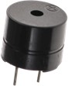
Figure 4.12.1: Buzzer

A buzzer is an electronic signalling device that produces a buzzing or beeping sound. It is commonly used to alert or notify users about specific events, conditions, or alarms. Buzzers can be found in a wide range of applications, from household

appliances to industrial equipment. Here are some key features and applications of buzzers.
    - FEATURES OF BUZZER

- Sound Generation: Buzzers generate sound through the rapid vibration of an internal diaphragm or other sound-producing components. The vibration creates audible sound waves, resulting in the characteristic buzzing or beeping noise.
- Simplicity: Buzzers are relatively simple devices, consisting of just a few essential components such as the diaphragm, an electromagnetic coil, and sometimes housing.
- Variety of Tones: Depending on the design and construction, buzzers can produce different tones and frequencies of sound. These tones can range from simple beeps to more complex alarm sounds.
- Activation Methods: Buzzers can be activated by electrical signals. They often have two terminals for connection to a power source, which allows them to be easily integrated into electronic circuits.
- Voltage Requirements: Buzzers typically operate at low voltages, making them suitable for a wide range of electronic devices and systems.
    - APPLICATIONS OF BUZZERS

- Alarms: Buzzers are commonly used as audible alarms to alert individuals about various events, such as a door being opened, a fire alarm, a security breach, or an emergency situation.
- Notifications: In consumer electronics and appliances, buzzers are used to provide notifications or reminders. For example, a washing machine might use a buzzer to signal the end of a cycle.
- Indicators: Buzzers can serve as indicators to convey information, such as low battery warnings in electronic devices or system faults in industrial equipment.
- Feedback: Buzzers are often used in user interfaces to provide feedback about button presses, touch interactions, or system status changes.

CHAPTER - 5

WORKING & BLOCK DIAGRAM

WORKING
The project involves developing a system to assist people during vehicle accidents. When a crash occurs, the system automatically sends alerts to emergency services and the contacts of those involved. The system uses sensors installed in vehicles that can detect sudden movements or impacts, such as during a crash. These sensors are connected to a small computer within the vehicle that processes the information quickly.
Upon detecting a crash, the system sends a signal to a central server using wireless technology. The server then triggers alerts to emergency responders with details about the crash, including the location and severity. Simultaneously, messages are sent to pre- registered contacts of the vehicle's occupants, informing them of the situation and location.
The objective is to reduce the time it takes for help to arrive after an accident. By notifying emergency services and contacts immediately, the goal is to save lives and minimize injuries. The system is designed to be reliable and fast, utilizing advanced technology to ensure alerts are sent even in remote areas with limited network coverage.
The focus is also on making the system user-friendly and affordable. No action is required from the driver or passengers during an emergency, as the system activates automatically when a crash is detected. The system is being rigorously tested to ensure functionality across various conditions and scenarios, from minor collisions to more severe accidents.
In conclusion, the vehicle accident alert system project aims to use technology to improve emergency response times and save lives. This proactive approach to road safety leverages sensors, computers, and wireless communication to ensure that help arrives quickly when needed most. The potential impact of the project is significant, contributing to safer roads for all.

BLOCK DIAGRAM
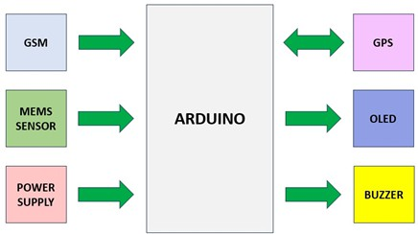

Figure 5.1: Block Diagram

CHAPTER - 6

SOFTWARE & CODING

INTRODUCTION TO ARDUINO UNO

Arduino is a prototype platform (open-source) based on an easy-to-use hardware and software. It consists of a circuit board, which can be programmed (referred to as a microcontroller) and ready-made software called Arduino IDE (Integrated Development Environment), which is used to write and upload the computer code to the physical board.

THE KEY FEATURES ARE

    - Arduino boards are capable of reading Analog or digital input signals from various sensors and converting them into outputs such as activating a motor, turning an LED on or off, connecting to the cloud, and performing many other actions.
    - Board functions can be controlled by sending a set of instructions to the microcontroller on the board via the Arduino IDE, a process referred to as uploading software.
    - Unlike many previous programmable circuit boards, Arduino does not require an additional piece of hardware (known as a programmer) to load new code onto the board. A simple USB cable is sufficient.
    - The Arduino IDE uses a simplified version of C++, making it easier to learn programming.
    - Arduino provides a standard form factor that breaks down the functions of the microcontroller into a more accessible package.
After learning the key components of the Arduino UNO board, the next step is setting up the Arduino IDE. Once this setup is complete, the program can be uploaded to the Arduino board.

ARDUINO DATA TYPES

Data types in C refer to an extensive system used for declaring variables or

functions of different types. The type of a variable determines how much space it occupies in the storage and how the bit pattern stored is interpreted.
The following table provides all the data types that you will use during Arduino programming.
Void: The void keyword is used only in function declarations. It indicates that the function is expected to return no information to the function from which it was called.

Example:
Void Loop ( )
{
// rest of the code
}
Boolean: A Boolean holds one of two values, true or false. Each Boolean variable occupies one byte of memory.
Char: A data type that takes up one byte of memory that stores a character value. Character literals are written in single quotes like this: 'A' and for multiple characters, strings use double quotes: "ABC".
However, characters are stored as numbers. You can see the specific encoding in the ASCII chart. This means that it is possible to do arithmetic operations on characters, in which the ASCII value of the character is used. For example, 'A' + 1 has the value 66, since the ASCII value of the capital letter A is 65.
Unsigned char: Unsigned char is an unsigned data type that occupies one byte of memory. The unsigned char data type encodes numbers from 0 to 255.
Byte: A byte stores an 8-bit unsigned number, from 0 to 255.
int: Integers are the primary data-type for number storage. int stores a 16-bit (2-byte) value. This yields a range of -32,768 to 32,767 (minimum value of -2^15 and a maximum value of (2^15) - 1).
The int size varies from board to board. On the Arduino Due, for example, an int stores a 32-bit (4-byte) value.
Unsigned int: Unsigned ints (unsigned integers) are the same as int in the way that they

store a 2 byte value. Instead of storing negative numbers, however, they only store positive values, yielding a useful range of 0 to 65,535 (2^16) - 1). The Due stores a 4 byte (32-bit) value, ranging from 0 to 4,294,967,295 (2^32 - 1).
Word: On the Uno and other ATMEGA based boards, a word stores a 16-bit unsigned number. On the Due and Zero, it stores a 32-bit unsigned number.
Long: Long variables are extended size variables for number storage, and store 32 bits (4 bytes), from 2,147,483,648 to 2,147,483,647.
Unsigned long: Unsigned long variables are extended size variables for number storage and store 32 bits (4 bytes). Unlike standard longs, unsigned longs will not store negative numbers, making their range from 0 to 4,294,967,295 (2^32 - 1).
Short: A short is a 16-bit data-type. On all Arduinos (ATMega and ARM based), a short stores a 16-bit (2-byte) value. This yields a range of -32,768 to 32,767 (minimum value of -2^15 and a maximum value of (2^15) - 1).
Float: Data type for floating-point number is a number that has a decimal point. Floating-point numbers are often used to approximate the analog and continuous values because they have greater resolution than integers.
Floating-point numbers can be as large as 3.4028235E+38 and as low as 3.4028235E+38. They are stored as 32 bits (4 bytes) of information.
Double: On the Uno and other ATMEGA based boards, Double precision floating-point number occupies four bytes. That is, the double implementation is exactly the same as the float, with no gain in precision. On the Arduino Due, doubles have 8-byte (64 bit) precision.
In this section, we will learn in easy steps, how to set up the Arduino IDE on our computer and prepare the board to receive the program via USB cable.
Step 1: First you must have your Arduino board (you can choose your favorite board) and a USB cable. In case you use Arduino UNO Download page, Arduino Duemilanove, Nano, Arduino Mega2560, or Diecimila, you will need a standard USB cable (A plug to B plug), the kind you would connect to a USB printer as shown in the following image.

Step 2: Download Arduino IDE Software.

You can get different versions of Arduino IDE from the on the Arduino Official website. You must select your software, which is compatible with your operating system (Windows, IOS, or Linux). After your file download is complete, unzip the file.
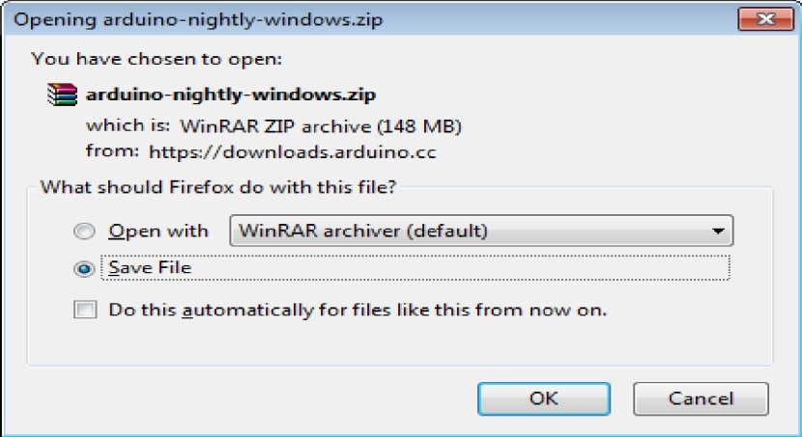

Step 3: Power up your board.
The Arduino Uno, Mega, Duemilanove and Arduino Nano automatically draw power from either, the USB connection to the computer or an external power supply. If you are using an Arduino Diecimila, you have to make sure that the board is configured to draw power from the USB connection. The power source is selected with a jumper, a small piece of plastic that fits onto two of the three pins between the USB and power jacks. Check that it is on the two pins closest to the USB port. Connect the Arduino board to your computer using the USB cable. The green power LED (labeled PWR) should glow.

Step 4: Launch Arduino IDE.
After your Arduino IDE software is downloaded, you need to unzip the folder. Inside the folder, you can find the application icon with an infinity label (application.exe). Double click the icon to start the IDE.
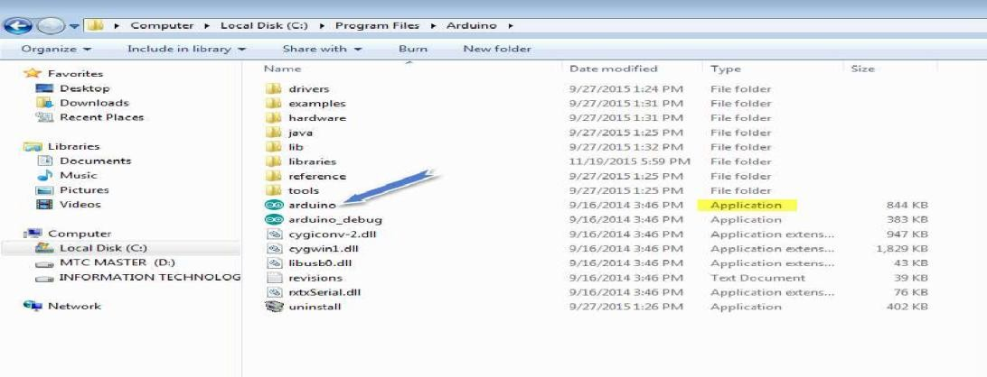

Step 5: Open your first project.
Once the software starts, you have two options:
- Create a new project.
- Open an existing project example.
To create a new project, select File --> New. To open
To open an existing project example, select File -> Example -> Basics -> Blink.
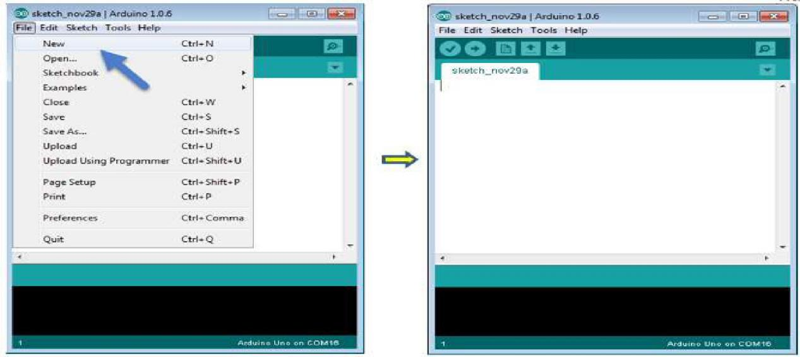

Here, we are selecting just one of the examples with the name Blink. It turns the LED on and off with some time delay. You can select any other example from the list.

Step 6: Select your Arduino board.
To avoid any error while uploading your program to the board, you must select the correct Arduino board name, which matches with the board connected to your computer.
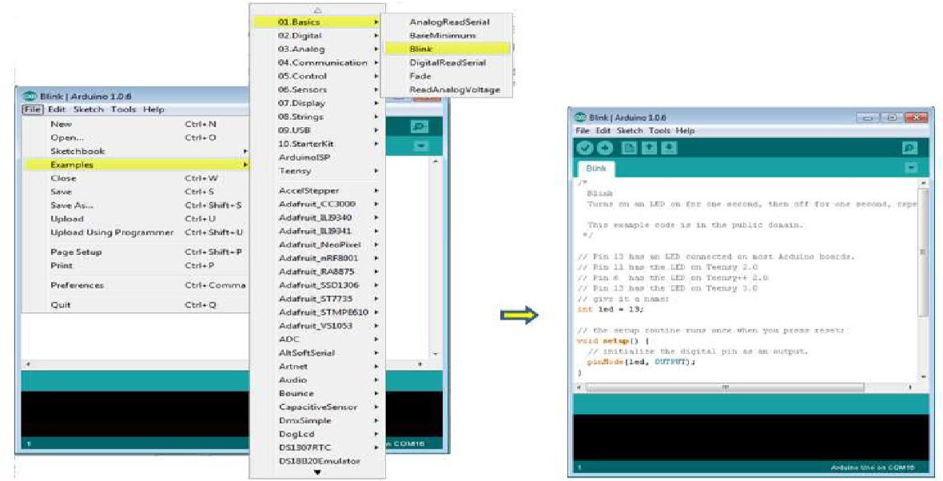

Go to Tools -> Board and select your board
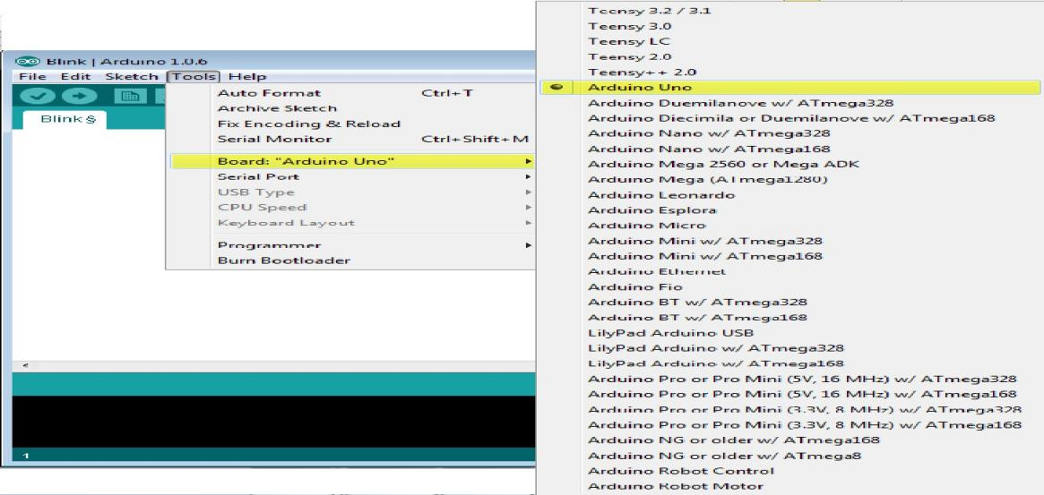

Here, we have selected Arduino Uno board according to our tutorial, but you must select the name matching the board that you are using.
Step 7: Select your serial port Select the serial device of the Arduino board. Go to Tools ->Serial Port menu. This is likely to be COM3 or higher (COM1 and COM2 are usually reserved for hardware serial ports). To find out, you can disconnect your Arduino board and re-open the menu, the entry that disappears should be of the Arduino board. Reconnect the board and select that serial port.
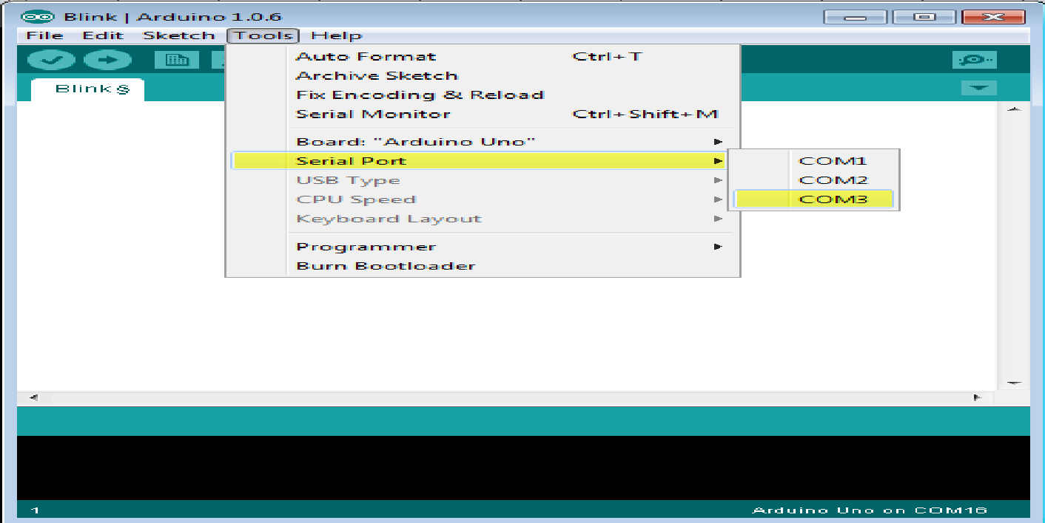

Step 8:
Upload the program to your board. Before explaining how we can upload our program to the board, we must demonstrate the function of each symbol appearing in the Arduino IDE toolbar.

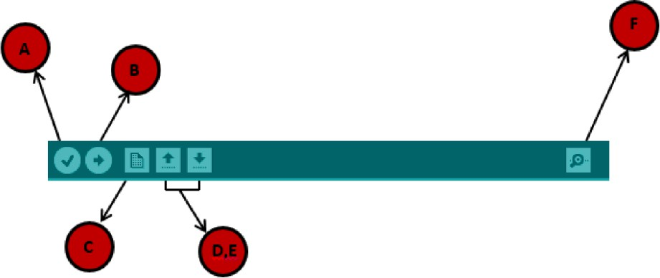

A- Used to check if there is any compilation error.
B- Used to upload a program to the Arduino board.
C- Shortcut used to create a new sketch.
D- Used to directly open one of the example sketch.
E- Used to save your sketch.
F- Serial monitor used to receive serial data from the board and send the serial data to board.
Now, simply click the "Upload" button in the environment. Wait a few seconds; you will see the RX and TX LEDs on the board, flashing. If the upload is successful, the message "Done uploading" will appear in the status bar.
Note: If you have an Arduino Mini, NG, or other board, you need to press the reset button physically on the board, immediately before clicking the upload button on the Arduino Software.

Arduino programming structure

In this chapter, we will study in depth, the Arduino program structure and we will learn more new terminologies used in the Arduino world. The Arduino software is open-source. The source code for the Java environment is released under the GPL and the C/C++ microcontroller libraries are under the LGPL.
Sketch: The first new terminology is the Arduino program called ―sketch‖.

Structure

Arduino programs can be divided in three main parts: Structure, Values (variables and constants), and Functions. In this tutorial, we will learn about the Arduino software program, step by step, and how we can write the program without any syntax or compilation error.
Let us start with the Structure. Software structure consist of two main functions:

- Setup( ) function
- Loop( ) function
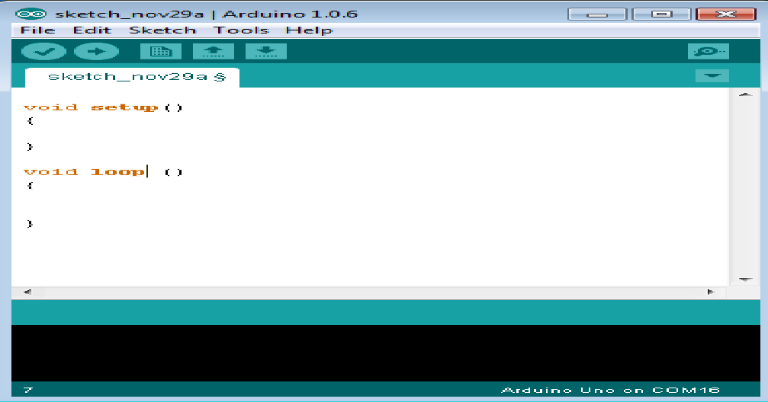

Void setup ( )
{
}

PURPOSE

The setup() function is called when a sketch starts. Use it to initialize the variables, pin modes, start using libraries, etc. The setup function will only run once, after each power up or reset of the Arduino board.

INPUT

OUTPUT RETURN
Void Loop ( )
{

}

PURPOSE

After creating a setup() function, which initializes and sets the initial values, the loop() function does precisely what its name suggests, and loops secutively, allowing your program to change and respond. Use it to actively control the Arduino board.

CHAPTER – 7

RESULT AND DISCUSSIONS
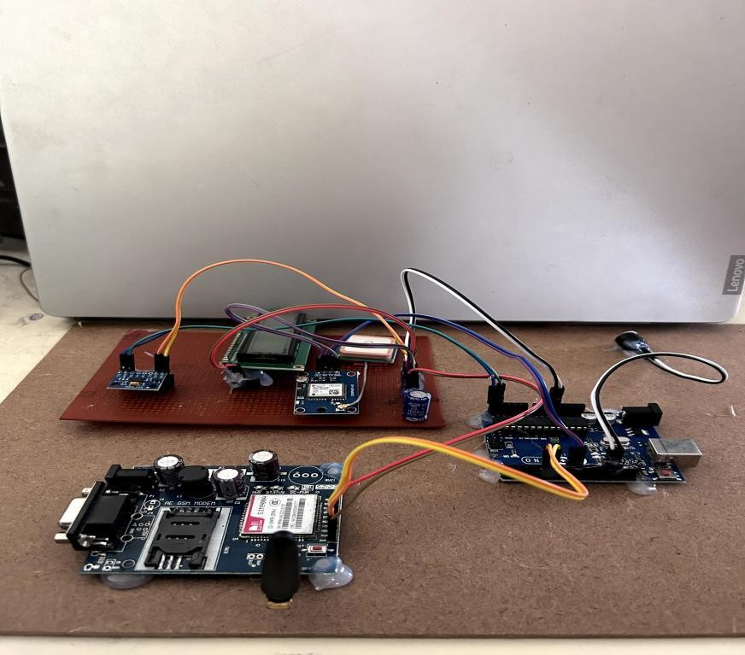
Figure 7.1: Project Kit

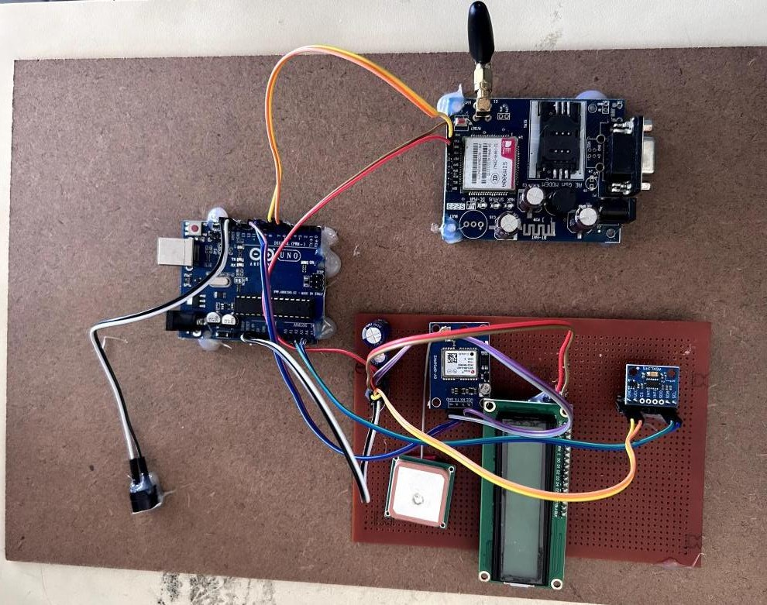

Figure 7.2: Project Kit

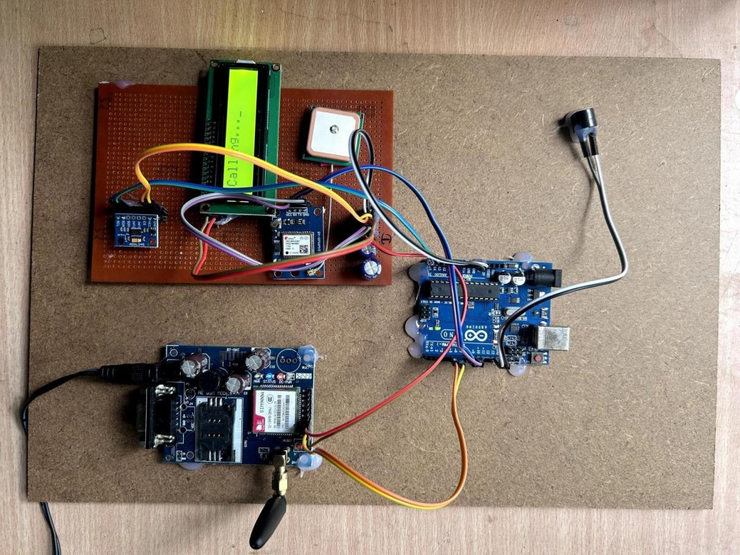
Figure 7.3: Result

Upon receiving data indicative of an accident, the central system employs machine learning algorithms to analyze the severity and type of collision. Location data from GPS and mapping systems help pinpoint the accident's exact location, aiding emergency responders in reaching the location quickly.
This system designed to notify emergency services, nearby vehicles, and designated contacts of the accident. Alerts can be transmitted through dedicated emergency channels, mobile networks, and connected vehicle platforms, ensuring comprehensive coverage and quick response. highlighting its potential to significantly reduce emergency response times and improve overall road safety.

CHAPTER – 8

ADVANTAGES & APPLICATIONS

ADVANTAGES

- Early detection and notification
- Automatic emergency alerts
- Location tracking
- Cost-effective solution
- Enhanced vehicle safety

APPLICATIONS

- Personal vehicles
- Fleet management
- Public transport
- Emergency response vehicle.

CHAPTER - 9

CONCLUSION AND FUTURE SCOPE

CONCLUSION

The proposed programmed accident detection system can be a rescuer of life for the people who met with accidents. The proposed system is exceptionally easy to understand and even a non-specialized Person can use it without any problem. The system consists of equipment and programming segments. The equipment unit includes accident detection sensors that are constrained by an Arduino board and is fitted in the vehicle. Then again, the programming part is an Android application introduced in drivers Smartphones which is used to get the point by point map. In general, the benefits of this system are low cost, secure and simple to use. The system introduced in this work reduces the casualties due to accidents

FUTURE SCOPE

The proposed system deals with the detection of the accidents. But this can be extended by providing medication to the victims at the accident spot. By increasing the technology we can also avoid accidents by providing alerts systems that can stop the vehicle to overcome the accidents.
The future scope of vehicle accident and safety alert systems is poised for significant advancements aimed at enhancing road safety and reducing the severity of accidents. These systems utilize a combination of advanced technologies to detect, respond to, and mitigate the impact of accidents effectively.

REFERENCES

- DR.C.K.Gomathy , V.Geetha , S.Madhumitha , S.Sangeetha , R.Vishnupriya Article: A Secure With Efficient Data Transaction In Cloud Service, Published by International Journal of Advanced Research in Computer Engineering & Technology (IJARCET) Volume 5 Issue 4, March 2016, ISSN: 2278 – 1323.
- Dr.C.K.Gomathy,C K Hemalatha, Article: A Study On Employee Safety And Health Management International Research Journal Of Engineering And Technology (Irjet)-
Volume: 08 Issue: 04 | Apr 2021
- Dr.C K Gomathy, Article: A Study on the Effect of Digital Literacy and information Management, IAETSD Journal For Advanced Research In Applied Sciences, Volume 7 Issue 3, P.No-51-57, ISSN NO: 2279-543X,Mar/2018
- Dr.C K Gomathy, Article: An Effective Innovation Technology In Enhancing Teaching
And Learning Of Knowledge Using Ict Methods, International Journal of Contemporary Research In Computer Science And Technology (IJCRCST) E-Issn: 2395-5325 Volume3, Issue 4,P.No-10-13, April ‘2017
- Dr.C K Gomathy, Article: Supply chain-Impact of importance and Technology in Software Release Management, International Journal of Scientific Research in Computer Science Engineering and Information Technology ( IJSRCSEIT ) Volume 3 | Issue 6 | ISSN : 2456-3307, P.No:1-4, July-2018.

APPENDIX

#include <SoftwareSerial.h> #include <AltSoftSerial.h> #include <TinyGPS++.h>

#include <Wire.h>
// #include <Adafruit_ADXL345_U.h>

// /* Assign a unique ID to this sensor at the same time */
// Adafruit_ADXL345_Unified accel = Adafruit_ADXL345_Unified(12345); #include <LiquidCrystal_I2C.h>
LiquidCrystal_I2C lcd(0x27, 16, 2); // set the LCD address to 0x27 for a 16 chars and 2 line display
const String PHONE = "+919398063635"; #define rxPin 5
#define txPin 6 String accSide = "";
SoftwareSerial sim800(rxPin, txPin); AltSoftSerial neogps;
TinyGPSPlus gps;
#define ADXL345_ADDRESS (0x53) // ADXL345 I2C address float readings[3]; // Array to store x, y, z readings
float avg_readings[3]; // Array to store x, y, z readings float X_out, Y_out, Z_out; // Outputs
uint8_t sensorAvgReadings = 100;
String sms_status, sender_number, received_date, msg; boolean ignition_status = false;
//boolean tracking_status = false; bool flag = true;
unsigned long previousMillis = 0; // last time update
long interval = 60000; // interval at which to do something (milliseconds)

//for timers
const unsigned long interval1s = 1000; // 1 second in milliseconds const unsigned long interval5s = 5000; // 5 seconds in milliseconds const unsigned long interval10s = 10000; // 10 seconds in milliseconds unsigned long previousTime1s = 0;
unsigned long previousTime5s = 0; unsigned long previousTime10s = 0; bool executed1s = false;
bool executed5s = false; bool executed10s = false;
//end for timers
//buzzer
const int buzzerPin = 11;
//checking gsm module void okcheck() { unsigned char rcr;
do {
rcr = sim800.read();
} while (rcr != 'K'); Serial.println("at ok");
}
void gsminit() { sim800.write("AT\r\n"); okcheck(); sim800.write("ATE0\r\n"); okcheck(); sim800.write("AT+CMGF=1\r\n");
//okcheck();
}
void setup() {
// put your setup code here, to run once:

pinMode(buzzerPin, OUTPUT); buzzerOff();
//delay(7000); delay(500); lcd.init();
lcd.clear(); Serial.begin(9600); sim800.begin(9600); neogps.begin(9600);
// Print a message to the LCD. lcd.backlight(); lcd.setCursor(0, 0); lcd.print("Welcome"); delay(1000);
lcd.setCursor(0, 0); lcd.print("Accident detection"); lcd.setCursor(0, 1); lcd.print("Alert system");
//delay(2000); lcd_cl();
lcd.print("Initializing ADXL"); lcd.setCursor(2, 1); lcd.print("module"); init_ADXL345();
//delay(2000); lcd_cl();
lcd.print("Initializing GPS"); lcd.setCursor(2, 1); lcd.print("module");
//buzzerr(500); while (flag) {

if (gps.encode(neogps.read())) { flag = false;
}
}
//delay(1000); lcd_cl();
lcd.print("Initialized GPS"); lcd.setCursor(2, 1); lcd.print("module");
Serial.println("neogps Software serial initialized"); sms_status = "";
sender_number = ""; received_date = ""; msg = "";
lcd_cl(); lcd.print("Initializing GSM"); lcd.setCursor(2, 1); lcd.print("module"); gsminit();
lcd_cl(); lcd.print("Initialized GSM"); lcd.setCursor(2, 1); lcd.print("module");
sim800.print("AT+CMGF=1\r"); //SMS text mode delay(1000);
lcd_cl(); lcd.print("Registerednumber"); lcd.setCursor(2, 1); lcd.print(PHONE); readAvgADXL345(); printAvgADXl345();

make_call();
}
void loop() {
// put your main code here, to run repeatedly: lcd_cl();
lcd.print("checking system"); lcd.setCursor(2, 1); lcd.print("Happy Journey"); checkAccident();
if (flag) {
//sendSmsGPS(accSide); timerSendSms(); lcd.clear(); lcd.print("SMS sent");
}
delay(1000);
}
void init_ADXL345() { Wire.beginTransmission(ADXL345_ADDRESS); Wire.write(0x2D); // Power register Wire.write(8); // Measurement mode Wire.endTransmission();
delay(10);
}
void readADXL345() { Wire.beginTransmission(ADXL345_ADDRESS); Wire.write(0x32); // Start reading from register 0x32 (X0) Wire.endTransmission(false);
Wire.requestFrom(ADXL345_ADDRESS, 6, true); // Request 6 bytes (x, y, z) for (int i = 0; i < 3; i++) {
readings[i] = Wire.read() | (Wire.read() << 8);

}
}
void readAvgADXL345() {
//int sensorAvgReadings = 100;
for (int i = 0; i < sensorAvgReadings; i++) { readADXL345();
avg_readings[0] += readings[0] / 256; avg_readings[1] += readings[1] / 256; avg_readings[2] += readings[2] / 256;
}
X_out = avg_readings[0] /= sensorAvgReadings; Y_out = avg_readings[1] /= sensorAvgReadings; Z_out = avg_readings[2] /= sensorAvgReadings;
}
void printAvgADXl345() { Serial.print("Xa= "); Serial.print(X_out); Serial.print(" Ya= "); Serial.print(Y_out); Serial.print(" Za= "); Serial.println(Z_out);
}void checkAccident() { readAvgADXL345(); if (X_out > 0.55) { lcd_cl();
accSide = "Left"; flag = true;
lcd.print("Left Accident");
} else if (X_out < -0.55) { lcd_cl();
accSide = "Right";

flag = true;
lcd.print("Right Accident");
} else if (Y_out > 0.55) { lcd_cl();
accSide = "Back"; flag = true;
lcd.print("Back Accident");

} else if (Y_out < -0.55) { lcd_cl();
accSide = "Front"; flag = true;
lcd.print("Front Accident");
} else {
flag = false; lcdDisplayInfo();
displayInfo(); printAvgADXl345();
//digitalWrite(buzzerPin,HIGH);
}
}
void lcd_cl() { delay(2000); lcd.clear(); lcd.setCursor(0, 0);
}

void sendSmsGPS(String text) {
// Can take up to 60 seconds
//boolean newData = false;

buzzerOn(100);
boolean newData = true;

for (unsigned long start = millis(); millis() - start < 2000;) { while (neogps.available()) {
if (gps.encode(neogps.read())) { newData = true;
}
}
}
Serial.println("in send loc");

if (newData) //If newData is true
{
while (neogps.available() > 0) {
// Serial.println("in loop");
if (gps.encode(neogps.read())) { displayInfo();
}
}

Serial.println("new data"); float flat, flon;
unsigned long age; Serial.print("Latitude= "); Serial.print(gps.location.lat(), 6); Serial.print(" Longitude= "); Serial.println(gps.location.lng(), 6); newData = false;
delay(300);
///*

sim800.print("AT+CMGF=1\r"); delay(1000);
sim800.print("AT+CMGS=\"" + PHONE + "\"\r"); delay(1000);
sim800.print(text);
sim800.print(" Accident occured clik on link to see location "); sim800.print("http://maps.google.com/maps?q=loc:"); sim800.print(gps.location.lat(), 6);
sim800.print(","); sim800.print(gps.location.lng(), 6); delay(100);
sim800.write(0x1A); delay(1000); Serial.println("loc sent");
Serial.print(gps.location.lat(), 6); Serial.print(","); Serial.println(gps.location.lng(), 6);
}
make_call(); buzzerOn(100);
}
void displayInfo() {

Serial.print(F("Location: ")); if (gps.location.isValid()) {
Serial.print(gps.location.lat(), 6); Serial.print(F(",")); Serial.print(gps.location.lng(), 6);

} else { Serial.print(F("INVALID"));

}

Serial.print(F(" Date/Time: ")); if (gps.date.isValid()) { Serial.print(gps.date.month()); Serial.print(F("/")); Serial.print(gps.date.day()); Serial.print(F("/")); Serial.print(gps.date.year());
} else { Serial.print(F("INVALID"));
}

Serial.print(F(" "));
if (gps.time.isValid()) {
if (gps.time.hour() < 10) Serial.print(F("0")); Serial.print(gps.time.hour()); Serial.print(F(":"));
if (gps.time.minute() < 10) Serial.print(F("0")); Serial.print(gps.time.minute());

Serial.print(F(":"));
if (gps.time.second() < 10) Serial.print(F("0")); Serial.print(gps.time.second()); Serial.print(F("."));
if (gps.time.centisecond() < 10) Serial.print(F("0")); Serial.print(gps.time.centisecond());
} else { Serial.print(F("INVALID"));
}
Serial.println();

}

void lcdDisplayInfo() { lcd_cl();
if (gps.location.isValid()) { lcd.print("Lat:"); lcd.print(gps.location.lat(), 6);
lcd.setCursor(0, 1); lcd.print("Lng:"); lcd.print(gps.location.lng(), 6);
} else {
lcd.print("Please Wait"); lcd.setCursor(0, 1); lcd.print("GPS data loading");
}
}

void timerSendSms() {
unsigned long currentTime = millis();
// Check for 1 second interval
if (currentTime - previousTime1s >= interval1s && !executed1s) {
// Perform action for 1 second
// Add your code here Serial.println("*"); sendSmsGPS(accSide);
executed1s = true; // Set flag to prevent repeated execution previousTime1s = currentTime; // Reset the timer
}
// Check for 5 second interval
if (currentTime - previousTime5s >= interval5s && !executed5s && executed1s) {
// Perform action for 5 seconds

// Add your code here Serial.println(""); sendSmsGPS(accSide);
executed5s = true; // Set flag to prevent repeated execution previousTime5s = currentTime; // Reset the timer
}
// Check for 10 second interval
if (currentTime - previousTime10s >= interval10s && !executed10s && executed5s) {
// Perform action for 10 seconds
// Add your code here Serial.println("*"); sendSmsGPS("2 " + accSide);
executed10s = true; // Set flag to prevent repeated execution previousTime10s = currentTime; // Reset the timer
} // If all actions have been executed, wait for 10 seconds before resetting if (executed1s && executed5s && executed10s) {
if (currentTime - previousTime10s >= interval10s) { executed1s = executed5s = executed10s = false; // Reset flags
previousTime1s = previousTime5s = previousTime10s = currentTime;
}
}
delay(2000); make_call();
}

void buzzerOn(uint8_t wait) { digitalWrite(buzzerPin, LOW); delay(wait * 30); digitalWrite(buzzerPin, HIGH);
}
// void buzzerOn(uint8_t wait) {

// for (uint8_t i = 0; i < 30; i++) {
// digitalWrite(buzzerPin, !digitalRead(buzzerPin));
// delay(wait);
// }
// digitalWrite(buzzerPin, HIGH);
// }
void buzzerOff() { digitalWrite(buzzerPin, HIGH);
}
void make_call() { Serial.println("calling"); delay(500);
lcd.clear(); lcd.print("Calling...");
sim800.println("ATD+919398063635;");
okcheck(); delay(500);
sim800.println("ATD+919398063635;");
okcheck();
delay(20000); // wait for 20 seconds... lcd.clear();
lcd.print("Call Ended"); sim800.println("ATH"); //hang up Serial.println("call ended"); delay(500);
// Serial.println("calling");
// delay(500);
// lcd.clear();
// lcd.print("Calling...");
// sim800.println("ATD+916301615840;");
// okcheck();

// delay(500);
// sim800.println("ATD+916301615840;");
// okcheck();
// delay(20000); // wait for 20 seconds...
// lcd.clear();
// lcd.print("Call Ended");
// sim800.println("ATH"); //hang up
// Serial.println("call ended");
// delay(500);
}

