SRI RAMAKRISHNA ENGINEERING COLLEGE



[Educational Service: SNR Sons Charitable Trust]

[Autonomous Institution, Reaccredited by NAAC with ‘A+’ Grade] [Approved by AICTE and Permanently Affiliated to Anna University, Chennai]

[ISO 9001:2015 Certified and all eligible programmes Accredited by NBA] VATTAMALAIPALAYAM, N. G. G. O. COLONY POST, COIMBATORE – 641 022.

**DEPARTMENT OF INFORMATION TECHNOLOGY**

**20EC223 –Digital Circuits and Microcontrollers**

**ALM**

**PERFORMANCE FOR LATCHES IN MICROCONTROLLER**

Regulation: R2020

Academic Year 2022 – 2023 (Even Semester)

**Submitted by**

**1. BHARATH P (2105018)**

**2. LAKSHANA S (2105052)**

**3. MYTHILI M (2105065)**

**Course Instructor**

**Ms. Sahanaa Sree N**

Assistant Professor

Department of Electronics and Communication Engineering

Sri Ramakrishna Engineering College, Coimbatore – 641 02

# 

# INTRODUCTION

# INTRODUCTION TO THE LATCHES IN THE MICROCONTOLLER

# WORKING OF LATCHES

# BASIC WORKING OF LATCHES IN A MICROCONTROLLER

# TYPES OF LATCHES

# METHODLOGY OF THE LATCHES

# CIRCUIT DIAGRAM

# TRUTH TABLE

# CHARACTERISTICS

# CHARACTERISTIC EQUATION OF EACH LATCHES

# APPLICATIONS

# APPLICATION OF LATCHES

# LATCHES IN MICROCONTROLLER

# MSP430 MICROCONTROLLER WITH LATCHES

# REFERENCES

**CASE STUDY**

**Performance of Latches in Microcontroller**

**Introduction:**

In digital electronics, a Latch is one kind of a logic circuit, and it is also known as a bistable-multivibrator. Because it has two stable states namely active high as well as active low. It works like a storage device by holding the data through a feedback lane. It stores 1-bit of data as long as the apparatus is activated. Once enable is declared then instantly latch can change the stored data. It constantly trials the inputs once enable signal is activated. The working of these circuits can be done in 2-states based on the enable signal being high or else low. When the latch circuit is the in an active high state, then both the i/ps are low. Similarly, when the latch circuit is then an active low state, then both the i/ps are high.

**Working of latches:**

Two working states of latches:

A latch is an example of a bistable multivibrator, that is, a device with exactly two stable states. These states are high-output and low-output. A latch has a feedback path, so information can be retained by the device. Therefore latches can be memory devices, and can store one bit of data for as long as the device is powered. As the name suggests, latches are used to "latch onto" information and hold in place. Latches are very similar to flip-flops, but are not synchronous devices, and do not operate on clock edges as flip-flops do.

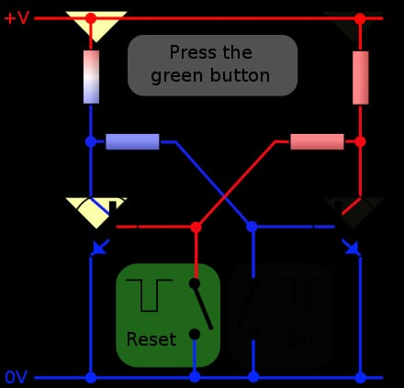

**Fig 1. Logical Diagram of latches**

**Types of Latches**

There are various types of latches used in digital circuits which are as follows:

* SR Latch
* Gated S-R Latch
* D latch
* Gated D Latch
* JK Latch
* T Latch.

**SR Latch**

The SR latch is a special type of asynchronous device which works separately for control signals. It depends on the S-states and R-inputs. The SR latch design by connecting two NOR gates with a cross loop connection. The SR latch can also be designed using the NAND gate. Below are the circuit diagram and the truth table of the SR latch.

**Circuit Diagram:**

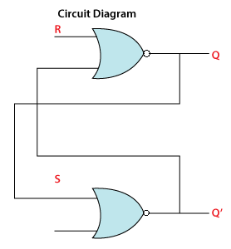

**Fig 2. Circuit diagram of SR latch**

**Truth Table:**

|  |  |  |  |
| --- | --- | --- | --- |
| **S** | **R** | **Q** | **Q'** |
| 0 | 0 | latch | Latch |
| 0 | 1 | 0 | 1 |
| 1 | 0 | 1 | 0 |
| 1 | 1 | 0 | 0 |

**Gated SR Latch**

A Gated SR Latch is a special type of SR Latch having three inputs, i.e., Set, Reset, and Enable. The enable input must be active for the SET and RESET inputs to be effective.The ENABLE input of gated SR Latch enables the operation of the SET and RESET inputs.This ENABLE input connects with a switch. The Set-Reset inputs are enabled when this switch is on. Otherwise, all the changes are ignored in the set and reset inputs. Below are the circuit diagram and the truth table of the Gated SR latch.

**Circuit Diagram:**

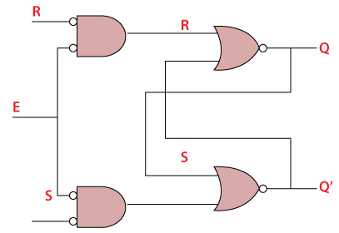

**Fig 3. Circuit Diagram for Gated SR latch**

**Truth Table:**

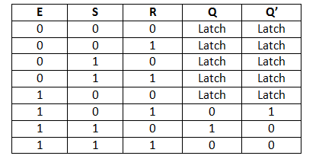

**D Latch**

The D latch is the same as D flip flop. The only difference between these two is the ENABLE input. The output of the latch is the same as the input passed to the Data input when the ENABLE input set to 1. At that time, the latch is open, and the path is transparent from input to output. If the ENABLE input is set to 0, the D latch's output is the last value of the latch, i.e., independent from the input D, and the latch is closed. Below are the circuit

diagram and the truth table of the D latch.

**Circuit Diagram:**

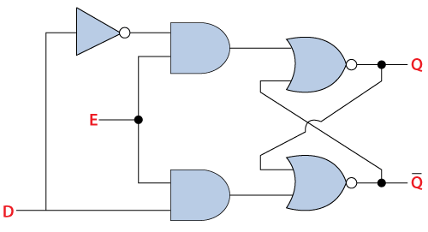

**Fig 4. Circuit diagram for D latch**

**Truth table:**

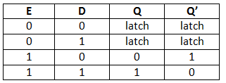

**Gated D Latch**

The **Gated D Latch** is another special type of gated latch having two inputs, i.e., DATA and ENABLE. When the enable input set to 1, the input is the same as the Data input. Otherwise, there is no change in output.

We can design the gated D latch by using gated SR latch. The set and reset inputs are connected together using an inverter. By doing this, the outputs will be opposite to each other. Below is the circuit diagram of the Gated D latch.

**Circuit Diagram:**

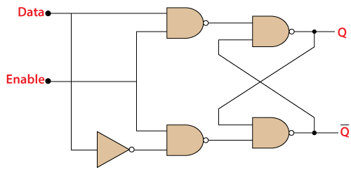

### **Fig 5. Circuit diagram for Gated D latch**

### **JK Latch**

The **JK Latch** is the same as the **SR Latch**. In JK latch, the unclear states are removed, and the output is toggled when the JK inputs are high. The only difference between SR latch JK latches is that there is no output feedback towards the inputs in the SR latch, but it is present in the JK latch.

**Circuit Diagram:**

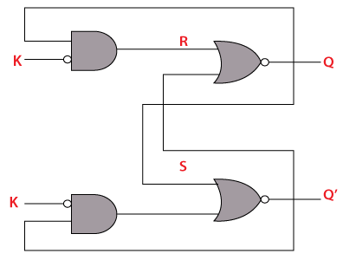

**Fig 6. Circuit diagram for JK Latch**

**Truth Table:**

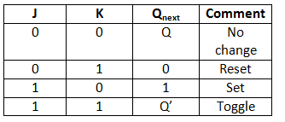

**T Latch**

The T latch forms by shorting the JK latch inputs. The output of the T latch toggle when the input set to 1 or high. Below is the circuit diagram of the T latch.

**Circuit Diagram:**

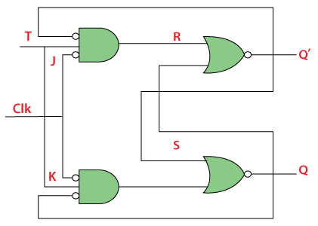

**Fig 7. Circuit diagram for T Latch**

**Truth Table:**

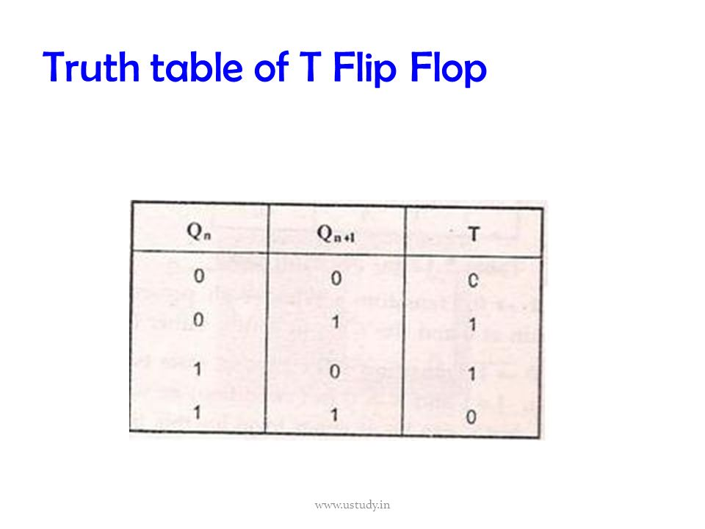

**Advantages of Latches**

The advantages of latches include the following:

* The designing of latches is very flexible when we compare with FFs (flip-flops)
* The latches utilize less power.
* The performance of latch in the design of the high-speed circuit is quick because these are asynchronous within the design and there is no need of CLK signal.
* The shape of the latch is very small and occupies less area
* If the operation of latch based circuit is not finished in a set time, they borrow the necessary time from other to complete the operation
* Latches give aggressive clocking when contrasted with flip-flop circuits.

**Disadvantages of Latches**

The disadvantages of latches include the following:

* There will be a chance of affecting the race condition, so these are less expected.
* When a latch is level sensitive, then there is a chance of meta-stability.
* Analyzing the circuit is difficult due to the property of level sensitive.
* The circuit can be tested by using an extra CAD program.

**Characteristic Equations of latches:**

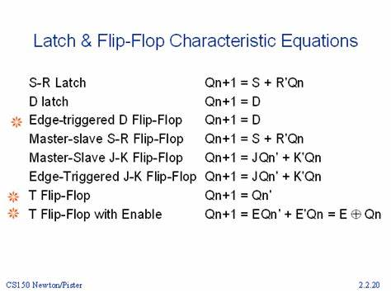

**Applications of latches:**

The applications of latches include the following.

* Generally, latches are used to keep the conditions of the bits to encode binary numbers
* Latches are single bit storage elements which are widely used in computing as well as data storage.
* Latches are used in the circuits like power gating & clock as a storage device.
* D latches are applicable for asynchronous systems like input or output ports.
* Data latches are used in synchronous two-phase systems for reducing the transit count.
* Thus, this is all about an overview of latches. These are the building blocks for sequential circuits. The designing of this can be done using logic gates. Its operation mainly depends on the input of an enable function.

**MSP430 microcontroller with latches:**

* The MSP430 microcontroller is a family of low-power microcontrollers developed by Texas Instruments. The MSP430 microcontroller has several features that make it suitable for a wide range of applications, including low power consumption, high processing power, and ease of use.
* Latches are simple digital circuits that are used to store a single bit of information. Latches can be used to store the output of a digital circuit so that it can be used at a later time.
* In the context of the MSP430 microcontroller, latches can be used in several ways. For example, latches can be used to store the state of an input signal, such as a switch or button, so that the microcontroller can read the state of the input signal at a later time.
* Latches can also be used to store the output of a digital circuit, such as a counter or a comparator. This can be useful when the output of the digital circuit needs to be used at a later time, such as in a feedback loop.
* To connect latches to an MSP430 microcontroller, you would typically use the GPIO (General Purpose Input/Output) pins of the microcontroller. The GPIO pins can be configured as either inputs or outputs, depending on the application. To connect a latch to the microcontroller, you would typically connect the input of the latch to a GPIO pin, and the output of the latch to another GPIO pin.
* Overall, using latches with an MSP430 microcontroller can be a useful way to store and retrieve digital information, and can help to simplify the design of digital circuits.

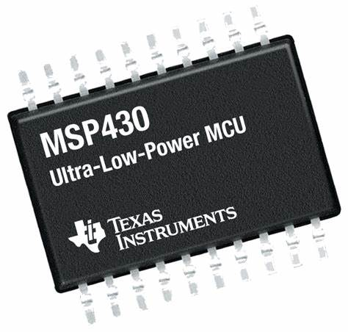

**Fig 8. MSP430 microcontroller**

**Circuit Diagram of latches connected to microcontroller:**

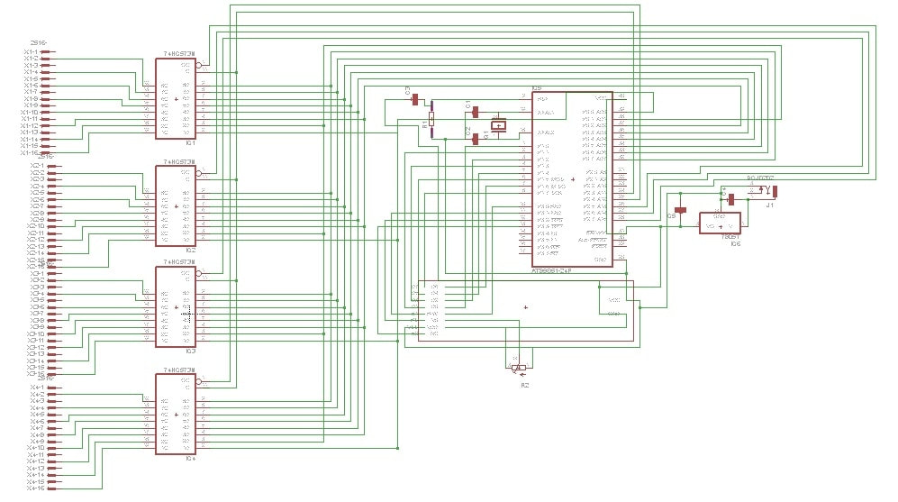

**Fig 9. Circuit diagram of latches connected with microcontroller**

**References:**

<https://www.geeksforgeeks.org/latches-in-digital-logic/amp/>

[https://www.javatpoint.com/latches-in-digital-electronics#](https://www.javatpoint.com/latches-in-digital-electronics)