  

**TAMILNADU SKILL DEVELOPMENT CORPORATION**

**Naan Mudhalvan Niral Thiruvizha Review - 1**

1. Name of the College:

Dr. Mahalingam College Of Engineering And Technology

1. College code:

7276

1. Theme:

Information/Communication Technology

1. Problem statement:

How might we create an advanced agricultural bot with multi-language support and animation that helps small-scale farmers with soil testing, pest detection, crop management, irrigation, and harvesting, while providing information on local government financial aids, farming schemes, and subsidies? The goal is to improve productivity, income, and food security, ultimately doubling agricultural output.

1. Faculty Guide Details:

|  |  |  |  |  |
| --- | --- | --- | --- | --- |
| **Team Leader Name** | **AU Reg.No** | **Year** | **Department** | **Mobile No** |
| 1. |  |  |  |  |
| **Team members** | | | | |
| 1. BHARATH KUMAR N | 21BIT064 | 4 | IT | 8903906588 |
| 1. NAVEEN V C | 21BIT074 | 4 | IT | 7010582553 |
| 1. DINESH M | 22BIT320 | 4 | IT | 8940458185 |

1. Attach photos of the prototype/App/Software:

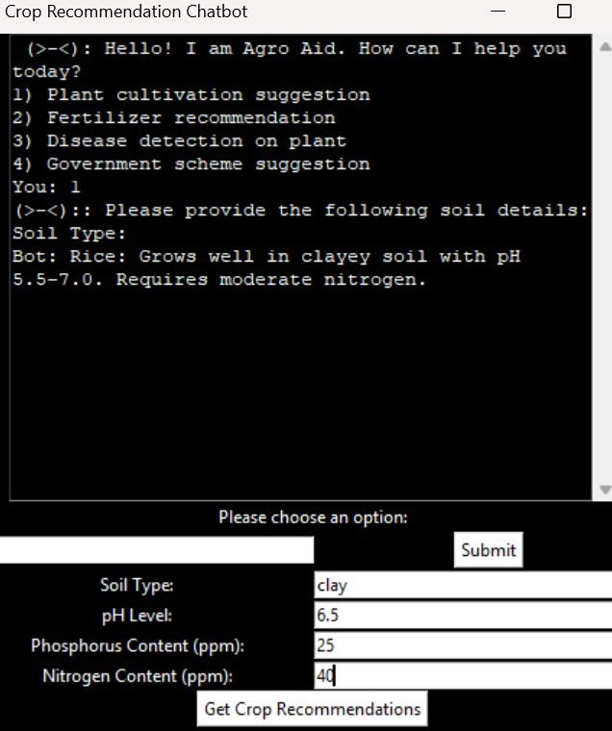

1. Attach photos of the 1st review being conducted:

**UNDERTAKING**

1. The college will provide the basic infrastructure and other required facilities to the students for timely completion of their projects.
2. The college will undertake the financial and other management responsibilities of the project also; college will be responsible in following the time lines.
3. The college will ensure that the funds provided are utilized only for the purpose provided and any remaining amount will be returned back to the University after the time of completion of the project.
4. I hereby declare that the details furnished above are true and correct.

**Signature of Faculty Guide Signature of Principal**