**Bharath Kumar N**

**PS ID:10843180**

**Python Mock assessment 2**

**Linux 1.2**

**Task1:**

**Handling Multiple Exceptions with Input and Files Your system accepts input and reads files, and needs to manage potential errors gracefully.**

**Tasks:**

**1. Prompt the user to enter a file name and try to open it in read mode. o If the file doesn’t exist, catch FileNotFoundError and print: "Error: File not found."**

**Program to open a file**

**Output of Correct file name fetch**

**Output of wrong filename fetch**

**2. Ask the user to input an integer. o If a non-integer is entered, catch ValueError and print: "Error: Please enter a valid integer."**

**The program for printing the integer**

**Output with integer and non integer factor**

**3. Ask the user for a divisor and perform a division using the previously entered integer. o If division by zero occurs, handle ZeroDivisionError and print: "Error: Division by zero is not allowed."**

**The program for division**

**Output with and without error**

**Task2:**

**Student Data Management**

**Create a program in Python to manage student data.**

**The program should meet the following requirements:**

**• Menu-Driven Interface:**

**Use a while loop to present a menu with three options:**

**1. Add a new student.**

**2. Calculate a student's percentage.**

**3. Exit the program.**

**• Add Student Functionality:**

**o Create a function that prompts the user for a student's name.**

**o Use the name as a key to store data in a dictionary.**

**o Prompt the user to enter the student's marks for three subjects.**

**o Store these marks as a list which will be the value associated with the student's name in the dictionary.**

* **Calculate Percentage Functionality:**

**o Create a separate function that asks the user to enter a student's name.**

**o Retrieve the student's marks from the dictionary using the provided name. o Calculate the student's percentage based on the three subjects.**

**o Display the student's name and their calculated percentage on the screen.**

**Program:**

**Add() -> function to add a student**

**Percentage-> function to calculate the percentage**

**While loop for continuous optioning**

**Output for this**

**Task3: Write a python program to find the sum of n natural numbers.**

**Program to print sum of n natural numbers:**

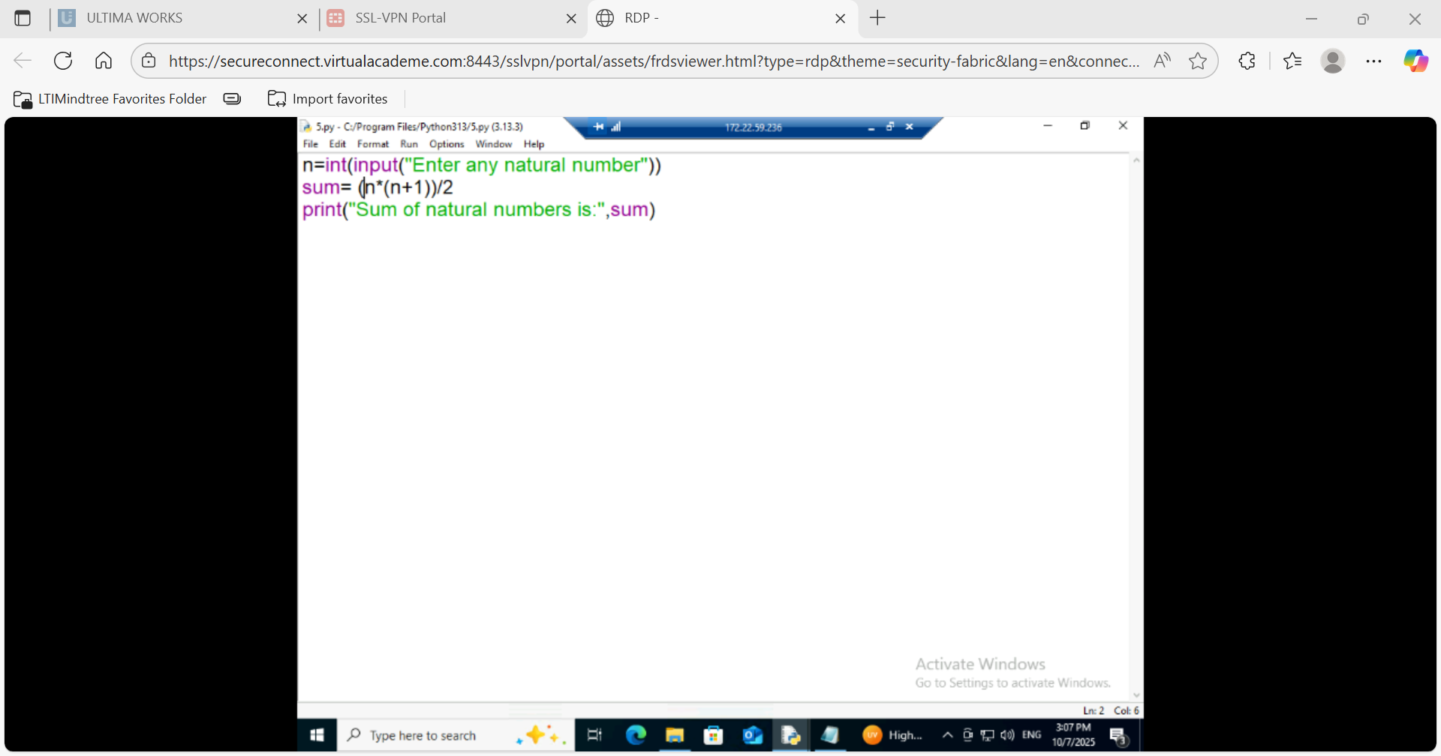

**Output:**

