PROJECT DOCUMENT



LTIMINDTREE AWS SPECIALIZATION BATCH DETAILS

Batch Name : Accelerated Batch -AWS
PS : 10843180
Location Using : South America (SAO PAULO)-SA-EAST-1
Date : 22/11/2025

PROJECT TITLE & DESCRIPTION

Project Title: Checking Compliance on S3 operational best practices

Description:
Check compliance score against operational best practices for S3 using AWS and conformance pack in it.

SERVICES USED

- - S3 Bucket
- - AWS Config
- - AWS Config performance pack

Remarks :

STEPS TO DEPLOY THE PROJECT

- Enabled AWS Config and Security Hub to evaluate S3 compliance against best practices.
- Activated AWS Managed Rules for S3 (e.g., encryption, public access).
- Ran AWS Config Conformance Pack to calculate compliance score.
- Reviewed Security Hub dashboard for S3 control findings.
- Generated S3 Inventory and Access Analyzer reports for bucket-level details.
- Calculated compliance percentage based on compliant vs. total controls.
- Documented findings and remediation recommendations in the compliance report.

Remarks :

ATTACH TESTIMONIALS
Creating an S3 bucket named “Bharath-project-report”
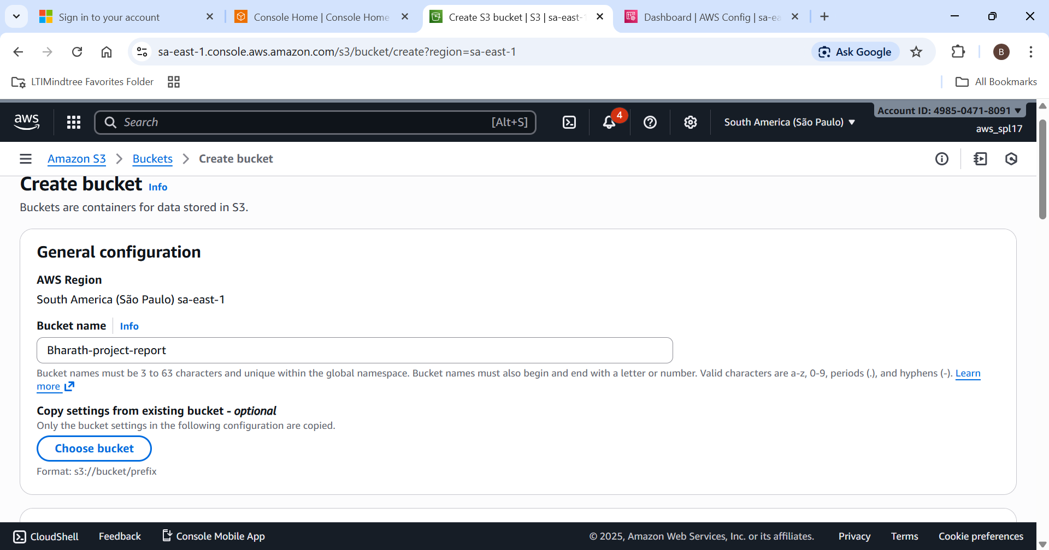

Opening the block access
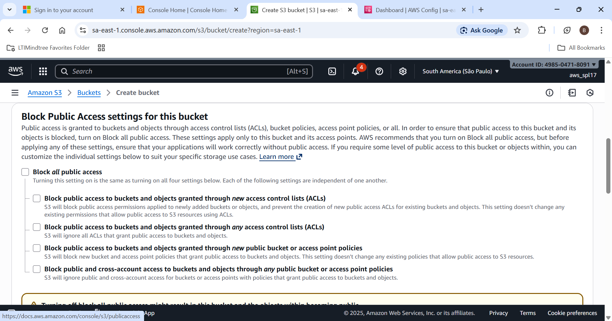

Open Coformance Pack in AWS Config
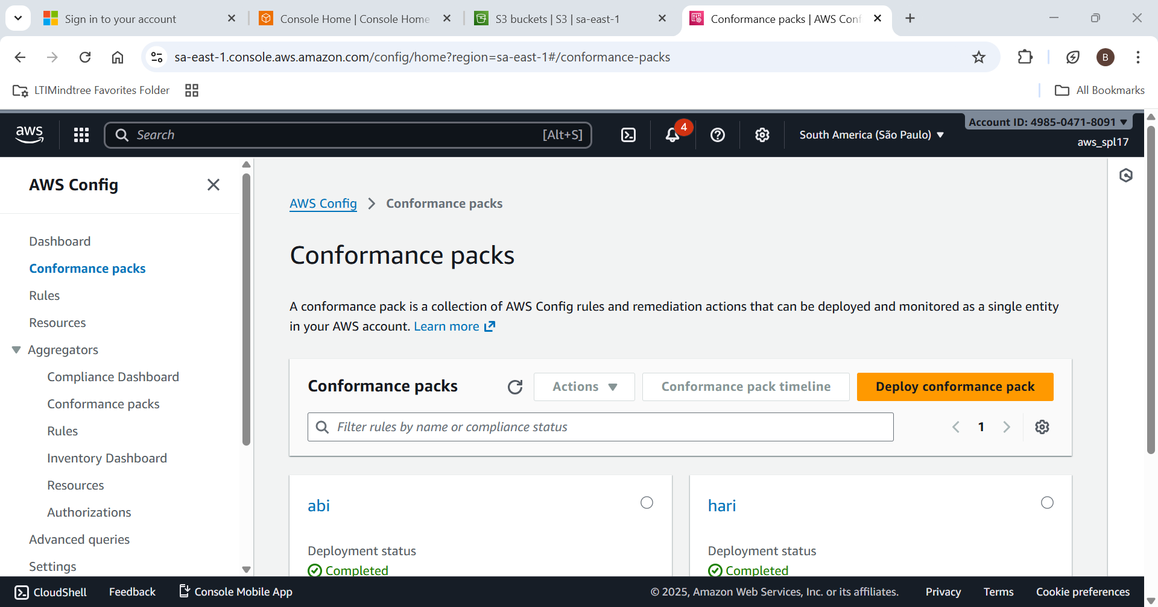

Deploy the coformance pack
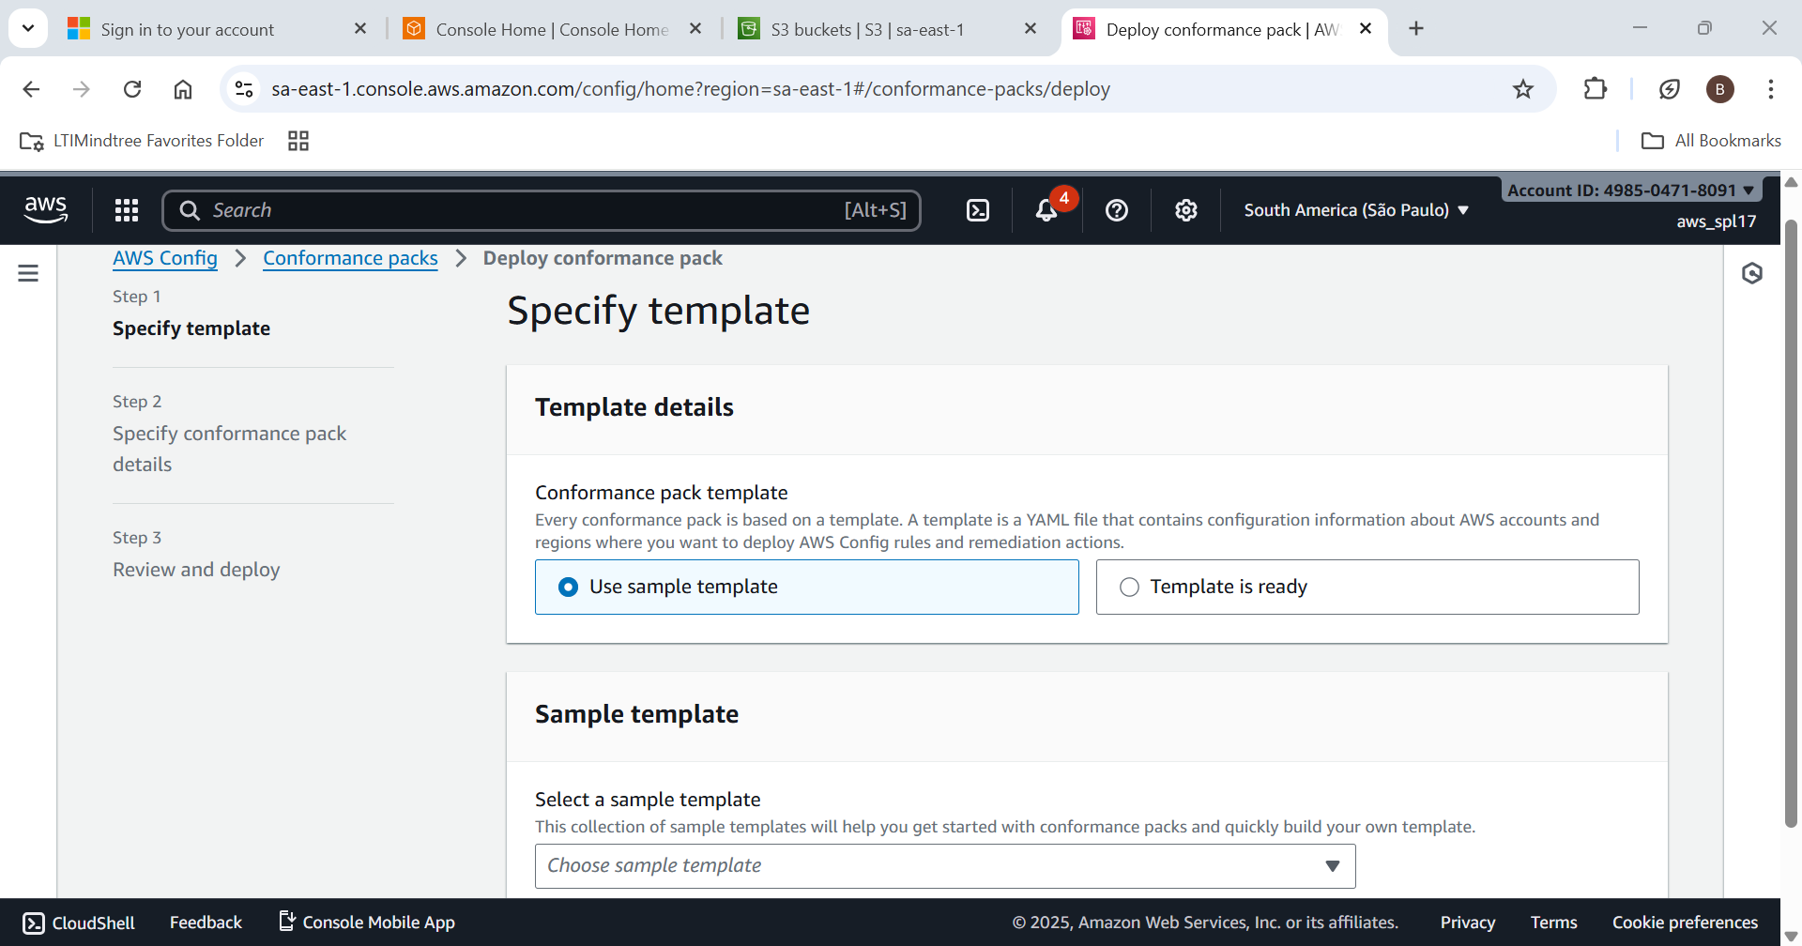

Select from the sample template > Select operational best practices
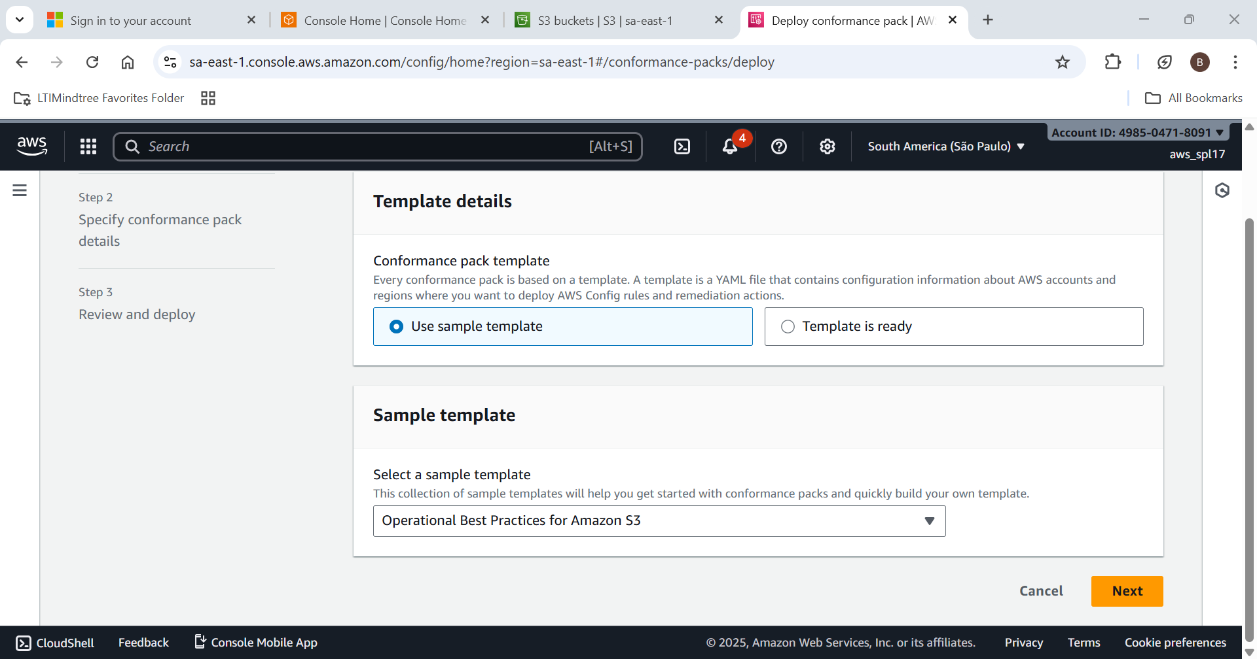

Add configurations and set the parameters required
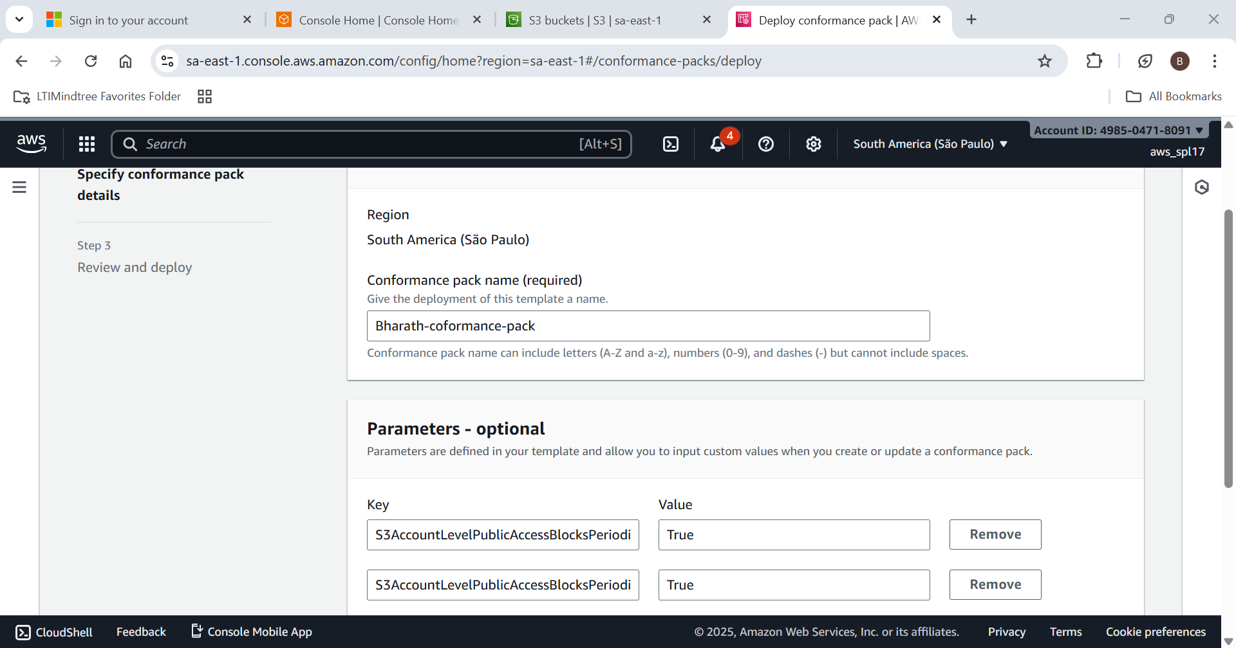

Post deployment data:
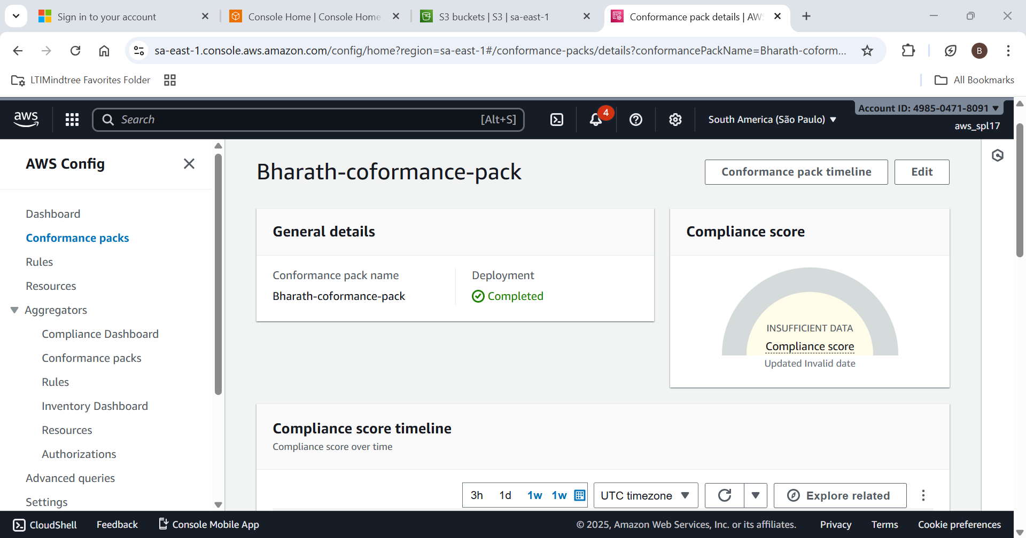

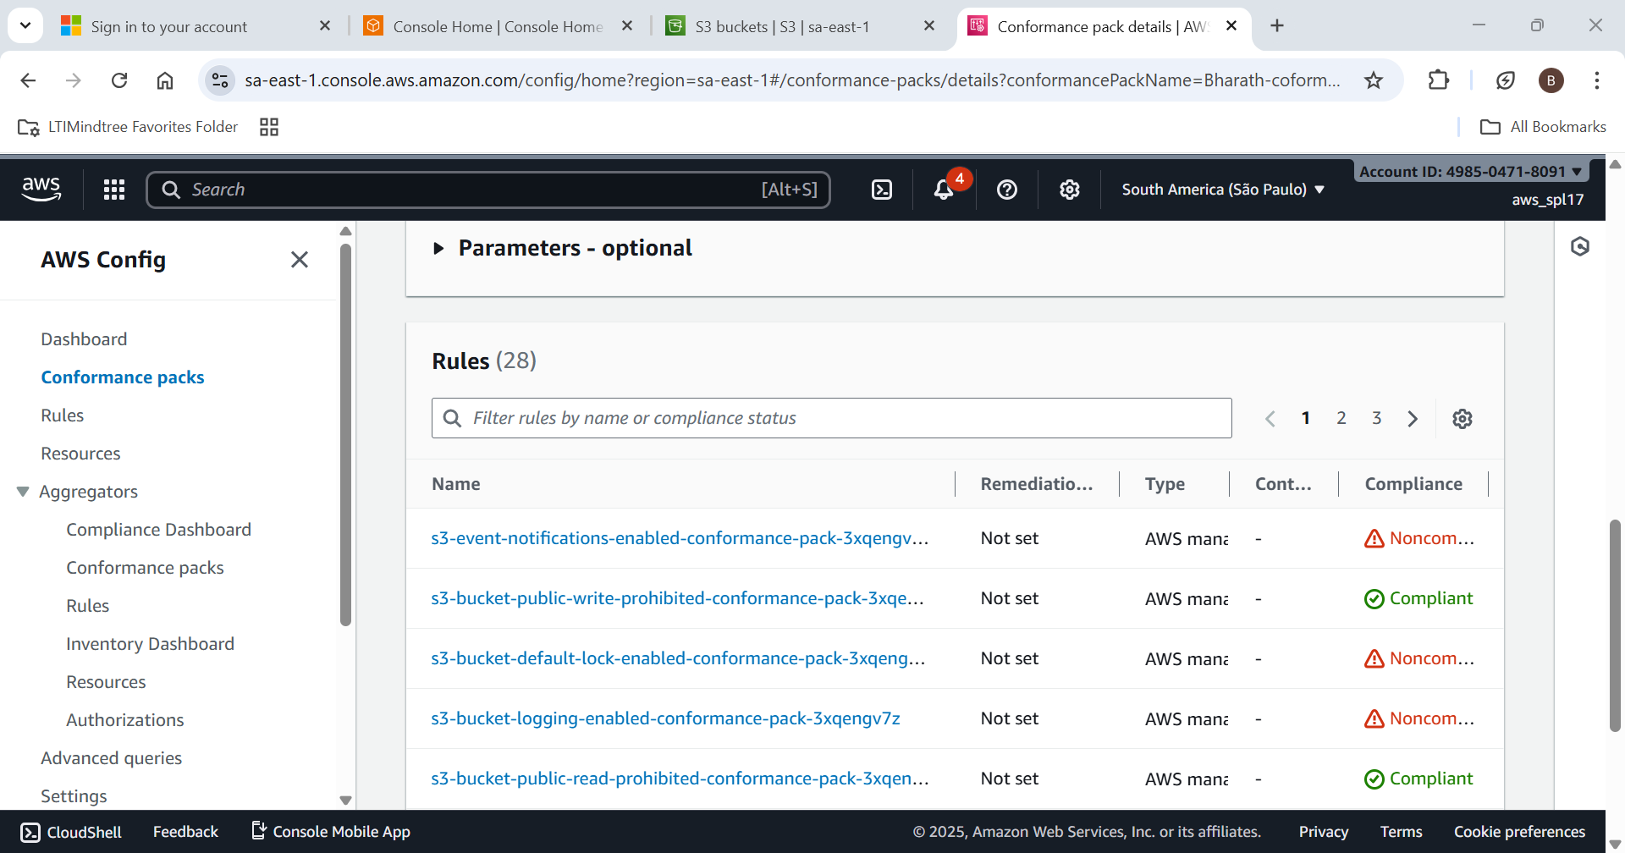

Remarks

CHALLENGES FACED
- Understanding AWS Config and Conformance Pack Setup – Grasping the integration of AWS Config with Conformance Packs and Security Hub required extensive research and testing.
- Parameter Configuration for Operational Best Practices – Choosing and validating correct parameters for compliance templates was complex and iterative.
- Interpreting Compliance Scores and Findings – Converting raw compliance data into actionable insights demanded careful analysis.
- Managing Permissions and Access Controls – Resolving IAM permission issues for deployment and reporting was a significant hurdle.
- Time Management During Deployment and Testing – Balancing long evaluation cycles with other tasks required strong time management.

