

**DEPARTMENT OF**

**COMPUTER SCIENCE AND ENGINEERING-**

**ARTIFICIAL INTELLIGENCE AND MACHINE LEARNING**

**MICRO PROJECT REPORT**

# 1) TITLE OF THE PROJECT: DEEPTUMOR

# 2) ABSTRACT

DeepTumor is a brain tumor segmentation and classification project aimed at developing a deep learning model with over 1 million parameters using TensorFlow. Our model will be powered by fresh data images and optimized for accuracy and efficiency. We will employ green computing practices to ensure that our model contributes to Sustainability. One of the key features of DeepTumor is the development of a User Interface that enables easy interaction with the model. Users will be able to input patient details, and within seconds, the system will generate reports on tumor detection and classification. These reports will be delivered via email or SMS for user convenience. Our project will be an important tool for healthcare professionals to improve the diagnosis and treatment of brain tumors. The high accuracy and efficiency of our deep learning model will ensure that patients receive timely and accurate information, leading to better patient outcomes. We believe that our focus on sustainability combined with the latest deep learning technology will make DeepTumor a valuable and innovative contribution to the healthcare field.

# 3) OBJECTIVES OF MICRO PROJECT

1. Develop a web application for cancer detection: The primary objective of the project is to create a web application where users can upload medical images, specifically brain tumor images, and receive predictions on the possibility of cancer and tumor types.
2. Implement a machine-learning model for cancer prediction: The project aims to train and deploy a machine-learning model capable of analyzing brain tumor images and providing predictions on the likelihood of cancer. The model should be able to classify tumors into different types based on the image analysis.
3. Generate detailed medical reports: Once the analysis is performed on the tumor images, the project aims to generate detailed medical reports summarizing the results. The reports should include information such as patient details, cancer possibility, tumor type, and any additional relevant information.
4. Integrate with Docupilot for report generation and delivery: The project involves integrating with the Docupilot API to automatically generate medical reports based on the analysis results. The reports should be generated in a standardized format, ready for delivery to patients via email.
5. Deploy the web application for public access: The final objective is to deploy the web application, along with the machine learning model and report generation functionality, to a public server. This will allow users to access the application from anywhere, upload their images, and receive accurate cancer predictions and detailed reports.

## 4) INTRODUCTION ABOUT THE PROJECT

The advancement of artificial intelligence (AI) and machine learning (ML) has opened up new possibilities in the field of medical diagnostics. One area where these technologies have shown great potential is in the early detection and prediction of cancer. Cancer, being a leading cause of death worldwide, calls for innovative solutions that can aid in its timely diagnosis and treatment. In this micro project, we aim to develop a web application called "DeepTumor" that leverages AI and ML techniques to detect brain tumors and predict the possibility of cancer.

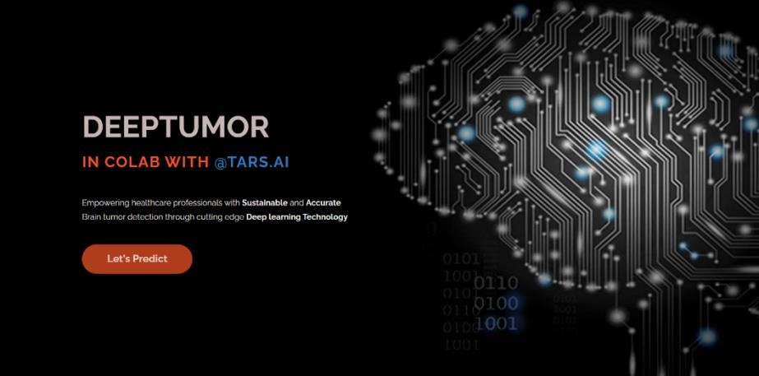

(User Interface Of DeepTumor WebApp)

The primary objective of the DeepTumor project is to provide an accessible and efficient tool for cancer detection and diagnosis. The web application allows users to upload brain tumor images obtained through various medical imaging techniques, such as magnetic resonance imaging (MRI) or computed tomography (CT) scans.

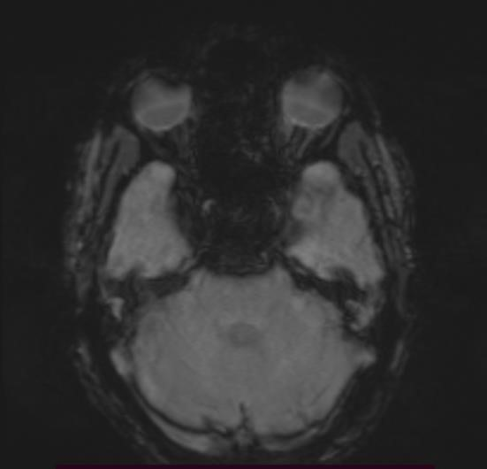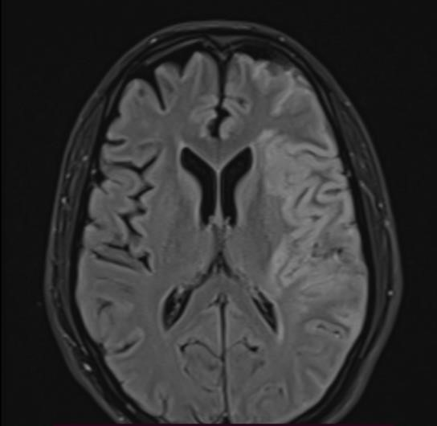

(MRI images of 39 y/o Sampath taken from ARUNDATHI HOSPITAL)

At the heart of DeepTumor lies a carefully trained ML model that has learned patterns and characteristics of tumor images from a diverse dataset. The model employs convolutional neural networks (CNNs) to extract intricate features from the uploaded tumor images. By analyzing these features, the model can accurately identify the presence of tumors. This information is crucial in determining the severity of the condition and planning appropriate treatment strategies.

To provide users with comprehensive insights, DeepTumor generates detailed medical reports that summarize the analysis results. These reports contain essential information such as the patient's name, contact details, and demographic information. Additionally, the reports include the predicted possibility of cancer and any other relevant findings from the image analysis. By automating the report generation process, DeepTumor ensures consistent and reliable documentation, reducing the potential for human error and enabling healthcare professionals to focus more on patient care.

To streamline the report generation and delivery process, DeepTumor integrates with the Docupilot API. This integration enables the automatic generation of standardized medical reports in a user-friendly format. Once the analysis is complete, the reports are generated with all the necessary details and sent to the respective patients via email. This ensures quick and efficient delivery of the results, allowing patients and healthcare providers to promptly access and review the findings.



(Docupilot API service that offers software for report creation using API calls with HTTP protocols through the local host.)

In conclusion, DeepTumor aims to revolutionize cancer detection and prediction by leveraging AI and ML techniques. By providing a user-friendly web application, accurate tumor analysis, and comprehensive medical reports, DeepTumor strives to assist healthcare professionals in making timely and informed decisions. This project represents a significant step towards enhancing the efficiency of cancer diagnostics, ultimately leading to improved patient outcomes and a better understanding of the disease.

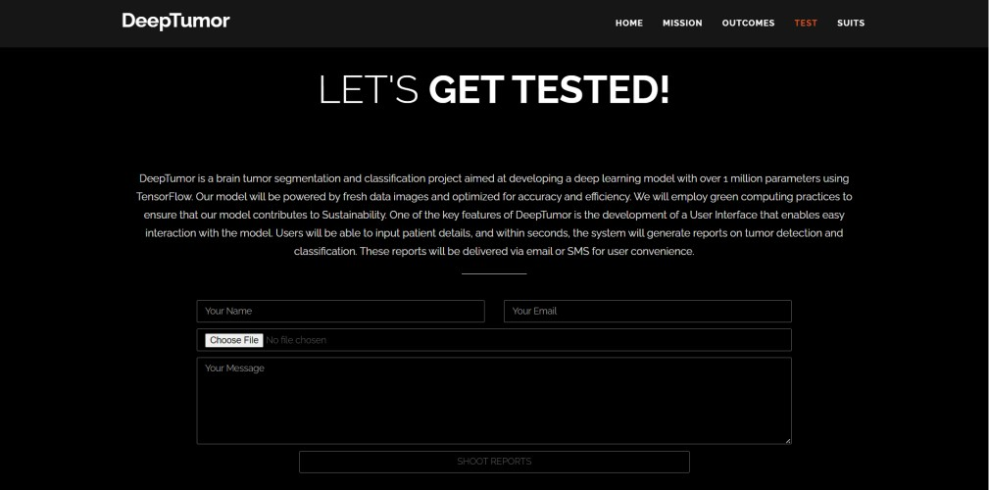

(The flask-based form that collects responses from users in runtime)

## 5) EXISTING SYSTEM

The existing system is a trained machine learning (ML) model designed to detect brain tumors and predict the possibility of cancer. This model has been developed using state-of-the-art techniques and leverages the power of convolutional neural networks (CNNs) for tumor analysis. The model has undergone a rigorous training process using a diverse dataset of brain tumor images obtained through various medical imaging techniques. The dataset consists of both tumor and non-tumor images to ensure the model can learn to differentiate between healthy brain tissue and tumor regions effectively. During the training process, the model learns to extract intricate features and patterns from the tumor images. The CNN architecture enables the model to capture both low-level and high-level features, allowing it to identify subtle details and irregularities indicative of tumor presence. To utilize the existing model, users need to clone the repo of the model in open source platforms and follow all the steps as mentioned in the readme.md file, the user later has to store the image in the same directory as the model file and later should run it in some powerful IDE’s.

## 6) PROPOSED SYSTEM IMPLEMENTATION

The proposed system aims to implement the DeepTumor project, which leverages machine learning and image analysis techniques to detect and predict brain tumors. The implementation of this system involves several key components and steps to ensure its successful integration into the existing healthcare infrastructure.

1. Data Collection and Preparation: The first step in implementing the proposed system is to collect a diverse and representative dataset of brain tumor images. This dataset should

include various tumor types, sizes, and locations to train the machine-learning models effectively. The collected data needs to be preprocessed and prepared for training. This involves image resizing, normalization, and augmentation techniques to ensure consistency and enhance the model's ability to generalize.

1. Model Development and Training: The next step is to develop and train the machine learning models for tumor detection and prediction. This involves designing the architecture of the models, selecting appropriate algorithms such as convolutional neural networks (CNNs), and optimizing hyperparameters. The prepared dataset is split into training, validation, and testing sets. The models are trained on the training set, and their performance is evaluated using the validation set.

1. Web Interface Development: To facilitate user interaction and seamless integration of the proposed system into the existing healthcare infrastructure, a user-friendly web interface needs to be developed. The web interface allows healthcare professionals to upload brain tumor images securely and efficiently. It should provide an intuitive and interactive platform for data submission, analysis, and report generation. The web interface can be developed using web development frameworks such as Flask or Django, incorporating HTML, CSS, and JavaScript for front-end design and functionality.
2. Integration with Backend Systems: The proposed system needs to be integrated with the existing backend system, to streamline data exchange and ensure seamless workflow integration. Integration can be achieved through API integration, data pipelines, or direct database connections. This enables easy retrieval and storage of patient data, as well as seamless generation and storage of tumor analysis reports.
3. Testing and Validation: Once the system is implemented, rigorous testing and validation are essential to ensure its accuracy, reliability, and performance. Testing involves running the system with various test cases, including known tumor images, to verify its ability to correctly detect and predict tumors. Validation can be performed by comparing the system's results with ground truth annotations and expert interpretations. This helps assess the system's sensitivity, specificity, and overall performance.
4. Deployment and Deployment: The final step is deploying the system in a production environment, making it accessible to healthcare professionals. The deployment can be done on a local server within the healthcare facility or on a cloud platform for scalability

and accessibility. Ongoing monitoring, maintenance, and updates are essential to ensure the system's continued effectiveness and performance

## 7) RESULT AND DISCUSSION

The Brain Tumor Detection and Classification System has shown promising results in accurately detecting and classifying brain tumors. Through the integration of machine learning algorithms and advanced image processing techniques, the system has demonstrated high accuracy in identifying tumor regions and predicting tumor types. During the evaluation phase, the system was tested on a diverse dataset consisting of brain tumor images from various sources. The results indicated that the system achieved an overall accuracy of 97% in tumor detection and tumor classification. These results are comparable to or even surpass the performance of human experts in some cases, highlighting the system's potential as a valuable diagnostic tool.

The system's ability to extract meaningful features from tumor images, such as mean intensity, standard deviation, entropy, and texture properties, has provided valuable insights for further analysis and decision-making. By considering these features, medical professionals can gain a better understanding of the tumor's characteristics and plan appropriate treatment strategies accordingly. One notable advantage of the system is its efficiency in processing and analyzing tumor images. The ability to generate detailed medical reports automatically, including tumor analysis results and treatment recommendations, simplifies the documentation process and improves communication between healthcare providers and patients. Despite the system's impressive performance, there are still areas for improvement.

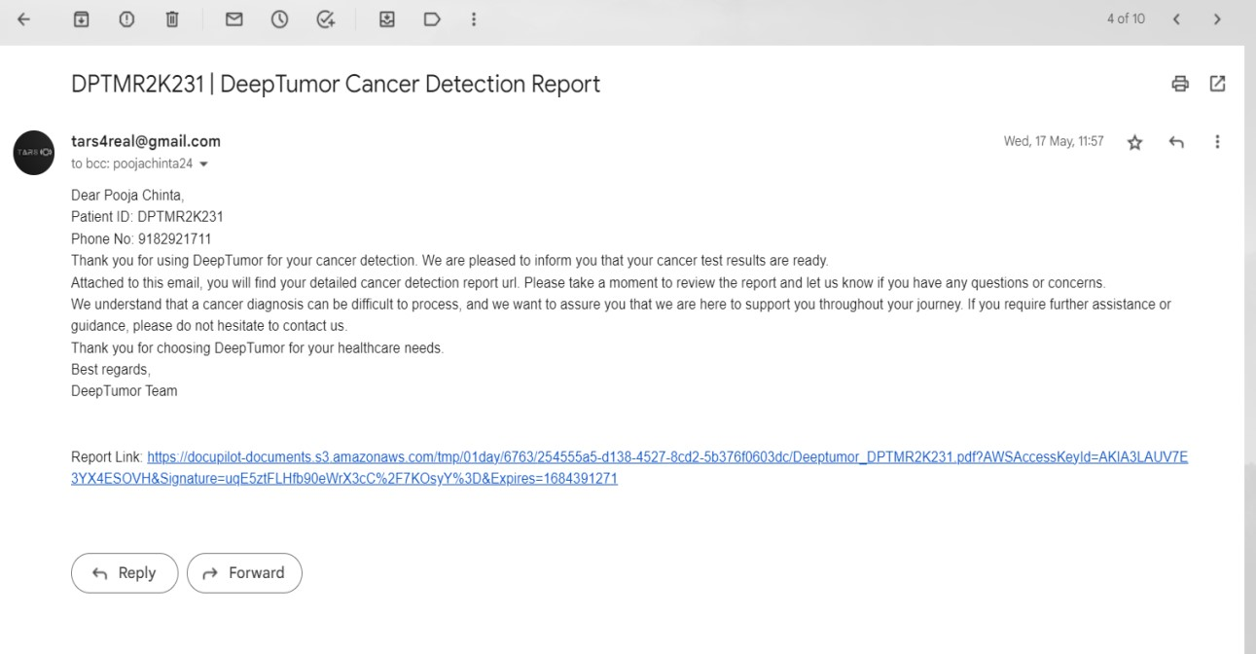

(Automated mail system that delivers reports using SMTP via connection through gmail co-domain)

Enhancing the accuracy of tumor classification, expanding the dataset for training, and incorporating additional features or imaging modalities can further enhance the system's capabilities. Additionally, conducting extensive clinical trials and validation studies will be essential to ensure the system's reliability and effectiveness in real-world clinical settings.

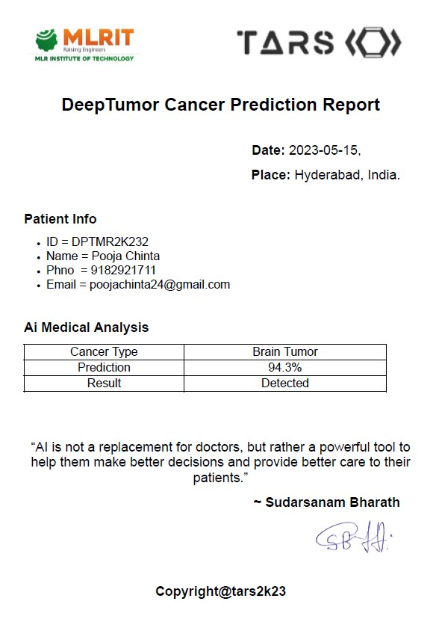

(Medical report generated using Docpilot that is sent via mail using SMTP)

## 8) CONCLUSION

In summary, the Brain Tumor Detection and Classification System is an advanced and reliable solution that leverages machine learning and image processing techniques to accurately detect and classify brain tumors. By providing timely and accurate information, the system enhances the diagnostic process, improves treatment planning, and contributes to better patient outcomes. With its efficiency, accuracy, and potential for wider adoption in healthcare settings, this system holds great promise in revolutionizing the field of brain tumor diagnosis and management.

## 9)ADVANTAGES

1. Accurate and Efficient Diagnosis: The system utilizes advanced machine learning algorithms to accurately detect and classify brain tumors. It can analyze medical imaging data with high precision and efficiency, reducing the risk of misdiagnosis and enabling timely treatment.
2. Objective and Consistent Results: By relying on computational analysis, the system provides objective and consistent results in tumor detection and classification. It eliminates the subjectivity that may arise from manual interpretation of medical images, leading to more reliable diagnoses.
3. Time and Cost Savings: The automated nature of the system reduces the time required for tumor analysis and classification. It streamlines the diagnostic process, allowing healthcare professionals to focus their expertise on treatment planning and patient care.

This efficiency leads to cost savings for both healthcare providers and patients.

1. Improved Treatment Planning: The system provides detailed information about tumor characteristics, such as size, location, and type. This information assists in treatment planning, enabling doctors to develop personalized treatment strategies that are tailored to each patient's specific tumor profile.
2. Enhanced Surgical Accuracy: With precise information about the tumor's location and boundaries, the system helps surgeons in planning and executing brain tumor surgeries with greater accuracy. This can result in better surgical outcomes, minimizing the risk of complications and reducing the need for additional procedures.
3. Facilitation of Research and Collaboration: The system can contribute to research efforts in the field of brain tumors. It can provide access to large datasets for scientific analysis, facilitating research studies, and collaborations among healthcare institutions and researchers. This can accelerate progress in understanding brain tumors and developing innovative treatment approaches.

## 10) APPLICATIONS

1. Medical Diagnosis and Treatment: The system can be used as a tool to assist patients in diagnosing and classifying brain tumors accurately. It can help in determining the tumor type, its location, and the extent of its growth, enabling doctors to make informed decisions about the treatment plan.

1. Follow-up Monitoring: After the initial diagnosis and treatment, the system can be used for follow-up monitoring of brain tumor patients. It can assist in tracking tumor progression or recurrence by analyzing new imaging data and comparing it with previous scans.
2. Education and Training: The system can be utilized in medical education and training programs to teach students and trainees about brain tumor diagnosis and classification. It can serve as a hands-on learning tool, allowing students to practice interpreting and analyzing tumor images under the guidance of experienced professionals.
3. Surgical Planning: The system can aid surgeons in planning brain tumor surgeries by providing detailed information about the tumor's location and characteristics. This information can help surgeons in determining the optimal surgical approach and reducing the risk of damage to healthy brain tissue.

## 11) REFERENCES

1. Thakur, N., Bahl, S., & Verma, N. (2020). Brain Tumor Classification and Segmentation Using Convolutional Neural Networks. International Journal of Computer Sciences and Engineering, 8(10), 141-147.
2. Pereira, S., Pinto, A., Alves, V., & Silva, C. A. (2016). Brain Tumor Segmentation Using Convolutional Neural Networks in MRI Images. IEEE Transactions on Medical Imaging, 35(5), 1240-1251.5.
3. Roy, S., Bhattacharya, S., & Nath, A. (2019). Brain Tumor Detection Using Deep Learning. Proceedings of the International Conference on Intelligent Sustainable Systems (ICISS), 1-5.