Step 1: Register and Download the Datset from KAGGLE.
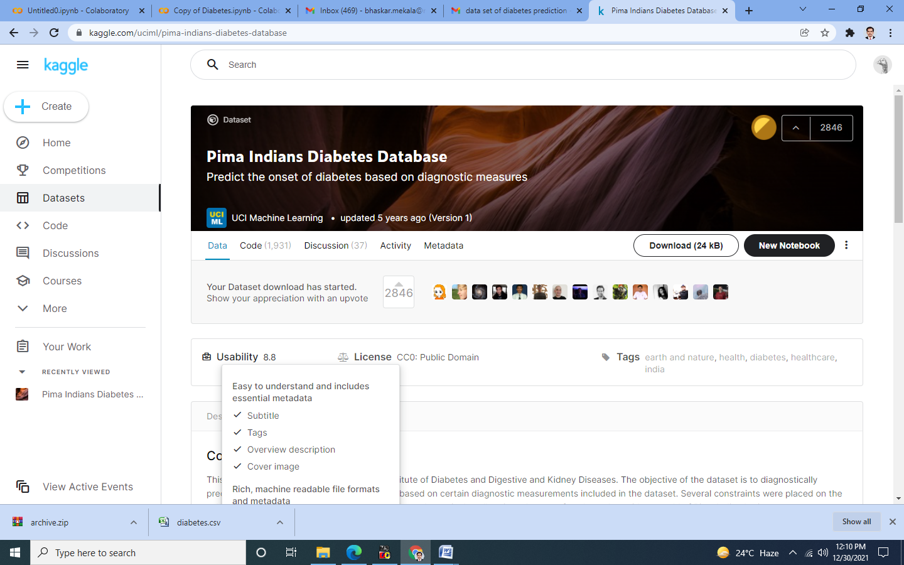

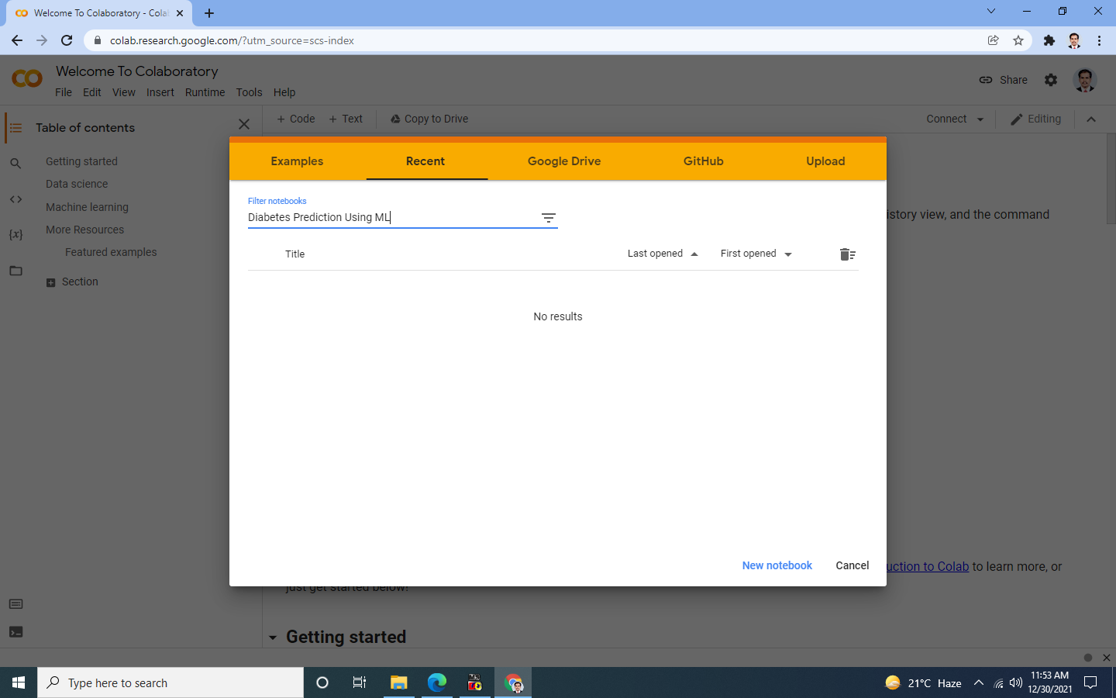
Step 2 : Create New NoteBook in Googe Colab

Step 3 : Upload the CSV file in NoteBook

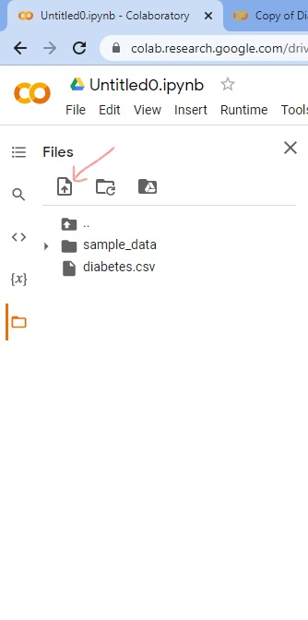

Step 4: Click on “CODE” to insert a new Cell.

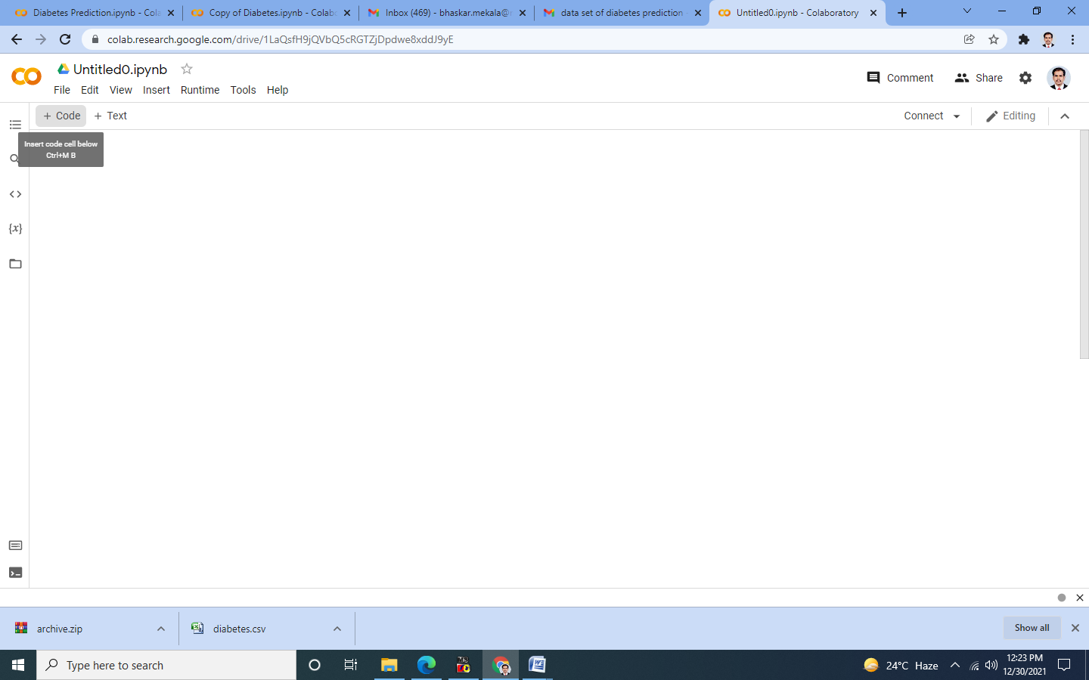

Step 5: Write your code in the cell
import pandas as pd
import numpy as np
import matplotlib.pyplot as plt
import seaborn as sns
import warnings
warnings.filterwarnings("ignore")
sns.set_style('darkgrid')

data=pd.read_csv('diabetes.csv')
data.head(10)

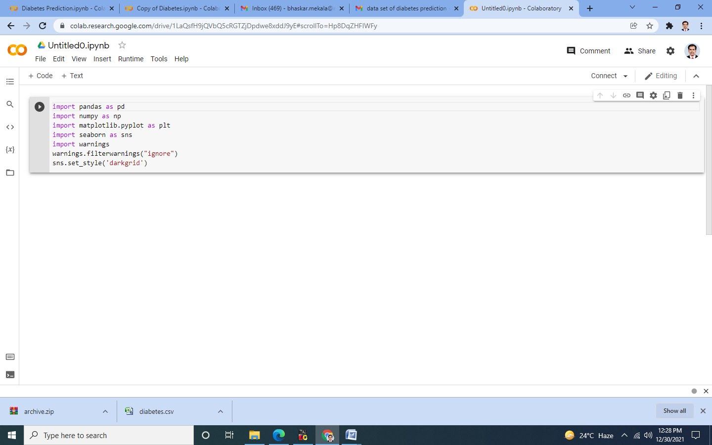
Step 6: Execute it by clicking on Run Button.
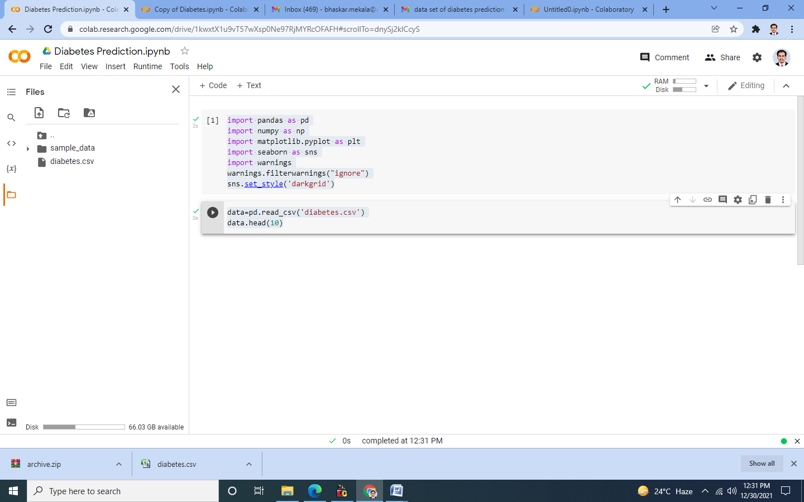

Step 7: Check the Output which should contain 10 columns.
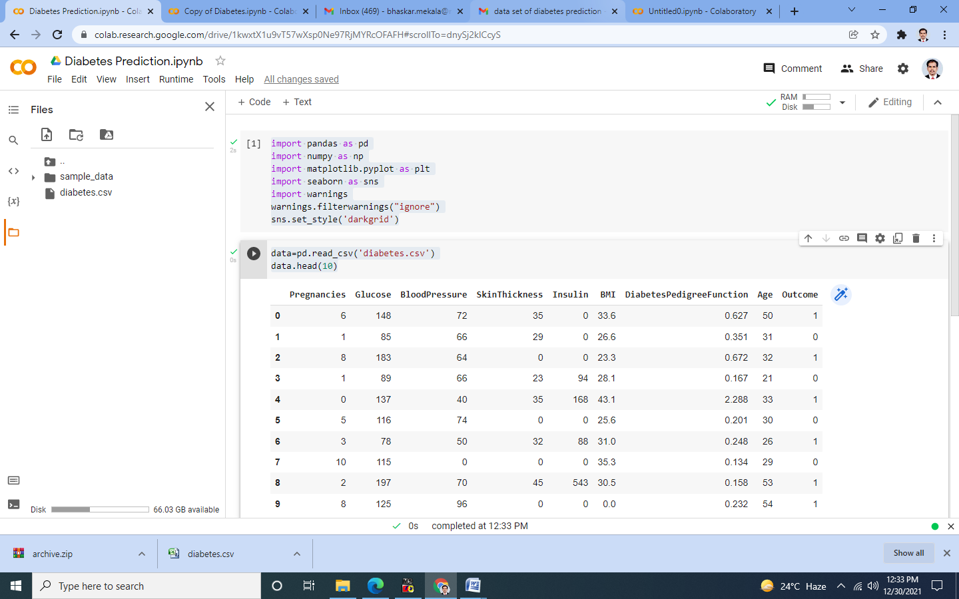

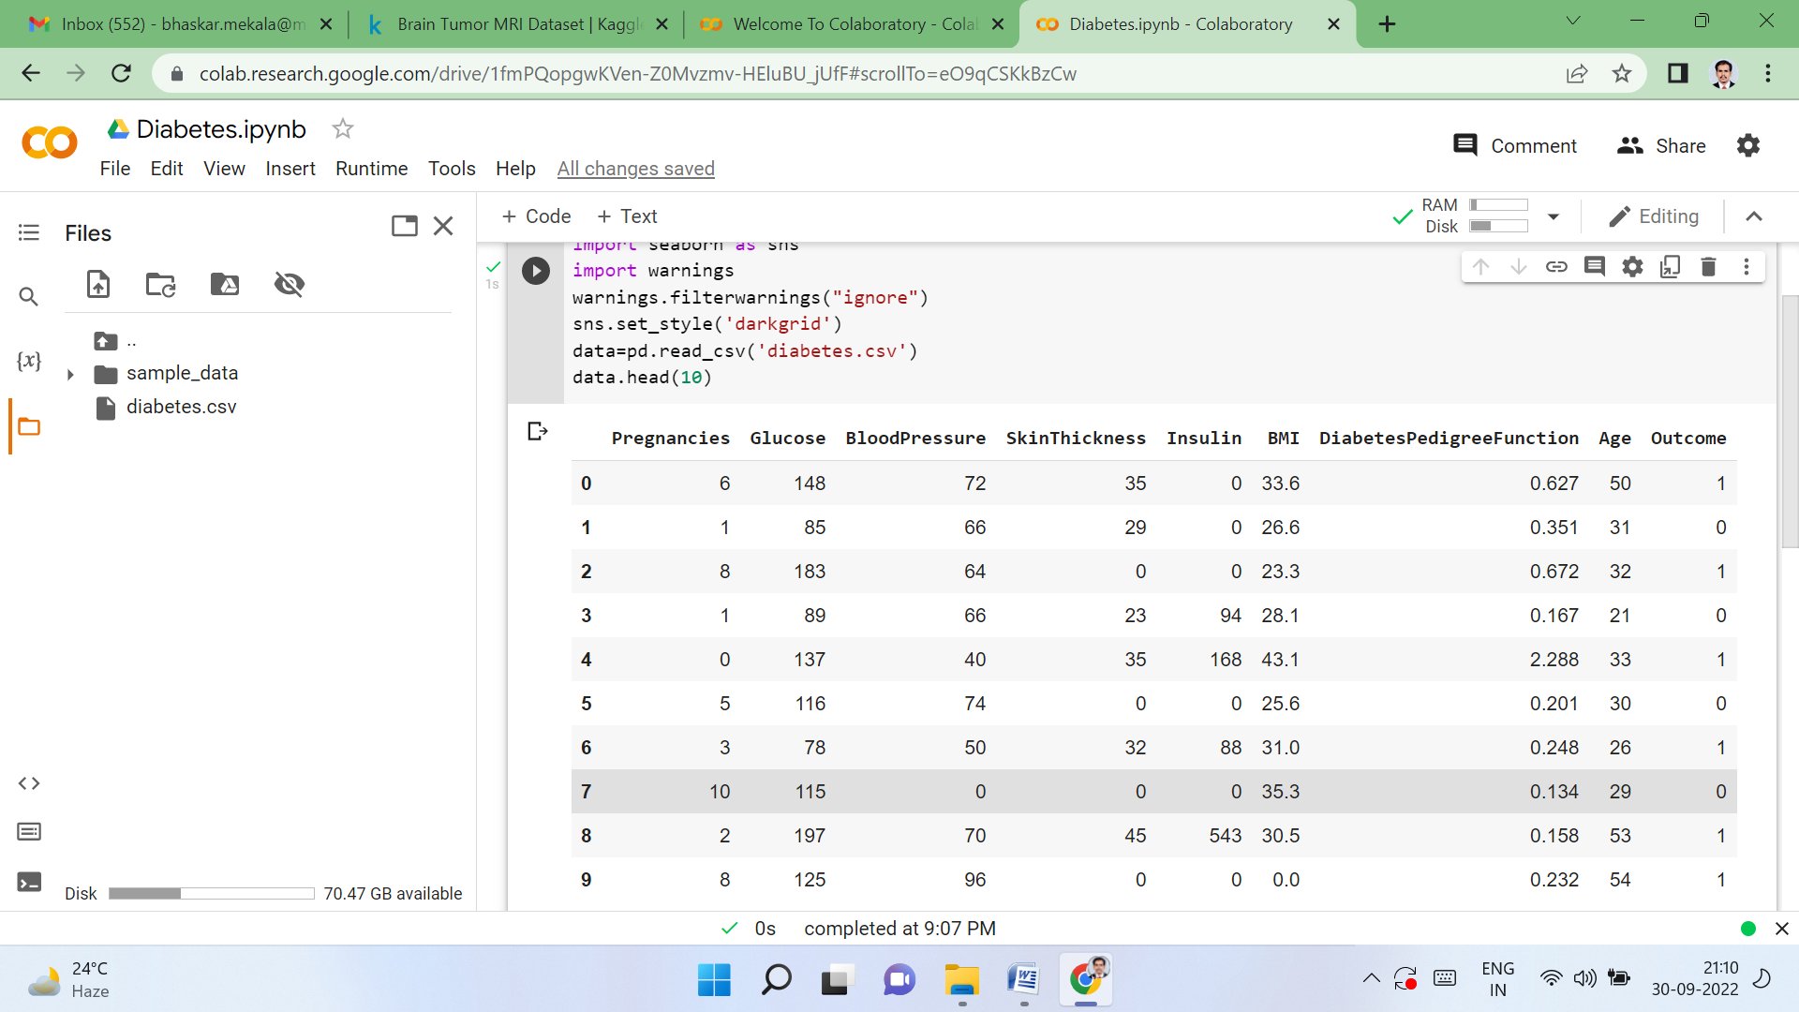

Step 8: Visualization of 9 Attributes.
plt.figure(1)
plt.subplot(121),sns.distplot(data['Glucose'])
plt.subplot(122),data['Glucose'].plot.box(figsize=(16,5))
plt.show()

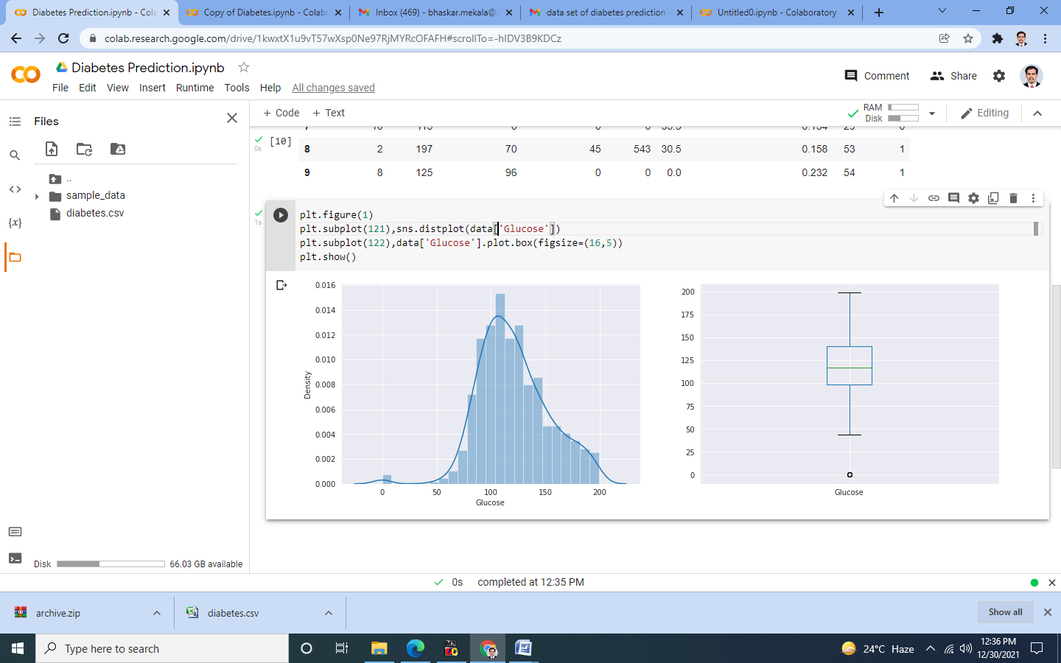
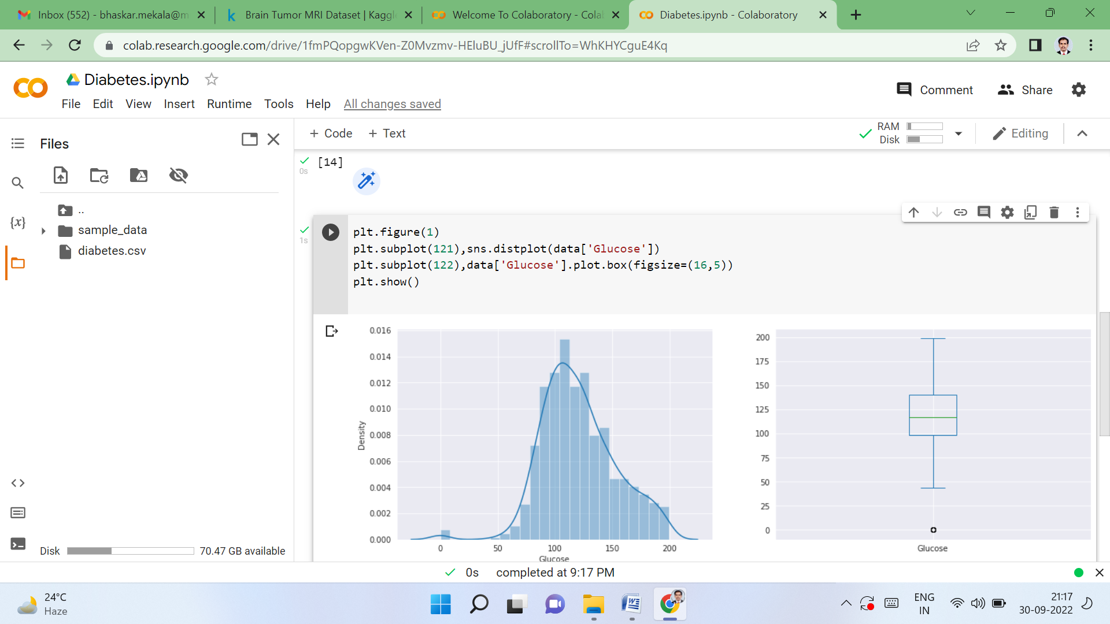

plt.figure(7)
plt.subplot(121),sns.distplot(data['Insulin'])
plt.subplot(122),data['Insulin'].plot.box(figsize=(16,5))
plt.show()
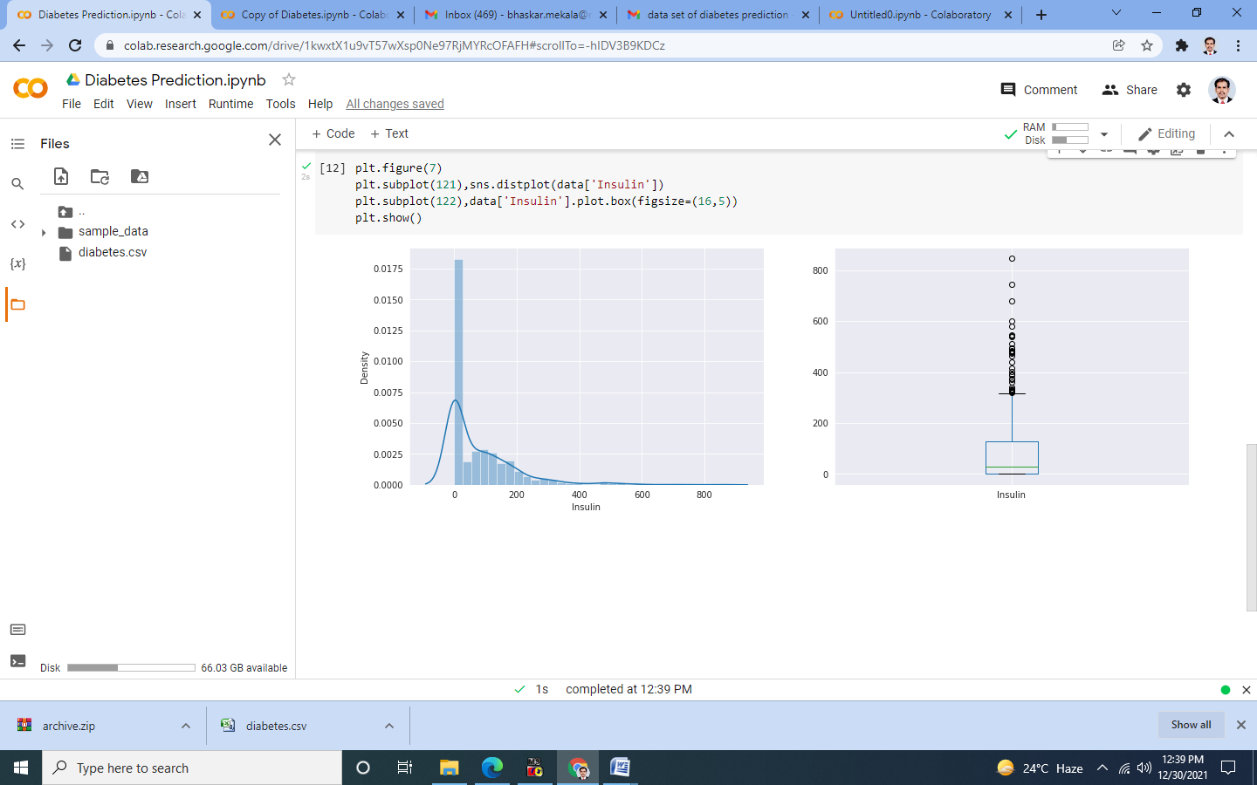

Step 9: Generating Correlation Matrix.
data.corr()
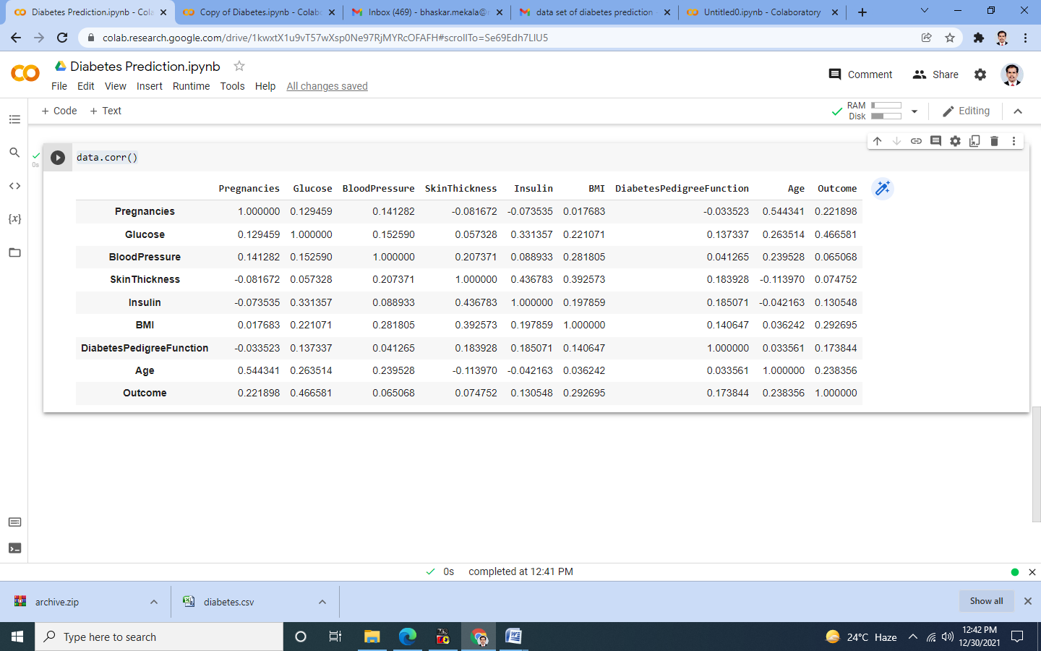

Step 10: Generating HeatMap.
matrix=data.corr()
ax=plt.subplots(figsize=(9,6)),sns.heatmap(matrix,vmax=.8,square=True,cmap="coolwarm")
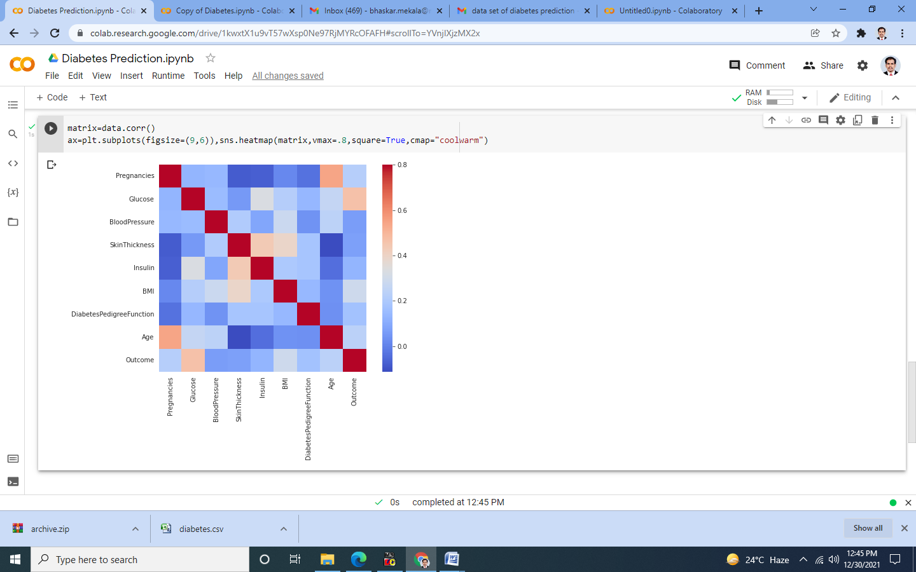

Step 11: Train the model.
from sklearn.model_selection import train_test_split
x_train,x_test,y_train,y_test=train_test_split(x,y,test_size=0.3,random_state=101)

Step 12: Build the model (XGBoost).
from xgboost import XGBClassifier
xgb_model =XGBClassifier(gamma=0)
xgb_model.fit(x_train,y_train)

Step 13: Predicting the accuracy of the model.
from sklearn import metrics
print("Accuracy Score =",format(metrics.accuracy_score(y_test,xgb_pred)))
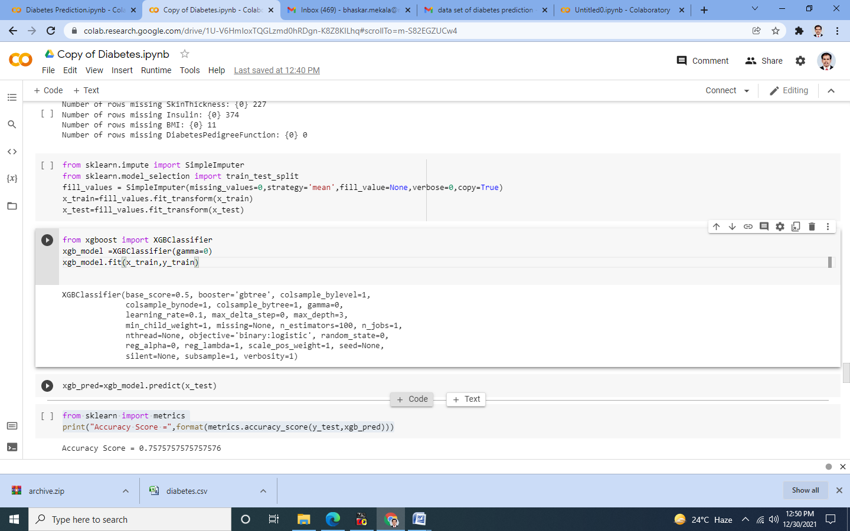

Step 14: Finding the metrics for XGBoost.
from sklearn.metrics import classification_report,confusion_matrix
print(confusion_matrix(y_test,xgb_pred))
print(classification_report(y_test,xgb_pred))
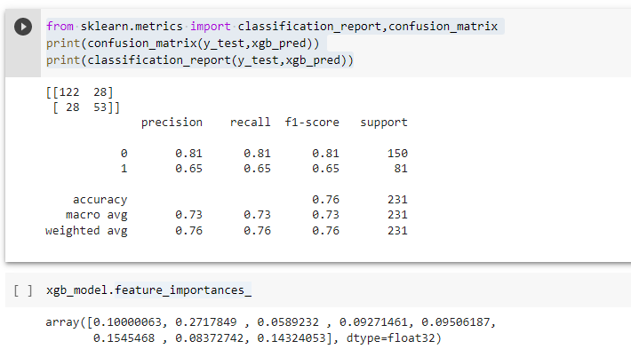

Step 15: Predicting the Possibility of a Patient having Diabetes.
print('Prediction Probabilities')
xgb_model.predict_proba(x_test)

