REVIEW II PROJECT REPORT
NoSQL Database Systems

ResearchIQ A Polyglot NoSQL Architecture for AI Driven Research Intelligence
Review of the implemented ResearchIQ baseline, the NoSQL migration design, and experiments completed to date
Name | Registration Number
Gursharath G V | 23BCE1825
Vinayagam Bharath | 23BCE1812
Pranavesh A | 23BCE1842

Course Details | Value
Course | NoSQL Database Systems
Faculty | Manjula V
Slot | D1 plus TD1
Review | Review II
Submission Date | 24 September 2026

This report documents the completed ResearchIQ baseline and the planned migration from SQLite and in-memory structures to a MongoDB and Neo4j polyglot persistence layer.

1 Project Overview
ResearchIQ is an MCP powered research intelligence platform that retrieves academic papers and implementation repositories, turns the retrieved material into AI assisted research outputs, and presents the results through a React interface. The running application uses a FastAPI backend, live ArXiv, Semantic Scholar and GitHub connectors, Groq hosted Llama 3.3 70B generation, a lightweight retrieval context store, and NetworkX based graph construction.
Review I proposed a persistence redesign rather than a replacement of the existing research workflow. The intended design assigns flexible, heterogeneous research records to MongoDB and relationship intensive citation and knowledge graph records to Neo4j. This Review II report therefore records both the fully implemented baseline and the migration and benchmarking work that remains.

2 Objectives From Review I
Objective 1
To design and implement a polyglot NoSQL persistence layer for ResearchIQ: MongoDB for heterogeneous semi structured research metadata, including papers, authors, repositories, chat sessions and research history; and Neo4j for citation and knowledge graph relationships. The new layer is intended to replace the current SQLite persistence model.
Objective 2
To empirically compare query performance, scalability and schema flexibility of the proposed document plus graph NoSQL design with the original relational SQLite model for multi source aggregation, citation network traversal and knowledge graph queries.

3 Current Implementation Scope
Layer | Implemented Capability | Evidence in Current Project
Frontend | React Vite single page interface | Eight user views: Discover, Review, Survey, Gaps, Compare, Chat, Roadmap and History.
Application API | FastAPI routes and Pydantic request models | Endpoints support discovery, citation retrieval, generated outputs, comparison, chat and history.
External data | ArXiv, Semantic Scholar and GitHub connectors | Asynchronous HTTP retrieval; paper records are normalised and duplicate titles are removed.
AI processing | Groq hosted Llama 3.3 70B | Literature review, survey, gap detection, paper comparison, chat answers and roadmap generation.
Graph and retrieval | NetworkX graph plus lightweight RAG context | Topic, paper, author and repository nodes; an in memory keyword overlap retrieval store.
Persistence | SQLite history database | Searches and generated reports are written as SQLite records with JSON payload fields.

4 System Architecture
The architecture below distinguishes the verified baseline from the proposed NoSQL persistence layer. Solid paths represent components that are present in the repository. The dashed MongoDB and Neo4j paths capture the Review I design and should not be interpreted as completed database integration.
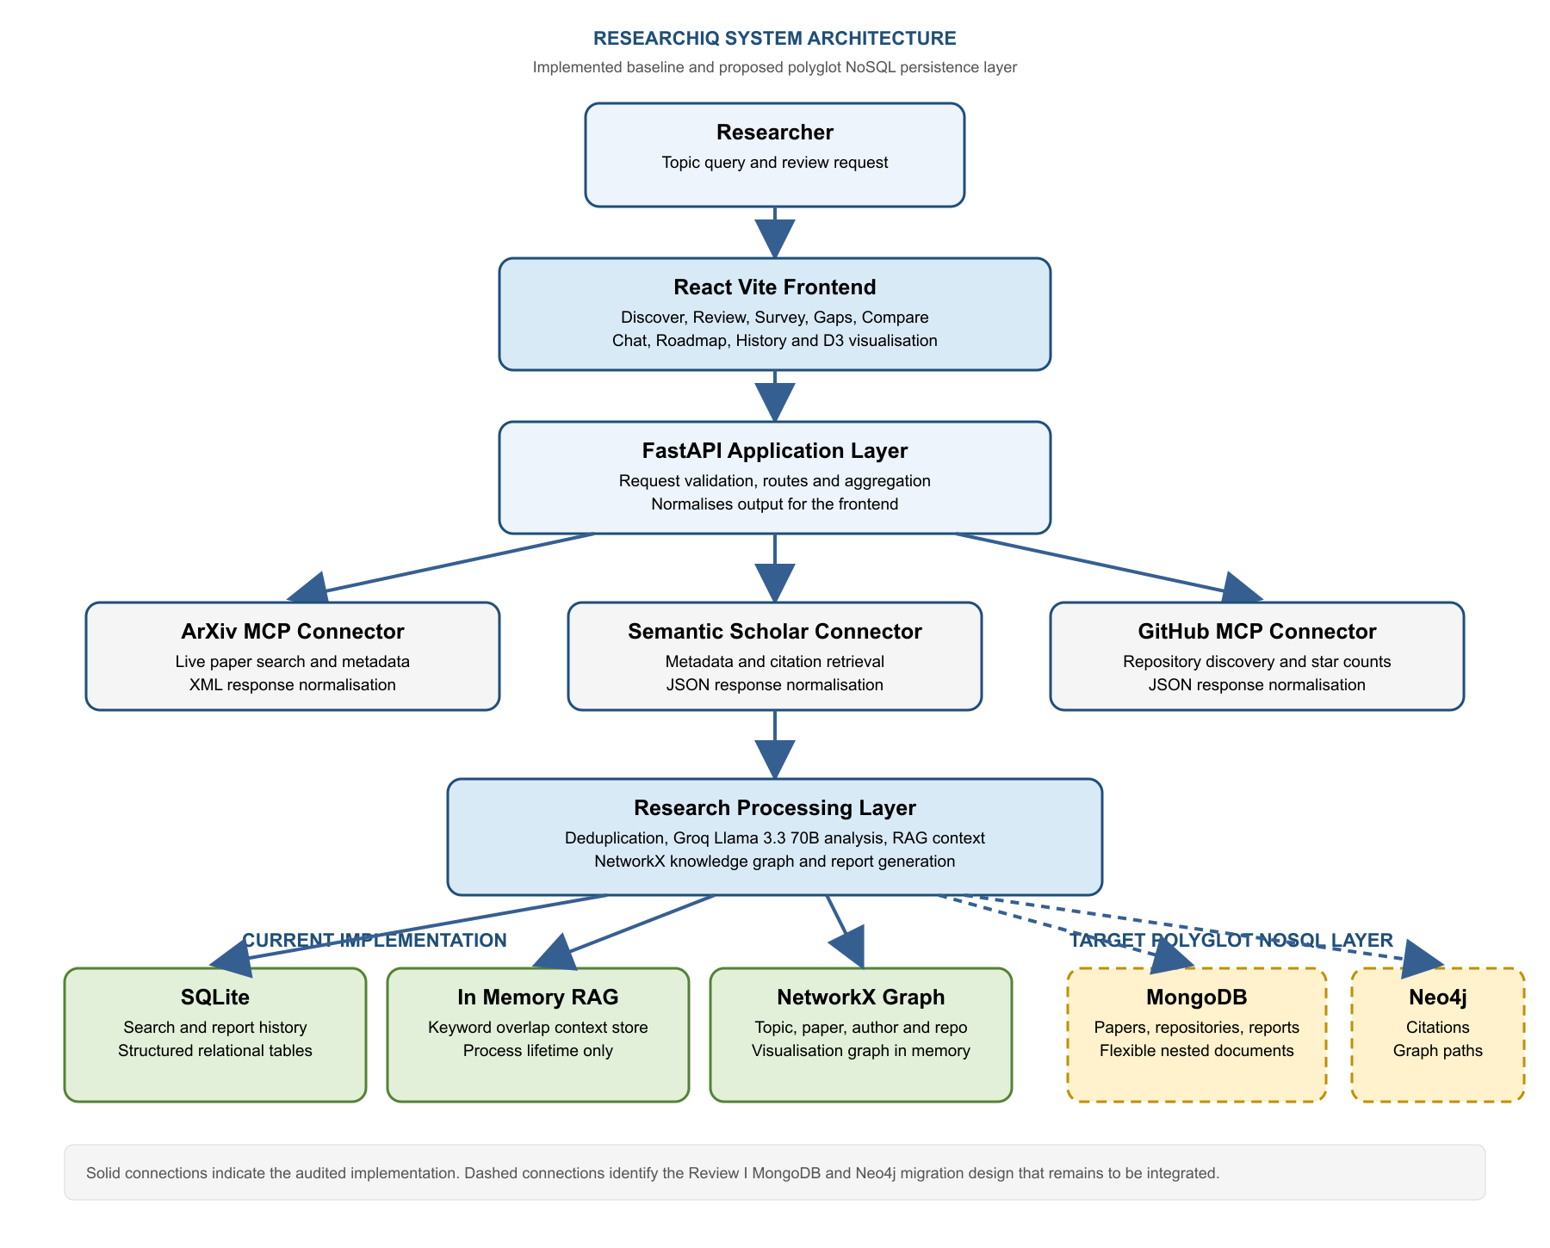
Figure 1. ResearchIQ architecture showing the current baseline and the target polyglot NoSQL persistence layer.

4.1 Data Placement Strategy
Data or Query Need | Current State | Target Store | Reason
Paper and repository metadata | SQLite and in memory records | MongoDB | Flexible nested fields from different sources and easy addition of new attributes.
Generated reviews surveys gaps and roadmaps | SQLite reports table | MongoDB | Variable length generated content and attached source lists fit document records.
Search history and chat sessions | SQLite searches table and process context | MongoDB | Session oriented nested history is better represented as documents.
Citation authorship topics and implementations | NetworkX graph in process memory | Neo4j | Persistent labelled property graph enables multi hop traversal and Cypher queries.

5 Experiments Conducted To Date
The completed work is functional prototype validation of the existing ResearchIQ workflow. It establishes the baseline and observable data paths required before the NoSQL migration benchmark. Numerical MongoDB Neo4j versus SQLite timings have not been recorded because the MongoDB and Neo4j adapters are not yet integrated.
Experiment | Protocol and Model | Result Obtained
E1 Multi source research discovery | Submit a topic through the Discover view. Query ArXiv and Semantic Scholar with asynchronous connectors; query GitHub for repositories; merge paper lists by normalised title. | The backend returns a unified paper list, related repositories, RAG count and a graph payload for the interface.
E2 AI research outputs | Retrieve topic papers, construct a bounded paper context, and invoke Groq Llama 3.3 70B. Dedicated prompt templates request a literature review, survey, five gaps, comparison JSON, chat answer or roadmap JSON. | The project contains callable endpoints and frontend views for each output type. Generated reviews, surveys, gaps and roadmaps are stored in report history.
E3 Knowledge graph construction | Create a directed NetworkX graph from the topic, retrieved papers, the first two authors per paper and GitHub repositories. Compute degree centrality and send node link data to D3. | An interactive graph visualisation is available. Citation retrieval also builds a separate cited by and references graph from Semantic Scholar data.
E4 Baseline persistence assessment | Inspect the database service and exercise the normal route flow conceptually: search results are saved as a search record and generated content is saved as a report record. | SQLite provides the current persistence baseline. Searches and reports are persisted; the RAG store and NetworkX graph remain process local.

5.1 Planned Comparative Benchmark Protocol
- Collect the same 500 to 1000 paper dataset for four to five research topics using the existing three live connectors.
- Load the dataset into SQLite, MongoDB and Neo4j using matched data preparation rules and record dataset size and loading time.
- Repeat each operation multiple times: topic or author filter, bulk ingestion, two hop citation traversal, three hop citation traversal and graph visualisation query.
- Report mean latency in milliseconds, ingestion throughput, growth trend from 100 to 1000 plus papers and the migration effort needed to add a field such as repository star count.

6 Procedures Followed And Results Obtained
Step | Procedure Followed | Observed Result
1 | The user provides a research topic in the frontend. The request is sent to the FastAPI API layer. | A typed request model receives the topic, sources and requested maximum number of results.
2 | The API calls ArXiv and Semantic Scholar for papers and GitHub for related implementation repositories. Returned fields are transformed into a common record shape. | A single response supplies title, summary, authors, year, URL, source and available citation data, alongside repository metadata.
3 | Paper records are deduplicated using a normalised title prefix. The retrieved papers are added to the context store. | Repeated results from different providers are reduced before graph construction and AI prompting.
4 | The application constructs a NetworkX directed graph and serialises it in node link form. The D3 component renders zoomable and draggable nodes. | The user can inspect paper, author, topic and repository relationships in the knowledge graph view.
5 | For review, survey, gaps, comparison, chat and roadmap requests, the backend passes a bounded research context to Groq Llama 3.3 70B through prompt templates. | The system produces research oriented text or structured JSON responses for the corresponding frontend page.
6 | Searches and generated reports are written to the SQLite history database. Reports can be listed and retrieved through API routes. | The current baseline has persisted search and report history, which becomes the direct reference point for the NoSQL migration.

6.1 Interpretation of the Current Results
The implemented application demonstrates the end to end research intelligence workflow needed for the database study: live multi source ingestion, normalisation, AI analysis, graph generation and history persistence. It also exposes the specific storage limitations that motivate the design: SQLite stores heterogeneous payloads as JSON text, the retrieval store disappears when the process ends, and graph relationships are rebuilt in memory rather than retained for traversal across sessions.
The current evidence supports the baseline implementation portion of the Review II milestone. The next implementation phase is to introduce a database service abstraction with MongoDB and Neo4j drivers, migrate the selected records and graph edges, and execute the matched benchmark protocol above.

7 Demonstration Evidence
The project repository includes captured interface outputs for the implemented workflow. The following figures show representative user facing evidence of multi source discovery, knowledge graph visualisation and AI assisted literature review.
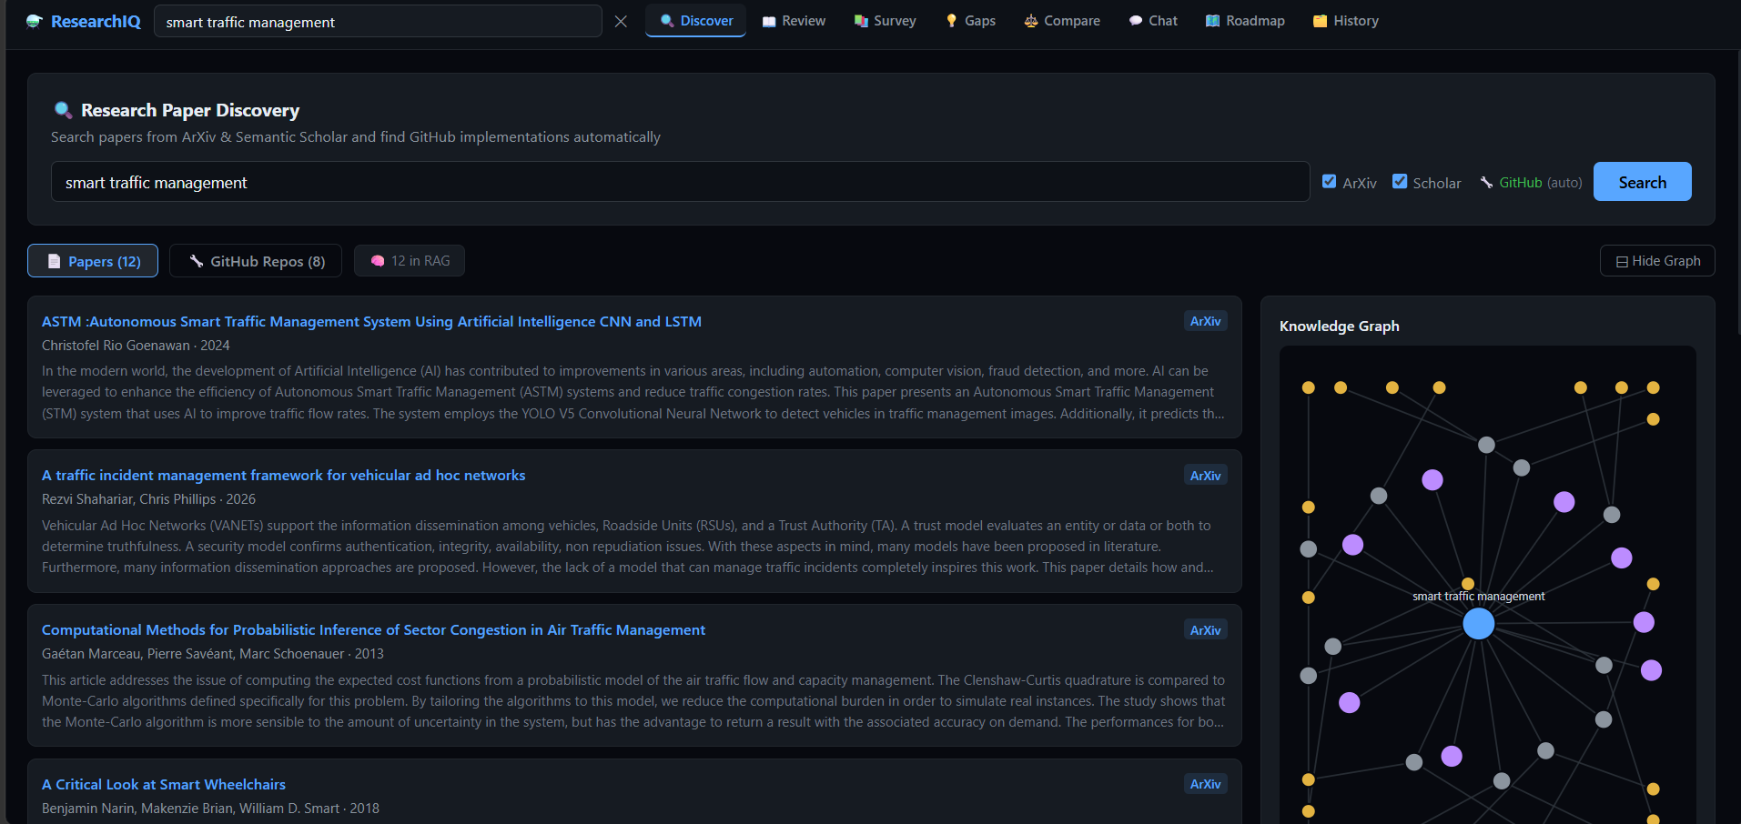
Figure 2. Research Discovery interface showing search controls, unified paper results, repository discovery and a RAG count.

7 Demonstration Evidence Continued
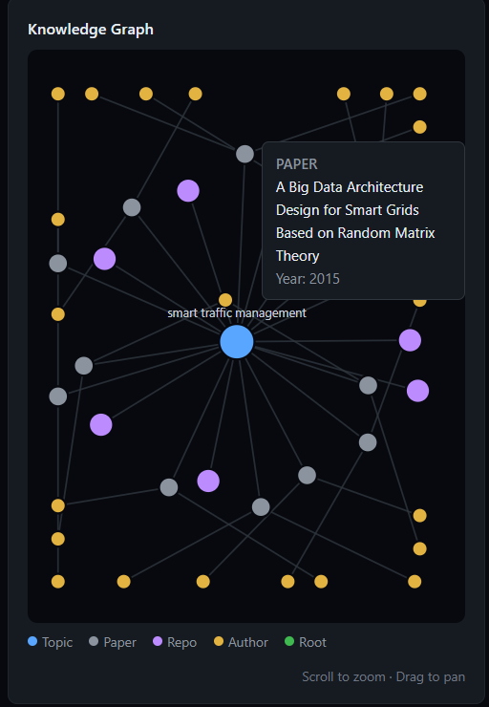
Figure 3. Knowledge Graph visualisation produced from topic, paper, author and repository data.

7 Demonstration Evidence Continued
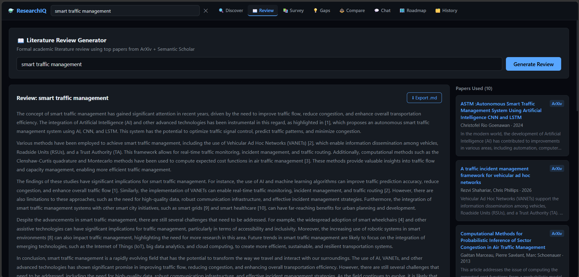
Figure 4. Literature Review interface used to generate an AI assisted, paper grounded review.

8 Implementation Status And Next Phase
Work Package | Status at Review II | Next Action
Core ResearchIQ application | Implemented | Use as the stable workload and user interface for migration validation.
Live data ingestion and output generation | Implemented | Use the same connectors and normalisation rules when loading benchmark datasets.
SQLite baseline | Implemented | Populate with the matched benchmark dataset and capture timing measurements.
MongoDB document persistence | Designed | Add MongoDB driver, document schemas and repository operations for metadata, reports and history.
Neo4j graph persistence | Designed | Add Neo4j driver, node and relationship mapping, Cypher traversal queries and persistent graph retrieval.
Empirical comparison | Planned | Run matched workload repetitions and publish latency, throughput, scaling and schema change results.

9 Conclusion
ResearchIQ has a complete working baseline for the intended study. It retrieves and integrates live scholarly and repository data, generates AI assisted research outputs, visualises research relationships and preserves search and report history. The proposed MongoDB and Neo4j architecture is aligned with the application data characteristics: document storage for variable research records and graph storage for citation and relationship queries.
At this review stage, the evidence supports the baseline workflow and the migration design. MongoDB and Neo4j persistence and the resulting performance measurements are the defined next deliverables. Keeping this distinction explicit allows the subsequent benchmark to be reproducible and avoids presenting projected NoSQL advantages as measured results.

10 One On One Demonstration Plan
- Enter a research topic and demonstrate multi source discovery from ArXiv, Semantic Scholar and GitHub.
- Open the generated knowledge graph and explain the topic, paper, author and repository relationships.
- Generate a literature review or survey and show the paper context used by the feature.
- Show report and search history to demonstrate the SQLite baseline persistence layer.
- Use Figure 1 to explain how MongoDB and Neo4j will replace the relevant baseline storage responsibilities before the comparative benchmark.

