Demo Class :

SAP ERP ---> SAP ECC or SAP S4HANA

SAP FICO
SAP MM
SAP SD
SAP PP
SAP HR .....

Travel from Hyd to Bangalore

1. Own Car
2. High Speed Train

Own Car: (On PRemise)
1. Buy Car ---> Customer
2. Infrastructure --> Customer
3. Fuel ---> Customer
4. Driver ---> Customer
5. Maintainance/Upgrade --> Customer
6. Failures ----> Customer
7. Travel cost ---> Customer

Train: (Cloud)
1. Buy Train ---> Vendor
2. Infrastructure --> Vendor
3. Fuel ---> Vendor
4. Driver ---> Vendor
5. Maintainance/Upgrade --> Vendor
6. Failures ----> Vendor
7. Travel cost ---> Customer

SAP XI 3.0 Dual Stack (ABAP and JAva Engine)
SAP PI 7.0
SAP PI 7.1
SAP PI 7.2
SAP PI 7.3 Dual System(ABAP System and JAVA System)
SAP PO 7.4 Single Stack ( JAVA)
SAP PO 7.5

PO support from is ending in 2027 and extended suport 2030

Cloud :

SAP HCI -- 2015
SAP CI
SAP CPI
SAP BTP Integration Suite -- Web UI

70% ---- SAP

OIC
Mulesoft ---> Cost
Dellboomi --->
Workato

Cloud Models :

IAAS -- Infrastructure as a Service --S4 HANA
PAAS -- Platform as a Service --> SAP CPI
SAAS -- Software as a service ---> SAP C4C / SF

PUser/SUser :
Integration --->
Dev ----> Build -->Dev subaccount
QA ----> Testing --> QA subaccount
Prod ---> Live Environment --> Prod subaccount

PUserID --> Personal User ID
SUserID --> SAP MarketID

Examples :
P1695659001
S1695659001

SF -🡪 HR Related system / operation .. HR Management
Eg : Recruitment , Payroll , Termination , Leave Cycles , Bank Details

Package : Its like a folder or a container which holds multiple artifacts
Iflow : Step by Step process from the Start to End i.e from Source system to Target System which includes Business rules / Logic..

Message : A data that is processed from Source to Target

DesignTime Node & RunTime Node :

DesignTime Node : It is the place where we will create or configure the artifacts
RunTime Node : Actual message that is being processed will be via this node

Whenever we deploy it will move from Design Time to Runtime Node

Creating Service Key :
Step1: go to BTP Cockpit and go to instances and subscriptions
Step2: Click on Create and Create an Instance with service “SAP Process Integration Runtime” and plan as “integration-flow” and give alias name.
Step3 : Click next and click on Create. This will create a service Instance
Step4: open Service Instance and click on Create Service Key with alias name.

Content → Headers + Properties + Body

Content Modifier —> If we want to modify the content or payload or body .
CM has another 2 parts apart from the body

Header : It is a variable that will be transferred / will go Target system.
Eg : Authorization , Content-Type
Property : It is a variable that will be used within the same flow

CPI is built on Apache Camel Framework

Data Format :
XML
JSON
CSV

XML Payload

<EmpData>
<EmpInfo>
<EmpiD>123</EmpiD>
<EmpName>Pavan</EmpName>
<Desg>Developer</Desg>
<Company>Infosys</Company>
</EmpInfo>
<EmpInfo>
<EmpiD>456</EmpiD>
<EmpName>Somi</EmpName>
<Desg>Tested</Desg>
<Company>LTM</Company>
</EmpInfo>
</EmpData>

Element : Any variable or any tag is considered as an element
Node : Any element has one or more element inside is considered as Node
Field : Any Element which has a value is considered as Field

Prerequisite for XML:
XML should always have a root tag and root tag should occur only once

JSON :
{
"EmpData": {
"EmpInfo": [
{
"EmpiD": "123",
"EmpName": "Pavan",
"Desg": "Developer",
"Company": "Infosys"
},
{
"EmpiD": "456",
"EmpName": "Somi123",
"Desg": "DevelopentManagement",
"Company": "IT"
}
]
}
}

XPath —> If you want to fetch a particular filed value from an xml content

Local Variable —> It is a variable which is stored outside the iflow so we can reuse the variable in other messages as well
How to store the value in Local Variable
- Persistence —> Write Variables → Give the details
Where do we see Local Variable :
Monitor Tab → Manage Stores → Variable
How to read the value from Local Variable

Content Modifier :

Types of Source Types :
XPath —> If you want to fetch a particular filed value from an xml content
Constant → Static / Fixed Values
Expression → to read some standard Camel expression provided by SAP
Variables –
Local Variable —> It is a variable which is stored outside the iflow so we can reuse the variable in other messages as well and only used in same Iflow
Global Variable —> It is a variable which is stored outside the iflow so we can reuse the variable in other messages as well and also in other Iflows as well
Header → For reading header
Property → for reading a property

How to Create a Local Varibale →
Pallent fn → Persistence → Write Variable → Give the details

Where you can view Local Variables →
Monitoring Tab → Manage stores → Variables

How to Read Local Variables →
Content Modifier → Source Types as Local Variable

Participants:

Sender → For connecting from any Source system to CPI
Receiver —> For connecting to any target from CPI

Process :
Main Integration Process —> This is the process from where CPI will receive the message or trigger an Iflow will start from this process
LocalIntegration Process → To achieve some common functionality or unique functionality or reusable functionalities can be configured in LIP . The reason is the simplify the flow and make it more readable kind of thing.
Exception SubProcess —> One type of Error Handling mechanism where in case of an error what action needs to be performed like Alert Email notification.

Call From / where | Main Integration Process | Local Integration Process | Exception SubProcess | How many Times | External system
Main Integration Process | No - excluding adpaters | No - excluding adpaters | No - excluding adpaters | Number of times | Yes
Local Integration Process | Yes | Yes | Yes | Number of times | No
Exception SubProcess | Yes | Yes | No | Number of times | No

Steps to connect to Gmail Server :

- Go to your Manage Google Account section.
- Search for App Passwords and click on app Passwords
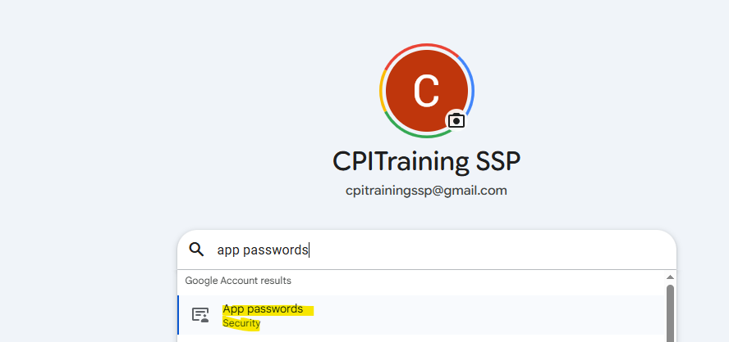
- Create an App Password and copy that password somewhere.
Note: Once app Password is created we cannot retrieve again

- Configure a security material in Monitor → ManageSecurity → Security Material for creating an username and password of gmail server. Click on create user credentials and then give gmail id as username and password as App Password.

Security Material → a Place where all the credentials are stored

Events :
Start Message Event —> This is the event used for starting the integration. CPI Iflow will always read the message from Source system via StartMessage
End Message Event→ this is the event used for ending the integration flow. It is also used to send the data to target system.
Start Event → Event used to start the LIP
End Event → Event used to end the LIP
Error Start Event → Event used in Exception SubProcess and where any error is received
Error End Event → Event used in ESP and status will be failed
Escalation End Event → event used to escalate any message inbetween
Terminate Message → If you want to Terminate the message inbetween instead of processing further
Timer —> Scheduling of the Iflow or Self trigger of the iflow

Use of Event in | Main Integration Process | Local Integration Process | Exception SubProcess
Start Message Event | Yes | No | No
End Message Event | Yes | No | Yes
Error Start Event | No | No | Yes
Error End Event | Yes | Yes | Yes
Start Event | No | Yes | No
End Event | Yes | Yes | No
Terminate Message | Yes | Yes | No
Escalation End event | Yes | Yes | Yes
Timer event | Yes | No | No

POC for Weekend :
Scenario1 :

- What if escalation event is used in Local Integration Process , Will it go back to the Main Integration process ?
- What if Terminate Message is used in Local Integration Process , Will it go back to the Main Integration process ?

POC :

Suppose if we have failure in LIP will the ESP of MIP ?

Message status :
Completed → If the message is successful or processed End to End
Failed —> Any message which is errored out
Processing → Any message that is still running
*Escalated —> If the Iflow is using escalation end event or custom status indicating an error which requires attention.
*Abandoned → Any message that is in Processing status, if we deploy / undeploy then status is changed to Abandoned
Retry – >If we are using JMS adapter then is the message is failed and JMS is trying to resend the message then this status will come.
Cancelled → if the message is in Retry mode and if we are deleting the message from the JMS queue.
*Discarded —> If we are using TimerEvent , then message will get process via one Runtime node then for other runtime nodes the message status will be discarded.

LogLevels :

All the Logs that are visible are only present for 1month .. After 1 month logs will be deleted.

None → No MPL logs will get created even if the message is getting processed
Info → MPL Log will get generated whenever a message is processed .
Error → Only when the message is Failed then only the MPL Log will get created.
*Debug → To debug the message how its getting processed . This status will be enabled for 24hours and after 24hrs this will revert back to previous status.
*Trace —> To read the message content at each and every step . This status will be enabled for 10mins and after 10mins this will revert back to previous status. Trace mode will be active for 1hour to see the message content.

**SFTP Connection:
- We need to get the Hostname , port
- Go to Connectivity Test —> SSH —> Enter host and port and click on Next
- Copy the Host key .
- Go to Security Material → Create Known hosts and update the known host with the copied Host Key .
- For Authentication , Basic Auth ,Public Key Based authentication and Dual Authentication
  - Basic Auth : go to Security Material and create a User Credentials
  - Public Key Based Authentication : Go to KeyStore → Create New Key pair/ssh key certificate. Once created download Public OpenSSHKey and share with SFTP team
  - Dual Authentication : combination of Public key based and Basic Authentication

Router → To Route the message to one direction based on a condition

Multicast : To Route the same message to multiple branches
2 Types of Multicast :
Parallel Multicast →To Route the same message to multiple branches at the same time
Sequential Multicast → To Route the same message to multiple branches in sequence i.e one by one

Scenario :

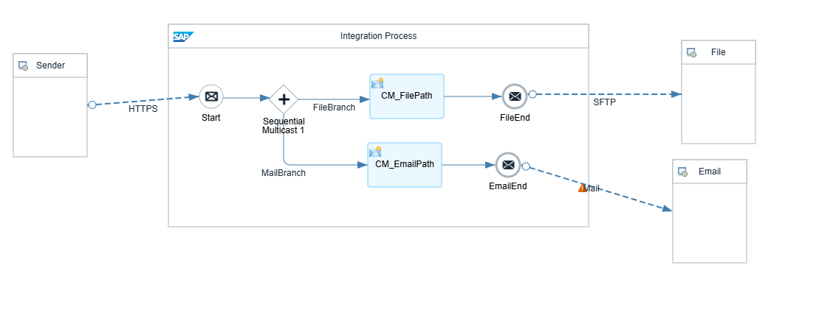
*POCs on above scenario :
- In Parallel Multicast , If the SFTP connection is failing Will the message goes to Email Path ?--> Yes
- In Sequential Multicast , If the SFTP connection is failing Will the message goes to Email Path ? → No
- In Parallel Multicast , In CM_FilePath we created a property or header and can we use that property in CM_EmailPath? →No
- In Sequential Multicast , In CM_FilePath we created a property or header and can we use that property in CM_EmailPath? →No

Splitters:
General Splitter → If we want to split the data based on XPath Condition or linebreak into multiple messages but with the root tags then we go with Splitter
Iterating → This will also split the data into multiple messages but this will not give the root tags
IDOC Splitter → If we want to split multiple IDOC to multiple messages then we got with IDOC Splitter
EDI Splitter → Split the EDI messages into multiple messages
PKCS Splitter → If the Payload is encrypted with PKCS format and if you want to split the PKCS format messages to multiple messages
Zip Splitter → When you have a zip file with multiple messages and we want decompress that zip file and send each payload as separate message
Tar Splitter → When you have a tar file with multiple messages and we want decompress that tar file and send each payload as separate message

Gather → It is used to combine multiple messages to a single message
Join → It is used to join multiple branches to single branch but it will not combine the messages.

Where is Gather will be used .
Scenario1 : When we are using splitter and if you want to combine the request or response to a single message
Scenario2 : When we are using multicast and if you want to combine the data from all branches then you will use Join and Gather together

Different Combining algorithms available in Gather:

XML (SameFormat)
Combine → If you want to combine both the same xml files as it is with the root node and also it will get combined with the Messages tag as a root element.
Combine at XPath → If you want to combine both the same xml files at a particular xpath .
Tar→ This will combine multiple files into single Tar file
Zip → This will combine multiple files into single zip file

XML(Different Format)
Combine → If you want to combine both the different xml files as it is with the root node and also it will get combined with the Messages tag as a root element.
Tar→ This will combine multiple files into single Tar file
Zip → This will combine multiple files into single zip file

PlainText
Cancatenate → It simply appends the 2 string data as it is
Tar→ This will combine multiple files into single Tar file
Zip → This will combine multiple files into single zip file
Any
Tar→ This will combine multiple files into single Tar file
Zip – > This will combine multiple files into single zip file

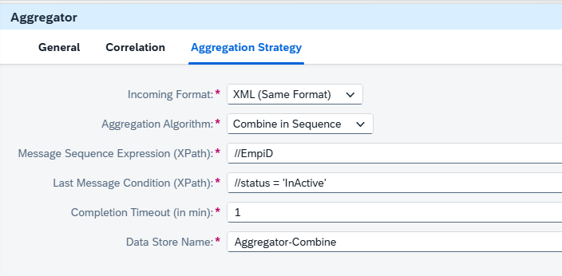--------------------------------------------

POC :
Test the below data with the above Configuration :
Tester--6 → Active
Tester--9 → Active
Tester--8 → Active
Tester--1 → InActive —--> Error
Tester--3 → Active
Tester–5 → Active

Aggregator : If we want to combine multiple messages to a single message by segregating the data based on correlation ID and it will combine till Completion timeout or Last Message Condition whichever comes first .
Options :
Combine → Which will combine the data in the same order that it came
Combine in sequence → Which will combine the data in sequence order

Completion TimeOut → Which is used to combine the data till this particular time
Last Message Condition → This message should always be the last message in the combined payload

POC : Use zip Compression and place a zip file in an SFTP server but the Filenames should be like
EmpInfo.zip and inside the zip file the file name should be employeeDetails.xml

POC2 : Use Zip decompression and decompress the zip file but this time read both the zip file and the compressed filenames as an header

DataStore :
DataStore → To Store the data temporary in cpi we use data store . basically for storing large payloads we prefer Data store

Write → To write the payload to datastore
Delete → To delete the entry from the datastore
Get → To fetch any particular entry from datastore
Select → To fetch bulk messages or multiple entries from datastore

MessageDigest : To generate a hash code/function of the payload and store it in Header.
Use Case : If you want to make sure the content that is sent from CPI same has been reached the target system.

XML Modifier : To Remove the xml declaration tags.

Filter : If we want to filter out the xml content based on a condition then we go with Filter

Encoder → Used to encode the data i.e sending the data in unreadable format
Decoder → Used to decode the data
Zip Compression → If we want to compress the payload as a zip format.
Zip Decompression → If we want to decompress the file or unzip the file
Note : Above compression and decompression only works when it is having only single payload / file

Encryption

If we want to encrypt the payload with a key then we go with encryptor
If target wants to decrypt the data they will use same key.

- For encryption , We use Public Key
- For Decryption , We use Private key

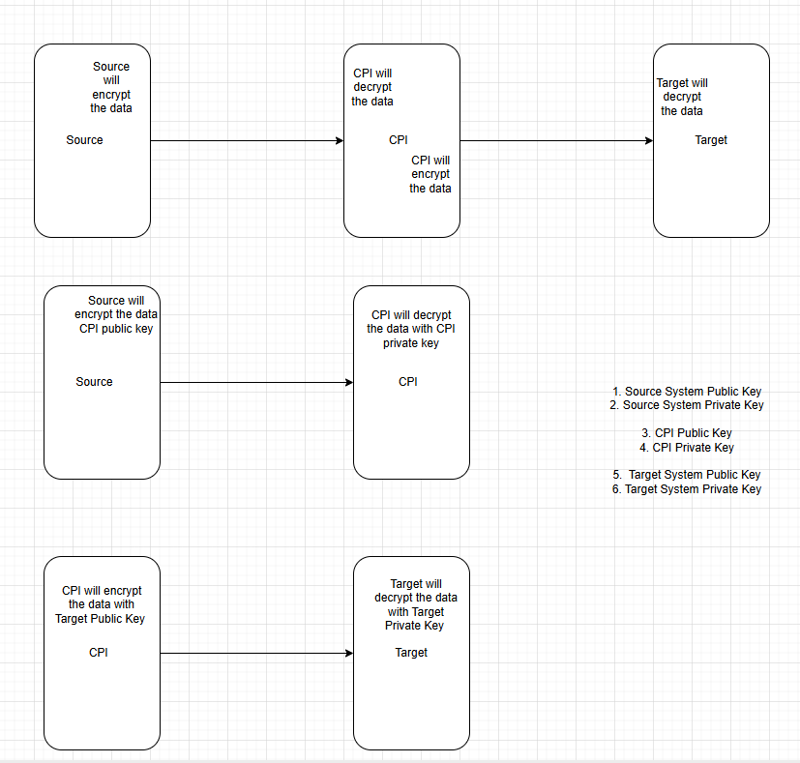

Steps to Create PGP Key pair in SAP CPI :
- Download a 3rd party tool like gpg4win and install kleopatra.
- Once kleopatra is installed , we need to click on File → New Open PGP Key Pair
- Give name and email , Also check the checkbox called “Protect Key with Password phrase”. Then on advanced options select key Material as “rsa2048”
- A key will get generated , Now right click and select export which will download the public Key and also right click and select export backup keys which will download the private Key .
Note: Make sure to have the password handy

Signer → If you to digitally sign the message content so that you can validate the message is coming for valid source
Verifier→ This will verify the message content is valid

- For Signer, We use Private Key
- For Verifier, We use Public key

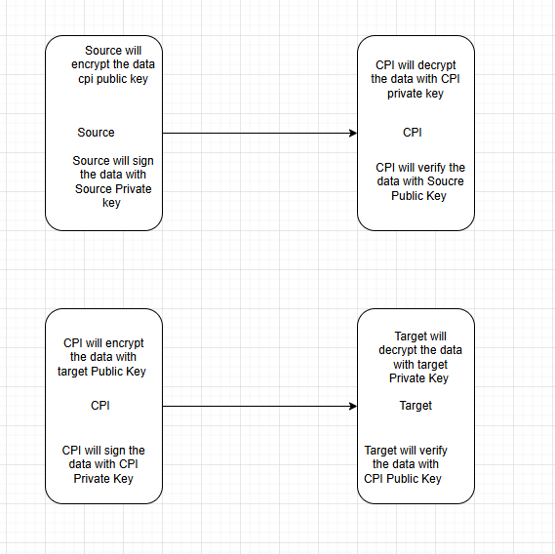

Mapping Functions :

SAP Reference Blog : https://help.sap.com/saphelp_snc70/helpdata/en/2c/2d8c4024d26e1de10000000a1550b0/content.htm?no_cache=true

Arthimetic :
Add : Add 2 numbers
Subtract : Subtract second value from first one . i,e F1 - F2
Multiply : It will multiply 2 values
Divide : It will divide first value / second value i.e F1/F2
equals (Number) : Returns 'true' if both numbers are equal,otherwise 'false' .
Absolute : Return the absolute value i.e positive value
Sqrt : Return square root of the number
Square : return square of the number
Sign : Returns -1 if number is negative, +1 if it is positive, 0 if 0
Neg : Multiply with -1
Inv : Calculates 1/x
Power : Returns of value of the first argument raised to the power of the second argument
Greater : Returns 'true' if first number is greater than second, 'false' otherwise
Lesser : Returns 'true' if first number is lesser than second, 'false' otherwise
Max : Returns maximal of two numbers
Min : Returns minimal of two number
Round : Returns the closest integer to the argument
Floor: return the nearest integer value which is less than the input number
Ceil : return the nearest integer value which is greater than the input number
Count : Counts number of invocations. Initial value and increment defined by parameters

Boolean :

And : If both the inputs are true then only output will be true
OR : If any one input is true then only output will be true
Not : IF input is true then output is false. If Input is false then output is true
equals(boolean) : It will check it both the input boolean values are equal , then true else false
Notequals : It will check it both the input boolean values are not equal , then true else false
If : If the input 2 (condition) is true then it will take the 1st input (True value) else it will take the 3rd Input(false value)
IfS : If the input 2 (condition) is true then it will take the 1st input (True value) else it will take the 3rd Input(false value)
Ifwithoutelse : If the input 1 (condition) is true then it will take the 2nd input (True value) else it will suppress
IfSwithoutelse : If the input 1 (condition) is true then it will take the 2nd input (True value) else it will suppress
IsNil : It will check the field has xsi:nil attribute , If present it takes true else false

Difference between If / IFS

IF → It will evaluate both the expression i.e True or False and then it will check the condition accordingly
IFS → It will evaluate only one expression based on the condition satisified

Constant:

Constant → Static value or Fix Value
Copy value → It will just copy the single value n number of times as per the target
Xsi:nil → This will generate xsi:nil attribute

Date:
CurrentDate : Gives currentdatetime in UTC timezone only and in the specified format
dateBefore → If date1(input1) is before date2(input2) then true else false
dateAfter → If date1(input1) is after date2(input2) then true else false
dateTrans → It will convert the date field from Source format (dd/MM/yyyy) to Target Format (yyyy-MM-dd)
compareDates → This will compare date1(input1) with date2(input2) . If date1 is after date2 then it will give 1 , else if If date1 is before date2 then it will give -1 , else if both date1 and date2 are equal , it will give 0

Text Functions:
Substring →This is used to fetch a part of the String
Concat —> It is used to merge / append two string
equals(string) → It will check if the 2 strings are equal
Compare → It will compare lexicographically
replaceString → It will replace a particular pattern from a string with a replace Value
Length → It will give length of the string
endsWith → It will check if the string ends with that particular string or character
Startswith(2) → It will check if the string starts with that particular string or character from the 1st index
startsWith (3) → It will check if the string starts with that particular string or character from the specified index
ToUpperCase → It will just keep all characters to capital letter
ToLowerCase → It will just keep all characters to smaller letter
Trim → It will remove spaces from Leading(starting) or trailing(ending) but not in between
indexOf(2) → It will provide the index of the first occurrence of that particular character / string from the given input(String)
lastindexOf(2) → It will provide the index of the last occurrence of that particular character / string from the given input(String)
indexOf(3) → It will provide the index of the first occurrence of that particular character / string from the given input(String) starting from the specified index
lastindexOf(3) → It will provide the index of the last occurrence of that particular character / string from the given input(String) from the specified index

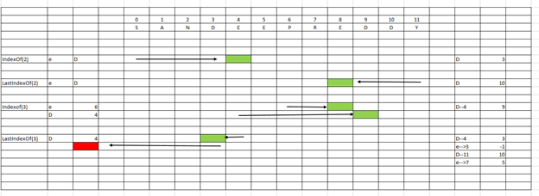
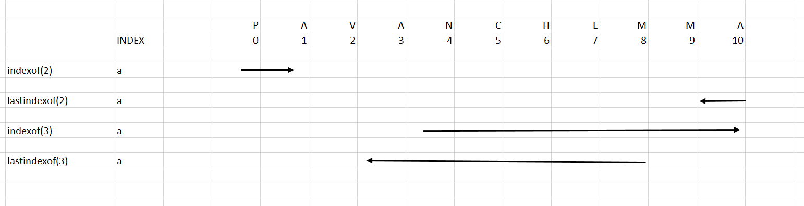

Statistics :
Sum : Take the sum of all values in each context
Average : Take the average of all values in each context
Count : Take the count of number of values in each context
Index : Take the index of values in each context .

Context Handling:
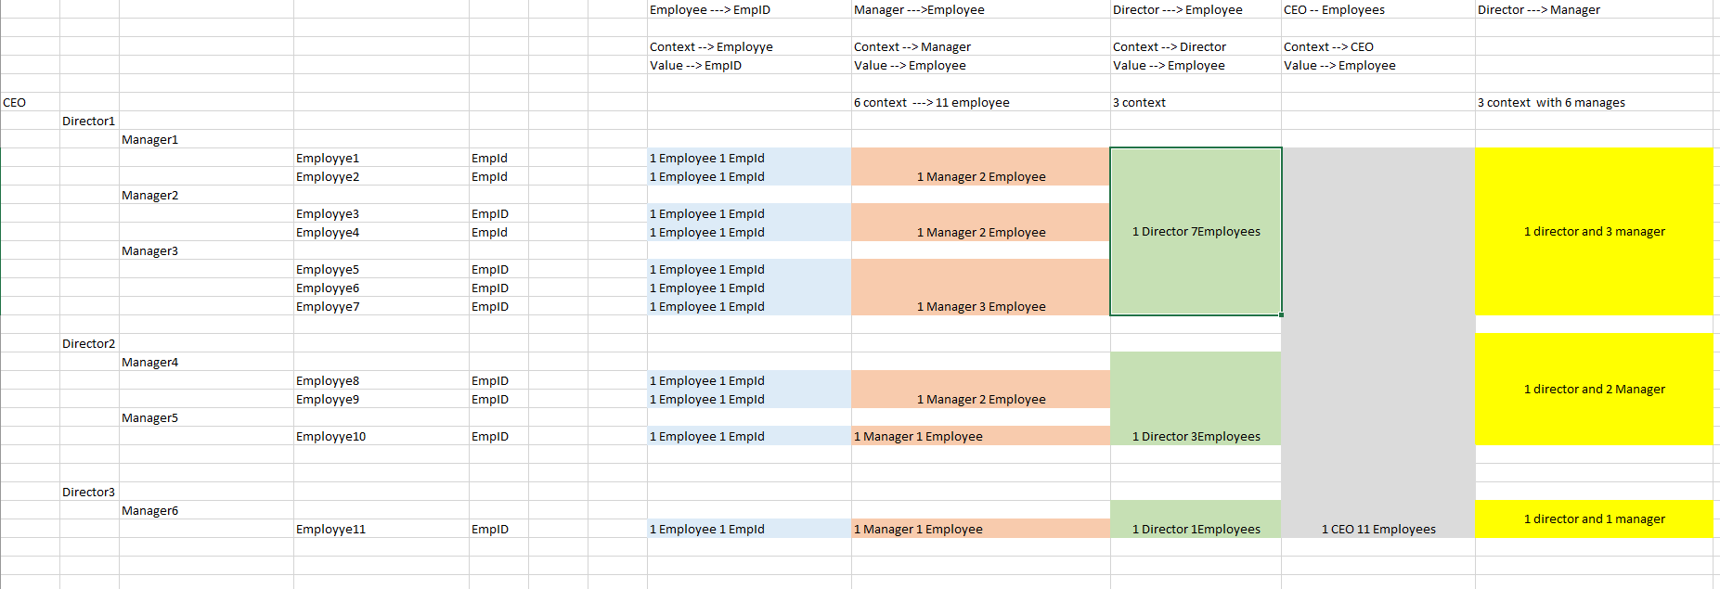

NodeFunctions:
getProperty → To read any property value in Mapping
getHeader → To read any header value in Mapping
Createif → This will create the Output field only if the input is true else it will suppress
Exists → It will check if the field is coming or not . If coming then true else false
replaceValue → This will replace the complete input with the new value
*RemoveContexts → This will remove all the context and takes all values from each context and place in single context
*CollapseContext → This will remove all the context and takes first value from each context and place in single context
Sort → It will sort the field either in ascending or descending order
sortByKey → It will sort the field 2 based on field 1 either in ascending or descending order
SplitByValue → It will add the context as per our requirement
Each Value → Add Context at each and every value
Value Change → Add Context whenever there is value change
Empty Value → Add Context whenever there is an empty value

*UseOneas Many —> So If i want to use one value multiple times
Input1 →Which value i need to repeat
Input2 → How many times i need to repeat
Input3 → In which format i need to repeat

Diff b/w copy Value and UseOneasMany
→ Copy value will only work for 1 index but not multiple whereas Useroneas Many can be used for multiple values

*FormatByExample → If we need to format the input1 based on input3

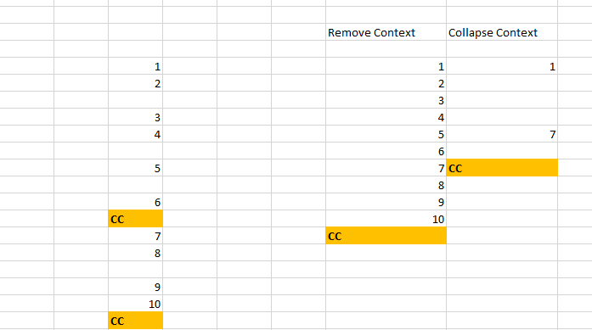

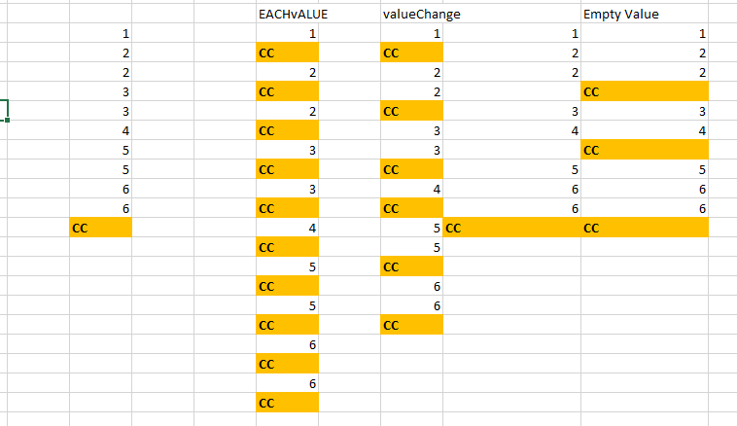

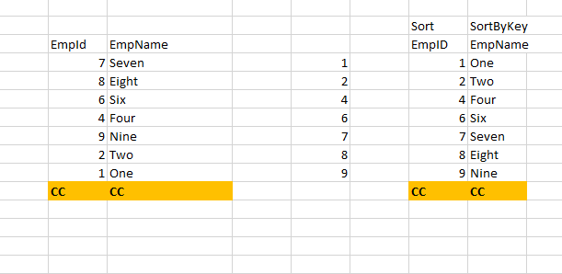

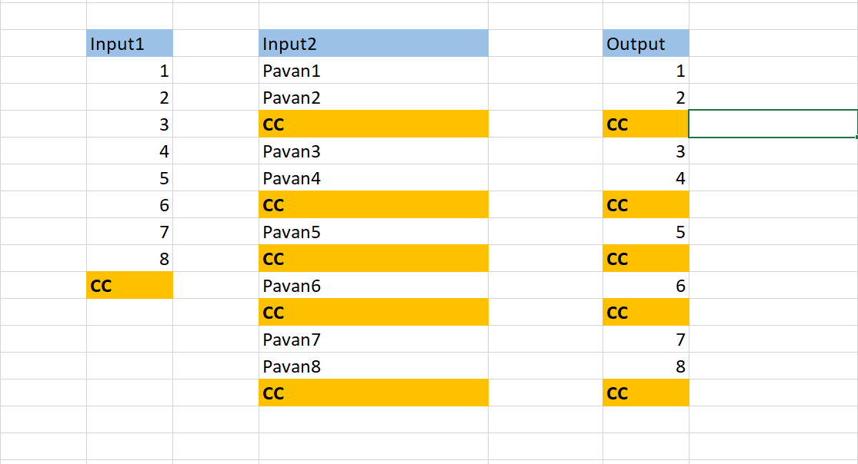

Odata

URI : https://<host>:<port>/<servicerootPath>/<ResourcePath>?<queryparams>

Eg : https://services.odata.org/northwind/northwind.svc/Employees

services.odata.org → Host
Post : 443
northwind/northwind.svc → service Root Path
Employees → Resource Path

QueryOptions :

Select → To only fetch the required fields
Expand →
Filter→ To Filter out the required data
Top → During Pagination , If you want to fetch the top number of records
Skip → During Pagination , If you want to skip any number of records
Inlinecount→ To get the count of all the records
Orderby→ To sort the data in ascending or descending order
Format → To format the data to json format

Cloud connector :

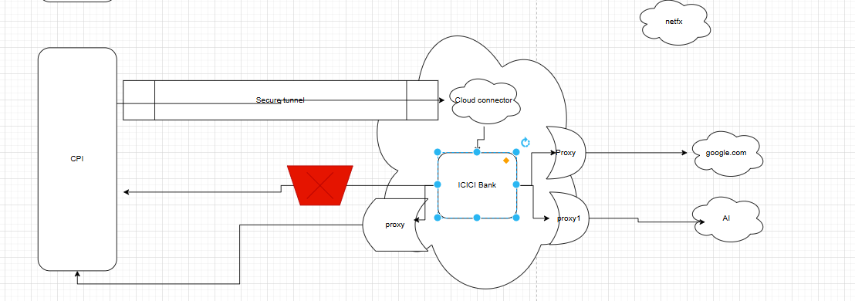

Configuration to Connect to OnPremise system :

1. Type of System --> SAP / Non SAP system
2. Type or Protocol --> HTTP / TCP
3. Give Internal Host of OnPremise System
4. Give Virtual Host which can be used in CPI

