Step1 : Register our id with SAP .

Visit : https://www.sap.com/
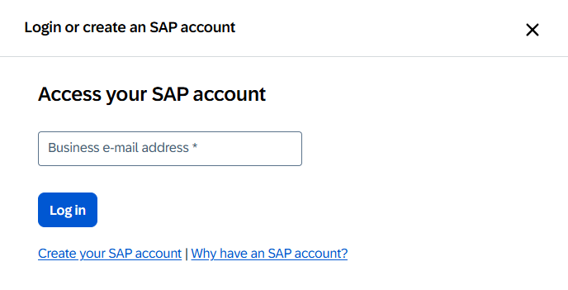
2. Click on Create your SAP account .

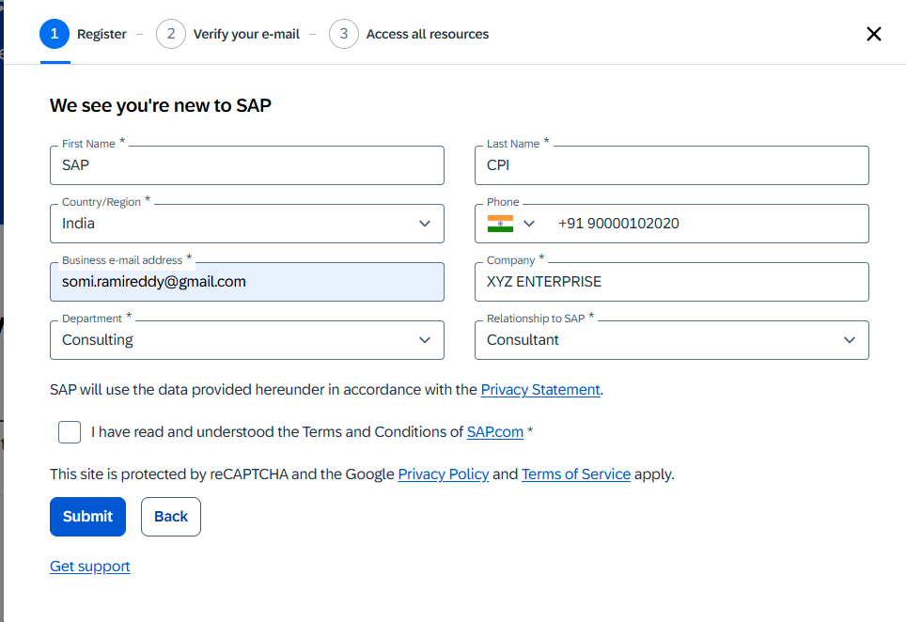

3. Click on Submit

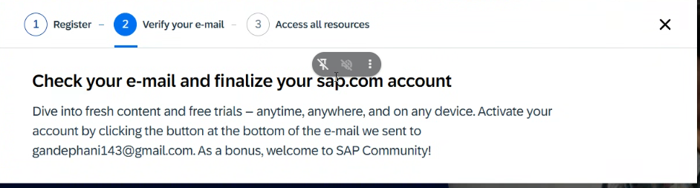

4. An activation Link will be sent to you Email ID . click on the activation link and provide the password and activate the services.

5. Go to https://accounts.sap.com/ui/protected/profilemanagement the Profile page of your PUserID.. Just to verify or check your PUser
6.From here we will start with the BTP Trial Account. Follow the Steps as mentioned in CPI Trail Account Creation.pptx

