 | SIMATS ENGINEERING  Department of Computer Science and Engineering
CSA15 Cloud Computing and Big Data Analytics
CO3 AT2 - Capstone Cloud Access and Service Integration Case Study Student Template
Course Code | CSA15 | Course Title | Cloud Computing and Big Data Analytics
Assessment | CO3 AT2 - Capstone Cloud Access and Service Integration Case Study | Submission Type | Individual digital case-study document
Faculty | Dr C. Rajesh Babu | Employee ID | SSETSCS415
Mode | Case study / capstone design reasoning | Submission | GitHub repository link through Google Classroom

How This Template Works
Read each case, connect it to the technical ideas learned in CO3 AT1, and then extend the design to your own capstone product. The answer must show cloud access, APIs, storage, serverless/event flow and edge/fog/cloud reasoning. Do not upload passwords, private keys, API tokens or sensitive personal data.

Student and Capstone Details
Student Name | J Bharath
Register Number | 192511234
Class / Slot | Slot B
Capstone Title | SkillForge – CO-Attainment Cloud Tutor Using Recommendation Analytics
CO3 AT1 Evidence Link
GitHub Repository Link
Submission Date

Case 1: Cloud-Native Backend and Web API Architecture
Scenario
A food delivery company wants to deploy a cloud-native backend with web APIs, browser/mobile clients and shared cloud storage for receipts and delivery images. Design the architecture and explain the role of each component.

A. Case Architecture Diagram
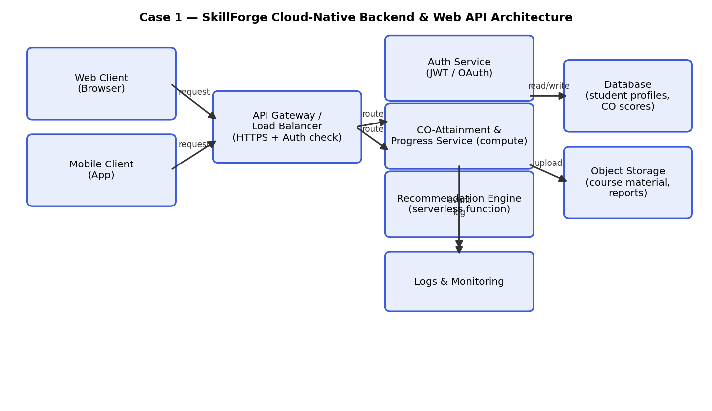

B. Component Role Explanation
Web/Mobile Clients: the student/faculty browser and mobile apps are thin clients that call the backend only through HTTPS REST endpoints – no direct database or storage access, which keeps credentials off the client.
API Gateway / Load Balancer: the single entry point for all requests. It terminates TLS, validates the auth token on every call, applies rate limiting, and routes requests to the correct backend service, so the backend never has to trust the client directly.
Auth Service: issues and verifies JWT/OAuth tokens for students and faculty, decoupled from business logic so it can scale and be updated independently.
CO-Attainment & Progress Service: the core compute layer that records quiz/assessment results, computes per-student and per-class Course Outcome (CO) attainment scores; stateless so it can be horizontally scaled behind the gateway.
Recommendation Engine (serverless function): triggered by events (e.g. a quiz just scored) to run the recommendation-analytics logic and suggest remedial content for weak COs, rather than running continuously – cost-efficient since inference only needs to happen after new data arrives.
Database: a managed SQL/NoSQL store for structured data (student profiles, quiz scores, CO attainment records) with built-in backups and replication.
Object Storage: holds unstructured binary content – course material (PDFs/videos) and generated recommendation/CO-attainment reports – referenced by URL from the database rather than stored as blobs in it, which keeps the database small and fast.
Logs & Monitoring: collects metrics/traces from every component so failures and latency issues can be diagnosed without touching student data directly.

C. Capstone Extension: user-to-cloud workflow for your product
SkillForge follows this same pattern directly: the student/faculty web or mobile client calls a REST API gateway that checks a JWT before reaching the CO-Attainment Service. When a student submits a quiz, the backend writes the raw score to the database and emits a 'quiz scored' event; a serverless Recommendation Engine function picks up that event, recalculates the student's CO-attainment profile, runs the recommendation-analytics logic, and writes a personalized study-plan report to object storage (with the URL saved back to the student's record). Faculty uploading course material (lecture PDFs/videos) upload directly to object storage via a pre-signed URL rather than through the compute service. All services emit logs to a central monitoring dashboard so attainment-calculation errors can be traced during grading/demo.

Case 2: Storage and Serverless Upload Workflow
Scenario
A media startup must decide between SAN-backed storage, object storage and serverless processing for upload workflows. Recommend a deployment model and justify it.
Data / Event | Best Storage | Serverless Action | Reason
Quiz/assessment submitted by student | Managed relational database | Trigger CO-attainment recalculation + recommendation-engine function | Scores are structured, relational data needing transactional consistency; the event trigger keeps recommendation compute at zero cost when idle.
Course material upload (lecture PDF/video) | Object storage (e.g. S3-class) | Trigger indexing/transcoding function | Large, mostly-immutable binaries; serverless processing avoids running a server 24/7 for occasional faculty uploads.
Generated recommendation / CO-attainment report | Object storage | Generate report via serverless function, store, then notify student | Reports are write-once documents best kept out of the relational DB; event-driven generation keeps cost near zero when idle.
Bulk CO-attainment analytics export (e.g. semester report) | Object storage (as export file) + SAN only if a legacy institutional system requires block access | Scheduled serverless job aggregates DB data into a report file | Infrequent, large, sequential read/write – ideal for serverless batch processing writing to cheap object storage rather than a database.

A. Storage and Serverless Recommendation
Recommendation: use object storage (not SAN) as the primary store for uploaded media, paired with serverless functions for processing. SAN (block storage) is optimized for low-latency attached-disk workloads like databases and VMs, but it is expensive to scale and not designed for storing millions of independent files accessed over HTTP. Object storage is purpose-built for exactly this: virtually unlimited scale, HTTP(S) access, per-object metadata, lifecycle policies (e.g. auto-archive old receipts), and native event triggers that fire a serverless function the moment a file lands – no server needs to be running to "watch" for uploads. SAN is reserved only for the database tier where the OS needs a real attached volume.

B. Failure Handling and Cost/Performance Explanation
Failure handling: uploads use pre-signed URLs so a failed upload simply fails client-side and can be retried without leaving a partial file recorded in the database (the DB record is only created after a successful upload event). Serverless processing functions are configured with a retry policy and a dead-letter queue, so an image that fails to resize twice is captured for manual review instead of silently disappearing. Idempotent function design (checking if a thumbnail already exists before regenerating) protects against duplicate event delivery.
Cost/performance: object storage bills per GB stored and per request, with no idle cost, versus SAN/EBS-style storage which is billed for provisioned capacity whether used or not. Serverless functions bill per invocation/duration, so the resize/notification workloads (which are bursty and idle most of the time) cost far less than running a dedicated always-on server. The trade-off is cold-start latency on infrequently invoked functions, which is acceptable here since uploads are not on the user's critical, real-time path.

C. Capstone Extension: one upload/event workflow
In SkillForge, a student completing a quiz triggers this exact workflow: the score is written synchronously to the database, which emits a 'quiz scored' event; a serverless function recalculates the student's CO-attainment values, invokes the recommendation-analytics logic to pick remedial resources for weak COs, writes a personalized report PDF to object storage, and finally a lightweight notification function alerts the student that a new study recommendation is ready. No backend server sits idle waiting – the whole chain only runs when a quiz is actually submitted.

Case 3: Edge, Fog and Cloud Placement
Scenario
A smart-city platform needs low-latency decision-making near sensors while still using the cloud for analytics. Decide what runs at edge, fog and cloud.
Task | Layer | Latency Need | Data Volume | Reason
Sensor anomaly detection (e.g. traffic/air quality spike) | Edge | Milliseconds | Small (per-sensor reading) | Immediate local action is required (e.g. trigger a signal change) before data can round-trip to the cloud.
Local data aggregation across a neighbourhood cluster | Fog | Seconds | Medium (batched readings) | A fog node close to the sensors can aggregate/filter data from many devices before sending only summaries upstream, cutting bandwidth.
Long-term trend analytics and city-wide dashboards | Cloud | Minutes to hours (not latency-sensitive) | Large (historical, city-wide) | Cloud offers the storage and compute needed for big-data analytics, ML model training and cross-district reporting.
Firmware/config updates to sensors | Cloud (orchestration) pushed via fog | Not latency-sensitive | Small per device, large in aggregate | Centralized management is easiest from the cloud, but fog nodes can cache/distribute updates locally to reduce cloud egress and handle intermittent connectivity.

A. Edge/Fog/Cloud Architecture Explanation
Edge (on/near the sensor device): runs the smallest, fastest logic – threshold checks and immediate local actuation – because network round-trips to the cloud are too slow for a millisecond-scale response and the device may briefly lose connectivity.
Fog (local gateway/mini-server serving a cluster of sensors, e.g. per intersection or district): aggregates and filters raw readings from many edge devices, reducing the volume of data sent onward and enabling near-real-time coordination across a small area (e.g. syncing several traffic lights) without needing the cloud.
Cloud: receives the filtered/aggregated data for storage, historical analytics, dashboards, and training of any predictive models, and pushes configuration/firmware changes back down through the fog layer to the edge devices.

B. Capstone Extension or Direct Cloud Access Justification
SkillForge itself is not latency-critical like a smart-city sensor grid, so it uses direct cloud access for essentially everything – there is no edge/fog tier because there are no physical sensors requiring sub-second local decisions. The justification for direct cloud access is that every user interaction (viewing course material, submitting a quiz, reading a recommendation report) can tolerate normal internet round-trip latency (tens to a few hundred milliseconds, or even a few seconds for the recommendation-analytics computation), and centralizing all logic in the cloud keeps the architecture simple, consistent, and easy to scale/monitor across many classes and departments. The one plausible extension mirroring Case 3 would be a fog-style local cache in a classroom/lab with unreliable internet: recently accessed course material and a locally cached copy of a student's last recommendation report could be served from a lab gateway so learning is not blocked by connectivity, while quiz submissions still sync to the cloud once connectivity returns.

Final Capstone Cloud Access Architecture
☐ Show Browser/Mobile Client.
☐ Show hosted frontend or app access path.
☐ Show REST API endpoint and authentication check.
☐ Show backend/serverless logic.
☐ Show database, object/blob storage, logs and monitoring.
☐ Label the arrows: request, response, upload, event, notification or monitoring signal.

Final Diagram and Explanation
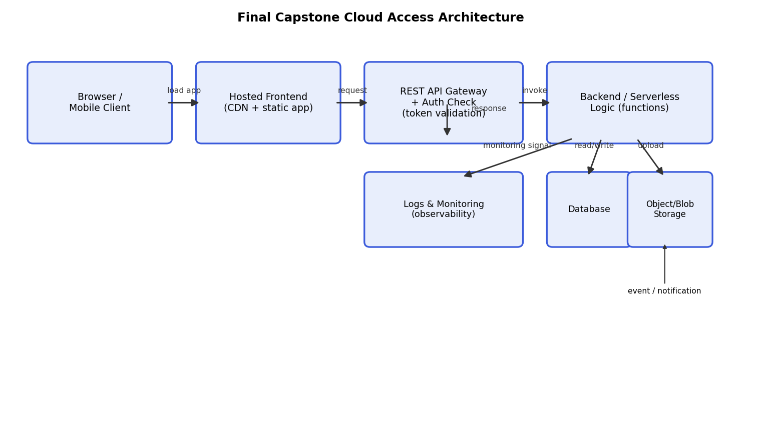
Browser/Mobile Client → Hosted Frontend: the student/faculty client loads the static app (HTML/JS or app bundle) from a CDN-backed hosted frontend, so the UI itself is served with low latency and no backend compute cost.
Hosted Frontend → REST API Gateway: once loaded, the app calls the REST API over HTTPS; the gateway performs the auth check (validating the student/faculty token) before any request reaches business logic.
REST API Gateway → Backend/Serverless Logic: validated requests are routed to the CO-Attainment Service or, after a quiz is scored, to the serverless Recommendation Engine that implements the recommendation-analytics logic.
Backend → Database & Object/Blob Storage: structured data (student profiles, quiz scores, CO attainment records) is read/written to the managed database; course material and generated recommendation reports are uploaded to object storage, and a completed report upload can trigger a downstream notification event to the student (notification arrow).
Backend → Logs & Monitoring: every layer emits a monitoring signal so failures and latency spikes (e.g. a stuck attainment calculation) are observable without accessing student data directly.
This single diagram satisfies the checklist: client, hosted frontend, authenticated REST endpoint, backend/serverless logic, database + object storage, logs/monitoring, and labeled arrows for request, response, upload, event/notification and monitoring signal.

Submission Checklist
☐ Template completed in DOCX format.
☐ Diagrams pasted clearly in the document.
☐ GitHub repository contains DOCX/PDF, diagrams and README.
☐ Google Classroom submission contains GitHub link.
☐ Sensitive credentials are not visible anywhere.

Student Assurance
Declaration
I confirm that this case-study answer, cloud access design, diagrams and capstone extensions were prepared individually by me for the stated capstone title.
Student Signature: _J Bharath_ Date: ____________________

