Jenkins-task01

Task Title
Install and Configure Jenkins on AWS EC2 (Amazon Linux 2023)

Objective
To launch an Amazon EC2 instance using Amazon Linux 2023, install Jenkins with Java 17, configure Jenkins to run on a custom port, and successfully access the Jenkins web interface for initial setup.

Prerequisites
- AWS account with EC2 access
- Key pair for SSH access
- Basic knowledge of AWS EC2 and Linux commands
- Security Group allowing inbound access on:
  - SSH (22)
  - Jenkins port (8080 or custom port like 8081)
- Internet access from local machine

Launch EC2 Instance
- Navigate to EC2 → Instances → Launch instance
- Instance Name: Jenkins
- AMI: Amazon Linux 2023 AMI
- Instance Type: t3.micro (Free tier eligible)
- Key Pair: Select or create key pair (jenkins)
- Network Settings:
  - Auto-assign public IP: Enabled
  - Security Group: Allow inbound SSH (22) and Jenkins port (8080/8081)
- Storage: 20 GB gp3 root volume

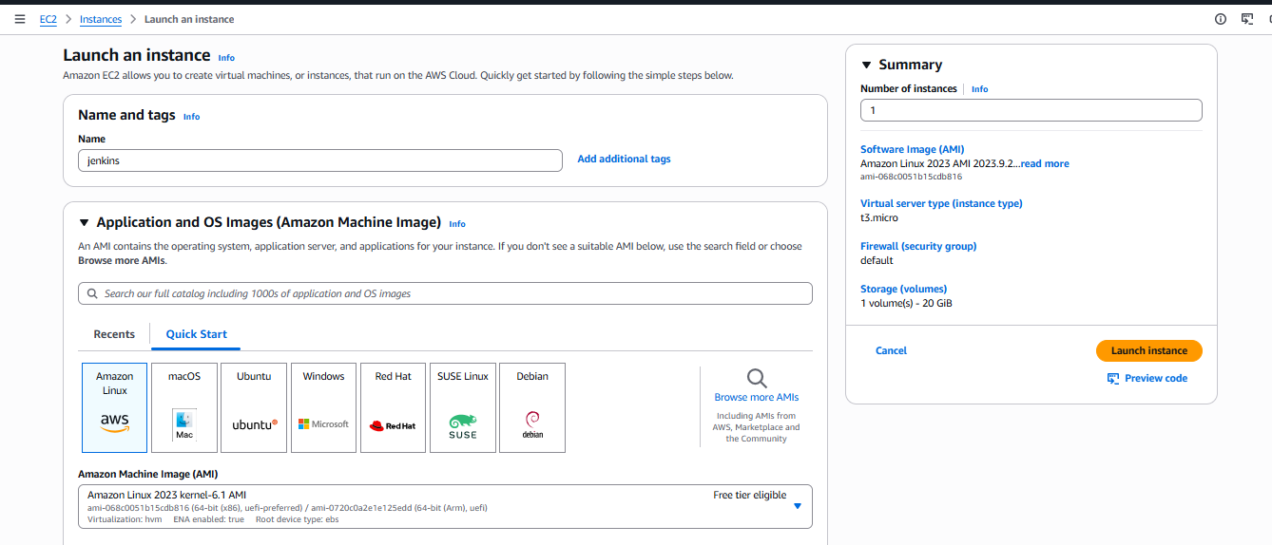
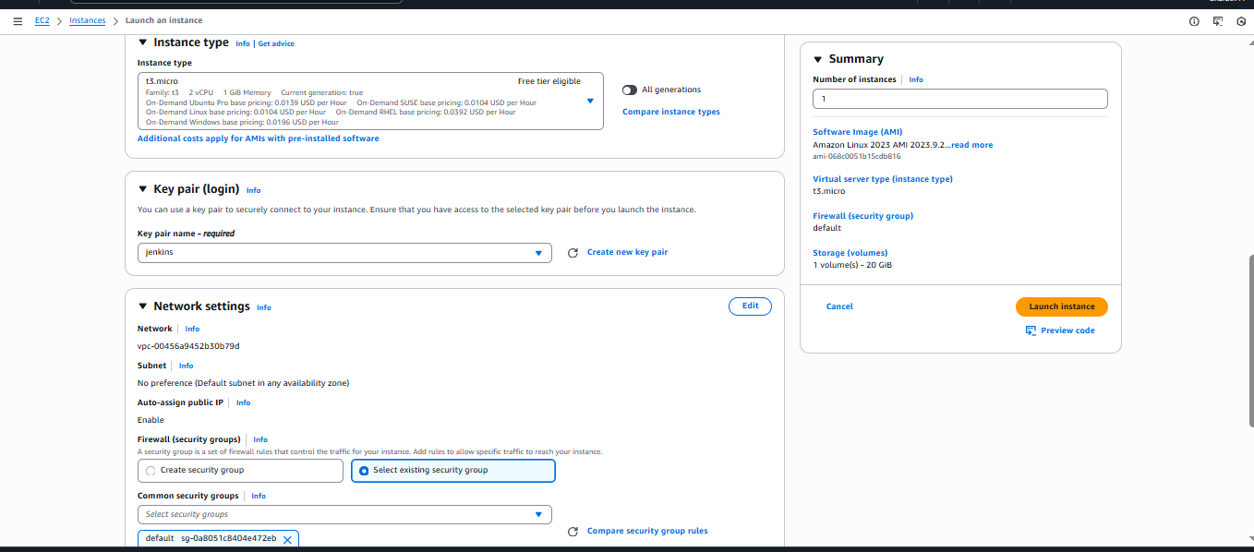
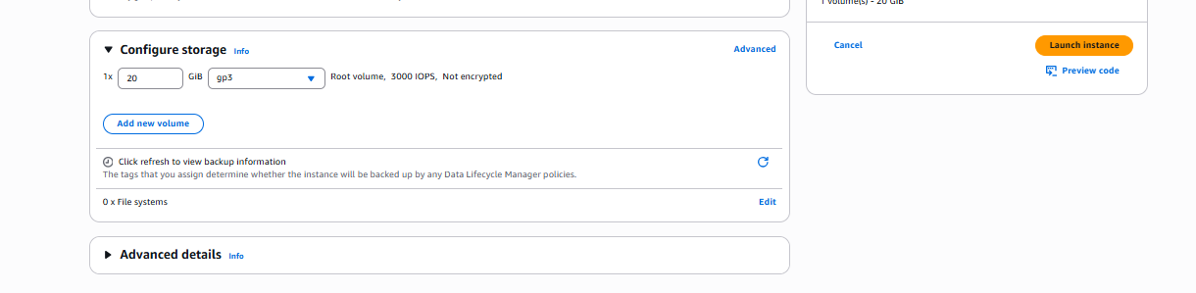

Connect to EC2 Instance
ssh -i jenkins.pem ec2-user@<public-ip>

Create Jenkins Installation Script
- Create a script jenkins.bash to automate installation and port change
- Key actions performed by the script:
  - Update system packages
  - Install Java 17 (Amazon Corretto)
  - Add Jenkins repository and GPG key
  - Install Jenkins
  - Modify Jenkins port (from 8080 to 8081)
  - Enable and start Jenkins service

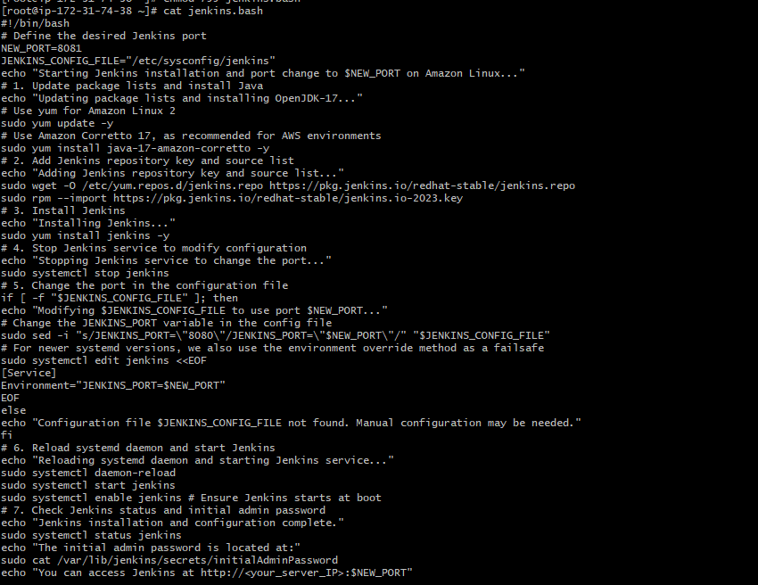
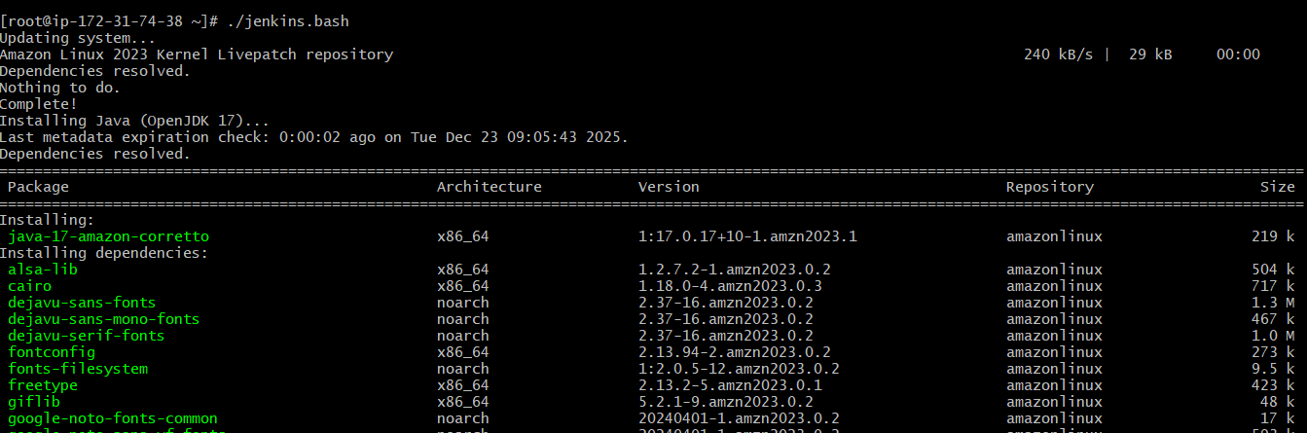
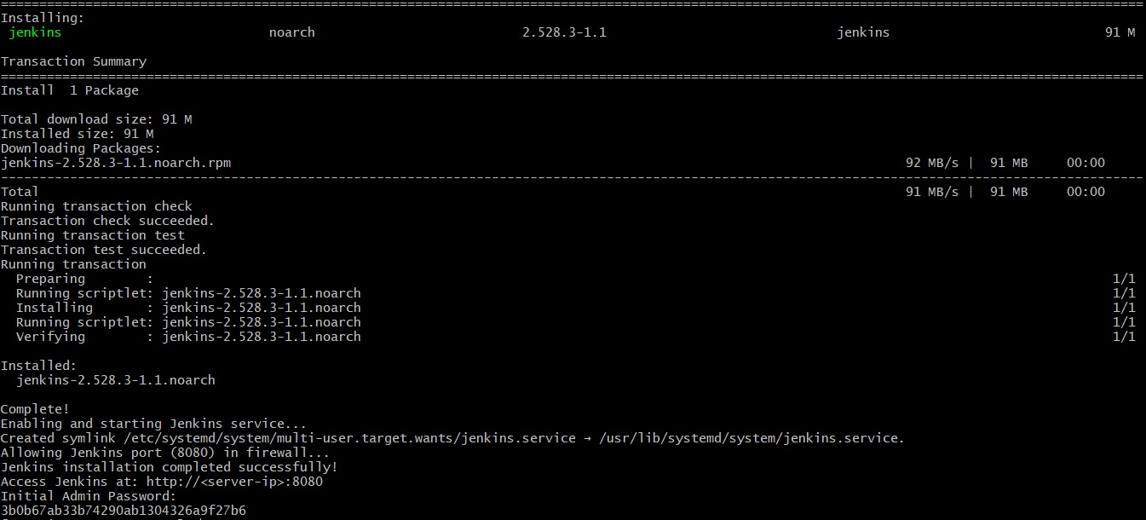

Verify Jenkins Service
systemctl status jenkins
- Ensure service is active (running)

Retrieve Initial Admin Password
cat /var/lib/jenkins/secrets/initialAdminPassword

Access Jenkins Web UI
- Open browser and navigate to:
http://<EC2-Public-IP>:8081
- Paste the initial admin password
- Click Continue to unlock Jenkins

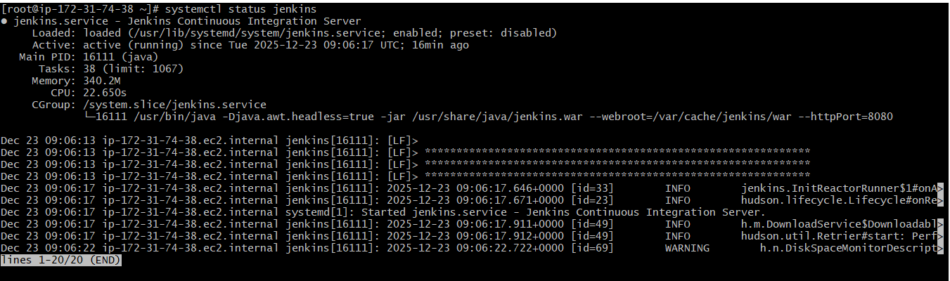
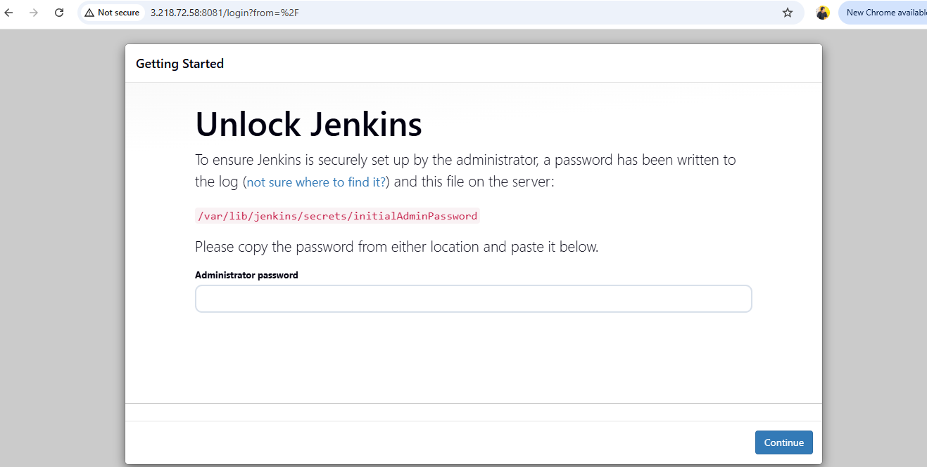

Validation Steps
- EC2 instance is in running state
- Jenkins service status shows active (running)
- Jenkins web UI loads successfully in browser
- Able to unlock Jenkins using initial admin password

Issues Faced
- Jenkins not accessible initially due to missing inbound rule for custom port
- Port change requires daemon reload and service restart
- Ensuring correct Java version (Java 17) compatibility

Conclusion
Jenkins was successfully installed and configured on an Amazon Linux 2023 EC2 instance. The service runs on a custom port and is accessible via browser for CI/CD pipeline configuration. This setup provides a reliable foundation for DevOps automation and continuous integration workflows.

Secure Jenkins server

Task Title
Change Jenkins Admin Password and Validate Login

Objective
To securely change the Jenkins admin user password and validate the change by successfully logging back into the Jenkins dashboard with the new credentials.

Prerequisites
- Jenkins installed and running
- Admin-level access to Jenkins
- Jenkins URL accessible in a browser
- Existing admin credentials available

Access Jenkins Dashboard
- Open the Jenkins URL in a web browser
- Login using admin credentials
- Verify the Jenkins dashboard loads successfully

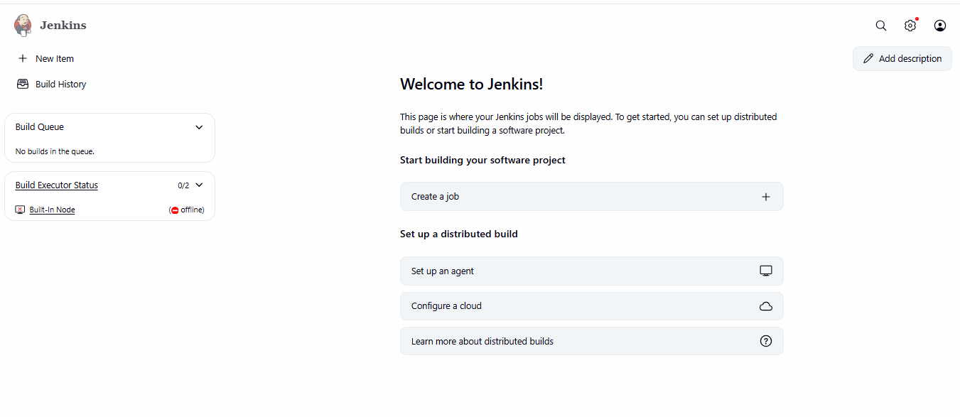

Navigate to Admin Security Settings
- Click on admin (top-right corner)
- Select Configure or Security
- Scroll to the Password section

Change Admin Password
- Enter the new password in the Password field
- Re-enter the same password in Confirm Password
- (Optional) Click Terminate All Sessions for security
- Click Save or Apply

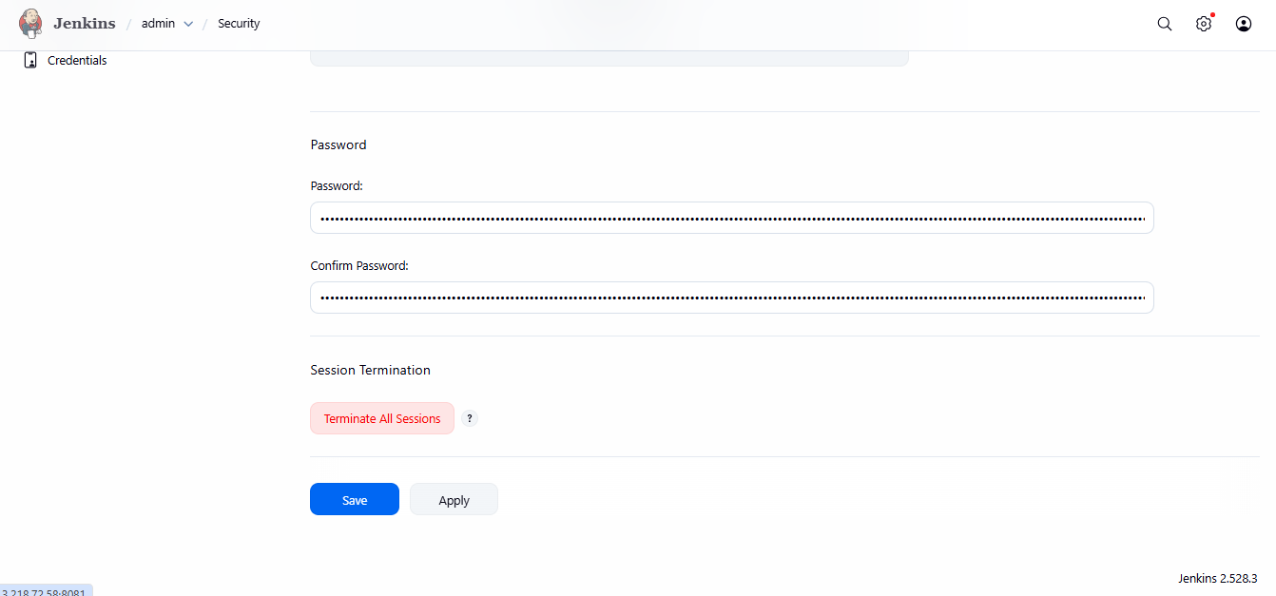
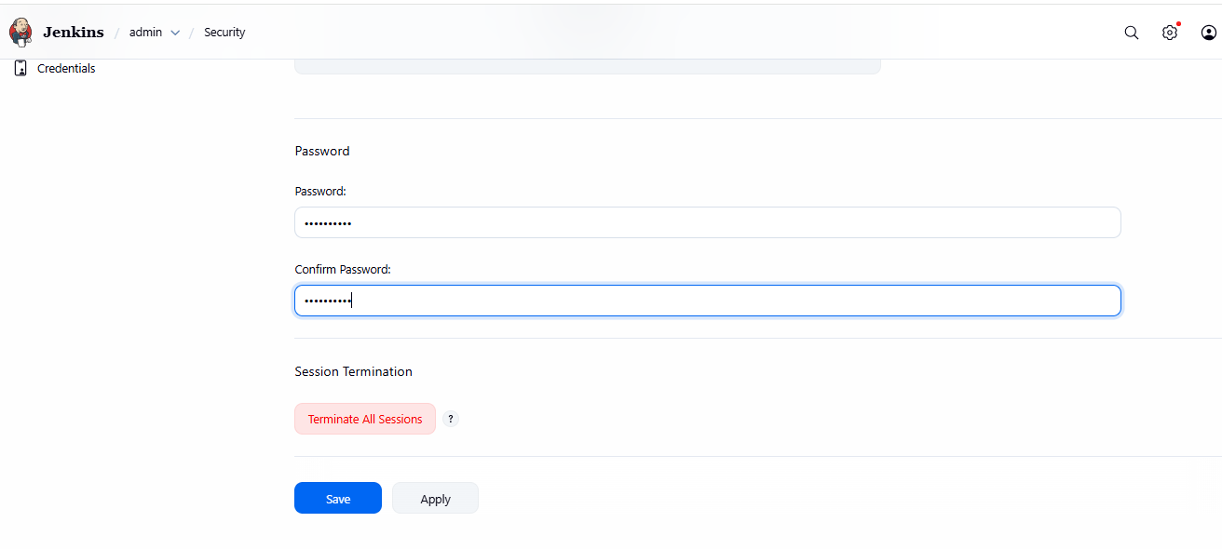

Validate Login with New Password
- Navigate to Jenkins login page
- Enter:
  - Username: admin
  - Password: new password
- Click Sign in

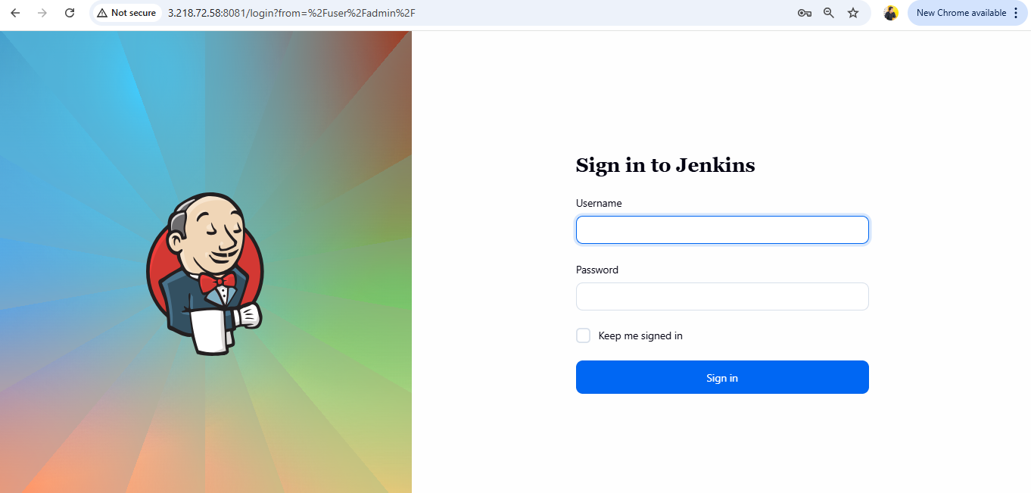

Validation Steps
- Jenkins dashboard loads without error
- Admin user is able to:
  - Access Manage Jenkins
  - Create or configure jobs
  - View system settings
- No authentication or permission errors observed

Issues Faced
- Browser showed “Not Secure” warning due to HTTP (no SSL)
- Required logout after password change to avoid session conflict
- Incorrect password confirmation caused save failure (resolved by retyping)

Conclusion
The Jenkins admin password was successfully updated and validated by logging in with the new credentials. This task improves security posture by enforcing credential updates and session termination. Jenkins is now accessible with the updated authentication details.

Create users called DevOps, Testing in Jenkins with Limited access.

Task Title
Create Limited Access User in Jenkins Using Role-Based Authorization Strategy

Objective
To configure role-based access control in Jenkins by installing the Role-Based Authorization Strategy plugin, creating a new user (DevOps), assigning limited permissions, and validating user access through login.

Prerequisites
- Jenkins server installed and running
- Administrator access to Jenkins
- Internet connectivity to install Jenkins plugins
- Jenkins own user database enabled
- Browser access to Jenkins UI

Step-by-Step Implementation

Access Jenkins Manage Page
- Log in to Jenkins as an administrator.
- Navigate to Manage Jenkins from the dashboard.

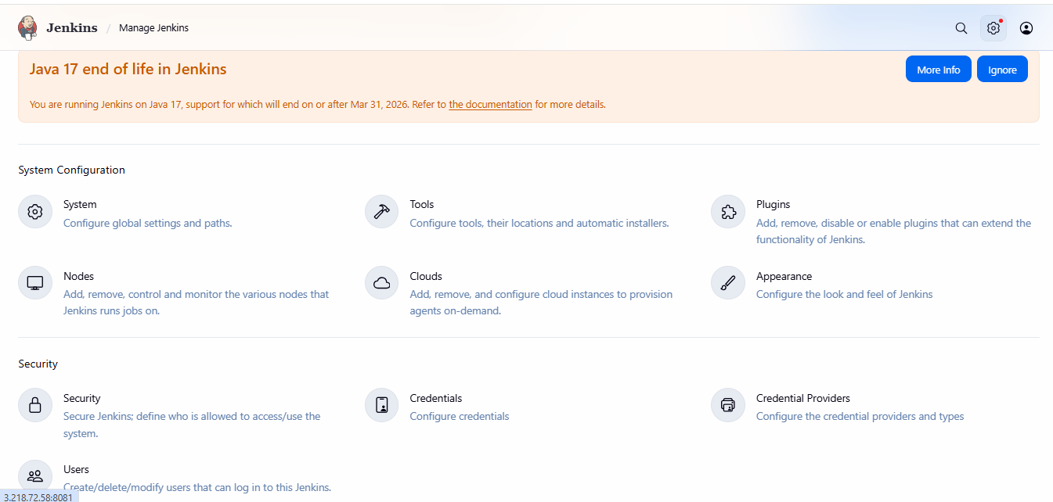

Install Role-Based Authorization Strategy Plugin
- Go to Manage Jenkins → Plugins.
- Click on Available Plugins.
- Search for Role-based Authorization Strategy.
- Select the plugin and click Install.
- Wait until the installation completes successfully.

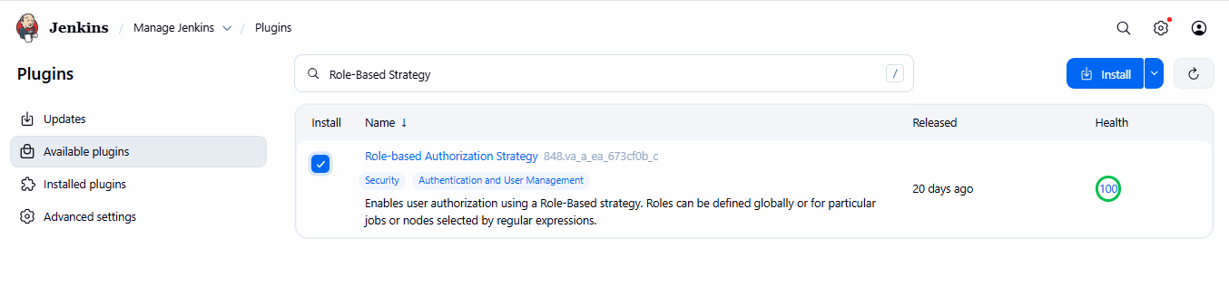
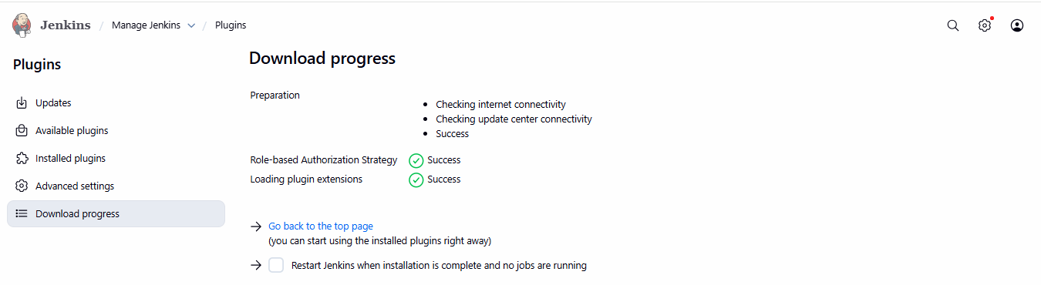

Create a New Jenkins User
- Navigate to Manage Jenkins → Users.
- Click Create User.
- Enter the following details:
  - Username: Devops
  - Password: (set secure password)
  - Full Name: Devops
  - Email Address: bharathmorsu1502@gmail.com
- Click Create User.

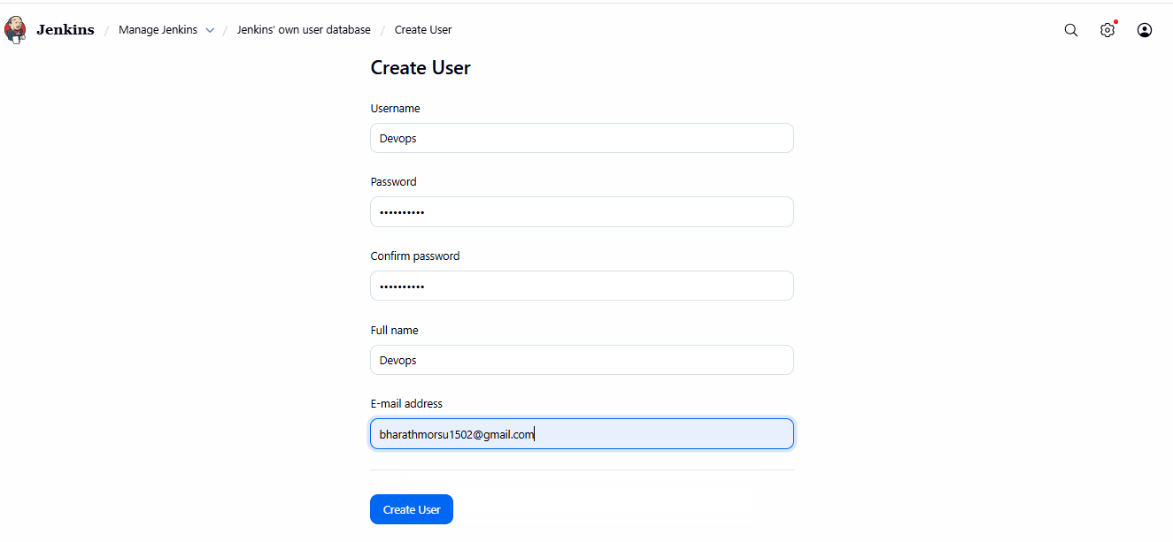
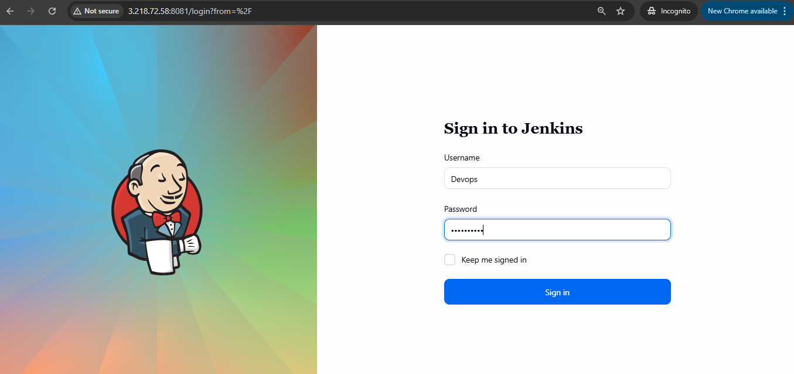
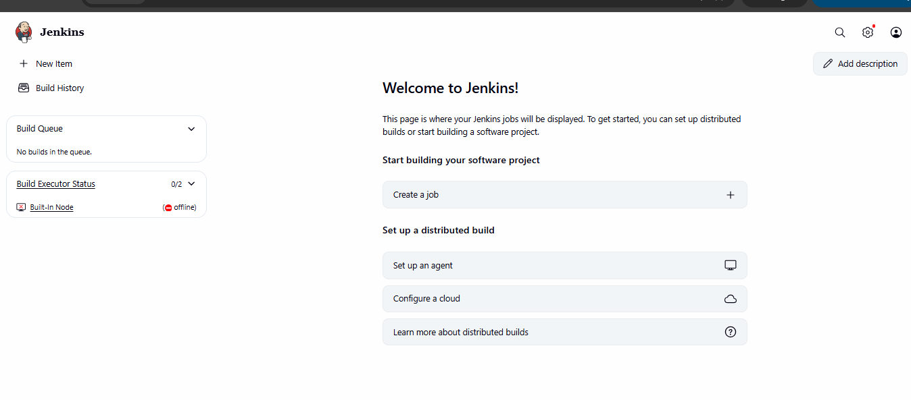

Configure Security Settings
- Go to Manage Jenkins → Security.
- Under Security Realm, select:
  - Jenkins’ own user database
- Under Authorization, select:
  - Project-based Matrix Authorization Strategy
- Add the user Devops.
- Grant limited permissions such as:
  - Job: Read, Build
  - View: Read
  - Overall: Read
- Click Save.

Login Validation
- Log out from the admin account.
- Open Jenkins login page.
- Log in using:
  - Username: Devops
  - Password: (configured password)
- Confirm successful login.
- Verify limited access:
  - Can view jobs
  - Cannot configure or delete jobs
  - Cannot access admin-level settings

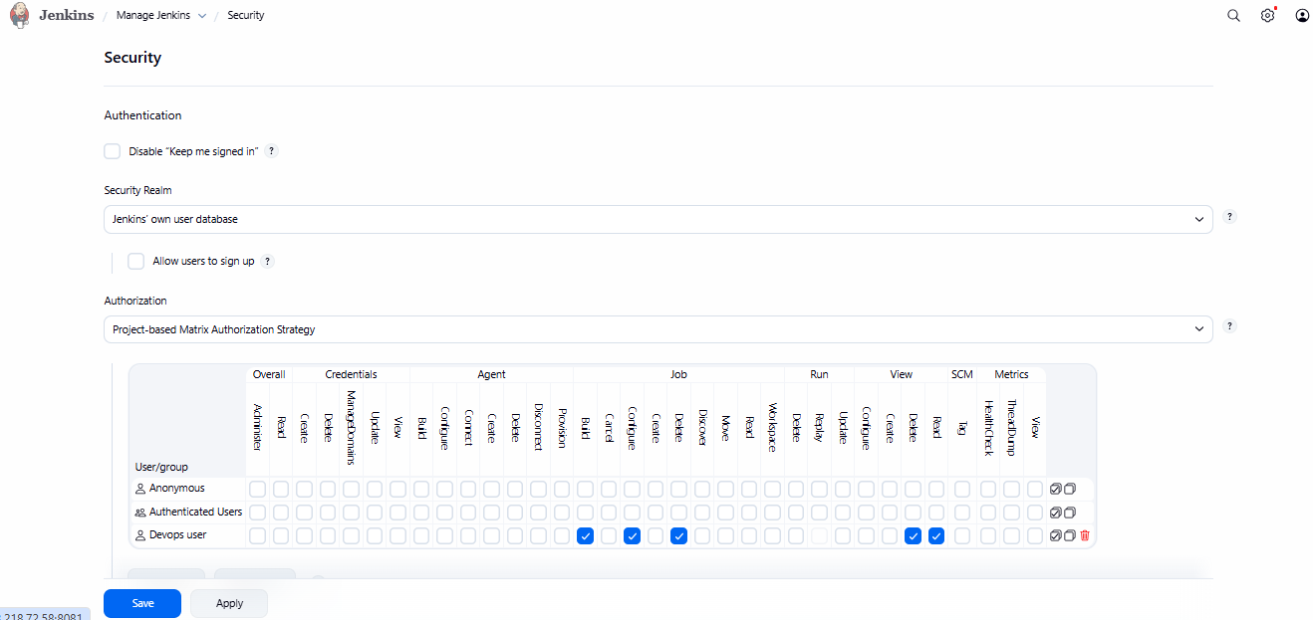

Validation Steps
- Plugin installation status shows Success
- Devops user is created successfully
- Devops user can log in to Jenkins
- Devops user sees only permitted options
- Admin-only menus are restricted

Issues Faced
- Plugin installation required stable internet connectivity
- Incorrect permission selection initially caused access denial
- Required Jenkins restart in some environments for plugin activation

Conclusion
The Role-Based Authorization Strategy was successfully implemented in Jenkins. A limited access user (Devops) was created and validated. This configuration improves security by ensuring users have only the permissions required for their role, following best practices for access control in CI/CD environments.

Configure labels and restrict the jobs to execute based on label only.

Task Title
Install Node and Label Parameter Plugin and Configure Node Label in Jenkins

Objective
To install the Node and Label Parameter plugin in Jenkins and configure node labels so that Jenkins jobs can dynamically select and run on specific nodes based on labels.

Prerequisites
- Jenkins installed and running
- Admin access to Jenkins
- Stable internet connectivity (to download plugins)
- At least one Jenkins node (controller or agent)

Step-by-Step Implementation

Step 1: Access Jenkins Plugin Manager
- Log in to Jenkins dashboard.
- Navigate to:
Manage Jenkins → Plugins

Step 2: Search and Install Plugin
- In the search bar, type node.
- Select Node and Label Parameter plugin.
- Click Install (or Install without restart).

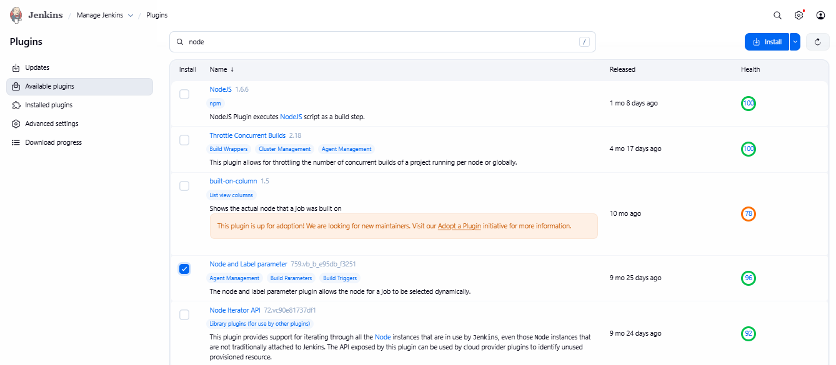

Step 3: Verify Plugin Installation
- Go to:
- Manage Jenkins → Plugins → Download progress
- Confirm the plugin shows Success status.
- Restart Jenkins if prompted (recommended).
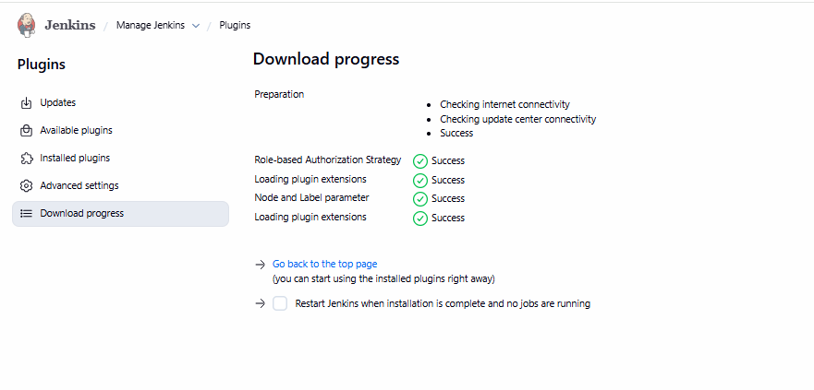

Step 4: Configure Node Label
- Navigate to:
- Manage Jenkins → System
- Locate the Labels field.
- Add a label (example: master, build-node, linux-agent).
- Save the configuration.

Step 5: Use Label in Jenkins Job
- Create or edit a Jenkins job.
- Enable This project is parameterized.
- Add parameter:
  - Node and Label Parameter
- Select the label created earlier.
- Save the job.

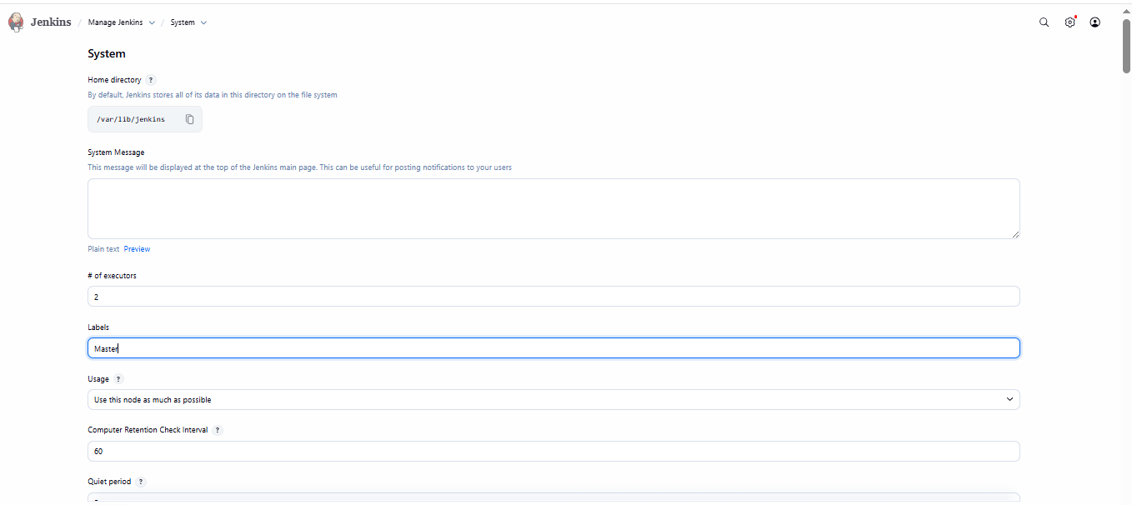

Validation Steps
- Plugin appears under Installed Plugins
- Node label is visible under Manage Jenkins → System
- Job successfully runs on the selected labeled node
- Console output confirms job execution on correct node

Issues Faced
- Plugin not visible due to outdated update center cache
Resolution: Refreshed update center and retried installation
- Jenkins restart required for plugin to take effect

Conclusion
The Node and Label Parameter plugin was successfully installed and configured. Node labels were assigned correctly, enabling Jenkins jobs to dynamically select execution nodes. This setup improves flexibility, scalability, and controlled job execution across multiple nodes.

Create Three sample jobs using the below URL. https://github.com/betawins/Techie_horizon_Login_app.git

Task Title
Creation and Execution of a Jenkins Freestyle Job Integrated with GitHub

Objective
To create a Freestyle Job in Jenkins, connect it to a GitHub repository, execute builds, and verify successful source code checkout and job execution.

Prerequisites
- Jenkins installed and running on an EC2/Linux server
- Jenkins service accessible via browser (http://<server-ip>:8080)
- Git installed on the Jenkins server
- Internet access from Jenkins server
- Public GitHub repository URL
- Jenkins user with admin privileges

Step-by-Step Implementation

Step 1: Create a New Jenkins Job
- Log in to Jenkins Dashboard
- Click New Item
- Enter job name: first-job
- Select Freestyle project
- Click OK

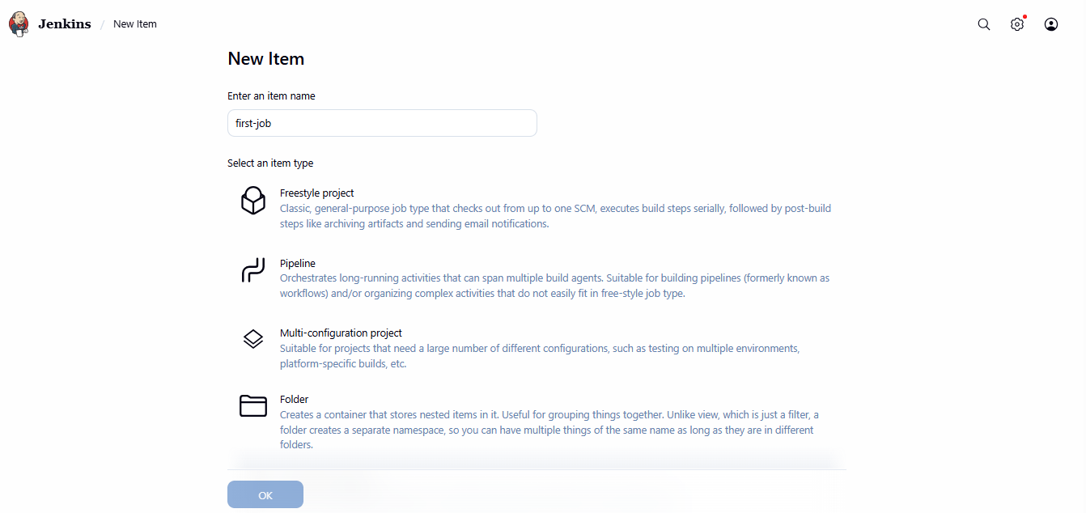

Step 2: Configure Job Settings
- Navigate to Configure for first-job
- Under General:
  - Keep default settings
  - Ensure job is Enabled

Step 3: Configure Source Code Management
- Select Git under Source Code Management
- Enter Repository URL:
https://github.com/betawins/Techie_horizon_Login_app.git
- Credentials: None (public repository)
- Branch: */master (default)

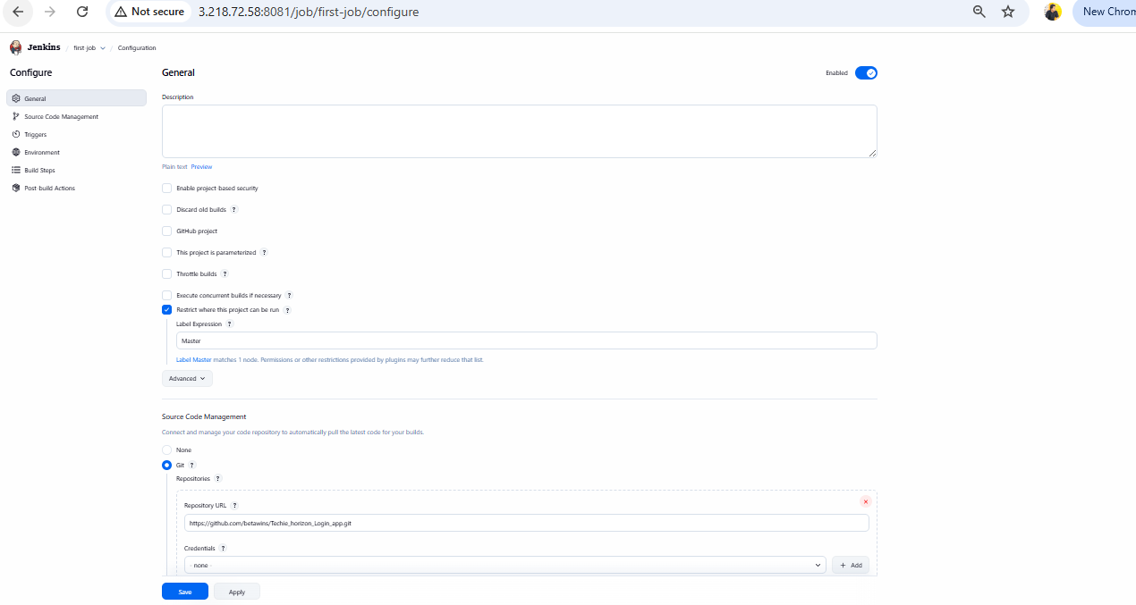

Step 4: Save and Build
- Click Save
- Click Build Now from job dashboard

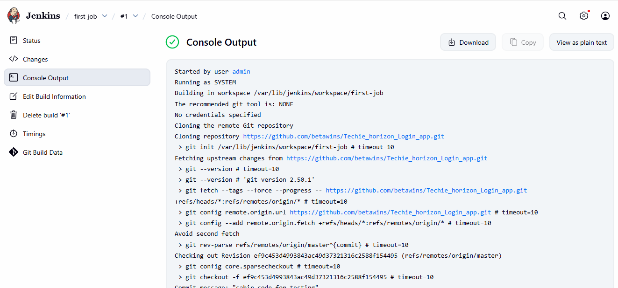

Step 5: Monitor Build Execution
- Click the build number (#1, #2, #3)
- Open Console Output
- Verify:
  - Git repository cloning
  - Fetching branches
  - Checkout completed successfully
  - No errors reported

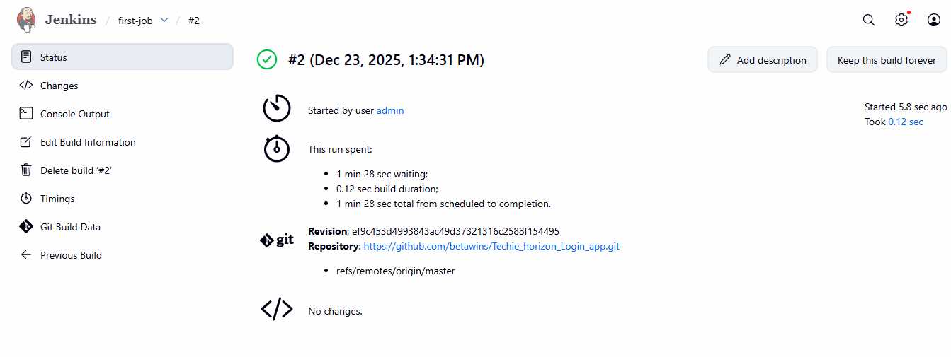
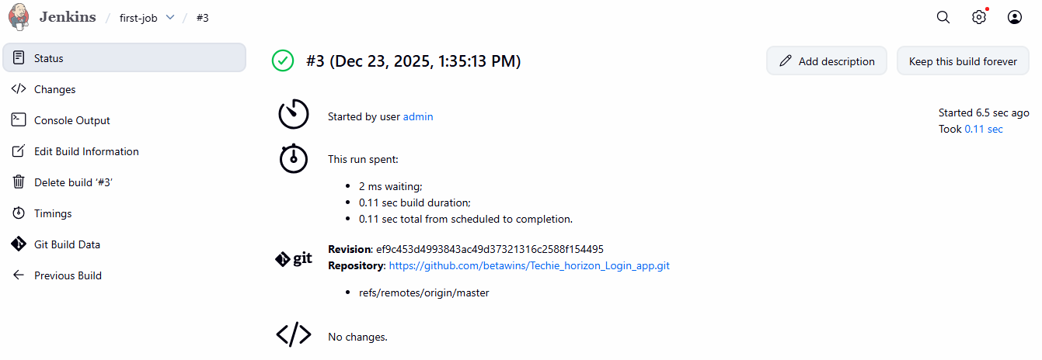
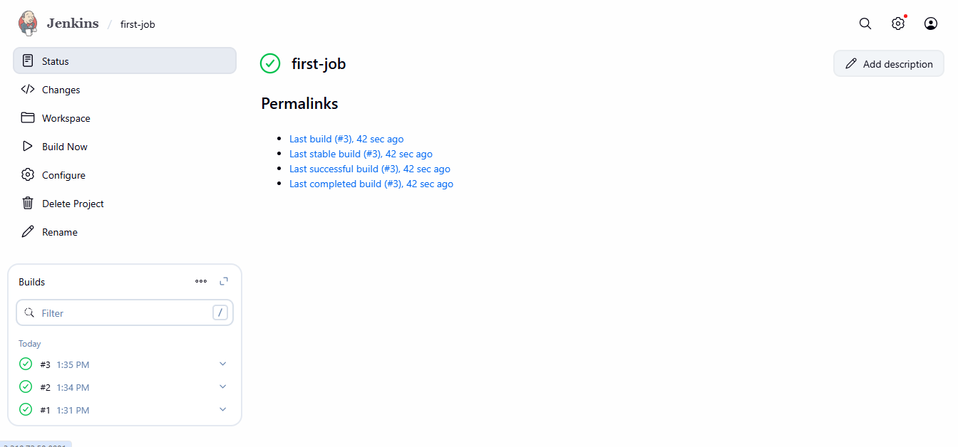
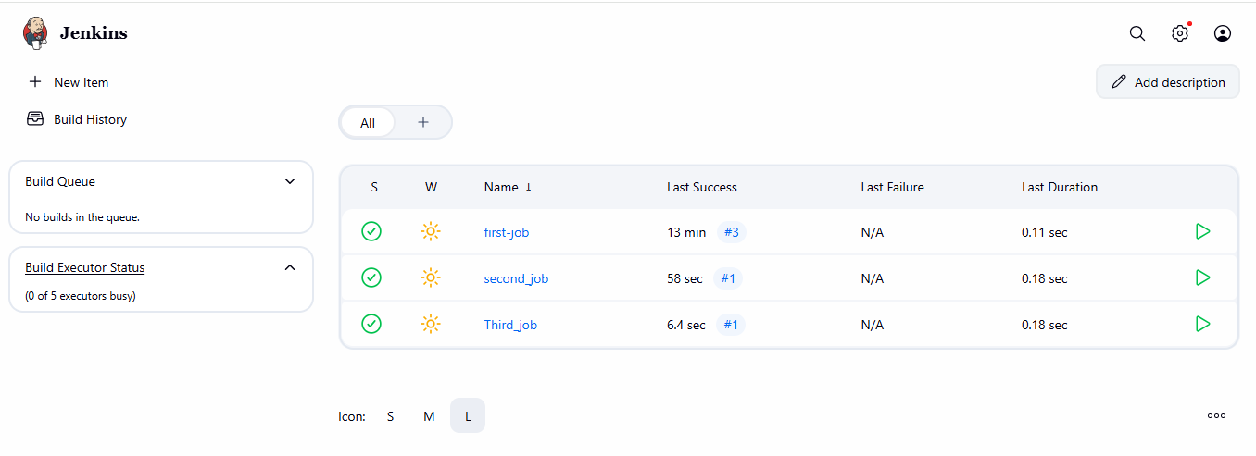

Step 6: Workspace Verification (Server-side)
- SSH into Jenkins server
- Navigate to workspace:
- cd /var/lib/jenkins/workspace/first-job
- Verify repository files:
- ls
Example files found:
  - Dockerfile
  - README.md
  - ansible
  - azure-pipelines.yml
  - pom.xml
  - src/

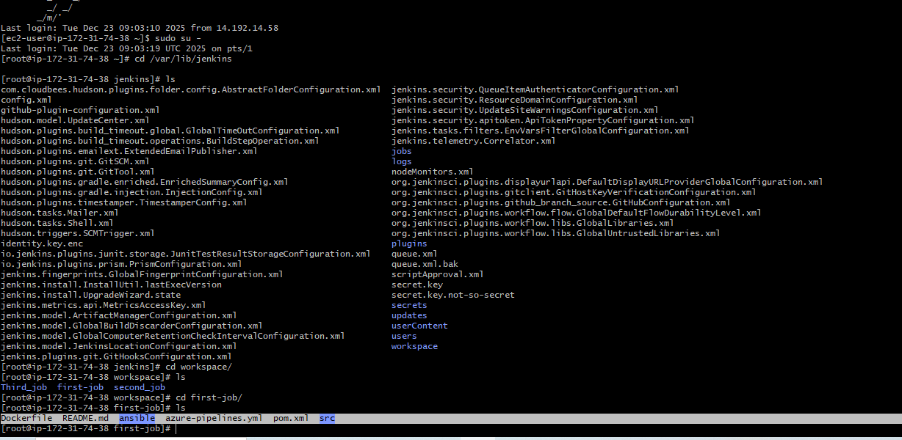

Validation Steps
- Jenkins build status shows green (Success)
- Console Output confirms:
  - git clone successful
  - Correct branch checked out
- Jenkins dashboard shows:
  - Last Successful Build
  - Last Stable Build
- Workspace contains repository source code

Issues Faced
- No issues encountered during this task
- Build execution completed without failures
- Repository cloned successfully in all builds

Conclusion
The Jenkins Freestyle job first-job was successfully created and configured. The job correctly integrated with a GitHub repository, executed builds without errors, and validated source code checkout both via Jenkins Console Output and server workspace verification. This confirms successful Jenkins–GitHub integration and establishes a foundation for further CI/CD pipeline development.

Create one Jenkins job using git hub Private repository.

Task Title
Integrate a Private GitHub Repository with Jenkins Using Personal Access Token (PAT)

Objective
To create a private GitHub repository and configure Jenkins to securely clone and build the repository using a GitHub Personal Access Token (PAT), ensuring successful source code checkout and build execution.

Prerequisites
- GitHub account with permission to create repositories
- Jenkins installed and running
- Jenkins Git plugin installed
- Internet access from Jenkins server
- Basic knowledge of Git, GitHub, and Jenkins
- Git installed on the Jenkins server

Step-by-Step Implementation

1. Create a Private GitHub Repository
- Logged in to GitHub.
- Created a new repository named private-repo.
- Set visibility to Private.
- Enabled README.md during repository creation.
- Verified initial commit was available on the default branch (main).

2. Generate GitHub Personal Access Token (PAT)
- Navigated to:
GitHub → Settings → Developer Settings → Personal Access Tokens (classic).
- Generated a new token with required permissions:
  - repo (Full control of private repositories)
- Copied and securely stored the token (visible only once).

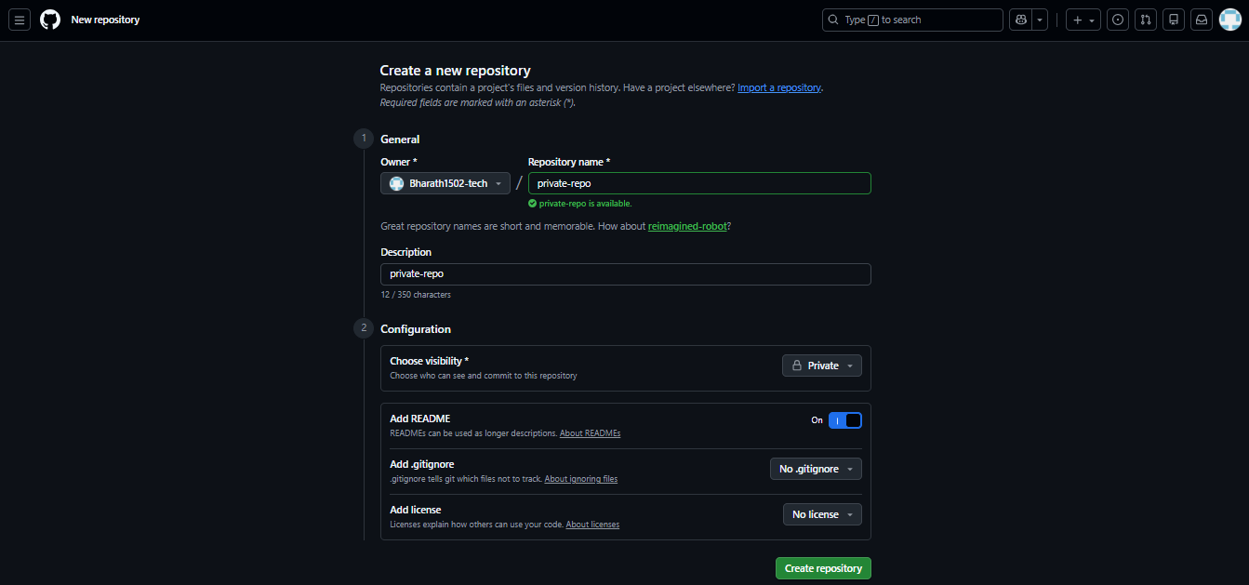

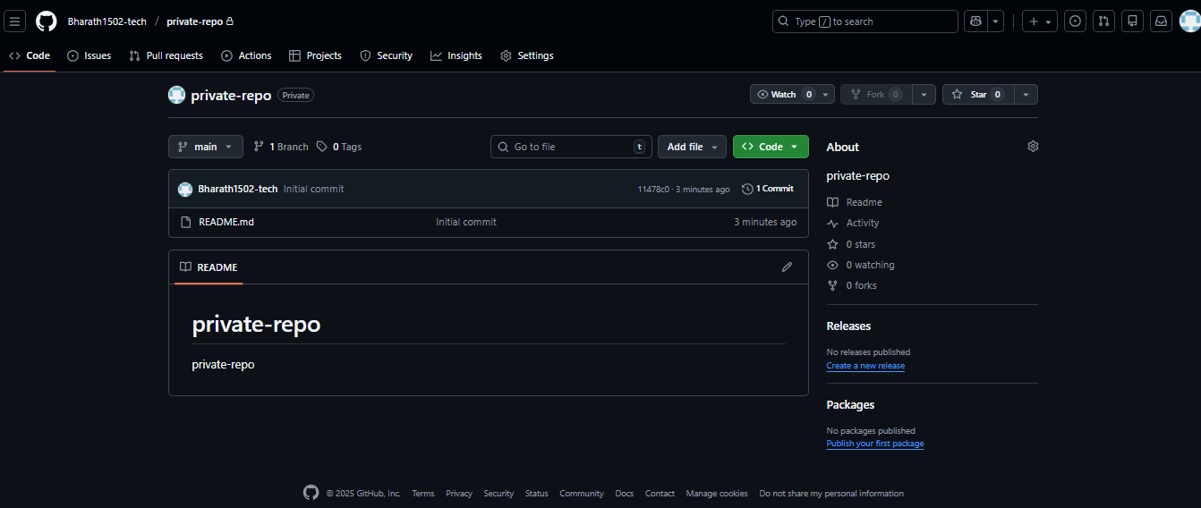
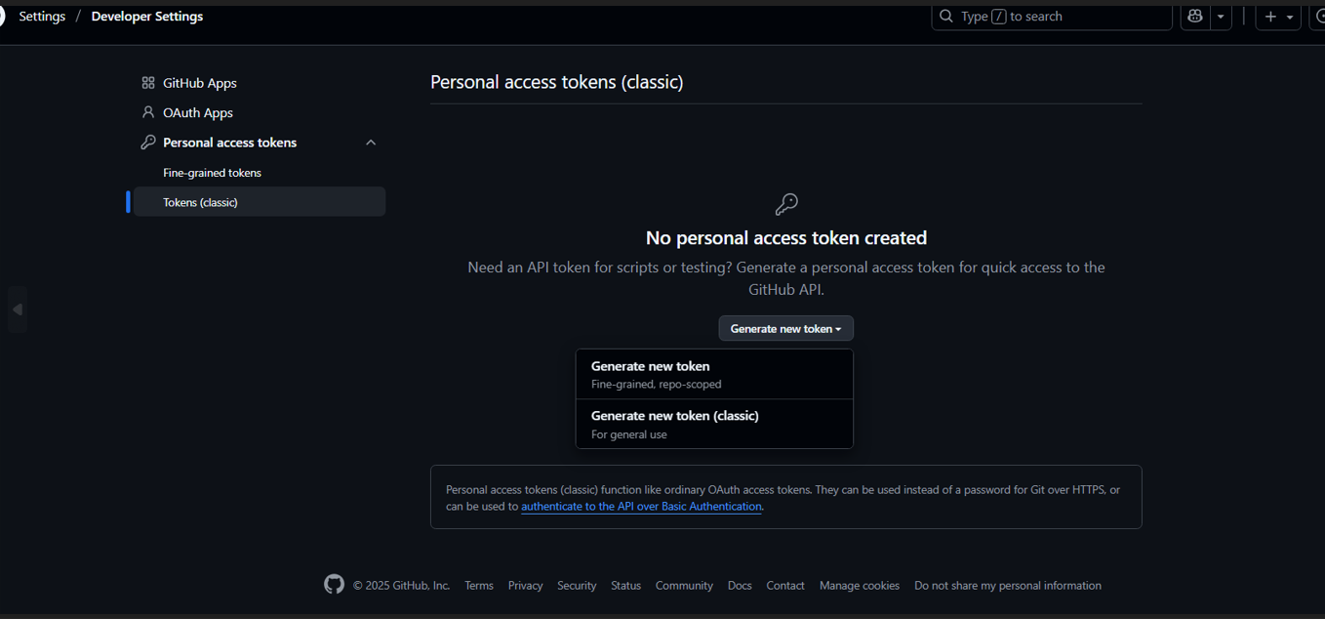
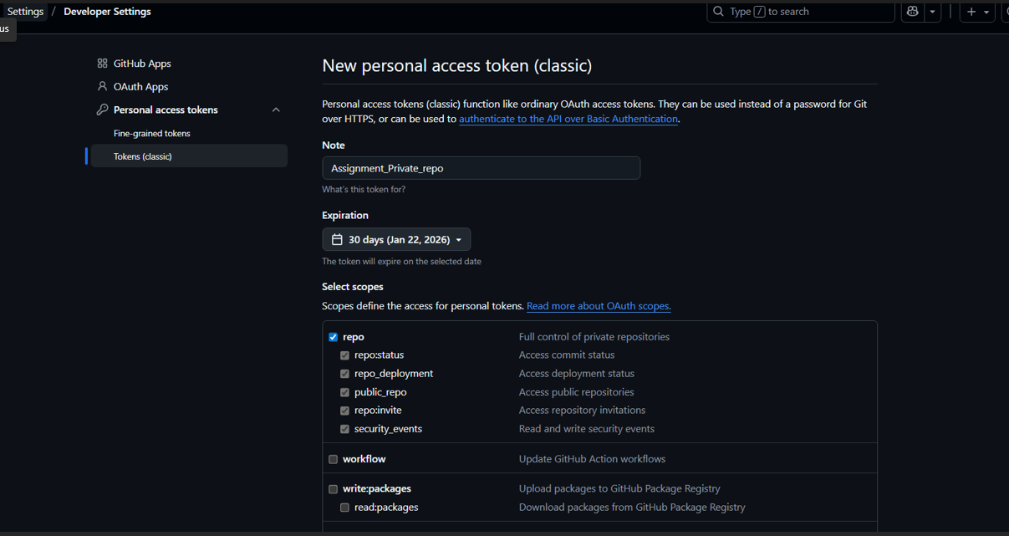
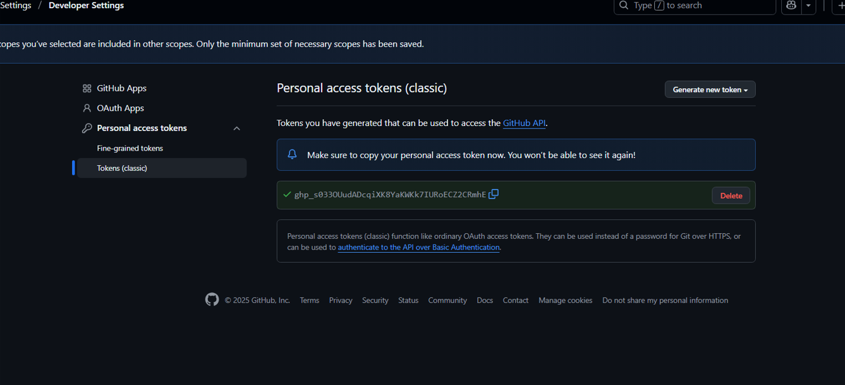

3. Create Jenkins Freestyle Job
- Opened Jenkins dashboard.
- Clicked New Item.
- Entered job name: private_job.
- Selected Freestyle project.
- Clicked OK.

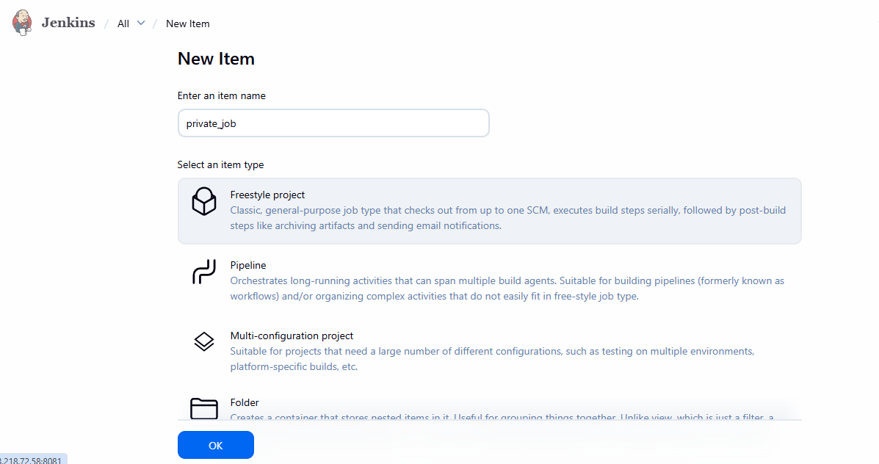

4. Configure GitHub Credentials in Jenkins
- Navigated to Source Code Management → Git.
- Entered repository URL:
- https://github.com/<username>/private-repo.git
- Added new credentials:
  - Kind: Username with password
  - Username: GitHub username
  - Password: GitHub Personal Access Token
  - ID: private-repo
- Saved credentials.

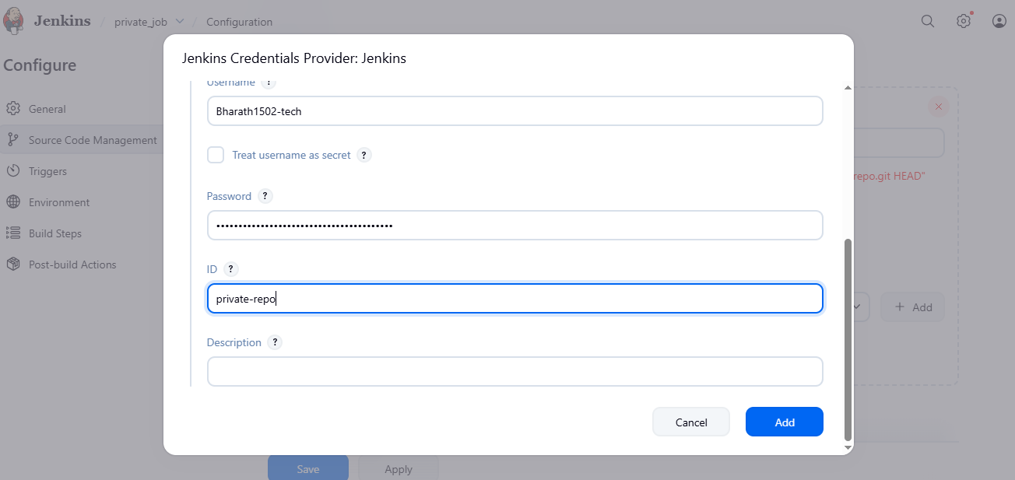

5. Configure Branch to Build
- In Branches to build, updated:
- */main
- Saved job configuration.

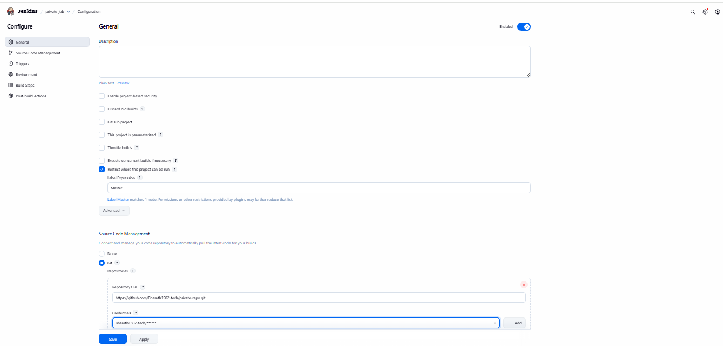
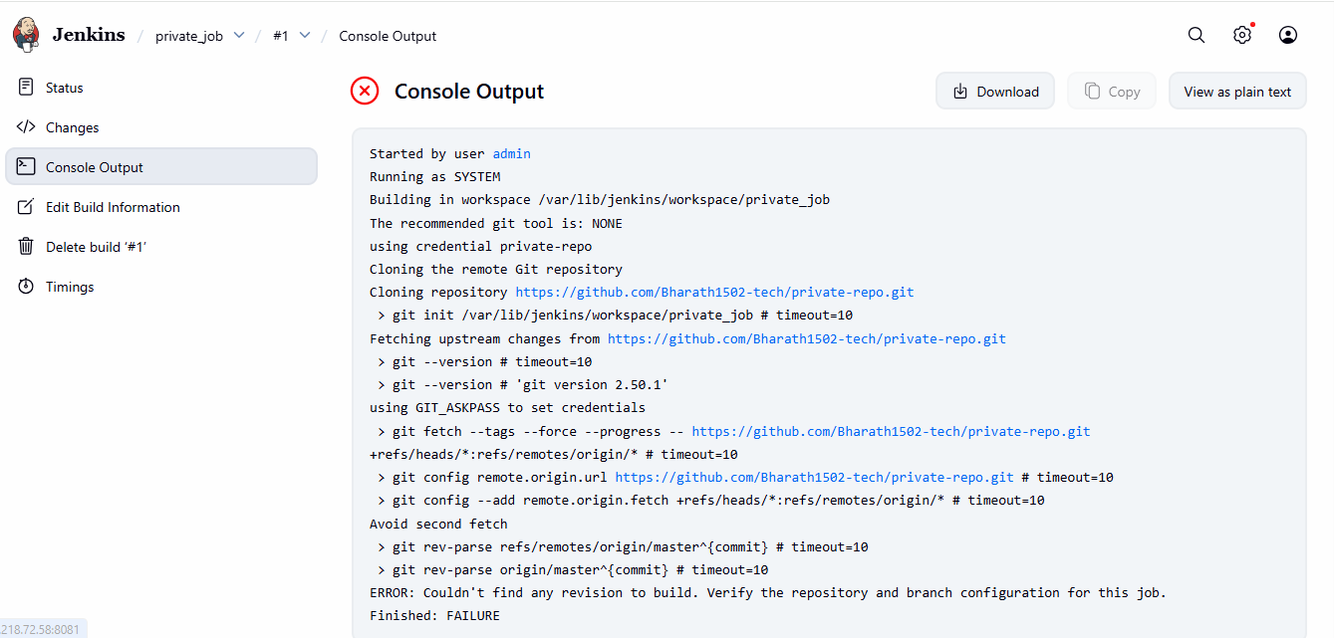

6. Build the Jenkins Job
- Clicked Build Now.
- Monitored build execution via Console Output.

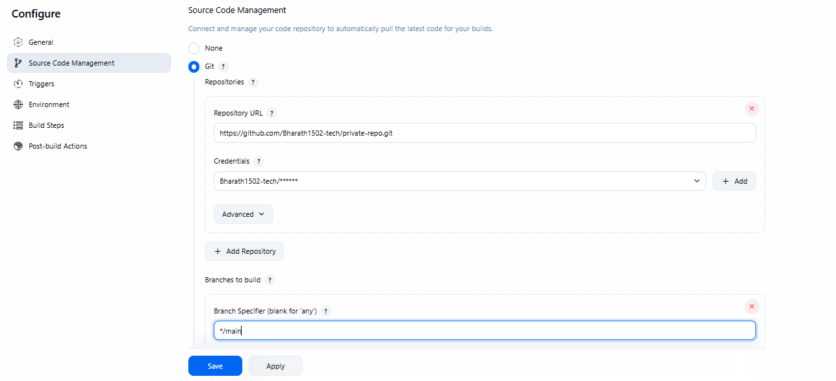
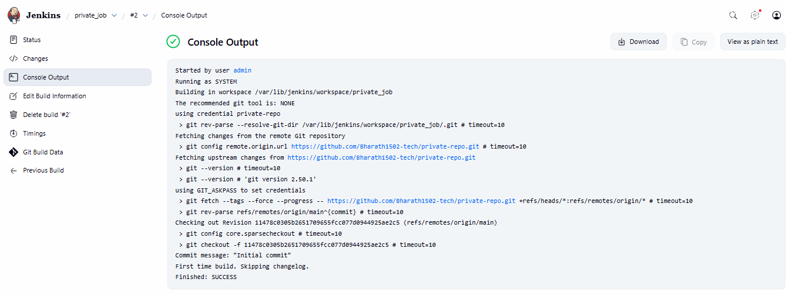

Validation Steps
- Jenkins successfully authenticated with GitHub using PAT.
- Repository was cloned without authentication errors.
- Console output confirmed:
  - Correct branch (main) detected.
  - Commit checked out successfully.
  - Build finished with SUCCESS status.
- Workspace contained README.md from the private repository.

Issues Faced
- Initial Build Failure
  - Error:
  - ERROR: Couldn't find any revision to build
  - Cause: Jenkins defaulted to master branch, but repository used main.
- Resolution
  - Updated branch specifier from */master to */main.
  - Re-ran the build.

Conclusion
The Jenkins job was successfully configured to access a private GitHub repository using a Personal Access Token. Proper credential management and correct branch configuration resolved authentication and revision issues. This setup enables secure CI integration for private repositories and serves as a foundation for future pipeline or automated build configurations.

