Jenkins-02

- Configure 2 slave machines in Jenkins master.

Task Title
Configure Jenkins Slave Nodes on AWS EC2 Instances

Objective
To create and configure EC2 instances as Jenkins slave nodes, install required dependencies, set up SSH-based authentication, and establish communication between Jenkins master and the slave nodes.

Prerequisites
- AWS account access with EC2 privileges
- Existing Jenkins Master server configured
- SSH key pair for EC2 access
- Security groups allowing:
  - Port 22 (SSH)
  - Port 8080 (Jenkins) for master
- Internet connectivity on instances
- IAM role or permissions for EC2 management

Step-by-Step Implementation

1. Launch Slave EC2 Instances
- Go to AWS EC2 → Launch instance
- AMI: Amazon Linux 2023
- Instance type: t3.micro
- Name:
  - slave-01
  - slave-02
- Storage: Default (8 GB)
- Configure Network:
  - Same VPC and Subnet as Jenkins master
- Launch the instances

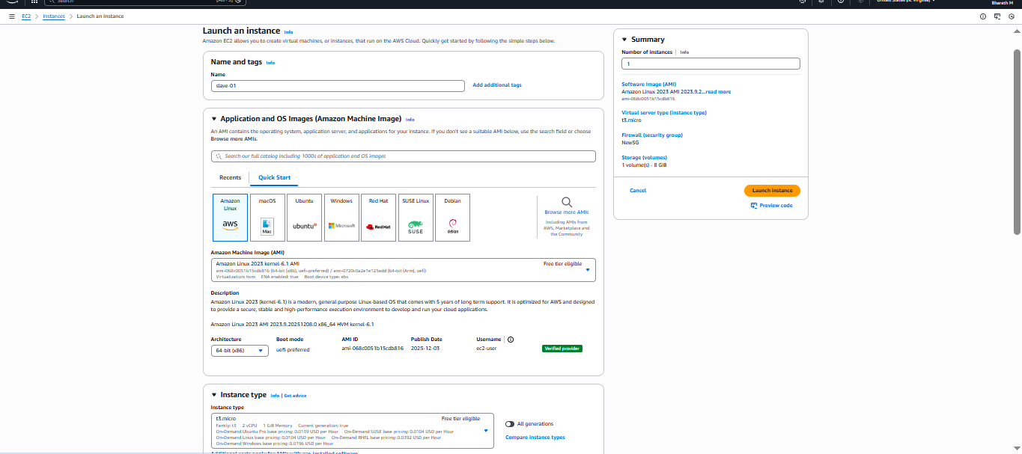
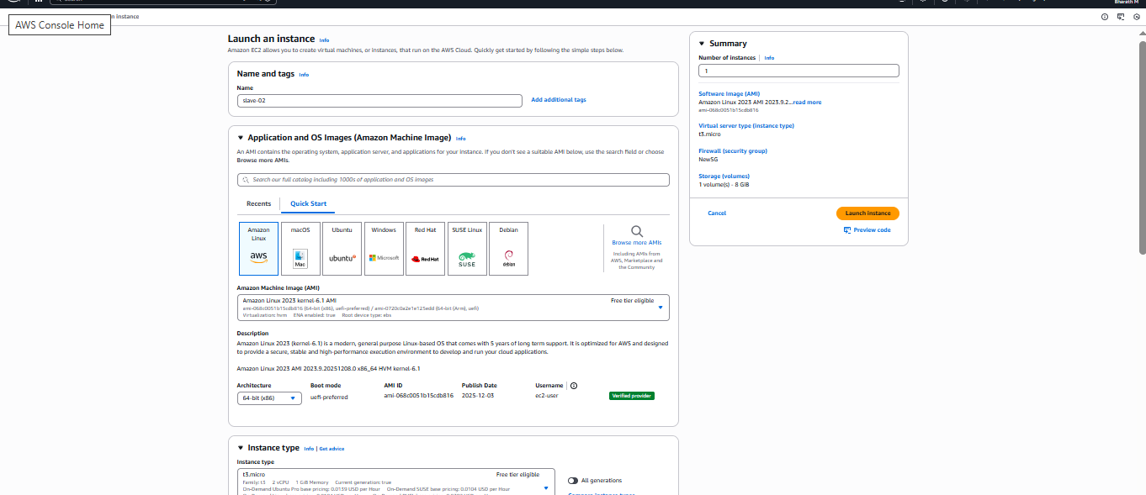
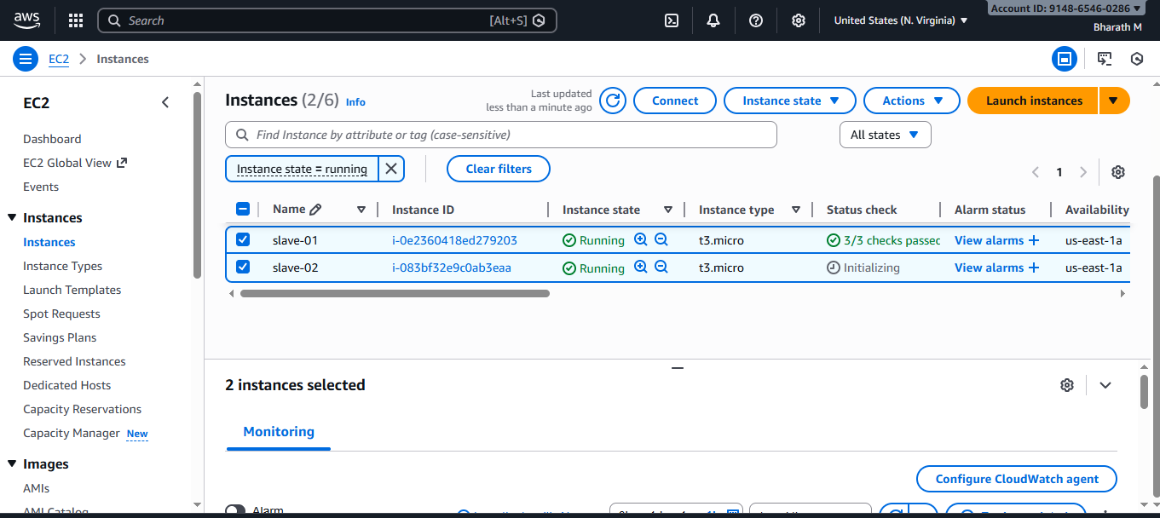

2. Install Java on Each Slave Node
sudo yum install java-17-amazon-corretto -y
java --version
📌 Expected output: OpenJDK 17.0.x

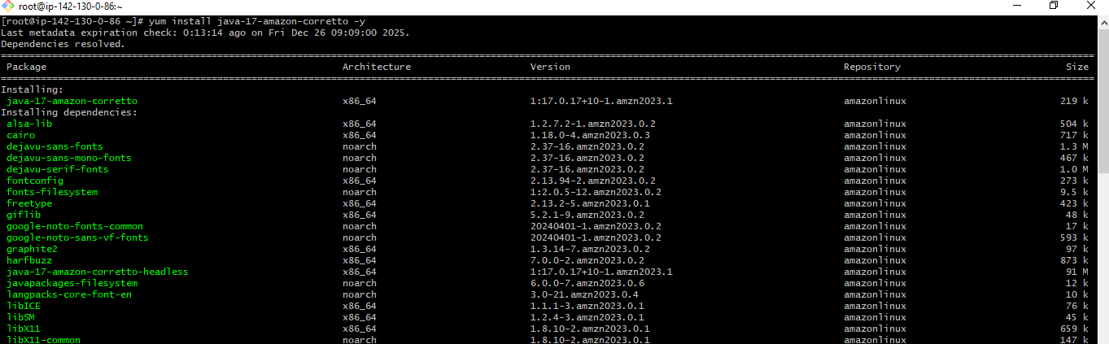
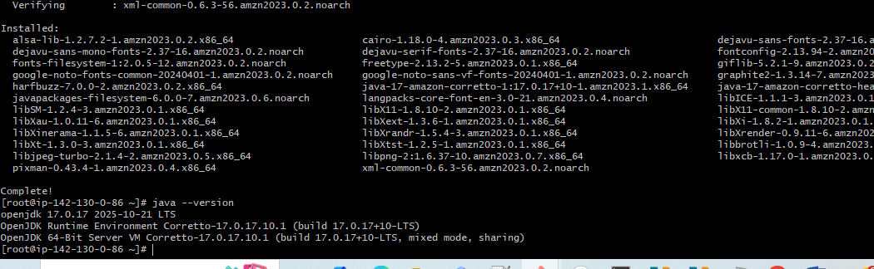

3. Create Workspace and SSH Keys
mkdir slave_workspace
ssh-keygen
- Save keys to default: /root/.ssh/id_rsa
- Copy public key to authorized keys:
cd ~/.ssh
cat id_rsa.pub > authorized_keys
chmod 700 authorized_keys
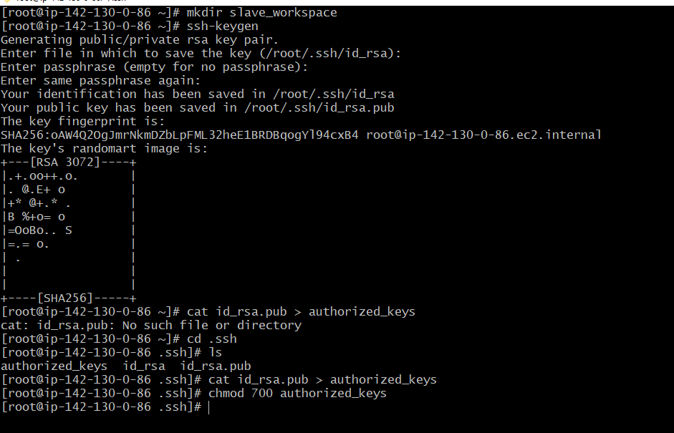

4. Install Git
sudo yum install git -y

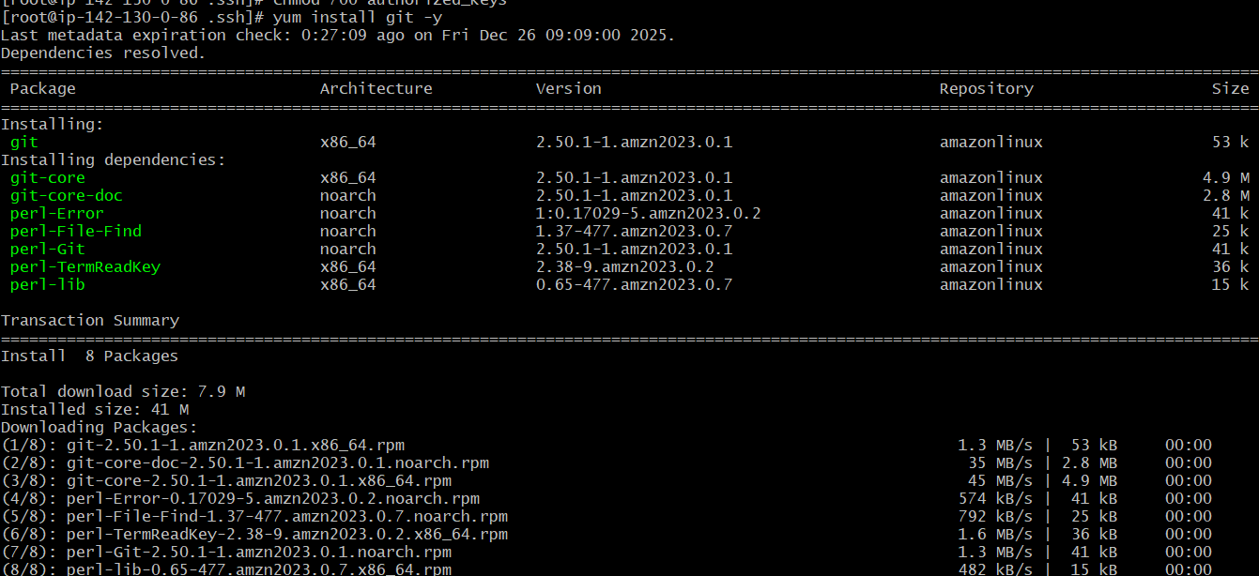

5. Configure SSH Access for Jenkins User (Master)
On Jenkins master:
mkdir -p /var/lib/jenkins/.ssh
cd /var/lib/jenkins/.ssh
ssh-keyscan -H <SLAVE_PUBLIC_IP> >> known_hosts
chown jenkins:jenkins known_hosts
chmod 700 known_hosts

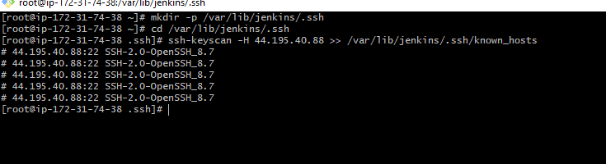
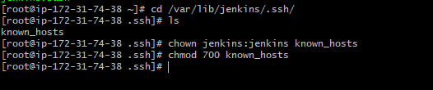

6. Add Slave in Jenkins UI
- Go to Jenkins → Manage Jenkins → Manage Nodes
- Click New Node
- Enter name: slave-01
- Node type: Permanent Agent
- Remote root directory: /slave_workspace
- Launch Method: Launch agents via SSH
  - Host: <Slave Node Public IP>
  - Credentials: SSH key from master (id_rsa)
- Save and connect
✔ Repeat for second slave

Jenkins Slave Node Configuration

Navigate to Node Management
- Go to Manage Jenkins → Nodes
- Click on New Node
📌 Screenshot Reference:
(Manage Jenkins > Nodes page)
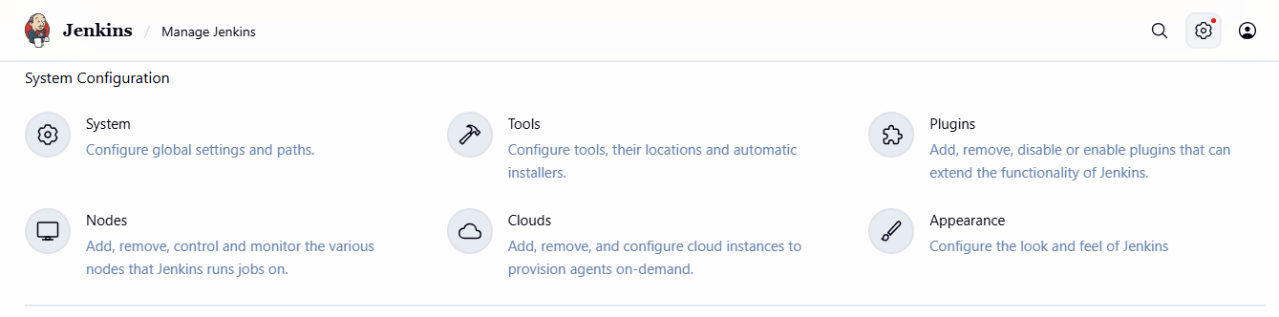
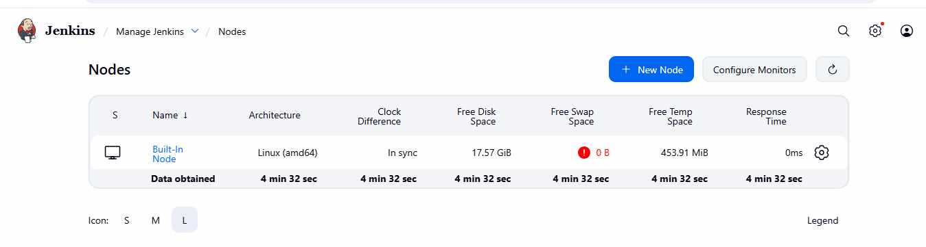

Create New Node
- Enter Node Name: slave-01
- Select Permanent Agent
- Click Create

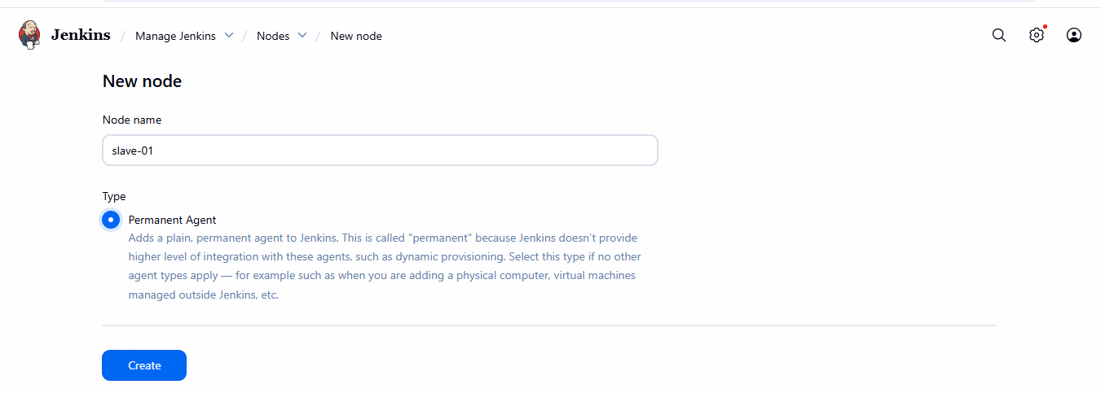

Configure Node Details
Field | Value
Name | slave-01
Description | slave for Java
Number of executors | 2
Remote root directory | /home/ec2-user (Absolute path recommended)
Labels | Java
Usage | Only build jobs with label matching this node
Launch Method | Launch agents via SSH

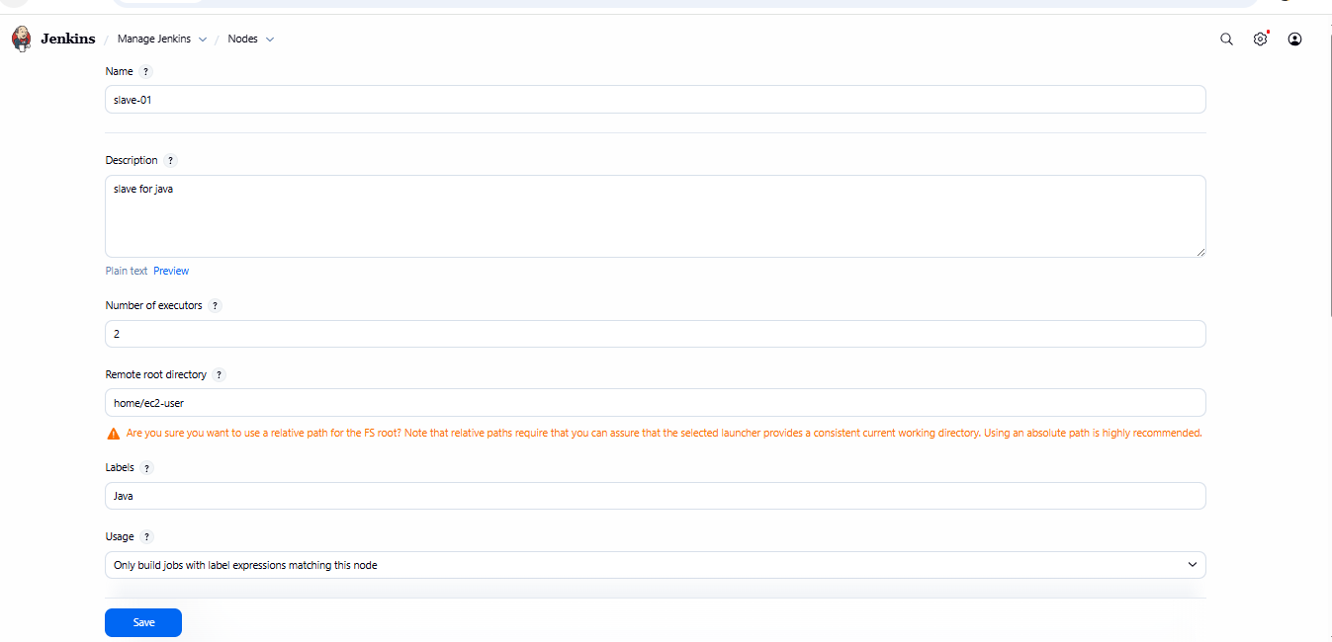

Add SSH Credentials
Manage Jenkins → Credentials → Global → Add Credentials
Option | Value
Kind | SSH Username with private key
ID | slave-01_key
Username | ec2-user
Private Key | Paste contents of id_rsa from slave
📌 Ensure:
chmod 600 /var/lib/jenkins/.ssh/id_rsa

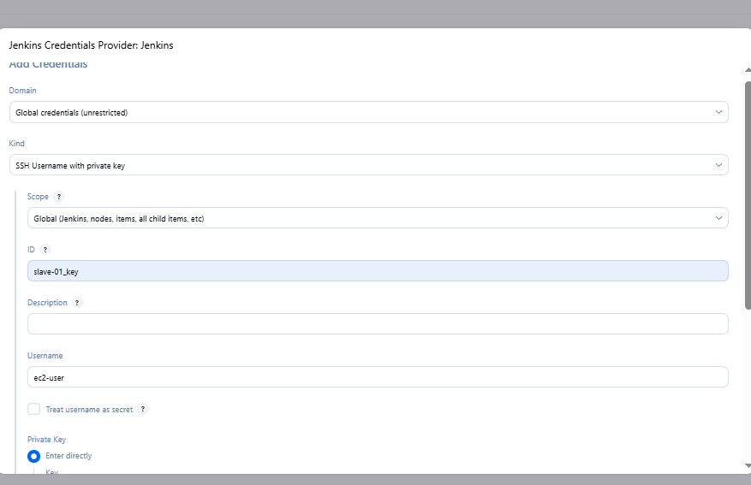

Link Credentials to Node
- In Node config → Select the SSH credential created
- Host = <Slave Public IP>
- Host key strategy = Known hosts file Verification Strategy

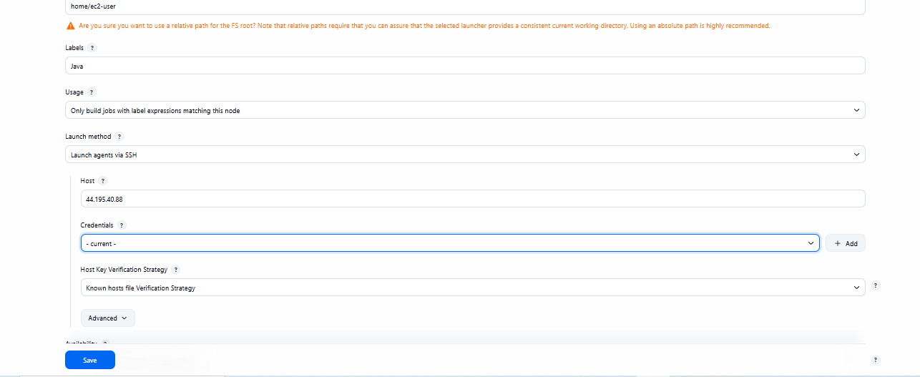

Save and Test Connection
- Click Save
- Jenkins will attempt automatic SSH connection
- Status should show: Connected

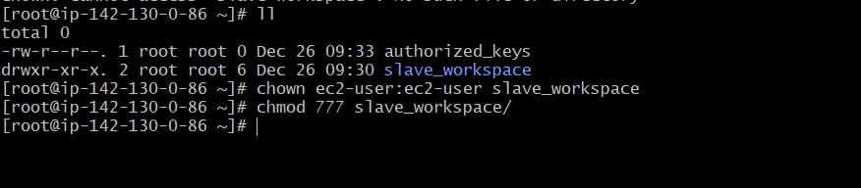
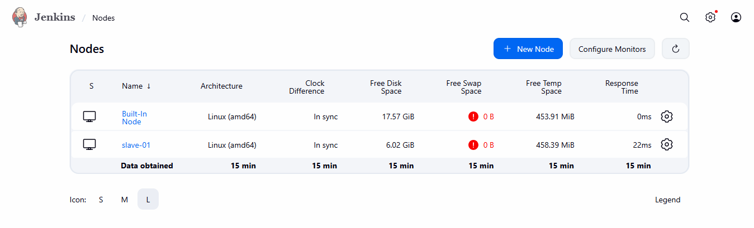

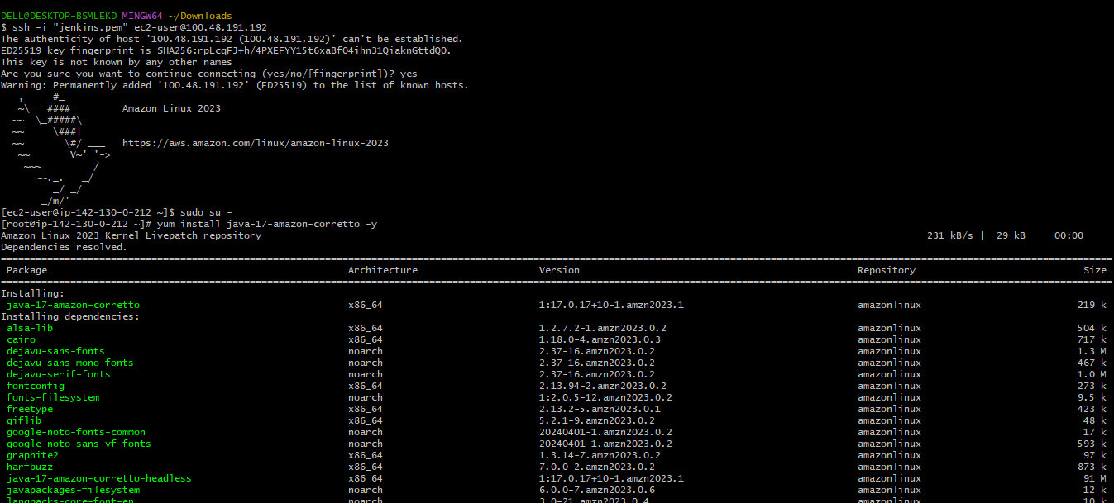
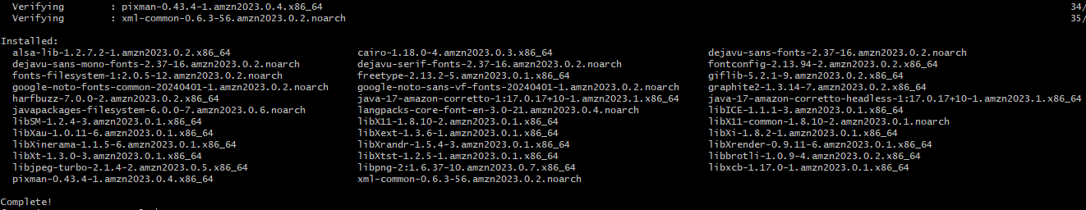
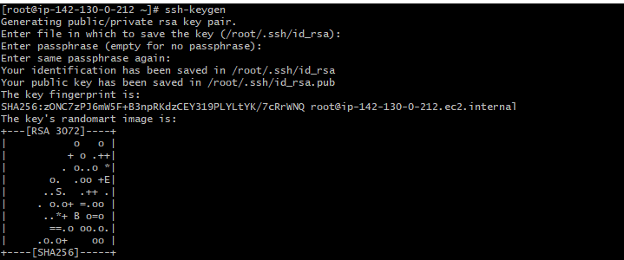
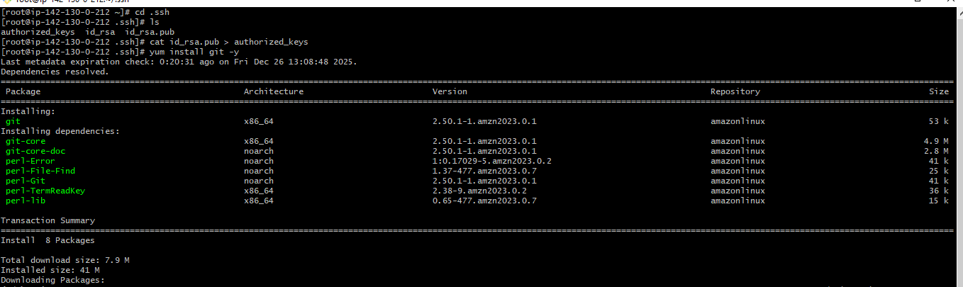
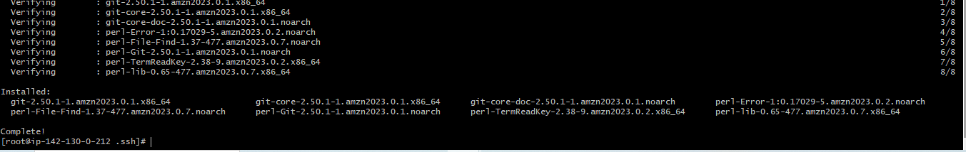
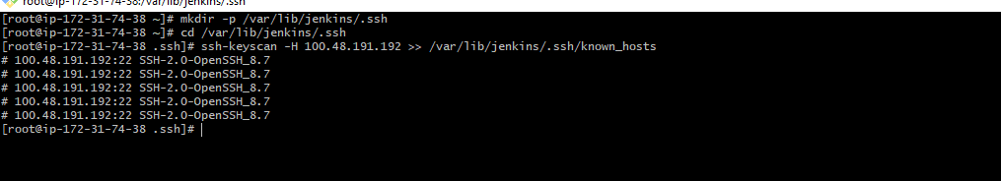
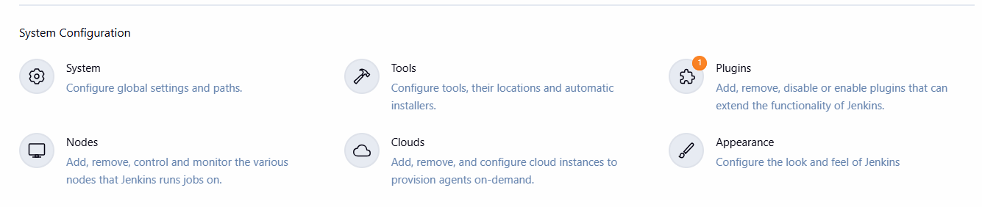
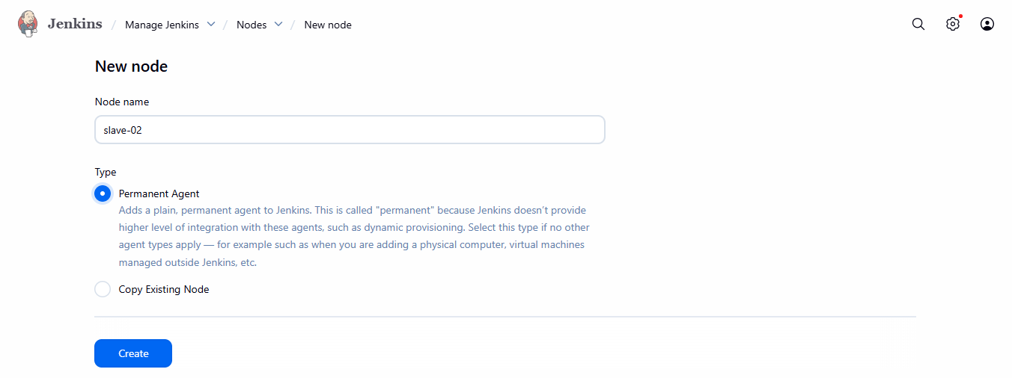
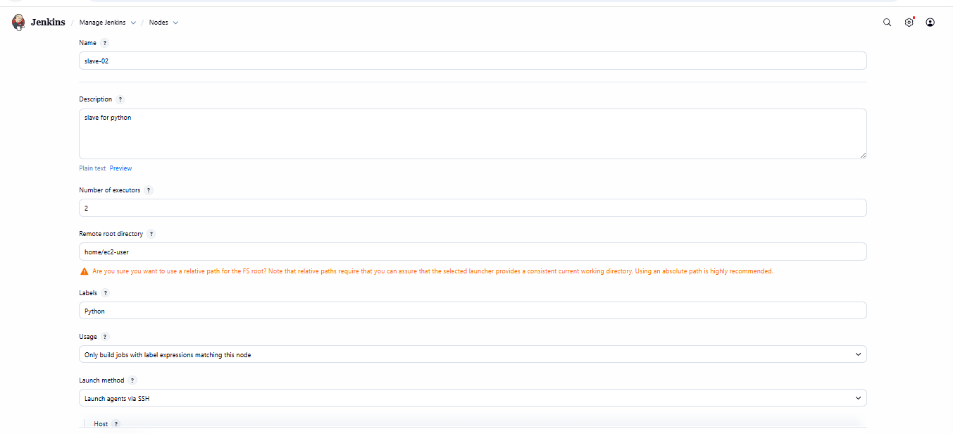
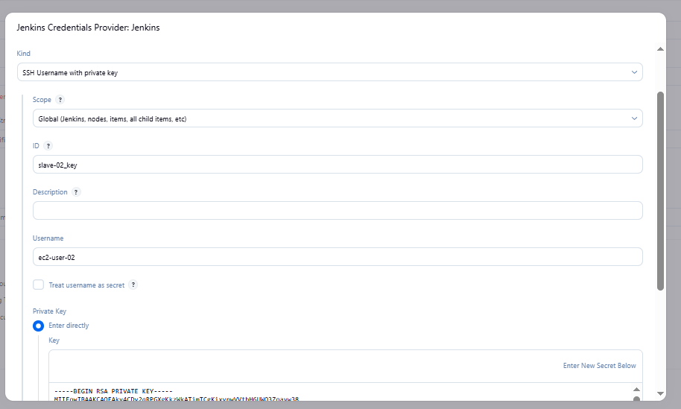
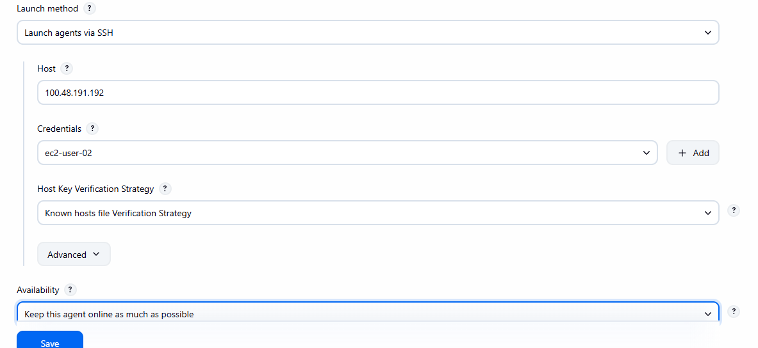
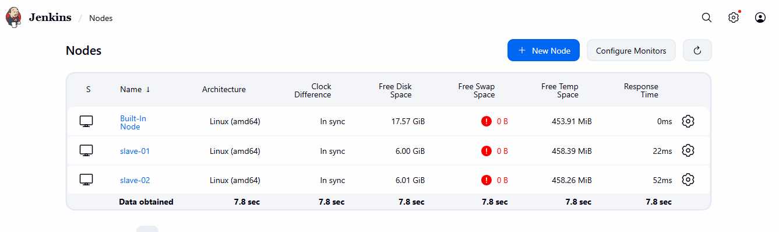

Conclusion for This Part
✔ Jenkins master successfully connected to slave-01 via SSH
✔ Slave node ready to execute jobs with label: Java
✔ System is now scalable for distributed CI/CD builds

Configure webhooks to Jenkins job.

Task Title
Configure GitHub Webhook to Trigger Jenkins Job Automatically

Objective
To automatically trigger a Jenkins job whenever a code change (push event) is made to the GitHub repository using a webhook integration.

Prerequisites
- Jenkins server installed and running (reachable from GitHub)
- GitHub account and repository
- Jenkins plugins installed:
  - Git Plugin
  - GitHub Integration Plugin (optional but helpful)
- Jenkins server public IP or domain accessible from GitHub (or use ngrok if on local machine)
- Basic Git understanding (push, commit)

Step-by-Step Implementation

Create a Freestyle Job in Jenkins
- Go to Jenkins Dashboard → New Item
- Enter name: webhook
- Select Freestyle Project
- Click OK

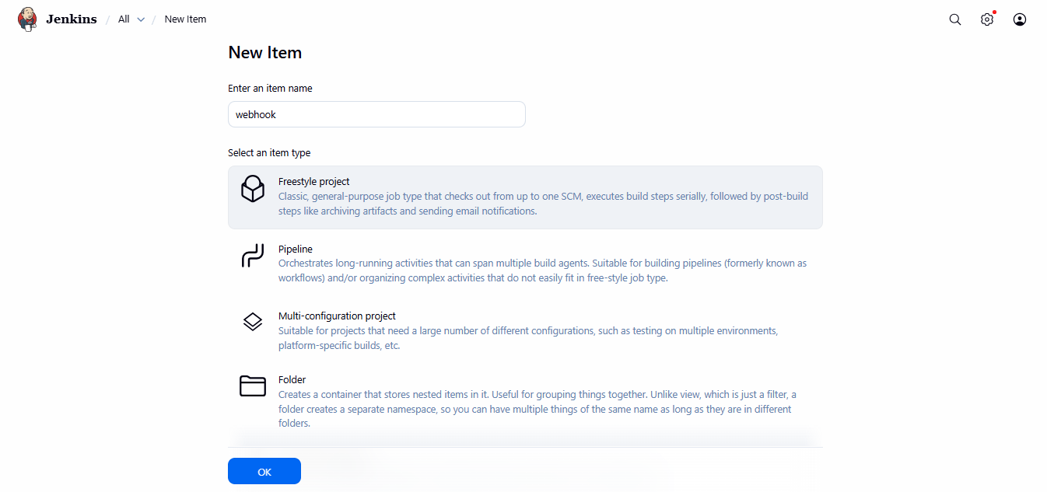

Configure GitHub Webhook
- Go to GitHub Repo → Settings → Webhooks → Add Webhook
- Payload URL:
- http://<Jenkins-Server-IP>:8081/github-webhook/
(example from screenshot: http://192.38.136.124:8081/github-webhook/)

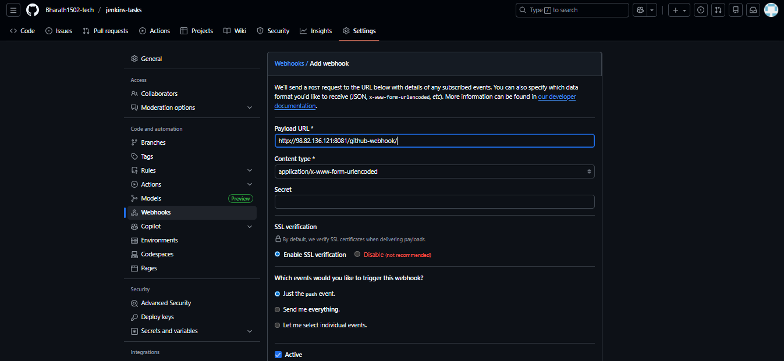
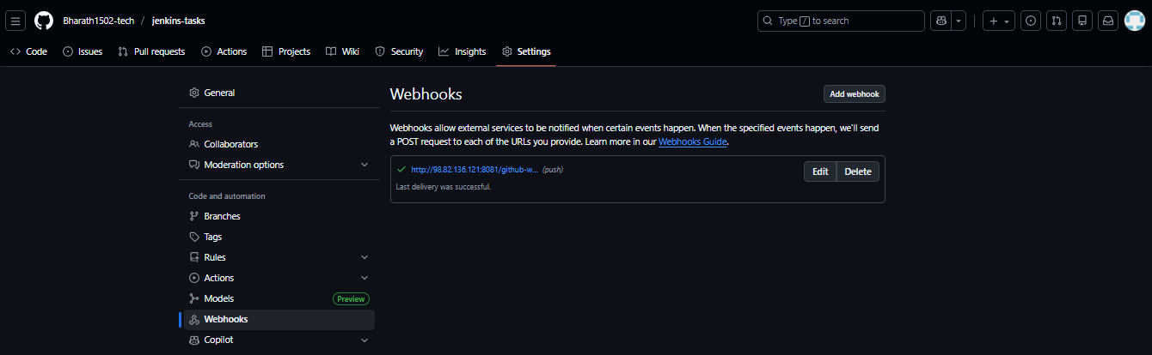

Configure Source Code Management
- In the Job configuration:
  - Select Git
  - Repository URL:
  - https://github.com/bharath1502-tech/jenkins-tasks.git
  - Branch to build:
*/main

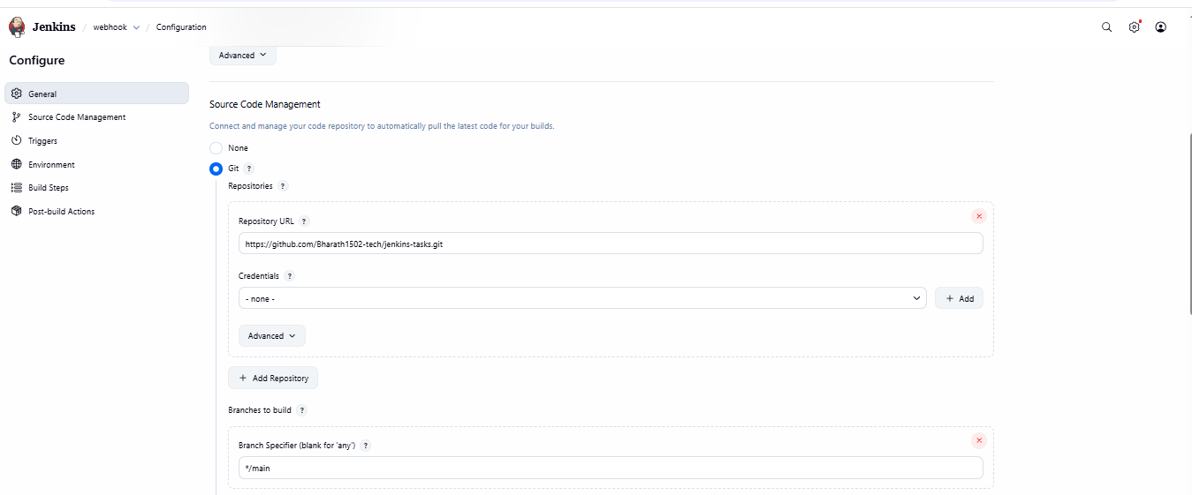

Set the Build Trigger
Check:
✔️ GitHub hook trigger for GITScm polling

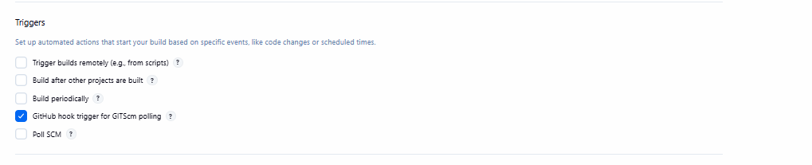
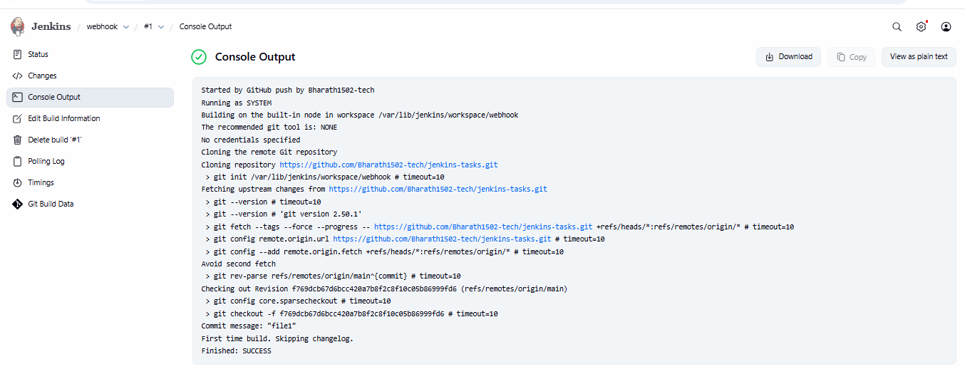
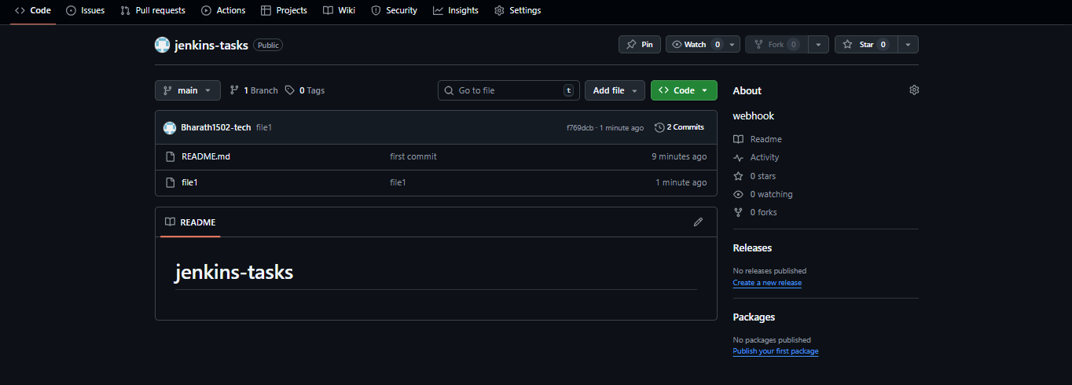
• Select event:
Just the push event
• Save webhook → Status should show "Last delivery successful"

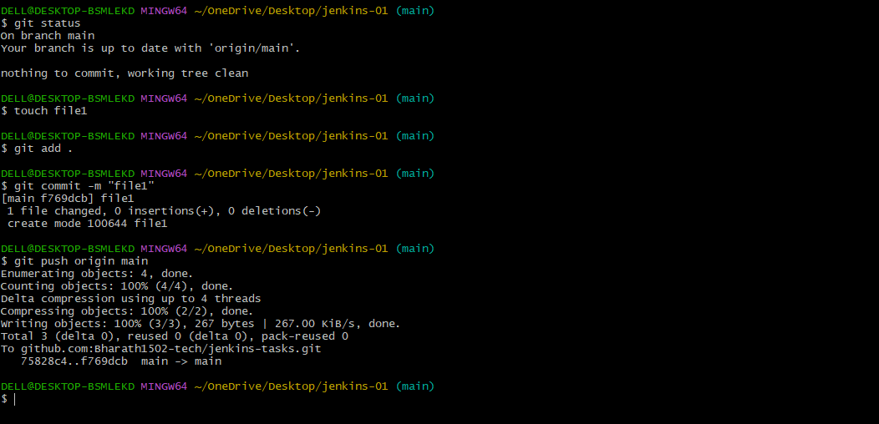

Validate Job Execution
- Make a change in repo:
- touch file1
- git add file1
- git commit -m "file1"
- git push origin main
- Check Jenkins → Build auto-starts
- Console Output should show successful build.

Configure poll scm and build periodical options in Jenkins job.

Task Title
Configure Jenkins Poll SCM and Build Periodically Jobs with GitHub Repository

Objective
To automate Jenkins job execution using two approaches:
- Poll SCM – Trigger builds whenever a change is detected in the GitHub repository.
- Build Periodically – Trigger builds at scheduled time intervals regardless of repository changes.

Prerequisites
- Jenkins installed and running
- Git installed and configured on Jenkins server
- GitHub account with a sample repository
- Jenkins plugins:
  - Git Plugin
- Internet connectivity on Jenkins server

Step-by-Step Implementation

A. Create Poll SCM Job
- Open Jenkins → Click New Item
- Enter Item Name: poll-scm
- Select Freestyle Project → Click OK
- Go to Source Code Management
  - Select Git
  - Repository URL:
  - https://github.com/Bharath1502-tech/jenkins-tasks.git
  - Branch to build:
*/main

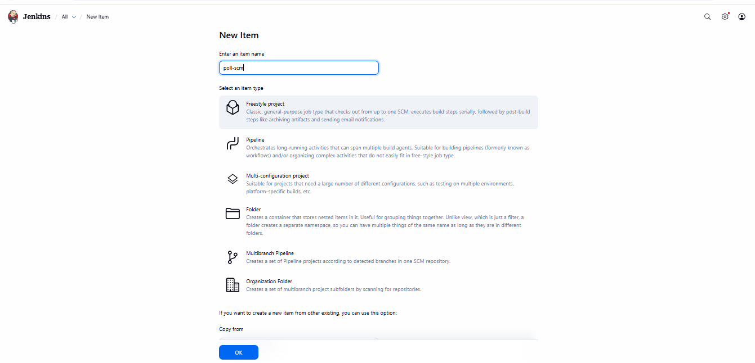
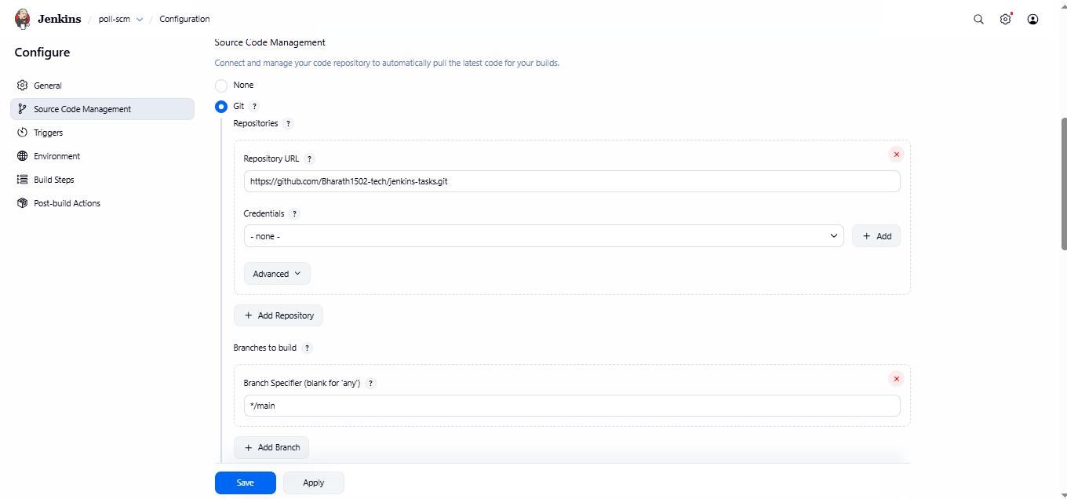

Go to Triggers
  - Enable Poll SCM
  - Set schedule:
  - * * * * *
(Checks for changes every 1 minute)
Click Save
📌 When you push changes using:
git add .
git commit -m "new change"
git push origin main
Jenkins detects changes and automatically triggers the build.

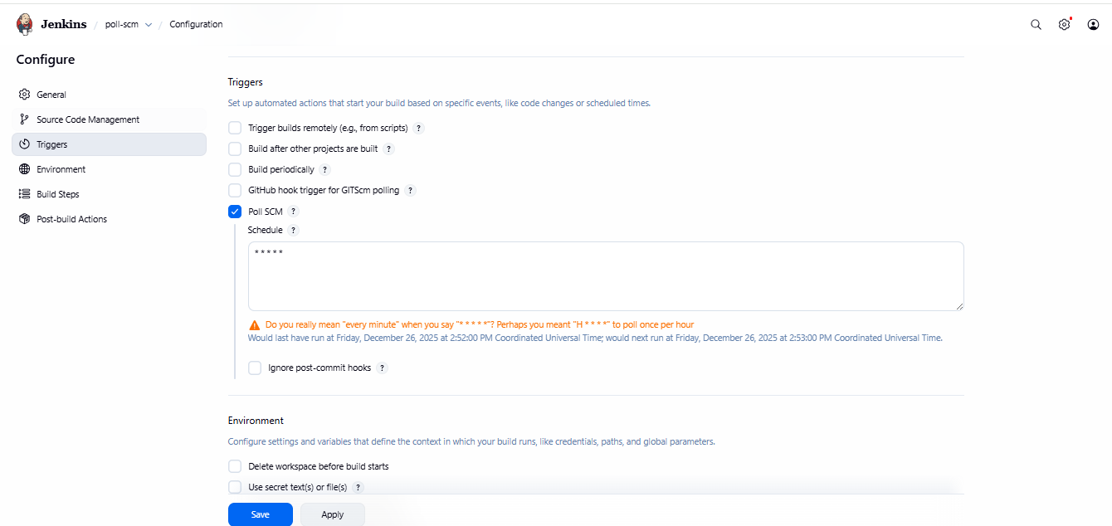
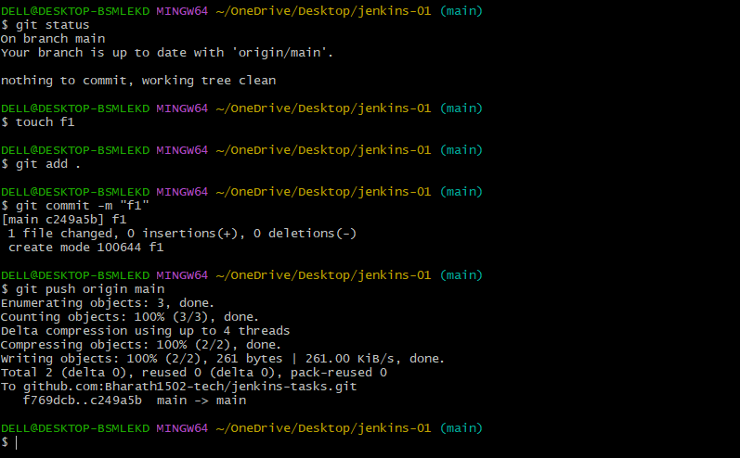
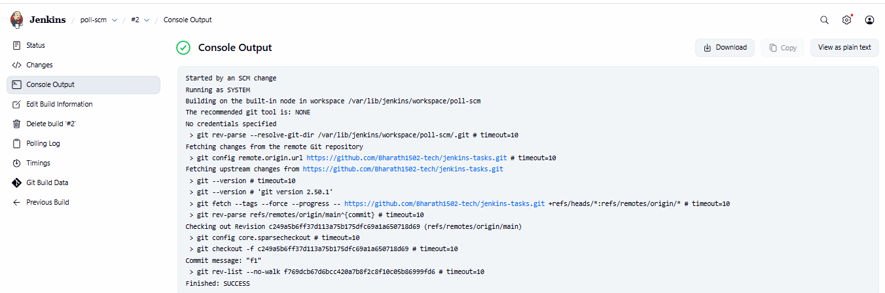
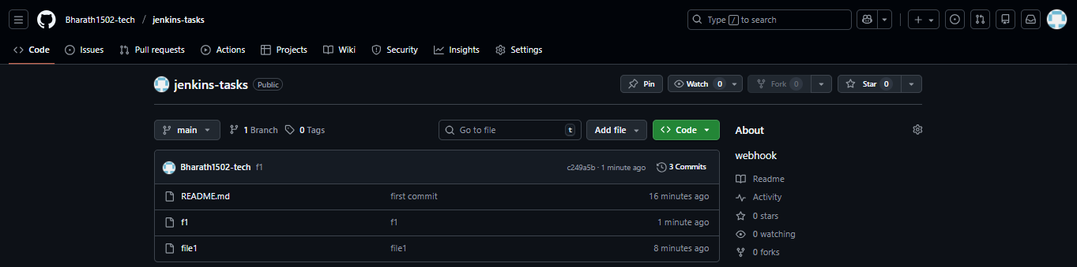

Create Build Periodically Job
- Go to Jenkins Dashboard → New Item
- Name: build-poll-scm
- Select Freestyle Project → OK
- Configure the same Git repository in Source Code Management
- Go to Triggers
  - Enable Build periodically
  - Enter schedule:
* * * * *
Click Save
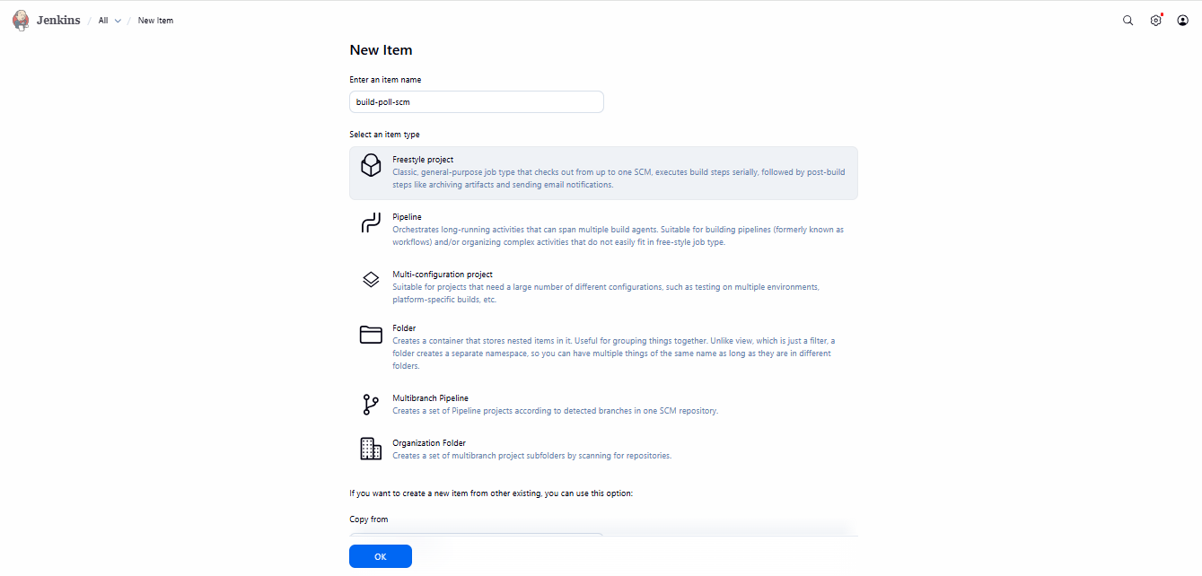
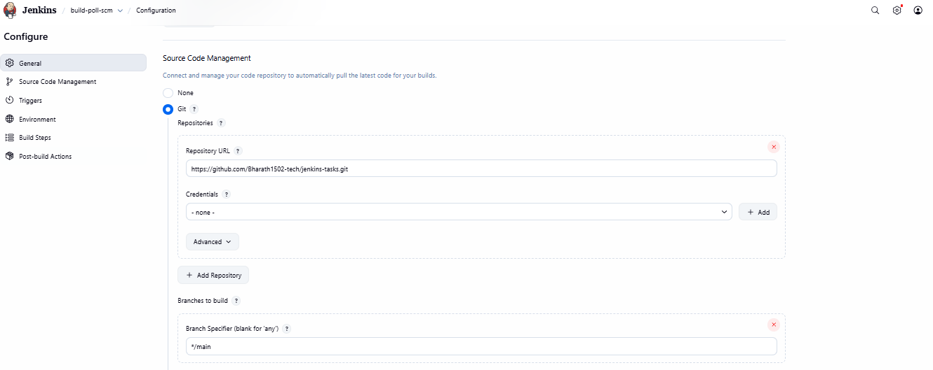
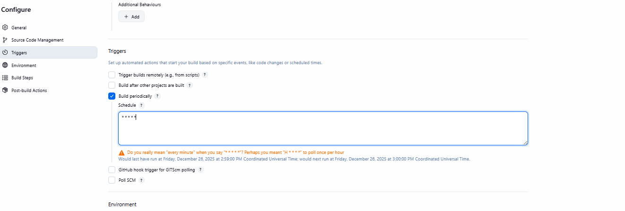
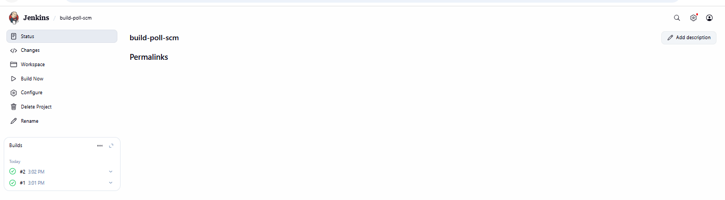

Validation Steps
- Push a new file or update to the GitHub repository and verify:
  - Poll SCM job is triggered automatically when a change is detected.
- Wait one minute and verify:
  - Build Periodic job executes automatically based on schedule.
- Check Console Output for success messages confirming:
Finished: SUCCESS

Issues Faced
Issue | Reason | Solution
Perhaps you meant 'H/5 * * * *' to poll once per hour warning | Jenkins interprets * * * * * as “every minute” | Ignore if intentional or specify exact need
No credentials added | Public repository allowed access | No action required
Build didn’t trigger | No new commits in repo (for Poll SCM) | Make a file change and commit again

Conclusion
- Successfully configured two Jenkins jobs:
  - Poll SCM: Runs only when commits are pushed.
  - Build periodically: Runs as per schedule irrespective of changes.
- Validated via Git updates and Jenkins build history.
- Automation achieved for continuous integration using GitHub and Jenkins.

Take backup of Jenkins server by using bash script.

Task Title
Jenkins Master Backup Script Setup & Execution

Objective
To create and execute an automated backup script that archives Jenkins configurations, jobs, plugins, and related data from the Jenkins home directory into a compressed .tar.gz file for disaster recovery and migration purposes.

Prerequisites
- Jenkins installed and running on the server
- Root or sudo user access
- Default Jenkins home directory located at:
- /var/lib/jenkins
- Bash shell environment
- Sufficient disk space for storing backup files

Step-by-Step Implementation
- Create the Backup Script
- vi backup.bash
Paste the script (from your screenshot):
#!/bin/bash -xe
set -o pipefail
dates="$(date +%d%m%Y%H%M)"
readonly JENKINS_HOME="/var/lib/jenkins"
readonly DEST_FILE="/root"
readonly CUR_DIR="$(cd "$(dirname "${BASH_SOURCE[0]}")" && pwd)"
readonly TMP_DIR="${CUR_DIR}/tmp"
readonly ARC_NAME="jenkins-backup"
readonly ARC_DIR="${TMP_DIR}/${ARC_NAME}"
readonly TMP_TAR_NAME="${TMP_DIR}/${dates}.tar.gz"

cleanup () {
rm -rf "${ARC_DIR}"
}

main() {
mkdir -p "${ARC_DIR}"
cd "${JENKINS_HOME}"
cp -r jobs plugins users secrets nodes workspace config.xml "${ARC_DIR}" 2>/dev/null || true
tar -czvf "${TMP_TAR_NAME}" "${ARC_DIR}" > /dev/null
mv "${TMP_TAR_NAME}" "${DEST_FILE}"
}

cleanup
main
cleanup
echo "Backup completed. File saved in ${DEST_FILE}/${dates}.tar.gz"

Give Script Execution Permission
chmod 755 backup.bash

Run the Backup Script
./backup.bash

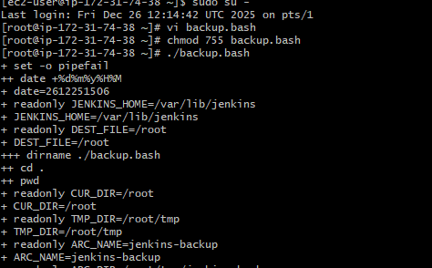
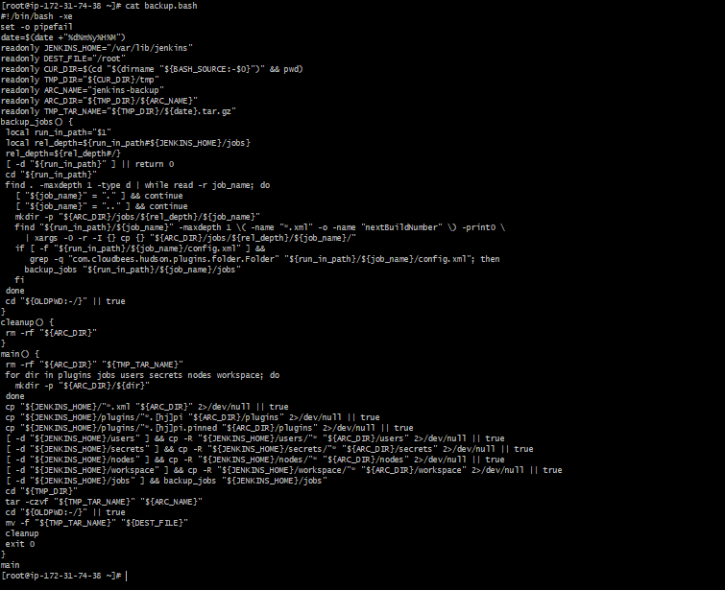
Verify Backup Output
ls -l /root
Expected result:
2612251506.tar.gz

Validation Steps
- Confirm backup file exists:
- ls -lh /root/*.tar.gz
- Check file contents:
- tar -tf /root/2612251506.tar.gz | head -20
- Ensure major folders are present:
  - jobs/
  - plugins/
  - workspace/
  - config.xml

Issues Faced
Issue | Cause | Resolution
Missing folders in tar | Some folders empty or permissions denied | Run script as root or add error-handling flags
Date format mismatch | Incorrect date variable formatting | Use consistent date +%d%m%Y%H%M
Jenkins running file locks | Jenkins service active during backup | Optional: stop Jenkins before backup (not mandatory)

Conclusion
The Jenkins backup script was successfully configured and executed. A timestamped compressed backup file (2612251506.tar.gz) was generated containing Jenkins configurations, jobs, plugins, and workspaces. This backup can be used for server migration, disaster recovery, or Jenkins restoration by extracting it into the Jenkins home directory on a new instance.

Setup a new Jenkins server and dump the backup taken in task4.

Task Title
Launch EC2 Instance and Install Jenkins Automatically using User Data Script

Objective
To provision an Amazon Linux 2023 EC2 instance, configure network and security rules, and automatically install Jenkins during instance boot using a cloud-init (User Data) script. Also, validate server access and transfer backup files for Jenkins.

Prerequisites
- AWS Account with EC2 launch permissions
- SSH Key Pair (.pem file)
- Basic Linux & AWS knowledge
- Internet access in the instance (public subnet)
- Jenkins backup file (optional for restore)

Step-by-Step Implementation

1. Launch EC2 Instance
- Service: EC2
- AMI: Amazon Linux 2023 AMI
- Instance Type: t3.micro (Free Tier eligible)
- Name Tag: backup-jenkins

2. Configure Network Settings
Setting | Value
VPC | Default (or custom)
Subnet | Any public subnet
Auto-assign Public IP | Enabled
Security Group | New SG

3. Security Group Rules
Type | Protocol | Port | Source
SSH | TCP | 22 | 0.0.0.0/0
HTTP | TCP | 80 | 0.0.0.0/0
HTTPS | TCP | 443 | 0.0.0.0/0
All traffic (Optional) | All | All | 0.0.0.0/0
⚠️ In Production, restrict SSH & traffic by IP ranges for security.

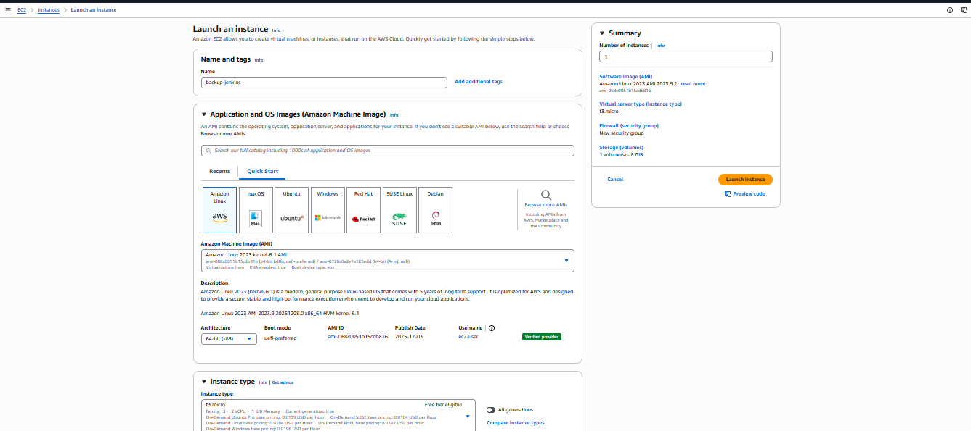
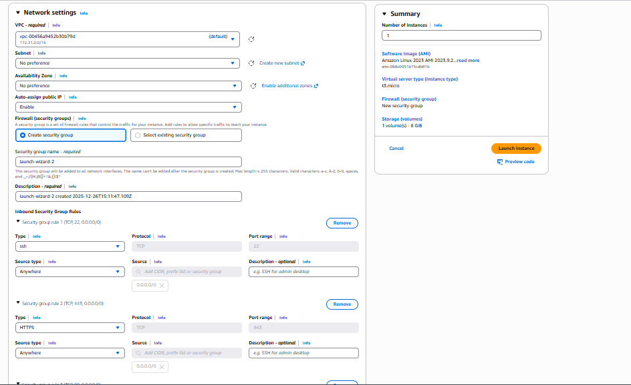
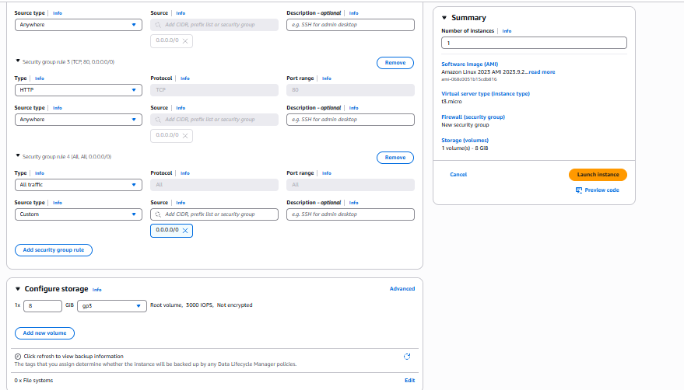

Add User Data Script
Used to auto-install Jenkins at first boot:
#!/bin/bash
set -e
sudo dnf update -y
sudo dnf install java-17-amazon-corretto -y
java -version

sudo wget -O /etc/yum.repos.d/jenkins.repo \
https://pkg.jenkins.io/redhat-stable/jenkins.repo

sudo rpm --import https://pkg.jenkins.io/redhat-stable/jenkins.io-2023.key
sudo dnf install jenkins -y

sudo systemctl enable jenkins
sudo systemctl start jenkins
sudo systemctl status jenkins

Validate Jenkins
- SSH into EC2
ssh -i jenkins.pem ec2-user@<EC2-Public-IP>
- Check Jenkins status:
sudo systemctl status jenkins
- Access Jenkins in Browser:
http://<EC2-Public-IP>:8080
- Get Administrator password:
sudo cat /var/lib/jenkins/secrets/initialAdminPassword

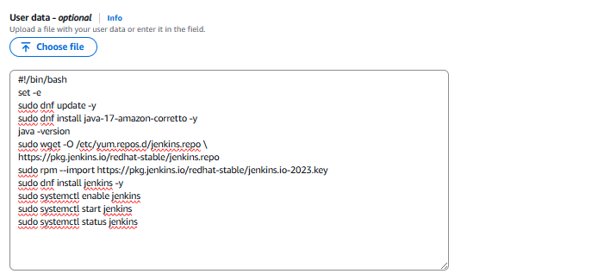

Transfer Jenkins Backup
From one server to another via SCP:
scp -i jenkins.pem 20221251506.tar.gz ec2-user@<EC2-Public-IP>:/tmp

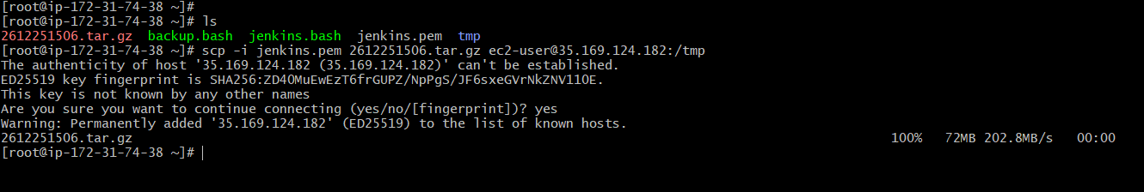

Validation Steps
✔️ Instance launched successfully
✔️ Jenkins auto-installed using User Data
✔️ Jenkins running on port 8080
✔️ Authentication password retrieved
✔️ Backup file transferred via SCP

Issues Faced
Issue | Reason | Resolution
Jenkins service failed to start | Missing Java | Installed Amazon Corretto 17 before Jenkins
Port access error | Security Group misconfiguration | Opened port 8080 or enabled HTTP/HTTPS
SCP connection warning | First-time fingerprint validation | Confirmed with yes prompt

Conclusion
The EC2 instance was successfully launched, configured with proper networking and security rules, and Jenkins was automatically installed using a startup script. SSH access was validated, and backup files were transferred for future restore. This setup ensures quick Jenkins deployment and reduces manual configuration time.

Take backup of Jenkins using rethin backup plugin.

Task Title
Jenkins ThinBackup Plugin Installation and Backup Configuration

Objective
To install the ThinBackup plugin on Jenkins and configure automated backups to safely store jobs, configurations, and credentials.

Prerequisites
- Jenkins server up and running
- Administrative access to Jenkins UI
- Root/Sudo access to server file system
- Sufficient storage space in backup directory

Step-by-Step Implementation

1. Install ThinBackup Plugin
- Login to Jenkins → Manage Jenkins
- Go to Plugins → Available plugins
- Search for ThinBackup
- Select the plugin → Click Install
- Wait for installation to complete → Restart Jenkins if required

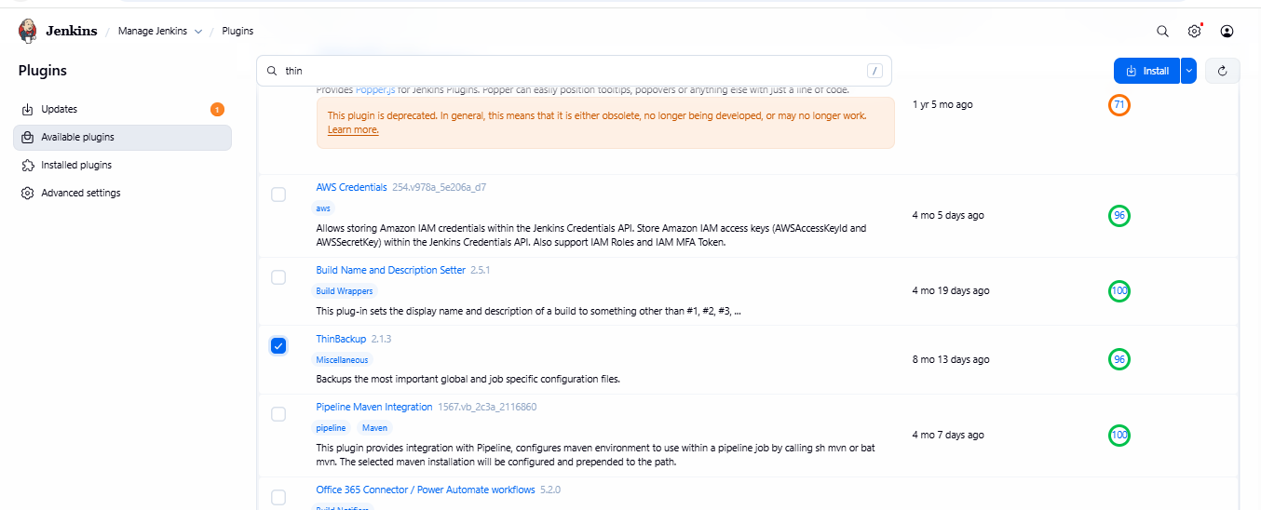
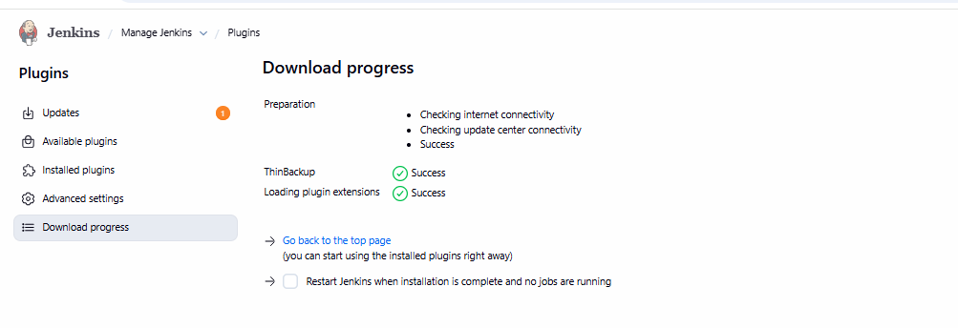

2. Configure Backup Directory
- Navigate to Manage Jenkins → ThinBackup
- Set Backup directory:
- /var/lib/jenkins/backup
- (Optional) Configure schedules:
  - Full Backup Schedule – Cron format (e.g., weekly)
  - Differential Backup – Between full backups
- Save the configuration

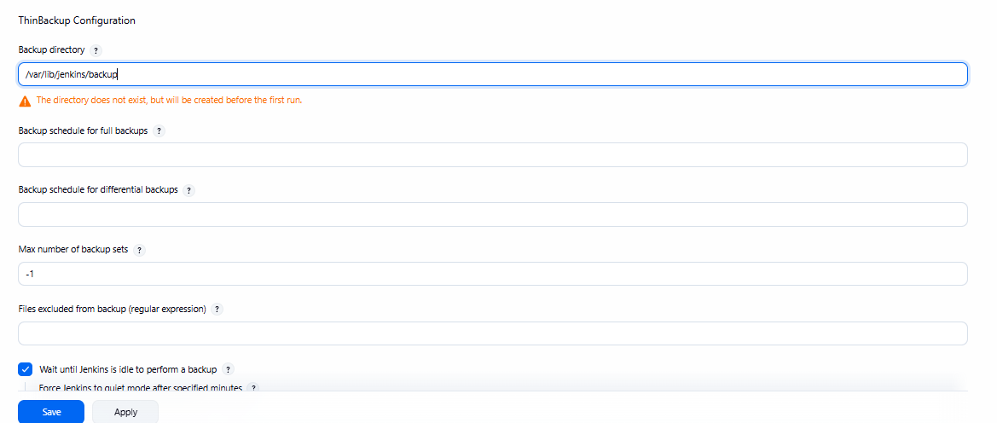

3. Create First Backup
- From the ThinBackup page → Click Backup Now
- Jenkins will generate a timestamped folder in the backup directory

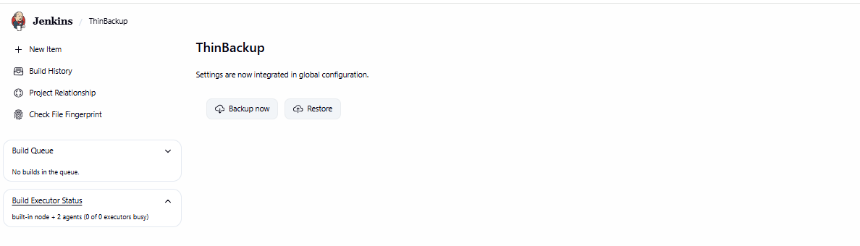
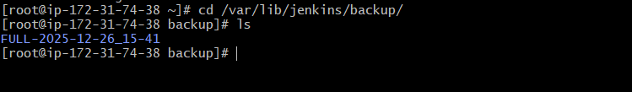

Validation Steps

Verify Backup Directory Creation
Run the following commands on Jenkins server:
cd /var/lib/jenkins/backup
ls
Expected Output Example:
FULL-2025-12-26_15-41

Check Backup Contents
cd FULL-2025-12-26_15-41
ls
Should include folders/files like:
config.xml
jobs/
plugins/
users/
credentials.xml

Issues Faced / Troubleshooting
Issue | Cause | Fix
Directory does not exist | Path not created | ThinBackup creates it on first run automatically
Backup fails due to permissions | Jenkins user not authorized | Run chown -R jenkins:jenkins /var/lib/jenkins/backup
Scheduling not working | Incorrect cron syntax | Validate cron format before saving

Conclusion
ThinBackup plugin is installed and configured successfully. Backups are being stored under:
/var/lib/jenkins/backup/
This ensures Jenkins configuration, jobs, and settings are secured and can be restored in case of system failures or migrations.

