CloudFront & Route 53

Configure VPC peering in cross regions.

Go to aws console
create on vpc in one region(Mumbai)
create public subnet
edit route tables 0.0.0.0/0 internet gateway
launch ec2 and add vpc and subnet
create on vpc in one region(Hyd)
create public subnet
edit route tables 0.0.0.0/0 internet gateway
launch ec2 and add vpc and subnet
inbound rules to all traffic

To Peer to another vpc which is in another region

Go to vpc peering you want to request to another vpc
create peering connection
add vpc id of requester and accepter

Go to another region vpc peering and accept the peering request
Go to route tables edit and add route of CIDR of another region vpc and target to peering connections
come another region vpc route table and add the CIDR of acceptor region target to peering connections

connect to the instance of requester ec2 region and ping to private ip of acceptor instance
peering connection will be successful.

peering connection will be successful.
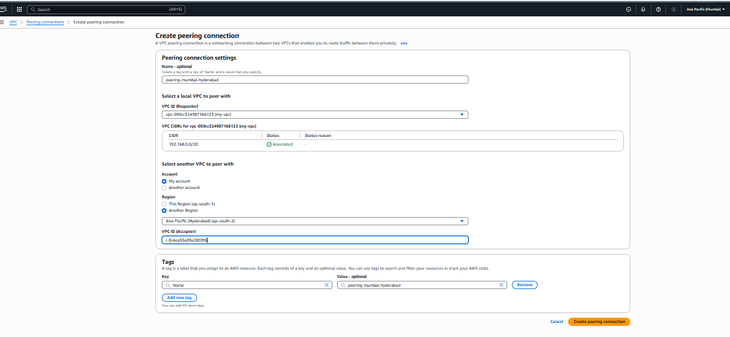

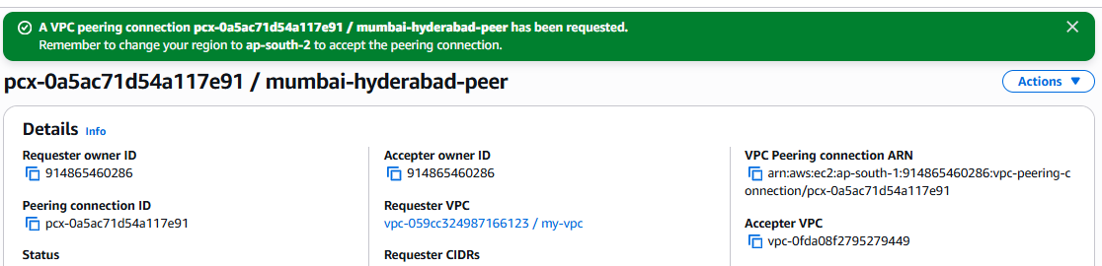

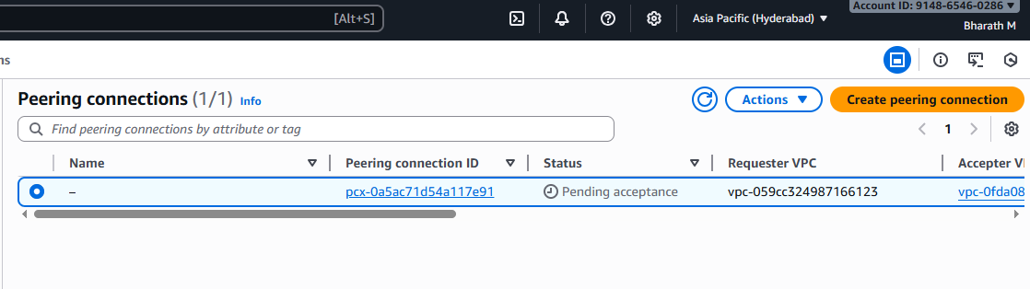
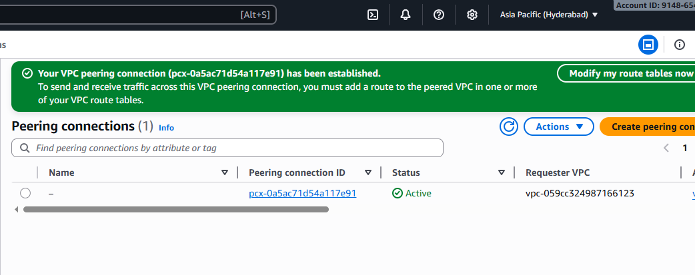
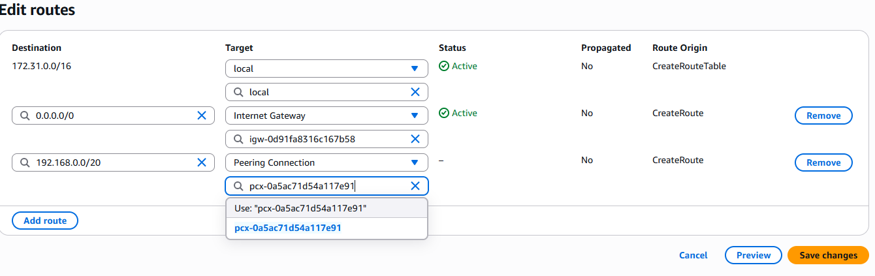
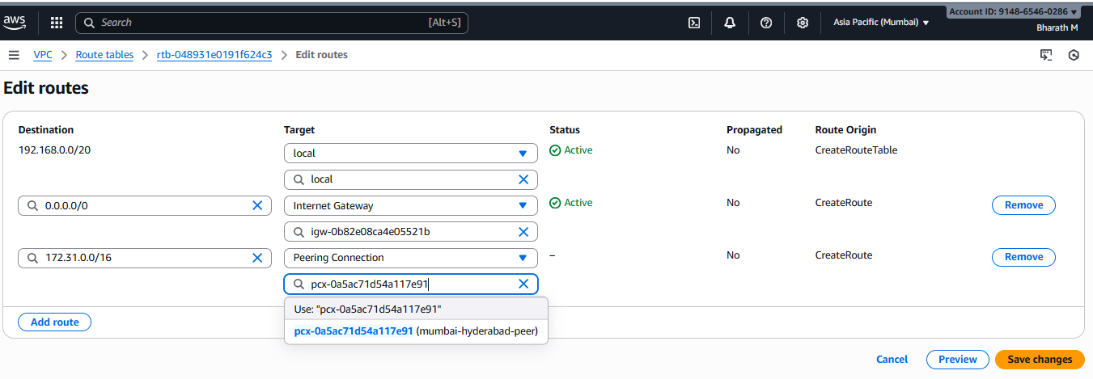

––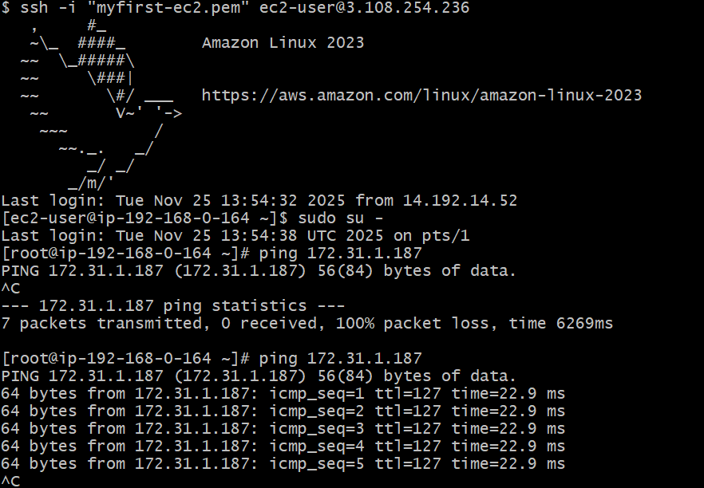

Purchase one domain from GoDaddy.
Purchased a domain with name “bharathindustries.online”

Deploy static website in S3.

Go to aws console and s3 service
Created a s3 bucket
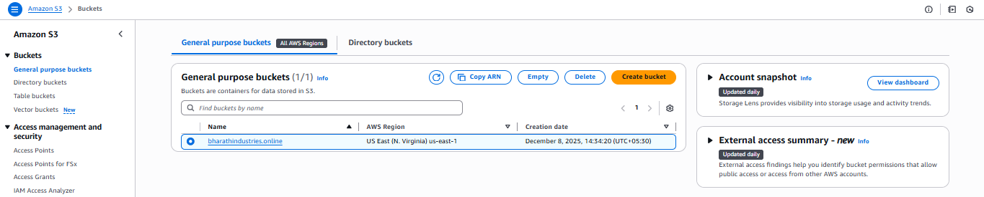
Upload the objects to the bucket
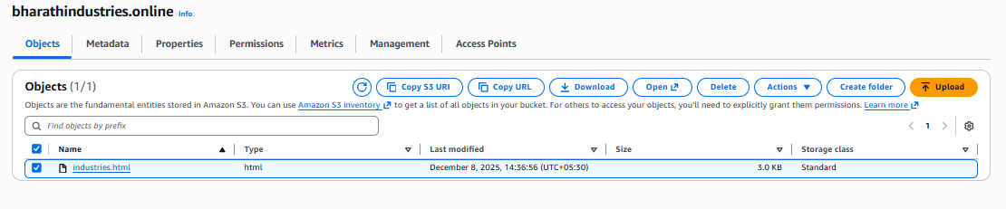
Go to properties and edit the static website hosting
Enable the static website hosting and hosting type as host a static website
Index document as the .html file name and save.
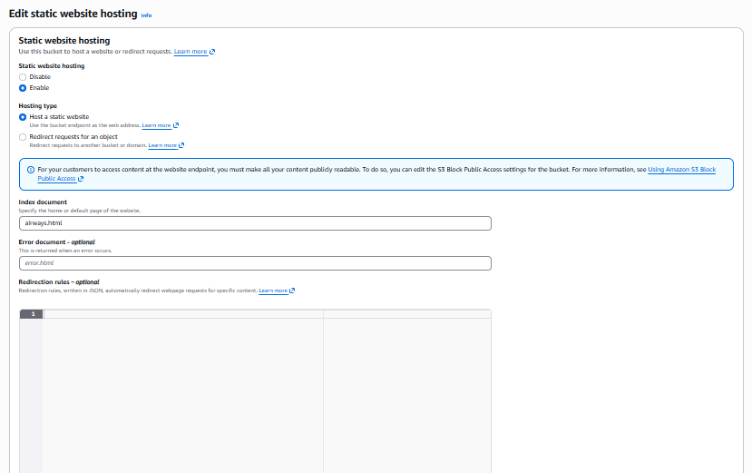

Check in browser we can see the static website.
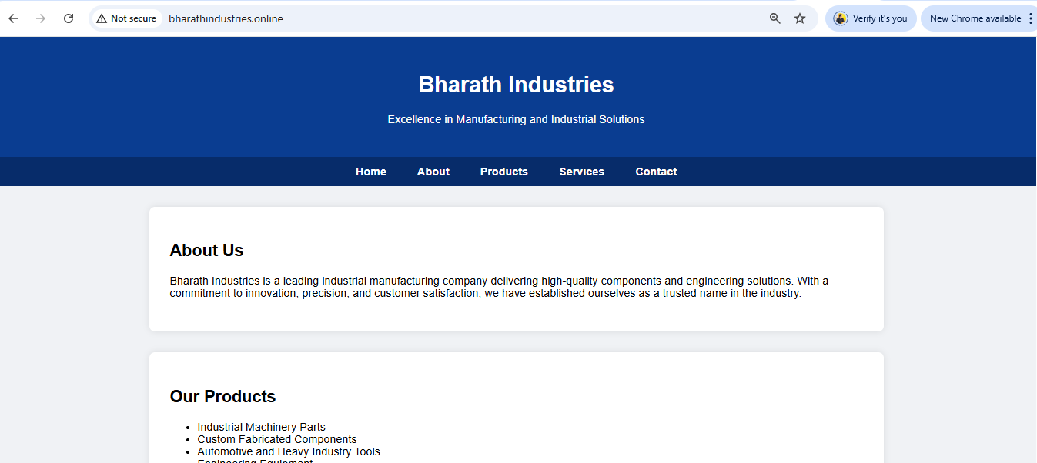

Create a CDN and attach one SSL certificate.
Create a Route 53 hosted zone and map the domain with the CDN.
Update the index.html in the S3 bucket and ensure the updated file is accessible using the domain name.

Go to aws console
Go to CloudWatch service
Create Disturbition.
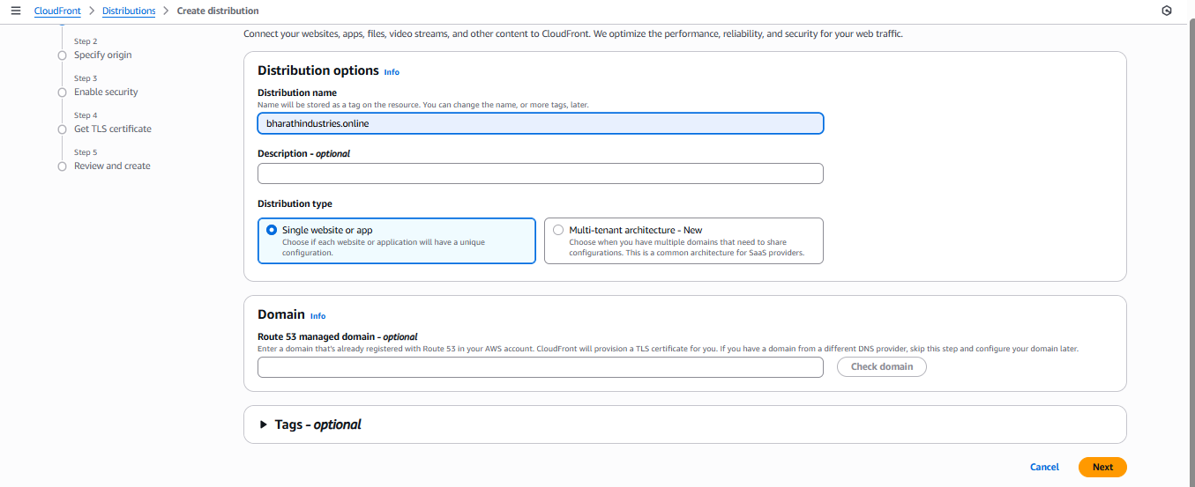
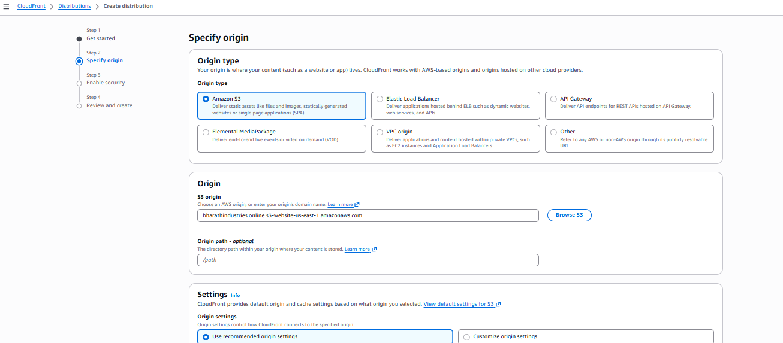
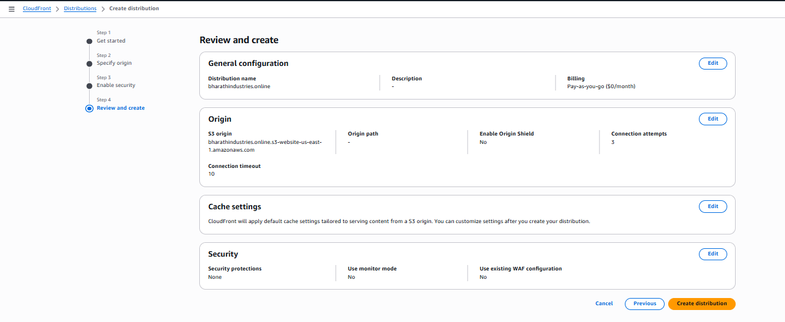
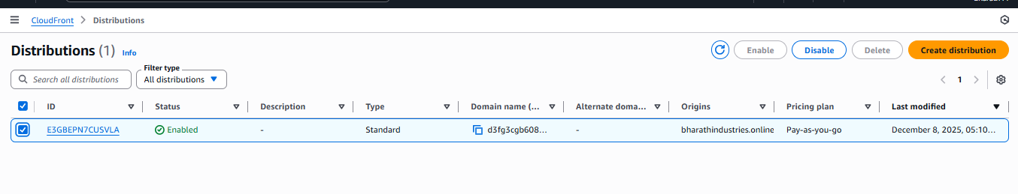
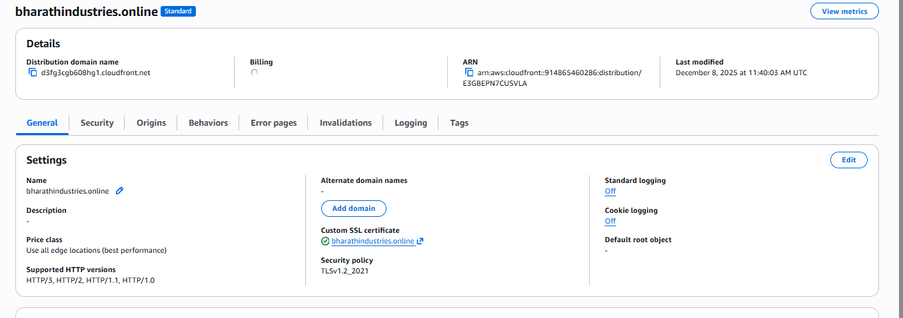

Go to route53 service and create hosted zone with domain name.
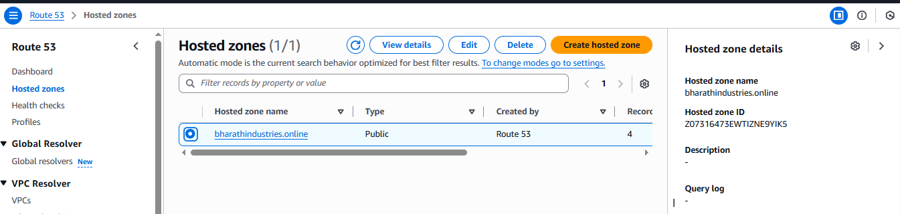
Records will be created after the creation of route53.
Go to domain site and edit the DNS, copy the DNS values from route53 DN record type
And save changes
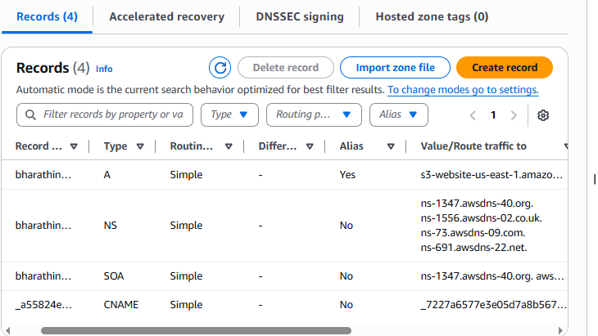
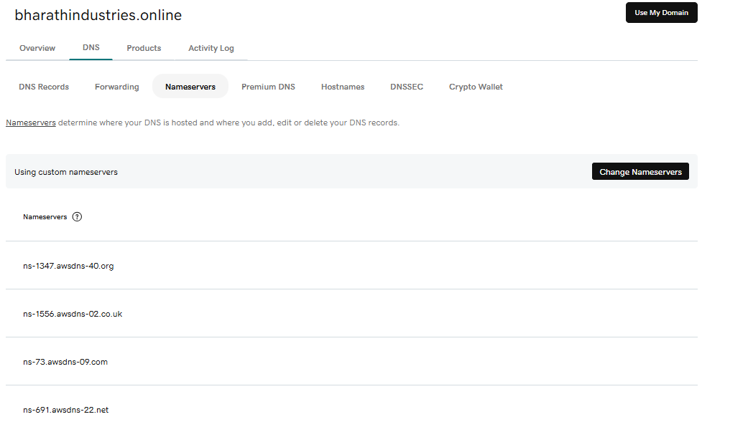

Go to SSL certificate and request one certificate.
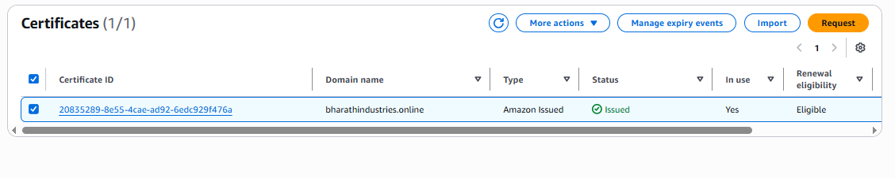

Create one record in route53.
CNAME and CValue record will be created in route53
Go to route53 service and create record
In record type select IPV4 and select alias,
Select the cloudfront endpoint.
Choose the region
And select the cloudwatch distribution endpoint
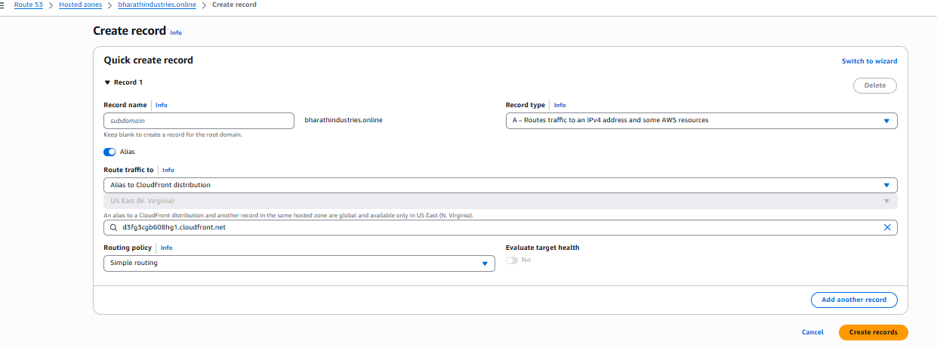
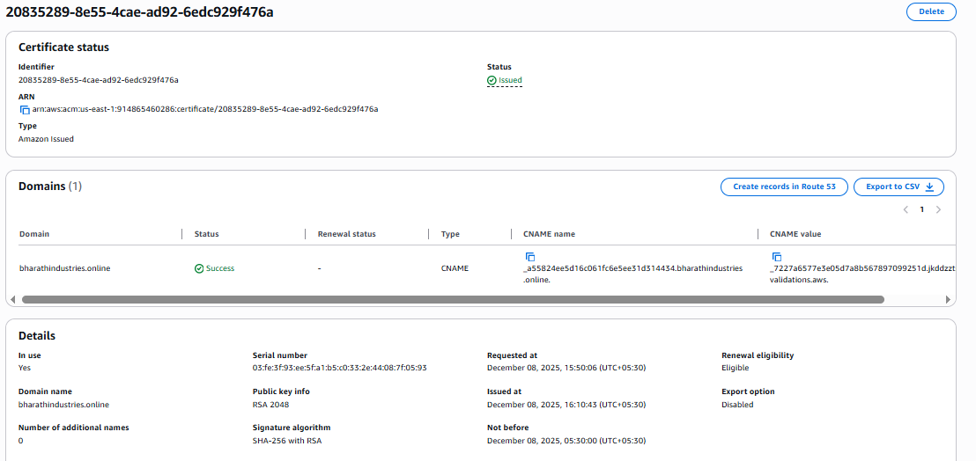

Check the website in browser whether it is accessing with domain name or not.
