ApacheTomcat
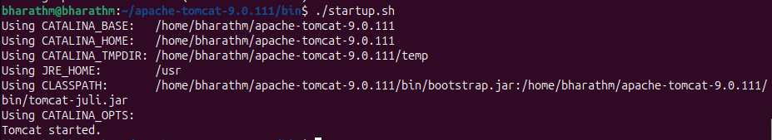

Install Jenkins in ec2 instance
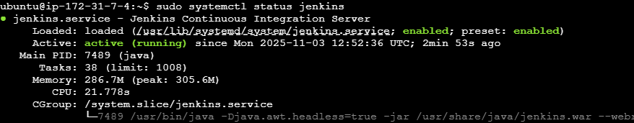

Docker
