AWS-EC2 Tasks

Launch one EC2 using Amazon Linux 2 image and add a script in user data to install Apache.
Created a instance and added user data to install httpd
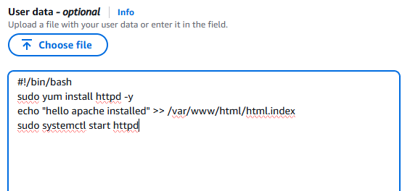
Httpd service running successfully.
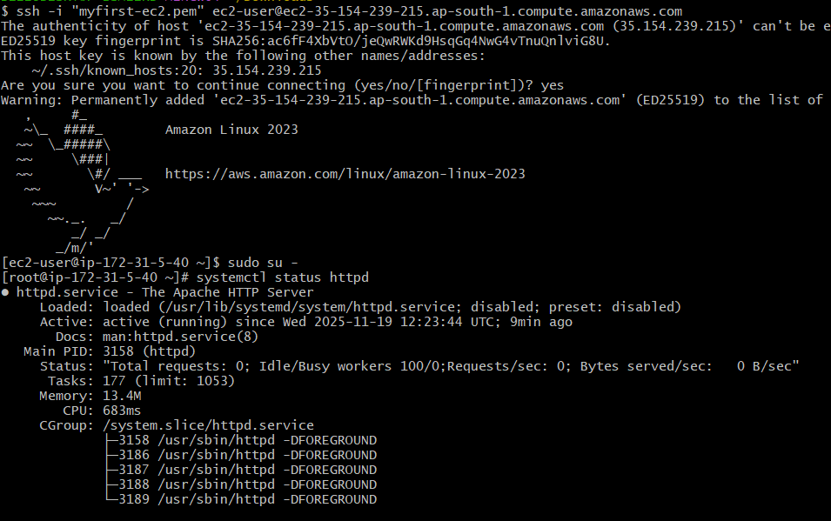
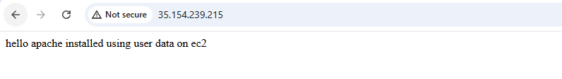

Launch one EC2 using Ubuntu image and add a script in user data to install Nginx.

Launched new instance and added data user for install nginx.

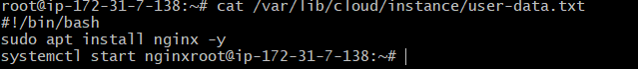
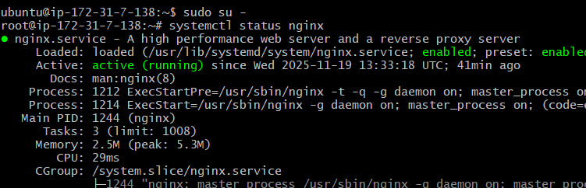
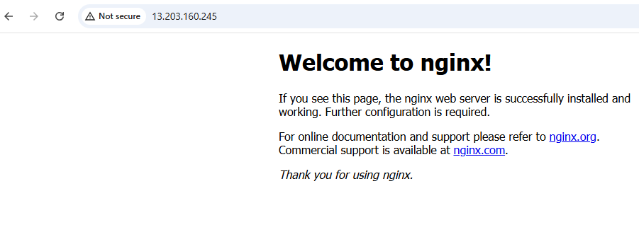

Launch one Windows server and install Tomcat on Windows.

Launch the instance by selecting the AMI windows
Add the inbound rules RDP 3389
Go to RDP client in console and Decrypt the password by adding the .pem key file.
Login to remote desktop (mstsc) by giving the RDP user id and password.
Install java and check the version in cmd.

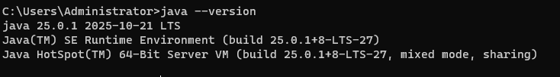
Download and Install tomcat for windows
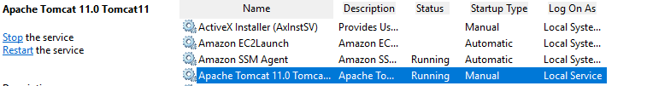
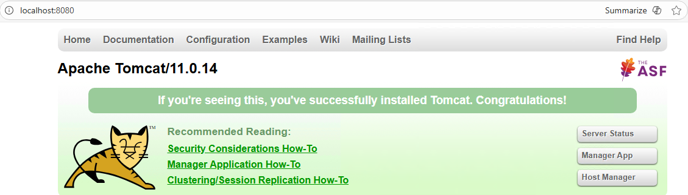

Take a snapshot of the instance created in Task 1.

Select the instance, to take snapshot for that instance.
Select the volume id
Go to actions and select to create a snapshot
Snapshot will be created and snapshot id will be generated for that instance.

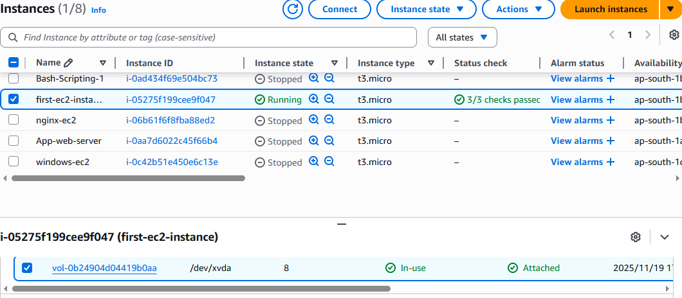
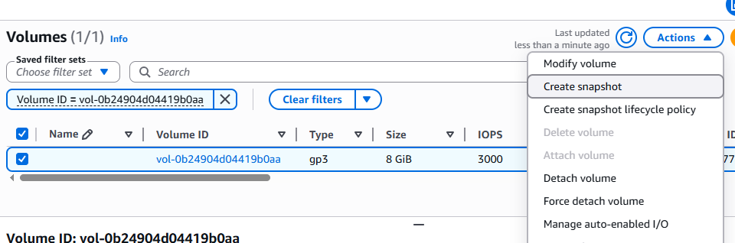

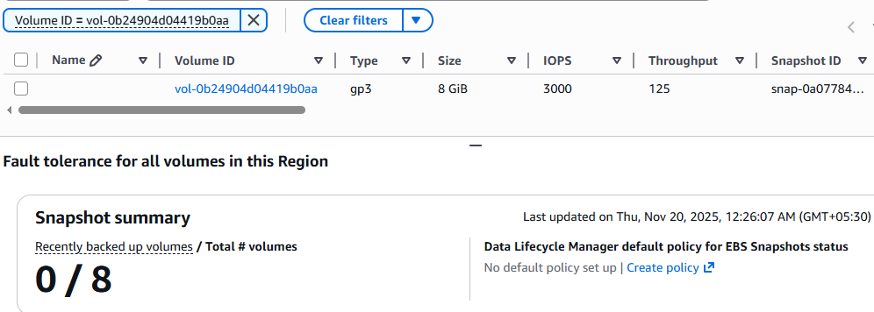
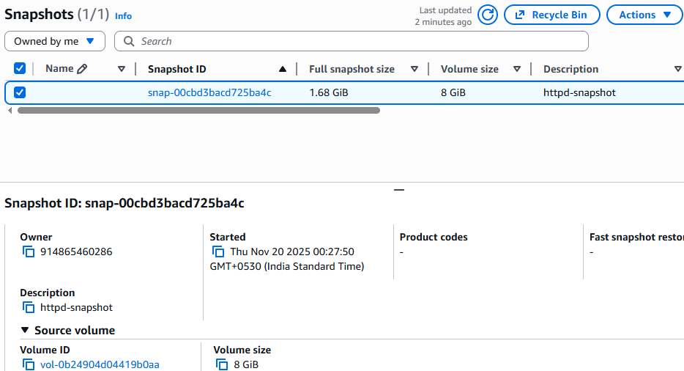

Assign passwordless authentication for the EC2 created in Task 2.

Create ssh-keygen, you will get a public key
Cat and copy the public key
Connect to instance and go to directory .ssh and paste the public key in authorized keys and save.
Logout from instance and connect to instance without using pem-key,
Server will connect to the instance.

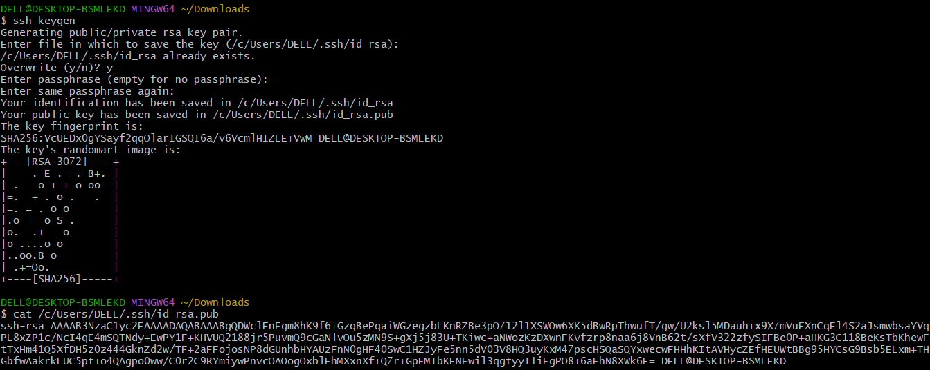
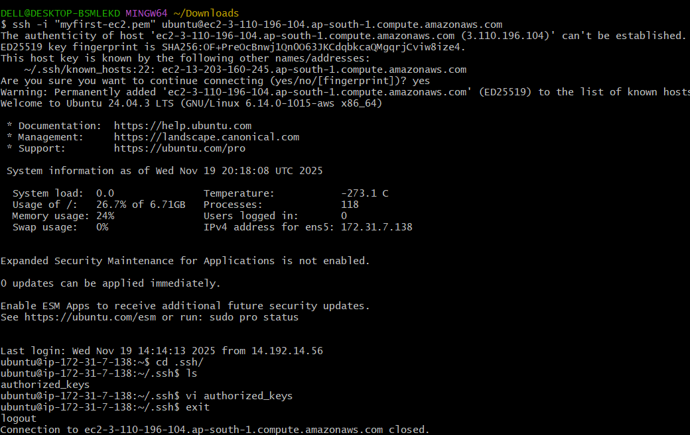
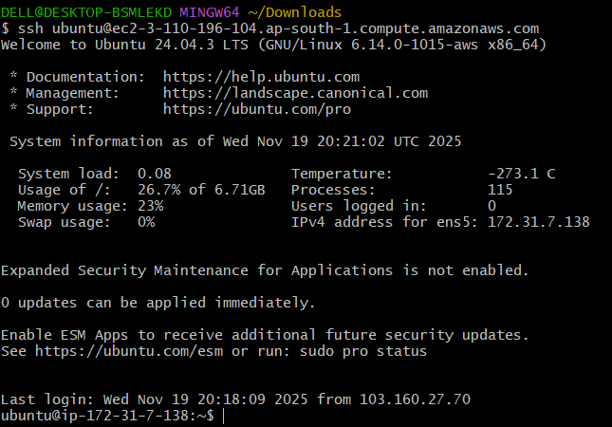

Launch any EC2 using the spot purchasing option.

Launched an instance by selecting spot instance in purchasing option.
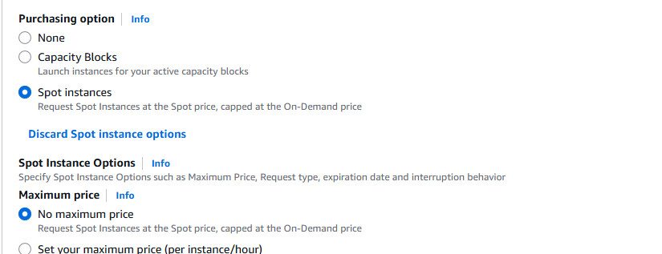

Enable termination policy on the EC2 created in Task 2.
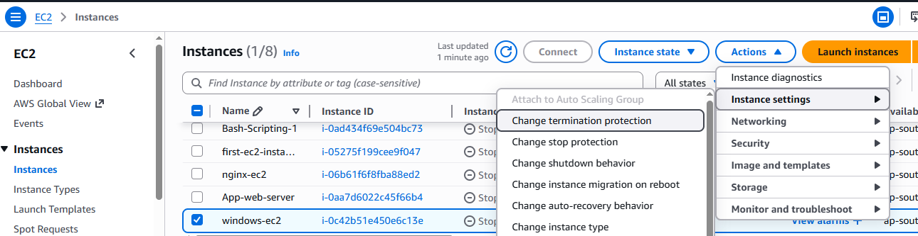
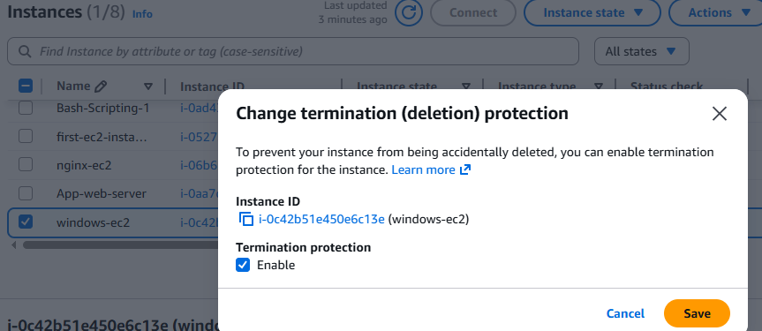
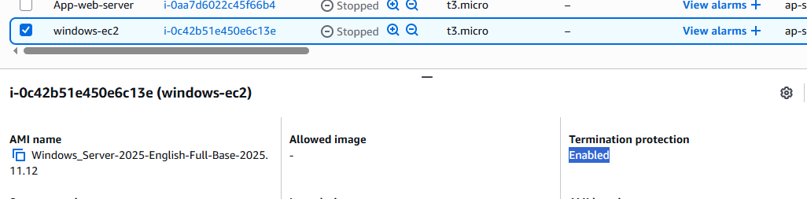

Launch one EC2 using AWS CLI.

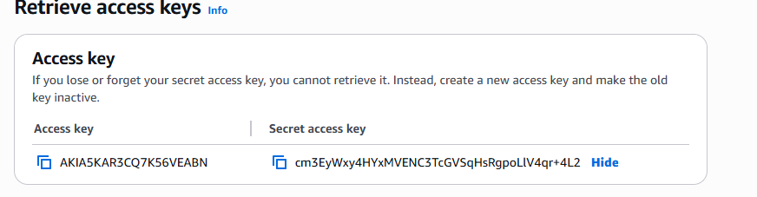
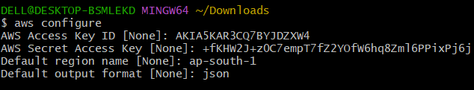
pem key generated.
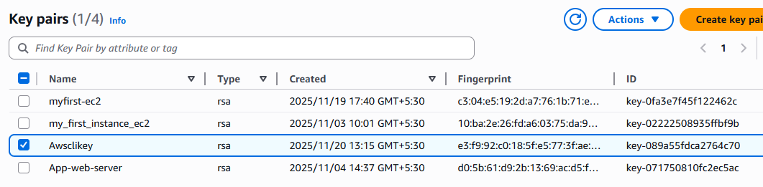
Created security group.
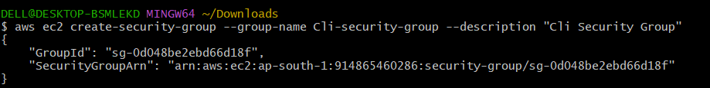
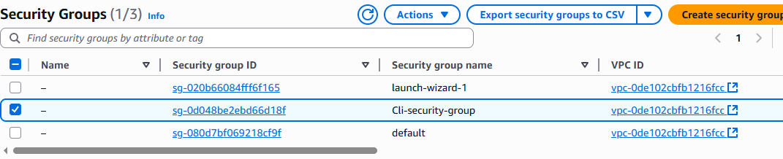
Access to inboud rules for SSH port 22
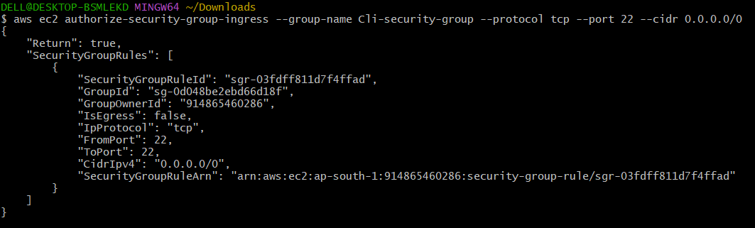
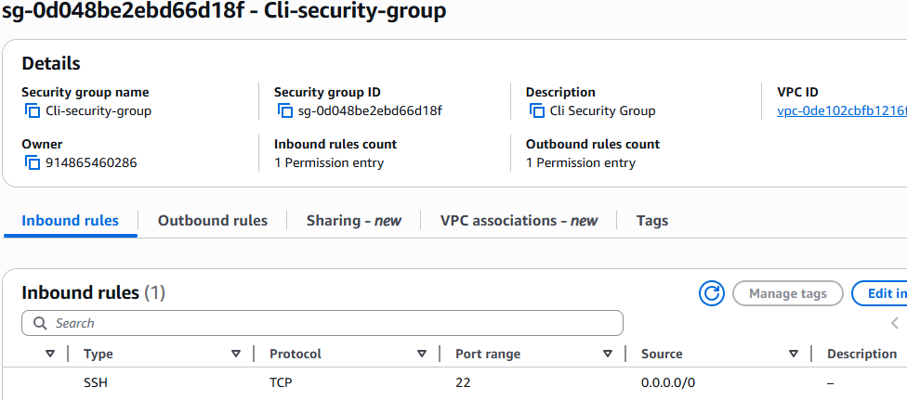
Launch instance in CLI
