Git and GitHub

Git commands execution:
Use command “git init” to initialise the git.
Created files using “touch” command file1 to file8
Use command “git status” to see the files which are in untracking are
To move them to tracking area use command “git add”
Commit the changes which are added to tracking area by using command “git commit -m “message of commit” ”.
To push the modified files or changes to central repo use command “git push”.
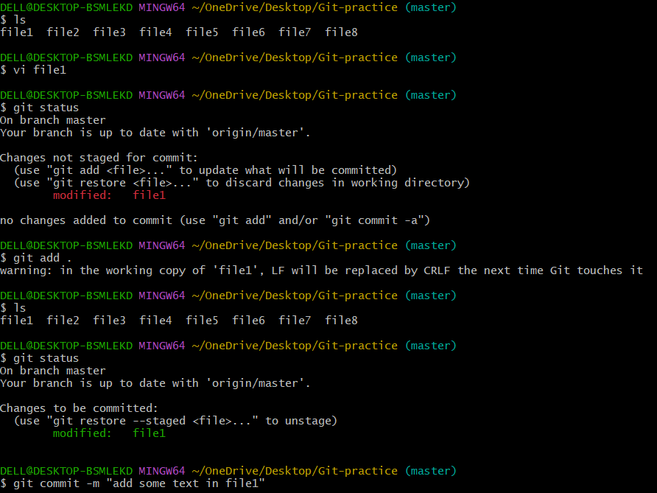
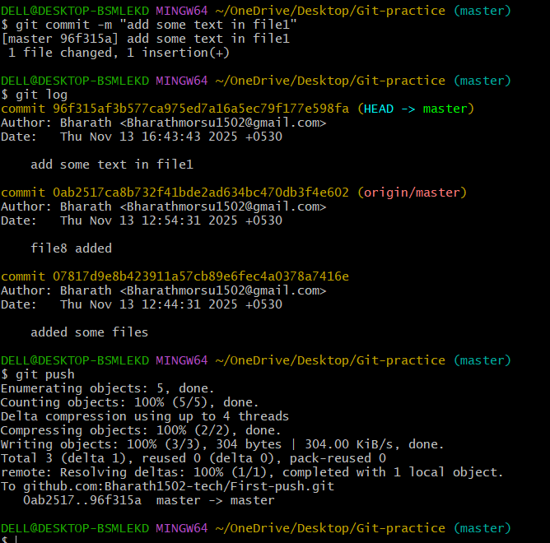
Github account:
Created a github account a created a repository.
Pushed all the files from local repo to central repo.
