IAM TASKS

Create one IAM user and assign EC2 and S3 full access roles.

Use case: To give limited permissions and required access to the user.

Go to AWS console
Go to IAM services
Go to users in IAM
Create user, add the user name and password—Next

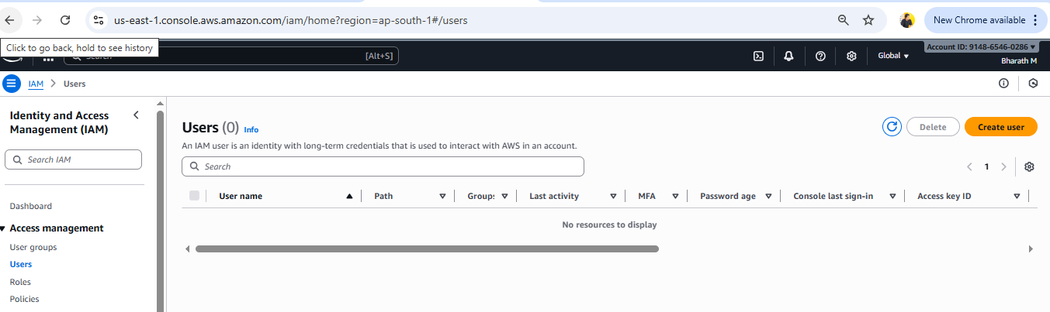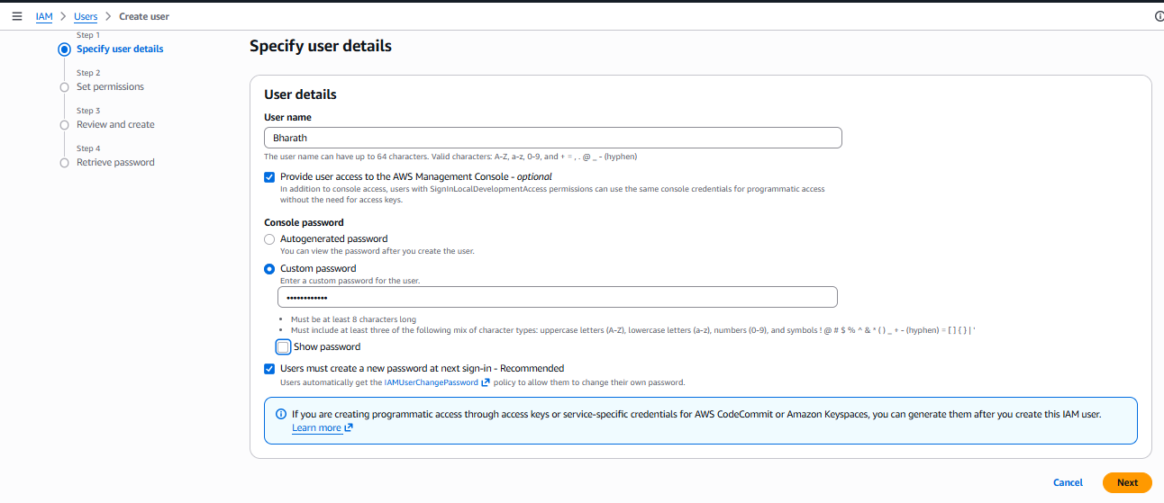

Attach policies directly to the user for EC2 full access and s3 full access-create user
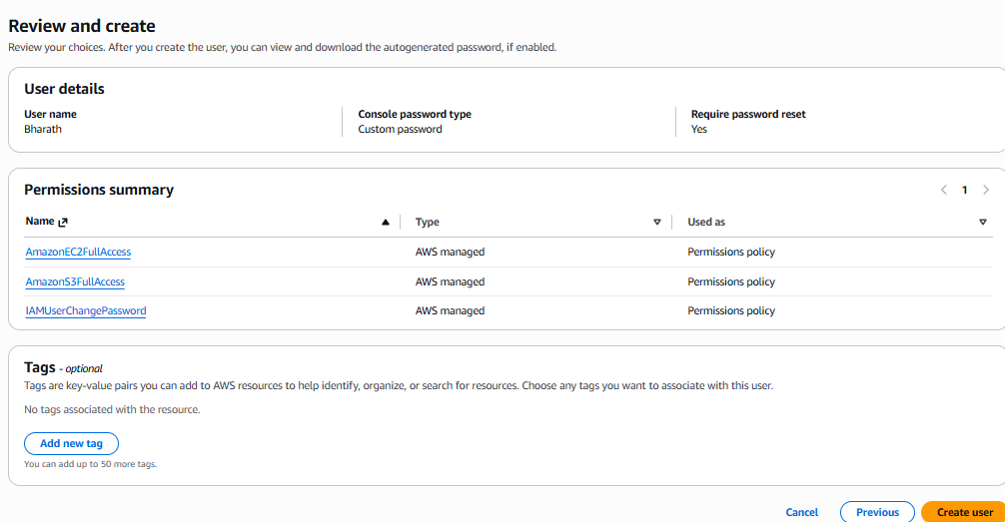
User will be created.
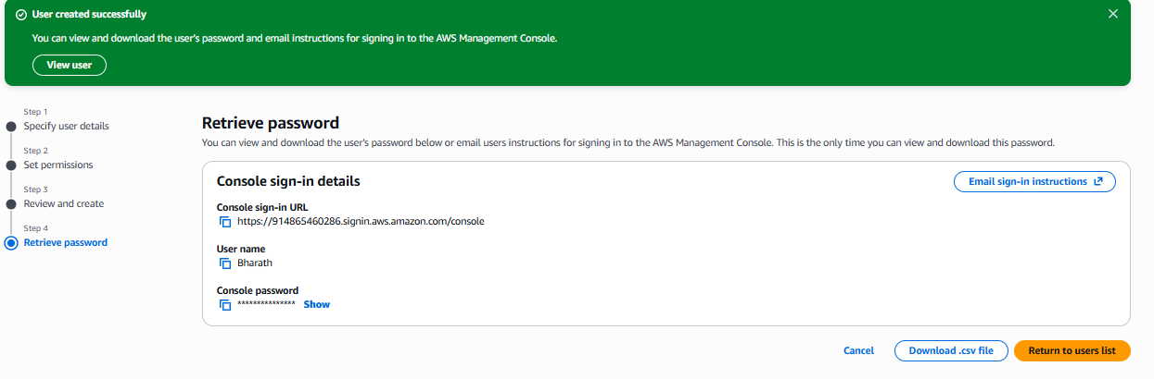
Login to aws console using created user credentials.
We can find no permissions for other services.
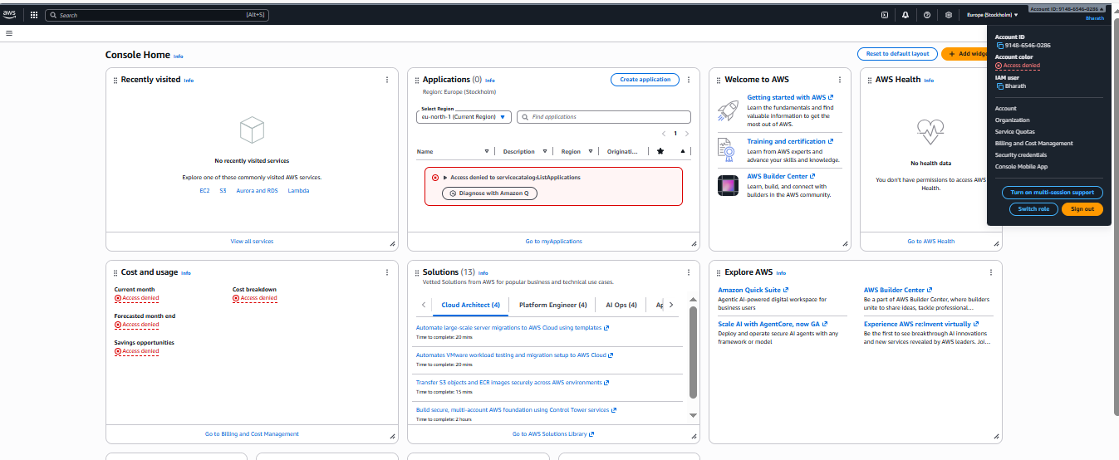

Check the ec2 service we can see that the user have full access to the ec2 services.
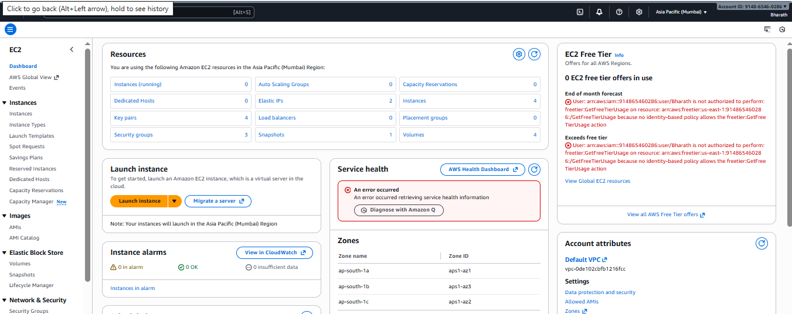

Same check the s3 service we can find the full access to s3 service for created user.
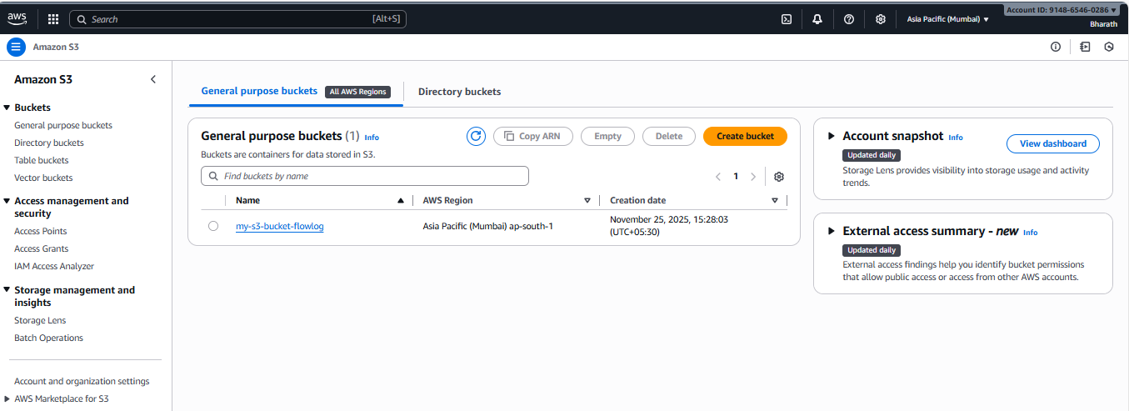

Create one group in IAM and assign read access for EC2.

Use case: we can add multiple users to the group, all the users who are in the group will be have the same permissions and access towards the services.

Go to IAM service in console
Create user Groups
Provide the group name.

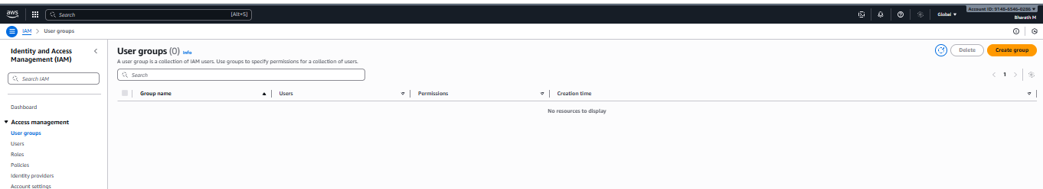
Attach the permissions for EC2 read only access for the group.
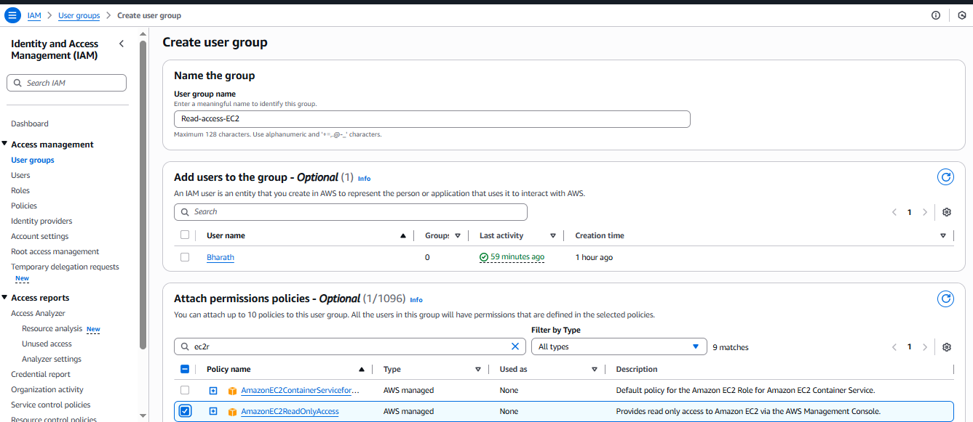
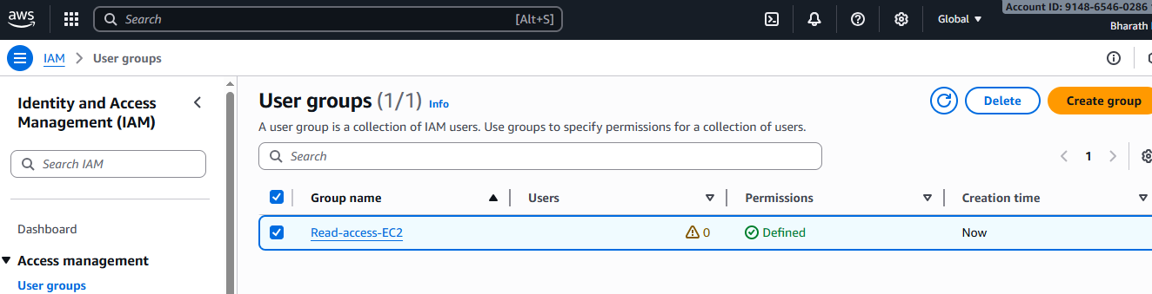

Create a new user named "Devops" and add to the group created in task 2.

Go to user in IAM
Create a user with name Devops and set the password for the user
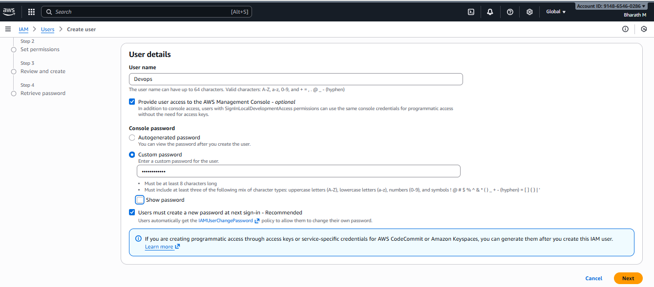

Add user to the group Read-access-ec2 which created earlier. The group users will have only read permission to the ec2 instances.
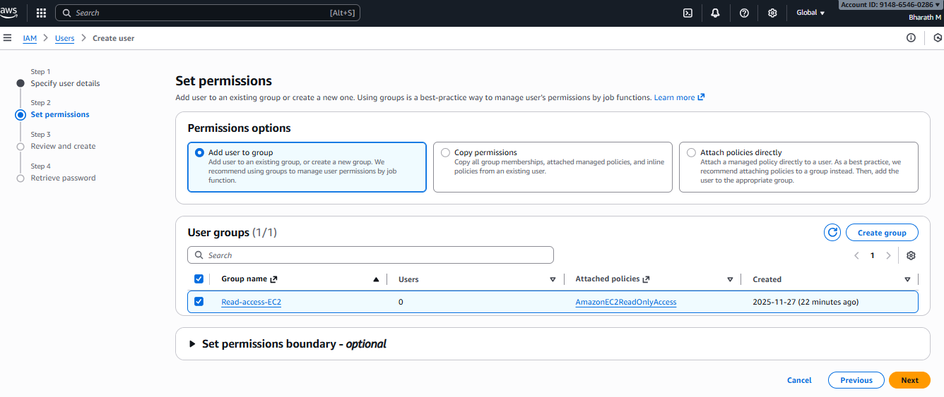
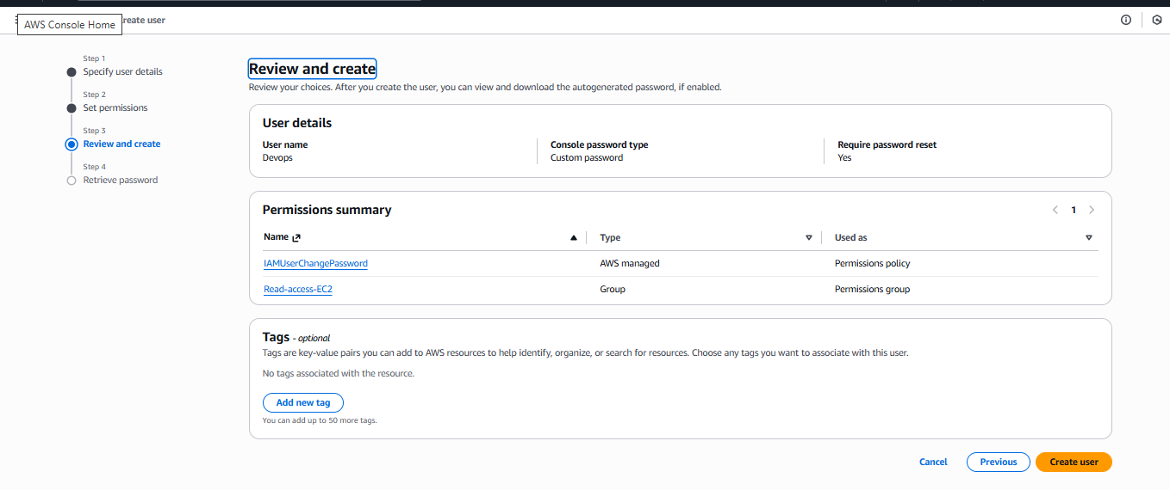
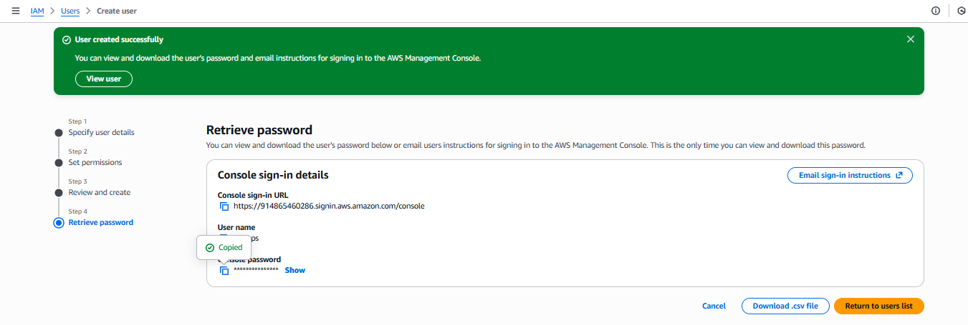
Sign-in with created user id and password

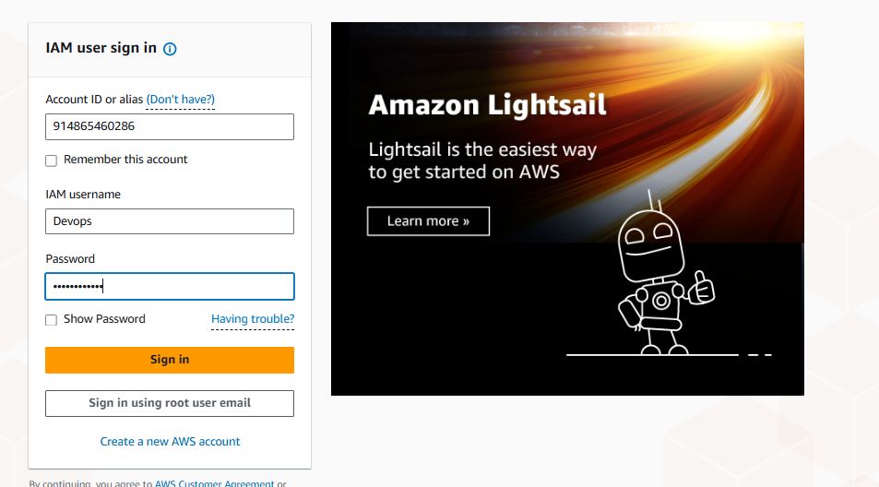
Signed into the created user account and can see the accessed permissions.
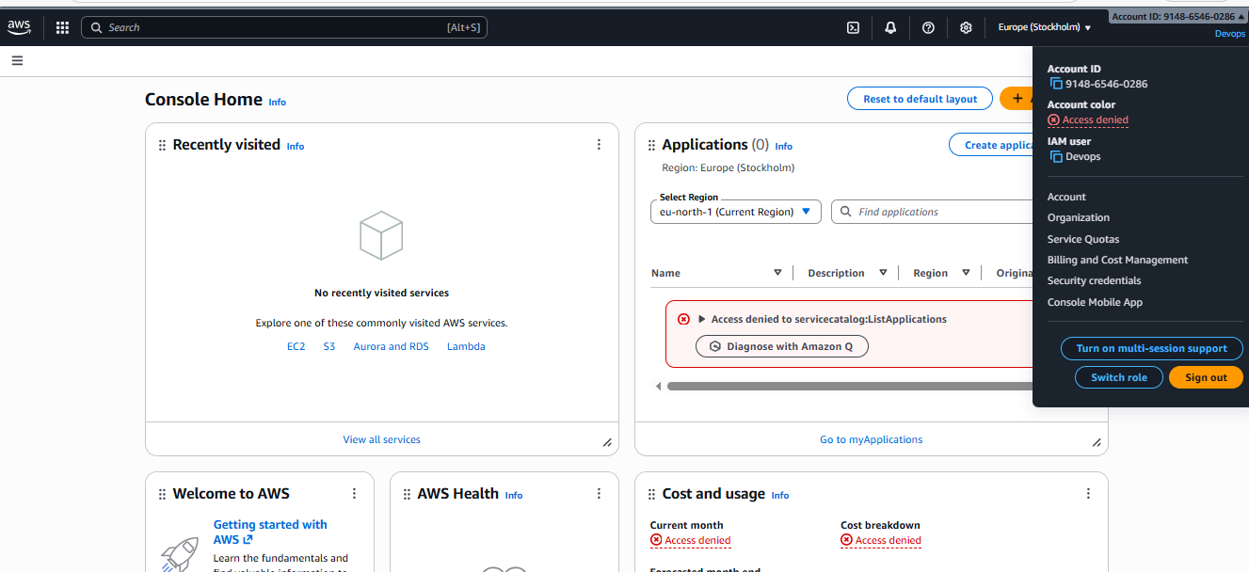
Go to ec2 dashboard we can see the resources of ec2 services.
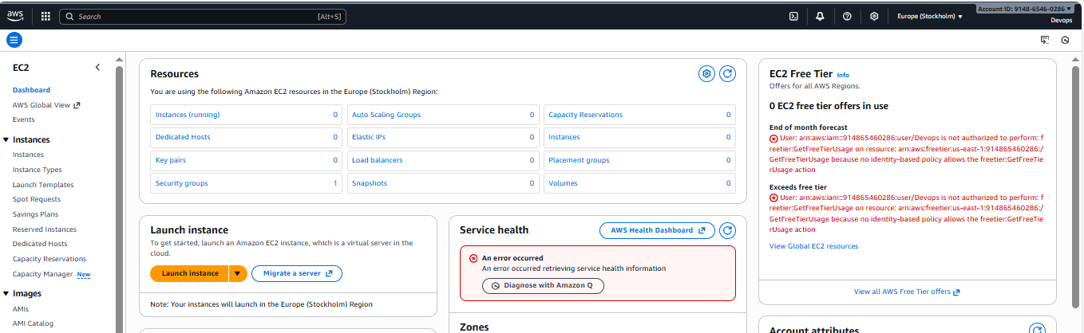
Try to launch ec2 and generate pem key, we can see the error stating user have no permissions to generate or launch the instance.
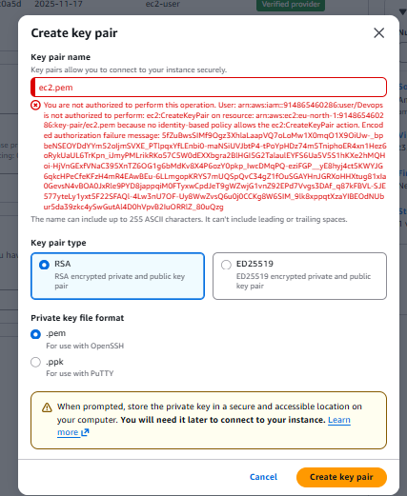

Write a bash script to create an IAM user with VPC full access.

Go to Aws console
Connect to the instance by using “ssh”
Generate Access key which will find in security credentials

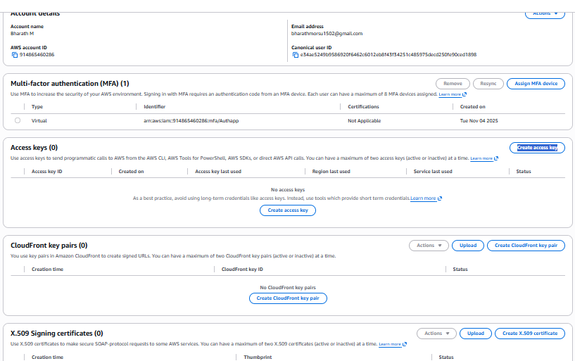
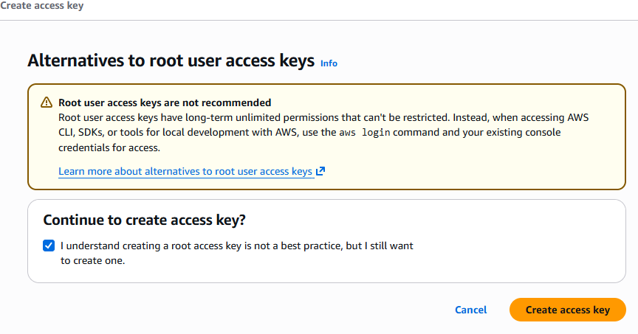
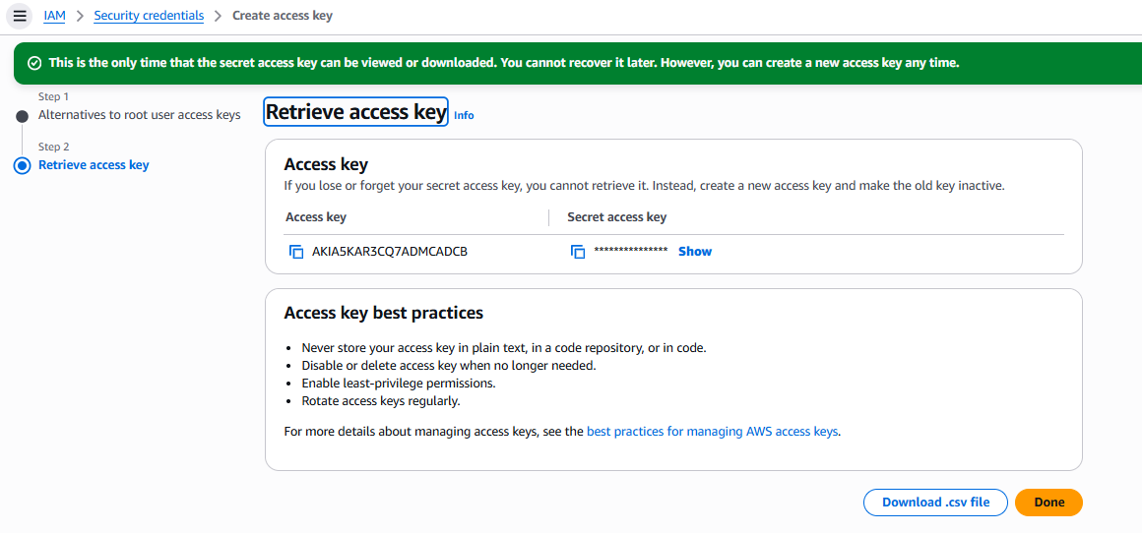
In cli configure access key and password “aws configure”
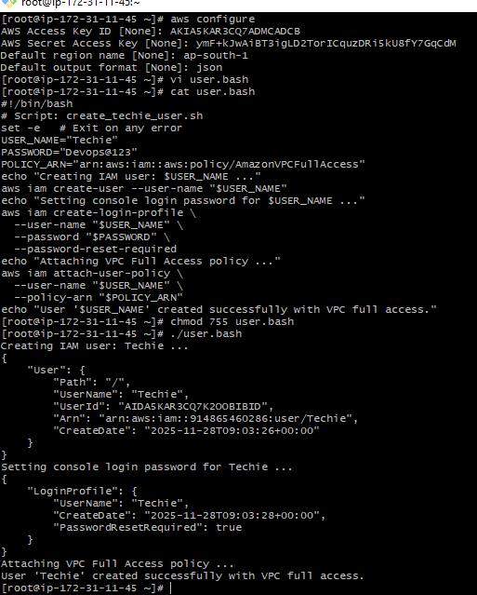
Created user Techie.
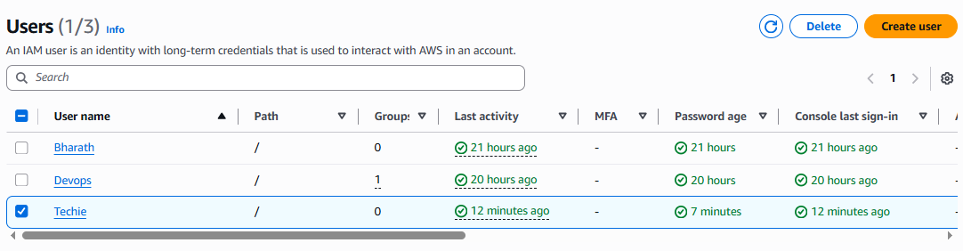

Login with the created user credentials to aws console
Check the vpc service, we can find the full permissions to the vpc
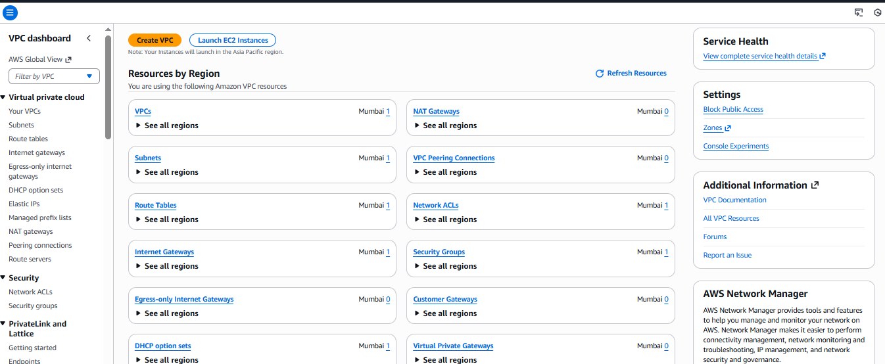
Check with other service s3, we can see the permissions denied for the user Techie
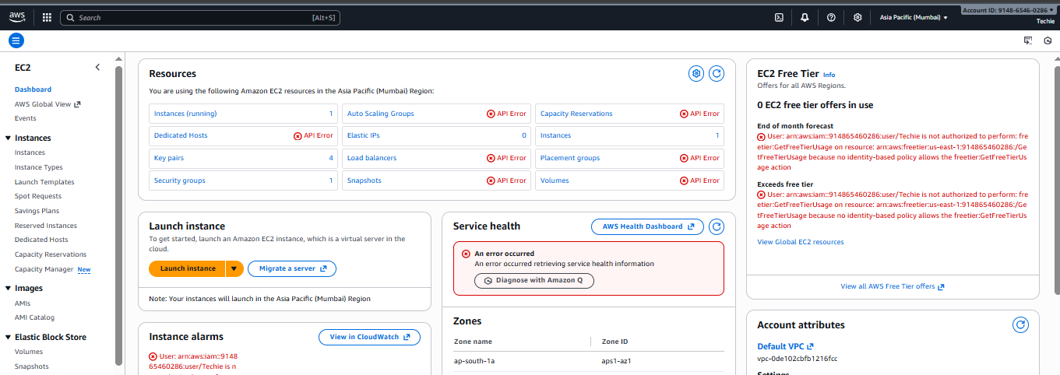

Create an IAM policy to allow EC2 access for a specific user in specific regions only.

Go to Aws console
Search for IAM service
Go to policies
Create policyselect json format
Add to code and create policy
Add the created policy to the user by going to user field and selecting user.
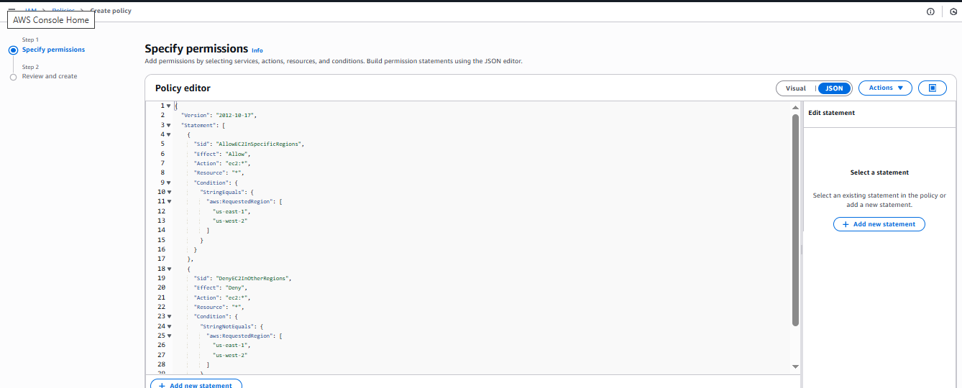
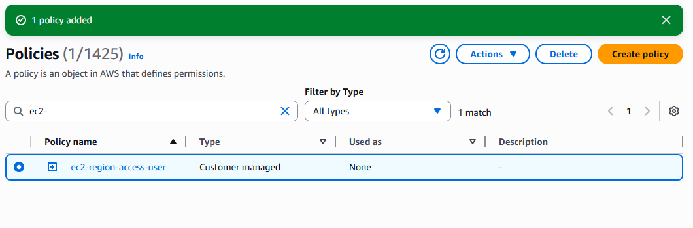
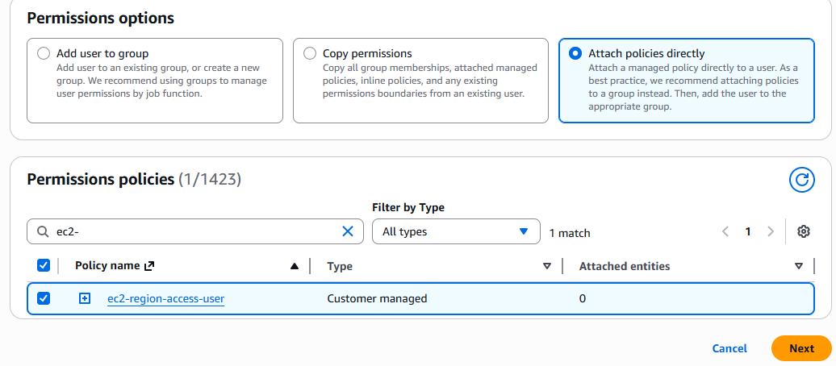

We have two accounts: Account A and Account B. Account A user should access an S3 bucket in Account B.

Create a s3 bucket
Enable the ACLs
Unblock all public access
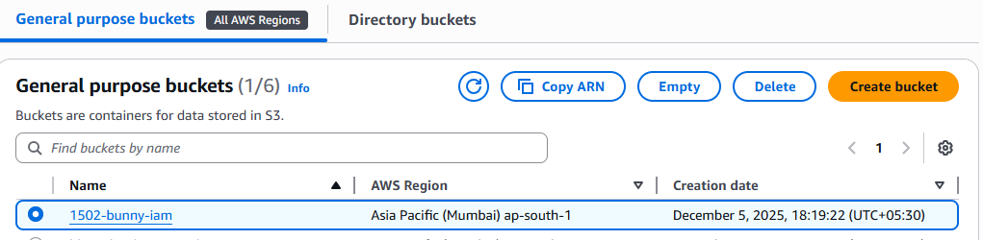

Go to permission in a bucket and edit the bucket policy and add a script by adding account A aws id and Account B created bucket name.
And save.
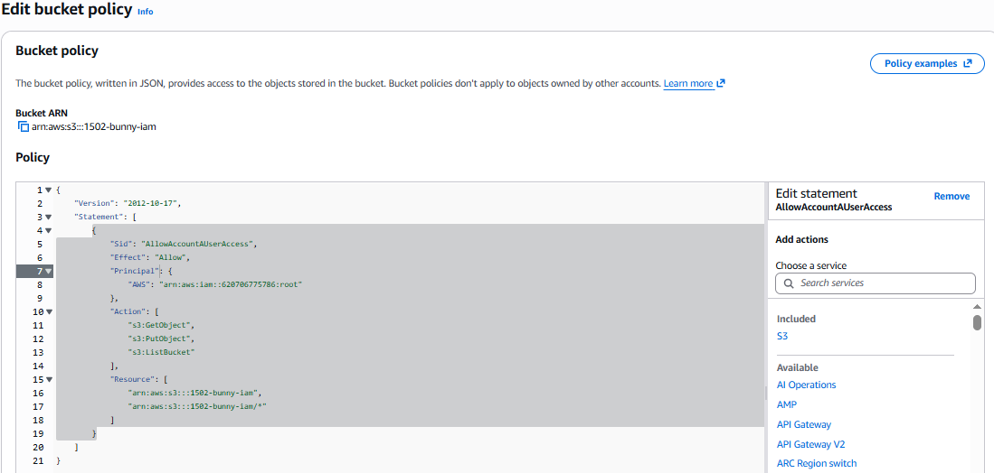

Go to account A cli and set the aws configuration with access id and password.
Check the “aws s3 ls s3://(account B bucket name)” to see the account B s3 bucket objects.
Below image is the reference of Account A
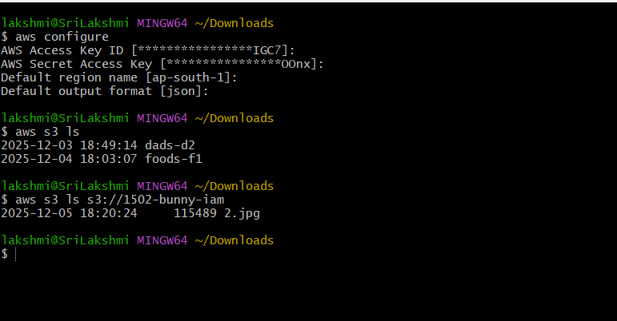
Below image is the reference of account B.
