LINUX-01 Commands

Pwd- Present working directory
This command will help us to find the current location you are working in that OS.
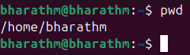

ls- List of Directories
This command will help us to find the list of files available in the working directory

Cd- Change Directory
Cd / command used for root directory
Cd ~ command is used for home directory
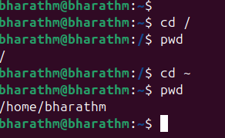

Cd .. : This command helps us to go back one step back from the current working directory
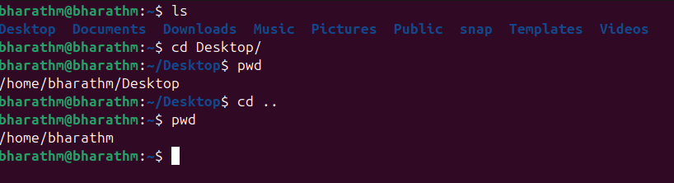

Ls -a : This command will help us to get the list of a hidden files 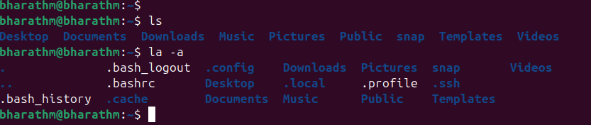

ll (long list): This command will shows the complete information of the files in the working directory also it will show the complete files available in that directory.

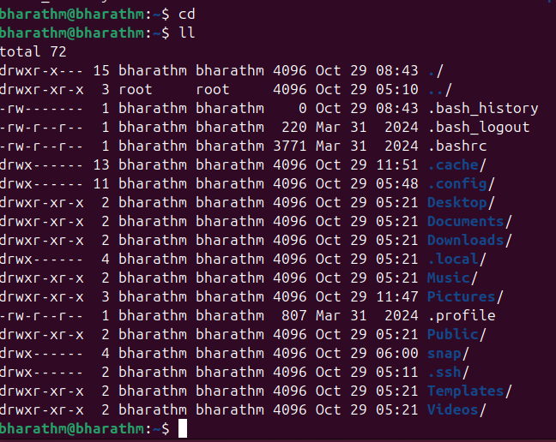

Mkdir : This command will help us to create a new directory, in windows we call it as folder where as in linux we call it as directory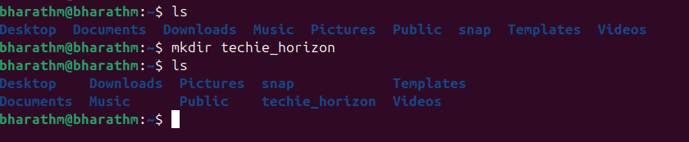

Mv : This command will help us to remane the file name.
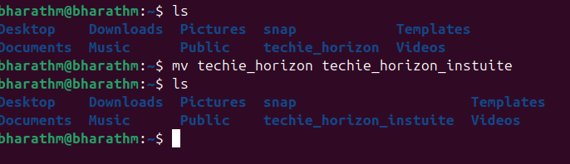

History : This command is used to check the commands we have executed recently.
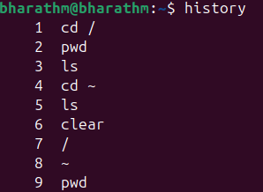

Date : This command will show the current date and time of the working terminal or OS.
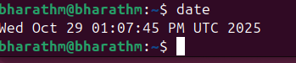

Clear : this command will clear the terminal and shows the plain terminal to work.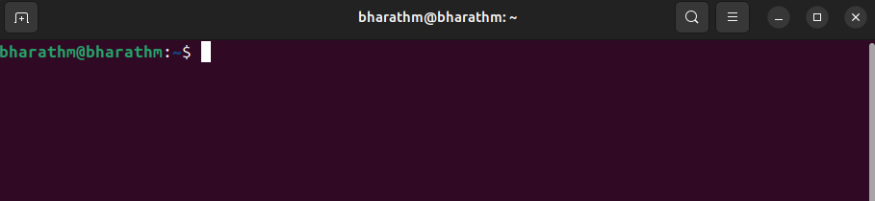

rm -rf : This command is used to delete the directory which are listed in present working directory.
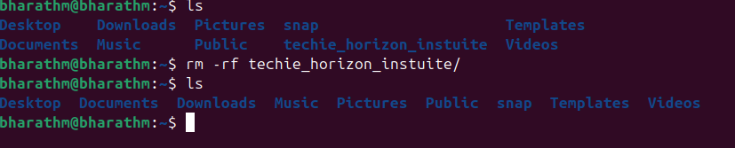

Touch : touch command is used to create a new file in the required directory.
