Personal Finance Manager – Project Documentation

Project Overview and Objectives
The Personal Finance Manager is a Python-based command-line application designed to help users track, store, and analyze daily expenses. The objective of this project is to provide a simple yet effective way to manage personal finances while demonstrating Python concepts such as Object-Oriented Programming, file handling, and modular design.
Objectives:
- Track daily expenses
- Store data permanently using CSV files
- Generate reports for better financial insights
- Build a real-world Python project

Setup and Installation Instructions
Prerequisites:
- Python 3.8 or above
- Command Prompt / Terminal
Installation Steps:
1. Download or copy the project folder.
2. Ensure all project files are in the same directory.
3. Open terminal and navigate to the project folder.
4. Run the command: python main.py
5. The CSV file will be created automatically on first run.

Code Structure Explanation
The project follows a modular architecture:
main.py – Entry point and menu-driven interface
expense.py – Defines the Expense class
file_handler.py – Handles CSV operations and backup
reports.py – Generates reports and summaries
expenses.csv – Stores expense data
backup.csv – Stores backup data

Screenshots of Working Application
Screenshots include:
- Main Menu Screen

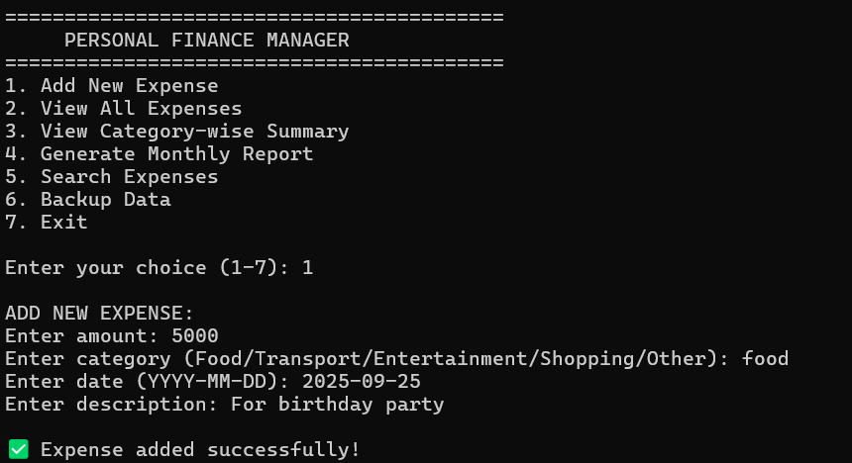
- Add Expense Screen
- Category-wise Summary Screen
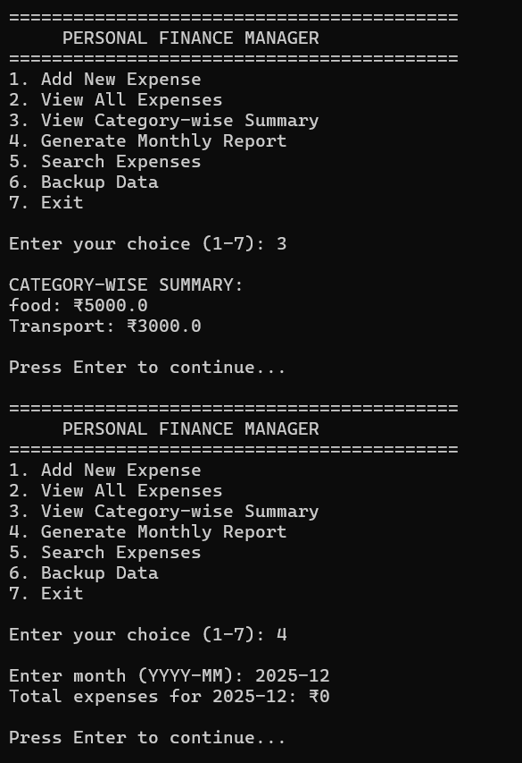

Technical Requirements Fulfillment
Expense Class:
- Implemented using OOP with attributes amount, category, date, and description.
File Operations:
- CSV module used for data persistence.
Error Handling:
- Implemented try-except blocks for input validation.
User Interface:
- Menu-driven CLI implemented using loops and conditionals.
Reports:
- Category-wise and monthly expense calculations implemented.
Backup:
- Backup functionality added to prevent data loss.

