**211039016**

**I.Bharath Simha Reddy**

**Program 1:**

AREA Nibble_add, CODE, READONLY

ENTRY

START

LDR R0, VALUE ;load the address location #0x40000004 to R0

LDR R1, [R0] ;load the content of R0 to R1

LDR R2, MASK ;load the mask value to R2---- R2 <- #0x0000000F

AND R3, R1, R2 ;AND with the mask value so that only nibble0 will be available

LSL R2, #16 ;logial left shift the mask value by 16 bits, so it shifts to 4th nibble -> #0x000F0000

AND R4, R1, R2 ;AND with new mask value to get nibble4

LSR R4, #16 ;logical right shift the nibble4 by 16 bits to move the value to LSB

ADD R5, R3, R4 ;Adding the nibble0 and nibble4

LDR R0, RESULT ;load the result address to R0

STR R5,[R0] ;Store the obtained answer in the result location

VALUE DCD &40000004 ;location of the 32-bit number to

MASK DCD &0000000F ; mask value

RESULT DCD &4000000C ;location the result should be stored

END

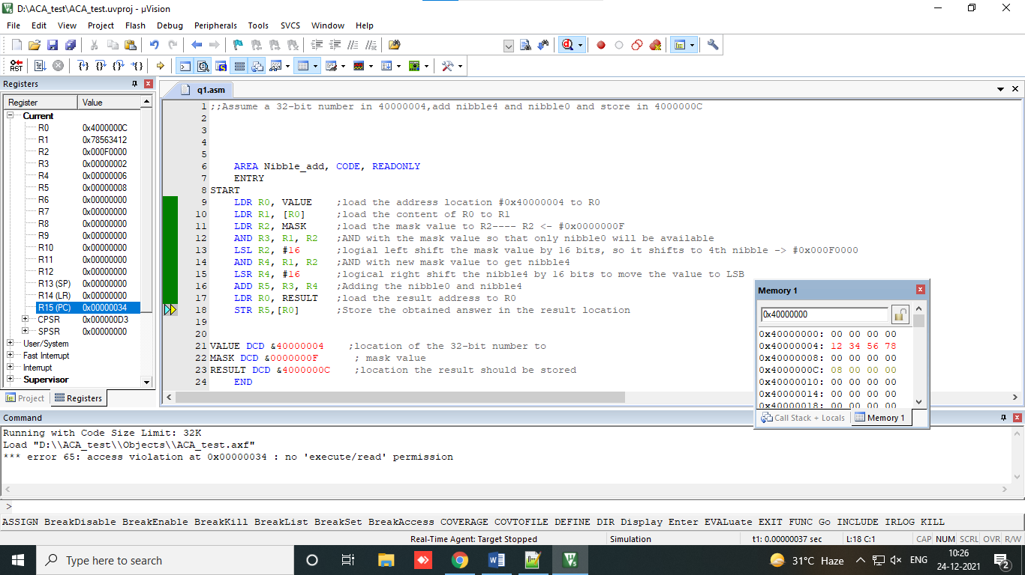

**Output:**

Given the input as 12345678

Number is stored as 78563412

Nibble0 ->2

Nibble4 ->6

Output sum is 8

**Program 2.**

AREA PG2, CODE, READWRITE

ENTRY

START

LDR R0, COUNT ; load the count to R0

LDR R1, [R0] ; load the content of R0 to R1

LDR R0, ARRAY ; loading the start address of the array

LDR R2, [R0] ;load the value present in start address

LDR R7, RESULT ;load the address to store the result

LOOP1

CMP R1, #0 ;compare the number count with zero

BEQ STOP ;if equal to zero goto STOP

LDR R3, [R0,#4]! ;loading the element to R3 and increment R0

SUB R1, R1, #1 ;Decrement the count by 1

CMP R3,#0 ;Compare for positive or negative

BPL LOOP2 ;if positive goto loop2

B LOOP1 ; Branch in loop1

LOOP2

ADD R2, R2, R3 ;positive numbers are added here

STR R2, [R7] ; store the added sum to result

B LOOP1 ;branch in loop1

STOP

B STOP ;stop the execution

COUNT DCD &40000000

ARRAY DCD &40000004

RESULT DCD &40000030

END

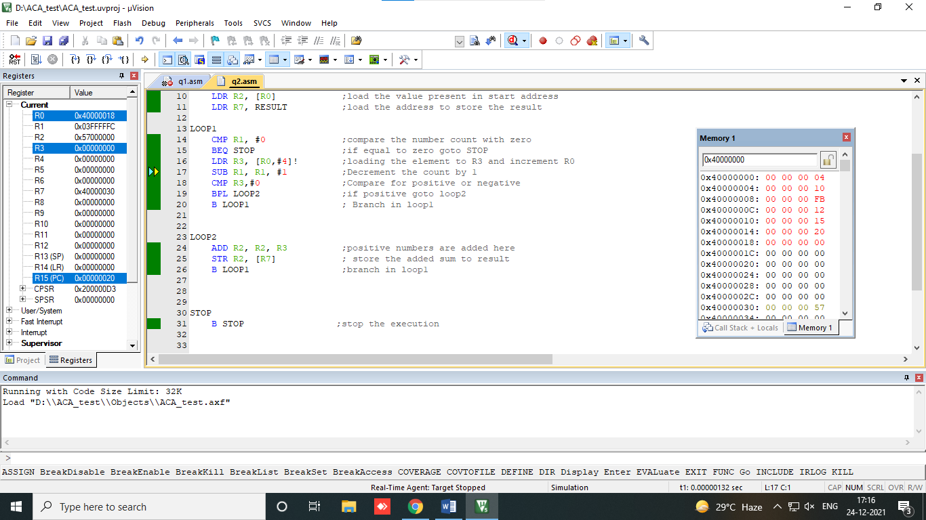

**Output:**

Given input:

Number count : 5

Array elements :

10

-10

12

15

20

Sum : 57 (-10 is ignored)