**Unit-3: Concept Learning & Unsupervised Learning:** Introduction to Bayes Theorem and Concept learning, Naive Bayes Classifier, Applications of Naïve Bayes Classifier, Clustering –Different types of the clustering techniques, K-Means Clustering

**Concept Learning & Unsupervised Learning**

**What is Concept Learning?**

Concept learning is the process of understanding and generalizing patterns or relationships from a given set of examples. It involves identifying **common features** among positive examples and distinguishing them from negative examples.

In simple terms, **concept learning is like learning a rule from examples** and then using that rule to classify new instances.

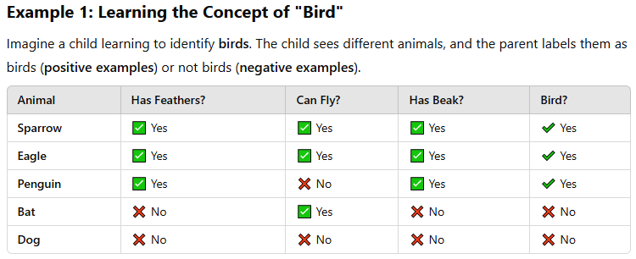

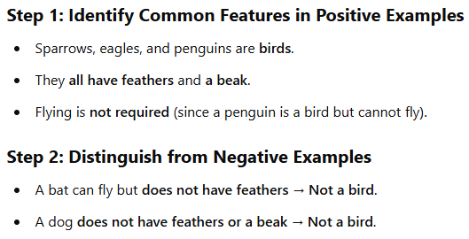

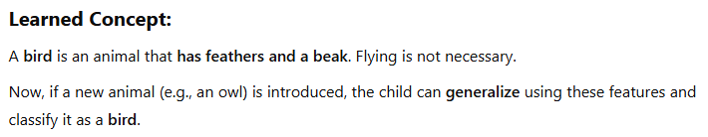

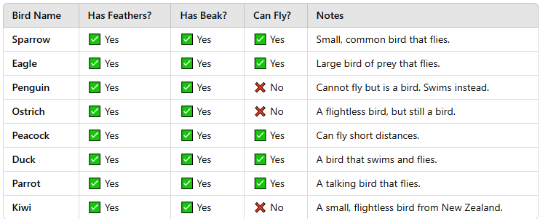

### ****Example 1: Learning to Identify Apples****

Imagine a child learning to recognize an **apple**. The parent shows different objects and says which apples (positive examples) are and which are not (negative examples).

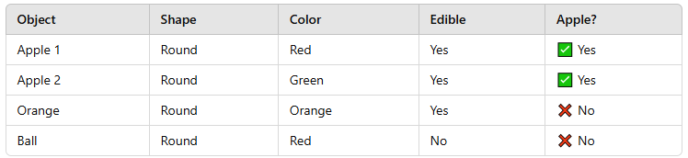

From these examples, the child **learns a concept**:

* An apple is **round** and **edible**.
* Color is not necessarily a factor since apples can be red or green.

This is an example of **concept learning** because the child generalizes from examples to identify apples in the future.

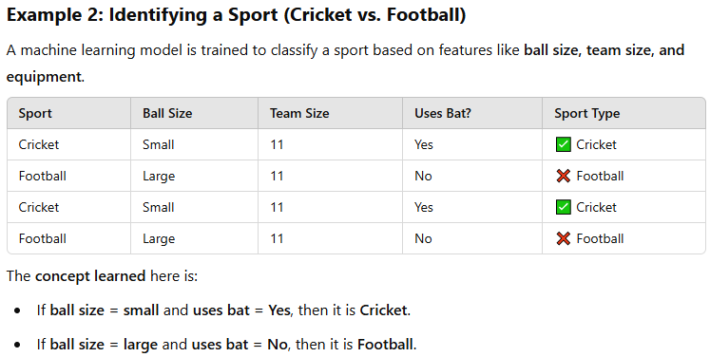

Concept learning is the foundation of **AI and Machine Learning**. It helps in **classification tasks, decision-making, and understanding patterns**.

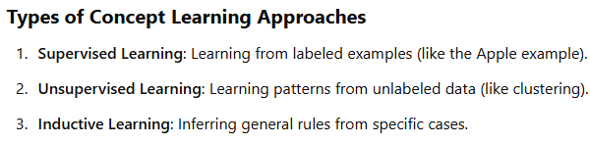

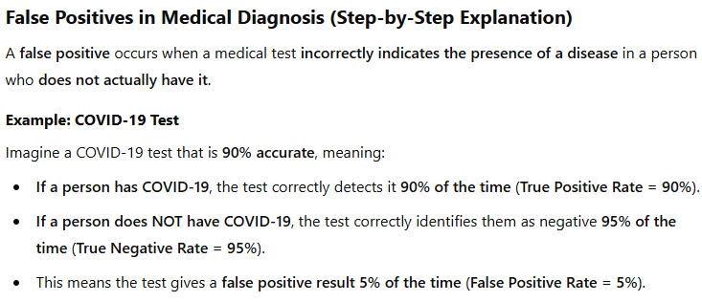

**Bayes Theorem**

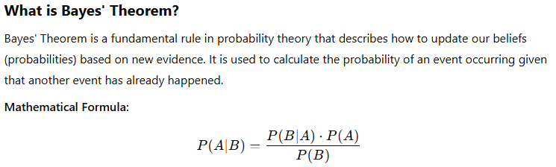 The notation **P(A | B)** is read as: **"The probability of A given B."**



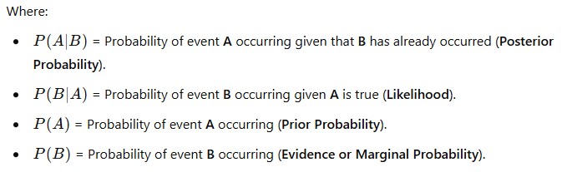 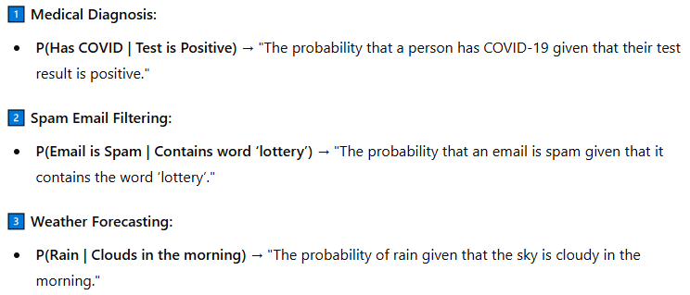

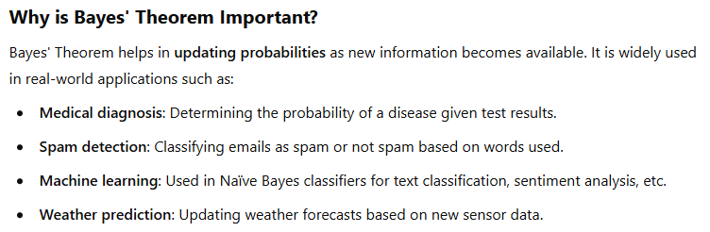

#### **Step 2: Given Information**

* **Prior Probability** of having the disease:

P(A) = 0.01 {(1% of the population has the disease)}

* **Likelihood** (Test correctly detects disease if person has it):

P(B | A) = 0.9 {(90% accurate for people who have the disease)}

* **False Positive Rate** (Test incorrectly detects disease in a healthy person):

P(B | ~neg A) = 0.05 {(5% false positive rate)}

* **Probability of a positive test result (Evidence)**:

Using the **law of total probability**, we calculate:

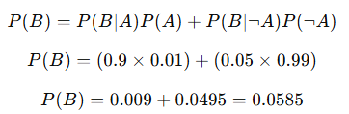

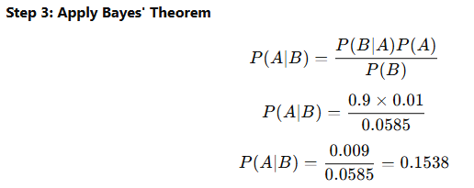 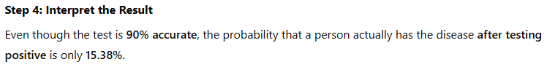

* **Bayes' Theorem allows us to update our beliefs** when new evidence is presented.
* Even with a **highly accurate test**, **false positives can significantly affect results** when the event is rare.

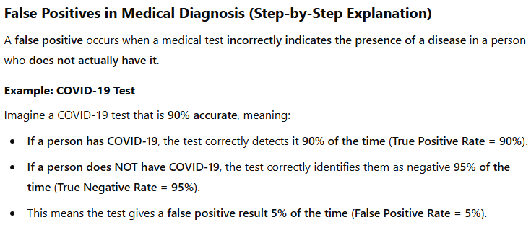 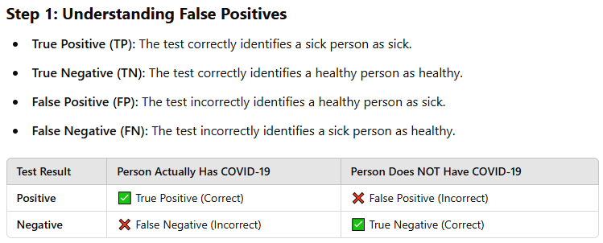

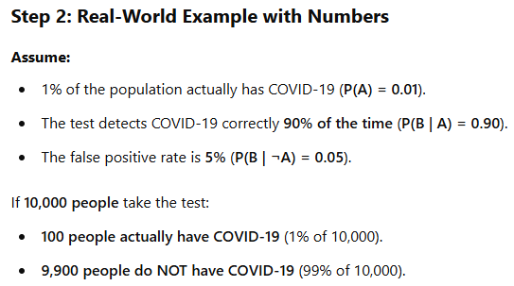 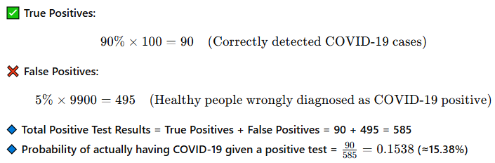 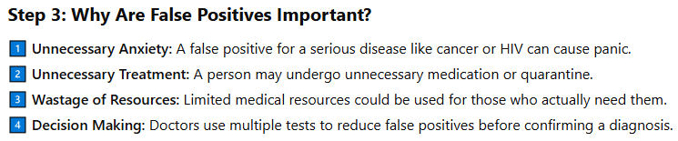

**NAÏVE Bayes Classifier**

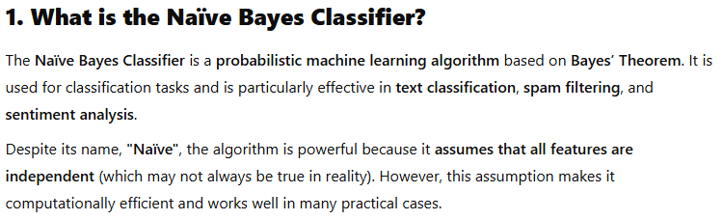 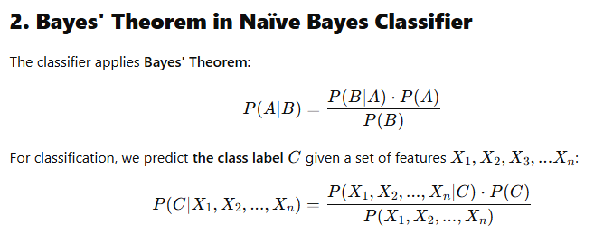 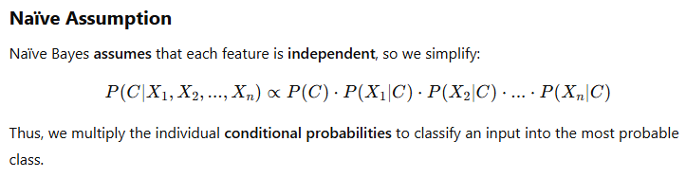 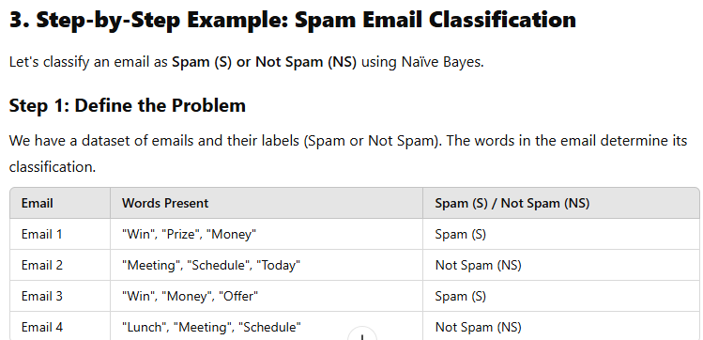 

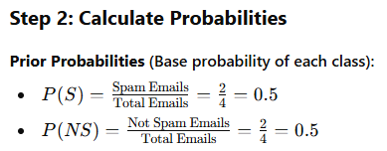 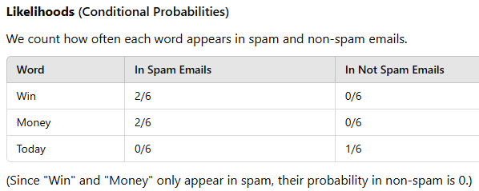 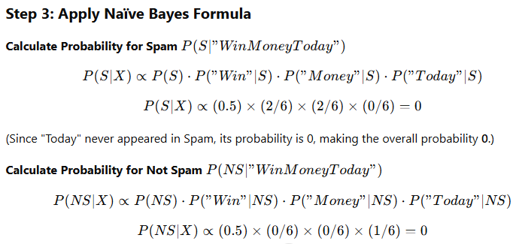 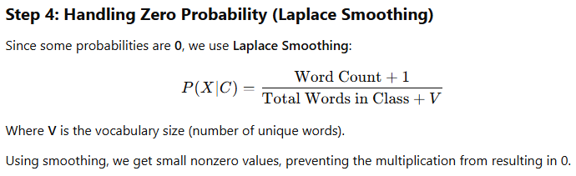 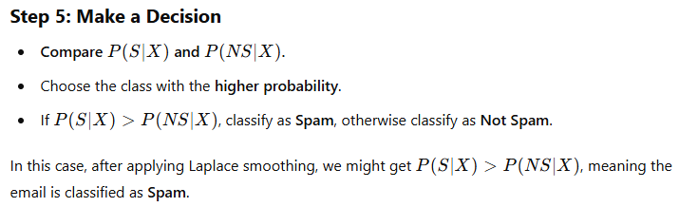

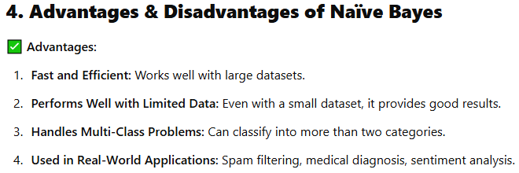 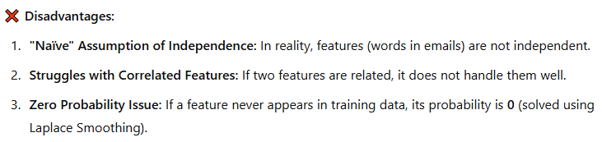

## **Applications of Naïve Bayes Classifier**

Naïve Bayes is widely used in various real-world applications due to its **efficiency, accuracy, and simplicity**. Below are some key applications:

