Experiment 8 Linear Regression
Machine Learning Lab Record

Question
Write a program to implement the Linear Regression algorithm in Python.

Program
# House size in square feet and its price in thousands of currency units.
sizes = [600, 800, 1000, 1200, 1400, 1600]
prices = [120, 150, 180, 210, 240, 270]

mean_x = sum(sizes) / len(sizes)
mean_y = sum(prices) / len(prices)
numerator = sum((x - mean_x) * (y - mean_y) for x, y in zip(sizes, prices))
denominator = sum((x - mean_x) ** 2 for x in sizes)
slope = numerator / denominator
intercept = mean_y - slope * mean_x

new_size = 1300
predicted_price = slope * new_size + intercept

print("Regression equation: price =", round(slope, 3), "* size +", round(intercept, 3))
print("House size:", new_size, "square feet")
print("Predicted price:", round(predicted_price, 2), "thousand units")

Program Output
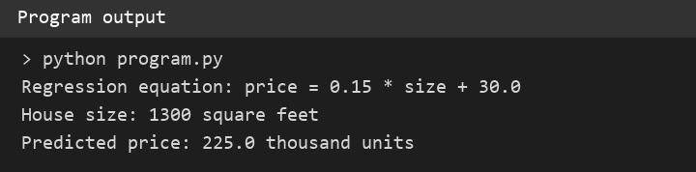
Figure 1 Actual output obtained by running the program

