

**Basic Linux Commands Assignments**

Assignment-1

Connect and disconnect with login Access

* What happens when you login a non-existent users or username?
  + Provide Screenshot and What you understand, explain in short brief?

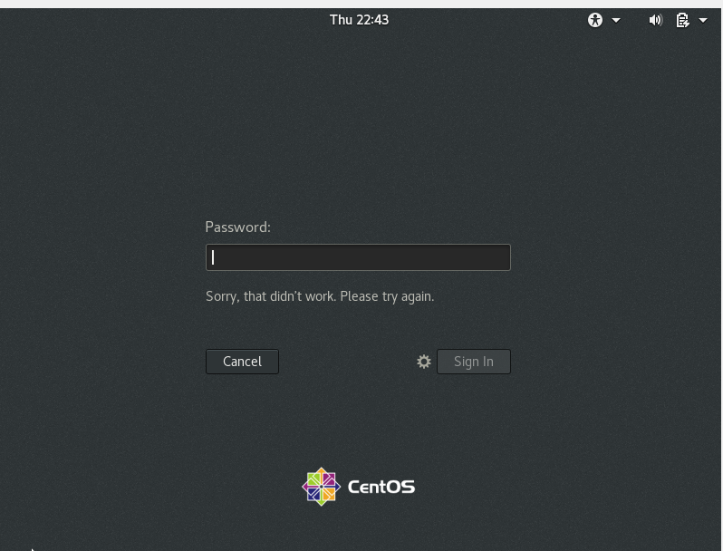

If we try to login with the invalid user then it will throw am error because the user is not registered

Assignment-2

Password changing

* Login into your account and then change password?
  + Change your password into **IneuR0n#42** and hit the **Enter** key
    - Explain what happen and give screenshot?

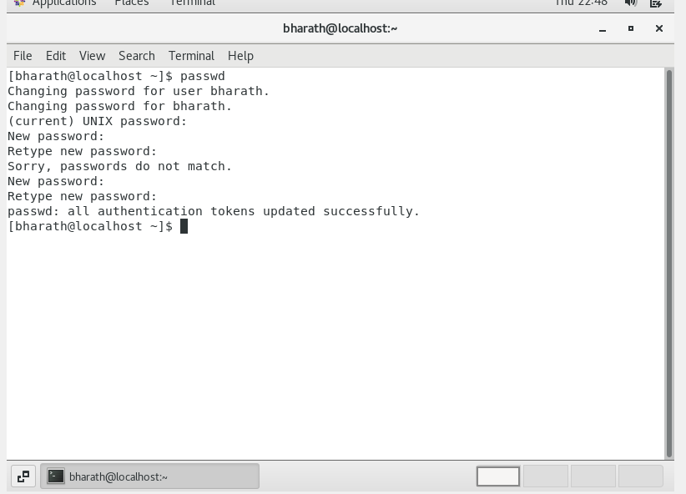

Password changed

* + Try again to change password but use like password ***1234*** or ***abcd***
    - Explain what happen and give screenshot?

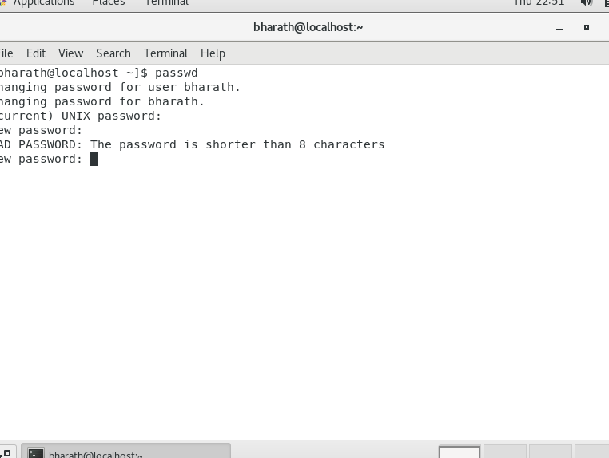

Throwed an error and the limit should be min of 8 characters.

* + Try again to change password but now don’t use any password just hit **Enter** key
    - Explain what happen and give screenshot?

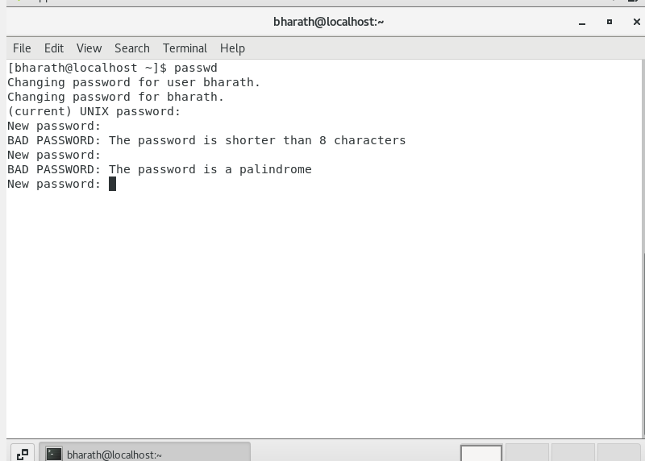

Throwed error that the password is palindrome.

Assignment-3

Working with Directories

* Enter the command **cd /** and then **ls** and then hit **Enter** key
  + Take screenshot and explain what output we got?

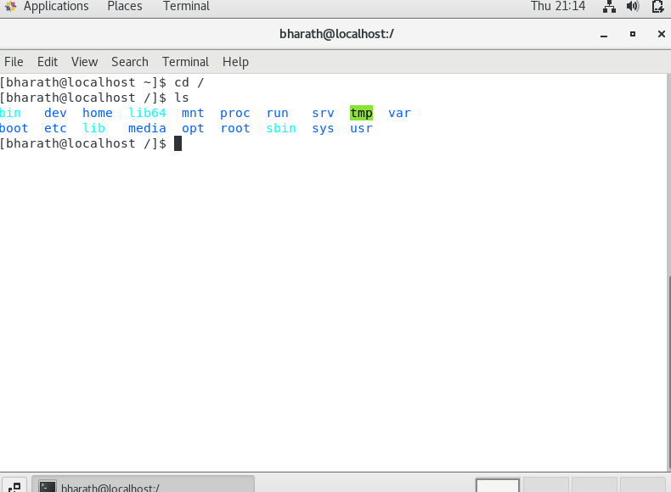

Cd / takes us to system root directory and ls command gives us the folders and the files present in it

* Enter the command now **cd /home** and then hit **Enter** key
  + Do **ls,** provide screenshot and explain what is **/home** directory used for?

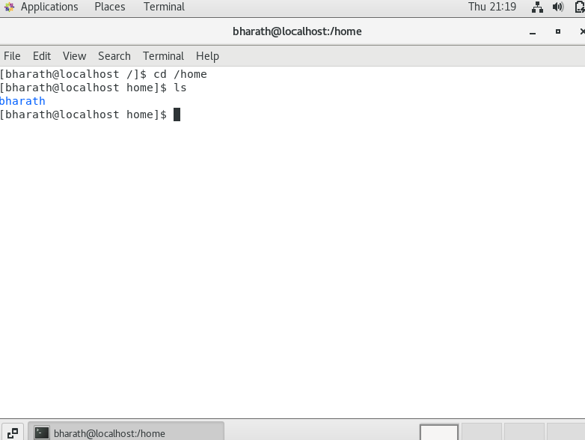

Cd / home command will takes us to the users directory which is under root

* Enter **cd ..** and hit **Enter** key [ *Note: here we have space after cd then use double dot*]
  + Check what happen and give screenshot?



By using cd .. command takes us to the one directory back .

* Now enter **cd /var/www/html** and then type **cd** and hit **Enter** key
  + Explain what happen and give screenshot?

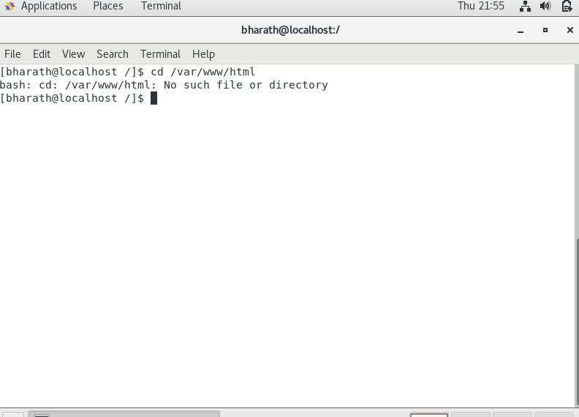

The above command gives us the root folder of a web server as it was not installed so it is showing directory not found error.

* Now type **cd /root** and then hit **Enter** key
  + Do **ls,** check any output we have on screen if yes then take screenshot?

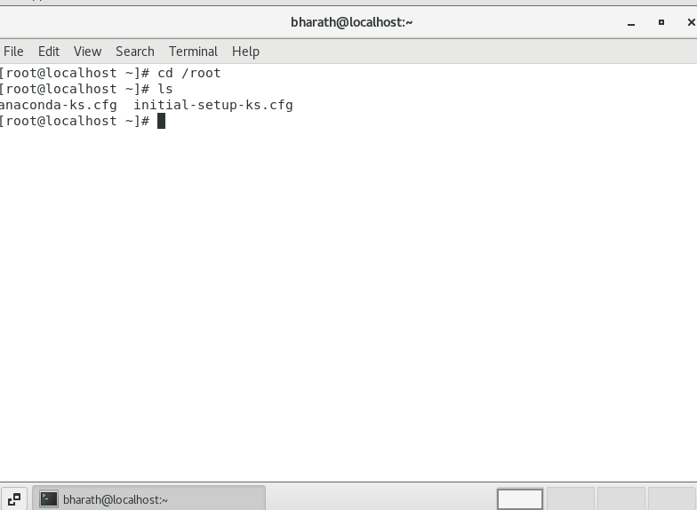

It is a starter file contains settings.

Assignment-4

Working with File Listing

* Go to **cd /etc** and type **ls**
  + Take screenshot and explain what files you have seeing?
  + Take screenshot and explain what different output you found compare to previous command you used?

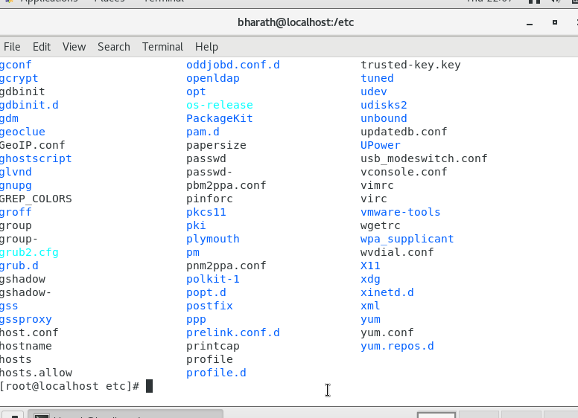

This command is used to access the configuration files

* Then type **ls -al** and hit **Enter** key
  + Take screenshot and explain what new file or directory you found?

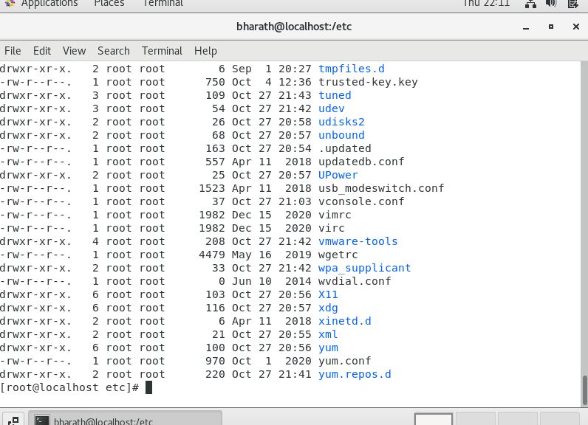

This command gives the all files in the directories

* Then use **ls -i** and hit **Enter** key
  + Now see what different output its shows and take screenshot?

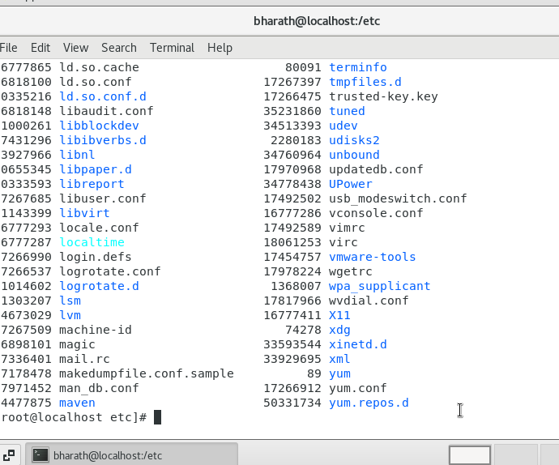

It lists the files in order

* Then use **ls –help** and see other options about **ls** command
  + Explore it and try with other attribute we can use with **ls** command

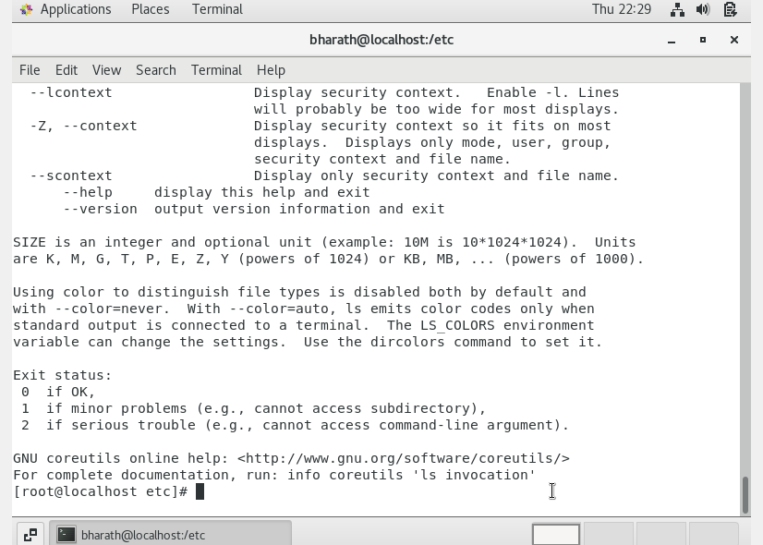

The correct command is ls --help

Assignment-5

Know where you are and where you working

*Here we use* ***pwd, cd and ls*** *as combine task to understand where you working on terminal and how you can switch from one directory to another one.*

* Open terminal after restart the linux
  + Check which location you working, type **pwd** and take screenshot

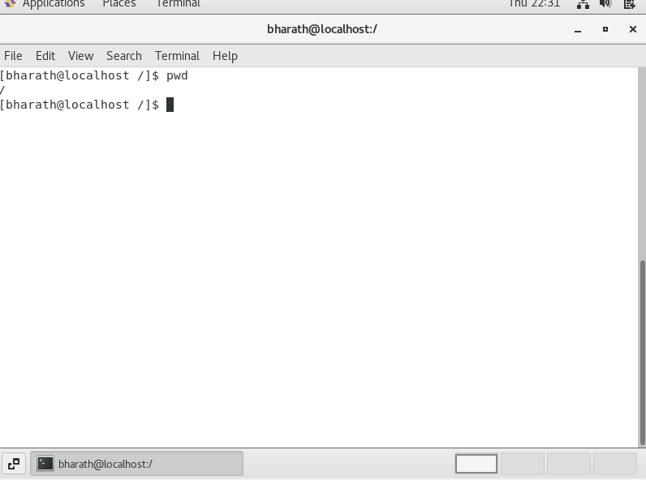

This command gives us the present working directory

* Now use **cd /var** and hit **Enter** key
  + Do **ls,** and see what output comes, give screenshot?

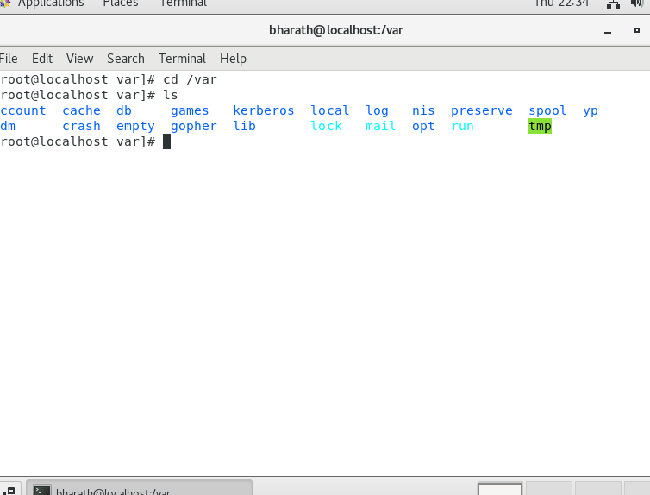

This contains logs data and temporary files etc.