

**Linux Basic Commands Assignment**

***Assignment Part-3***

Playing with files

1. Create a file like **nano file1.txt**

o Edit some data and then save the file

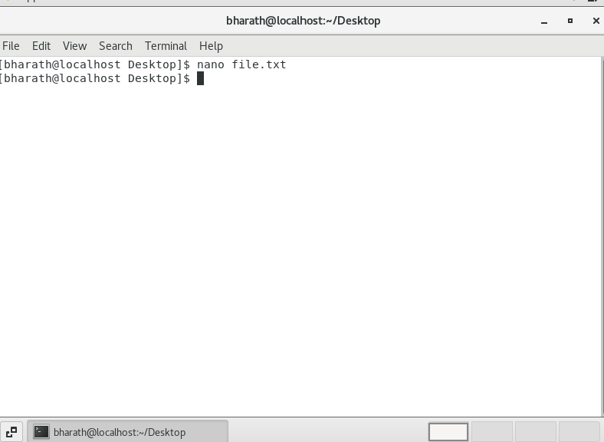

Edited and saved file

2. Now we will copy date from file1 to new file2

**o cp file1.txt file2.txt**

o Then see the output of file2.txt, **cat file2.txt**

o Give screenshot

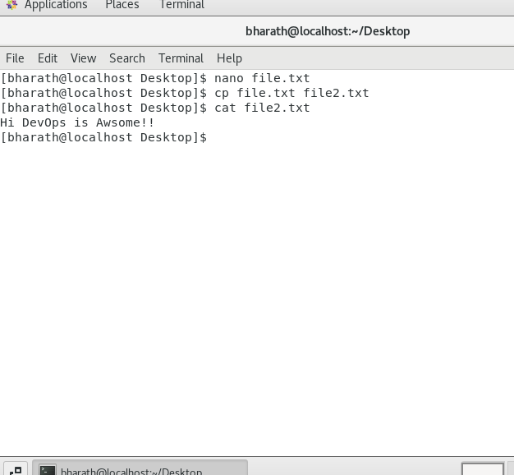

Copied data to file2.txt

3. Now we will move the file2.txt to new folder **/home**

o **mv file2.txt /home**

o Then go to **home** directory and check **ls,** file exits or not? o Given screenshot

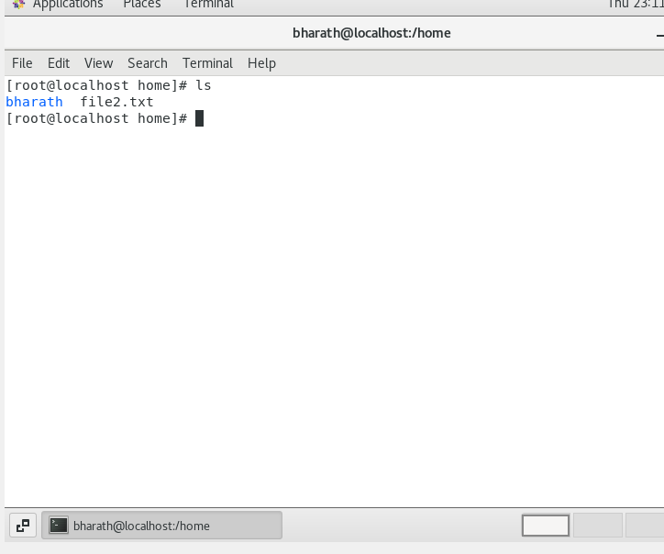

File moved to the home directory

4. Then we create a new **file3.txt and file4.txt** in **home directory** and add content in it.

o Now do **echo “Hello I am newline” > file3.txt** and provide the output of file3.txt

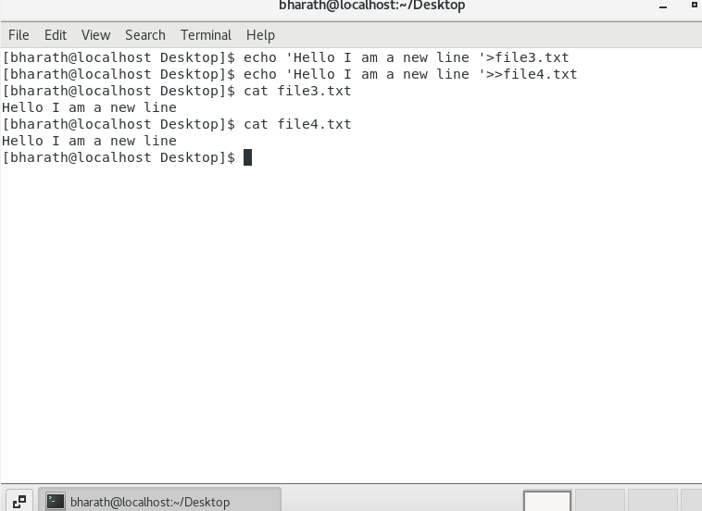

o Now do **echo “Hello I am newline” >> file4.txt** and provide the output of file4.txt



o Tell the different between both step you follow and the reason behind it



The main difference is that ‘>’ its will override the existing data and ‘>>’ will append the data

5. For remove a file or directory you can use the below two commands **o** To delete a file – **rm <any_filename>**

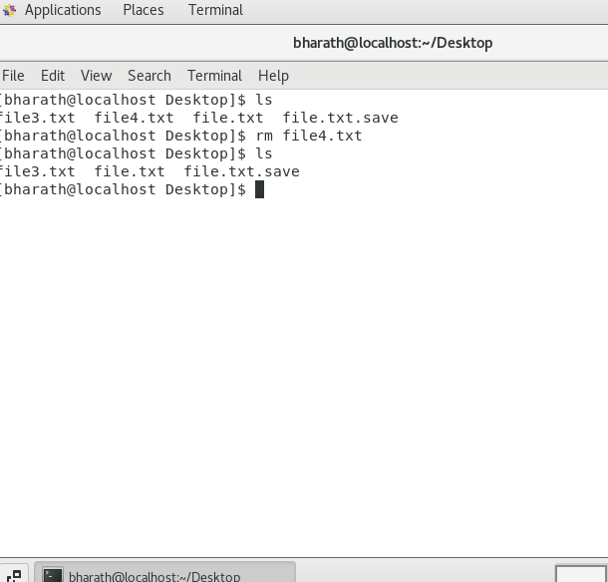

File4 is deleted

**o**Todeleteadirectory-**rmdir<any_directoryname>**

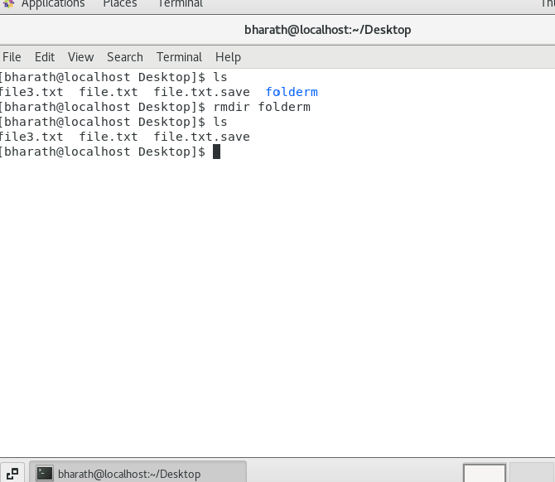

Deleted the folderm directory.

