**Ex.no: 04 221501019**

**03/04/2025**

**Checking stationarity of time series data using augmented dickey fuller test**

# AIM:

To check stationarity of time series data using augmented dickey fuller test.

**Code:**

import pandas as pd

from statsmodels.tsa.stattools import adfuller import matplotlib.pyplot as plt

try:

data = pd.read_csv('/content/Gold_Price_DataSet.csv', index_col='Date') # Assuming 'Date' is your date/time index column

except FileNotFoundError:

print("Error: '/content/Gold_Price_DataSet.csv' not found. Please upload your data file.")

data = None except KeyError:

print("Error: 'Date' column not found in the CSV. Please specify correct index column name.")

data = None

if data is not None:

# Extract the time series data

# The column name was changed from 'value' to 'Price'

timeseries = data['Price'] # Assuming 'Price' is your time series data column

# Perform the Augmented Dickey-Fuller test result = adfuller(timeseries)

# Print the test results

print('ADF Statistic: %f' % result[0]) print('p-value: %f' % result[1]) print('Critical Values:')

for key, value in result[4].items(): print('\t%s: %.3f' % (key, value))

print(result[1])

# Interpret the results if result[1] <= 0.05:

print("The time series is likely stationary.") else:

print("The time series is likely non-stationary.")

# OUTPUT:

ADF Statistic: -3.140151

p-value: 0.023721 Critical Values:

1%: -3.433

5%: -2.863

10%: -2.567

0.02372101223380104

The time series is likely stationary.

plt.figure(figsize=(12, 6)) plt.plot(data.index, timeseries) plt.title('Gold Price Time Series') plt.xlabel('Date') plt.ylabel('Price')

plt.grid(True) plt.show()

# OUTPUT:

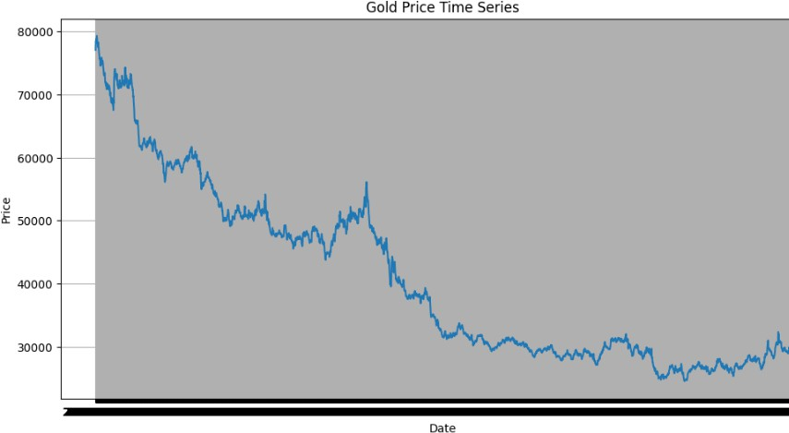

**RESULT:**

The program for checking a time series data stationary or not has been successfully implemented .