AmExpert 2021 – Machine Learning Hackathon
XYZ Bank is a mid-sized private bank that includes a variety of banking products, such as savings accounts, current accounts, investment products, credit products, and home loans.
The Bank wants to predict the next set of products for a set of customers to optimize their marketing and communication campaigns.
The data available in this problem contains the following information:
- User Demographic Details : Gender, Age, Vintage, Customer Category etc.
- Current Product Holdings
- Product Holding in Next 6 Months (only for Train dataset)
Here, our task is to predict the next set of products (upto 3 products) for a set of customers (Test data) based on their demographics and current product holdings.

Dataset Description
Train.csv
Customer_ID | Unique ID for the customer
Gender | Gender of the Customer
Age | Age of the Customer (in Years)
Vintage | Vintage for the Customer (In Months)
Is_Active | Activity Index, 0 : Less frequent customer, 1 : More frequent customer
City_Category | Encoded Category of customer's city
Customer_Category | Encoded Category of the customer
Product_Holding_B1 | Current Product Holding (Encoded)
Product_Holding_B2 | Product Holding in next six months (Encoded) - Target Column

Test.csv
Customer_ID | Unique ID for the customer
Gender | Gender of the Customer
Age | Age of the Customer (in Years)
Vintage | Vintage for the Customer (In Months)
Is_Active | Activity Index, 0 : Less frequent customer, 1 : More frequent customer
City_Category | Encoded Category of customer's city
Customer_Category | Encoded Category of the customer
Product_Holding_B1 | Current Product Holding (Encoded)

Evaluation Metric
The evaluation metric is Mean Average Precision (MAP) at K (K = 3). MAP is a well-known metric used to evaluate ranked retrieval results. E.g. Let’s say for a given customer, we recommended 3 products and only 1st and 3rd products are correct. So, the result would look like — 1, 0, 1
In this case, The precision at 1 will be: 1*1/1 = 1 The precision at 2 will be: 0*1/2 The precision at 3 will be: 1*2/3 = 0.67 Average Precision will be: (1 + 0 + 0.67)/3 = 0.556. The formula is:

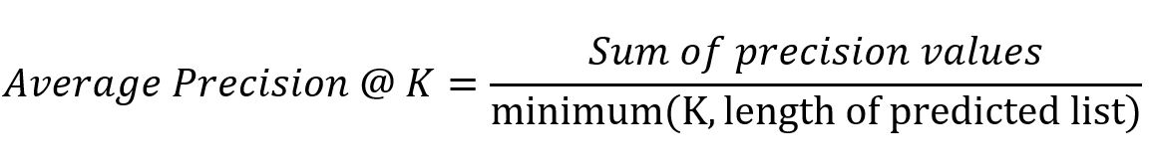
Mean average precision is the mean of average precision calculated across all users
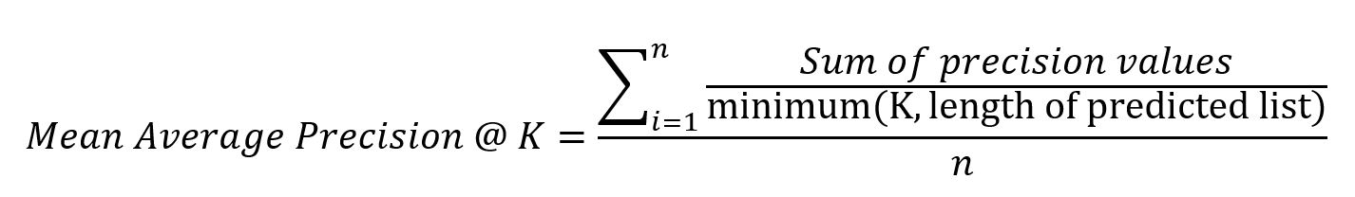
Where n = number of customers

Public and Private split
Note that the test data is further randomly divided into Public (30%) and Private (70%) data. Your initial responses will be checked and scored on the Public data.
The final rankings would be based on your private score which will be published once the competition is over.
Guidelines for Final Submission
Please ensure that your final submission includes the following:
- Solution file containing the predictions for next 3 products (format is given in sample submission csv)
Note : Format of your submission should be as mentioned in the sample submission file.
- Code file for reproducing the submission, note that it is mandatory to submit your code for a valid final submission
Hackathon Rules
- The final standings would be based on private leaderboard score.
- You should not use Customer_ID as a feature to build the model.
- Setting the final submission is recommended. Without a final submission, the submission corresponding to best public score will be taken as the final submission
- Use of external data is prohibited
- You can only make 10 submissions per day
- Entries submitted after the contest is closed, will not be considered
- The code file pertaining to your final submission is mandatory while setting final submission
- Throughout the hackathon, you are expected to respect fellow hackers and act with high integrity.
- Analytics Vidhya and American Express holds the right to disqualify any participant at any stage of the competition if the participant(s) are deemed to be acting fraudulently.
- Use of multiple Login IDs will lead to immediate disqualification

