WEEK 3 – ADVANCED DATA ANALYSIS AND VISUALIZATION IN LOGISTICS
Yuva Intern | Logistics Data Analyst Project
Dataset: 600-row synthetic logistics shipment dataset continued from Weeks 1 and 2

1. Executive Summary
This report presents exploratory data analysis of 600 hypothetical logistics shipments. It examines shipment outcomes, delivery duration, carrier performance, monthly shipment volume and transportation costs. Pandas, Matplotlib and Seaborn were used to calculate performance measures and create visualizations. The purpose is to demonstrate how visual analytics can support logistics performance monitoring and data-driven operational decisions.

2. Objectives
- Explore the structure and characteristics of the logistics dataset.
- Calculate descriptive statistics and operational performance indicators.
- Identify patterns in shipment volume, delivery duration, carrier performance and cost.
- Examine relationships among distance, shipment weight and transportation cost.
- Translate analytical findings into practical recommendations.

3. Dataset Overview and Methodology
The analysis uses the same 600-row synthetic dataset used in Weeks 1 and 2. Fields include order and shipment identifiers, order date, warehouse, region, carrier, service type, planned distance, shipment weight, dispatch time, promised delivery time, delivered time, shipment status and actual transportation cost in INR. The data is simulated for educational purposes; it is not actual company or operational data.
Date/time fields were converted to datetime format. Delivery duration was calculated as delivered time minus dispatch time. Delivery delay was calculated as delivered time minus promised delivery time. On-time delivery was defined as a delivered shipment arriving at or before its promised time. Delivery-time and carrier comparisons exclude shipments without a valid delivered timestamp.

4. Descriptive Analysis and Key Performance Indicators
Metric | Result
Total shipments | 600
Delivered shipments | 543 (90.5%)
Average delivery time | 4.62 hours
Median delivery time | 4.15 hours
On-time rate among delivered | 76.8%
Average transportation cost | INR 258.79
Average planned distance | 118.95 km
Average shipment weight | 16.12 kg

5. Visualizations and Interpretations
Figure 1. Shipment volume by delivery status
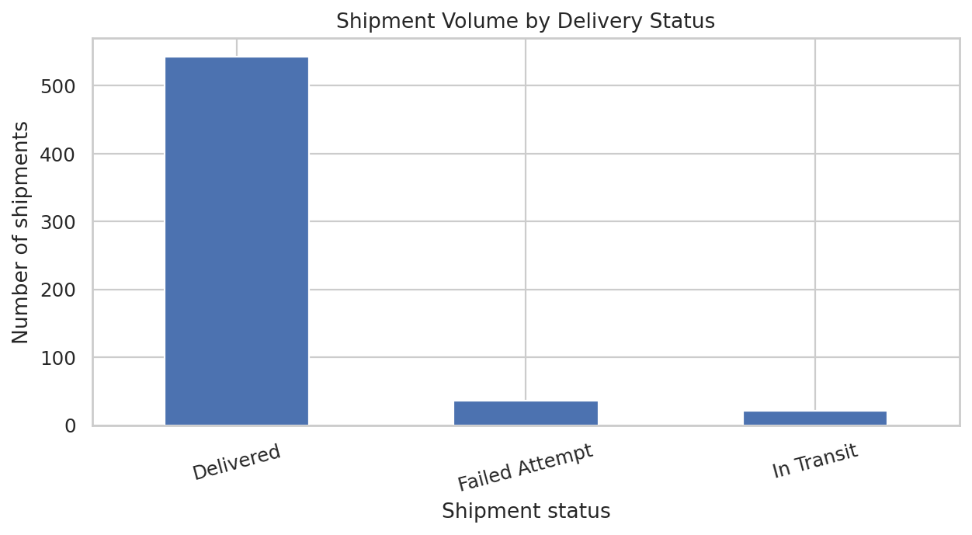
A bar chart compares categorical shipment outcomes. It helps identify the volume of delivered, failed-attempt and other status groups, directing attention to processes that may need investigation.
Figure 2. Monthly shipment volume
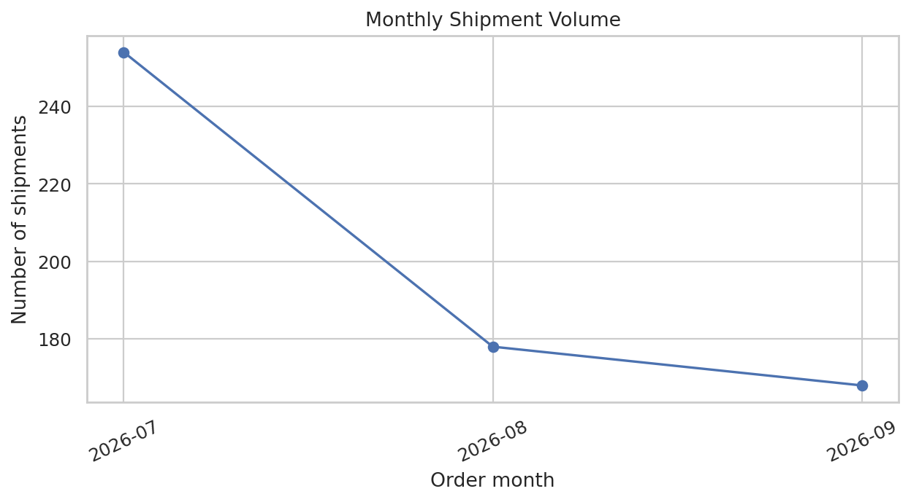
A line chart is suitable for time-ordered data and makes changes across months easy to see. Volume trends can support staffing, warehouse-capacity and carrier planning.
Figure 3. Distribution of actual delivery time
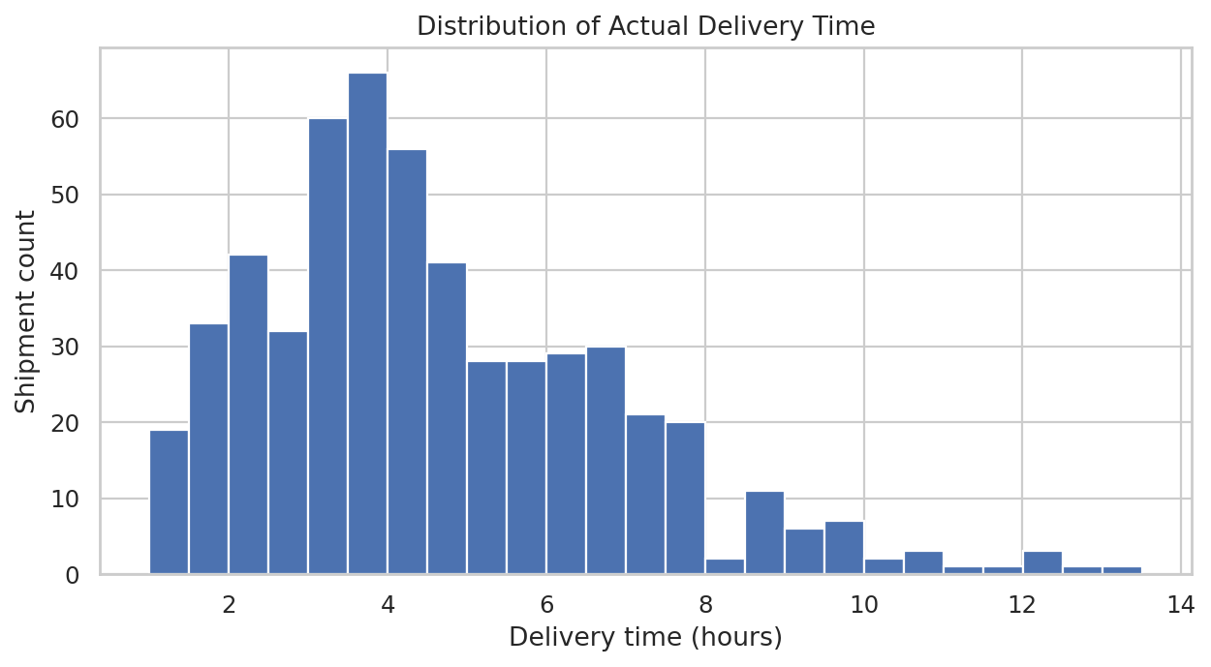
A histogram shows the spread and shape of delivery durations. It helps identify concentration, skew and unusually long deliveries. Mean and median should be reviewed together because long durations can pull the mean upward.
Figure 4. Average delivery time by carrier
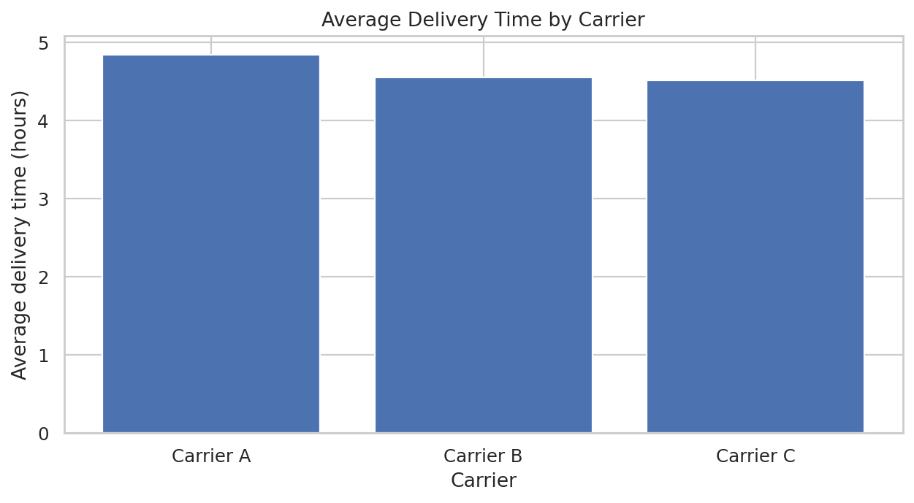
A bar chart enables direct comparison of average delivery time across carriers. It includes delivered shipments only. Differences should be reviewed alongside route distance, service type and sample size.
Figure 5. Transportation cost versus planned distance
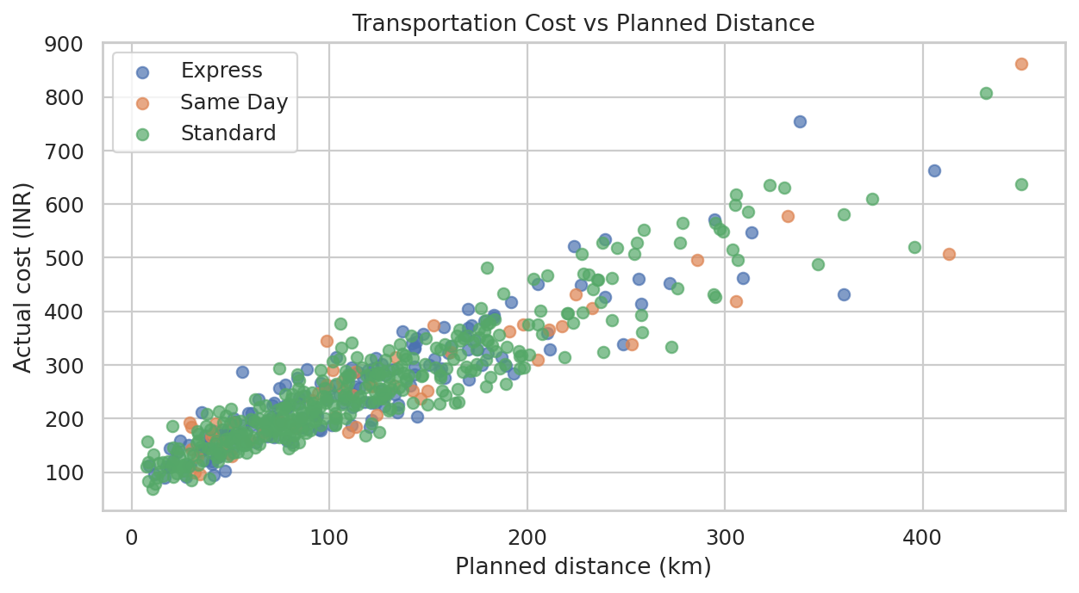
A scatter plot examines the relationship between two numerical variables. It can show whether longer planned distances tend to be associated with higher transportation costs and whether service types show different patterns.
Figure 6. Correlation among numeric logistics variables
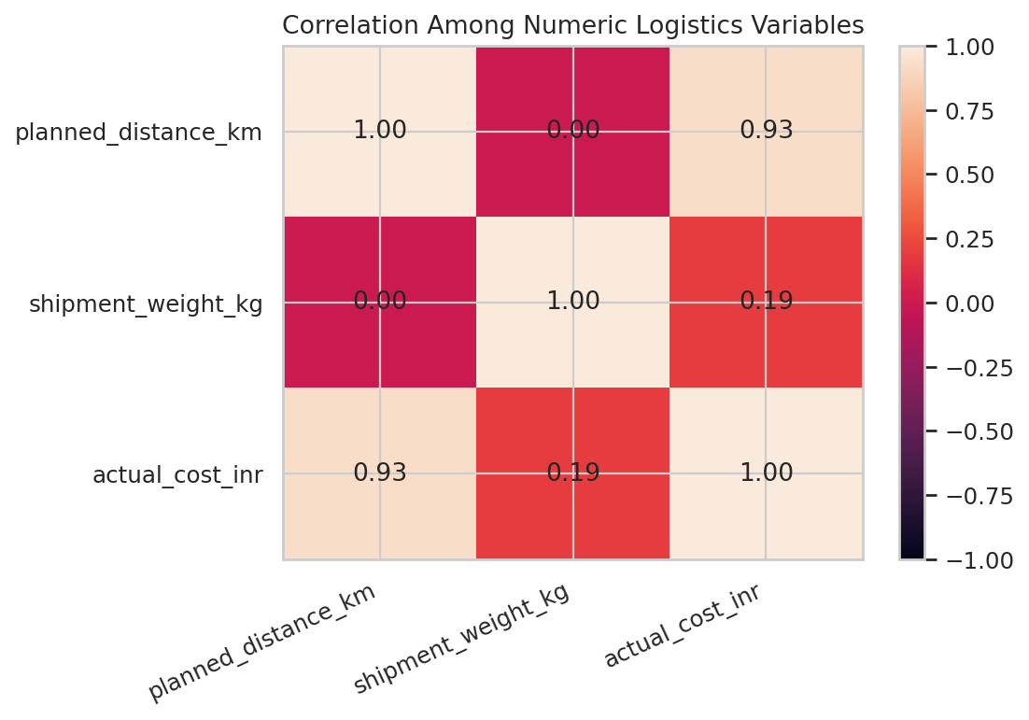
A correlation heatmap summarizes the direction and strength of linear relationships among distance, weight and cost. Correlation does not prove causation and should be treated as exploratory evidence.

6. Analytical Insights
The delivery completion rate is 90.5%. Among delivered shipments, the on-time rate is 76.8% and average delivery duration is 4.62 hours. Average transportation cost is INR 258.79.
The Pearson correlation between planned distance and actual cost is 0.93; between shipment weight and actual cost it is 0.19. These values describe linear association in this sample and do not establish causality.
Among carriers with delivered shipments, Carrier C has the lowest observed average delivery time (4.51 hours), while Carrier A has the highest (4.84 hours). Shipment mix and distance may affect this comparison.

7. Recommendations
- Monitor delivery completion and on-time delivery rates together because they measure different aspects of performance.
- Review failed-attempt shipments to identify address, customer-availability, dispatch or carrier-process issues.
- Use monthly shipment trends to plan staffing, warehouse capacity and carrier allocation.
- Compare like-for-like routes and service types before changing carrier assignments.
- Track transportation cost per shipment and cost per kilometre, and assess the influence of shipment weight and service type.
- Repeat the analysis with validated operational data before making financial or service-level decisions.

8. Tools and Visualization Choices
Pandas was used for loading, datetime conversion, feature engineering, aggregation and summary tables. Matplotlib and Seaborn were used for the bar chart, line chart, histogram, scatter plot and correlation visualization. Each chart was selected to match the variable types and analytical question.

9. Limitations
The dataset is synthetic, has a limited number of records and may not reflect real-world logistics complexity. Observed patterns are illustrative and should not be generalized to an actual company. Carrier comparisons may be affected by route distance, service type and shipment mix. Correlation describes association and does not establish causality.

10. Conclusion
This task demonstrates how exploratory data analysis and visualizations can turn shipment-level records into interpretable logistics performance information. The KPI summary and charts provide complementary views of shipment outcomes, workload trends, delivery-time variation, carrier performance and transportation costs. The workflow can be reused with validated operational data to support more reliable planning and continuous improvement.

