WEEK 4 – PREDICTIVE MODELING AND OPTIMIZATION IN LOGISTICS SYSTEMS
Yuva Intern | Logistics Data Analyst Project
Predictive objective: Estimate delivery duration for completed shipments

1. Executive Summary
This project develops and evaluates regression models to estimate delivery duration in hours using a synthetic logistics dataset. The modeling sample contains 543 completed shipments with valid positive delivery durations. Linear Regression, Random Forest and a tuned Random Forest were compared using a held-out test set. Linear Regression achieved test MAE 1.24 hours, RMSE 1.67 hours and R² 0.451. The tuned Random Forest achieved MAE 1.35 hours, RMSE 1.73 hours and R² 0.410. The lowest test MAE was achieved by Linear Regression in this experiment; therefore it is selected as the best-performing candidate on the held-out test set.

2. Problem Definition
The prediction problem is to estimate the elapsed time between dispatch and delivery for a shipment. The target variable is delivery_time_hours = delivered_time − dispatch_time. The intended use is planning support: estimating expected delivery duration so logistics teams can review potentially long-duration shipments and plan resources. The prediction is not a guaranteed delivery promise.

3. Dataset and Feature Design
The project reuses the same 600-row synthetic logistics dataset from Weeks 1–3. It contains order and shipment IDs, order date, warehouse, region, carrier, service type, planned distance, shipment weight, dispatch time, promised delivery time, delivered time, status and actual transportation cost. Only rows with status Delivered and a valid positive delivery duration were used for supervised training because the target cannot be calculated for undelivered records.
Predictor variables: planned distance, shipment weight, carrier, service type, region, warehouse, order month and order day of week. Target: delivery duration in hours. IDs, delivered timestamp, delivery status and actual cost were excluded from predictors to avoid using identifiers, post-outcome information or a cost measure that may not be known at dispatch.

4. Data Preparation and Modeling Method
Date columns were parsed as datetime values. Delivery duration was calculated from delivered and dispatch timestamps, and records with missing or non-positive duration were excluded. The modeling sample was split into 80% training and 20% testing with random_state=42. Numeric features were median-imputed and standardized. Categorical features were imputed with the most frequent category and one-hot encoded. All preprocessing was placed inside Scikit-learn pipelines so transformations were fitted on training data only.

5. Model Selection
Linear Regression was selected as an interpretable baseline for estimating a continuous target. Random Forest Regressor was selected as a nonlinear ensemble candidate that can represent interactions and nonlinear patterns. A small GridSearchCV search tested 150 or 250 trees, maximum depth None or 8, and minimum leaf size 1 or 2. Five-fold shuffled cross-validation was performed within the training partition. The test set was reserved for final comparison.

6. Model Performance Evaluation
Model | MAE (hours) | RMSE (hours) | R²
Mean baseline | 1.857 | 2.256 | -0.007
Linear Regression | 1.244 | 1.666 | 0.451
Random Forest (default) | 1.360 | 1.724 | 0.412
Random Forest (tuned) | 1.351 | 1.727 | 0.410
The tuned Random Forest's best cross-validation MAE on the training folds was 1.304 hours. Best parameters: {'model__max_depth': 8, 'model__min_samples_leaf': 1, 'model__n_estimators': 150}. Tuning did not outperform Linear Regression on the held-out test MAE in this run. This is an important result: a more complex model is not automatically better.
MAE is the average absolute prediction error and is easy to interpret in hours. RMSE penalizes larger errors more strongly. R² describes the proportion of target variance explained relative to a mean baseline; it can be negative when a model performs worse than that baseline.
Model selection: Linear Regression is selected for this experiment because it produced the lowest test MAE among the evaluated models. This choice is specific to this synthetic sample and split and should be revalidated on real, time-ordered operational data.
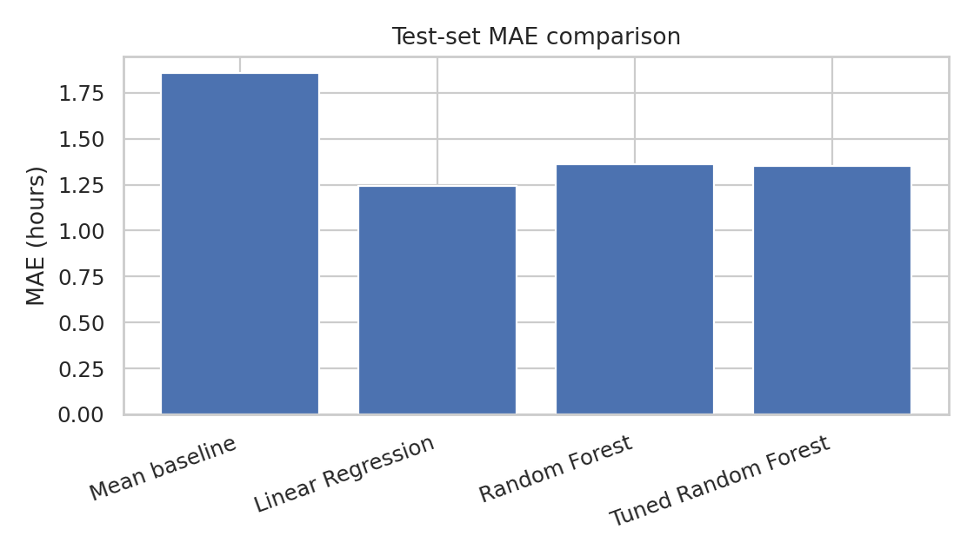
Figure 1. Test-set MAE comparison across candidate models.
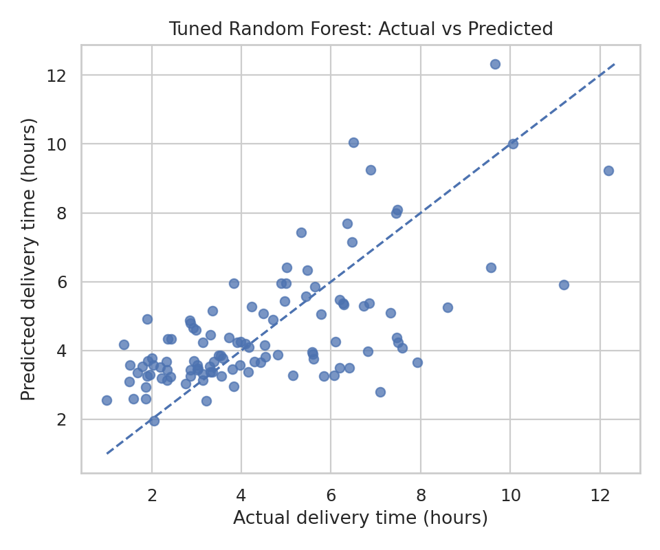
Figure 2. Actual versus predicted delivery duration for the tuned Random Forest. The diagonal reference line represents perfect predictions.
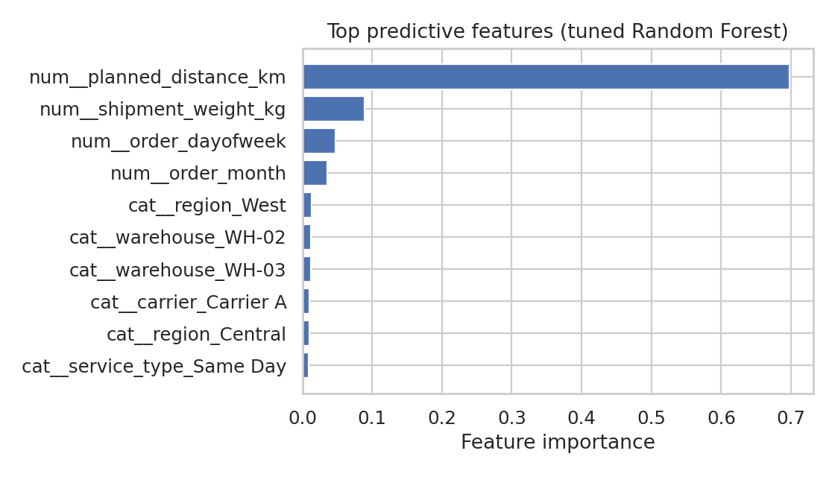
Figure 3. Top Random Forest feature importances. These values describe model reliance, not causal effects.

7. Findings and Interpretation
On the held-out test set, Linear Regression achieved MAE 1.24 hours and RMSE 1.67 hours. Its R² was 0.451. The tuned Random Forest recorded MAE 1.35 hours. The Random Forest feature-importance analysis ranks planned distance as the strongest predictor in this fitted model (importance 0.697), followed by shipment weight and order calendar features. Feature importance does not prove that a variable causes longer delivery times.

8. Optimization Strategies
- Use predicted delivery duration as a planning signal to flag shipments likely to require longer delivery windows; do not treat it as a guaranteed customer promise.
- Review high-distance shipments during dispatch planning and consider realistic time buffers based on route and service type.
- Compare carriers on similar routes, shipment weights and service types before reallocating shipment volume.
- Use capacity planning to align carrier and warehouse resources with expected shipment workload.
- Track actual-versus-predicted errors and investigate systematic underprediction or overprediction by region, carrier or service type.
- Pilot route or carrier changes and evaluate delivery time, cost and on-time performance together before scaling.

9. Validation, Limitations and Responsible Use
Random train/test splitting and five-fold cross-validation were used for this educational comparison. For deployment, a chronological train/validation/test split is preferable because future deliveries should be predicted from past data. The dataset is synthetic, small and may not reflect real operational variability. The target is observed only for completed deliveries, so the model does not predict failed or still-open shipments. Feature importance and correlation are not causal explanations. Real deployment requires representative historical data, leakage checks, model monitoring, and human review.

10. Conclusion
This project demonstrates an end-to-end predictive modeling workflow for logistics delivery duration. Candidate regression models were trained and evaluated using MAE, RMSE and R², with cross-validation and hyperparameter tuning applied to the Random Forest model. Linear Regression achieved the lowest test MAE in this experiment. The resulting insights support practical ideas for delivery-window planning, carrier comparison, resource allocation and continuous model monitoring. All conclusions are illustrative because the dataset is synthetic.

