Originl table with Diagnosis updated from Flu to PNEUMONIA.

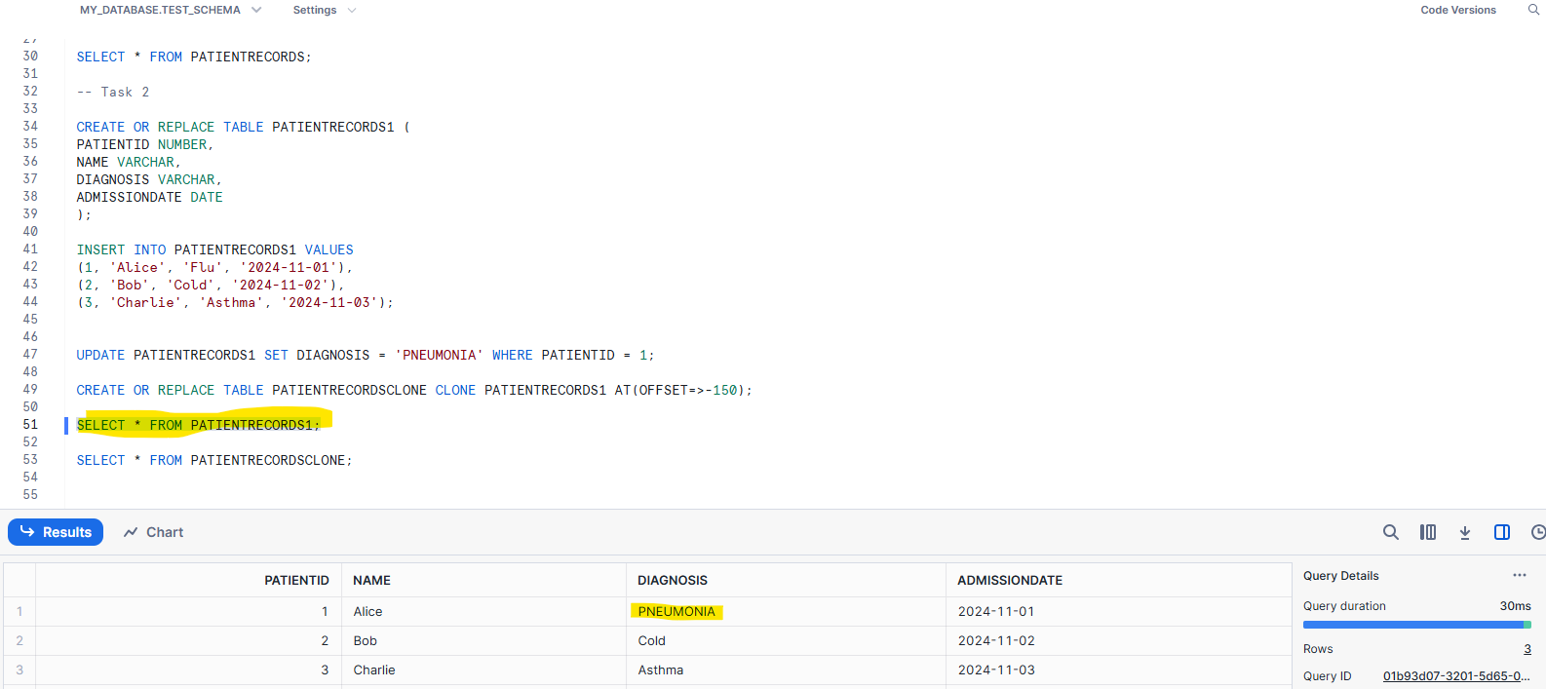

Cloned table:

