Assignment-1

Task 2: Create and Query a Materialized View

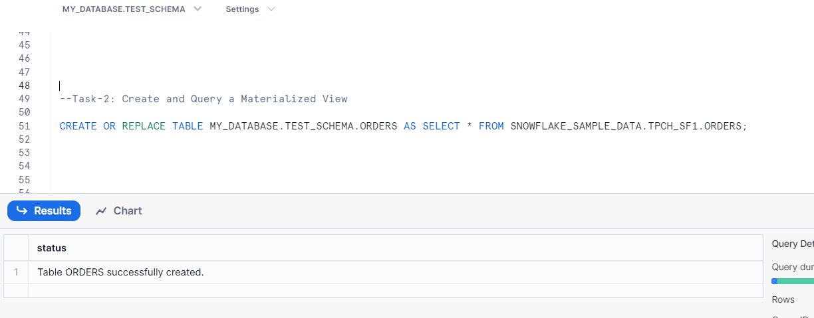

Code:

--Task-2: Create and Query a Materialized View

CREATE OR REPLACE TABLE MY_DATABASE.TEST_SCHEMA.ORDERS AS SELECT * FROM SNOWFLAKE_SAMPLE_DATA.TPCH_SF1.ORDERS;

SELECT * FROM MY_DATABASE.TEST_SCHEMA.ORDERS;

CREATE OR REPLACE MATERIALIZED VIEW ORDERS_BY_ORDER_PRIORITY AS

SELECT O_ORDERPRIORITY, COUNT(O_ORDERKEY) AS ORDERS

FROM MY_DATABASE.TEST_SCHEMA.ORDERS

GROUP BY O_ORDERPRIORITY;

SELECT * FROM ORDERS_BY_ORDER_PRIORITY;

UPDATE MY_DATABASE.TEST_SCHEMA.ORDERS SET O_ORDERPRIORITY = '5-LOW' WHERE O_ORDERKEY = 2400001;

SELECT O_ORDERPRIORITY, COUNT(O_ORDERKEY) AS ORDERS

FROM MY_DATABASE.TEST_SCHEMA.ORDERS

GROUP BY O_ORDERPRIORITY;