Project Proposal: VoiceArmor-Edge
Real-Time On-Device Voice Spoof & Synthetic Call Detection
for Snapdragon-Powered HP PCs

Challenge: Snapdragon AI Lab Build & Present Challenge 2026
Participant: Bharath G Devadiga
Email: bharath.23ec014@sode-edu.in
Discipline: Electronics & Communication Engineering (ECE)
Target Hardware: Snapdragon X HP OmniBook PCs (Hexagon NPU) + Arduino UNO Q

1. Project Overview
AI tools can now clone a person's voice using just a short 3-second recording. Scammers are using these cloned voices to impersonate police officers, bank officials or family members to steal money -- a major issue right now with "Digital Arrest" scams in India.
Current solutions rely on cloud servers to analyze audio. This does not work for live calls:
- Sending call audio over the internet is too slow to warn someone in real time.
- It requires an internet connection and leaks private conversations.
- It drains laptop battery and can make video calls laggy.
VoiceArmor-Edge solves this by running entirely on the laptop using the Snapdragon Hexagon NPU. It listens to incoming call audio in short 250ms chunks, converts sound into frequency pictures (spectrograms) and runs a lightweight AI model to check if the voice is real or fake in under 15ms.
It also connects via USB to an Arduino UNO Q board. If a fake voice is detected, the Arduino turns on a red warning light and buzzer -- a physical warning the user cannot miss.

2. Real-World Need & Use Case
The Problem
- Voice Cloning Fraud: Fraudsters call victims pretending to be law enforcement or family members in distress, demanding urgent bank transfers.
- No Protection on Meeting Apps: Microsoft Teams, Zoom and WhatsApp Desktop have no built-in way to check if a voice is human or AI-generated.

Why It Must Run on the Snapdragon NPU
- Fast Response: The NPU checks speech in under 15ms, warning the user while the caller is still speaking.
- Complete Privacy: Audio never leaves the laptop. Works 100% offline, even in Airplane Mode.
- No Video Call Lag: The NPU handles AI work, leaving CPU and GPU free for the video call.
- Low Battery Drain: The NPU uses very little power, runs quietly in the background all day.

3. Technical Implementation
System Architecture
The system follows a 4-step pipeline:
- Step 1 - Audio DSP Pipeline: Takes 250ms audio chunks at 16 kHz and produces a 64-band Mel Spectrogram.
- Step 2 - Qualcomm AI Hub Model: INT8 quantized CNN classifier compiled with qai-hub toolchain.
- Step 3 - Hexagon NPU Inference: Runs via ONNX Runtime + QnnHtp.dll with under 15ms latency.
- Step 4 - Alert System: Windows notification + Arduino UNO Q red LED and buzzer.
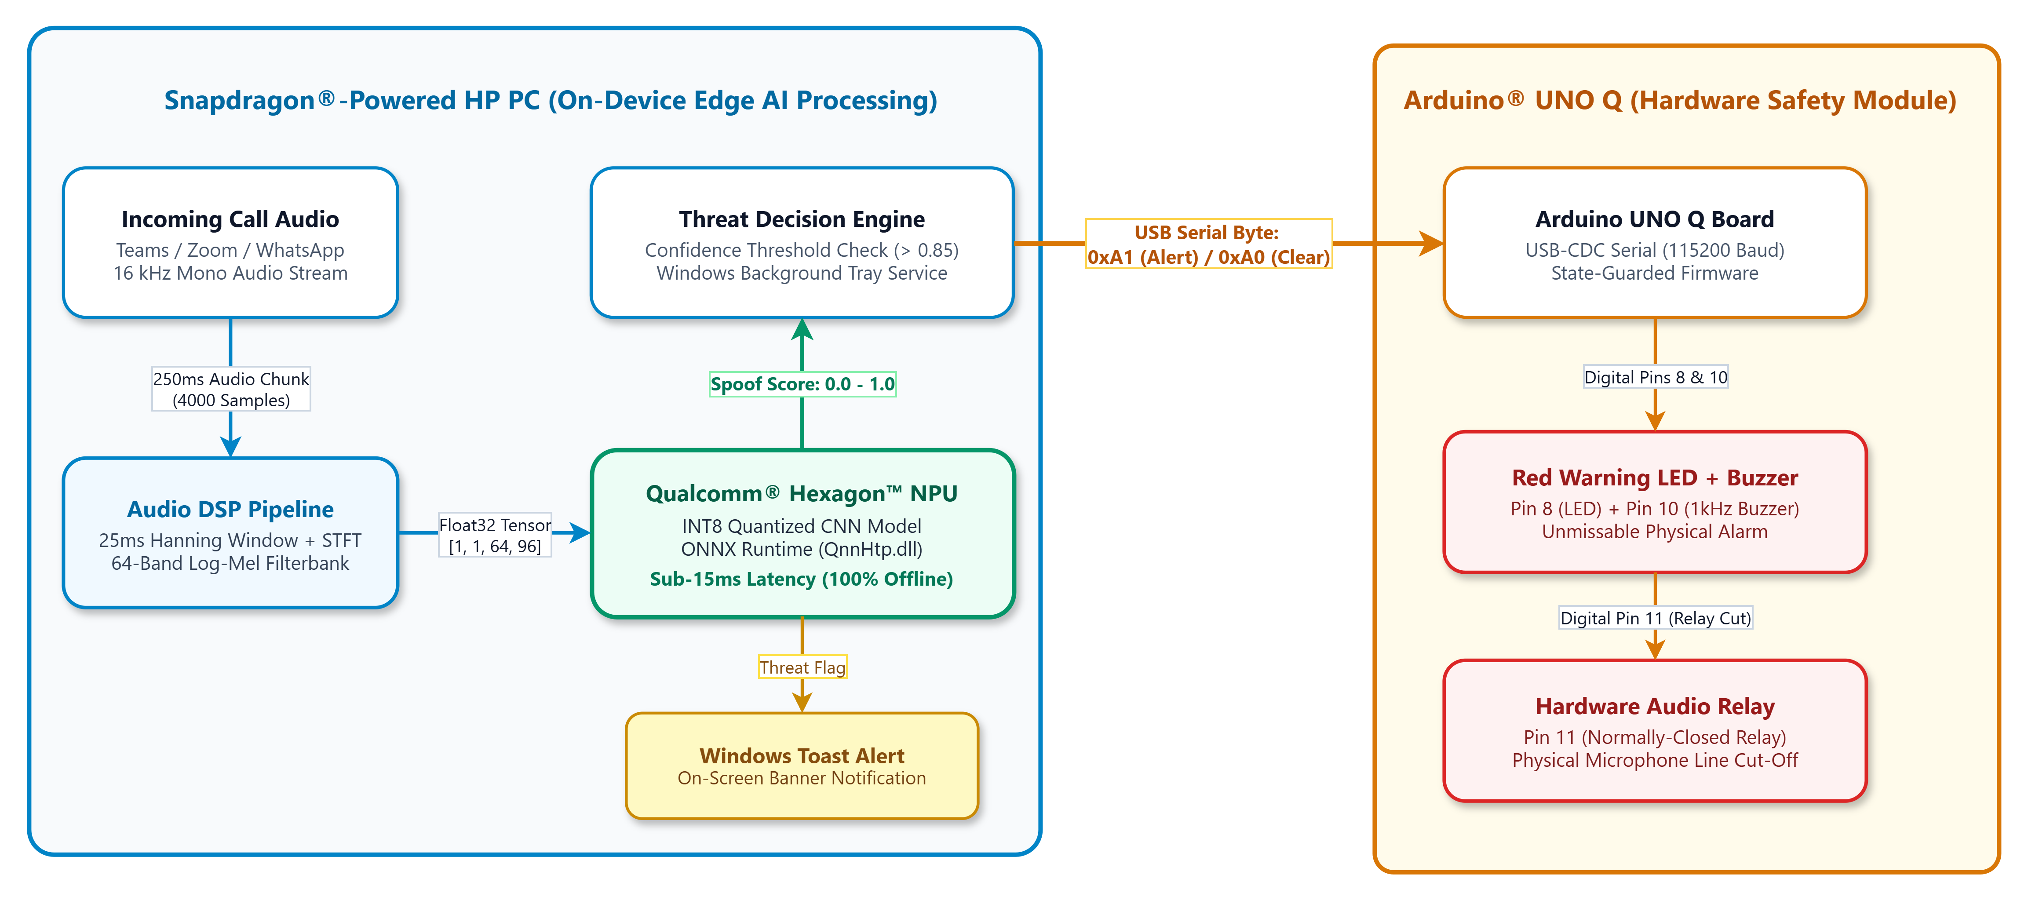
Figure 1: VoiceArmor-Edge End-to-End System Architecture
A. Audio Feature Extraction (DSP)
When AI tools generate fake speech, they leave subtle irregularities in higher frequencies that natural human vocal cords do not produce.
- Captures audio from the computer's audio output in real time.
- Slices sound into 250ms chunks and generates a Log-Mel Spectrogram (a visual representation of sound frequencies over time).
- Runs on the CPU and passes the data straight to the NPU.
B. Qualcomm AI Hub Model
- Adapted from standard audio models in the Qualcomm AI Hub catalog.
- INT8 Quantization: Weights converted from 32-bit to 8-bit integers for fast NPU processing with minimal accuracy loss.
- Compiled using Qualcomm's qai-hub toolchain for ONNX + QNN acceleration.
C. Running on Windows on Snapdragon
- Runs as a native Windows service using onnxruntime with onnxruntime-qnn plugin.
- Links directly with Qualcomm's QnnHtp.dll driver for Hexagon NPU execution.

D. Hardware Alert with Arduino UNO Q
In line with the Snapdragon AI Lab setup:
- The Snapdragon HP PC does the AI computation.
- Arduino UNO Q connects via USB as a physical out-of-band indicator.
- If fake voice detected: PC signals Arduino to turn on red LED and buzzer.
- Physical light alerts the user even if screen is covered or minimized.

4. Why This Approach Stands Out
- Practical & Focused: Solves one critical problem very well -- live synthetic voice detection.
- True Edge Computing: Proves why an on-device NPU is needed. Cloud APIs cannot match sub-15ms speed and privacy.
- Physical Hardware Safety: Bridges software AI with real-world hardware alerts using Arduino UNO Q.

5. Deployment on Snapdragon HP PCs
- Target: HP OmniBook laptops with Snapdragon X Elite / X Plus.
- OS: Windows 11 on ARM64.
- Lightweight: Under 120 MB RAM, under 3% CPU.
- Works Offline: Fully functional in Airplane Mode.
- Easy to Use: Runs quietly in the system tray, monitors calls automatically.
- Testing & Accessibility: Includes a built-in CPU fallback and hardware simulation mode so evaluators can run and verify the codebase on standard PCs.

6. Project Presentation & Code
- Slide Deck: 10-slide presentation covering the problem, architecture, NPU integration and roadmap.
- Source Code: Full project on GitHub with audio processing pipeline, NPU inference script and Arduino sketch.

7. Conclusion
VoiceArmor-Edge is a focused and practical project that shows the real value of the Snapdragon Hexagon NPU. By combining digital signal processing, Qualcomm AI Hub model optimization and a physical hardware alert, it protects everyday users from AI voice scams safely and privately on their own laptops.

