VISVESVARAYA TECHNOLOGICAL UNIVERSITY
“Jnanasangama”, Belagavi-590018, Karnataka



BANGALORE INSTITUTE OF TECHNOLOGY
K.R. Road, V.V.Puram, Bangalore-560 004



DEPARTMENT OF COMPUTER SCIENCE & ENGINEERING

APPLICATION DEVELOPMENT USING PYTHON
18CSL55

“Implementation of FTPS(FTP over SSL) to
overcome drawbacks of FTP ”

Submitted By

Sl.No | Name | USN
1 | Bharath Gowda B | 1BI19CS038
2 | Harish V | 1BI19CS058
3 | Harshith Reddy G | 1BI19CS063
4 | Suyog S Shimpukade | 1BI19CS161

for the academic year 2020-21

Department of Computer Science & Engineering
Bangalore Institute of Technology
K.R. Road, V.V.Puram, Bangalore-560 004

VISVESVARAYA TECHNOLOGICAL UNIVERSITY
“Jnanasangama”, Belagavi-590018, Karnataka

BANGALORE INSTITUTE OF TECHNOLOGY
K.R. Road, V.V.Puram, Bangalore-560 004

Department of Computer Science & Engineering

Certificate

This is to certify that the implementation of ADP MINI PROJECT entitled
“Implementation of FTPS(FTP over SSL) to overcome drawbacks of FTP” has been successfully completed by
USN: 1BI19CS038 NAME: BHARATH GOWDA B
USN: 1BI19CS058 NAME: HARISH V
USN : 1BI19CS063 NAME: HARSHITH REDDY G
USN : 1BI19CS161 NAME: SUYOG S SHIMPUKADE
of V semester B.E. for the partial fulfillment of the requirements for the Bachelor's degree in Computer Science & Engineering of the Visvesvaraya Technological University during the academic year 2021-2022.

Prof.Sushma.H.R Dr. Girija.J
Asst.Professor Professor and Head
Dept. of CS&E Department of CS&E
Bangalore Institute of Technology Bangalore Institute of Technology
Bangalore Bangalore

ACKNOWLEDGEMENT
The knowledge and satisfaction that accompany the successful completion of any task would be incomplete without mention of people who made it possible, whose guidance and encouragement crowded my effort with success. We would like to thank all and acknowledge the help we have recieved to carry out this mini project.

We would like to convey our thanks to Head of the Department Dr. Girija.J
for being kind enough to provide the necessary support to carry out the mini project.

We are most humbled to mention the enthusiastic influence provided by Prof.Sushma.H.R, on the project for their ideas, time to time suggestions for being a constant guide and co-operation showed during the venture and making this project a great success.

Bharath Gowda B 1BI19CS038
Harish V 1BI19CS058
Harshith Reddy G 1BI19CS063
Suyog S Shimpukade 1BI19CS161

Contents
1. |  | Introduction | 1
1. | 1.1 | What is FTP?
1. | 1.2 | Problem Statement
2. |  | FTP | 3
2. | 2.1 | Existing systems and drawbacks
2. | 2.2 | Advantages
2. | 2.3 | Drawbacks
3 |  | FTPS
 | 3.1 | Objectives
 | 3.2 | Software/hardware requirement
 | 3.3 | Architecture
4 | 4.1 | Implementation using Python
5 | 5.1 | Snapshots
6 | 6.1 | Applications

INTRODUCTION :
What is FTP? One of the most popular uses of the Internet is to download files - that is, transfer files from a computer on the Internet to your computer. Many thousands of files are downloaded every day from the Internet. Most of these files are downloaded using the Internet's File Transfer Protocol, commonly referred to as FTP. This protocol can also be used to upload files from your computer to another computer on the Internet.

File Transfer Protocol is a standard network protocol used to exchange and manipulate files over a TCP/IP-based network, such as the Internet. FTP is built on client-server architecture and utilizes separate control and data connections between the client and server applications. FTP is used with user-based password authentication or with anonymous user access. Applications were originally interactive command-line tools with standardized command syntax, but graphical user interfaces have been developed for all desktop operating systems in use today.

FTP servers listen on the well-known port number 21 (IANA-reserved) for incoming connections from clients. A connection to this port from the FTP client forms the control stream on which commands are passed to the FTP server and responses are collected. FTP uses out-of-band control; it opens dedicated data connections on other port numbers. The parameters for the data streams depend on the specifically requested transport mode. Data connections usually use port number 20.

An FTP server can be placed in two different default modes by an administrator:
Active or Passive.

In active mode, the FTP client opens a dynamic port, sends the FTP server the dynamic port number on which it is listening over the control stream and waits for a connection from the FTP server. When the FTP server initiates the data connection to the FTP client it binds the source port to port 20 on the FTP server.

In passive mode, the FTP server opens a dynamic port, sends the FTP client the server's IP address to connect to and the port on which it is listening over the control stream and waits for a connection from the FTP client. In this case, the FTP client binds the source port of the connection to a dynamic port.

In extended passive mode, the FTP server operates exactly the same as passive mode, however it only transmits the port number (not broken into high and low bytes) and the client is to assume that it connects to the same IP address that was originally connected to. Extended passive mode was added by RFC 2428 in September 1998.
PROBLEM STATEMENT

Implementation of FTPS (FTP over SSL) to overcome the drawbacks of traditional File Transfer Protocol (FTP). The FTPS application is console-based application and is implemented using Python and Socket module.

EXISTING SYSTEM AND DRAWBACKS:

Features of FTP
- Data representation
- FTP handles three types of data representations-ASCII (7 bit), EBCDIC (8-bit) and 8- binary data.
- The ASCII file is the default format for transferring text files
- Each character is encoded using 7-bit ASCII. The sender transforms the file from its own representation into ASCII characters and the receiver transforms the ASCII character to its own representation.
- The image file is the default format for transferring binary files. The file is sent as continuous streams of bits without any interpretation or encoding.

- File organization and Data structures
- FTP supports both unstructured and structured file.
- An unstructured file contains string of bytes and is end-marked by EOF (End of file). The data structure that corresponds to such a file is called file structure.
- A structured file contains a list of records and each record is delimited by EDR (End of Record). The data structure of such file is called record structure i.e. file is divided into records.
- Another structured file contains pages, with each page having a page number and a page header. The pages can be stored and accessed randomly or sequentially. The corresponding data structure is called page structure i.e. file is divided into pages.

- Transmission modes
FTP can transfer a file by using one of the following three modes:

Stream mode
• It is the default mode.
• File is transmitted as continuous stream of bytes to TCP.
• TCP is responsible for chopping data into segments of appropriate size.

Block mode
• Data is delivered from FTP to TCP in blocks.
• Each block is preceded by 3 bytes header.
• The first byte is called the block descriptor.
• The second and third byte defines the size of the block in bytes.

Compressed mode
• Data is usually compressed if the file to be transmitted is very big.
• The compression method normally used in Run-length encoding.
• In a text file, usually spaces (blanks) are removed.
• In a binary file, null characters are compressed.

- Error control
  - Since TCP is used for data transfer no additional error recovery mechanism is required.

- Access control
  - File access protection is done using login procedure with login name and password. FTP operation
  - FTP uses client/server model for communication.
  - Two TCP connections are used for file transfer.
  - On one connection control signals (commands and responses) are exchanged and the other connection is used for actual data transfer. These two connections are called control connection and data connection respectively.

Control Connection

The Control connection has following features:
- It is used to transfer control signals (commands and responses) between the client and server.
- This connection is used by the control process of client and server. The control process is called Protocol Interpreter (PI).
- The TCP connection for control signal uses well-known FTP server port 21.
- This control connection remains connected during the entire interactive FTP session.
- The control connection uses very simple rules of communication. We need to transfer only a line of command or a line of response at a time
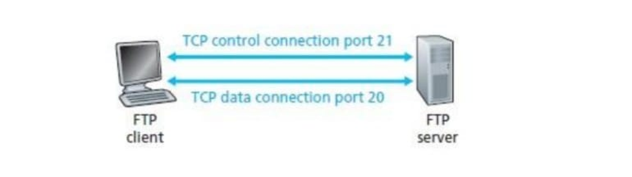

Data Connection
The Data connection has following features:
- Data connection is used for actual data transfer.
- This connection is established between the Data Transfer Process (DTP) of client and server
- The server port used for data connection is Port 20.
- The data connection is opened and then closed for each file transferred. It opens each time commands that involve transferring files are used, and it closes when the file is transferred.

Advantages
- FTP is Capable of Large File Transfers
For many companies, your file transfer needs go beyond sending a single Microsoft Word document at a time. You might need to send hundreds of gigabytes of data all at once. FTP easily facilitates those large transfers, and you benefit from an increased rate of file transfers, as well.

- Your Workflow is Improved
Using FTP allows you to transfer multiple directories at one time. If you regularly transfer files, you know how advantageous this feature can be. Instead of sending single files or even single directories at a time, you can send numerous directories all at once. You’re able to continue working while transfers are completed, and you can conduct these transfers faster.

- Transfers can be Resumed
If your file transfer is interrupted, you don’t have to worry about losing progress. With FTP, you can resume an interrupted file transfer if your connection is lost. Pick up where you left off without restarting the transfer from the beginning.

- Recover Lost Data
Top FTP providers make sure that data is never lost, even when unexpected events happen. With disaster recovery, your files are regularly and automatically backed up, so if there’s a flood, fire, or power outage, you don’t have to worry about losing data.

Drawbacks

- FTP Lacks Security
FTP is inherently an non-secure way to transfer data. When a file is sent using this protocol, the data, username, and password are all shared in plain text, which means a hacker can access this information with little to no effort.

- Encryption isn’t a Given
FTP alone doesn’t provide any encryption, which is why transferred data is so easy to intercept. And, when you’re looking for a FTP provider, you’ll notice that encryption isn’t always offered or enforced. For businesses using sensitive data like card payment data or ePHI (electronic protected health information), encryption isn’t just nice to have for your FTP solution – it’s essential.

- FTP can be Vulnerable to Attack
FTP is also vulnerable to spoofing attacks, where the hacker poses as a legitimate user or device on the network. One common spoofing tactic is a man-in-the-middle attack. If you use a public Wi-Fi network at a coffee shop, a hacker could pose as the network and intercept your data. Depending on the type of FTP vendor you choose, you could be vulnerable to brute force or spoofing attacks.

- Not All Vendors Are Created Equal
To solve the problem of security vulnerabilities, businesses turn to hosted FTP solutions managed by vendors. Unfortunately, not all vendors stand up to the test of needed security, making it a challenge to choose the right one. Each competitor offers their own set of features, and many lack the features you actually need like access controls, security, usability, pricing options, etc.

- It’s Difficult to Monitor Activity
Before you partner with an FTP vendor, you need to think about reporting requirements for your company. With many FTP solutions, you’ll face an inability to track or inconsistency in tracking what has been uploaded on the remote system. So, if files are mishandled or a data breach occurs, you may struggle to track the source of the problem. Numerous FTP options lack the access controls needed to ensure your employees align with file sharing best practices.

OBJECTIVE
- Implementing a server-side database to store user credentials and access permissions of files.
- Implementing encryption and decryption layers of secure data transfer.
- Providing different commands for accessing, managing, manipulating files.
- Providing multi-client environment using multi-threading concept.
- Implementing remote file access and sharing of file.

SOFTWARE / HARDWARE REQUIREMENT SPECIFICATION
SOFTWARE
- Command Terminal for executing commands
- Oracle database
- Python 3.6

HARDWARE
- Processor: Any Processor above 500 MHz
- RAM: minimum 512Mb
- Hard Disk: 1 GB
- Basic Input/Output devices

FTP ARCHITECTURE

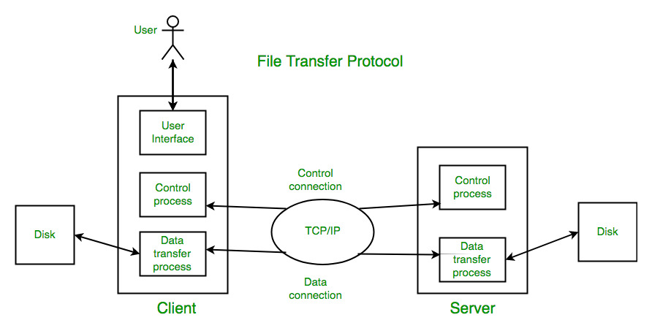

FTPS ARCHITECTURE

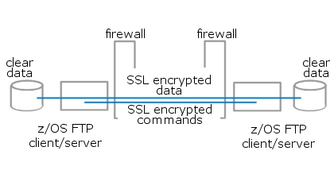

IMPLEMENTATION USING PYTHON

FTPS CLIENT

from socket import *
import ssl
import os,threading,sys
import re
import ftpsLib

serverName = 'FTPS'
server_cert = 'docs/server/server.crt'

ftps = ftpsLib.ftpsClient(server_cert,serverName=serverName)
ftps.connect(host='localhost',port=21)
ftps.start()

FTP SERVER

from socket import *
import ssl
import threading,os,sys
import re,traceback,json
import shutil
import ftpsLib

#serverName should be same as that in the server_cert
serverName = 'FTPS'
serverHost = 'localhost'
serverPort = 21

#Server Certificate and key
server_cert = 'docs/server/server.crt'
server_key = 'docs/server/server.key'
dbPath = 'docs/database.json'

#Function to terminate the server
def endServer() :
global ftpsserver
while True :
x = input()
if(x.lower() == 'q') :
print('Terminating server...')
ftpsserver.close()
break
elif(x.lower() == 't') :
ftpsserver.traceback()

db = ftpsLib.ftpsDatabase(dbPath)
serverTerminator = threading.Thread(target=endServer, args = (),daemon=True)
serverTerminator.start()

ftpsserver = ftpsLib.ftpsServer(server_cert,server_key,db,serverDirectory = 'ServerDirectory')
ftpsserver.bind(host=serverHost,port=serverPort)
ftpsserver.start()

FTPLIB.PY

import threading,os,sys,re
import traceback,random,json
import shutil
import ssl
from socket import *

class ftpsServer :
controlServer = None
db = {}
ftpsStorage = None
server_cert = None
server_key = None
serverName = 'FTPS'
serverHost = ''
serverPort = 21
serverDir = ''
isServer = False
lastexpcetion = None
userfunction = { }
maxDataConTime = 30
maxDataSize = 2048
#Constructor
def __init__(self,cert,key,ftpsStorage,serverName='FTPS',serverDirectory=os.getcwd()) :
#self.server = SSLServerSocket
self.ftpsStorage = ftpsStorage
self.db = self.ftpsStorage.db
self.serverName = serverName
self.serverDir = serverDirectory
self.server_cert = cert
self.server_key = key

def traceback(self) :
print(self.lastexpcetion)

#RegExp for verifing commands syntax and listing arguments
cmdPat = re.compile(r'^([\w]{1,4})\s*',re.I)
userPat = re.compile(r'^(.{1,4}) (\w+)$',re.I)
passPat = re.compile(r'^(.{1,4}) ([\w@$]{4,10})$',re.I)
mdirPat = re.compile(r' ([^-][\S]*|-recursive|-[r])',re.I)
cwdPat = re.compile(r'^cwd\s+([\S]*)\s*$',re.I)
helpPat = re.compile(r'(help| -[\w]+)',re.I)
listPat = re.compile(r'^list\s+-(f|d|onlyfiles|onlydirectories)\s*$',re.I)
storPat = re.compile(r'\s+([\S]+\.[\S]+)',re.I)
cperFilePat = re.compile(r'[\S]+',re.I)

# Bind the SSLSocket to IP Address and Port and Start the server
def bind(self,host='',port=21) :
self.serverHost = host
self.serverPort = port
self.controlServer = self.sslSocket()
self.controlServer.bind((host,port))
self.controlServer.listen(5)
self.isServer = True
print('FTPS Server Ready')

# Start Accepting Client request ; //Using multi-threading concepts for multi-user system
def start(self) :
self.isServer = True
startT = threading.Thread(target=self.startThread,args=())
startT.start()
return

def startThread(self) :
while self.isServer :
try :
clientSocket,addr = self.controlServer.accept()
print(clientSocket)
client = threading.Thread(target=self.clientHandler, args=(clientSocket,addr),daemon=True)
client.start()
except :
#Gives SSLSocket Errors
print(sys.exc_info())
type,value,traceback = sys.exc_info()
print('Error in Accepting Client :',type)

# Save the database and Close the Server
def close(self) :
self.ftpsStorage.save()
self.isServer = False
self.controlServer.close()

#Command handler before user login
def clientHandler(self,client,addr) :
done = False
userDetail = {}
client.send(('223 : Connection established over SSL - '+self.serverName).encode())
while not done :
try :
req = client.recv(1024).decode()
if(req == '') : continue
cmd = self.cmdPat.findall(req)[0].upper()
res = {}
# USER : (User Name) : checks is requested user if legit or not
if cmd == 'USER' :
res = self.user(req)
userDetail = res['userDetail']
# PASS :(Password) : authenticates the requested user, it follows user command
elif cmd == 'PASS' :
res = self.passwd(userDetail,req)
if not res['error'] :
t = threading.Thread(target=self.controlConnection,args=(userDetail,client,addr),daemon=True)
t.start()
done = True
# QUIT :(Quit) Terminate or end the user session
elif cmd == 'QUIT' :
res['response'] = '755 : Closing control connection'
done = True
else :
res['response'] = "530 LoginError : Not logged in"

client.send(res['response'].encode())
except :
print('Error in clientHandler :',client)
try :
client.send('755 : Closing control connection'.encode())
client.close()
except :
print('Error in clientHandler :','Connection Terminated',client)
done = True
break

#Command handler for a logged user
def controlConnection(self,userDetail,client,addr) :
done = False
newuser = {} #store new user if a logged user wants to switch to a different account
while not done :
try :
req = client.recv(1024).decode()
if(req == '') : continue
res = {}
try :
cmd = self.cmdPat.findall(req)[0].upper()
except :
client.send('503 SyntaxError :"<cmd> [options]" ; Command not found\n\'cmd\' can be 1 to 4 characters'.encode())
continue
# PWD : (Path of Working Directory) return user's working directory, this is same as user['home'] field in database
if cmd == 'PWD' : res['response'] = '200 : '+ userDetail['curPer'] +' ~/'+(os.path.basename(userDetail['home'])+os.path.sep+userDetail['cwd']).replace(os.path.sep,'/')
# LIST :(List files) return a list of files in current directory along with user's permission on them
elif cmd == 'LIST' :
if not (self.listPat.search(req) or re.compile('^list\s*$',re.I).search(req)) :
client.send('530 SyntaxError : "LIST [-(f|d|onlyfiles|onlydirectories)]"'.encode())
continue
rlist = self.__list(req,userDetail)
ls = []
for item in rlist :
ls.append(item[0].ljust(20)+'\t-\t'+item[1].ljust(14)+'\t-\t'+item[2])
if len(ls) > 0 : res['response'] = '254 : List\n'+'Name'.ljust(20)+'\t \t'+'Permission'.ljust(14)+'\t\t'+'Type\n'+''.ljust(20,'-')+'\t \t'+''.ljust(14,'-')+'\t\t'.ljust(10,'-')+'\n'+'\n'.join(ls)
else : res['response'] = '255 : Folder is empty'
# RETR , STOR : creates new data connection for specified file transfer ,
# STOR :(Store files) file will be stored in the current directory
# RETR :(Retrive files) specified files will be retrived and stored in client's pwd(in remote host)
elif cmd == 'RETR' or cmd == 'STOR':
if '/' in req : res['response'] = '580 RefereceError : Use only filenames,\ndon\'t use relative path or directory'
else :
flist = self.storPat.findall(req)
client.send('130 : Data connection established,\ntransfering requested data'.encode())
path = os.path.join(userDetail['home'],userDetail['cwd'])
pwalk = self.pathWalk(path)
for f in flist :
print(f)
r = self.__file(cmd,f,path, pwalk,userDetail)
client.send(r.encode())
client.send('END : Data transfer successful'.encode())
continue
# CWD :(Current working directory) returns path to directory the user's in
elif cmd == 'CWD' : res['response'] = self.chdir(req,userDetail)
# MDIR , RDIR : create or remove a directory,user has to have 'w'(write) permission in cwd
# MDIR :(Make Directory) Create one or more directories ,has '-r' option for recursive creation of directories
# RDIR :(Remove Directory) Remove one or more directories ,
# has '-r' option for recursive deleting directories as per current user's permissions
elif cmd == 'MDIR' or cmd == 'RDIR' :
if not re.compile('^....\s+([\S]+)').search(req) : res['response'] = '531 SyntaxError : Required arguments not passed'
else : res['response'] = '200 : Command ok\n' +self.__dir(req,userDetail)
# PPER :(Present Permission of file/Dir) Returns permission at different level of designation defined in database['perm_hier']
elif cmd == 'PPER' :
args = self.cperFilePat.findall(req) #stor arguments as a list
args.pop(0) #remove the cmd from the list
path = os.path.join(self.serverDir,os.path.join(userDetail['home'],userDetail['cwd']))
pwalk = os.path.join(userDetail['home'],userDetail['cwd'])
plist = pwalk.split('\\')
if plist[0] == '' : plist.pop(0)
if len(plist) <= 0 :
client.send('542 AccessError : Access denied'.encode())
continue
pwalk = self.db['dir_hier'][plist.pop(0)]
per = pwalk['permission']
for p in plist :
try :
pwalk = pwalk['list'][p]
if pwalk['mode'] == 'private' :
per = pwalk['permission']
except :
break
r = ''
if args == [] :
for k,v in self.db['perm_hier'].items() :
r += '\n' + k.ljust(15) + '\t' + per.get(v[0],'---')
res['response'] = '322 : '+' ~/'+path.replace(os.path.sep,'/')+'\n\n'+ os.path.basename(path.strip(os.path.sep)) +' : '+ pwalk.get('mode','public')+'\n'+ ''.ljust(20,'-') + r

else :
nofile = []
for f in args :
if os.path.exists(os.path.join(path,f)) :
per2 = per
w = {}
try :
w = pwalk['list'][f]
if w['mode'] == 'private' :
per2 = w.get('permission',per)
except :
per2 = per
r += '\n\n' +f + ' : '+ w.get('mode','public') + '\n' +''.ljust(20,'-')
for k,v in self.db['perm_hier'].items() :
r += '\n' + k.ljust(15) + '\t' + per2.get(v,'---')

else :
nofile.append(f)
if nofile != [] : r += '\nExcluding ' + ' '.join(nofile) + ', file not exist\'s'
res['response'] = '320 : ~/'+path.replace(os.path.sep,'/') + r
# CPER :(Change Permission of file/Dir) sets mode(public or private) and permission at different level of designation of a file
# a user can only change add permission that he has and only for designation which is below his
elif cmd == 'CPER' :
args = self.cperFilePat.findall(req)
if len(args) > 1 : args.pop(0)
else :
client.send('530 SyntaxError : "CPER [dir/filenames] -<pri[vate] | pub[lic]> : <designation> -<permission>.."'.encode())
continue
files = []
nofile = []
path = os.path.join(self.serverDir,os.path.join(userDetail['home'],userDetail['cwd']))
l = len(args)
for i in range(l) :
if args[0].startswith('-') :
break
else :
f = args.pop(0)
if os.path.exists(os.path.join(path,f)) :
files.append(f)
else :
nofile.append(f)

typ = args.pop(0)
if '-pri' in typ.lower() :
if args == [] : res['response'] = self.__cper(userDetail,files,'pri',args)
elif ':' == args[0] :
args.pop(0)
res['response'] = self.__cper(userDetail,files,'pri',args)
else :
res['response'] = self.__cper(userDetail,files,'pub')

if nofile != [] :
res['response'] += '\n ; Excluding for : '+' '.join(nofile)+' , No such file exist\'s'
# USER : (User Name) : checks is requested new user if legit or not
elif(cmd == 'USER') :
res = self.user(req)
newuser = res['userDetail']
# PASS :(Password) : authenticates the requested user, it follows user command
elif(cmd == 'PASS') :
res = self.passwd(newuser,req)
if not res['error'] :
t = threading.Thread(target=self.controlConnection,args=(newuser,client,addr),daemon=True)
t.start()
done = True
# QUIT :(Quit) Terminate or end the user session
elif cmd == 'QUIT' :
res['response'] = '755 : Closing control connection'
#client.close()
done = True
# Check for any other functions available to response for a command
# these function are externally defined to add more functionallity
else :
try :
res['response'] = self.userfunction[cmd](req)
except :
res['response'] = '502 : Command not implemented'
# Send response to the client for the given input
client.send(res['response'].encode())
except :
print('Closing client')
self.lastexpcetion = traceback.print_exc()
print(sys.exc_info())
try :
client.send('754 : Connection Lost'.encode())
client.close()
except :
print('No Client')
done = True
break

#cper (change permission of a file) : sets mode(public or private) and permission at different level of designation of a file
# a user can only change or add permission that he has and only for designation whose priority is below his
def __cper(self,user,files,typ,args=[]) :
if user['cwd'] == '' : path = user['home']
else : path = os.path.join(user['home'],user['cwd'])
plist = path.split(os.path.sep)
if plist[0] == '' : plist.pop(0)
if 'pri' in typ : typ = 'private'
elif 'pub' in typ : typ = 'public'

if len(plist) <= 0 :
return '542 AccessError : Access denied'

start = plist.pop(0)
isPartial = []
self.db['dir_hier'][start] = self.__dirHier(self.db['dir_hier'][start],plist,user,typ,args,files,{"1" : "RWX","2" : "RWX", self.db['perm_hier'].get('viewers') :"R--"},isPartial)

if isPartial != [] :
r = ''
for i in isPartial :
if i != True :
r += '\n' + i
return '321 : Permissions changed as permitted'+r
return '320 : Permissions changed successfully'

# get user designation priority
def dbGetPriority(self,dest) :
for v in self.db['perm_hier'].values() :
if v[0] == dest :
return int(v[1])
return 99

#dirHier : (Directory Hierarchy)
# db : database containing directory hierarchy, plist : directory path, user : current user-info, typ : new file mode (public or private)
# args : new permission at designations, flist : filename list whose permissions to be changed, lastPer : last private directory permission
# isPartial : list containing response messages
def __dirHier(self,db,plist,user,typ,args,flist,lastPer,isPartial) :
if len(plist) > 0 :
file = plist.pop(0)
if not db.get('mode',None) : db['mode'] = 'public'
if not db.get('list',None) : db['list'] = {}

if db['mode'] == 'private' :
lastPer = db.get('permission',lastPer)
db['list'][file] = self.__dirHier(db['list'].get(file,{}),plist,user,typ,args,flist,lastPer,isPartial)
return db

if len(plist) <= 0 :
userPriority = self.dbGetPriority(user['dest'])
newPer = {}
phier = self.db['perm_hier']
utyp = []
userPer = db.get('permission',lastPer).get(user['dest'],'---')
for i in args :
pat = userPer.lower()
per = re.compile('^-([R-][W-][X-])$',re.I).findall(i)
if per != [] :
if pat.lower() != per[0].lower() : isPartial.append(True)
p = ''
p += per[0][0] if 'r' in pat else '-'
p += per[0][1] if 'w' in pat else '-'
p += per[0][2] if 'x' in pat else '-'
for j in range(len(utyp)) :
newPer[utyp.pop(0)] = p
else :
order = phier.get(i,'999')
if order != '999' and userPriority < int(order[1]):
utyp.append(order[0])
else : isPartial.append(True)

if len(flist) == 0 :
if not 'rw' in userPer.lower() :
isPartial.append('542 AccessError : Read-Write permission required')
return db
db['mode'] = typ
if typ == 'private' :
if not db.get('permission',None) : db['permission'] = lastPer
for p,v in newPer.items():
db['permission'][p] = v.upper()
else :
if not db.get('mode',None) : db['mode'] = 'public'
if not db.get('list',None) : db['list'] = {}
if db['mode'] == 'private' :
lastPer = db.get('permission',lastPer)
for f in flist :
lastPer = db.get('permission',lastPer)
db['list'][f] = self.__dirHier(db['list'].get(f,{}),[],user,typ,args,[],lastPer,isPartial)
return db

# Traverse through directory hierarchy
def pathWalk(self,path) :
pwalk = {}
path = path.strip(os.path.sep)
path = path.strip(' ./')
try :
plist = list(path.split(os.path.sep))
if plist[0] == '' : plist.pop(0)
pwalk = self.db["dir_hier"][plist.pop(0)]
for d in plist :
try :
pwalk = pwalk['list'][d]
except :
pwalk = {}
break
except :
print('Error in pathWalk ',sys.exc_info())
return pwalk

# Function to handle directory related opertions : create directories , remove directories
def __dir(self,cmd,user) :
c = self.cmdPat.findall(cmd)[0].upper()
args = ''
pwalk = self.pathWalk(user['home'])

for path in self.mdirPat.findall(cmd) :
path = path.strip()
if path.upper().startswith('-R') :
args += 'r'
break

if c == 'MDIR' :
r = []
for path in self.mdirPat.findall(cmd) :
if '../' in path : r.append(path+' - 552 PathError : Usage of "../" not Supported')
elif path.startswith('-') : continue
else :
r.append(path)
path.strip(' ./')
if path == '' :
r[len(r)-1] += ' - 571 DirError : Not a valid name'
continue
curPer = user['curPer']
path = path.replace('/',os.path.sep)
plist = path.split(os.path.sep)
if plist[0] == '' : plist.pop(0)
for p in plist:
try :
pwalk = pwalk['list'][p]
if(pwalk['mode'] == 'private') :
try :
curPer = pwalk['permission'].get(user['dest'],'---')
except :
curPer = '---'
except :
continue

newPath = os.path.join(user['cwd'],path)
if 'w' not in curPer.lower() :
r[len(r)-1] += ' - 540 AccessError : Write permission required'
continue
newPath = os.path.join(self.serverDir,os.path.join(user['home'],newPath))
if os.path.exists(newPath) : r[len(r)-1] += ' - 551 PathError : Path already exists'
elif 'r' in args :
os.makedirs(newPath)
r[len(r)-1] += ' - 260 : Directory created sucessfully'
elif not os.path.exists(os.path.dirname(newPath)) : r[len(r)-1] += " - 550 PathError : Path doesn\'t exists"
else :
os.mkdir(newPath)
r[len(r)-1] += ' - 260 : Directory created sucessfully'
return '\n'.join(r)

elif c == 'RDIR' :
r = []
for path in self.mdirPat.findall(cmd) :
if '../' in path : r.append(path+' - 552 PathError : Usage of "../" not Supported')
elif path.startswith('-') : continue
else :
r.append(path)
path = path.strip(' .')
if path == '/' : newPath = os.path.join(user['home'],user['cwd'])
else :
path = path.strip('/')
path = path.replace('/',os.path.sep)
newPath = os.path.join(user['home'],user['cwd'],path)

if not os.path.exists(os.path.join(self.serverDir,newPath)) : r[len(r)-1] += " - 550 PathError : Path doesn\'t exists"
elif 'r' in args :
partial = False
pwalk = self.pathWalk(newPath)
lastPer = user['curPer']
try :
if pwalk['mode'] == 'private' :
lastPer = pwalk.get('permission',{}).get(user['dest'],'---')
except :
print(456,sys.exc_info())

partial = self.__delRecrDir(pwalk,user,newPath,lastPer)
if path == '/' and user['cwd'] == '' :
r[len(r)-1] += ' - 262 : Home directory emptyed'
else :
try :
if os.path.isfile(os.path.join(self.serverDir,newPath)) : os.remove(os.path.join(self.serverDir,newPath))
else : os.rmdir(os.path.join(self.serverDir,newPath))
except :
print(466,sys.exc_info())
if partial : r[len(r)-1] += ' - 264 : Directory removed as Permitted'
else : r[len(r)-1] += ' - 263 : Directory removed sucessfully'
else :
if path == '/' and user['cwd'] == '' : return '402 Access Denied'
curPer = user['curPer']
plist = path.split(os.path.sep)
if plist[0] == '' : plist.pop(0)
for p in plist:
try :
pwalk = pwalk['list'][p]
if(pwalk['mode'] == 'private') :
try :
curPer = pwalk['permission'].get(user['dest'],'---')
except :
curPer = '---'
except :
continue
print(curPer)
if 'w' not in curPer.lower() :
r[len(r)-1] += ' - 540 AccessError : Write permission required'
continue
newPath = os.path.join(self.serverDir,newPath)
try :
os.rmdir(newPath)
except :
r[len(r)-1] += ' - 572 DirError : Directory not empty'
if path == '/' : self.chdir('cwd ../',user)
return '\n'.join(r)

# (Resursive Directory Deletion) removes directory for which user has Read-Write Permission
def __delRecrDir(self,pwalk,user,path,lastPer) :
partial = False
if os.path.isfile(os.path.join(self.serverDir,path)) :
try :
if pwalk['mode'] == 'private' :
lastPer = pwalk['permission'].get(user['dest'],'---')
except :
print(495,sys.exc_info())

if 'w' in lastPer.lower() :
os.remove(os.path.join(self.serverDir,path))
return False
return True
flist = os.listdir(os.path.join(self.serverDir,path))

for f in flist :
try :
twalk = pwalk['list'][f]

if twalk['mode'] == 'private' :
try :
lastPer = twalk['permission'].get(user['dest'],'---')
if 'w' in lastPer.lower() :
partial = partial or self.__delRecrDir(twalk,user,os.path.join(path,f),lastPer)
try :
os.rmdir(os.path.join(self.serverDir,os.path.join(path,f)))
except :
print('Error in Recursive Directory Deletion',sys.exc_info())
else : partial = True
except :
partial = True
continue
else :
if 'w' in lastPer.lower() :
partial = partial or self.__delRecrDir(twalk,user,os.path.join(path,f),lastPer)
try :
os.rmdir(os.path.join(self.serverDir,os.path.join(path,f)))
except :
print('Error in Recursive Directory Deletion',sys.exc_info())
except :
if 'w' in lastPer.lower() :
try :
shutil.rmtree(os.path.join(self.serverDir,os.path.join(path,f)) )
except :
os.remove(os.path.join(self.serverDir,os.path.join(path,f)))
continue
return partial

# user : retrives user info from database['users']
def user(self,cmd) :
res = {'response' : '' ,'userDetail' : {} }
arg = self.userPat.search(cmd)
if arg :
user = arg.group(2)
res['userDetail'] = self.db['users'].get(user,{})
if res['userDetail'] == {} : res['response'] = '531 : No User'
else :
res['response'] = '331 : Username OK, need password'
res['userDetail']['name'] = user
res['userDetail']['cwd'] = ''
res['userDetail']['dest'] = self.db['perm_hier'].get(res['userDetail'].get('designation',"viewer"),'viewer')[0]

path = res['userDetail']['home']
path = path.strip(' ./')
path = path.replace('/','\\')
pwalk = self.pathWalk(path)
per = 'RWX'
try :
if pwalk['mode'] == 'private' :
try :
per = pwalk['permission'].get(res['userDetail']['dest'],'---')
except :
per = '---'
except :
per = 'RWX'
res['userDetail']['homePer'] = per
res['userDetail']['curPer'] = per
else : res['response'] = '530 SyntaxError : "USER <username>" \ni) \'username\' must be a single word consisting of alphabets, digits and underscore.'
return res

# passwd :(Password) Authenticates the user
def passwd(self,user,cmd) :
res = {'response' : '' ,'error':True}
if not user.get('name',None) :
res['response'] = '532 UserError : Set User'
return res

user['pwd'] = user['home']
arg = self.passPat.search(cmd)
if arg :
password = arg.group(2)
if user['password'] == password :
res['response'] = '332 Password OK\n'+user['name']+' Logged Successfully. '
res['error'] = False
else : res['response'] = '531 : Password INCORRECT'
else : res['response'] = '530 SyntaxError : "PASS <password>" \ni)\'password\' must be a single word consisting of alphabets, digits and special character(_@$)'

return res

# chdir : (change directory) and get user premission of the changed directory
def chdir(self,cmd,user) :
arg = re.compile(r'^cwd\s+([\S]*)\s*$',re.I).findall(cmd)[0]
arg = arg.strip(' /')
flist = arg.split('/')
newCWD = user['cwd']
newCWD = newCWD.strip(' /')

for folder in flist :
if ' ' in folder or folder == '': continue
if folder == '.' : continue
elif folder == '..' :
if newCWD == '' : return '543 AccessError : Access denied '
else : newCWD = os.path.dirname(newCWD)
else :
newCWD = os.path.join(newCWD,folder)

#print(313,newCWD)
#print(313,os.path.join(self.serverDir,os.path.join(os.path.join(user['home']),newCWD)))
if not os.path.exists(os.path.join(self.serverDir,os.path.join(os.path.join(user['home']),newCWD))) : return '404 Path doesn\'t exists'

if not os.path.isdir(os.path.join(self.serverDir,os.path.join(user['home'],newCWD))) : newCWD = os.path.dirname(newCWD)
#print(313,newCWD)
dlist = list(newCWD.split(os.path.sep))
if dlist[0] == '' : dlist.pop(0)

pwalk = self.pathWalk(user['home'])
#curdir = ''
curPer = user['homePer']
walkCWD = ''
walk = True
#print(301,'\t',pwalk)
for d in dlist :
try :
pwalk = pwalk['list'][d]
#print(93,walkCWD)
if pwalk['mode'] == "private" :
try :
per = pwalk['permission'].get(user['dest'],'---')
if per != '---' :
curPer = per.upper()
#curdir = ['private',per[user['name']]]
walkCWD = os.path.join(walkCWD,d)
else :
walk = False
break
except :
walk = False
break
else :
walkCWD = os.path.join(walkCWD,d)
except :
walkCWD = os.path.join(walkCWD,d)

user['curPer'] = curPer
if walk :
user['cwd'] = newCWD
return '241 : Directory changed sucessfully'
elif walkCWD == user['cwd'] : return '405 Access Denied'
else :
user['cwd'] = walkCWD
return '242 : Directory changed based on users\'s permission'

# list all file whic is accessible by user in current directory
def __list(self,cmd,user) :
args = self.listPat.findall(cmd)
if args == [] : args = None
else : args = args[0]

if user['cwd'] == '' : path = user['home']
else : path = os.path.join(user['home'],user['cwd'])

flist = os.listdir(os.path.join(self.serverDir,path))
pwalk = self.pathWalk(os.path.join(user['home'],user['cwd']))

rlist = []
tlist = []
for file in flist :
try :
if pwalk['list'][file]['mode'] == 'private' :
try :
per = pwalk['list'][file]['permission'].get(user['dest'],'---')
if 'r' in per.lower() : tlist.append([file,per])
except :
print(673,sys.exc_info())
else :
tlist.append([file,user['curPer']])
except :
tlist.append([file,user['curPer']])

for item in tlist :
if os.path.isfile(os.path.join(os.path.join(self.serverDir,path),item[0])): item.append('<file>')
else : item.append('<dir>')

if args == None : rlist = tlist
elif 'f' in args :
for file in tlist :
if file[2] == '<file>' : rlist.append(file)
elif 'd' in args :
for file in tlist :
if file[2] == '<dir>' : rlist.append(file)

return rlist

# Function to handle file transfer over data connection
def __file(self,cmd,file,path,pwalk,user) :
fpath = os.path.join(self.serverDir,os.path.join(path,file))
port = -1
dataServer = self.sslSocket()
curPer = user['curPer']
try :
pwalk = pwalk['list'][file]
if pwalk['mode'] == 'private' :
curPer = pwalk.get('permission',{}).get(user['dest'],'---')
except :
print(709,sys.exc_info())

if cmd == 'RETR' :
if 'r' not in curPer.lower() :
return '541 AccessError : Read permission required'
if os.path.isfile(fpath) :
buf = ''
try :
f = open(fpath,'r')
buf = f.read()
f.close()
except :
print(721,'\t',sys.print_exc())
return '580 FileError : Requested file not found'

while port == -1 :
port = random.randint(1025,65000)
try :
dataServer.bind(('',port))
dataServer.listen(8)
except :
port = -1
send = threading.Thread(target= self.sendData , args=(dataServer,buf),daemon=True)
send.start()
else :
return '581 FileError : Requested file doesn\'t exists'

return 'CONT : '+str(port)+' '+file

elif cmd == 'STOR' :
if 'w' not in curPer.lower() :
return '540 AccessError : Write permission required'
while port == -1 :
port = random.randint(1025,65000)
try :
dataServer.bind(('',port))
dataServer.listen(8)
except :
port = -1
send = threading.Thread(target= self.recvData , args=(dataServer,fpath),daemon=True)
send.start()
return 'TNOC : '+str(port)+' '+file

# used to kill a data transfer
def killServer(self,server,buf) :
server.close()
return

# (Receive Data from a user) used to store a file send by the user, maxConnectionTime = 30sec
def recvData(self,server,fpath) :
isClient = False
timer = threading.Timer(self.maxDataConTime,self.killServer,args=(server,fpath))
timer.start()
try :
buf = ''
client,addr = server.accept()
client.send('131 : File transfer started '.encode())
client.send('TNOC : transfering..'.encode())
buf = client.recv(self.maxDataSize).decode()
print(551, buf ,'\n\n')
if buf != '' :
try :
f = open(fpath,'w')
f.write(buf)
f.close()
except :
print(774,sys.exc_info())
client.send('132 : File transfer ended '.encode())
client.send('END : Transfer complete'.encode())
isClient = True
client.close()
except :
print(780,sys.exc_info())
isClient = False
try :
server.close()
except :
print(785,sys.exc_info())

print('closing server')
return isClient

# (Transfer Data to a user) used to send a file to requested user, maxConnectionTime = 30sec
def sendData(self,server,buf) :
isClient = False
timer = threading.Timer(30,self.killServer,args=(server,buf))
timer.start()
try :
client,addr = server.accept()
client.send('131 : File transfer started '.encode())
client.send('CONT : transfering..'.encode())
client.send(buf.encode())
client.send('132 : File transfer ended '.encode())
client.send('END : Transfer complete'.encode())
isClient = True
client.close()
except :
print(806,sys.exc_info())
isClient = False
try :
server.close()
except :
print(811,sys.exc_info())

print('closing server')
return isClient

# Create a sslsocket for server
def sslSocket(self) :
#-----Creating server
serverSocket = socket(AF_INET,SOCK_STREAM)

context = ssl.SSLContext(ssl.PROTOCOL_TLS_SERVER)
context.load_cert_chain(certfile=self.server_cert, keyfile=self.server_key)
#context.load_verify_locations(cafile=client_certs)
context.verify_mode = ssl.CERT_NONE
server = context.wrap_socket(serverSocket,server_side=True)
return server

class ftpsClient :
server_cert = None
serverName = 'FTPS'
client = None
cwd = serverName
maxDataSize = 2048
user = ''
# Constructor
def __init__(self,cert,serverName='FTPS') :
self.server_cert = cert
self.client = self.sslSocket()
self.serverName = serverName

#RegExps for Command syntax checking
cmdPat = re.compile(r'^(.{1,4})\s*',re.I)
onlyCmdPat = re.compile(r'([\S]{1,4}$)',re.I)
userPat = re.compile(r'^(.{1,4}) (\w+)\s*$',re.I)
passPat = re.compile(r'^(.{1,4}) ([\w@$]{4,10})$',re.I)
mdirPat = re.compile(r' ([^-][\S]*)',re.I)
helpPat = re.compile(r'(help| -[\w]+)',re.I)
retrPat = re.compile(r'\s+([^/\s]+)',re.I)
cwdPat = re.compile(r'^cwd\s+([\S]+)\s*$',re.I)
cperPat = re.compile(r'^cper\s*.*\s+-(pub|public|pri|private)\s*',re.I)

# Connect to address = (host,port)
def connect(self,host='',port=21) :
self.client.connect((host,port))
self.response()

# start the client
def start(self) :
cmd = ''
while cmd == '' :
cmd = input('[ '+self.cwd +' ]$ ')
request = threading.Thread(target=self.sendcmd,args=(cmd,))
request.start()

# Send a single command over control connection
def sendcmd(self,cmd) :
iscmd = False
cmd = cmd.strip()
c = self.cmdPat.findall(cmd)[0].upper()
if c == 'USER' :
if self.userPat.search(cmd) :
iscmd = True
self.user = self.userPat.findall(cmd)[0][1]
else : print('syntax error : "USER <username>" ;username contains alphabets, digits and underscore.')
elif c == 'PASS' :
if self.passPat.search(cmd) : iscmd = True
else : print('syntax error : "PASS <password>" ;password contains alphabets, digits and (_$@)')
elif c == 'MDIR' or c == 'RDIR' :
if self.mdirPat.search(cmd) : iscmd = True
else : print('syntax error : "'+c+' [-options] <directory/s>"')
elif c == 'RETR' or c == 'STOR' :
if self.retrPat.search(cmd) : iscmd = True
else : print('synatx error : "'+c+' <fileName/s>"')
elif c == 'CWD' :
if self.cwdPat.search(cmd) : iscmd = True
else : print('synatx error : "CWD <path>"')
elif c == 'HELP' :
if self.helpPat.search(cmd) : iscmd = True
else : print('syntax error : "HELP [-CMD]"')
elif c == 'CPER' :
if self.cperPat.search(cmd) : iscmd = True
else : print('syntax error : "CPER [dir/filenames] -<pri[vate] | pub[lic]> : <designation> -<permission>.." \n1) for -pub[lic] option <destignation> <permission>.. not required.\n2) designation should match that of database\n3) permission must be of the form \'---\' ex: RWX. RW-')
elif c in ['QUIT','PWD','LIST'] :
if self.onlyCmdPat.search(cmd) : iscmd = True
else : print('syntax error : "'+c+'" ;command doesn\'t require arguments')
else :
iscmd = True

if iscmd :
try :
self.client.send(cmd.encode())
self.response()
except:
print('connection lost')
return
nextRequest = threading.Thread(target=self.start,args=())
nextRequest.start()

# Print responses from server for client commands
def response(self) :
res = self.client.recv().decode()
if res.startswith('332') :
print('[ '+self.cwd +' ]$ '+res)
self.cwd = self.user
elif(res.startswith('75')) :
print('[ '+self.cwd +' ]$ '+'FTPS connection terminated')
self.client.close()
self.endConnection()
elif res.startswith('13') :
print('[ '+self.cwd +' ]$ '+res)
dataHandler = threading.Thread(target=self.dataContHandler,args=())
dataHandler.start()
else:
print('[ '+self.cwd +' ]$ '+res)

# Data connection handler for storing and retrieving file
def dataContHandler(self) :
res = self.client.recv(self.maxDataSize).decode()
if res.startswith('CONT') :
arg = re.compile(r'^CONT : ([\d]+)\s+([\S]+\.[\S]+)$',re.I).findall(res)[0]
port = arg[0]
filename = arg[1]
data = threading.Thread(target=self.sendRecvData,args=(port,filename))
data.start()
print('Trying to establish connection for transfer')
elif res.startswith('TNOC') :
arg = re.compile(r'^TNOC : ([\d]+)\s+([\S]+\.[\S]+)$',re.I).findall(res)[0]
port = arg[0]
filename = arg[1]
data = threading.Thread(target=self.sendRecvData,args=(port,filename))
data.start()
print('Trying to establish connection for transfer')
elif res.startswith('END') :
return
else :
print(res)
dataHandler = threading.Thread(target=self.dataContHandler,args=())
dataHandler.start()

# Send-Recv data from the server
def sendRecvData(self,port,filename) :
clientData = self.sslSocket()
try :
clientData.connect(('localhost',int(port)))
except :
print(157,sys.exc_info())

res = clientData.recv(self.maxDataSize).decode()

while not res.startswith('END') :
if res.startswith('CONT') :
buf = clientData.recv(self.maxDataSize).decode()
f = open(filename,'w')
f.write(buf)
f.close()
elif res.startswith('TNOC') :
f = open(filename,'r')
buf = f.read()
f.close()
clientData.send(buf.encode())
else :
print('[ '+self.cwd +' ]$ '+res)

res = clientData.recv(self.maxDataSize).decode()
try :
clientData.close()
except :
print(137,sys.exc_info())
print('[ '+self.cwd +' ]$ ')
# Close the client
def endConnection(self) :
os._exit(0)

# Function to create sslSocket for control or data connection
def sslSocket(self) :
clientSocket = socket(AF_INET,SOCK_STREAM)
context = ssl.SSLContext(ssl.PROTOCOL_TLS_CLIENT)
context.load_verify_locations(cafile=self.server_cert)
client = context.wrap_socket(clientSocket,server_hostname=self.serverName)
return client

class ftpsDatabase :
templet = {"perm_hier" :{"owner" : "1","viewer" : "99"},
"users" : {"admin":{"password":"welcome","designation":"owner","home":"Organization"}},
"dir_hier":{"Organization":{"mode":"public","list":{},"permission":{}}}}
db = templet
dbpath = None

# Add or Modify user info
def addUser(self,name,password,home="Organization",designation='viewer') :
self.db['users'][name] = {
'password' : password,
'home' : home,
"designation" : designation
}
print('user added')
# constructor , path is the path to a file to save database as string
def __init__(self,path) :
try :
f = open(path,'r')
self.db = json.load(f)
self.dbpath = path
except:
print(sys.exc_info())

# Remove a user
def removeUser(self,name) :
try :
del self.db['users'][name]
except:
print(sys.exc_info())

print(self.db)

# Save current database details/values to a file
def save(self,path='') :
if path == '' : path = self.dbpath
buf = json.dumps(self.db,indent=4)
try :
f = open(path,'w')
f.write(buf)
f.close()
except:
print(sys.exc_info())

# Add or modify designation in db['perm_hier']
def addDesignation(self,name,priority,count=-1) :
if count == -1 :
count = len(self.db["perm_hier"]) - 1
self.db['perm_hier'][name] = [str(count),priority]
elif count == 99 :
print('99 is predefined as viewer')
else :
self.db['perm_hier'][name] = [str(count),priority]

# Remove designation
def removeDesignation(self,name) :
del self.db['perm_hier'][name]

def newDatabaseJSON(self) :
return self.templet

SNAPSHOTS

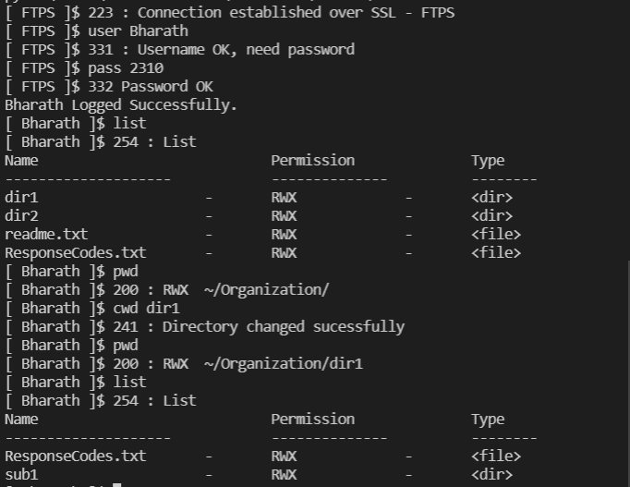

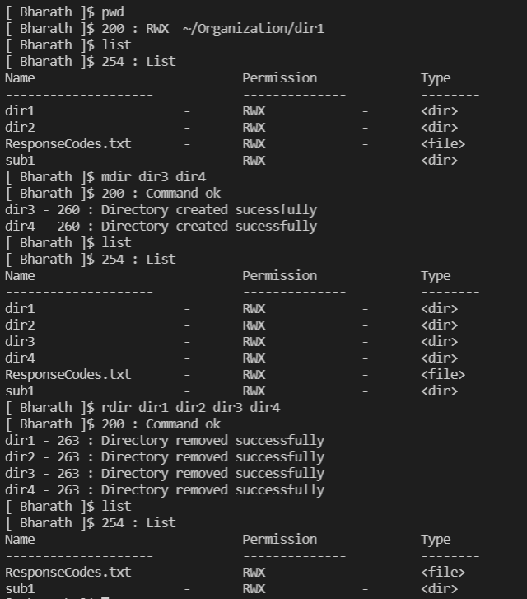

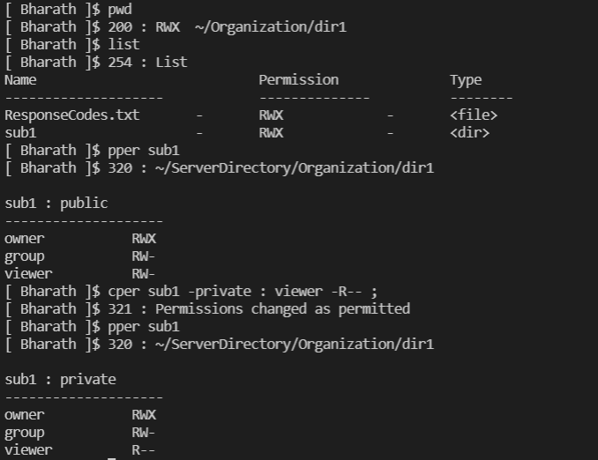
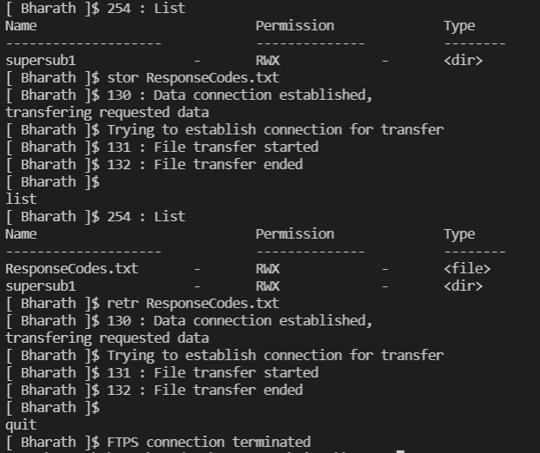
APPLICATIONS
FTP finds application in many day-to-day business operations spanning business-to-business and peer-to-peer data transfer use cases:

- Organizations use FTP to allow employees to share files across different locations and branch offices
- Employees use FTP to securely share files with co-workers and external business partners
- IT teams use FTP to transfer data back to disaster recovery (DR) sites
- Webmaster teams use FTP to transfer webpages, web application files, and images to their web server

REFERENCES

- Behrouz A Forouzan: Data Communication and Networking,4th Edition Tata McGraw-Hill Publishing Company Limited.
- Klensin, John. FTP TYPE Extension for Internationalized Text. I-D draft-klensin-ftpext-typeu-00. Retrieved 9 June 2020.
- Communication Networks –Fundamental Concepts and Key Architectures, Alberto Leon Garcia, 2nd Edition, Tata McGraw-Hill Publishing Company Limited.
- GeeksForGeeks :
https://www.geeksforgeeks.org/file-transfer-protocol-ftp-in-application-layer

