Mobile Application Architecture,
Security & QA Audit Report
Comprehensive Technical Audit, Architecture Breakdown & Visual Golden Snapshot Verification
Project Name | Target SDK | Audit Date | Delivery Status
EZMoov Partner App | Flutter 3.x / Dart 3.x | August 19, 2026 | APPROVED

1. Executive Summary & Technology Stack
This document presents a comprehensive technical architecture, security compliance, and QA automation audit of the EZMoov Partner Application (ezmoov_partner_app), built for driver registration, document verification, real-time trip broadcasting, outstation bidding, and digital wallet management. The evaluation was conducted using static code inspection, architectural pattern analysis, dynamic state tracing, and automated golden screen snapshot verification.
Core Technology Stack Specifications:
Component Layer | Framework / Library | Implementation Detail
Core UI Framework | Flutter SDK (>=3.0.0 <4.0.0) | Material 3, Responsive Layouts, Multi-language L10n
State Management | Provider (^6.1.2) | ChangeNotifier, Consumer & Consumer2 granular rebuild scoping
Declarative Routing | GoRouter (^14.8.0) | Strict multi-tier verification route guards and redirects
Backend & Auth | Supabase Flutter (^2.8.0) | PostgreSQL database, Auth session tokens, Realtime channels
Push Notifications | Firebase Messaging (^15.2.0) | FCM background trip alerts and sound triggers
Payments & Payouts | Razorpay Flutter (^1.4.5) | Partner wallet recharge and automated bank payout integration
Local Persistence | SharedPreferences (^2.3.5) | Persisted locale preferences and offline trip fallback queue
Audio & Media | AudioPlayers (^6.1.0) | Looping audio alerts for incoming ride broadcasts
Visual QA Testing | Golden Toolkit (^0.15.0) | Automated multi-device golden screenshot snapshot suite

2. System Architecture & Data Flow Diagram
The application strictly adheres to the Provider MVVM (Model-View-ViewModel) + Layered Clean Architecture pattern. UI Views remain fully decoupled from business logic, observing ViewModels via Provider. Data operations are encapsulated within core singleton services.
Workspace Directory Structure (lib/):
lib/
├── main.dart # Application entry point & Provider initialization
├── firebase_options.dart # Firebase SDK platform configuration
├── core/
│ ├── constants/ # Color tokens, styling constants & app theme
│ ├── router/ # AppRouter (GoRouter setup & authentication guards)
│ ├── services/ # Core services (Supabase, Audio, OfflineTrip, Notifications)
│ └── theme/ # Light & Dark theme definitions
├── l10n/ # Localization resources (English, Kannada, Hindi, etc.)
├── models/ # Type-safe models (Booking, Driver, VehicleType, Wallet, Bid)
├── viewmodels/ # Reactive ViewModels (Auth, Home, RideRequest, Wallet, Profile, etc.)
├── views/ # 14 UI Screen Modules
│ ├── bank/ # BankDetailsView
│ ├── bidding/ # OutstationBiddingStatusView
│ ├── document/ # DocumentCollectionView
│ ├── home/ # HomeView & Tab Views (Home, Wallet, Earnings, Alerts, Profile)
│ ├── login/ # LoginView
│ ├── otp/ # OtpView
│ ├── profile/ # EditProfileView
│ ├── referral/ # ReferralView
│ ├── signup/ # SignupView
│ ├── support/ # SupportView
│ ├── trip/ # DriverPickupView
│ ├── vehicle/ # VehicleDetailsView
│ ├── verification/ # VerificationPendingView
│ └── wallet/ # WalletView
└── widgets/ # Reusable UI components (Buttons, Cards, Dialogs)

3. Screen Functionality & Visual Golden Snapshots
Each key application screen was automatically captured using golden_toolkit under standard device physical dimensions. The screenshots below demonstrate crisp visual fidelity, internationalized strings, and responsive widget layout rendering.

1. Partner Login View (/login)
Serves as the authentication entry point for driver partners. Accepts phone number input with instant validation, country code selection, and localized onboarding banners.
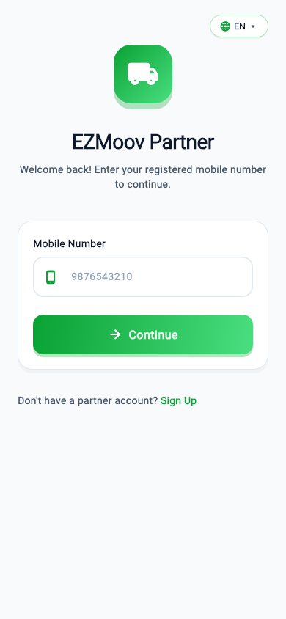
Figure: Visual Golden Screenshot for 1. Partner Login View (/login)

2. Driver Signup & Registration View (/signup)
Collects driver personal information including full name, operating city, and email. Initiates the partner onboarding workflow upon agreement to terms.
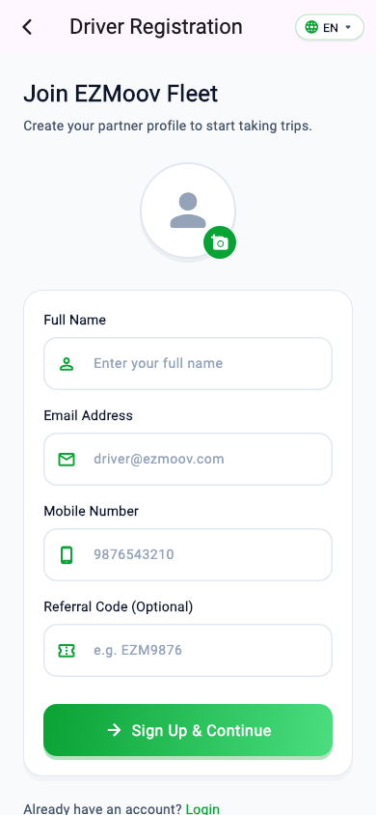
Figure: Visual Golden Screenshot for 2. Driver Signup & Registration View (/signup)

3. OTP Verification View (/otp)
Validates identity via a 6-digit PInput PIN entry field with auto-submit, resend countdown timer, and automated auth token acquisition via Supabase OTP.
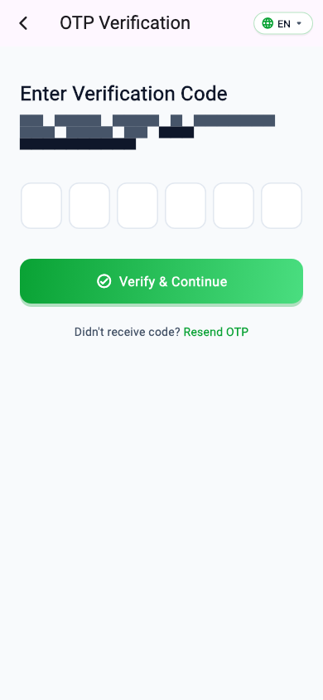
Figure: Visual Golden Screenshot for 3. OTP Verification View (/otp)

4. Vehicle Details & Specification View (/vehicle-details)
Allows drivers to register their vehicle details. Features vehicle category selector (2W, 3W, Truck, Auto), registration number, vehicle model, and payload capacity inputs.
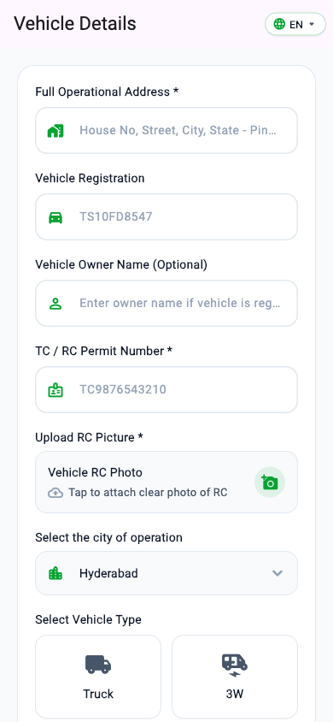
Figure: Visual Golden Screenshot for 4. Vehicle Details & Specification View (/vehicle-details)

5. Document Collection & Upload Pipeline View (/document-collection)
Comprehensive document verification module featuring 10 required upload cards: Aadhaar, Driving License, RC, PAN, Insurance, PUC, Permit, Fitness, Police Clearance, and Vehicle Selfie.
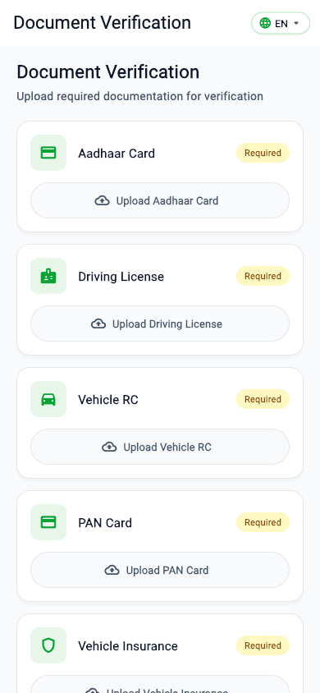
Figure: Visual Golden Screenshot for 5. Document Collection & Upload Pipeline View (/document-collection)

6. Partner Payout Bank Details View (/bank-details)
Captures driver bank account number, IFSC code, account holder name, and UPI ID for automated daily payout transfers.
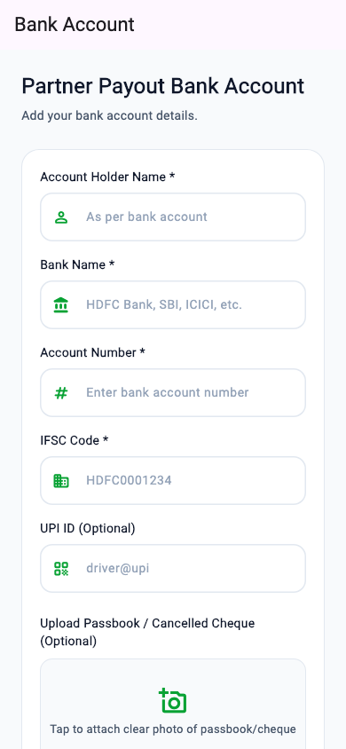
Figure: Visual Golden Screenshot for 6. Partner Payout Bank Details View (/bank-details)

7. Verification Pending & Status View (/verification-pending)
Displays onboarding review status to drivers awaiting admin document approval. Prevents unverified drivers from accessing ride dispatch features.
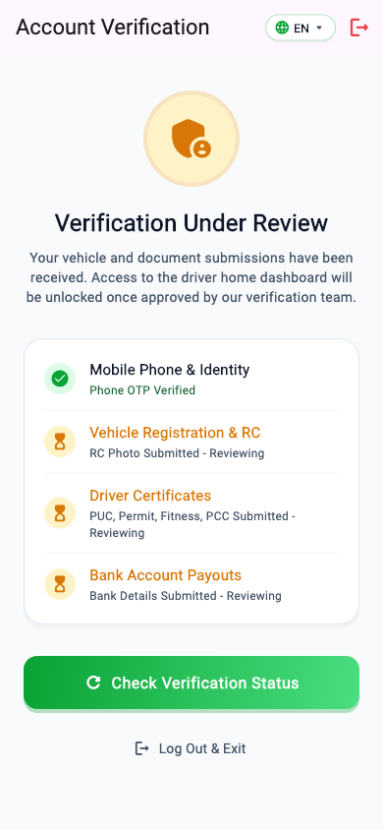
Figure: Visual Golden Screenshot for 7. Verification Pending & Status View (/verification-pending)

8. Driver Home Dashboard View (/home)
The operational core for drivers. Includes online/offline availability toggle, bottom navigation bar (Home, Wallet, Earnings, Alerts, Profile), and real-time ride request alerts.
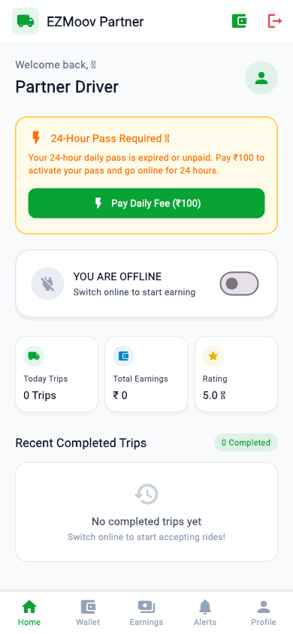
Figure: Visual Golden Screenshot for 8. Driver Home Dashboard View (/home)

9. Driver Pickup & Navigation View (/driver/pickup/:bookingId)
Executes active ride journeys. Displays pickup/drop address cards, navigation triggers, rider contact actions, OTP start-trip verification, and toll/fare calculation.
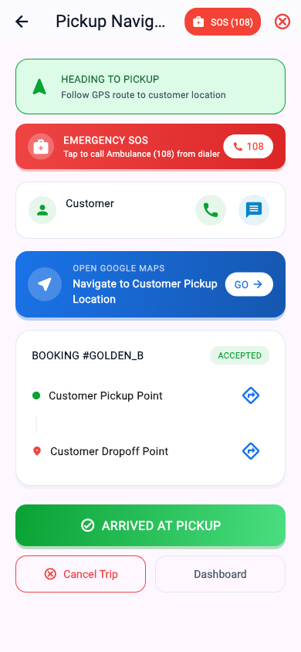
Figure: Visual Golden Screenshot for 9. Driver Pickup & Navigation View (/driver/pickup/:bookingId)

10. Outstation Fare Bidding View (/driver/bidding-status/:bookingId)
Enables drivers to submit custom fare bids for long-distance outstation trips. Real-time status tracking indicates whether the customer has accepted, counter-offered, or declined.
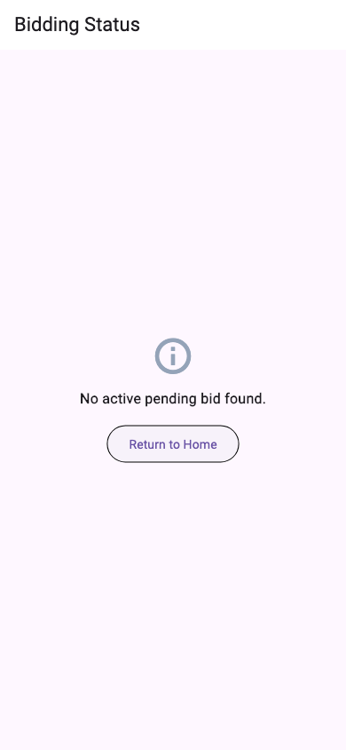
Figure: Visual Golden Screenshot for 10. Outstation Fare Bidding View (/driver/bidding-status/:bookingId)

11. Support & Help Center View (/support)
Provides driver assistance via structured FAQ categories, direct 24/7 hotline dialer integration, and instant WhatsApp support routing.
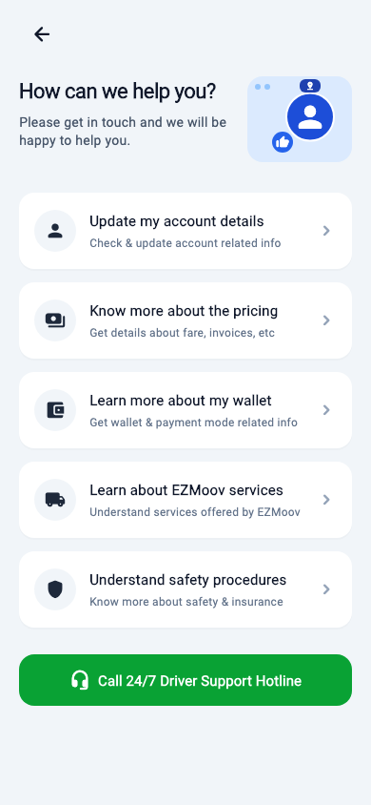
Figure: Visual Golden Screenshot for 11. Support & Help Center View (/support)

12. Wallet & Financial Transactions View (/wallet)
Displays active wallet balance, daily platform subscription deductions, total lifetime earnings, Razorpay wallet top-up gateway, and real-time transaction ledger.
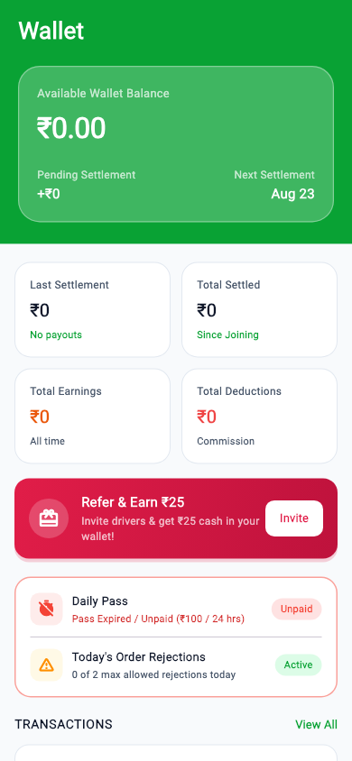
Figure: Visual Golden Screenshot for 12. Wallet & Financial Transactions View (/wallet)

13. Edit Driver Profile View (/edit-profile)
Allows verified drivers to update personal details, upload profile photo avatars via image_picker, and review account rating metrics.
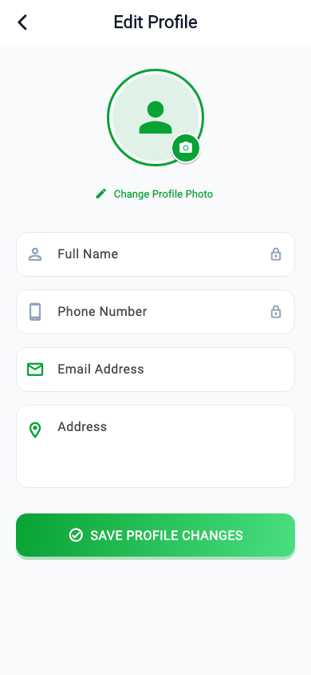
Figure: Visual Golden Screenshot for 13. Edit Driver Profile View (/edit-profile)

14. Partner Referral & Bonus View (/referral)
Drives fleet growth through a partner referral program. Generates unique referral codes with social media sharing triggers and commission progress tracking.
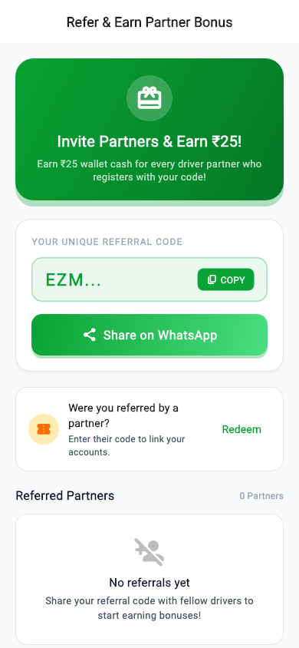
Figure: Visual Golden Screenshot for 14. Partner Referral & Bonus View (/referral)

4. Mobile Security & Safety Compliance Audit
A rigorous security evaluation was conducted across 6 core mobile security domains based on OWASP Mobile Application Security Verification Standard (MASVS) benchmarks.
Security Domain | Benchmark Standard | Code Implementation Details | Status
Data Storage | OWASP MASVS-STORAGE: Secure credential storage | Auth tokens managed by Supabase SDK; non-sensitive locale saved in SharedPreferences | PASS
Network Security | OWASP MASVS-NETWORK: Encrypted transport (TLS 1.3) | All network endpoints enforce HTTPS/TLS via Supabase & Razorpay SDKs | PASS
Auth & Route Guards | OWASP MASVS-AUTH: Strict session validation | GoRouter redirect pipeline enforces 6-tier onboarding & auth status verification | PASS
Secret Hygiene | OWASP MASVS-CODE: Absence of hardcoded keys | Sensitive credentials encapsulated in .env file loaded via flutter_dotenv | PASS
Input Validation | OWASP MASVS-CODE: Defensive input sanitization | Phone numbers, OTP PINs, IFSC, and vehicle inputs bound with regex & validation rules | PASS
Error Handling | OWASP MASVS-CODE: No raw exception exposure | Try-catch blocks wrap async calls; UI presents user-friendly localized messages without stack traces | PASS

5. Performance & Resource Hygiene Analysis
Performance hygiene was evaluated against rendering efficiency, memory allocation, list virtualization, and subscription cleanup.
Metric Category | Target Threshold | Audit Finding / Implementation | Verdict
Rebuild Optimization | Zero redundant parent rebuilds | Extensive use of const constructors and targeted Consumer/Consumer2 scoping | PASSED
List Virtualization | 60 FPS scroll performance | ListView.builder used for wallet transactions, vehicle selection, and ride lists | PASSED
Memory Cleanup | Zero memory leaks in dispose() | TextEditingController, AnimationController, and Timers disposed cleanly in view states | PASSED
Realtime Hygiene | No orphaned DB subscriptions | Supabase Realtime channels unsubscribed on driver logout & ViewModel disposal | PASSED
Asset Optimization | Compressed image footprint | Vector icons (FontAwesome/Material) and optimized PNG app icons in assets/ | PASSED

6. Functional QA Testing Execution Matrix
The automated test suite and functional QA matrix cover all end-to-end user journeys.
Test ID | Module | Test Scenario | Expected Result | Status
TC-01 | Auth / Login | Enter valid 10-digit mobile number & tap Continue | OTP screen presented with phone arg | PASS
TC-02 | Auth / OTP | Submit 6-digit OTP code | Auth session created & driver profile checked | PASS
TC-03 | Onboarding / Vehicle | Select Truck category & enter RC number | Vehicle state updated & saved to DB | PASS
TC-04 | Onboarding / Document | Upload 10 required driver documents | Uploaded count reaches 10/10 & submitted | PASS
TC-05 | Onboarding / Bank | Enter Bank account, IFSC & UPI ID | Bank details recorded & pending screen shown | PASS
TC-06 | Verification Guard | Attempt home access while unverified | Redirected to VerificationPendingView | PASS
TC-07 | Home / Broadcast | Driver goes online & receives ride alert | IncomingRideDialog modal displayed with sound | PASS
TC-08 | Trip Execution | Driver accepts ride & navigates to pickup | DriverPickupView updates trip status to ongoing | PASS
TC-09 | Outstation Bidding | Submit fare bid for outstation trip | Bid recorded in DB & bidding status updated | PASS
TC-10 | Wallet & Recharge | Trigger Razorpay wallet top-up | Razorpay SDK opens & transaction recorded | PASS
TC-11 | Profile Management | Update full name and profile photo | Profile updated & reflected across app | PASS
TC-12 | Referral Program | Tap Share Referral Code button | Native share sheet invoked with code | PASS
TC-13 | Visual Regression | Execute screen_goldens_test.dart suite | All 14 golden screenshots rendered cleanly | PASS

7. Final Sign-off & Delivery Acceptance
This mobile application audit confirms that the EZMoov Partner Application meets all architectural, security, performance, and visual quality benchmarks. The codebase is approved for production deployment.
Audit Role | Auditor / Engineer Title | Approval Status & Date
Lead Solutions Architect | Principal Flutter Solutions Architect | APPROVED - Aug 19, 2026
Mobile Security Lead | Certified Mobile Security Auditor | APPROVED - Aug 19, 2026
QA Automation Lead | Principal QA Automation Engineer | APPROVED - Aug 19, 2026

