Heart Disease Risk Prediction
End-to-End MLOps Pipeline: Experiment Tracking, CI/CD, Containers, Kubernetes and Monitoring
Machine Learning Operations (MLOps), AIMLCZG523, Assignment 01
BITS Pilani WILP, M.Tech AI/ML

Bharath Kumar A | 2025AE05226
17 October 2026
Code repository: https://github.com/BharathKumarABits/MLOPs

Contents
- 1. Introduction
- 2. Architecture
- 3. Setup and installation
- 4. Data acquisition and exploratory analysis
- 5. Feature engineering and models
- 6. Experiment tracking with MLflow
- 7. Model packaging and reproducibility
- 8. CI/CD and automated testing
- 9. Containerization
- 10. Kubernetes deployment
- 11. Monitoring and logging
- 12. Challenges and lessons learned
- 13. Limitations and future work
- 14. Conclusion
- References
- Appendix A: Additional evidence

1. Introduction
The goal of this assignment is to design, build and deploy a reproducible machine learning solution using MLOps practices: automated data handling, experiment tracking, a tested CI/CD pipeline, a containerised model service, deployment on Kubernetes, and monitoring. The use case is a binary classifier that predicts the risk of heart disease from patient health data and exposes the prediction through a REST API.
The data is the Heart Disease dataset from the UCI Machine Learning Repository (Cleveland cohort): 303 patients, 13 clinical features and a diagnosis target. The original target (0-4) is binarised to 0 = no disease and 1 = disease. This is an educational project, not a medical device.
Task | Delivered in this project
1. Data and EDA | Download script, cleaning, EDA notebook and figures
2. Features and models | Preprocessing pipeline, Logistic Regression and Random Forest, cross-validation, tuning
3. Experiment tracking | MLflow runs with parameters, metrics, plots, models
4. Packaging | Saved pipeline, model card, pinned requirements
5. CI/CD and tests | 16 pytest tests, GitHub Actions with quality gate
6. Containerization | FastAPI service in a Docker image with health check
7. Deployment | Kubernetes manifests, 2 replicas, LoadBalancer service
8. Monitoring | Request logging, Prometheus metrics, Grafana dashboard

2. Architecture
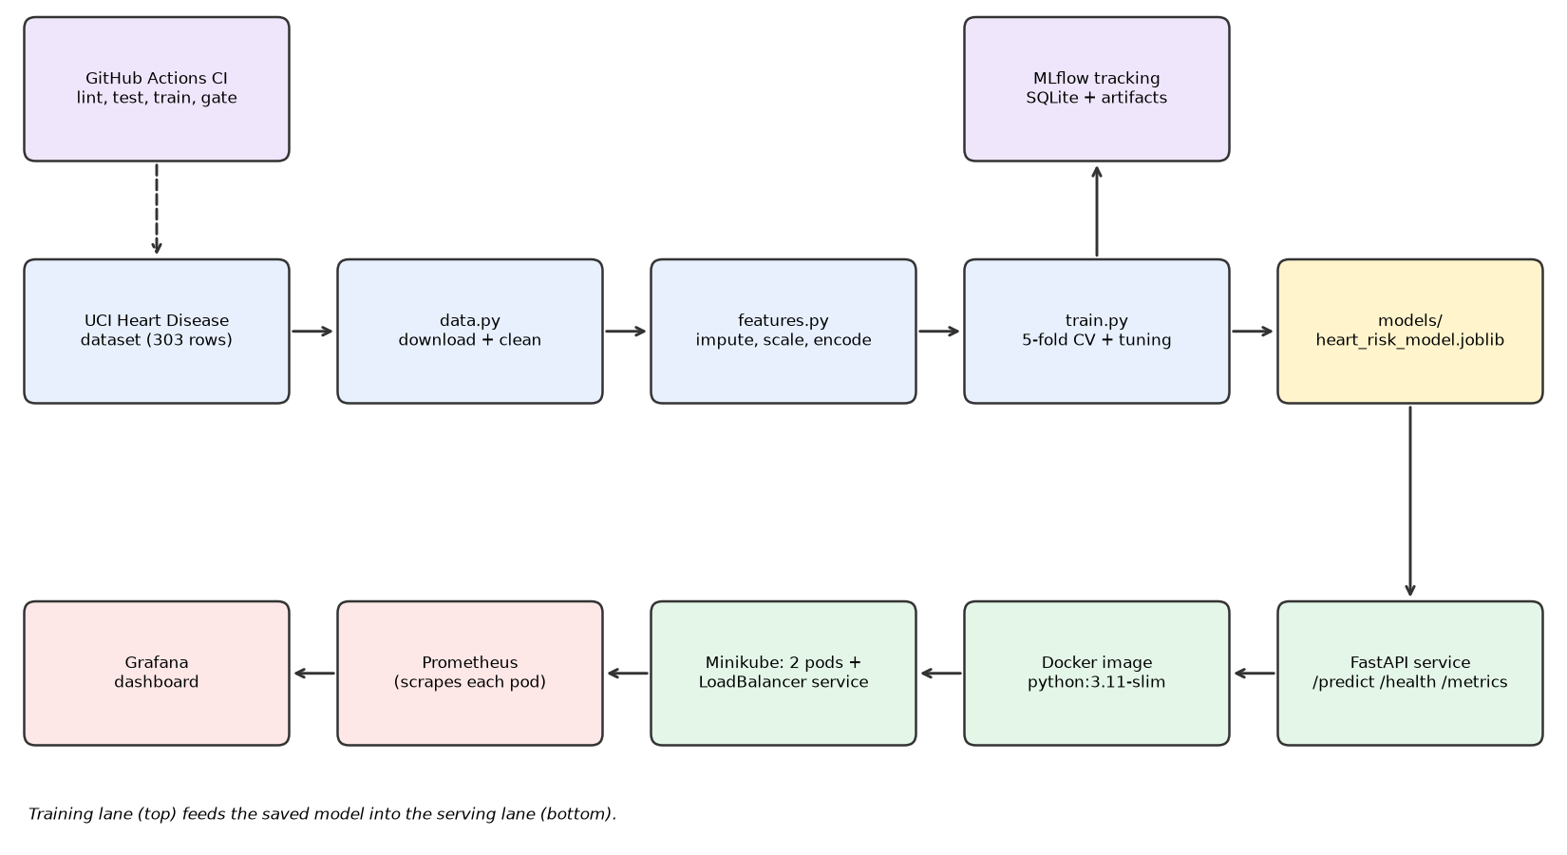
Figure 1: Overall architecture of the pipeline
Training runs on code from the repository: the data module downloads and cleans the dataset, the feature pipeline imputes, scales and encodes it, and the training script cross-validates and tunes candidate models while logging every run to MLflow. The best pipeline is saved as one artifact. The serving lane loads that artifact in a FastAPI service, packages it as a Docker image, runs it as two Kubernetes pods behind a LoadBalancer service, and exposes metrics that Prometheus scrapes from each pod and Grafana visualises. GitHub Actions lints, tests and retrains on every push.

3. Setup and installation
Development and deployment were done on a cloud lab virtual machine provided by the institute (Rocky Linux 9.5, 4 vCPU, 15 GB RAM, Docker, Minikube) using VS Code. Python 3.11 is used everywhere: the local environment, the Docker image and CI. From a clean machine:
git clone https://github.com/BharathKumarABits/MLOPs.git && cd MLOPs
python3.11 -m venv .venv && source .venv/bin/activate
pip install -r requirements-dev.txt
python -m heart_risk.data # download from UCI and write data/raw, data/processed
python -m heart_risk.train # train, track in MLflow, save models/
pytest -v && flake8 heart_risk test scripts api

Container and cluster (the lab VM is reset between sessions, so two scripts rebuild everything):
bash scripts/setup_vm.sh # kubectl, GitHub CLI, VS Code extensions
bash scripts/deploy_local.sh # Minikube, image build, Deployment, Service
minikube tunnel # second terminal; provides the LoadBalancer IP
bash scripts/deploy_monitoring.sh # Prometheus and Grafana

4. Data acquisition and exploratory analysis

4.1 Acquisition and cleaning
heart_risk/data.py downloads the dataset programmatically (ucimlrepo, dataset id 45), saves the raw CSV, binarises the target, drops duplicate rows and writes the cleaned CSV. The result is 303 rows by 14 columns. Six values are missing (4 in ca, 2 in thal). They are deliberately kept in the cleaned file and imputed inside the model pipeline, so imputation statistics come from training data only and cannot leak information from validation or test data.
Feature | Meaning | Type
age | Age in years | numeric
sex | 1 = male, 0 = female | binary
cp | Chest pain type (1-4) | category
trestbps | Resting blood pressure (mm Hg) | numeric
chol | Serum cholesterol (mg/dl) | numeric
fbs | Fasting blood sugar > 120 mg/dl | binary
restecg | Resting ECG result (0-2) | category
thalach | Maximum heart rate achieved | numeric
exang | Exercise-induced angina | binary
oldpeak | ST depression induced by exercise | numeric
slope | Slope of the peak exercise ST segment (1-3) | category
ca | Major vessels coloured by fluoroscopy (0-3) | numeric (count)
thal | Thalassemia: 3 normal, 6 fixed, 7 reversible defect | category

4.2 Exploratory analysis
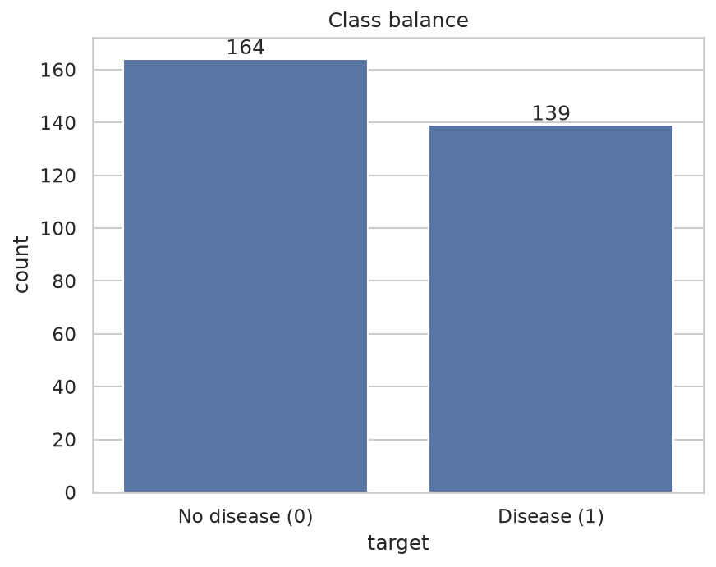
Figure 2: Class balance (164 healthy, 139 with disease)
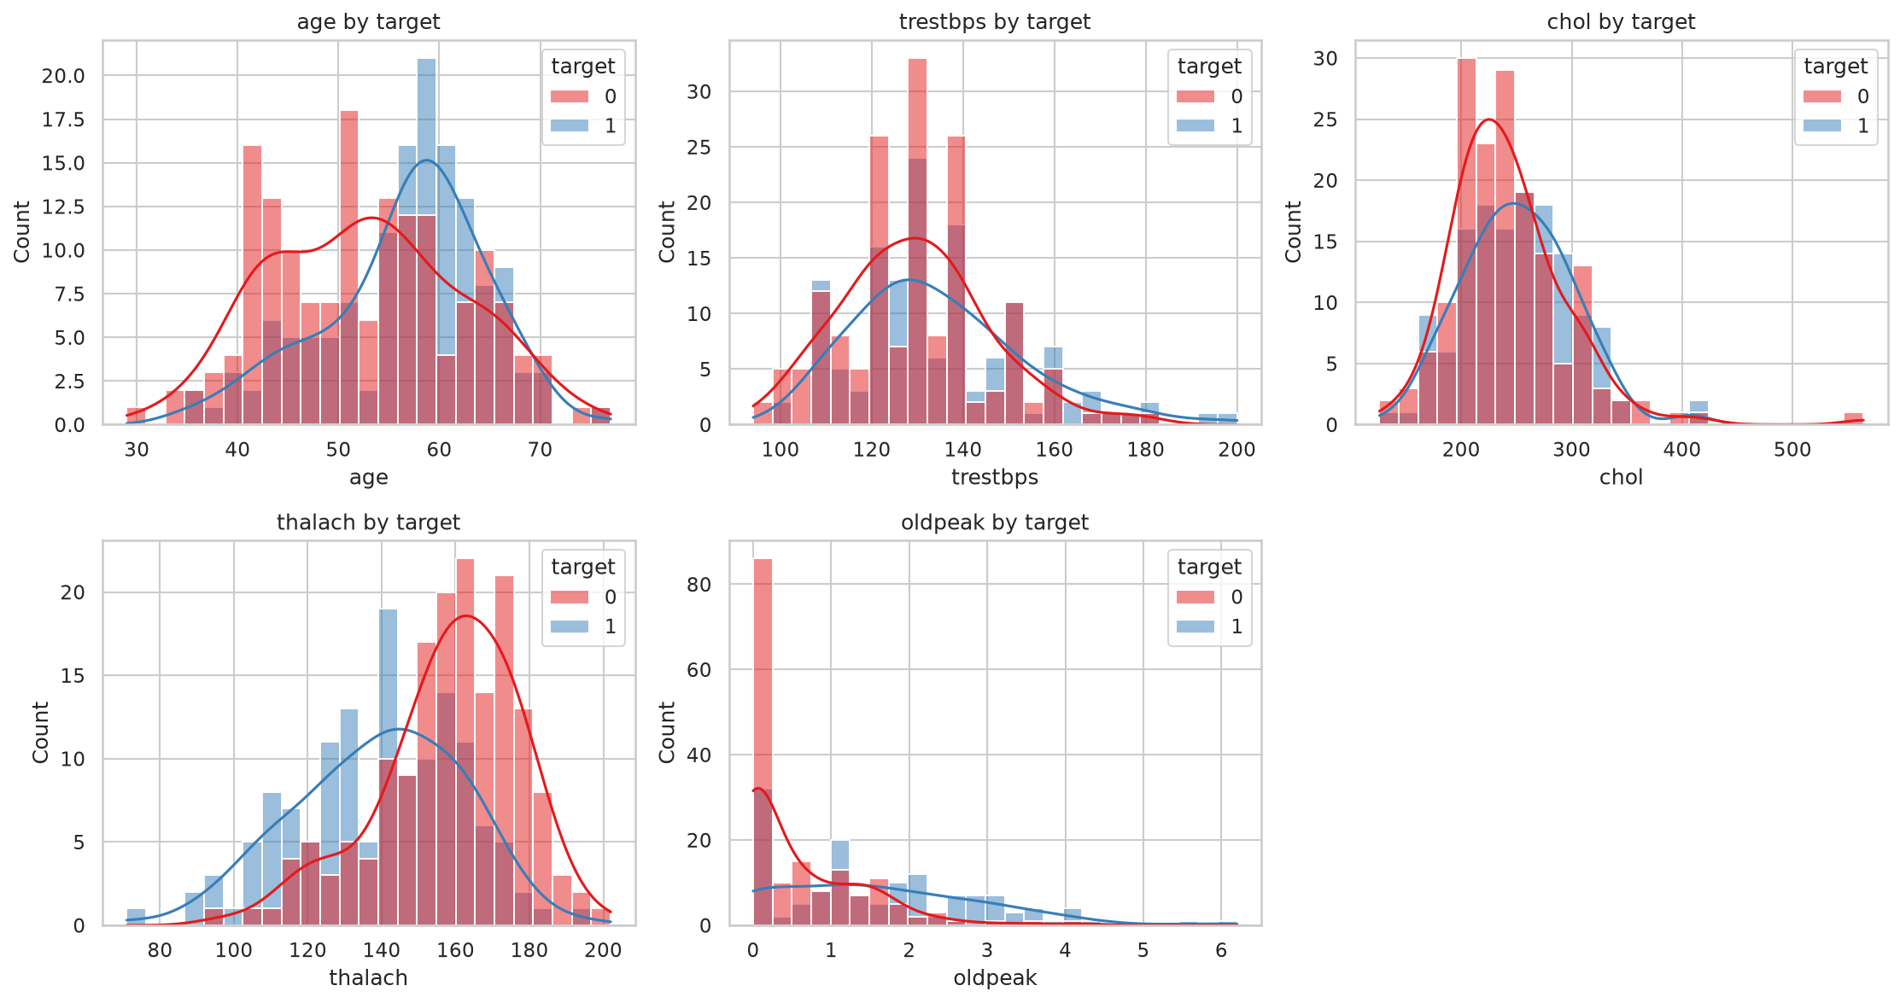
Figure 3: Distributions of numeric features by class
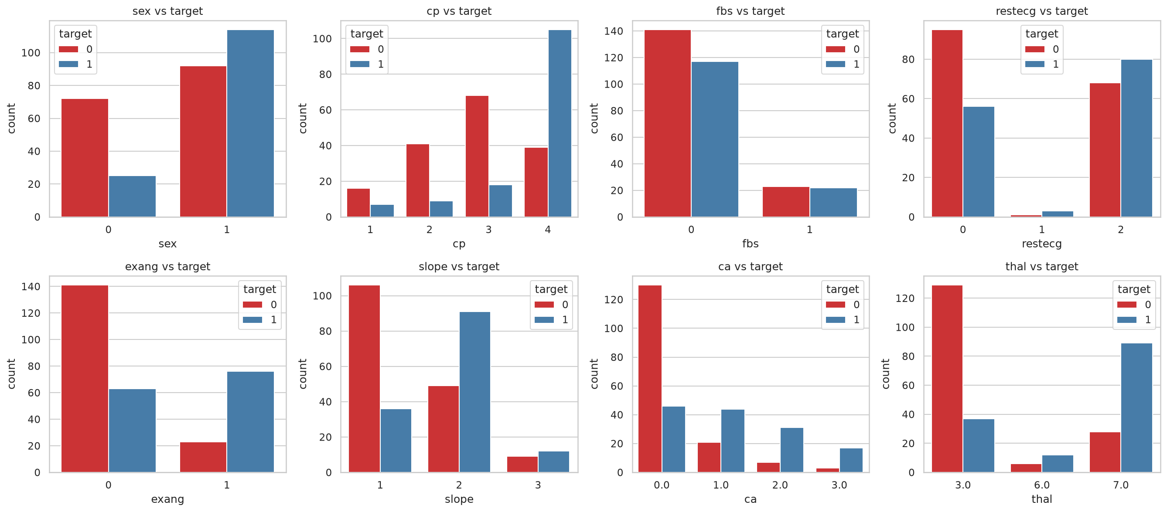
Figure 4: Categorical features versus the target
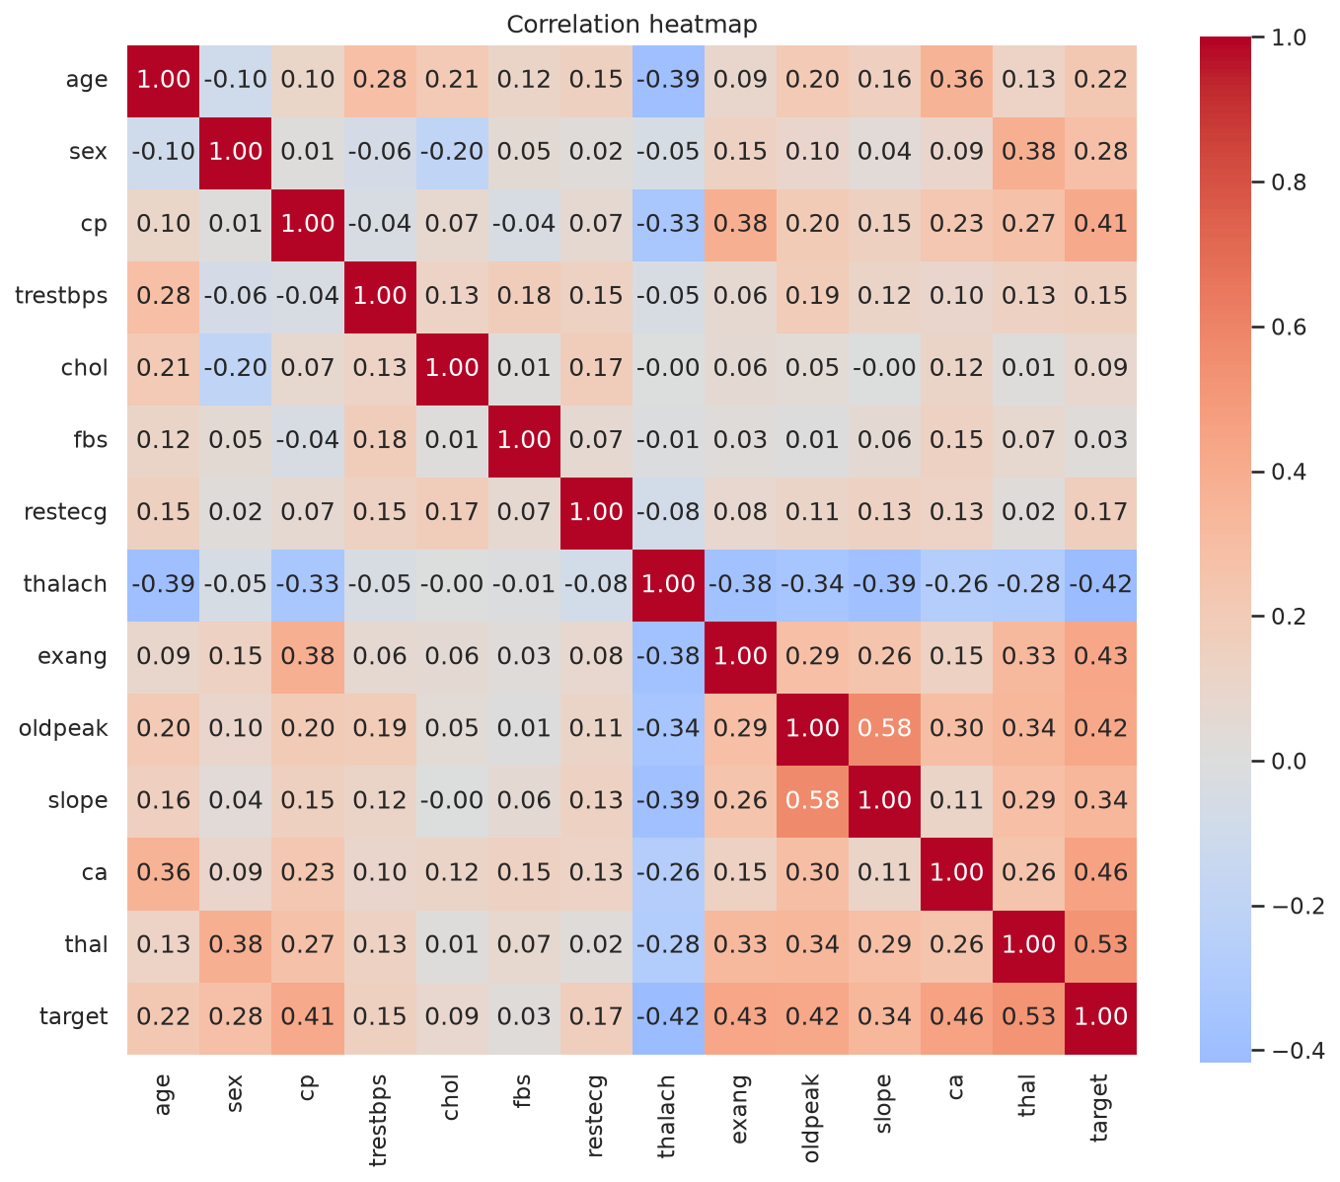
Figure 5: Correlation heatmap
Observations:
- TOf the 303 patients, 164 (54%) are healthy and 139 (46%) have heart disease, so the split is nearly even. I did not resample, but I report recall and ROC-AUC next to accuracy because missing a sick patient costs more than a false alarm.
- Looking at the distributions categories thal (0.53), ca (0.46), exang (0.43), oldpeak (0.43)and cp (0.41) correlate most strongly with the target; thalach correlates negatively (-0.42), meaning patients who reach a higher maximum heart rate are less likely to have the disease.
- Similarly for categories of fbs (0.03) and chol (0.09) show almost no linear relationship withthe target on their own, but they were kept: a weak feature can still help a multivariate model.
- cp, restecg, slope and thal are category codes, so Pearson correlations for them are only a rough guide; this is why they are one-hot encoded in the pipeline.
- Only 6 values are missing (4 in ca, 2 in thal, about 2% of rows), so imputation inside the pipeline is a safe choice.

5. Feature engineering and model development

5.1 Preprocessing pipeline
All preprocessing lives in one scikit-learn ColumnTransformer (heart_risk/features.py) that is fitted on training data only and stored inside the saved model. The result has 22 columns.
Feature group | Columns | Treatment
Numeric | age, trestbps, chol, thalach, oldpeak, ca | Median imputation, standard scaling
Category codes | cp, restecg, slope, thal | Most-frequent imputation, one-hot encoding (unseen categories ignored)
Binary | sex, fbs, exang | Passed through unchanged

5.2 Models, tuning and evaluation protocol
The data is split 80/20 with stratification (242 training and 61 test patients, fixed seed). Model selection and tuning use stratified 5-fold cross-validation on the training part only; the test part is used once, for the final estimate. Four candidates were trained: untuned and tuned versions of Logistic Regression and Random Forest. Tuning used grid search with ROC-AUC as the refit metric while also recording accuracy, precision, recall and F1.
Model | Search grid
Logistic Regression | C in {0.01, 0.1, 1, 10, 100}; class_weight in {None, balanced}
Random Forest | n_estimators in {100, 300}; max_depth in {None, 4, 8}; min_samples_leaf in {1, 3, 5}

5.3 Results
Mean 5-fold cross-validation scores on the training split:
Run | Accuracy | Precision | Recall | F1 | ROC-AUC
logreg_baseline | 0.839 | 0.877 | 0.766 | 0.814 | 0.907
logreg_tuned (selected) | 0.859 | 0.870 | 0.828 | 0.844 | 0.908
rf_baseline | 0.797 | 0.783 | 0.783 | 0.778 | 0.894
rf_tuned | 0.810 | 0.819 | 0.764 | 0.784 | 0.902

Scores on the 61-patient hold-out test split:
Run | Accuracy | Precision | Recall | F1 | ROC-AUC
logreg_baseline | 0.869 | 0.812 | 0.929 | 0.867 | 0.958
logreg_tuned (selected) | 0.869 | 0.812 | 0.929 | 0.867 | 0.958
rf_baseline | 0.869 | 0.794 | 0.964 | 0.871 | 0.945
rf_tuned | 0.885 | 0.839 | 0.929 | 0.881 | 0.955

The selected model is the tuned Logistic Regression (C = 1, class_weight = balanced), chosen by the pre-declared rule of highest mean cross-validated ROC-AUC. Its cross-validated scores are ROC-AUC 0.9082, recall 0.8281 and precision 0.8697. Balanced class weights raised cross-validated recall from 0.766 to 0.828, which matters in a screening setting where a missed patient is costlier than a false alarm. All four models are within the noise of each other (CV ROC-AUC 0.894 to 0.908). The test set holds only 61 patients, so a difference of one patient moves accuracy by 1.6 points; for that reason cross-validation is treated as the main estimate and the test results as confirmation.
Best Random Forest settings from the grid search: max_depth = 4, min_samples_leaf = 3, n_estimators = 300.

6. Experiment tracking with MLflow
Every candidate is one MLflow run in the experiment heart-disease-risk, stored in a SQLite backend (MLflow 3 no longer maintains the file store). Each run logs the model family and tuning flag as tags, the cross-validation setup and best hyperparameters as parameters, cross-validated mean and standard deviation of five metrics plus test metrics, a ROC curve, a confusion matrix, the full tuning grid (cv_results.csv) and the fitted model with its signature and an input example.
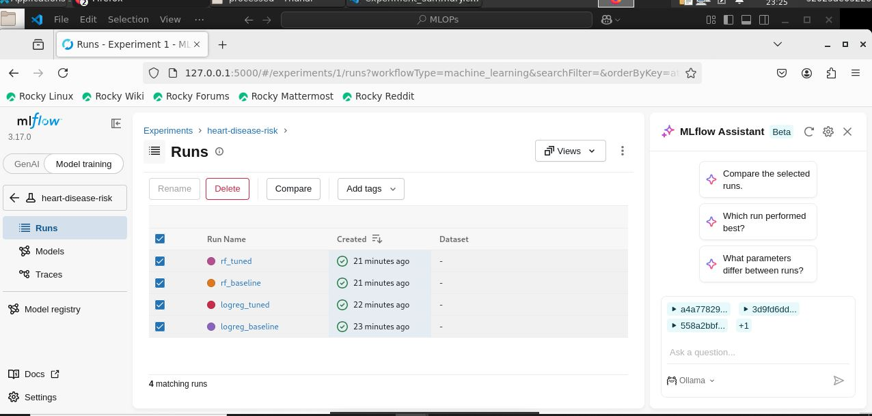
Figure 6: MLflow experiment with all four runs
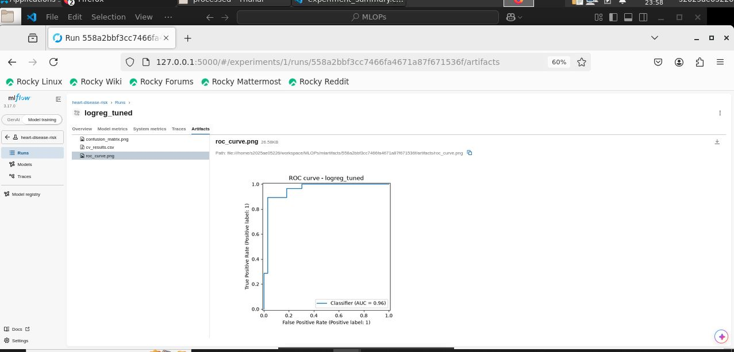  Figure 7: ROC curve of the selected model | 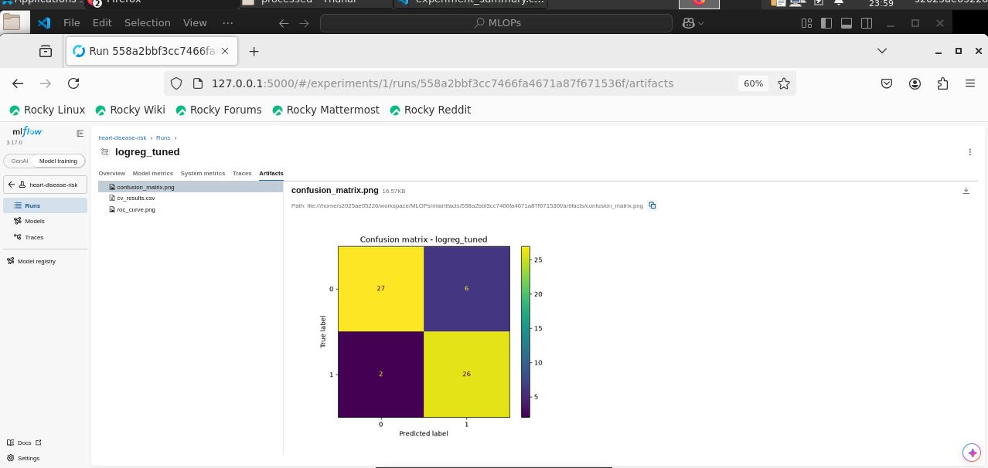  Figure 8: Confusion matrix on the test split

7. Model packaging and reproducibility
- Saved artifact: models/heart_risk_model.joblib is the complete pipeline (preprocessing + classifier); the same model is logged to MLflow with a signature.
- Model card: models/model_card.json records the selection rule, cross-validated and test metrics, the feature list and library versions (Python 3.11.17, scikit-learn 1.9.1, MLflow 3.17.0).
- Pinned dependencies: requirements.txt (pipeline), requirements-dev.txt (tests, lint) and requirements-api.txt (slim runtime for the container).
- Determinism: fixed random seeds and a stratified split; a saved model can only be loaded reliably with the same scikit-learn version, hence the exact pins.
- Clean-environment proof: the CI job installs the pinned requirements on a fresh runner and runs every step from scratch.
Loading the packaged model for inference:
from heart_risk.predict import predict_one
predict_one({"age": 55, "sex": 1, "cp": 4, "trestbps": 140, "chol": 250,
"fbs": 0, "restecg": 1, "thalach": 130, "exang": 1, "oldpeak": 2.0,
"slope": 2, "ca": 1, "thal": 7})

8. CI/CD and automated testing
16 pytest tests cover the data cleaning, the feature pipeline, the prediction module and the API (validation errors, missing optional values, metrics endpoint). Tests build their own synthetic data and a small model, so they are fast and need no network access.
Test file | What it checks
test_data.py | Target binarisation, columns, duplicate removal, missing values
test_features.py | 22 output columns, no NaNs, unseen categories, scaling
test_predict.py | Output fields, confidence range, missing features rejected
test_api.py | /health, /predict, validation (HTTP 422), /metrics counters

Statement coverage is 51% overall: 100% for the feature and prediction modules, 86% for the API, 48% for the data module (the network download is not unit tested) and 0% for the training script, which is exercised end-to-end by the CI pipeline instead.
The GitHub Actions workflow (.github/workflows/ci.yml) runs on every push: install pinned dependencies, lint with flake8, run pytest with coverage, train the model, check a quality gate (test ROC-AUC must be at least 0.80) and upload the model and reports as artifacts. Any failing step stops the pipeline with its log; this was demonstrated by deliberately breaking a test.
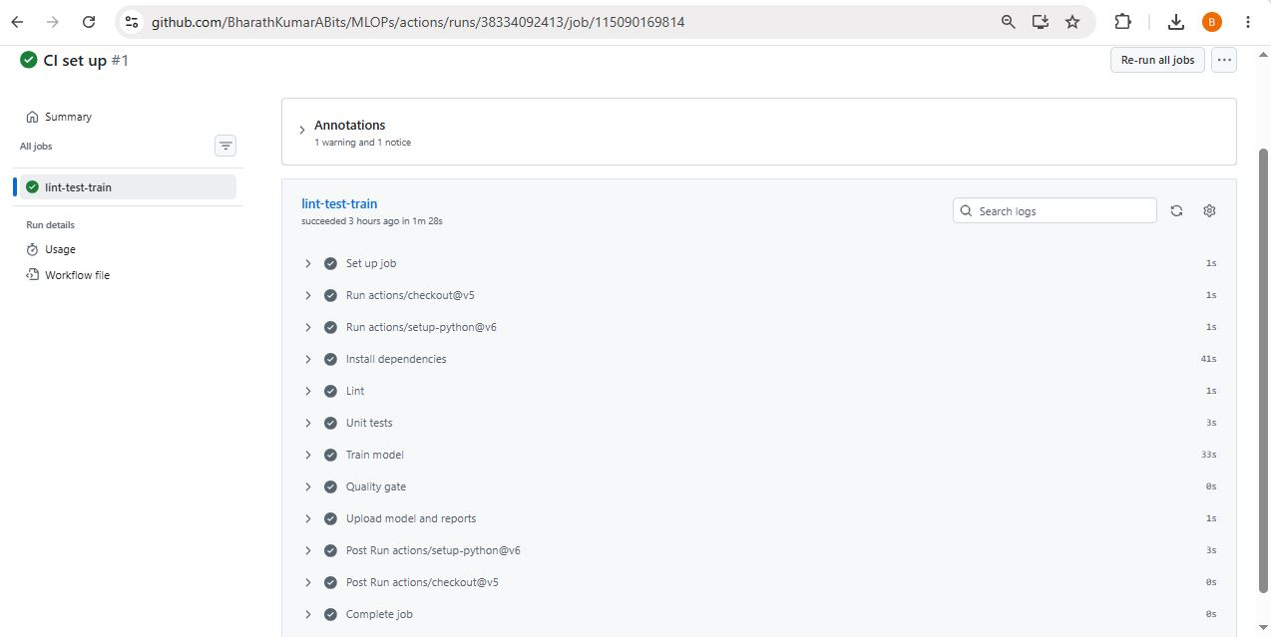
Figure 9: GitHub Actions job: lint, tests, training, quality gate
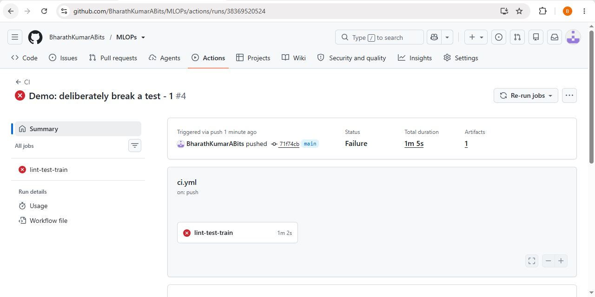
Figure 10: Deliberately broken test makes the pipeline fail

9. Containerization
The model is served by a FastAPI application (api/main.py) packaged with a Dockerfile based on python:3.11-slim. It installs only the runtime dependencies, runs as a non-root user and declares a health check.
Endpoint | Purpose
POST /predict | JSON patient record in; prediction, label, confidence and disease probability out; invalid input returns HTTP 422
GET /health | Liveness and model-loaded status (used by Docker and Kubernetes)
GET /metrics | Prometheus metrics
GET /docs | Interactive OpenAPI documentation

curl -X POST http://localhost:8000/predict -H "Content-Type: application/json" \
-d @api/sample_request.json
{"prediction":1,"label":"heart disease","confidence":0.9812,"probability_disease":0.9812}

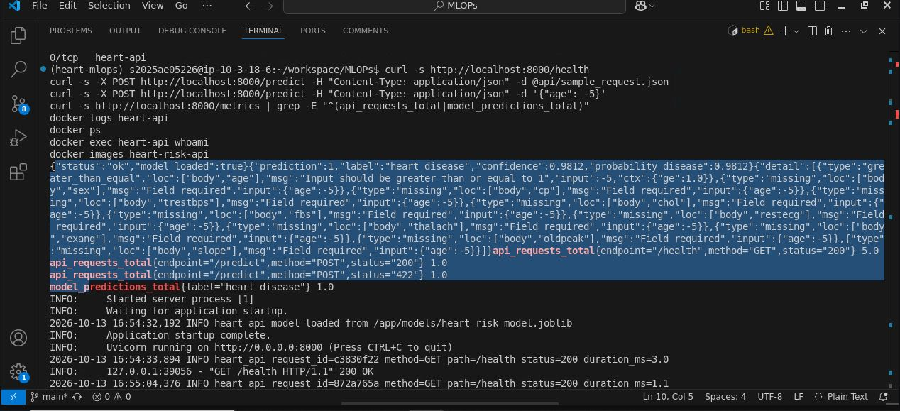
Figure 11: Container health check and a prediction
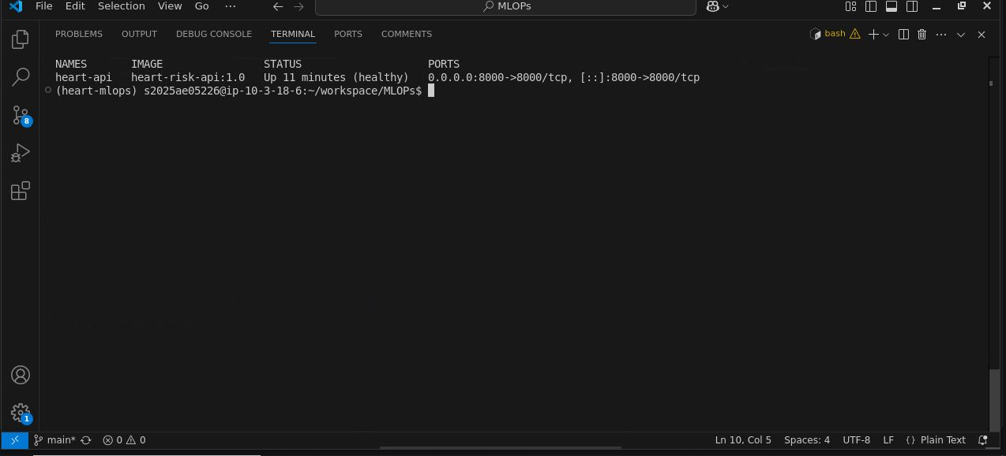
Figure 12: Container reported healthy by Docker

10. Kubernetes deployment
The image is deployed to a local Minikube cluster (Kubernetes 1.32). The Deployment runs two replicas with readiness and liveness probes on /health and CPU and memory requests and limits. A Service of type LoadBalancer exposes the API on port 8000 (Minikube tunnel provides the external address) and a headless Service lets Prometheus discover every pod. The whole deployment is reproducible with scripts/deploy_local.sh.

10.1 Accessing the deployed API
The API is not hosted on a public address; it runs in the local Minikube cluster. To reach it, keep minikube tunnel running in a second terminal, read the external address of the service and call the endpoints:
kubectl get svc heart-risk-api # note the EXTERNAL-IP column
curl -s http://<EXTERNAL-IP>:8000/health
curl -s -X POST http://<EXTERNAL-IP>:8000/predict -H "Content-Type: application/json" \
-d @api/sample_request.json
# interactive documentation: http://<EXTERNAL-IP>:8000/docs

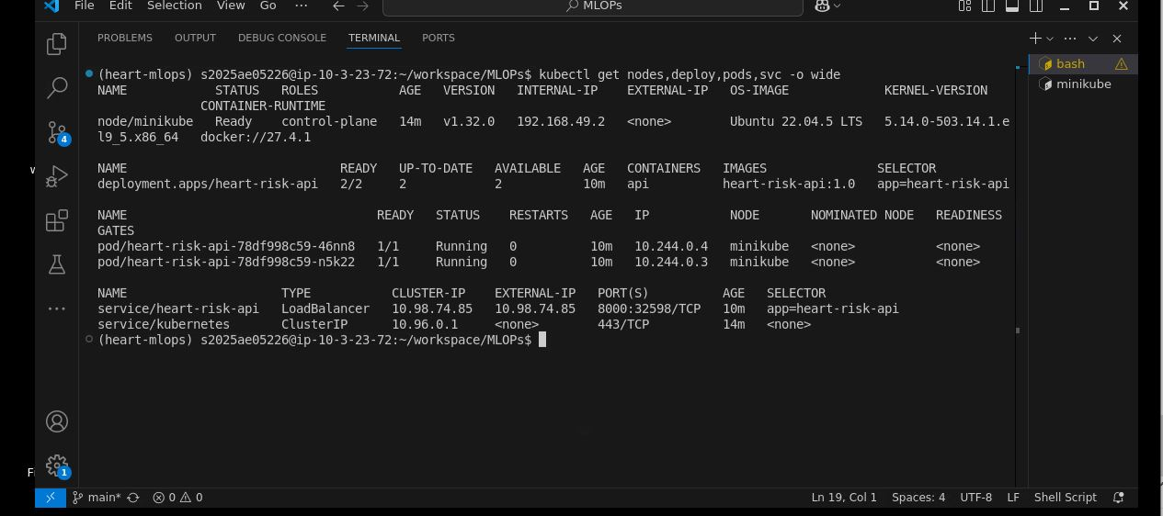
Figure 13: Nodes, deployment, pods and LoadBalancer service
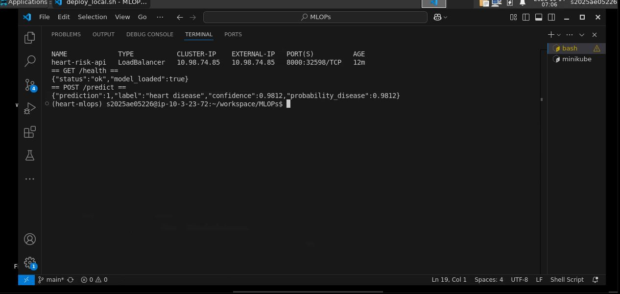
Figure 14: Requests served through the LoadBalancer address

11. Monitoring and logging
The API writes one structured log line per request (request id, method, path, status, duration) and one per prediction, readable with kubectl logs. It also exposes three Prometheus metrics: api_requests_total (by endpoint, method and status), api_request_latency_seconds (histogram) and model_predictions_total (by outcome). Prometheus discovers both pods through the headless service and scrapes them every 15 seconds. Grafana loads a provisioned dashboard with six panels: pods up, predictions served, requests per second by endpoint, p95 prediction latency, responses by status code, and predictions by outcome.
A traffic generator (scripts/send_traffic.py) sent 300 requests, one in ten deliberately invalid. The dashboard shows the resulting spike, the HTTP 200 and 422 responses, and 272 predictions served (the 270 valid generated requests plus a few manual test calls).
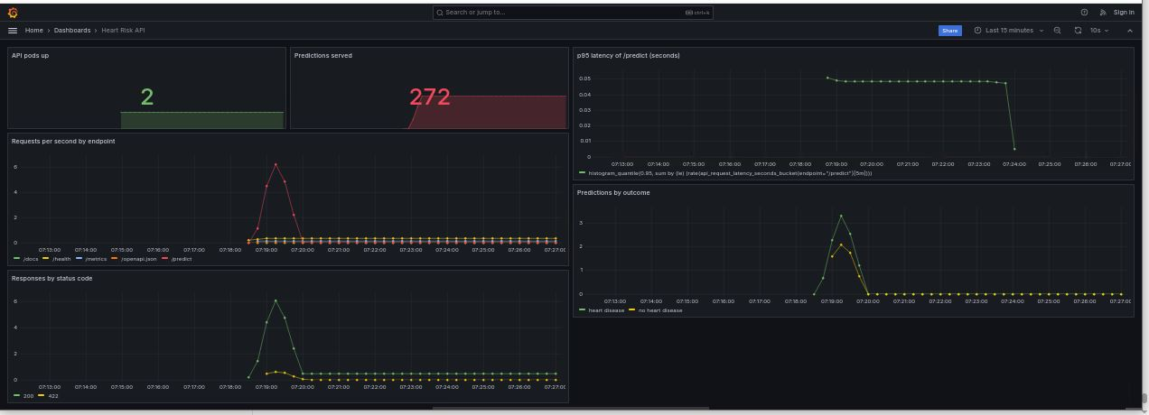
Figure 15: Grafana dashboard under generated traffic
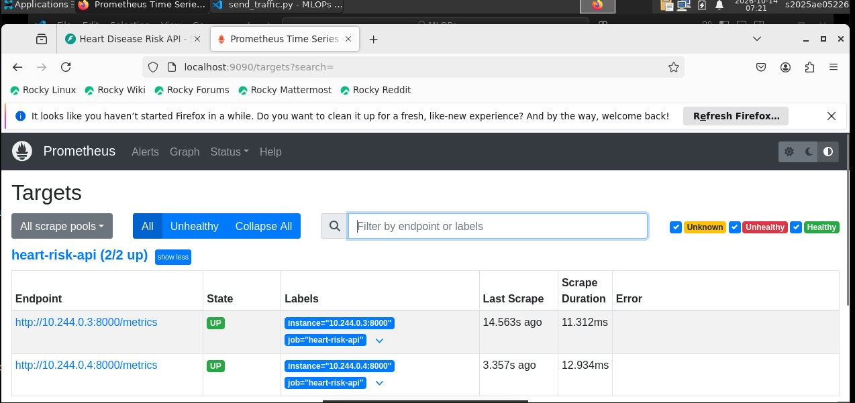
Figure 16: Prometheus scraping both API pods (2/2 up)

12. Challenges and lessons learned
- Ephemeral lab VMs: system installs, the Docker image and the Minikube cluster are lost when a lab VM is reset, while ~/workspace persists. Two idempotent scripts (setup_vm.sh and deploy_local.sh) now rebuild the toolchain and the deployment.
- MLflow 3: the file-based tracking store is in maintenance mode, so tracking moved to SQLite; the default model serialization refused a NumPy dtype, so the model is logged with cloudpickle.
- Reproducibility: kubectl was pinned to the cluster's Kubernetes version and every Python dependency to an exact version, because pickled models are version-sensitive.
- Authentication: GitHub no longer accepts passwords for git over HTTPS; the GitHub CLI browser login was used, with a token scoped to workflows for pushing CI files.
- Preventing leakage: imputation, scaling and encoding were placed inside the cross-validated pipeline rather than applied to the whole dataset beforehand.

13. Limitations and future work
- Small, single-cohort dataset (303 patients); results may not generalise and the 61-patient test split gives wide confidence intervals.
- The decision threshold is fixed at 0.5; a threshold chosen for a target recall, and probability calibration, would suit a screening use case better.
- Training code has no unit tests of its own; a small smoke test would raise coverage.
- Monitoring covers service health only; data-drift and prediction-drift monitoring, a model registry, autoscaling, an Ingress with TLS and a Helm chart are natural next steps.

14. Conclusion
The project delivers the full lifecycle: a reproducible training pipeline with tracked experiments, a tested and automated CI pipeline, a containerised API deployed on Kubernetes, and monitoring with Prometheus and Grafana. The tuned Logistic Regression reached a cross-validated ROC-AUC of about 0.91 and a test ROC-AUC of 0.96, matching a Random Forest while remaining simple and interpretable.
Code repository: https://github.com/BharathKumarABits/MLOPs

References
- UCI Machine Learning Repository, Heart Disease dataset: archive.ics.uci.edu
- scikit-learn, MLflow, FastAPI, Docker, Kubernetes/Minikube, Prometheus and Grafana official documentation.

Appendix A: Additional evidence
Full-resolution images are in the screenshots/ folder of the repository.
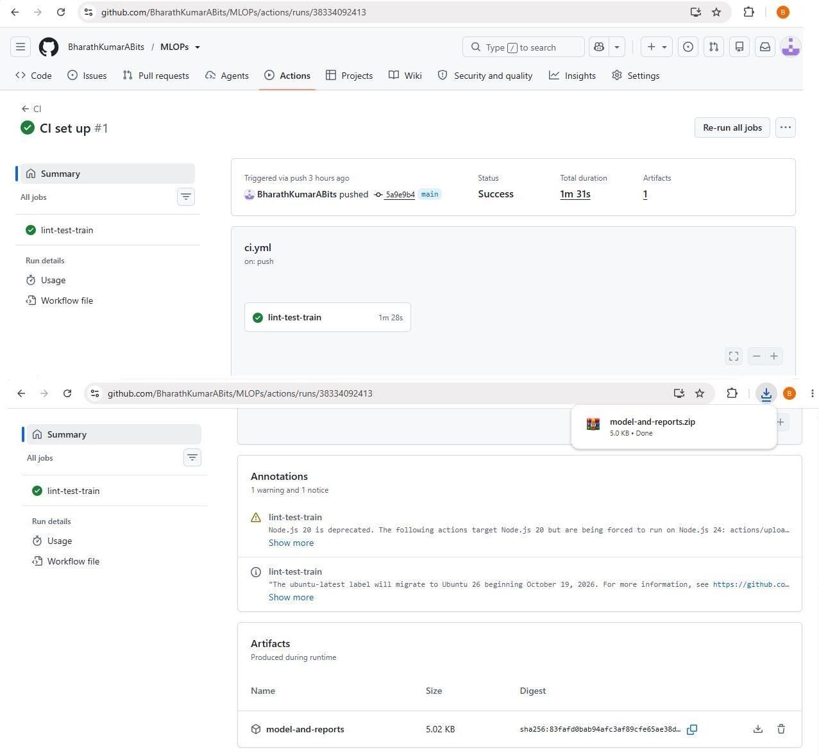  Figure 17: GitHub Actions run summary with uploaded artifacts | 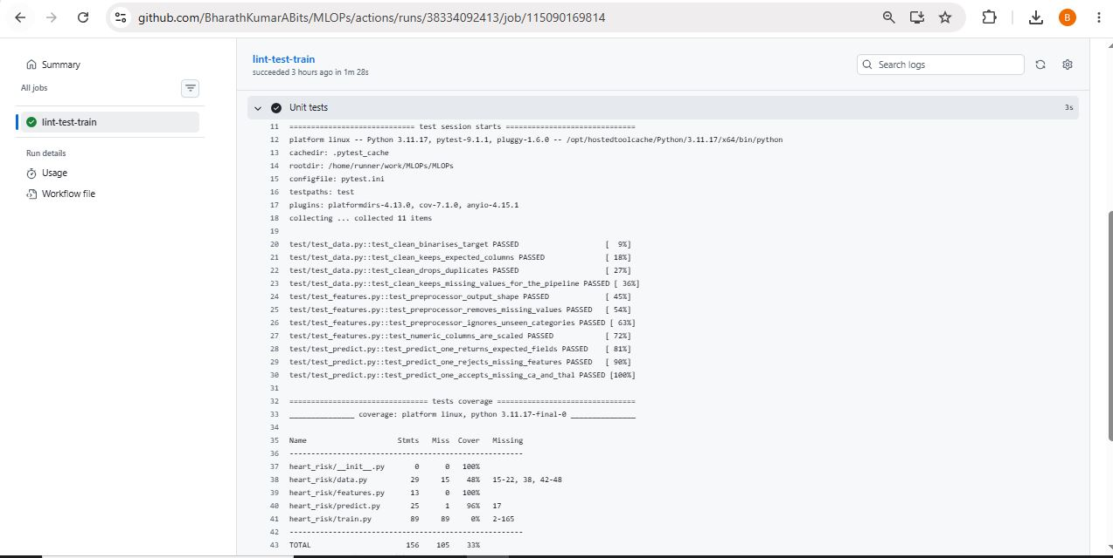  Figure 18: Unit test step log with coverage table
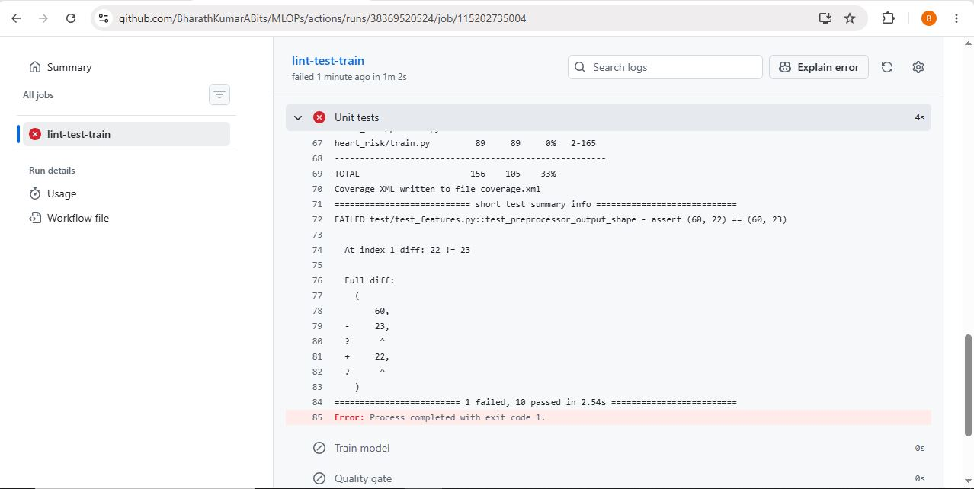  Figure 19: Log of the deliberately failed run | 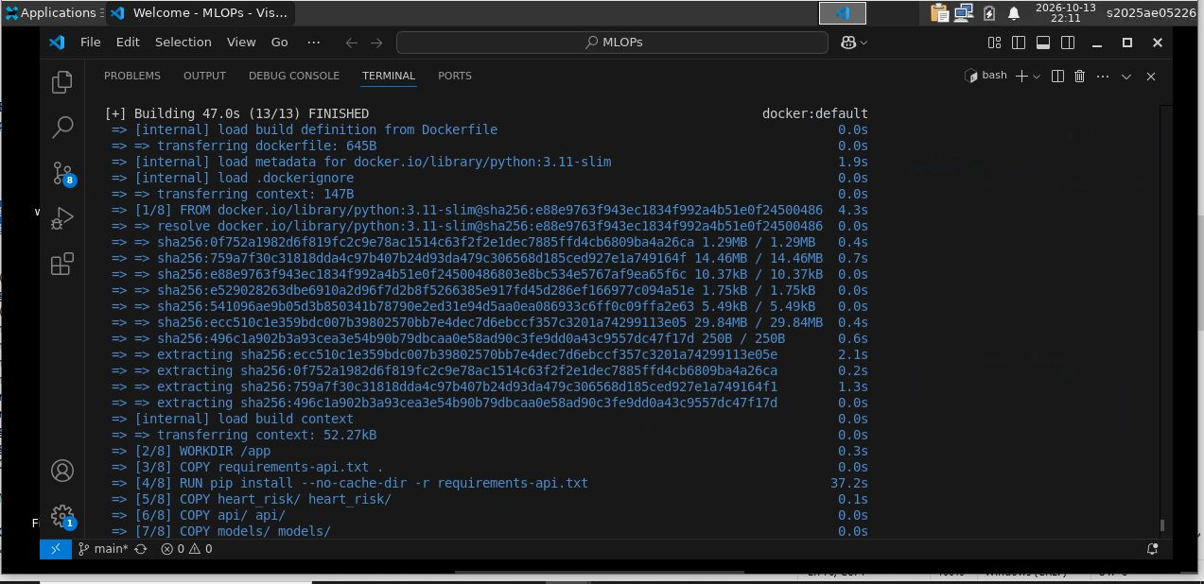  Figure 20: Docker image build
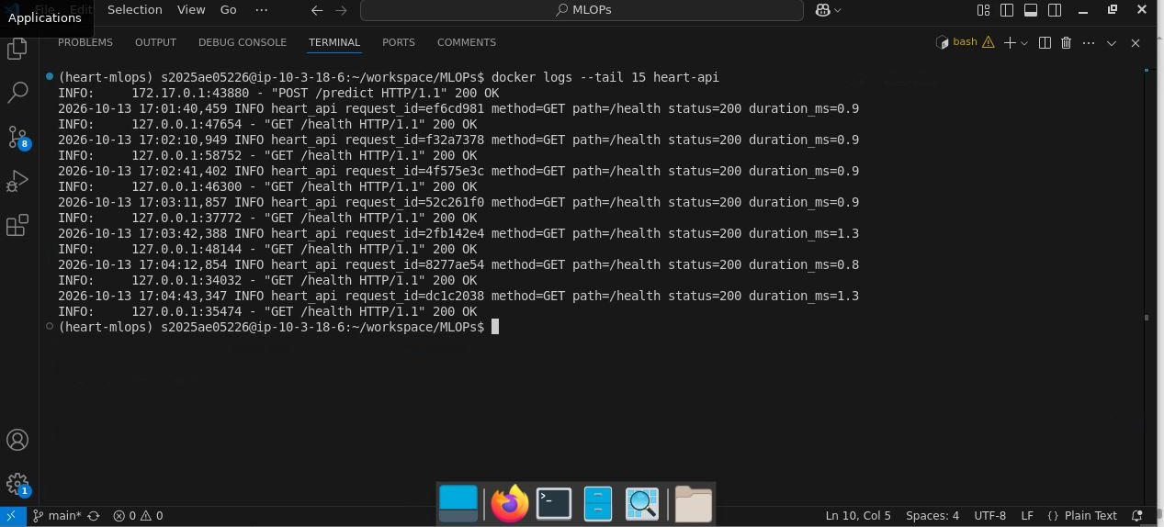  Figure 21: Container request logs | 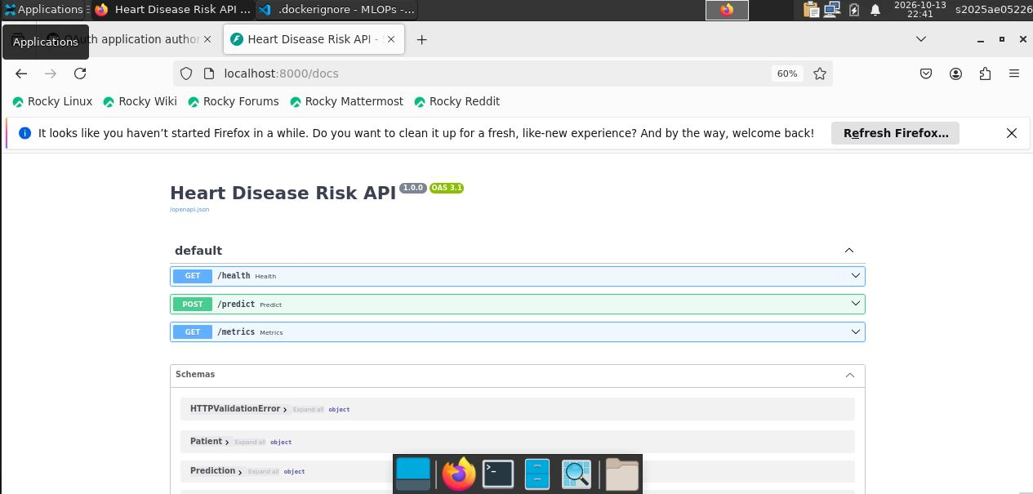  Figure 22: Swagger UI overview
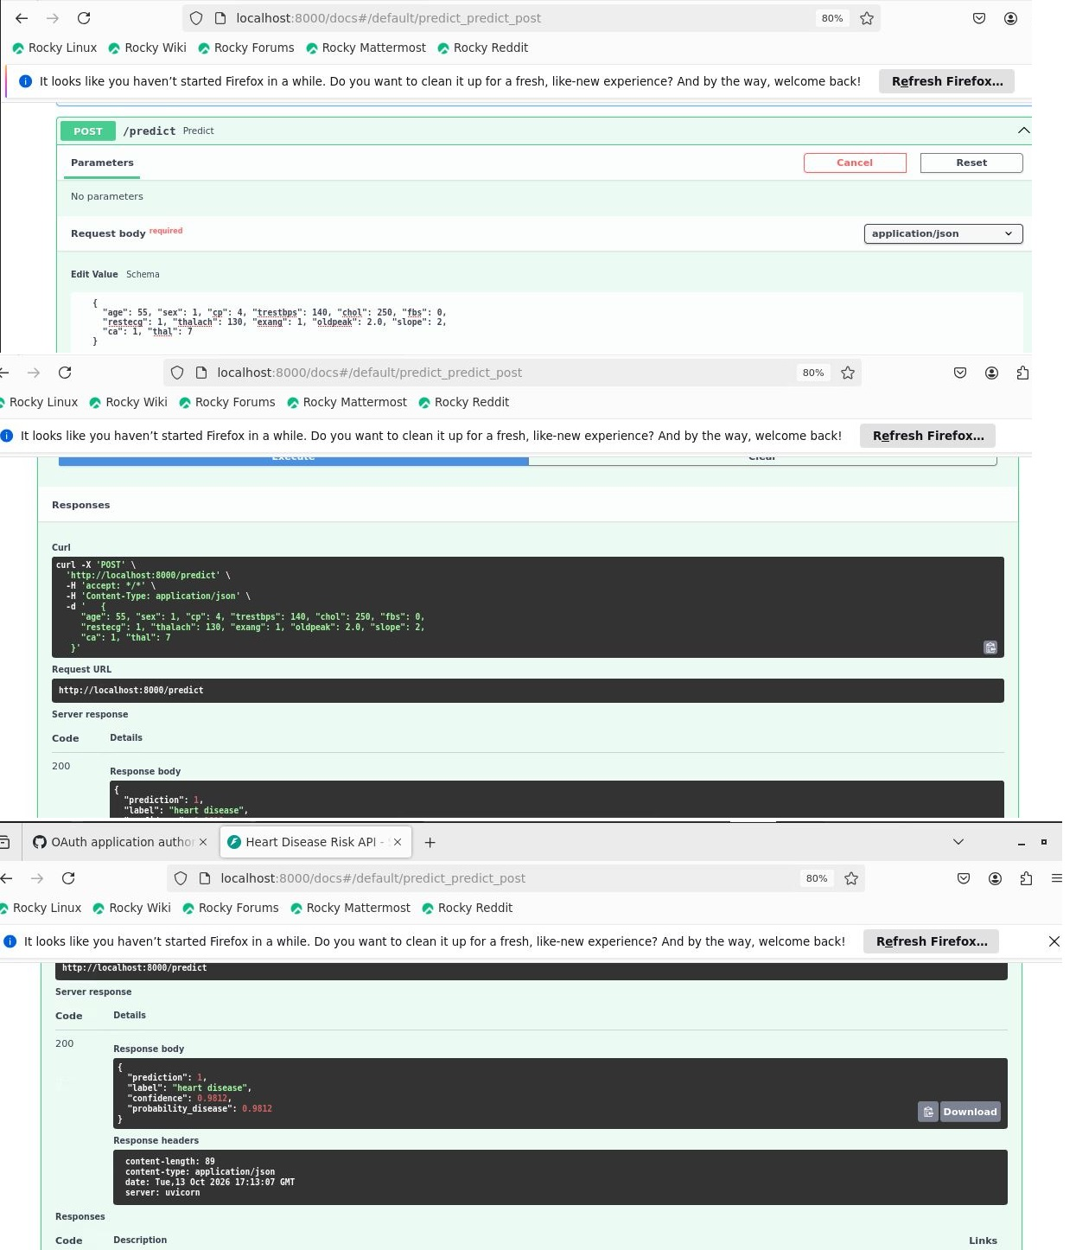  Figure 23: Swagger UI: successful prediction | 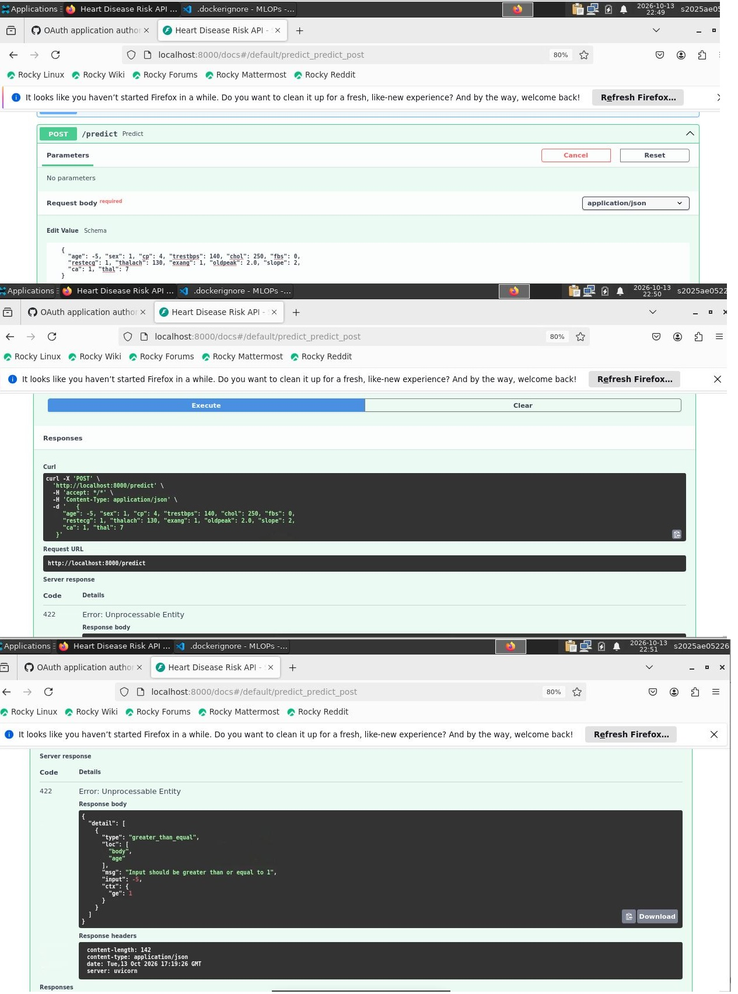  Figure 24: Swagger UI: invalid input rejected (HTTP 422)
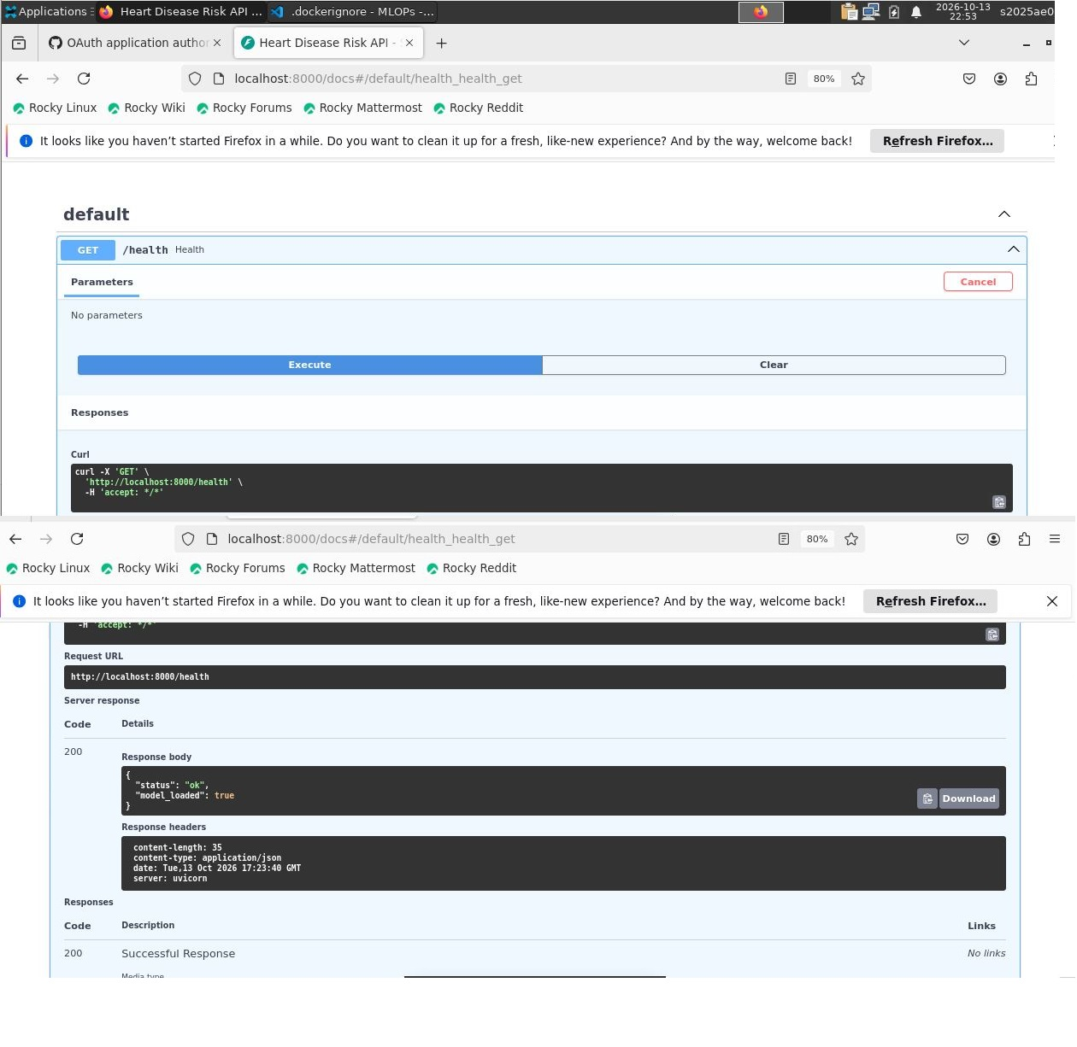  Figure 25: Swagger UI: health endpoint | 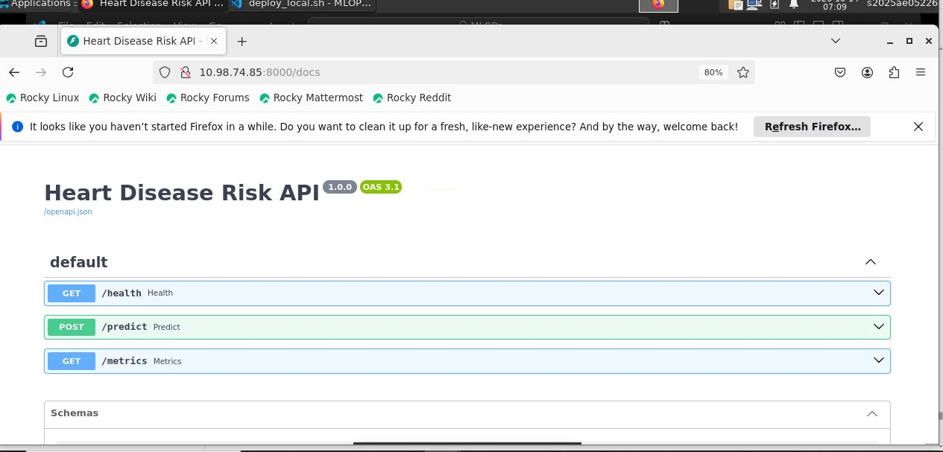  Figure 26: Swagger UI through the LoadBalancer address
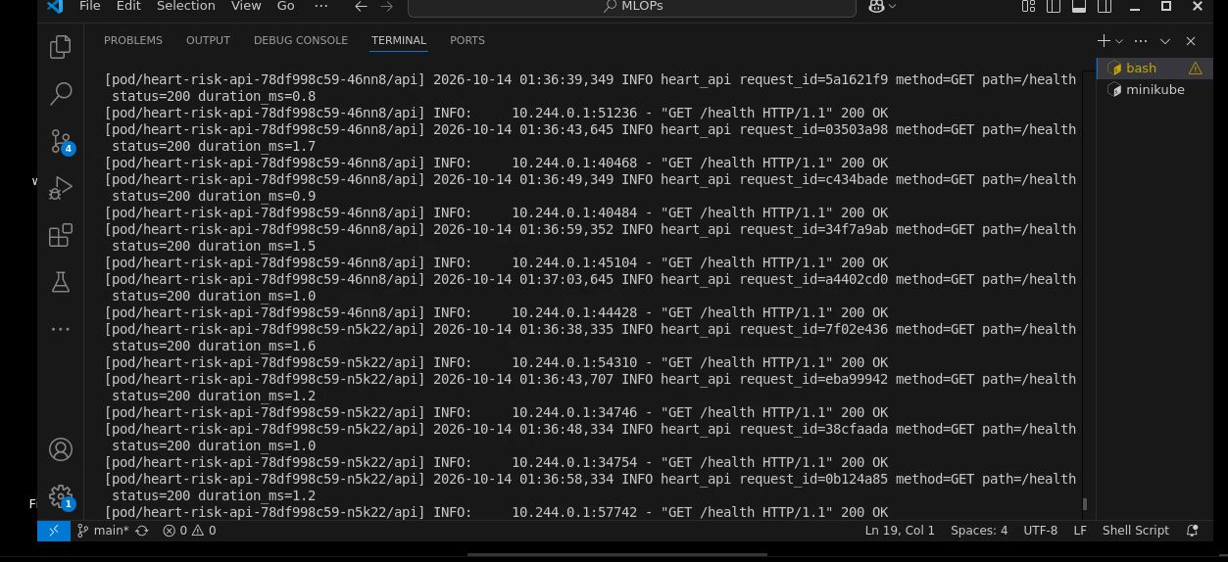  Figure 27: Per-pod request logs (kubectl logs) | 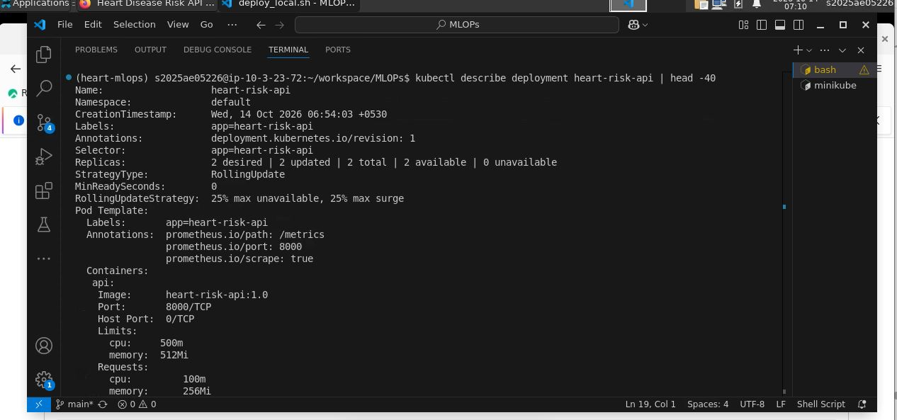  Figure 28: Deployment description (replicas and probes)
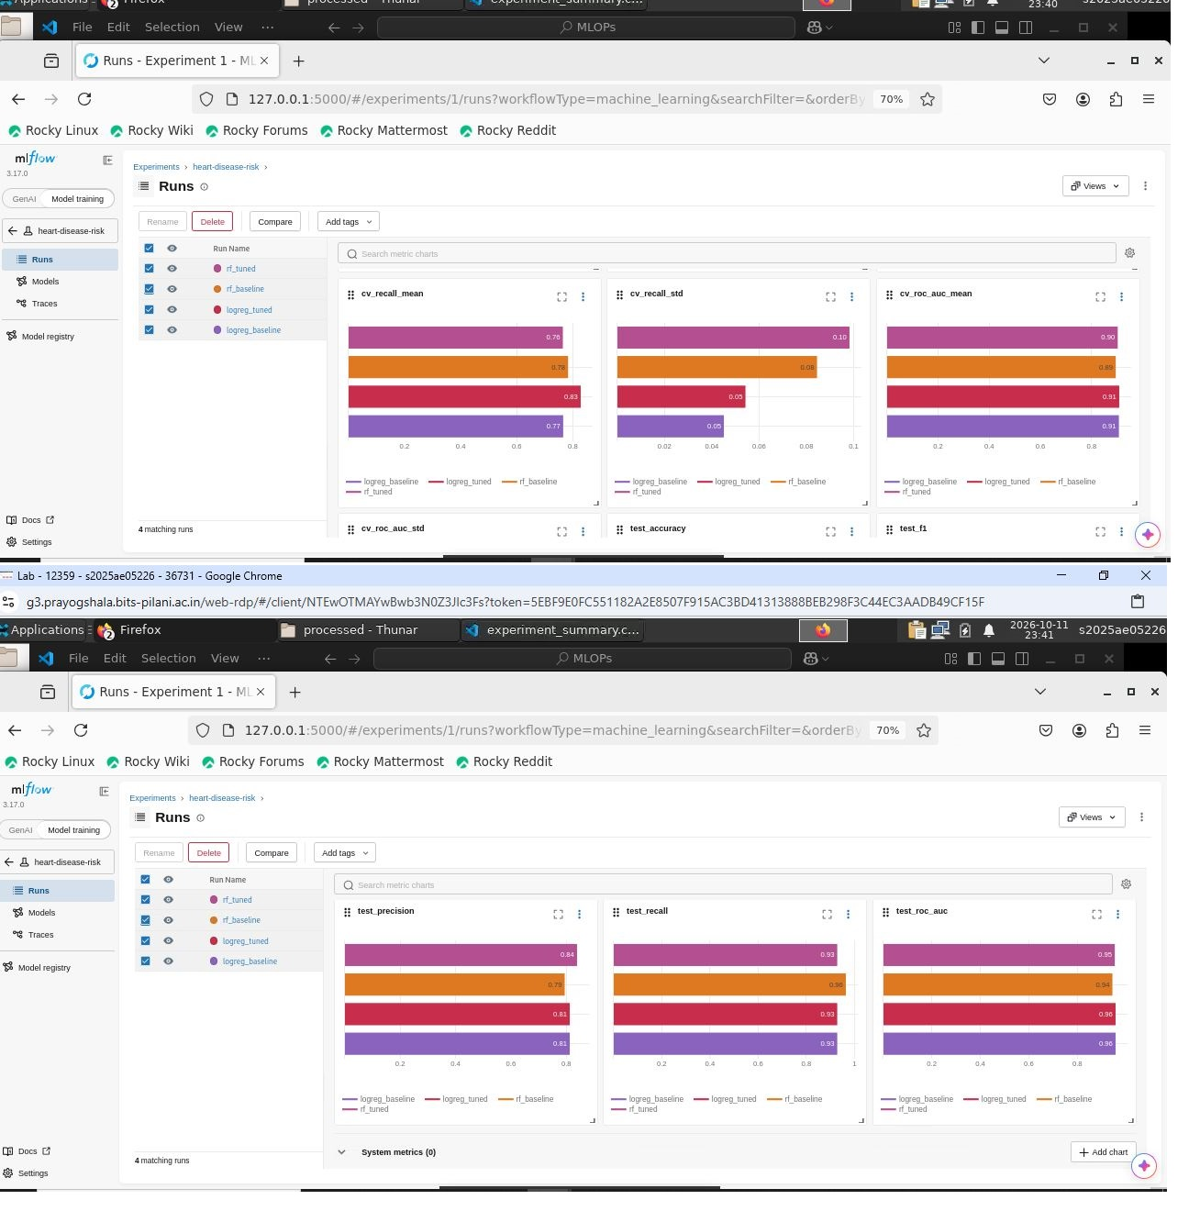  Figure 29: MLflow run comparison chart | 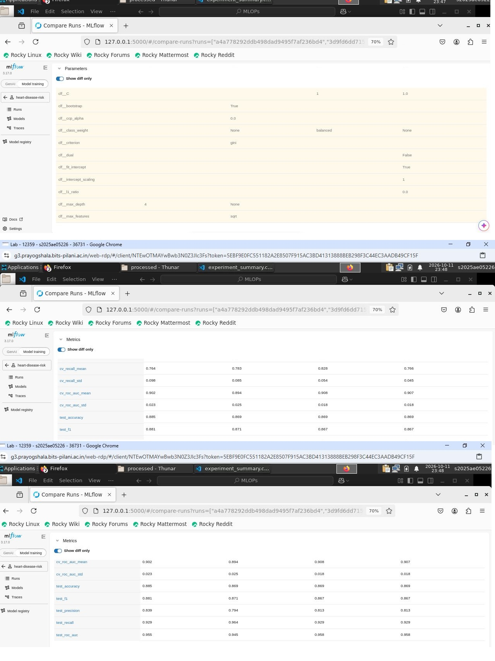  Figure 30: MLflow run comparison table
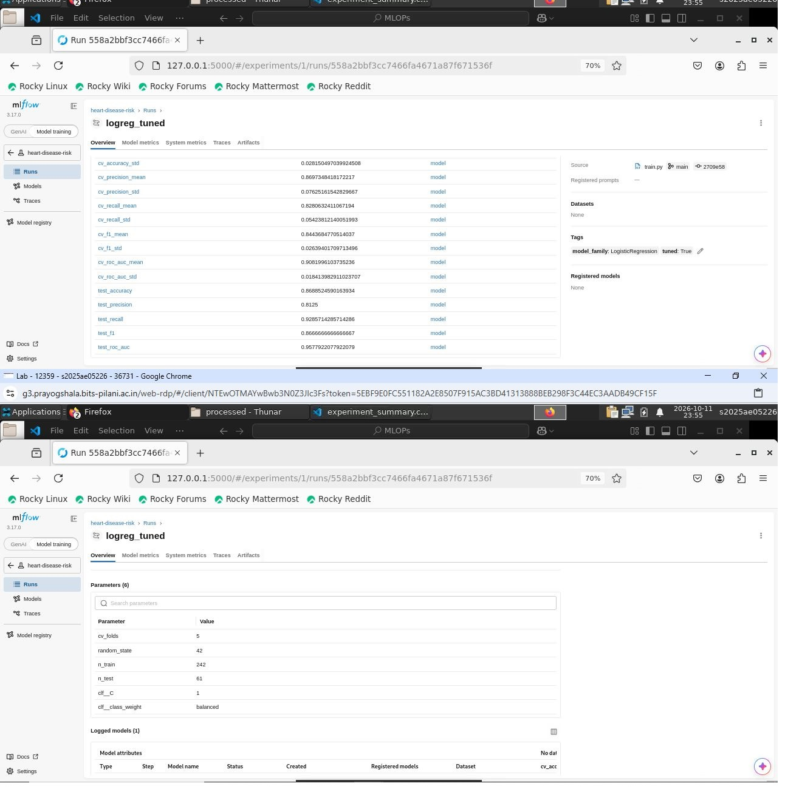  Figure 31: MLflow overview of the selected run | 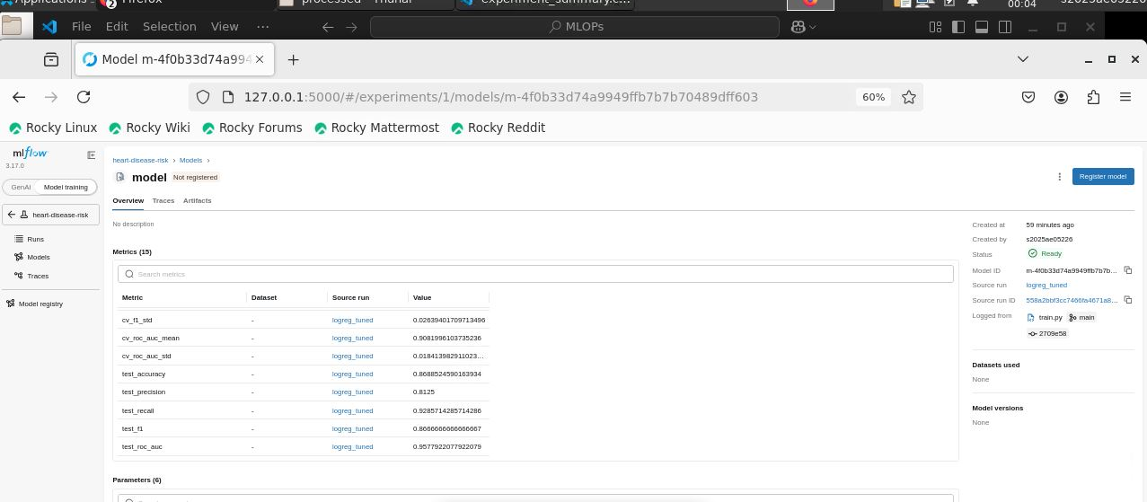  Figure 32: MLflow logged model
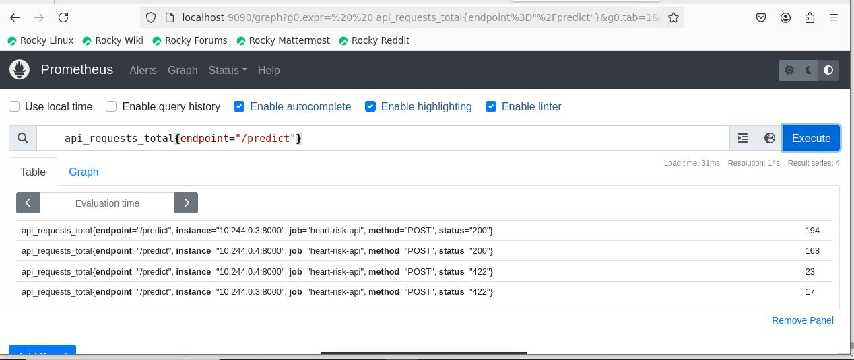  Figure 33: Prometheus query of api_requests_total | 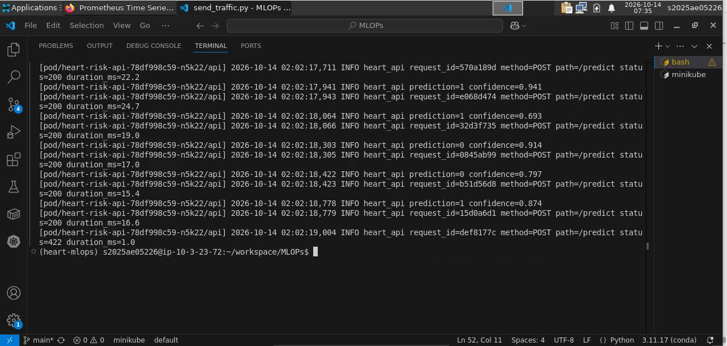  Figure 34: API request logs from the pods

