Product Table Created in Local DB:

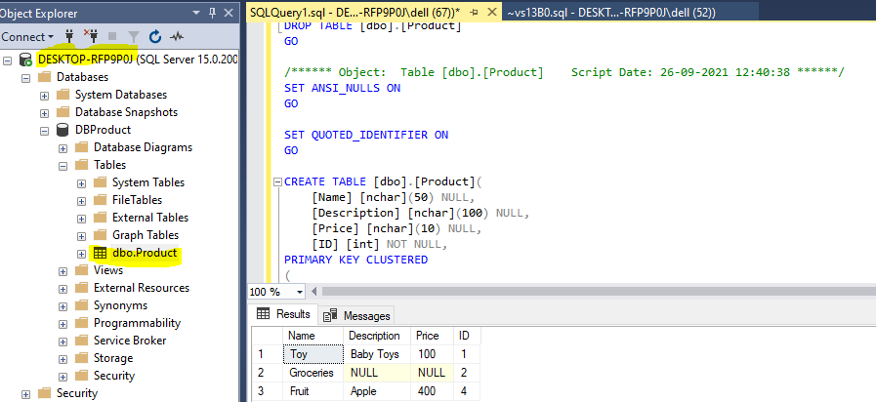

Table Creation Script:



API Methods are Unit tested with BDD:

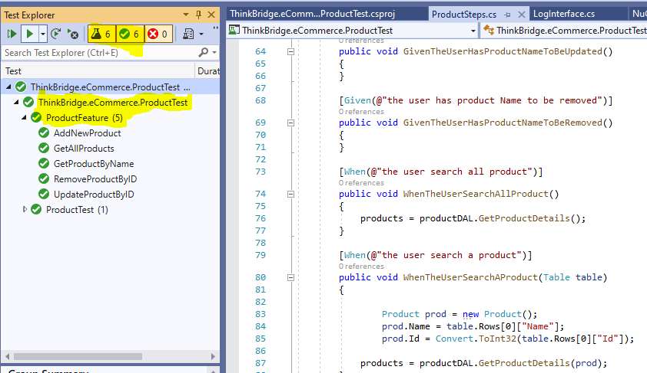

Features definition for Unit testing:

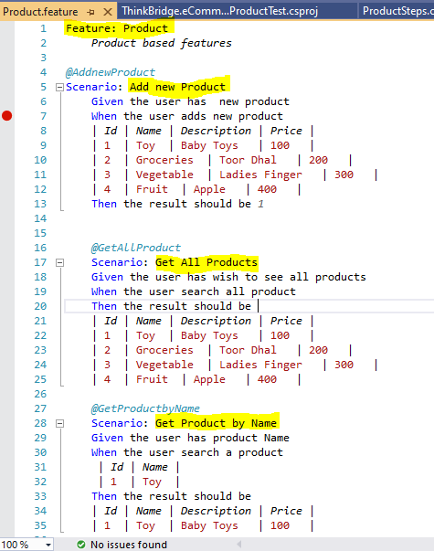

3 Projects Created in solution,

1. Entity Project – DAL
2. Web API Project - API Project
3. ProductTest – Test Project

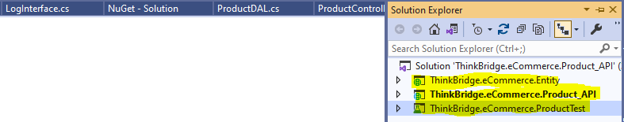

Logging implementation:

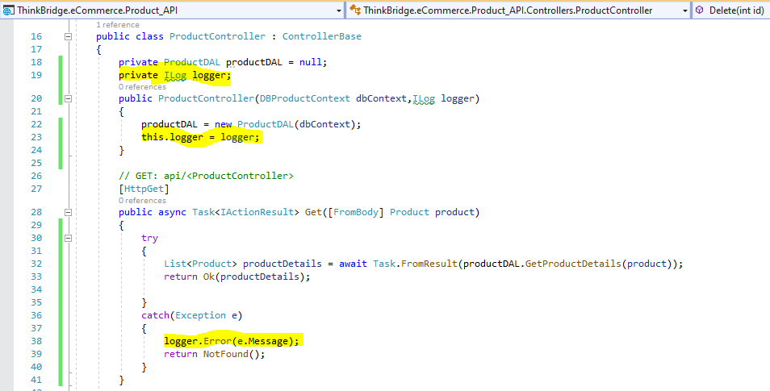

Logger Class, this class is also registered in Start-up’s class,

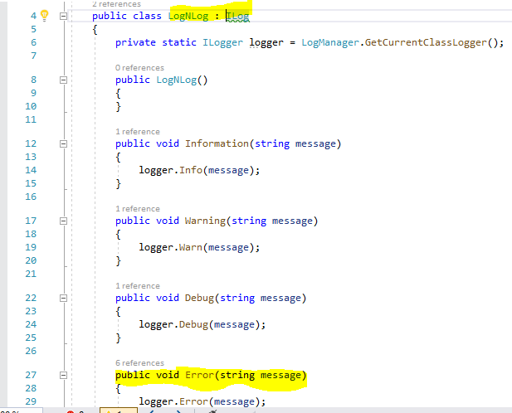

In case if you are running Unit Testing/API URL in your local machine, below steps needs to be followed,

1. Create table with attached script (*available in first page*)
2. Updated DB Server Name and DB Name in DBProductContext.cs (*#1*) & appsettings.json(*#2*) file (Screen Shots below)
3. Update log file path in nlog.config file(*#3*)
4. Local API URL - <http://localhost:32019/api/product/GetAllProducts> (*#4*)

*#1:*

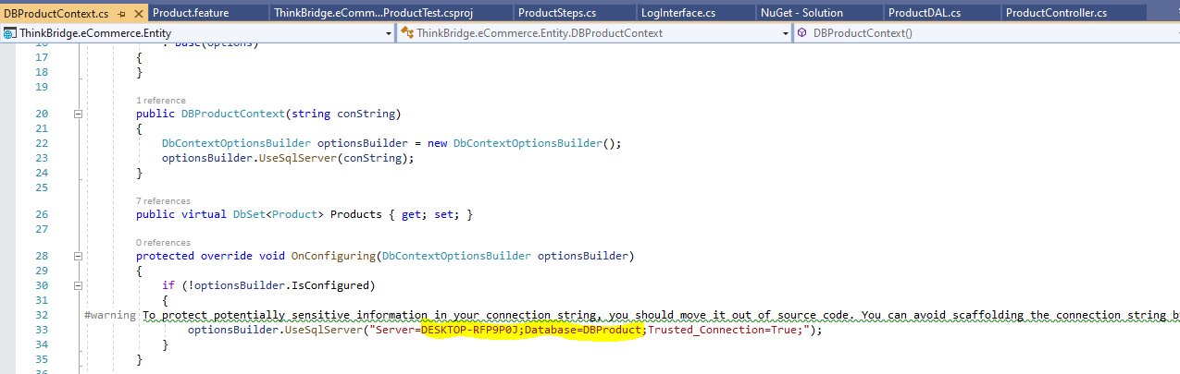

*#2:*

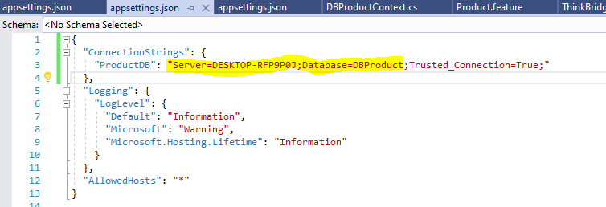

*#3:*

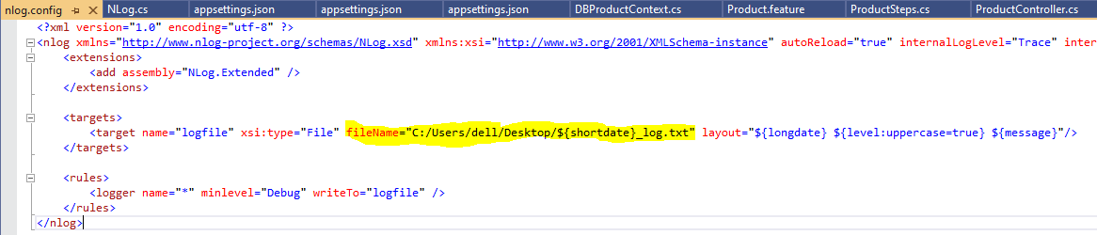

API result for a Get method (*#4*),

