

COMPUTER

PROJECT  
 IN C++

**$ PINE $**

**GAMING SOFTWARE**

**OUR PINE MEMBERS :**

* **ATHITHYA KUMAR N B**



* **BHARATH KUMAR R**
* **MAHADHARSAN R**
* **NAVEEN PRASHANNA G**



**NAME : . . . . . . . . . . . . . . . . . . . . . . . . . . . . . . . . . . . . . . .**

**CLASS : . . . . . . . . . . . . . . . . . . . . . . . . . . . . . . . . . .**

**SUBJECT : . . . . . . . . . . . . . . . . . . . . . . . . . . . . . . . . . .**

**REGISTRATION NO : . . . . . . . . . . . . . . . . . . . . . . . . . . . . . . . . . .**

**It is certified that this is a bonafide project work, done by the above mentioned student in the subject of computer science in the laboratory of JAWAHAR HIGHER SECONDARY SCHOOL, Neyveli.**

**Submitted for the practical examination held on _ _ _ _ _ _ _ _ _ _**

**INTERNAL EXAMINER EXTERNAL EXAM**

It is with real pleasure that I record my indebtness to our PRINCIPAL, VICE PRINCIPAL and STAFF MEMBERS for their counsel and guidance for the preparation of the project

I extend my sincere thanks to Mrs V.SUJATHA our computer science teacher for giving a lot of consideration and guidance in developing our project. The guidance she had been giving me from time to time had been great help and without which the completion of the project would have been difficult

**PAGE NO**

* **SYNOPSIS**
* **SYSTEM REQUIREMENTS**
* **CODING**
* **OUTPUT**
* **BIBLIOGRAPHY**

**Our project deals with Gaming platform with the exploitation of data files and built in functions available in C++.**

**This Program has been developed with the intention of giving the users a platform for entertainment and stress relief. The concept of classes and functions has been made use of in integrating the template of all the records of users.**

**Another added advantage of our program is, it is user friendly. The data are also secure considering the fact that only authorized persons ( with a password) get to access the stored records.**

**HARDWARE REQUIREMENTS :**

* Intel Pentium II Processor or higher
* 2 GB of RAM or higher
* 15” CRT/TFT/LCD color monitor
* 102 keys keyboard
* Mouse

**SOFTWARE REQUIREMENTS :**

* Disk Operating System
* Turbo C++

#include<iostream.h>

#include<stdlib.h>

#include<string.h>

#include<conio.h>

#include<graphics.h>

#include<fstream.h>

#include<process.h>

#include<dos.h>

#include<time.h>

char chpass[32];

int p[2][2];

int i,j;

int o;

int score1=0;

int n2,n1,n3;

const int MAXLENGTH=80;

const int MAX_TRIES=5;

const int MAXROW=7;

int letterFill (char, char[], char[]);

void initUnknown (char[], char[]);

void checkid(char*);

void checkeid(char*);

void totalscore(int);

void coan();

void guess();

void norush();

void d_lay();

void logout();

class get_info

{ public:

char name[32];

char userid[32];

char eid[64];

char pass[32];

int tscore;

get_info()

{tscore=0;}

}I;

void create()

{ bh:

cleardevice();

gotoxy(1,1);

fstream f1("datb.dat",ios::binary|ios::in|ios::out|ios::app);

cout<<"\nhttps://www.ThePine.com/createacc.php";

cout<<"\n\n\n\t\t\t\tCreate a account";

cout<<"\n\n\t\t Name :\t";

cin>>I.name;

cout<<"\n\n\t\t Username :\t";

cin>>I.userid;

checkid(I.userid);

cout<<"\n\n\t\t E-Mail :\t";

cin>>I.eid;

checkeid(I.eid);

cout<<"\n\n\t\t Password :\t";

cin>>I.pass;

cout<<"\n\n\t\t Re-enter Password :\t";

cin>>chpass;

if(strcmp(I.pass,chpass)!=0)

{

cout<<"\n\n\t\tPasswords do not match!!!";

cout<<"\n\n\t\tSorry, Try again.";

delay(2000);

goto bh;

}

f1.write((char*)&I,sizeof(I));

f1.close();

d_lay();

cleardevice();

gotoxy(1,1);

cout<<"\n\n\n\n\n\n\tWe assure you that your details will never be shared...";

delay(2000);

cout<<"\n\n\n\tThank you for Signing up!";

delay(2000);

cout<<"\n\n\n\tEnjoy Pine Gaming experience";

}

void checkid(char c[32])

{

get_info K;

ifstream f2("datb.dat",ios::binary);

while(f2.read((char*)&K,sizeof(K)))

if(strcmp(K.userid,c)==0)

{

cout<<"\n\n\t\tThe ID Is Already In Use!";

delay(2000);

cout<<"\n\n\n\t\tSorry, Try again.";

create();

}

f2.close();

}

void checkeid(char c[64])

{

get_info F;

ifstream f3("datb.dat",ios::binary);

while(f3.read((char*)&F,sizeof(F)))

if(strcmp(F.eid,c)==0)

{

cout<<"\n\n\t\tThe E-Mail ID Is Already In Use!";

delay(2000);

cout<<"\n\n\n\t\tSorry, Try again.";

create();

}

f3.close();

}

void begin()

{

int a=DETECT,b;

initgraph(&a,&b,"..\\bgi");

delay(250);

setcolor(GREEN);

line(0,0,7000,0);

line(0,1,7000,1);

line(0,2,7000,2);

delay(250);

line(0,0,0,7000);

line(1,0,1,7000);

line(2,0,2,7000);

delay(250);

line(639,0,639,500);

line(637,0,637,500);

line(638,0,638,500);

delay(250);

line(0,478,700,478);

line(0,480,700,480);

line(0,479,700,479);

line(0,477,700,477);

delay(1000);

setcolor(RED);

settextstyle(BOLD_FONT,HORIZ_DIR,4);

outtextxy(100,50,"$P");

delay(500);

outtextxy(155,50,"I");

delay(500);

outtextxy(170,50,"N");

delay(500);

outtextxy(200,50,"E$");

delay(500);

settextstyle(DEFAULT_FONT,HORIZ_DIR,2);

outtextxy(220,175," presents");

delay(750);

int i=0;

for(i;i<=3;i++)

{

int a=1;

delay(300);

if(a%2!=0)

{

setcolor(RED);

settextstyle(DEFAULT_FONT,HORIZ_DIR,1+i);

outtextxy(10,270,"a Gaming Software");

a++;

}

if(a%2==0)

{

setcolor(BLACK);

settextstyle(DEFAULT_FONT,HORIZ_DIR,i);

outtextxy(10,270,"a Gaming Software");

a++;

}

} cout<<"\n\n\n\n\n\n\n\n\n\n\n\n\n\n\n\n\n\n\n\n\n\n\n\n\n\n\n\n \t\t PRESS ANY KEY TO CONTINUE....";

getch();

closegraph();

}

void menu()

{

int c;

char cr;

int gd=DETECT,gm;

men:

initgraph(&gd,&gm,"..//bgi");

cleardevice();

gotoxy(1,1);

setcolor(GREEN);

settextstyle(DEFAULT_FONT,HORIZ_DIR,2);

outtextxy(100,100," * MENU:");

gotoxy(60,5);

cout<<"SCORE : "<<I.tscore;

cout<<"\n\n\n\n\n 1. Guessing game ";

cout<<"\n\n 2. Analyser ";

cout<<"\n\n 3. Number rush ";

cout<<"\n\n 4. Credits ";

cout<<"\n\n 5. Logout ";

cout<<"\n\n\n\n Enter your choice... : " ;

cin>>c;

switch(c)

{case 2: back1:

cleardevice();

gotoxy(1,1);

coan();

// cleardevice();

gotoxy(1,1);

cout<<"Do you want to play again...?";

cin>>cr;

if(cr=='y'||cr=='Y')

{ goto back1;

}

else

{goto men;

}

case 1: back2:

cleardevice();

gotoxy(1,1);

guess();

cleardevice();

gotoxy(1,1);

cout<<"Do you want to play again...?";

cin>>cr;

if(cr=='y'||cr=='Y')

{ goto back2;

}

else

{goto men;

}

case 3: back3:

cleardevice();

gotoxy(1,1);

norush();

cleardevice();

gotoxy(1,1);

cout<<"Do you want to play again...?";

cin>>cr;

if(cr=='y'||cr=='Y')

{ goto back3;

}

else

{goto men;

}

case 4: cleardevice();

gotoxy(1,1);

cout<<"\n\n***********************************************************************";

cout<<"\n\n\n\n\t\t\tThis console platform was developed by PINE TEAM in association with Steam.";

cout<<"\n\t\t\tIt provides entertainment for people of all ages.";

cout<<"\n\t\t\tIt enhances the logical thinking of the user,";

cout<<"\n\t\t\tdeveloping thinking skills and speed from all angles";

cout<<"\n\t\t\tIt coordinates our hands and our mind.";

cout<<"\n\n\n\n\t\t\t*** PINE TEAM : *** ";

cout<<"\n\t\t\t### ATHITHYA KUMAR N B ";

cout<<"\n\t\t\t### BHARATH KUMAR R ";

cout<<"\n\t\t\t### MAHADHARSAN R ";

cout<<"\n\t\t\t### NAVEEN PRASHANNA G ";

cout<<"\n\n\n\n\n*****************************************************************";

delay(1500);

cout<<"\n\n\n\n\n\n\n\n\n\n\n\n\t\t\tPress any key to go to menu...";

cin>>cr;

goto men;

case 5: cleardevice();

gotoxy(1,1);

cout<<"\n\n\n\n\n\n\t\t\tWe hope to see you again";

delay(1500);

logout();

default:cleardevice();

gotoxy(1,1);

cout<<"\n\n\n\n\t\t Sorry, You have entered a Wrong Choice!";

cout<<"\n\n\t\t\t Please try again";

delay(2000);

goto men;

}

}

void totalscore(int score)

{ fstream f4("datb.dat",ios::binary|ios::out|ios::in);

int a;

get_info u;

while(!f4.eof())

{a=f4.tellg();

f4.read((char*)&u,sizeof(u));

if(strcmp(u.eid,I.eid)==0)

{I.tscore+=score;

f4.seekp(a);

f4.write((char*)&I,sizeof(I));

}

}

f4.close();

}

void coan()

{ clearviewport();

int x1=150,y1=200;

int x2=150,y2=250;

int x3=200,y3=200;

int x4=200,y4=250;

int i=0,j=0;

char ch;

int time=0,score=0;

int p=0,q=0;

int gd=DETECT,gm;

initgraph(&gd,&gm,"..//bgi");

char ch1;

setcolor(GREEN);

settextstyle(DEFAULT_FONT,HORIZ_DIR,2);

outtextxy(50,50," Welcome to");

outtextxy(150,100," coordination analyser");

delay(500);

cout<<"\n\n\n\n\n\n\n\n\n\n";

cout<<"$ BRIEF INTRODUCTION:";

cout<<"\n This is not just a game actually...!!";

cout<<"\n This will check your coordination power between your hand, ";

cout<<"\n eye and your brain...";

delay(500);

cout<<"\n\n\n$ HOW TO PLAY :";

cout<<"\n * This game will end within few seconds after the start";

cout<<"\n * you must be able to keep your tile within the boundary";

cout<<"\n * In every 1 second speed is increased twice, If you hit the ";

cout<<"\n boundary \"you are out...!!\" ";

cout<<"\n\n\n\n\n PRESS y(or)Y TO CONTINUE......";

cin>>ch1;

if(ch1=='y'||ch1=='Y')

{

for(long int a=0;a>=0;a++)

{

setcolor(CYAN);

line(10,10,10,470);

line(10,10,630,10);

line(630,10,630,470);

line(10,470,630,470);

setcolor(RED);

setcolor(BLUE);

line(x1,y1,x2,y2);

line(x1,y1,x3,y3);

line(x3,y3,x4,y4);

line(x2,y2,x4,y4);

setcolor(RED);

circle(((x1+x2)/2),((y1+y2)/2),10);

circle(((x1+x2)/2),((y1+y2)/2),5);

circle(((x3+x4)/2),((y3+y4)/2),5);

circle(((x1+x3)/2),((y1+y3)/2),5);

circle(((x2+x4)/2),((y4+y2)/2),5);

circle(((x3+x4)/2),((y3+y4)/2),10);

circle(((x1+x3)/2),((y1+y3)/2),10);

circle(((x2+x4)/2),((y4+y2)/2),10);

if(kbhit())

{

ch=getch();

if(ch=='w'|| ch==72 || ch=='W')

{

i=0;

j=-5;

}

else if(ch=='s' || ch==80 || ch=='S')

{

i=0;

j=5;

}

else if(ch=='a'|| ch==75 || ch=='A')

{

i=-5;

j=0;

}

else if(ch=='d' || ch==77 || ch=='D')

{

i=5;

j=0;

}

if(ch==27)

{exit(0);}

}

x1=x1+i; x2=x2+i;x3=x3+i; x4=x4+i;

y1=y1+j; y2=y2+j;y3=y3+j; y4=y4+j;

if(a%100==0)

{

time=time+1;

}

if(a%10000==0)

{

score=score+5;

}

if(x1==15 || x4==625 || y1==15 || y4==465)

{

cleardevice();

delay(100);

setcolor(YELLOW);

settextstyle(DEFAULT_FONT,HORIZ_DIR,3);

outtextxy(120,200," YOU ARE OUT !! ");

textcolor(10);

textbackground(0);

cout<<endl<<"total time played is :";

cout<<" "<<time<<":00";

cout<<endl<<"Your score is :";

cout<<" "<<score;

delay(1500);

totalscore(score);

break;

}

if(a%25==0&&q>=5)

{

p=p+2;

}

q=50-p;

delay(q);

cleardevice();

}

}

closegraph();

}

void guess()

{ char unknown [MAXLENGTH];

char letter;

int score3=0;

int num_of_wrong_guesses=0;

char word[MAXLENGTH];

char words[][MAXLENGTH] =

{

"india",

"pakistan",

"nepal",

"malaysia",

"philippines",

"australia",

"iran",

"ethiopia",

"oman",

"indonesia"

};

randomize();

int n=random(10);

strcpy(word,words[n]);

initUnknown(word, unknown);

char ch;

int gd=DETECT,gm;

initgraph(&gd,&gm,"..//bgi");

setcolor(GREEN);

settextstyle(DEFAULT_FONT,HORIZ_DIR,2);

outtextxy(50,50," Welcome to");

outtextxy(150,100," \"GUESS A COUNTRY NAME\" ");

setcolor(BLACK);

cout<<"\n\n\n\n\n\n\n\n\n$ RULES : ";

cout << "\n\n * Each letter is represented by a star.";

cout << "\n\n * You have to type only one letter in one try";

cout << "\n\nYou have " << MAX_TRIES << " tries to try and guess the word.";

cout << "\n~~~~~~~~~~~~~~~~~~~~~~~~~~~~~~~~~~~~~~~~~~~~";

cout<<"\n\n\n\n\n PRESS y (or) Y TO CONTINUE.....";

cin>>ch;

if(ch=='y'||ch=='Y')

{

cleardevice();

gotoxy(1,1);

while (num_of_wrong_guesses < MAX_TRIES)

{

cout << "\n\n" << unknown;

cout << "\n\nGuess a letter: ";

cin >> letter;

if (letterFill(letter, word, unknown)==0)

{

cout << endl << "Whoops! That letter isn't in there!" << endl;

num_of_wrong_guesses++;

}

else

{

cout << endl << "You found a letter! Isn't that exciting!" << endl;

}

cout << "You have " << MAX_TRIES - num_of_wrong_guesses;

cout << " guesses left." << endl;

if (strcmp(word, unknown) == 0)

{

cout << word << endl;

cout << " Yeah! You got it!";

score3=MAX_TRIES - num_of_wrong_guesses;

totalscore(score3);

break;

}

}

if(num_of_wrong_guesses == MAX_TRIES)

{

cout << "\nSorry, you lose...you've been hanged." << endl;

cout << "The word was : " << word << endl;

}

}

getch();

}

int letterFill (char guess, char secretword[], char guessword[])

{

int i;

int matches=0;

for (i = 0; secretword[i]!='\0'; i++)

{

if (guess == guessword[i])

return 0;

if (guess == secretword[i])

{

guessword[i] = guess;

matches++;

}

}

return matches;

}

void initUnknown (char word[], char unknown[])

{

int i;

int length = strlen(word);

for (i = 0; i < length; i++)

unknown[i]='*';

unknown[i]='\0';

}

void disp()

{for(i=0;i<2;i++)

{ gotoxy(34,5+(i*3));

for(j=0;j<2;j++)

{if(j==1)

{gotoxy(42,5+(i*3));

cout<<p[i][j];

}

else

cout<<p[i][j];

}

cout<<'\n';

}

setcolor(6);

settextstyle(1,HORIZ_DIR,2);

outtextxy(10,72,"Score:");

gotoxy(10,6);

cout<<score1;

setcolor(2);

rectangle(260,56,290,86);

rectangle(324,103,354,133);

rectangle(260,103,290,133);

rectangle(324,56,354,86);

rectangle(259,55,291,87);

rectangle(323,102,355,134);

rectangle(259,102,291,134);

rectangle(323,55,355,87);

rectangle(0,0,630,460);

rectangle(1,1,629,459);

rectangle(2,2,628,458);

setcolor(15);

line(253,192,283,192);

line(293,192,323,192);

line(333,192,363,192);

setcolor(4);

switch(o)

{case 1:settextstyle(0,HORIZ_DIR,1);

outtextxy(286,181,"+");

outtextxy(326,181,"=");

settextstyle(0,HORIZ_DIR,2);

outtextxy(302,87,"+");

break;

case 2:settextstyle(0,HORIZ_DIR,1);

outtextxy(286,181,"-");

outtextxy(326,181,"=");

settextstyle(0,HORIZ_DIR,2);

outtextxy(302,87,"-");

break;

case 3:settextstyle(0,HORIZ_DIR,1);

outtextxy(286,181,"*");

outtextxy(326,181,"=");

settextstyle(0,HORIZ_DIR,1);

outtextxy(304,92,"*");

break;

case 4:settextstyle(0,HORIZ_DIR,1);

outtextxy(286,181,"/");

outtextxy(326,181,"=");

settextstyle(0,HORIZ_DIR,2);

outtextxy(302,87,"-");

outtextxy(302,86,":");

break;

}

}

void norush()

{ char ch3;

int gd=DETECT,gm;

initgraph(&gd,&gm,"..//bgi");

setcolor(GREEN);

settextstyle(DEFAULT_FONT,HORIZ_DIR,2);

outtextxy(50,50," Welcome to");

outtextxy(150,100," NUMBER RUSH ");

cout<<"\n\n\n\n\n\n\n\n $INSTRUCTION: ";

cout<<"\n * You have four numbers before you " ;

cout<<"\n * You also have an operator ";

cout<<"\n * You only have 60 seconds to form the right equation..";

cout<<"\n * Each correct equation formed will add 2 seconds ...";

cout<<"\n\n\n\n\n PRESS y (or) Y TO CONTINUE.....";

cin>>ch3;

if(ch3=='y'||ch3=='Y')

{

class sum

{

public:

int n,a,b,c,d,o;

}s;

clrscr();

randomize();

score1=0;

int r;

int bonus=0;

int x=-100,y=-100,z=-100,z1;

long t1;

time_t t=time(0);

t1=t;

int gd=DETECT,gm;

initgraph(&gd,&gm,"C:\\TC\\BGI");

ifstream f("rush.txt",ios::in);

while((t-t1)<30+bonus)

{ r=random(1)+1;

while(!f.eof())

{f.read((char*)&s,sizeof(s));

if(r==s.n)

{p[0][0]=s.a;

p[0][1]=s.b;

p[1][0]=s.c;

p[1][1]=s.d;

o=s.o;

f.seekg(0);

break;

}

}

while((t-t1)<30+bonus) //2nd while

{

if(x==-100)

{ disp();

gotoxy(34,12);

cin>>x;

if(x!=p[0][0]&&x!=p[0][1]&&x!=p[1][0]&&x!=p[1][1])

{x=-100;

cleardevice();

gotoxy(3,14);

cout<<"Enter the nos. from the above set...";

}

}

else

{ if(y==-100)

{ cleardevice();

h:disp();

gotoxy(34,12);

cout<<x;

gotoxy(39,12);

cin>>y;

if(y!=p[0][0]&&y!=p[0][1]&&y!=p[1][0]&&y!=p[1][1])

{ y=-100;

cleardevice();

gotoxy(3,14);

cout<<"Enter the nos. from the above set...";

goto h;

}

}

else

{ cleardevice();

k:disp();

gotoxy(34,12);

cout<<x;

gotoxy(39,12);

cout<<y;

gotoxy(44,12);

cin>>z;

if(z!=p[0][0]&&z!=p[0][1]&&z!=p[1][0]&&z!=p[1][1])

{ z=-100;

cleardevice();

gotoxy(3,14);

cout<<"Enter the nos. from the above set...";

goto k;

}

}

}

if(x!=-100&&y!=-100&&z!=-100)

{ switch(o)

{case 1:z1=x+y;

break;

case 2:z1=x-y;

break;

case 3:z1=x*y;

break;

case 4:z1=x/y;

break;

}

if(z1==z)

{ score1++;

bonus+=2;

t=time(0);

break;

}

else

{ cleardevice();

disp();

gotoxy(34,12);

cout<<x;

gotoxy(39,12);

cout<<y;

gotoxy(44,12);

cout<<z;

gotoxy(3,14);

cout<<"Sorry, Wrong. Please try again!";

x=-100;

y=-100;

z=-100;

delay(1000);

cleardevice();

}

}

t=time(0);

}

cleardevice();

x=-100;

y=-100;

z=-100;

}

setcolor(2);

rectangle(0,0,630,460);

rectangle(1,1,629,459);

rectangle(2,2,628,458);

setcolor(6);

settextstyle(2,HORIZ_DIR,7);

outtextxy(265,151,"TIME OUT");

outtextxy(215,169,"Your score is :");

gotoxy(50,12);

cout<<score1;

delay(2000);

totalscore(score1);

f.close();

}

}

void d_lay()

{

cleardevice();

gotoxy(1,1);

cout<<"\n\n\n\n\n\n\n\n\n\n\t\t\tLoading ";

for(int x=0;x<20;x++)

{

delay(100);

cout<<'\4' ;

}

cleardevice();

gotoxy(1,1);

}

//..................................................................................

void logout()

{

int a=DETECT,b;

initgraph(&a,&b,"..\\bgi");

for(int i=160;i<450;i++)

{

settextstyle(BOLD_FONT,HORIZ_DIR,2);

outtextxy(150,110,"LOGGING OUT.....");

settextstyle(DEFAULT_FONT,HORIZ_DIR,2);

outtextxy(120,300,"Thank you .... Visit us soon.....");

setcolor(2);

rectangle(160,210,450,225);

rectangle(160,210,i,225);

delay(3);

}

delay(1000);

closegraph();

exit(0);

}

//.................................................................................

void main()

{ clrscr();

int l;

char c;

begin();

char id[64],passwd[32];

fstream f5("datb.dat",ios::binary|ios::out|ios::in|ios::app);

int a=DETECT,b;

initgraph(&a,&b,"..\\bgi");

start:

cout<<"\n\n\n\n\n\t https://www.ThePine.com/login.php ";

setcolor(GREEN);

settextstyle(DEFAULT_FONT,HORIZ_DIR,3);

outtextxy(200,50,"$ PINE $");

cout<<"\n\n\n\n\n\n\n\t\t 1. Create an account - Signup ";

cout<<"\n\n\t\t 2. Already have an account - Login ";

cout<<"\n\n\n\n\n\t\t Enter your choice: ";

cin>>l;

switch(l)

{ case 1 :signup:

create();

cleardevice();

gotoxy(1,1);

cout<<"\n\n\n\n\t\t\tWelcome "<<I.name<<"!";

delay(1500);

f5.close();

menu();

break;

case 2 :login:

cleardevice();

gotoxy(1,1);

cout<<"\nhttps://www.ThePine.com/login.php";

cout<<"\n\n\n\n\t\tEnter Your E-Mail ID: ";

cin>>id;

while(!f5.eof())

{ f5.read((char*)&I,sizeof(I));

if(strcmp(id,I.eid)==0)

{ cout<<"\n\n\t\tEnter Your Password: ";

cin>>passwd;

if(strcmp(passwd,I.pass)==0)

{ d_lay();

cleardevice();

gotoxy(1,1);

cout<<"\n\n\n\n\t\t\tWelcome "<<I.name<<"!";

delay(2000);

f5.close();

menu();

}

else

{ d_lay();

cleardevice();

gotoxy(1,1);

cout<<"\n\n\n\n\t\t\tIncorrect PASSWORD";

goto login;

}

}

}

cout<<"\n\n\n\n\t\t\tEmail ID doesn't exist...";

cout<<"\n\n\n\n\t\t\tDo you want to create an account? (y/n) :";

cin>>c;

if(c=='y'||c=='Y')

goto signup;

else

{cleardevice();

f5.close();

exit(0);

}

break;

default:cout<<"\n\n\n\t\t\tSorry, wrong choice!! ";

delay(1000);

cout<<"\n\n\t\t\tTry again! ";

delay(600);

goto start;

}

}

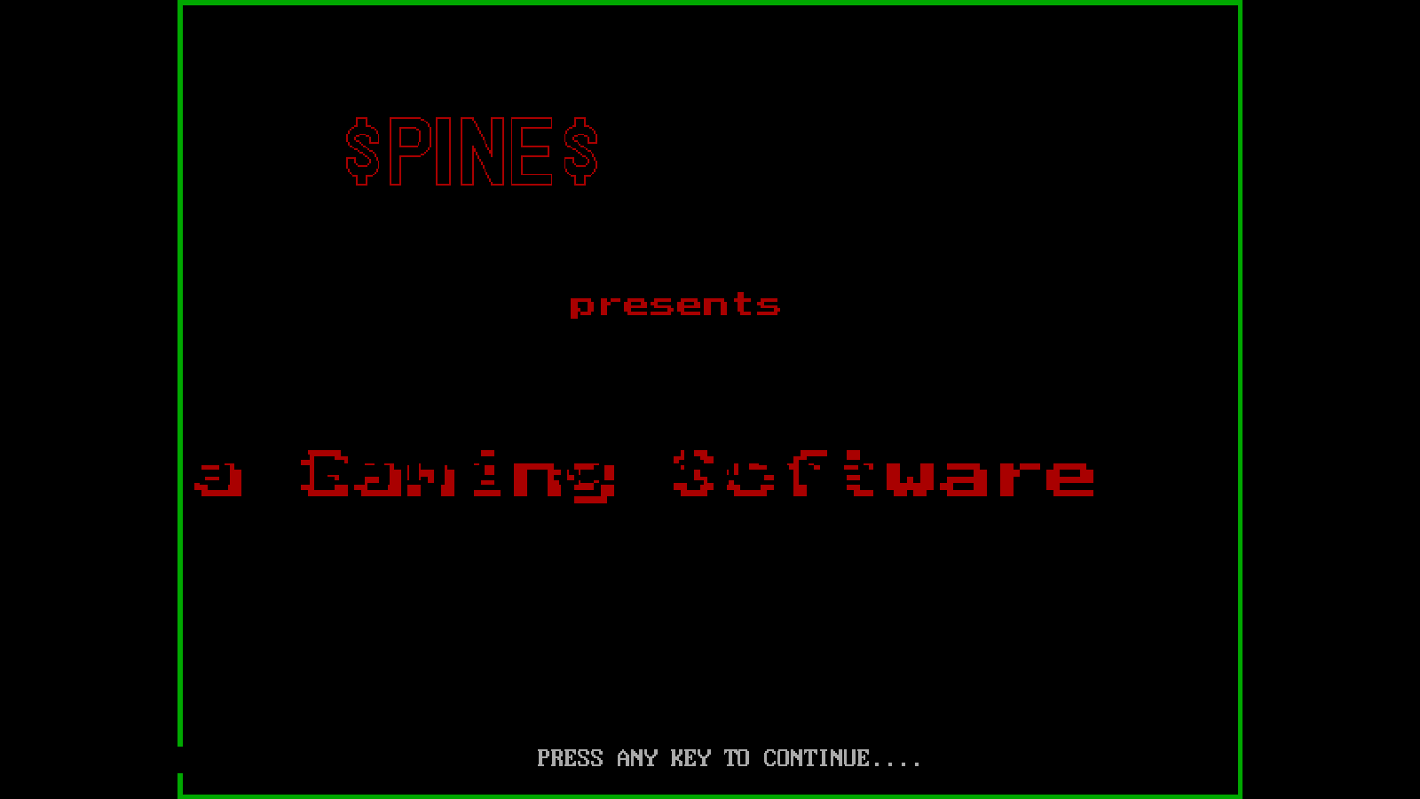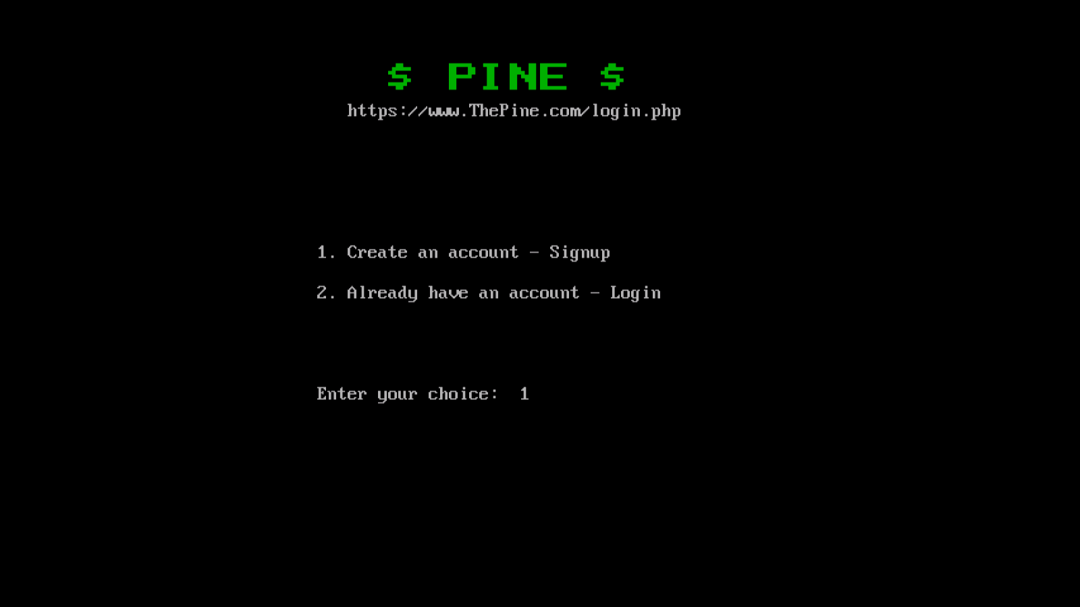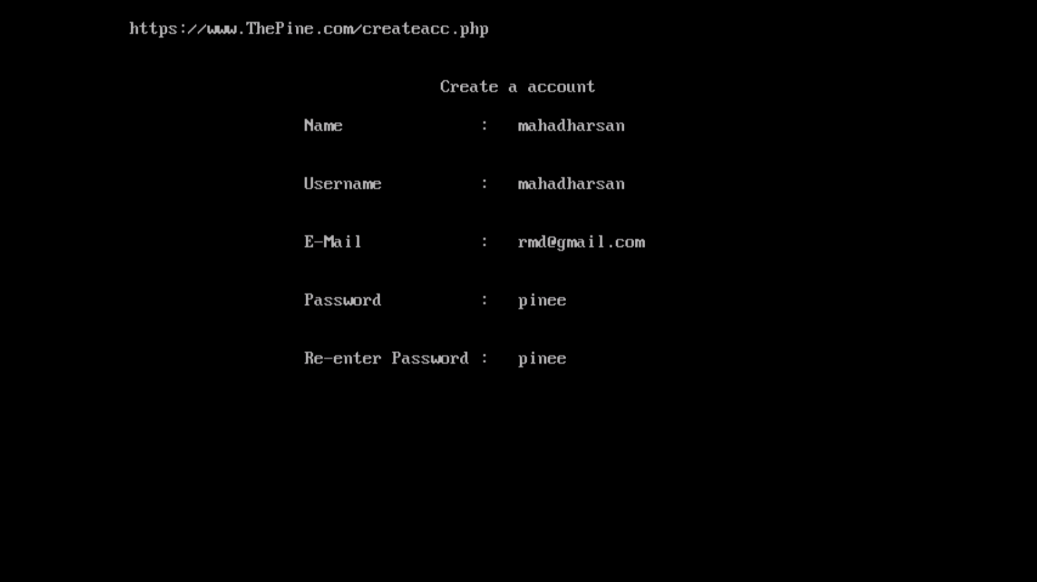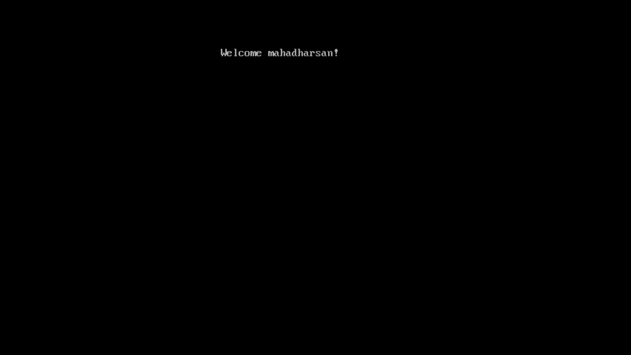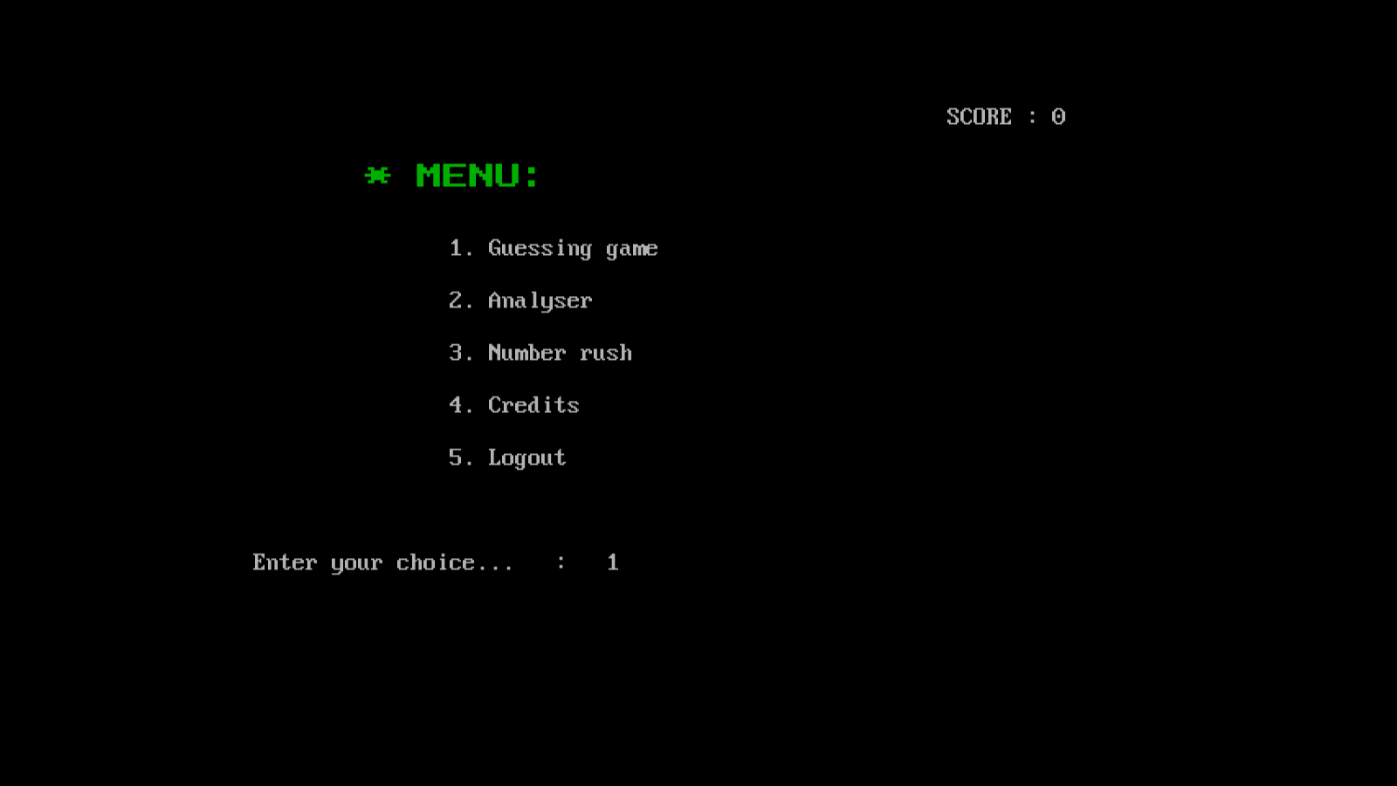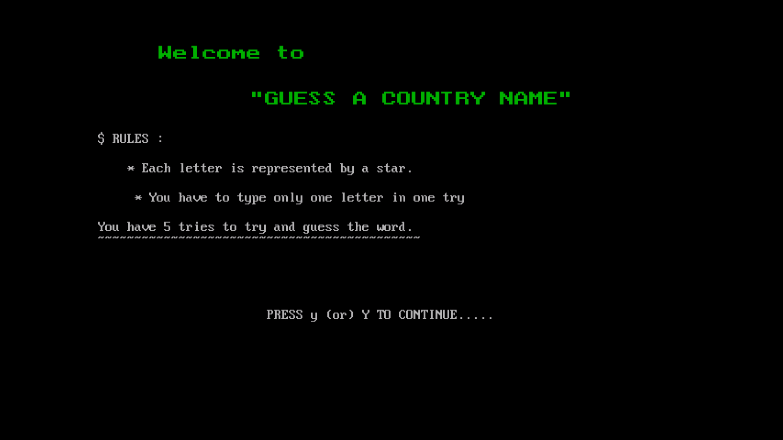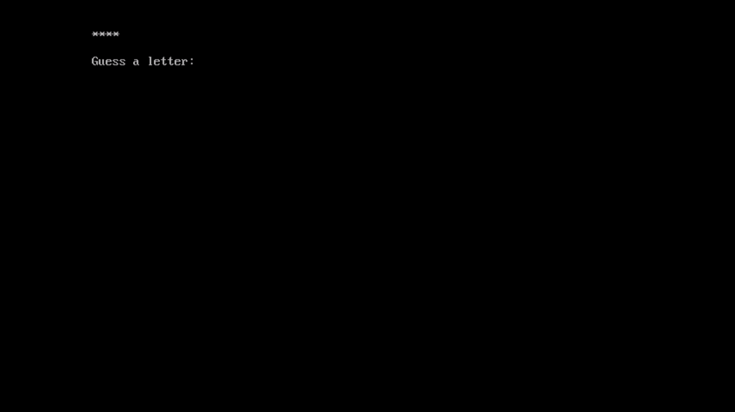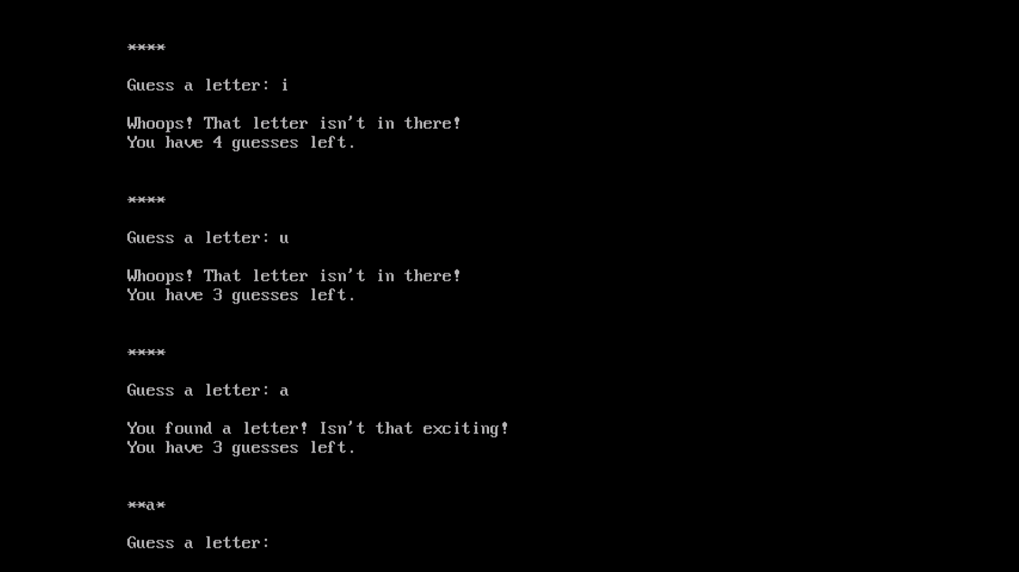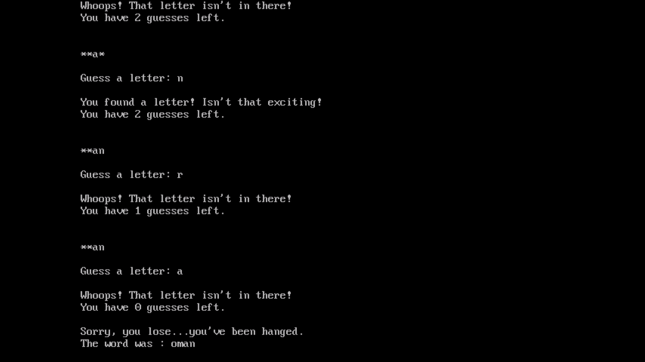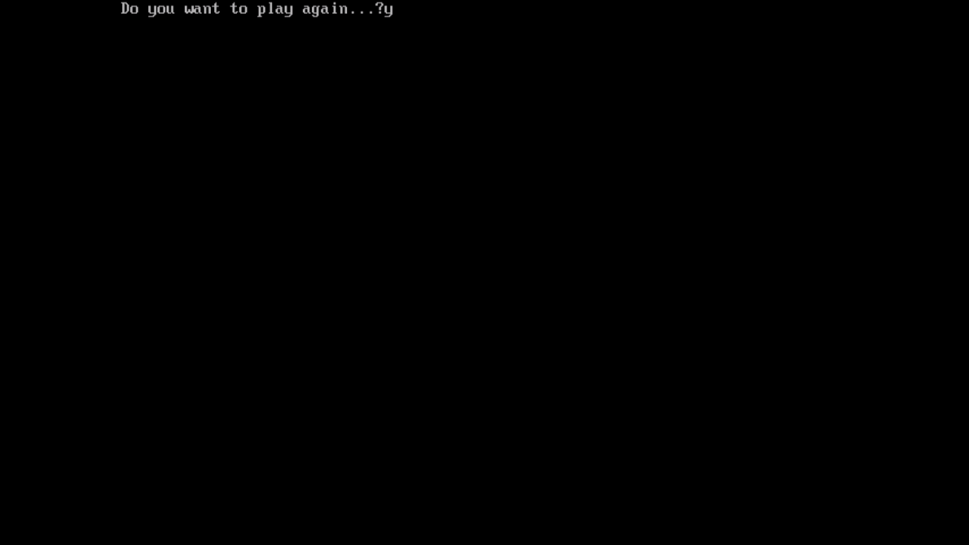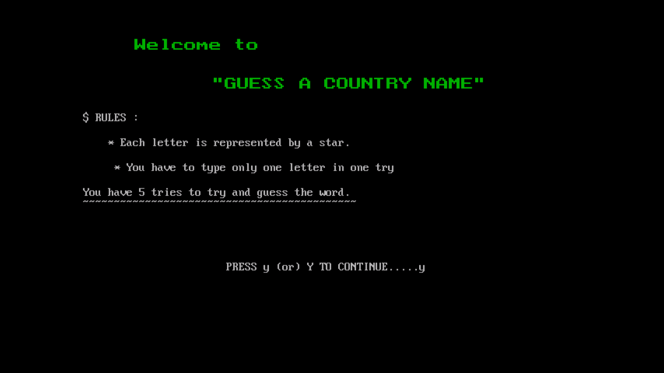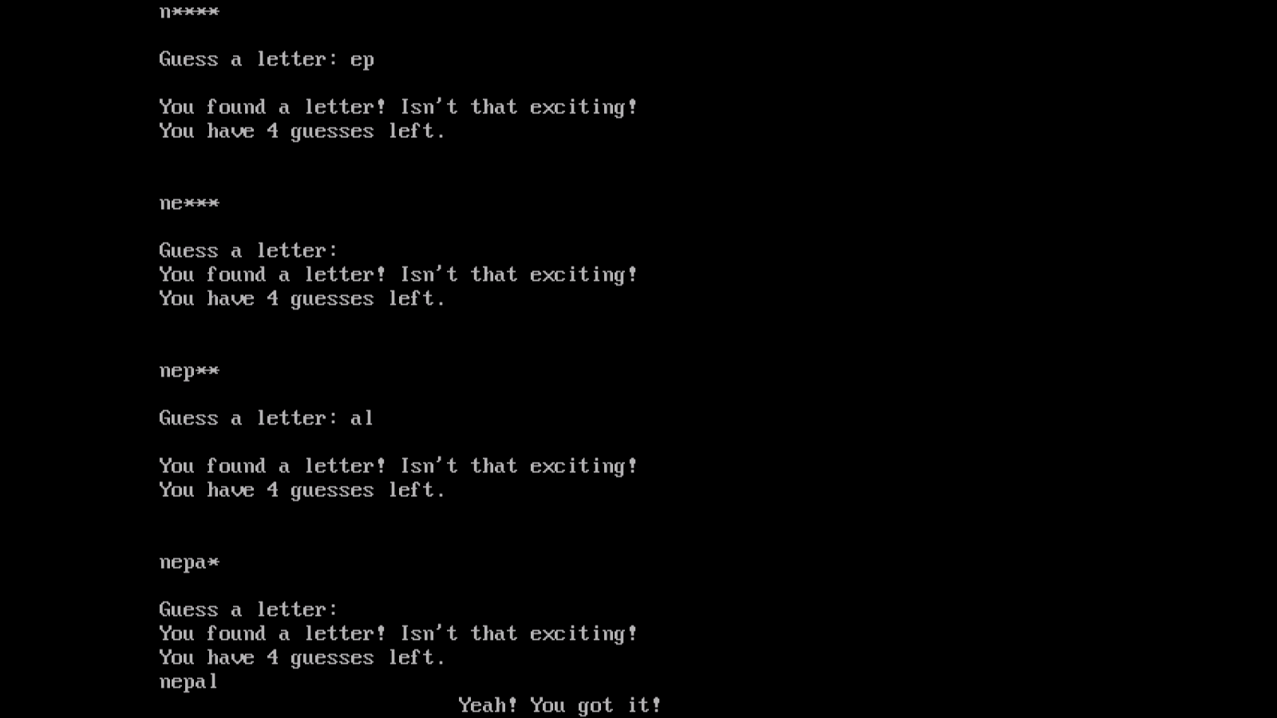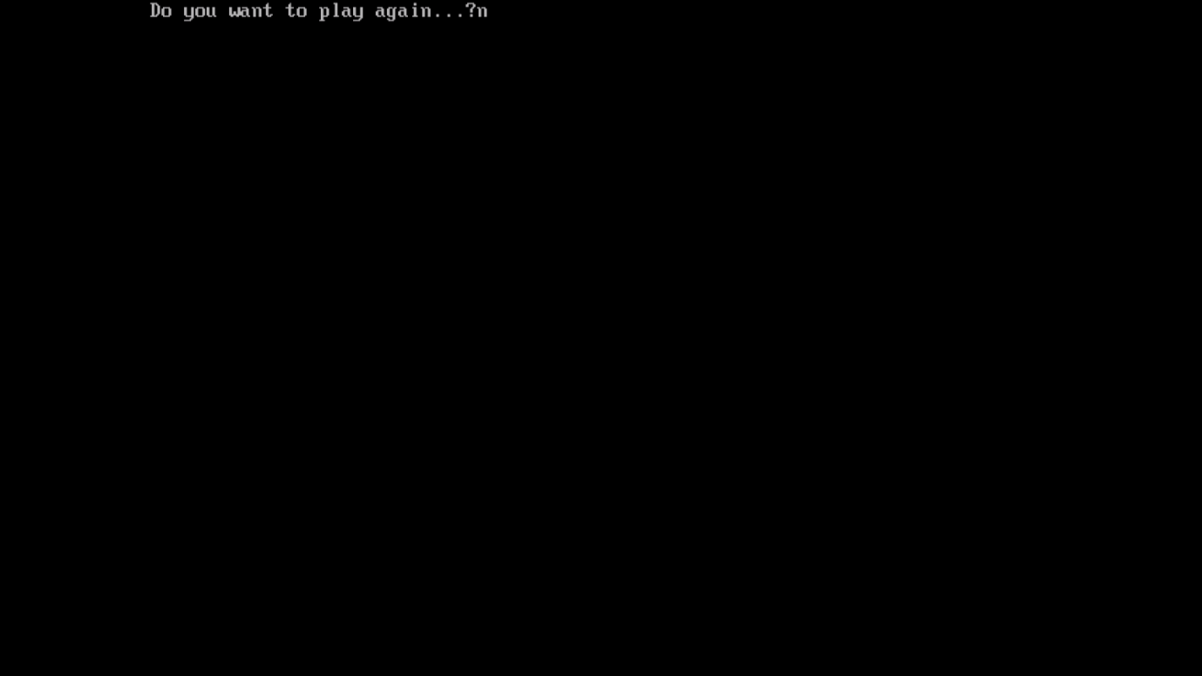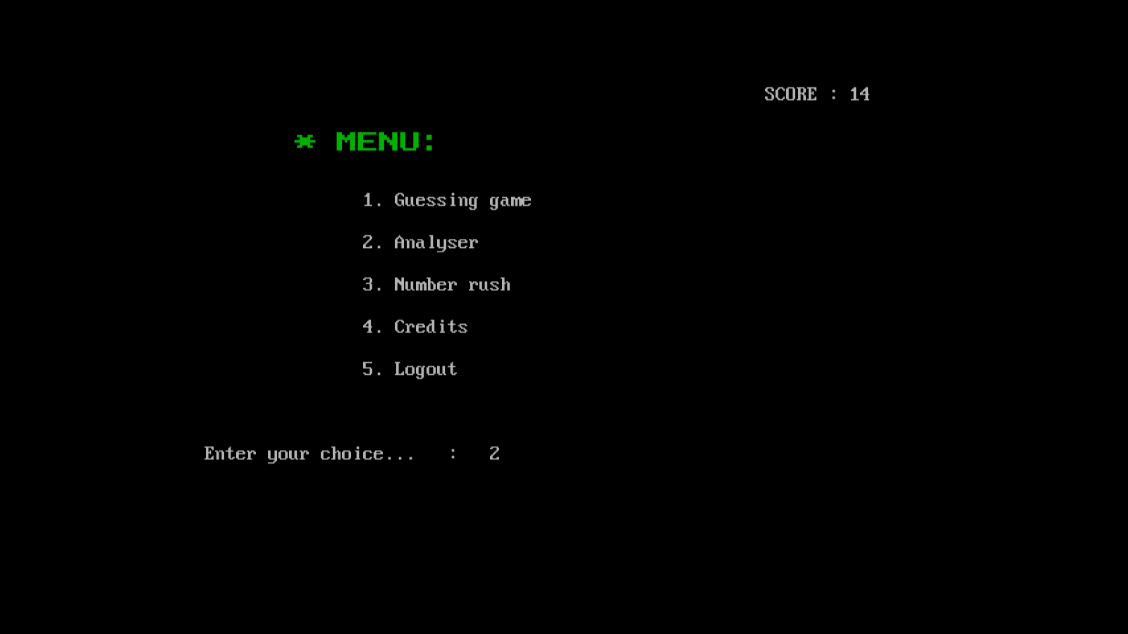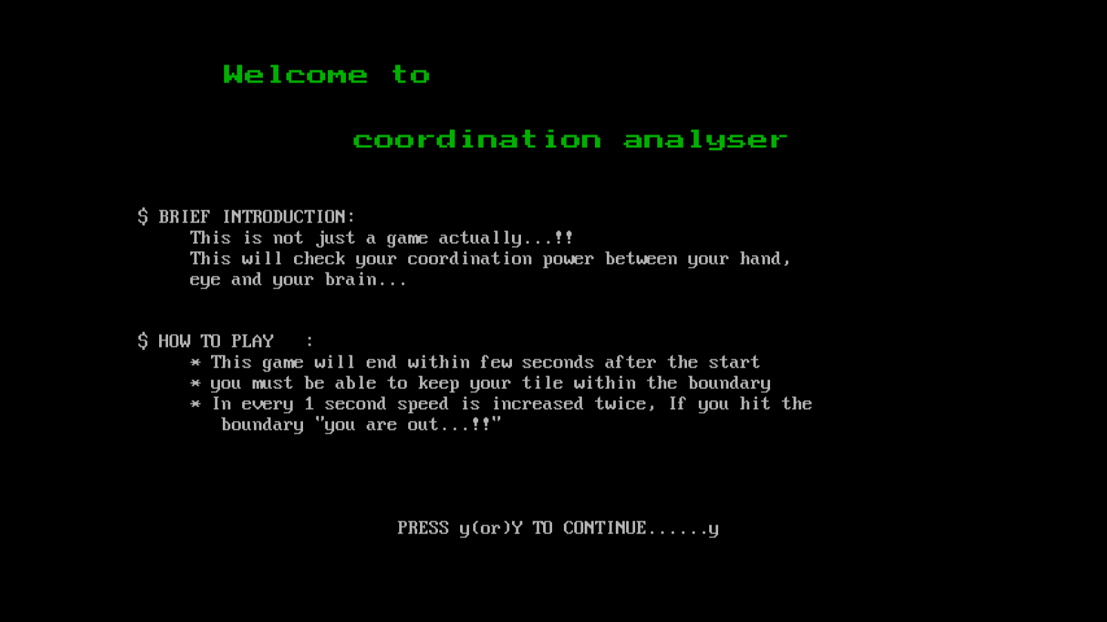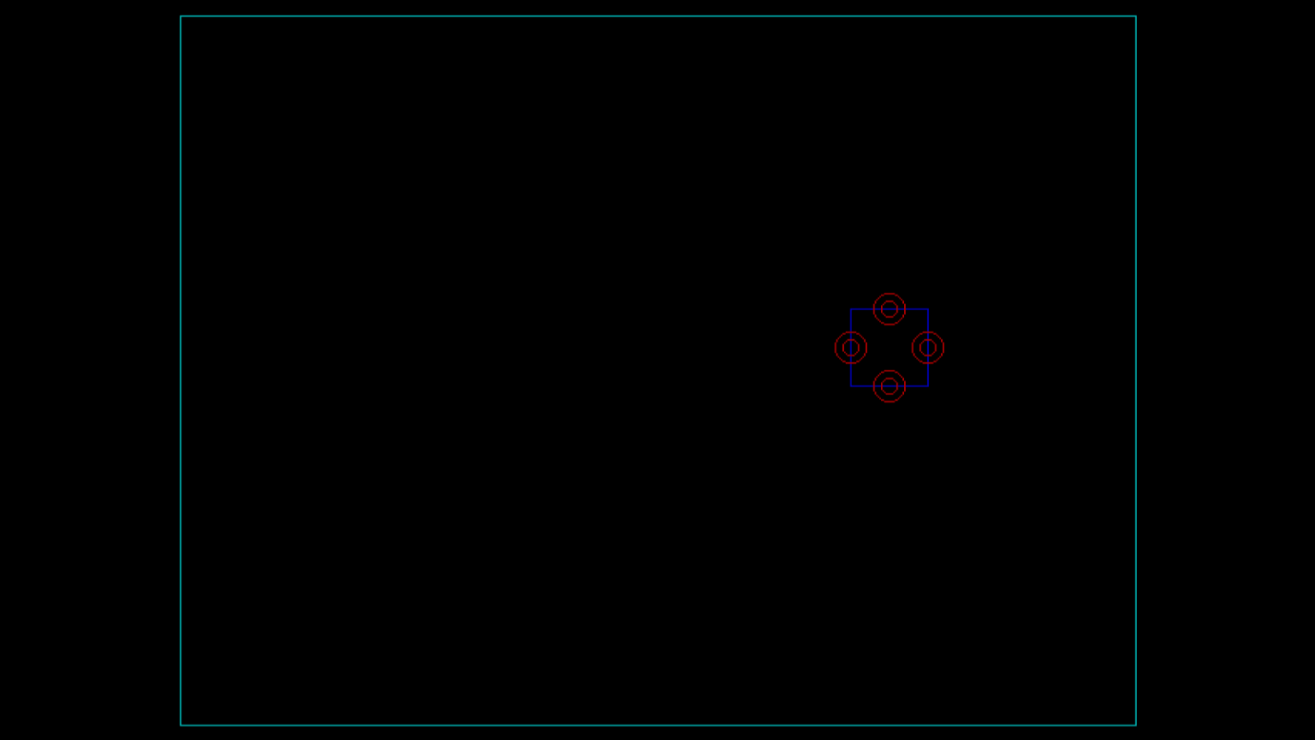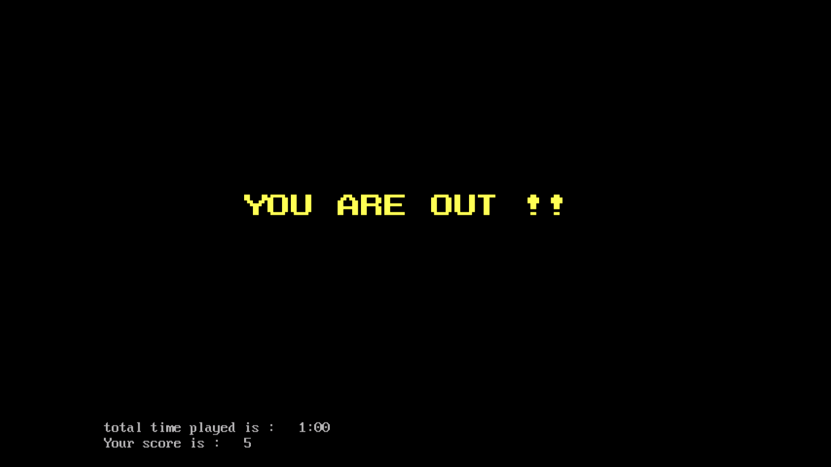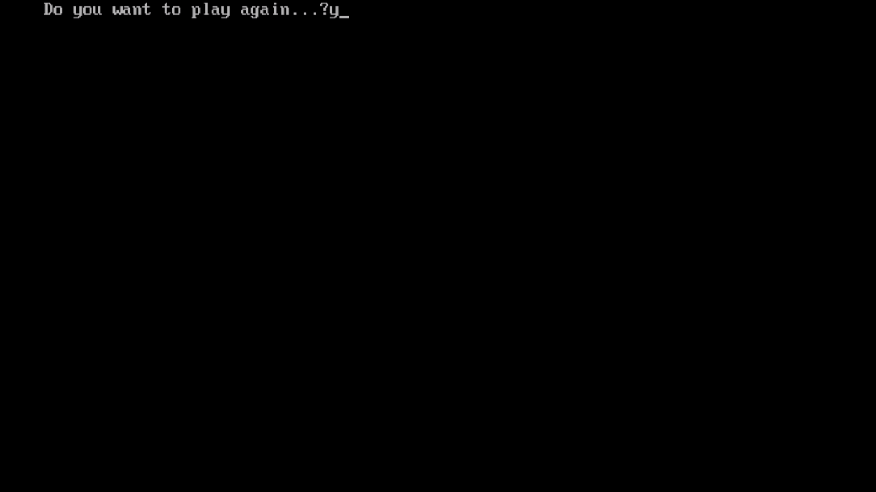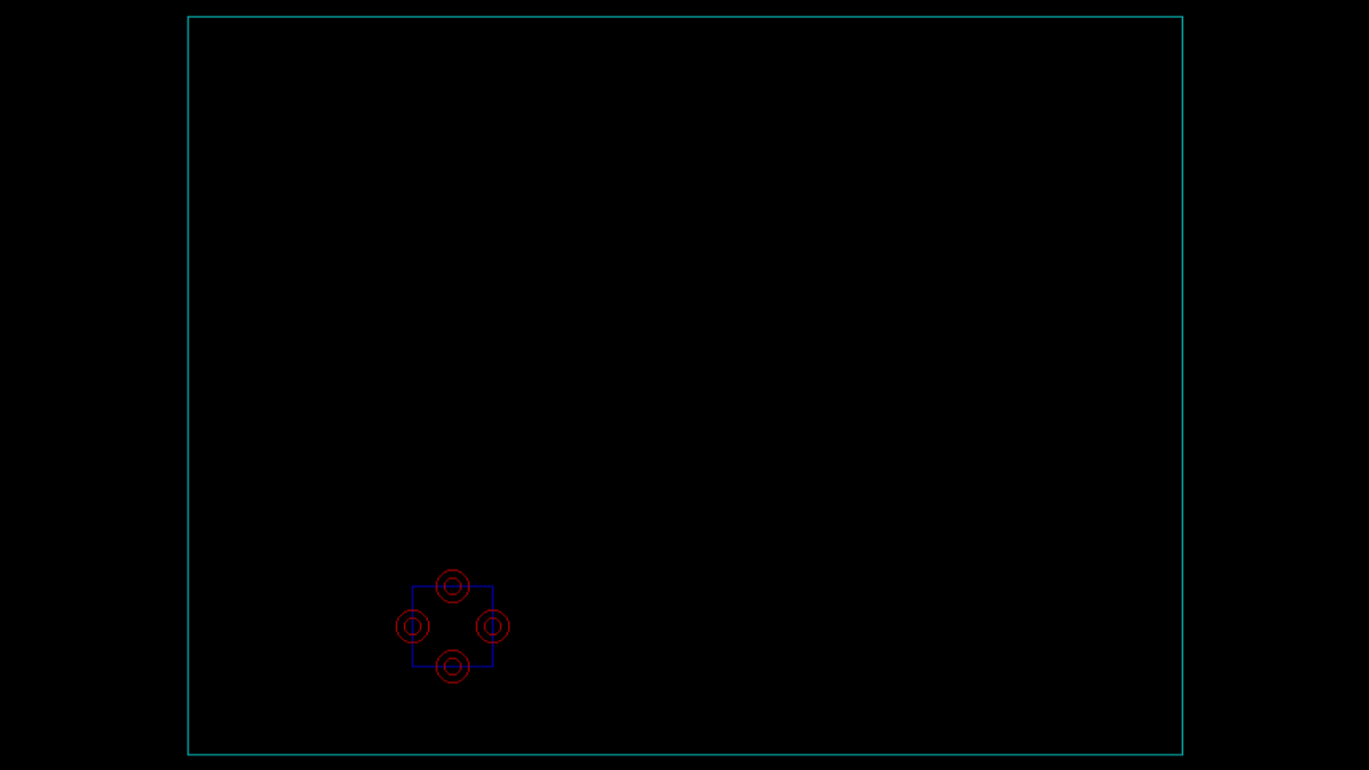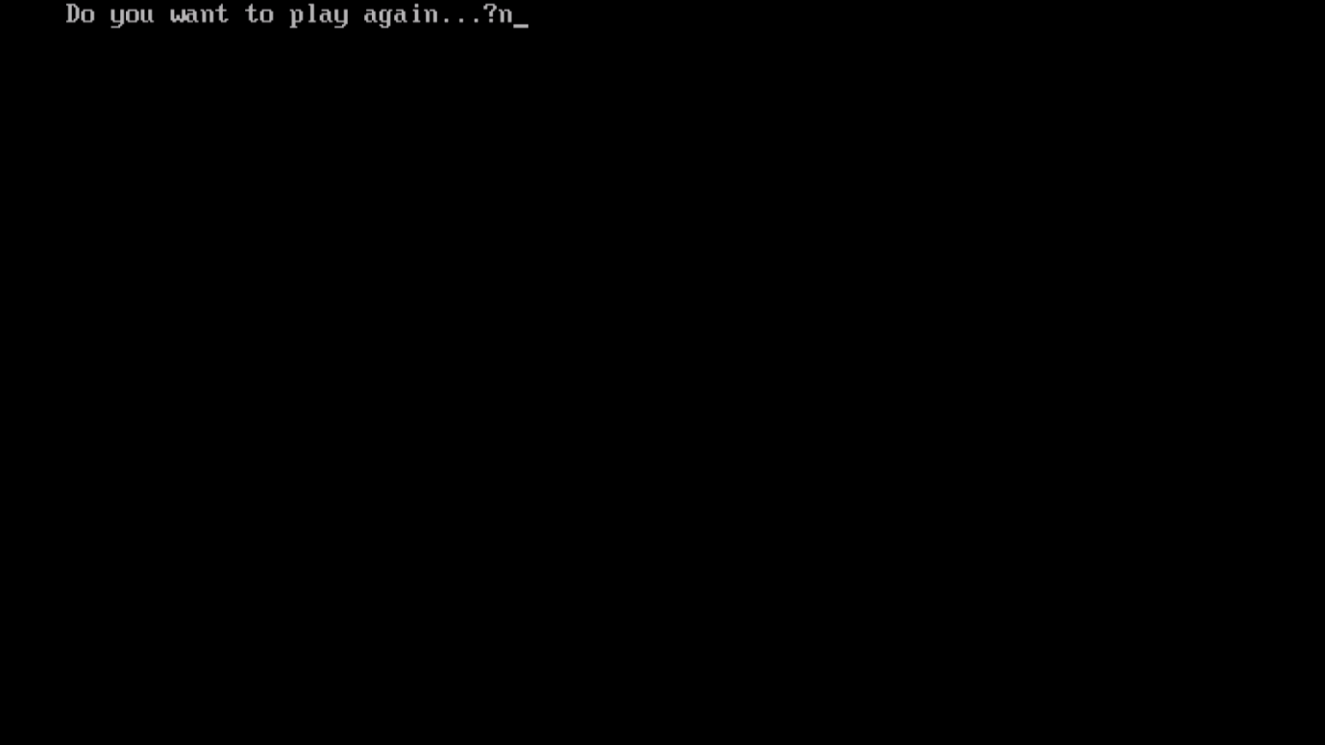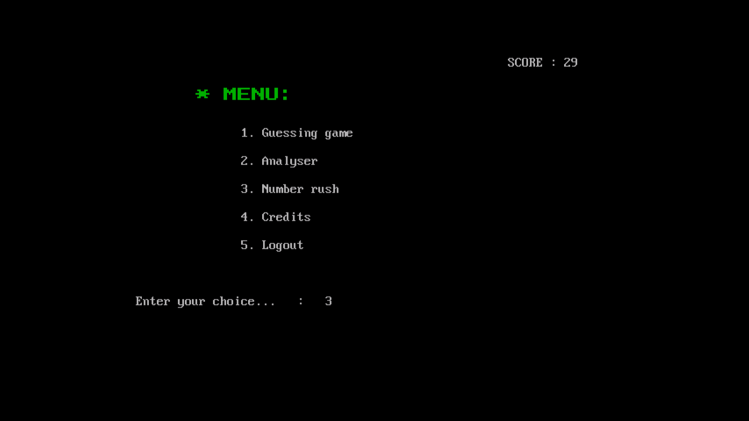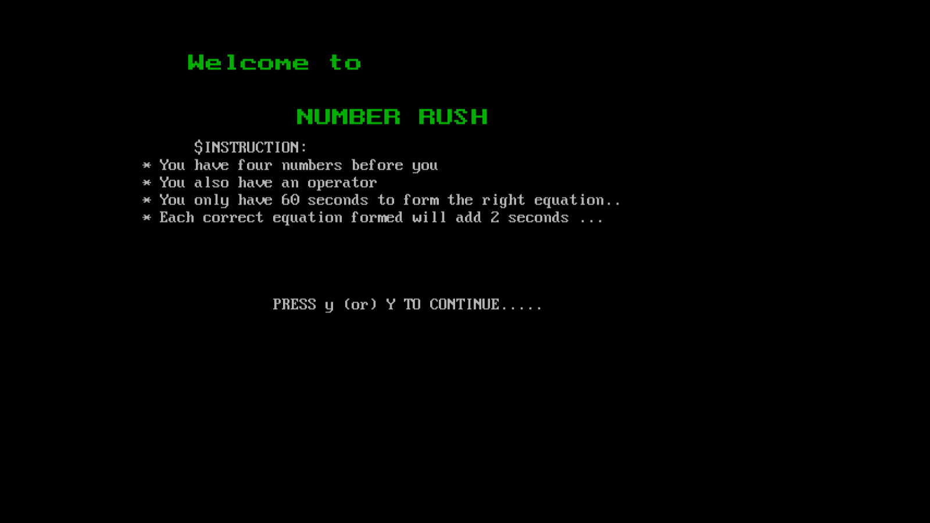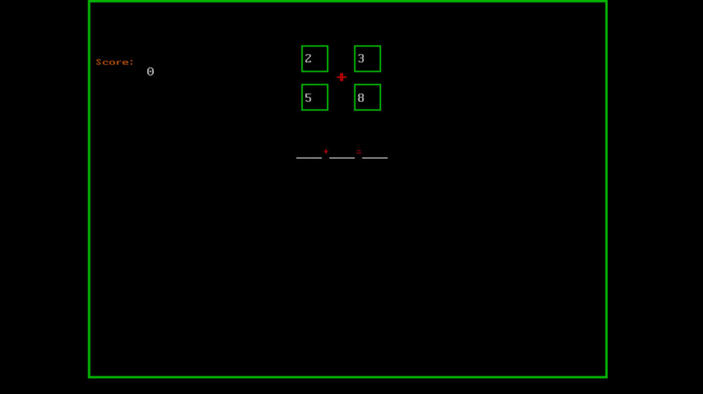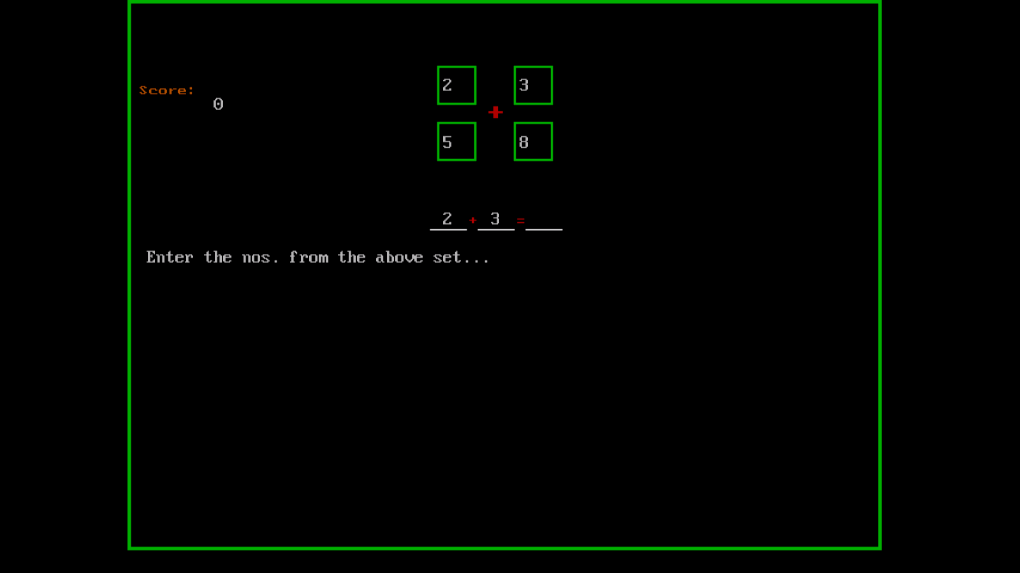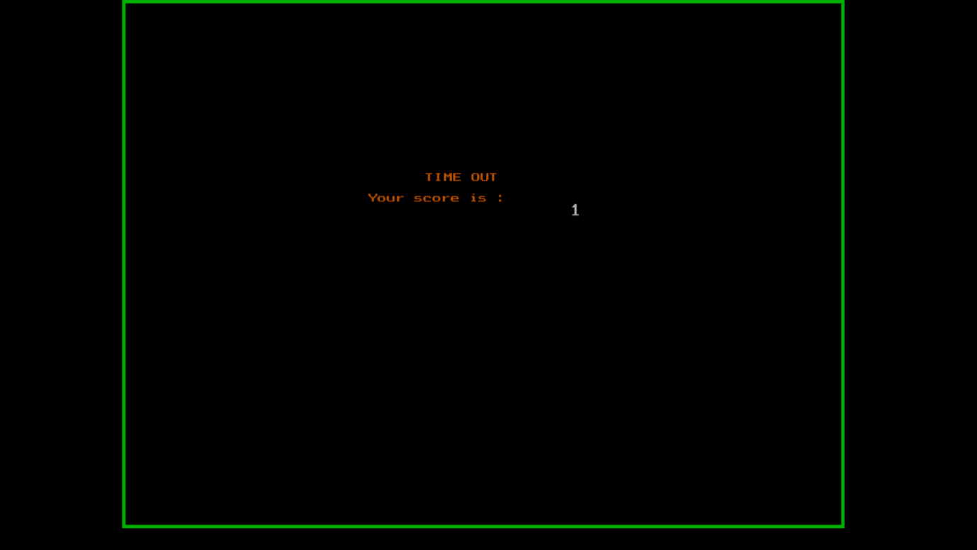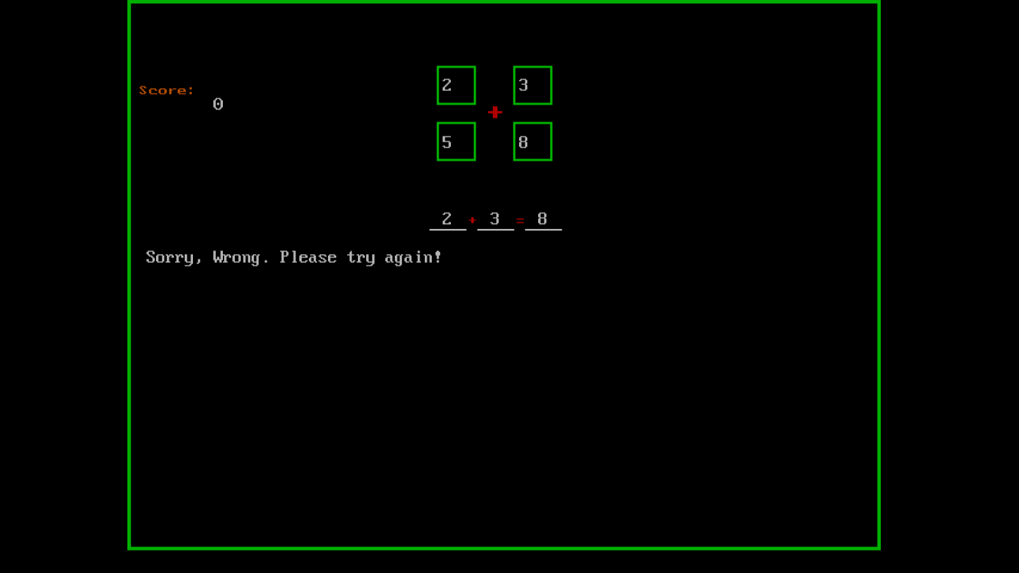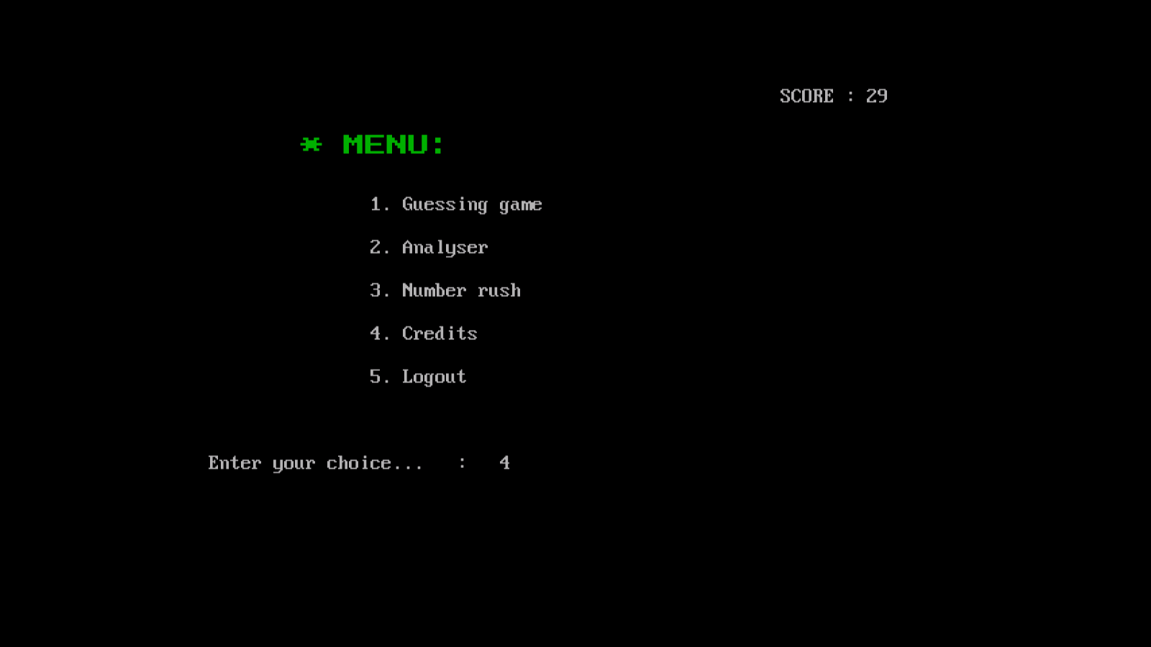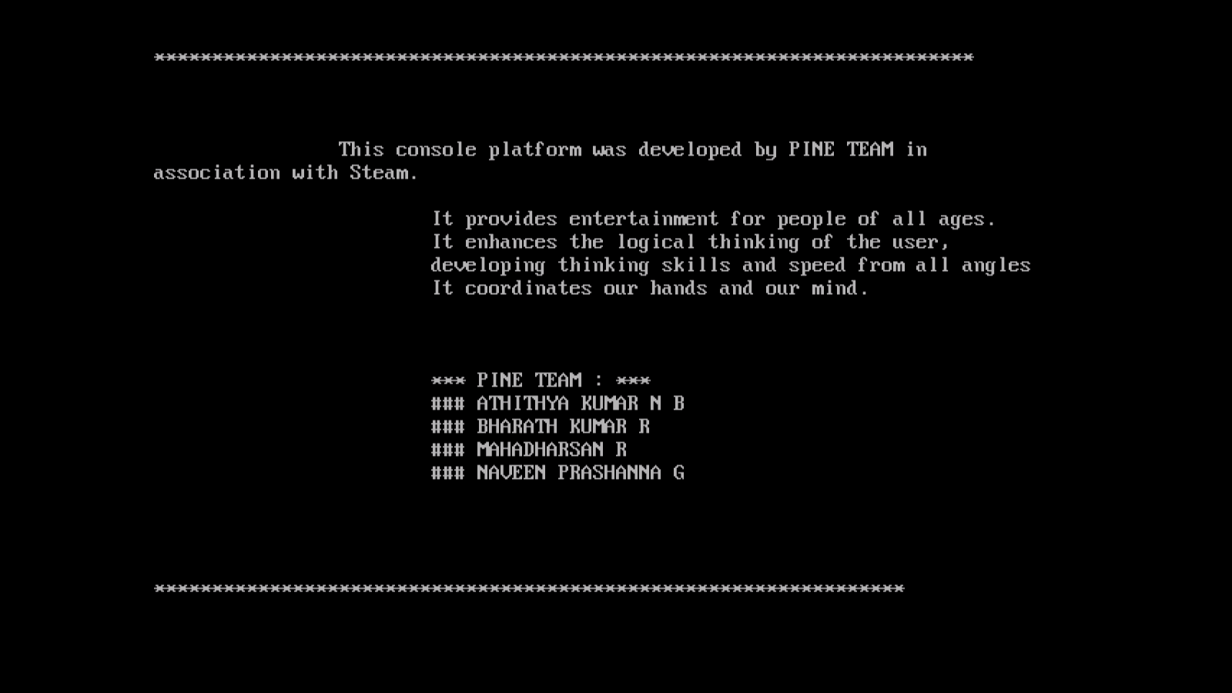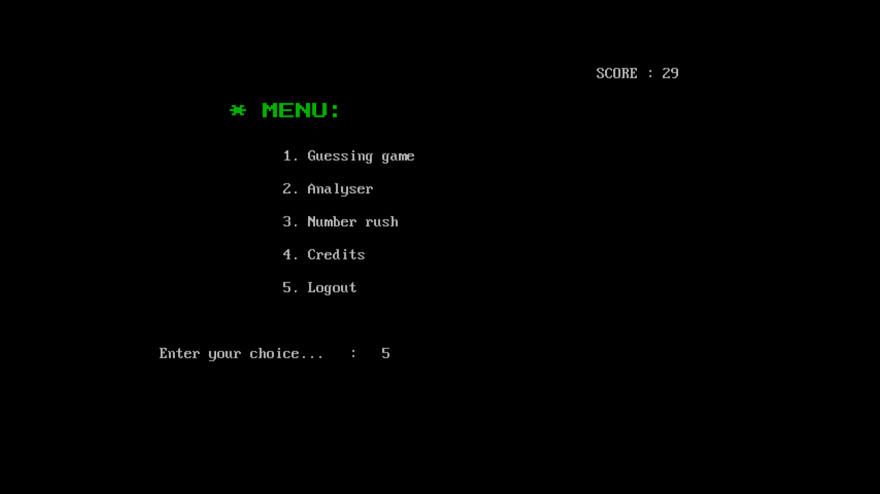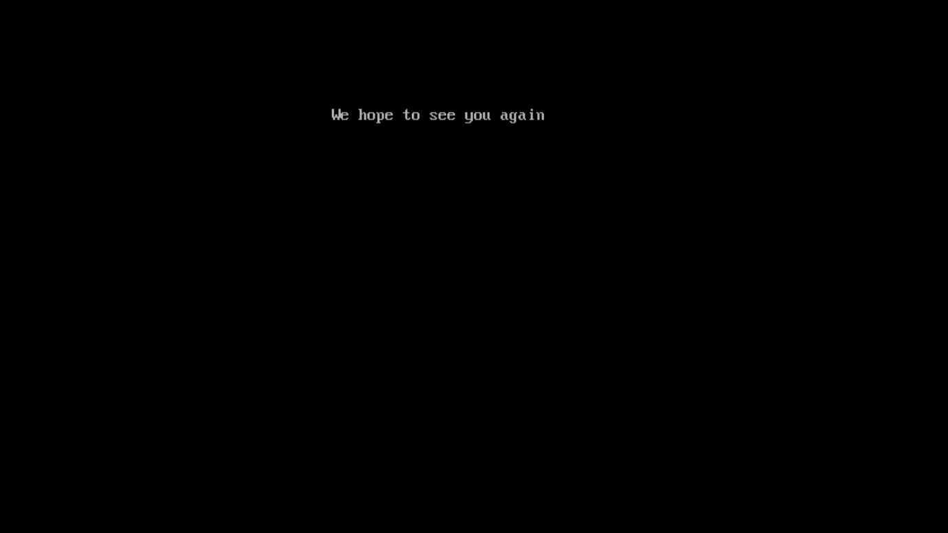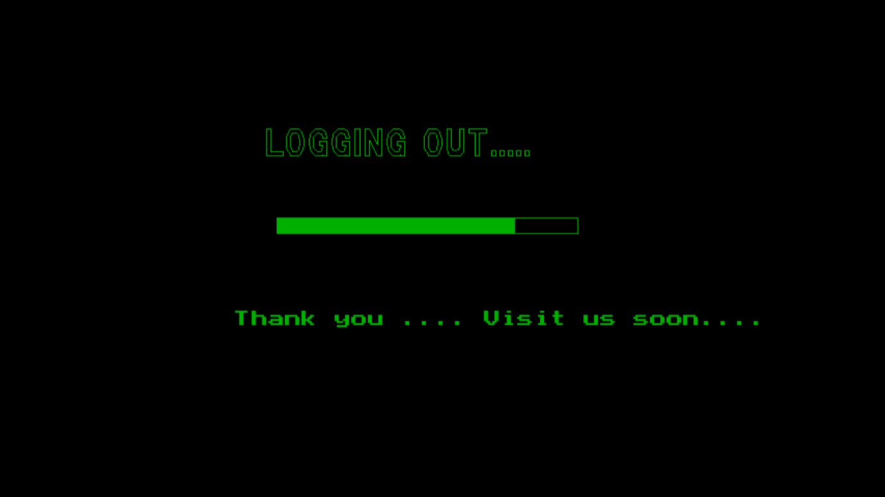

1. Computer Science with C++ by Sumita Arora
2. http://www.cpluspluslearning.com

