|  |  |
| --- | --- |
| Product: | OpenText™ Content Connect |
| Version: | 20.2 CE |
| Task/Topic | Performance |
| Audience: | Administrators, Decision Makers |
| Platform: | Kubernetes, Windows |
| Document ID: |  |
| Updated: | March 15, 2021 |
|  | Performance White Paper  OpenText™ Content Connect 20.2 CE on K8s & VMs  Gopi Dev Injamuri, Bharath Raj Reddy Marrivada |

Contents

Audience 3

Disclaimer 3

Executive Summary 4

About Product and Purpose 5

Assessment Overview 6

Objectives 6

Test Setup 6

Test Strategy 9

User load distribution 9

Test data set 10

Test Types 11

User Gauging Test 11

Standard Load Test 11

Endurance Test 11

Test Tool 11

Test Results 12

1. Small Size 12

User Gauging 12

Conclusion: 13

Standard Load Test 13

User mix 14

Client-Side Metrics 14

Server-Side Metrics 17

Conclusion 19

2. Medium Size 20

User Gauging 20

Conclusion: 21

Standard Load Test 21

User mix 22

Client-Side Metrics 22

Server-Side Metrics 24

Conclusion 28

3. Large Size 28

User Gauging 28

Conclusion: 29

Standard Load Test 29

Client-Side Metrics 30

Server-Side Metrics 32

Conclusion 35

Endurance Test 35

User mix 35

Client-Side Metrics 36

Server-Side Metrics 38

Conclusion 43

Appendices 44

Appendix A – Test Environment Details 44

Appendix B – Cloud Sizing Guide 45

Appendix C - Application and System Tuning Guide 45

Documentum Content Server PODs 45

DCTM Rest PODs 47

Database Configuration 48

Appendix D - Detailed Test Scenarios 49

Appendix E- Glossary 51

Appendix F - Think time Assumptions 52

# Audience

The document is intended for a technical audience that is planning an implementation of OpenText™ products. OpenText recommends consulting with OpenText Professional Services who can assist with the specific details of individual implementation architectures.

Disclaimer

The tests and results described in this document apply only to the OpenText configuration described herein. For testing or certification of other configurations, contact OpenText Corporation for more information.

All tests described in this document were run on equipment located in the OpenText Performance Laboratory and were performed by the OpenText Performance Engineering Group. Note that using a configuration similar to that described in this document, or any other certified configuration, does not guarantee the results documented herein. There may be parameters or variables that were not contemplated during these performance tests that could affect results in other test environments.

For any OpenText production deployment, OpenText recommends a rigorous performance evaluation of the specific environment and applications to ensure that there are no configuration or custom development bottlenecks present that hinder overall performance.

All results in this paper are based on server-side measurements and do not capture browser rendering of results. Actual timings including client-side (e.g. browsers) timings may vary significantly depending on the client machine specifications, the client network, browser variations, and other conditions of the user’s environment.

# Executive Summary

This document describes the testing efforts undertaken by the OpenText™ performance engineering team to assess the performance of OpenText™ Content Connect 20.2 CE (Cloud Edition) application on a Kubernetes (K8s) cluster and Virtual Machine (VM) environment on three cloud size models (Small, Medium and Large). Each of the cloud size specifications can be found in Appendix B – Cloud Sizing Guide.

Contextual Content Engine (CCE) was deployed on a VM environment, while the rest of the components were deployed on the K8s cluster. NAS storage mount was attached to the K8s cluster and SAN Storage Class was only used only for the PostgreSQL server. Content Connect 20.2 CE helm chart was used to deploy the application on the K8s Cluster.

12 different test scenarios were considered in this assessment. A combined test scenario was executed on each of the cloud size models and test results were presented in this report. Test scenario details can be found in Appendix D - Detailed Test Scenarios.

The following table shows the summary of the test results. The average transaction SLA was < 2 seconds.

|  |  |  |  |  |
| --- | --- | --- | --- | --- |
| **Cloud Size**  **(Test Duration)** | **Concurrent Users** | **DCS POD’s**  **Replica Count** | **DCS PostgreSQL**  **CPU Usage (Cores)** | **Transaction**  **Count (Millions)\*** |
| Small (1 Hour) | 140 | 2 | 1.24 | 0.18 |
| Medium (1 Hour) | 320 | 3 | 2.86 | 0.43 |
| Large (1 Hour) | 800 | 5 | 8.65 | 1 |
| Large (20 Hour) | 800 | 5 | 8.96 | 23 |

*The Cumulative sum of all the 12 different test scenarios that were executed during the test.

During the Endurance test for the Large size (20 Hours), it was observed that the PostgreSQL server writes a large amount of data to the disk intermediately. It was recommended to use a high performance disk for the Database that could handle around 50 MB/second write throughput.

The product performance tuning guidelines can be found in Appendix C - Application and System Tuning Guide.

# About Product and Purpose

Content Connect is a connector for Office thick client and Office Online/O365 cloud infrastructure, which would be supporting Documentum, Leap & CMIS repositories. Build Next-Generation connectors for Office/Office Online (Extensible to other applications) that would work across multiple repositories including both on-prem and cloud-hosted environments. Replace Legacy connectors with new technology that is cloud-enabled, with a new modern administrative and end-user experience.

# Assessment Overview

## Objectives

The objective of the assessment was as follows

* Baseline the Content Connect Application on K8s cluster on 3 different cloud sizing models.
* Load test on each cloud sizing model (Small, Medium and Large).
* Identify the POD and resource bottleneck.
* SLA < 2 seconds was defined on all the transactions.

## Test Setup

Kubernetes (K8s) cluster and Windows based VM (Virtual Machine) were used for conducting all the load tests in this assessment. POD details were described in Table-1 and VM details were described in Table-2.

Table-1: POD Details

|  |  |  |
| --- | --- | --- |
| **S No** | **POD** | **Description** |
| 1 | Content Connect | The Content Connect POD for Admin Portal. |
| 2 | Content Connect DB | Content Connect DB POD interacts with Content Connect and PostgreSQL. |
| 3 | PostgreSQL (CC) | The PostgreSQL POD specific to Content Connect (CC). |
| 4 | D2 Custom Script | D2 Custom Script POD stores files or details for installing D2 on Documentum Content Server. |
| 5 | D2 Config | D2 Config POD was for D2 Config Application. |
| 6 | D2 Client | D2 Client POD was for D2 Client Application. |
| 7 | D2 Rest | D2 Rest services. |
| 8 | Documentum Administrator | The Documentum Administrator is administration portal for Documentum Content Server. |
| 9 | Documentum Content Server | Documentum Content Server (DCS). |
| 10 | Docbroker | The Docbroker POD is used by other applications to interact with Documentum Content Server. |
| 11 | PostgreSQL (DCS) | The PostgreSQL POD specific to Documentum Content Server. |
| 12 | Index Server | These three PODs are related to xPlore which takes care of search operations like full text search etc. |
| 13 | Index Agent |
| 14 | CPS |

Table-2: VM Details

|  |  |  |
| --- | --- | --- |
| **S No** | **VM** | **Description** |
| 1 | Contextual Content Engine (CCE) | Windows bases VM that contains Contextual Content Engine 16.6 |

Perflab K8s cluster consists of 12 worker nodes + 1 master node. Each of the K8s cluster nodes had 16 CPUs and 60 GB RAM. This K8s cluster was deployed using the Bosh Director on VMware vSphere and this deployment is called Kubo-release (Kubernetes Bosh), installation details can be found in this link <https://github.com/cloudfoundry-incubator/kubo-release>. In the OpenText this kind of K8s deployment was called CFCR (Cloud Foundry Container Runtime). The K8s version was 1.15.5 and the Build Date was 2019-10-15T19:07:57Z. The worker and master nodes had Ubuntu 16.04 LTS as the base operating system. This was a shared cluster environment that was being used by different teams to conduct performance assessments. There were multiple Storage Classes created on this cluster for various project storage requirements.

Based on the project CPU, Memory, and Storage resource requirements one or more K8s nodes were assigned to that project. By using the K8s “Admission-Controllers", the K8s cluster makes sure that all the Project-related objects would get deployed on those assigned K8s worker nodes only. Four K8s worker nodes (Node1, Node 2, Node3 and Node4) were assigned for this performance assessment. Prometheus and Graphite tools were used to collect different Metrics on the K8s cluster and the VMs during the test execution.

VMware vCenter was used for the creation of the Contextual Content Engine VM.

K8s nodes and Storage specifications can be found in Appendix A – Test Environment Details

K8s PODs specifications can be found in  Appendix B – Cloud Sizing Guide

Figure-1a shows the test deployment architecture that comprises of K8s cluster and VM’s.

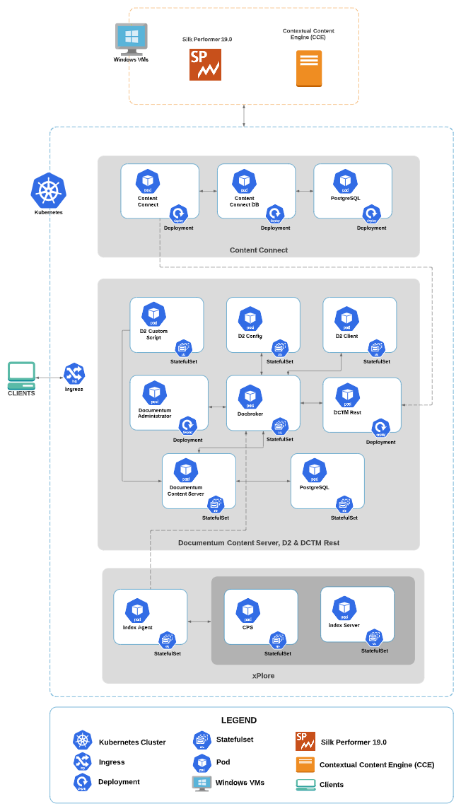

Figure-1a: Content Connect - Deployment Diagram

The Content Connect 20.2 CE product, except for the Contextual Content Engine (CCE) was deployed on the K8s cluster. Helm chart that was downloaded from the knowledge center was used for the K8s deployment. The helm chart version details can be found in Table-3a. The Contextual Content Engine war file version details can be found in Table-3b.

Table-3a: Helm Chart Details

|  |  |  |  |
| --- | --- | --- | --- |
| **S No** | **Product** | **Type** | **Version** |
| 1 | Documentum D2 | Helm Chart | 20.2.0 |
| 2 | Documentum Content Server | Helm Chart | 20.2 |
| 3 | Documentum Administrator | Helm Chart | 20.2 |
| 4 | Documentum xPlore | Helm Chart | 16.7 |

Table-3b: War Deployment Details

|  |  |  |  |
| --- | --- | --- | --- |
| **S No** | **Product** | **Type** | **Version** |
| 1 | Contextual Content engine | .war file deployment on Windows VM | 16.7 |

## Test Strategy

The gauging test was designed to measure the scalability point of the Content Connect 20.2 platform until the hardware resources such as CPU, RAM, network bandwidth, or I/O were at or near saturation, while the response times for individual transactions were < 2 seconds. The results were specific to the hardware available in the OpenText performance lab. Resources that were being stressed for each of the tests have been highlighted to enable hardware deployments to be planned based on usage levels.

## User load distribution

The Table-4 shows the twelve different test scenarios that were executed in this assessment and each of the test scenarios user load distribution %. The user load mix for each of the cloud sizing models (small, medium and large) was determined based on the total number of users and Table-4. Separate, combined scenario tests with varying numbers of users were executed for each of the cloud sizing models and presented in this assessment report.

Table-4: Percentage User Load Distribution

|  |  |  |
| --- | --- | --- |
| **S No** | **Scenario** | **User Load Distribution (%)** |
| 1 | Folder operations | 20 |
| 2 | Document metadata operations | 20 |
| 3 | Favorite operations | 5 |
| 4 | Document versioning | 10 |
| 5 | Document import | 10 |
| 6 | Document preview & export | 10 |
| 7 | Outlook attachments import into repository | 2 |
| 8 | Attach repository document to the email | 5 |
| 9 | Full-text search | 14 |
| 10 | Bulk-import search | 1 |
| 11 | Document import with checksum | 2 |
| 12 | Check Document Versions | 1 |

## Test data set

1K users and 1,00,000 documents were populated into the system in the following structure

* 1000 users were equally divided between 10 groups.
* 1000 cabinets were created as the home cabinets of the 1000 users respectively. Each user cabinet comprises of folders and documents as mentioned below
  + 10 folders under each home cabinet.
  + 10 documents under each folder. They are all docx (type "msw12" in Documentum) word document. One of them was of 10 MB content, and the other 9 files were of 42 KB content.

Table-5: Test data set

|  |  |
| --- | --- |
| **Data set details** | **Count** |
| Users | 1,000 |
| Cabinets | 1,000 |
| Word Document (42 KB) | 90,000 |
| Word Document (10 MB) | 10,000 |

## Test Types

* User Gauging Test
* Standard Load Test
* Endurance Test

### User Gauging Test

The scalability point of a system is defined as the maximum load that it can support without compromising on end-user performance experience. The purpose of the gauging test was to determine the scalability point of a system. This was done by subjecting the system to a steadily increasing user load to the point beyond which the addition of users causes the response time to deteriorate or system resources to reach the saturation point.

### Standard Load Test

This involves running a test with the load equal to the scalability point identified in the gauging test and kept it stable for a 1-hour duration, to measure the throughput and consistency for response time.

### Endurance Test

Endurance testing involves testing a system with a significant load over an extended period, to discover how the system behaves under sustained use. That is to ensure that the throughput and/or response times after some long period of sustained activity are as good or better than at the beginning of the test.

## Test Tool

 Silk Performer 19.0 tool was used to conduct all the tests in this assessment.

# Test Results

This section summarizes the results for the tests executed as part of this assessment. The test results were specific to the hardware available in the performance lab. Resources that were being stressed during the test had been highlighted to allow you to plan hardware deployments based on the usage levels of the various functions in their expected usage profile.

## Small Size

The deployment was created based on the Small Size details as shown in Appendix B – Cloud Sizing Guide.

**PODs allocation in the K8s nodes**

The performance lab K8s cluster consists of 12 worker nodes; only four worker nodes were assigned for this assessment. All the PODs that were created as part of this test scenario need to be placed in one of these four worker nodes only. After deploying the application using the Helm chart, Table-6 shows the corresponding created PODs worker node location. This information would help to understand resource usage and NFS mount attachment variations among the worker nodes.

Table-6: POD location details

|  | **k8s - Node 1** | **k8s - Node 2** | **k8s - Node 3** | **k8s - Node 4** |
| --- | --- | --- | --- | --- |
| POD Name's and Replica number | Content Connect-1  Index Server-1  D2config-1  D2client-1 | Content Server-2  Docbroker-2  xPlore CPS-2  xPlore CPS-1 | Content Connect - 2  Content Connect DB - 1  D2customscript-1  Docbroker-1  Content Server - 1  PostgreSQL (CC) | Index Agent - 1  D2client-1  PostgreSQL (DCS) |

### User Gauging

The scalability point of a system was defined as the maximum load that the system can support without compromising on end-user performance experience. The purpose of the gauging test was to determine the scalability point of a system. This was done by subjecting the system to an increasing user load to the point beyond which the addition of users caused the response time to increase beyond the SLA or system resources, to reach the saturation point or system generating application exceptions.

Figure 1 shows the Small Size combined test scenario gauging graph.

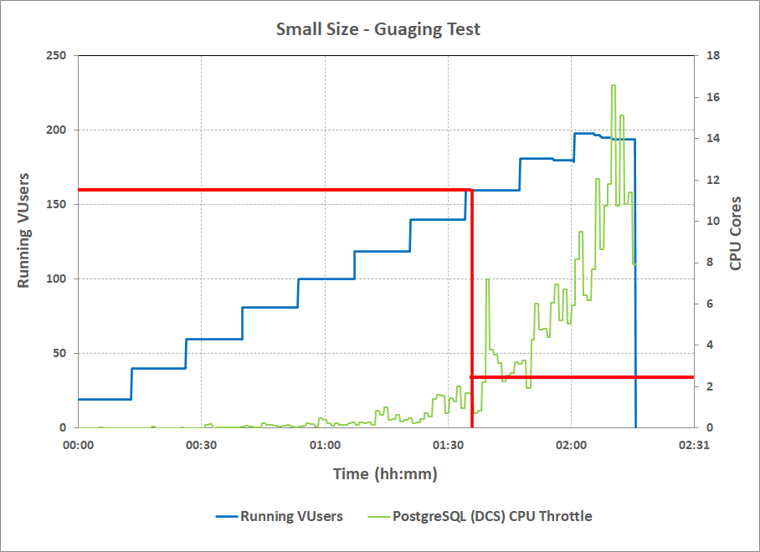

*Figure-1: Small Size – Gauging Test Graph*

**Observations:**

* Beyond 140 users load; PostgreSQL (DCS) POD Throttling CPU had increased beyond 1 CPU cores, due to this few transaction’s response time went beyond 2 seconds SLA.

#### Conclusion:

Based on the above observations, 140 users load was considered as the gauging point for small size.

### Standard Load Test

The combined test scenario was executed with 140 users, as determined in the gauging test. The test scenarios details can be found in Appendix D - Detailed Test Scenarios.

Users ramp up rate was 1 user every 5 seconds; it took around 10 minutes to bring all the 140 users into the system.

#### User mix

Table-7 contains the exact number of users considered for each of the test scenarios for running the combined test scenario with 140 users. The following table was calculated based on the user load distribution % located at User load distribution.

*Table-7: User Load Distribution*

|  |  |  |
| --- | --- | --- |
| **#** | **Test Scenario** | **User Load Distribution** |
| 1 | Folder operations | 28 |
| 2 | Document metadata operations | 28 |
| 3 | Favorite operations | 7 |
| 4 | Document versioning | 14 |
| 5 | Document import | 14 |
| 6 | Document preview & export | 14 |
| 7 | Outlook attachments import into repository | 3 |
| 8 | Attach repository document to the email | 7 |
| 9 | Full-text search | 20 |
| 10 | Bulk-import | 1 |
| 11 | Documents import with checksum | 3 |
| 12 | Check Document Versions | 1 |
|  | **Total** | **140** |

#### Client-Side Metrics

Table-8 shows the client-side metrics calculated from the Silk Performer Tool test report. A stable period of 1 hour was considered for presenting the test results.

*Table-8: Overall Summary*

|  |  |
| --- | --- |
| Test duration (hh:mm) | 01:00 |
| Concurrent users | 140 |
| **Throughput** | |
| Avg. throughput - Sent [kB]/sec | 455.42 |
| Avg. throughput - Received [kB]/sec | 4,599.44 |
| Avg. HTTP hits/sec | 138.66 |

Table-9 contains the response times of the transactions that were part of standard load test.

*Table-9: Client-Side Statistics*

|  |  |  |  |  |
| --- | --- | --- | --- | --- |
| **#** | **Scenarios** | **Name** | **Count** | **Average Response Time (seconds)** |
| 0 | Common Transactions across all scenarios | w000_LaunchAddin | 140 | 0.22 |
| w001_Login | 140 | 0.42 |
| w002_OpenHomeCabinet | 62,989 | 0.03 |
| w003_OpenRndFolder | 81,688 | 0.03 |
| 1 | Folder operations | s1_a0_ClickOnAddButton | 6,538 | 0.25 |
| s1_a1_EnterFolderNameClickSave | 6,536 | 0.11 |
| 2 | Document metadata operations | s2_a0_OpenDocument | 6,494 | 0.14 |
| s2_a1_ViewDocumentProperties | 6,492 | 0.25 |
| s2_a2_EditTileAndClickOnSave | 6,500 | 0.08 |
| 3 | Favorite operations | s3_a0_AddDocumentAsFav | 1,662 | 0.04 |
| s3_a1_BrowseFavouritiesDocs | 1,662 | 0.02 |
| s3_a2_UnFavouriteTheDocument | 1,663 | 0.06 |
| 4 | Document versioning | s4_a0_OpenDocument | 2,021 | 0.10 |
| s4_a1_LockTheDocument | 4,041 | 0.12 |
| s4_a2_UnLockTheDocument | 2,019 | 0.10 |
| s4_a3_SubmitUpdatedDocument | 2,021 | 0.27 |
| s4_a4_ClickOnSave | 2,020 | 0.16 |
| 5 | Document import | s5_a0_ClickOnSaveAs | 2,668 | 0.57 |
| s5_a1_EnterFileDetailsClickSave | 2,668 | 0.21 |
| s5_a2_ViewImportedDocument | 2,665 | 0.06 |
| 6 | Document preview & export | s6_a1_OpenDocument_10MB | 570 | 0.80 |
| s6_a1_OpenDocument_42KB | 4,922 | 0.07 |
| 7 | Outlook attachments import into repository | s7_a0_ImportEmail1Attachment | 670 | 0.38 |
| s7_a1_ImportEmail3Attachment | 668 | 0.71 |
| 8 | Attach repository document to the email | s8_a0_RepositoryDocumentToEmailAsAttachment_10MB | 209 | 0.79 |
| s8_a0_RepositoryDocumentToEmailAsAttachment_42KB | 1,863 | 0.05 |
| 9 | Full-text search | s9_a0_CCESearchSuggestions | 7,299 | 0.03 |
| s9_a1_FullTextSearch | 7,298 | 0.77 |
| 10 | Bulk-import search | s10_a0_BulkImport5Items | 275 | 0.93 |
| 11 | Documents import with checksum | s11_a0_MoveEmail1Attachment | 664 | 0.36 |
| s11_a1_MoveEmail3Attachment | 665 | 0.84 |
| 12 | Check Document Versions | s12_a0_ViewDocumentVersions | 398 | 0.04 |

**Observations:**

* All the transactions average response times were within SLA of 2 seconds and there were no errors or failures observed during the test.

**Response Times Graph**

Figure-2 shows the Average Response Time trend of the top five high response time transactions during the stable user load.

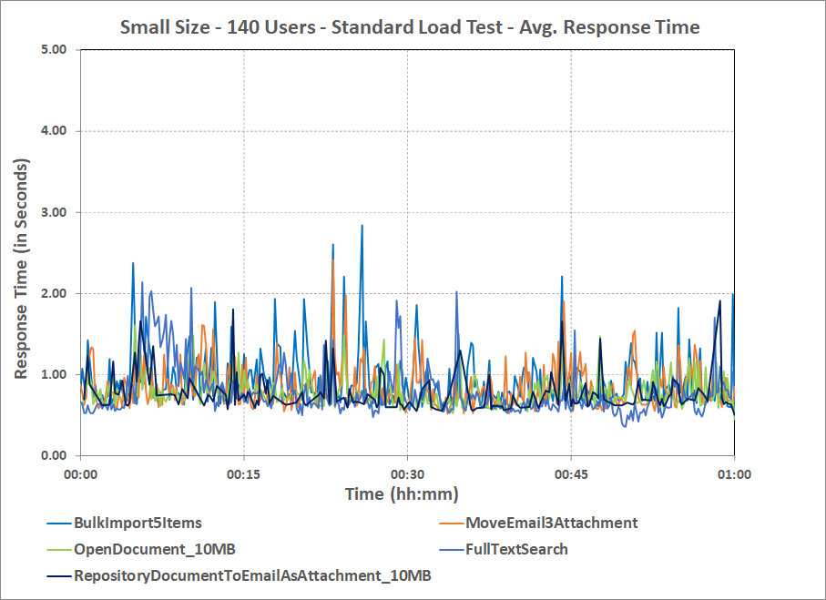

*Figure-2: Small Size - Standard Load Test - Average Response Time Graph*

**Observations:**

* Overall average response time of all the transactions were within SLA of 2 seconds.

#### Server-Side Metrics

Table-10 contains the POD metrics that were captured during the Load Test.

Table-10: POD Statistics

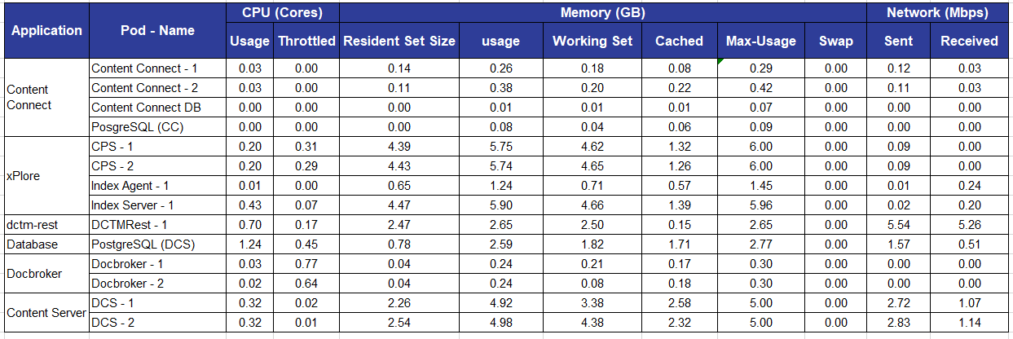

**Observations:**

* The PostgreSQL (DCS) POD CPU usage was around 1.24 CPU and all other PODs CPU usage was < 1.

**CPU Utilization Graph**

Figure-3 shows the CPU utilization of major PODs during the stable user load.

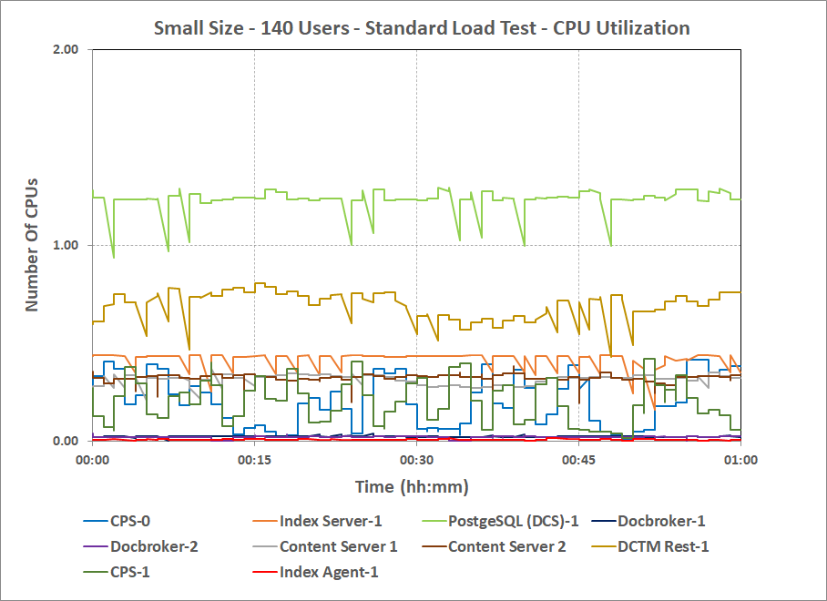

Figure-3: Small Size - Standard Load Test - Major Pods CPU Utilization

**Observations:**

* All the PODs CPU utilization were less than 2 CPUs.

Table-11 contains the K8s Node and VM metrics that were captured during the Load Test.

*Table-11: Node and VM Statistics*

|  |  |  |  |  |  |
| --- | --- | --- | --- | --- | --- |
|  | **Node 1** | **Node 2** | **Node 3** | **Node 4** | **CCE** |
| **(K8s)** | **(K8s)** | **(K8s)** | **(K8s)** | **(Windows VM)** |
| **CPU Usage (Cores)** | | | | | |
| Total | 1.11 | 0.98 | 1.26 | 1.43 | 0.24 |
| User | 0.63 | 0.7 | 0.97 | 1.19 | 0.13 |
| System | 0.38 | 0.17 | 0.15 | 0.1 | 0.10 |
| iowait | 0.01 | 0.04 | 0.04 | 0.08 | NA |
| softirq | 0.08 | 0.06 | 0.1 | 0.06 | NA |
| irq | 0 | 0 | 0 | 0 | NA |
| nice | 0 | 0 | 0 | 0 | NA |
| steal | 0 | 0 | 0 | 0 | NA |
| idle | 16.74 | 16.89 | 16.58 | 16.47 | 99.55 |
| **Memory usage (GB)** | | | | | |
| Total | 58.98 | 58.98 | 58.98 | 58.98 | 16 |
| Used (Total - (Free + Cached + Buffers)) | 15.91 | 22.55 | 7.2 | 3.5 | 10.68 |
| Free | 34.01 | 23.01 | 3.97 | 8.14 | 4.06 |
| Cached | 8.28 | 13.02 | 47.24 | 46.76 | 1.26 |
| Buffers | 0.78 | 0.4 | 0.57 | 0.58 | NA |
| **Load Average** | | | | | |
| Load Average 1m | 1.38 | 1.17 | 1.3 | 1.65 | NA |
| Load Average 5m | 1.33 | 1.16 | 1.31 | 1.65 | NA |
| Load Average 15m | 1.3 | 1.13 | 1.29 | 1.57 | NA |
| **Network Usage (Mbps)** | | | | | |
| Sent | 142.05 | 82.03 | 182.21 | 45.62 | 0.01 |
| Received | 147 | 88.92 | 192.6 | 45.86 | 0.01 |

NA - Not Applicable

**Observations:**

* No resource contention was observed in the K8s nodes or the VMs.

Table-12 contains the major POD and VM I/O metrics that were captured during the Load Test.

Table -12: POD, VM I/O Statistics

|  |  |  |  |  |  |  |  |  |
| --- | --- | --- | --- | --- | --- | --- | --- | --- |
| **Container/Vm** | **Device** | **Disk Queue Length** | **Reads/sec** | **Writes/sec** | **Read Rate (MB/Sec)** | **Write Rate (MB/sec)** | **Read Latency (msec)** | **Write Latency (msec)** |
| Content Server (dcs-pg-pvc) - Node2 | NAS | NA | 3 | 2 | 1.33 | 0.19 | 19 | 12 |
| Content Server (dcs-pg-pvc) - Node3 | NAS | NA | 3 | 2 | 1.43 | 0.17 | 17 | 13 |
| PostgreSQL (DCS) | SAN | 1 | < 0.01 | 70 | < 0.01 | 1.58 | 8 | 20 |
| Contextual Content Engine (CCE) | SAN | < 0.01 | NA | NA | NA | NA | < 0.01 | < 0.01 |

NA - Not Applicable

**Observations:**

* The Content Server PODs cumulative I/O throughput rate was 2.76 read and 0.36 write MB/sec.
* The PostgreSQL (DCS) POD I/O throughput rate was 1.58 write MB/sec.

### Conclusion

The small size was able to handle 140 concurrent users, with all transaction response times < 2 seconds.

## Medium Size

The deployment was created based on the Medium Size details as shown in Appendix B – Cloud Sizing Guide.

**PODs allocation in the K8s nodes**

The performance lab K8s cluster consists of 12 worker nodes; only four worker nodes were assigned for this assessment. All the PODs that were created as part of this test scenario need to be placed in one of these four worker nodes only. After deploying the application using the Helm chart, Table-6 shows the corresponding created PODs worker node location. This information would help to understand resource usage and NFS mount attachments variations among the worker nodes

Table-13: POD location details

|  | **k8s - Node 1** | **k8s - Node 2** | **k8s - Node 3** | **K8s – Node 4** |
| --- | --- | --- | --- | --- |
| POD Name's and Replica number | Content Connect - 1  DCTM Rest - 1  DCTM Rest - 2  Index Server - 1 | CPS – 1  CPS – 2  Content Server - 3 | Content Connect - 2  Content Connect DB - 1  d2customscript - 1  DCTM Rest - 3  PostgreSQL (DCS) - 1  Docbroker - 1  Docbroker - 2  Content Server – 1  Content Server – 2  PostgreSQL (CC) – 1 | Index Agent - 1  D2 client - 1  D2 config - 1  DA - 1 |

### User Gauging

The scalability point of a system was defined as the maximum load that the system can support without compromising on end-user performance experience. The purpose of the gauging test was to determine the scalability point of a system. This was done by subjecting the system to an increasing user load to the point beyond which the addition of users caused the response time to increase beyond the SLA or system resources, to reach the saturation point or system generating application exceptions.

Figure 4 shows the Medium Size combined test scenario gauging graph.

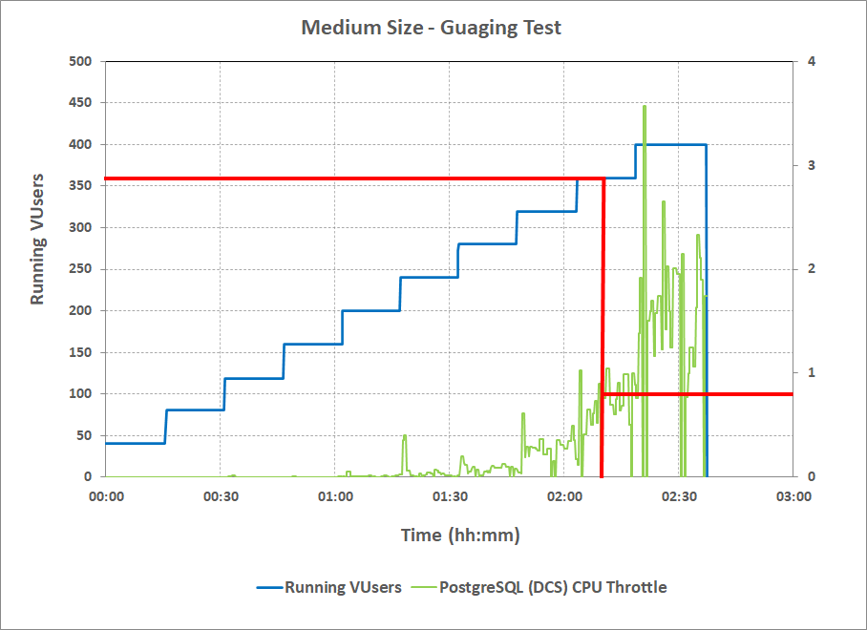

Figure-4: Medium Size – Gauging Test Graph

**Observations:**

* Beyond 320 users load; PostgreSQL (DCS) POD Throttling CPU had increased beyond 1 CPU cores, due to this few transaction’s response time went beyond 2 seconds SLA.

#### Conclusion:

Based on the above observations, 320 users load was considered as gauging point for medium size.

### Standard Load Test

The combined test scenario was executed with 320 users, as determined in the gauging test. The test scenarios details can be found in Appendix D - Detailed Test Scenarios.

Users ramp up rate was 1 user every 5 seconds; it took around 30 minutes to bring all the 320 users into the system.

#### User mix

Table-14 contains the exact number of users considered for each of the test scenarios for running the combined test scenario with 320 users. The following table was calculated based on the user load distribution % located at User load distribution.

Table-14: User Load Distribution

|  |  |  |
| --- | --- | --- |
| **#** | **Test Scenario** | **User Load Distribution** |
| 1 | Folder operations | 64 |
| 2 | Document metadata operations | 64 |
| 3 | Favorite operations | 16 |
| 4 | Document versioning | 32 |
| 5 | Document import | 32 |
| 6 | Document preview & export | 32 |
| 7 | Outlook attachments import into repository | 7 |
| 8 | Attach repository document to the email | 16 |
| 9 | Full-text search | 45 |
| 10 | Bulk-import | 3 |
| 11 | Documents import with checksum | 6 |
| 12 | Check Document Versions | 3 |
|  | **Total** | **320** |

#### Client-Side Metrics

Table-15 shows the client-side metrics calculated from the Silk Performer Tool test report. A stable period of 1 hour was considered for presenting the test results.

*Table-15: Overall Summary*

|  |  |
| --- | --- |
| Test duration (hh:mm) | 01:00 |
| Concurrent users | 320 |
| **Throughput** | |
| Avg. throughput - Sent [kB]/sec | 1,040.96 |
| Avg. throughput - Received [kB]/sec | 10,166.09 |
| Avg. HTTP hits/sec | 318.06 |

Table-16 contains the response times of the transactions that were part of standard load test

*Table-16: Client-Side Statistics*

|  |  |  |  |  |
| --- | --- | --- | --- | --- |
| **#** | **Scenarios** | **Name** | **Count** | **Average Response Time (seconds)** |
| 0 | Common Transactions across all scenarios | w000_LaunchAddin | 320 | 0.21 |
| w001_Login | 320 | 0.38 |
| w002_OpenHomeCabinet | 1,45,319 | 0.05 |
| w003_OpenRndFolder | 1,88,178 | 0.03 |
| 1 | Folder operations | s1_a0_ClickOnAddButton | 14,921 | 0.23 |
| s1_a1_EnterFolderNameClickSave | 14,915 | 0.12 |
| 2 | Document metadata operations | s2_a0_OpenDocument | 14,845 | 0.14 |
| s2_a1_ViewDocumentProperties | 14,846 | 0.23 |
| s2_a2_EditTileAndClickOnSave | 14,844 | 0.09 |
| 3 | Favourite operations | s3_a0_AddDocumentAsFav | 3,791 | 0.04 |
| s3_a1_BrowseFavouritiesDocs | 3,795 | 0.02 |
| s3_a2_UnFavouriteTheDocument | 3,789 | 0.06 |
| 4 | Document versioning | s4_a0_OpenDocument | 4,621 | 0.10 |
| s4_a1_LockTheDocument | 9,236 | 0.13 |
| s4_a2_UnLockTheDocument | 4,616 | 0.10 |
| s4_a3_SubmitUpdatedDocument | 4,616 | 0.24 |
| s4_a4_ClickOnSave | 4,619 | 0.17 |
| 5 | Document import | s5_a0_ClickOnSaveAs | 6,076 | 0.57 |
| s5_a1_EnterFileDetailsClickSave | 6,077 | 0.23 |
| s5_a2_ViewImportedDocument | 6,080 | 0.07 |
| 6 | Document preview & export | s6_a1_OpenDocument_10MB | 1,209 | 0.70 |
| s6_a1_OpenDocument_42KB | 11,306 | 0.08 |
| 7 | Outlook attachments import into repository | s7_a0_ImportEmail1Attachment | 1,547 | 0.43 |
| s7_a1_ImportEmail3Attachment | 1,547 | 0.79 |
| 8 | Attach repository document to the email | s8_a0_RepositoryDocumentToEmailAsAttachment_10MB | 453 | 0.67 |
| s8_a0_RepositoryDocumentToEmailAsAttachment_42KB | 4,269 | 0.05 |
| 9 | Full-text search | s9_a0_CCESearchSuggestions | 17,069 | 0.03 |
| s9_a1_FullTextSearch | 17,070 | 0.39 |
| 10 | Bulk-import search | s10_a0_BulkImport5Items | 820 | 1.06 |
| 11 | Document import with checksum | s11_a0_MoveEmail1Attachment | 1,312 | 0.41 |
| s11_a1_MoveEmail3Attachment | 1,314 | 0.92 |
| 12 | Check Document Versions | s12_a0_ViewDocumentVersions | 1,187 | 0.05 |

**Observations:**

* All the transaction average response times were within SLA of 2 seconds and there are no errors or failures observed during the test.

**Response Times Graph**

Figure-5 shows the Average Response Time trend of the top five high response time transactions during the stable user load.

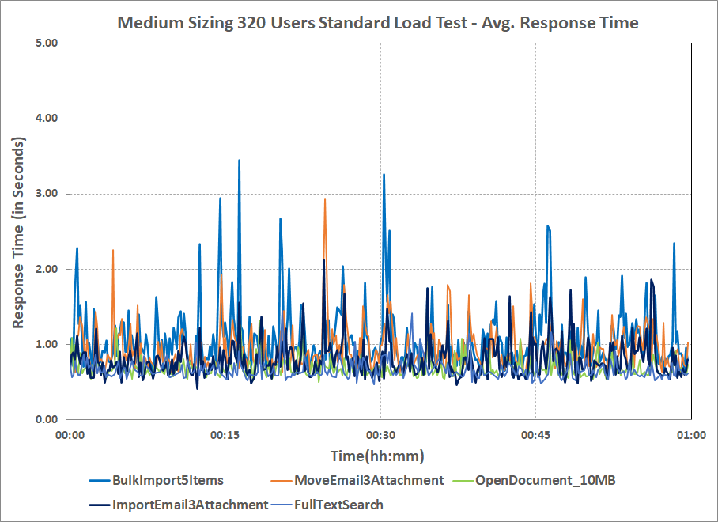

*Figure-5: Medium Size - Standard Load Test - Average Response Time*

**Observations:**

* Overall average response time of all the transactions were within SLA of 2 seconds.

#### Server-Side Metrics

Table-17 contains the POD metrics that were captured during the Load Test.

Table-17: POD Statistics

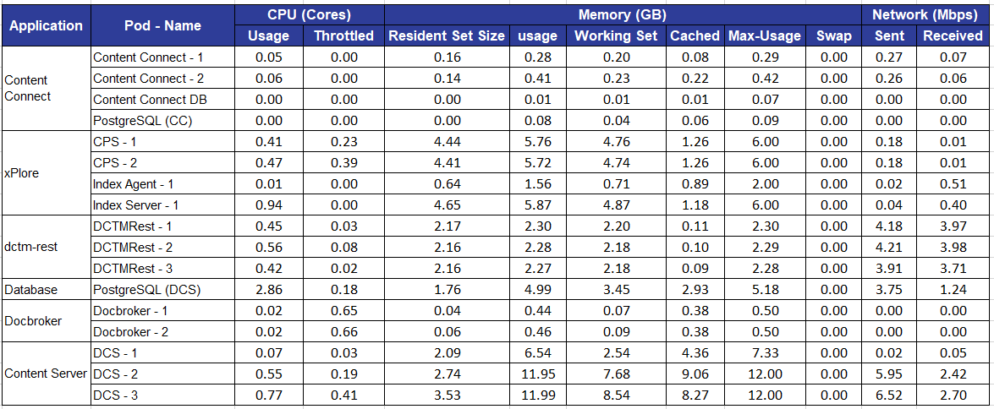

**Observations:**

* The Postgres (DCS) PODs CPU usage was around 2.86 CPU and all other PODs CPU usage was < 1.

**CPU Utilization Graph**

Figure-6 shows the CPU utilization of major PODs during the stable user load.

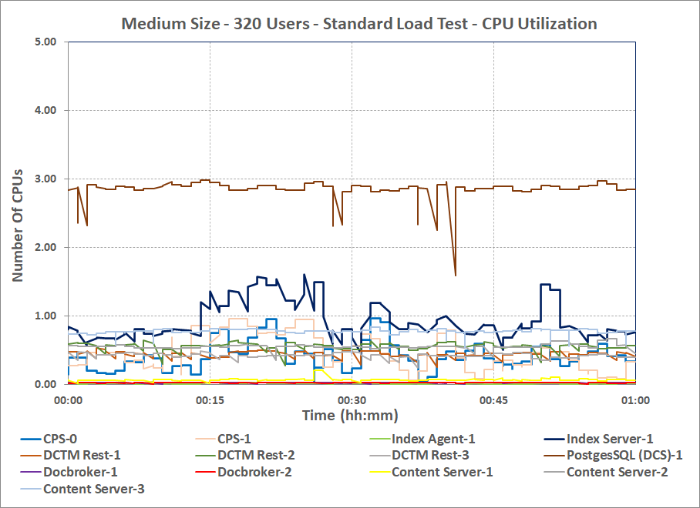

Figure-6: Medium Size - Standard Load Test - Major Pods CPU Utilization

**Observations:**

* All the PODs CPU utilization were less than 3 CPUs.

Table-18 contains the K8s node and VM metrics that were captured during the Load Test.

Table-18: K8s Node and VM Statistics

|  |  |  |  |  |  |
| --- | --- | --- | --- | --- | --- |
|  | **Node 1** | **Node 2** | **Node 3** | **Node 4** | **CCE** |
| **(K8s)** | **(K8s)** | **(VM)** | **(VM)** | **(Windows VM)** |
| **CPU Usage (Cores)** | | | | | |
| Total | 3.78 | 2.04 | 4.41 | 0.57 | 0.43 |
| User | 1.59 | 1.43 | 3.62 | 0.45 | 0.26 |
| System | 1.01 | 0.31 | 0.34 | 0.07 | 0.17 |
| Iowait | 0.86 | 0.14 | 0.19 | 0.01 | NA |
| Softirq | 0.31 | 0.16 | 0.26 | 0.04 | NA |
| irq | 0 | 0 | 0 | 0 | NA |
| nice | 0 | 0 | 0 | 0 | NA |
| steal | 0 | 0 | 0 | 0 | NA |
| steal | 0 | 0 | 0 | 0 | NA |
| steal | 0 | 0 | 0 | 0 | NA |
| idle | 13.95 | 15.73 | 13.39 | 17.33 | 99.34 |
| **Memory usage (GB)** | | | | | |
| Total | 58.98 | 58.98 | 58.98 | 58.98 | 16 |
| Used (Total - (Free + Cached + Buffers)) | 19.41 | 24.32 | 12.22 | 5.87 | 10.73 |
| Free | 30.96 | 12.55 | 3.91 | 1.59 | 4.09 |
| Cached | 7.83 | 21.69 | 42.12 | 51.05 | 1.18 |
| Buffers | 0.78 | 0.42 | 0.73 | 0.47 | NA |
| **Load Average** | | | | | |
| Load Average 1m | 5.33 | 2.46 | 5.43 | 0.59 | NA |
| Load Average 5m | 5.4 | 2.51 | 5.41 | 0.6 | NA |
| Load Average 15m | 5.38 | 2.53 | 5.1 | 0.58 | NA |
| **Network Usage (Mbps)** | | | | | |
| Sent | 384.42 | 184.41 | 266.17 | 156.24 | 0.02 |
| Received | 372.75 | 193.29 | 279.5 | 157.91 | 0.02 |

NA - Not Applicable

**Observations:**

* No resource contention was observed in the K8s nodes or the VMs.

Table-19 contains the Major POD and VM I/O metrics that were captured during the Load Test.

Table -19: POD, VM I/O Statistics

|  |  |  |  |  |  |  |  |
| --- | --- | --- | --- | --- | --- | --- | --- |
| **Container/VM** | **Disk Queue Length** | **Reads/sec** | **Writes/sec** | **Read Rate (MB/Sec)** | **Write Rate (MB/sec)** | **Read Latency (msec)** | **Write Latency (msec)** |
| Content Server (dcs-pg-pvc) - Node2 | NA | 5 | 6 | 2.25 | 0.39 | 19 | 11 |
| Content Server (dcs-pg-pvc) - Node3 | NA | 5 | 4 | 1.88 | 0.36 | 18 | 12 |
| Content Server (dcs-pg-pvc) - Node4 | NA | < 0.01 | < 0.01 | < 0.01 | < 0.01 | < 0.01 | < 0.01 |
| PostgreSQL (DCS) | 1 | < 0.01 | 90 | < 0.01 | 2.06 | < 0.01 | 7 |
| Contextual Content Engine (CCE) | < 0.01 | NA | NA | NA | NA | < 0.01 | < 0.01 |

NA - Not Applicable

**Observations:**

* The Content Server PODs cumulative I/O throughput rate was 4.13 read and 0.75 write MB/sec.
* The PostgreSQL (DCS) POD I/O throughput rate was 2.06 write MB/sec.

### Conclusion

The medium size was able to handle 320 concurrent users, with all transaction response times < 2 seconds.

## Large Size

The deployment was created based on the Large Size details as shown in Appendix B – Cloud Sizing Guide.

**PODs allocation in the K8s nodes**

The performance lab K8s cluster consists of 12 worker nodes; only four worker nodes were assigned for this assessment. All the PODs that were created as part of this test scenario need to be placed in one of these four worker nodes only. After deploying the application using the Helm chart, Table-6 shows the corresponding created PODs worker node location. This information would help to understand resource usage and NFS mount attachments variations among the worker nodes.

Table-20: POD location details

|  | **k8s - Node 1** | **k8s - Node 2** | **k8s - Node 3** | **K8s – Node 4** |
| --- | --- | --- | --- | --- |
| POD Name's and Replica number | Content Connect – 2  CPS - 2  Index Server - 1  Index Agent – 1  DCTM Rest - 1  DCTM Rest – 2  D2 client - 1  D2 config - 1 | CPS – 1  DCTM Rest – 3  Content Server – 2  Content Server – 4 | Docbroker - 1  Docbroker - 2  Docbroker - 3  Content Server – 1  Content Server – 3  Content Server – 5  PostgreSQL (CC) – 1 | PostgreSQL (DCS) - 1 |

### User Gauging

The scalability point of a system was defined as the maximum load that the system can support without compromising on end-user performance experience. The purpose of the gauging test was to determine the scalability point of a system. This was done by subjecting the system to an increasing user load to the point beyond which the addition of users caused the response time to increase beyond the SLA or system resources, to reach the saturation point or system generating application exceptions.

Figure 7 shows the Large Size combined test scenario gauging graph.

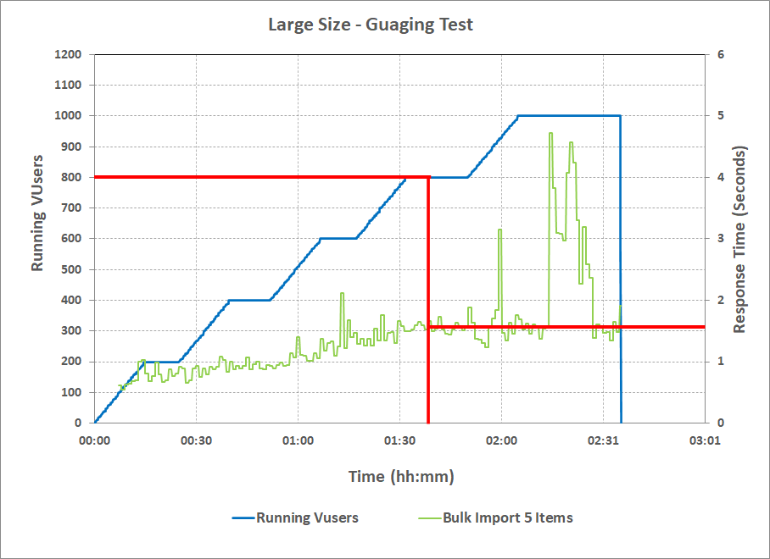

Figure-7: Large Cloud Size – Gauging Test Graph

**Observations:**

* Beyond 800 users load; the “Bulk Import 5 items” transaction response time went beyond 2 seconds SLA.

#### Conclusion:

Based on the above observations, 800 users load was considered as the gauging point for large size.

### Standard Load Test

The combined test scenario was executed with 800 users, as determined in the gauging test. The test scenarios details can be found in Appendix D - Detailed Test Scenarios.

Users ramp up rate was 1 user every 5 seconds; it took around 60 minutes to bring all the 800 users into the system.

User mix

Table-21 contains the exact number of users considered for each of the test scenarios for running the combined test scenario with 800 users. The following table was calculated based on the user load distribution % located at User load distribution.

Table-21: User Load Distribution

|  |  |  |
| --- | --- | --- |
| **#** | **Test Scenario** | **User Load Distribution** |
| 1 | Folder operations | 160 |
| 2 | Document metadata operations | 160 |
| 3 | Favorite operations | 40 |
| 4 | Document versioning | 80 |
| 5 | Document import | 80 |
| 6 | Document preview & export | 80 |
| 7 | Outlook attachments import into repository | 16 |
| 8 | Attach repository document to the email | 40 |
| 9 | Full-text search | 112 |
| 10 | Bulk-import | 8 |
| 11 | Document import with checksum | 16 |
| 12 | Check Document Versions | 8 |
|  | **Total** | **800** |

#### Client-Side Metrics

Table-22 shows the client side metrics calculated from the Silk Performer Tool test report. A stable period of 1 hour was considered for presenting the test results.

*Table-22: Overall Summary*

|  |  |
| --- | --- |
| Test duration (hh:mm) | 01:00 |
| Concurrent users | 800 |
| **Throughput** | |
| Avg. throughput - Sent [kB]/sec | 2,505.94 |
| Avg. throughput - Received [kB]/sec | 25,492.28 |
| Avg. HTTP hits/sec | 775.17 |

Table-23 contains the response times of the transactions that were part of standard load test.

*Table-23: Client-Side Statistics*

|  |  |  |  |  |
| --- | --- | --- | --- | --- |
| **#** | **Scenarios** | **Name** | **Count** | **Average Response Time (seconds)** |
| 0 | Common Transactions across all scenarios | w000_LaunchAddin | 800 | 0.25 |
| w001_Login | 800 | 0.49 |
| w002_OpenHomeCabinet | 3,56,603 | 0.12 |
| w003_OpenRndFolder | 4,61,327 | 0.09 |
| 1 | Folder operations | s1_a0_ClickOnAddButton | 36,484 | 0.31 |
| s1_a1_EnterFolderNameClickSave | 36,482 | 0.20 |
| 2 | Document metadata operations | s2_a0_OpenDocument | 36,256 | 0.23 |
| s2_a1_ViewDocumentProperties | 36,263 | 0.31 |
| s2_a2_EditTileAndClickOnSave | 36,263 | 0.15 |
| 3 | Favorite operations | s3_a0_AddDocumentAsFav | 9,302 | 0.10 |
| s3_a1_BrowseFavouritiesDocs | 9,300 | 0.07 |
| s3_a2_UnFavouriteTheDocument | 9,297 | 0.12 |
| 4 | Document versioning | s4_a0_OpenDocument | 11,256 | 0.17 |
| s4_a1_LockTheDocument | 22,517 | 0.22 |
| s4_a2_UnLockTheDocument | 11,258 | 0.19 |
| s4_a3_SubmitUpdatedDocument | 11,261 | 0.33 |
| s4_a4_ClickOnSave | 11,260 | 0.27 |
| 5 | Document import | s5_a0_ClickOnSaveAs | 14,805 | 0.66 |
| s5_a1_EnterFileDetailsClickSave | 14,806 | 0.38 |
| s5_a2_ViewImportedDocument | 14,805 | 0.13 |
| 6 | Document preview & export | s6_a1_OpenDocument_10MB | 3,149 | 0.81 |
| s6_a1_OpenDocument_42KB | 27,406 | 0.16 |
| 7 | Outlook attachments import into repository | s7_a0_ImportEmail1Attachment | 3,365 | 0.66 |
| s7_a1_ImportEmail3Attachment | 3,363 | 1.19 |
| 8 | Attach repository document to the email | s8_a0_RepositoryDocumentToEmailAsAttachment_10MB | 1,202 | 0.80 |
| s8_a0_RepositoryDocumentToEmailAsAttachment_42KB | 10,404 | 0.13 |
| 9 | Full-text search | s9_a0_CCESearchSuggestions | 41,327 | 0.09 |
| s9_a1_FullTextSearch | 41,329 | 0.47 |
| 10 | Bulk-import search | s10_a0_BulkImport5Items | 2,080 | 1.58 |
| 11 | Document import with checksum | s11_a0_MoveEmail1Attachment | 3,335 | 0.64 |
| s11_a1_MoveEmail3Attachment | 3,336 | 1.34 |
| 12 | Check Document Versions | s12_a0_ViewDocumentVersions | 3,084 | 0.12 |

**Observations:**

* All the transaction average response times were within SLA of 2 seconds and there were no errors or failures observed during the test.

**Response Times Graph**

Figure-8 shows the Average Response Time trend of the top five high response time transactions during the stable user load.

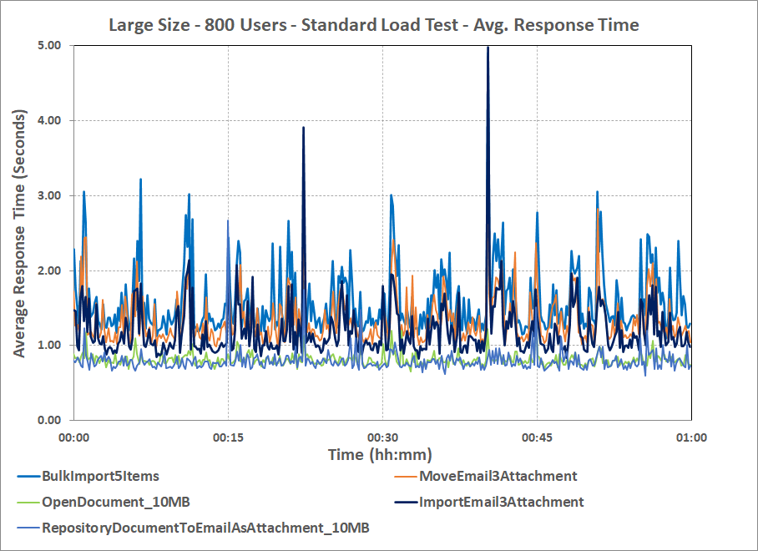

*Figure-8: Large Size - Standard Load Test - Average Response Time*

**Observations:**

* Few spikes in the transaction response time were observed intermediately but the average response times were < 2 seconds.

#### Server-Side Metrics

Table-24 contains the POD metrics that were captured during the Load Test.

Table-24: POD Statistics

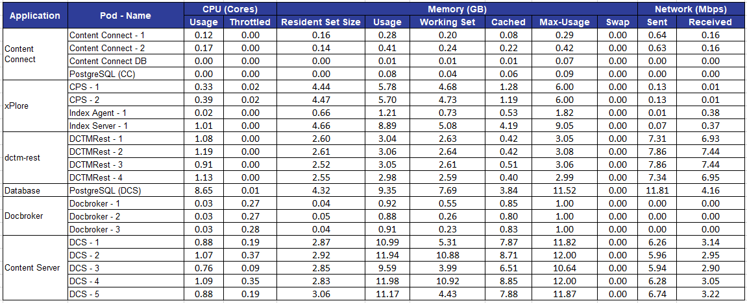

**Observations:**

* The PostgreSQL (DCS) PODs CPU usage was around 8.65 CPUs and all other PODs CPU usage was < 2.

**CPU Utilization Graph**

Figure-9 shows the CPU utilization of all the PODs during the stable user load.

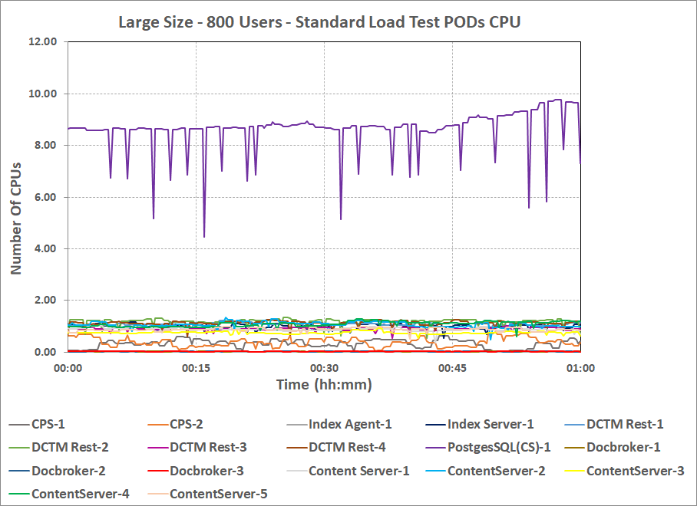

Figure-9: Large Size - Standard Load Test - Major Pods CPU Utilization

**Observations:**

* All the PODs CPU utilization were less than 2 CPUs except PostgreSQL (DCS) POD which had CPU Utilization < 10 CPUs.

Table-25: K8s Node and VM Statistics

|  |  |  |  |  |  |
| --- | --- | --- | --- | --- | --- |
|  | **Node 1** | **Node 2** | **Node 3** | **Node 4** | **CCE** |
| **(K8s)** | **(K8s)** | **(VM)** | **(VM)** | **(Windows VM)** |
| **CPU Usage (Cores)** | | | | | |
| Total | 6.92 | 4.78 | 4.87 | 9.25 | 1.19 |
| User | 3.95 | 2.79 | 2.8 | 7.81 | 0.78 |
| System | 1.35 | 0.75 | 0.62 | 0.64 | 0.41 |
| iowait | 0.85 | 0.55 | 0.77 | 0.14 | NA |
| softirq | 0.77 | 0.69 | 0.68 | 0.66 | NA |
| irq | 0 | 0 | 0 | 0 | NA |
| nice | 0 | 0 | 0 | 0 | NA |
| steal | 0 | 0 | 0 | 0 | NA |
| idle | 10.69 | 12.86 | 12.81 | 8.5 | 98.54 |
| **Memory usage (GB)** | | | | | |
| Total | 58.98 | 58.98 | 58.98 | 58.98 | 16 |
| Used (Total - (Free + Cached + Buffers)) | 28.44 | 26.75 | 15.05 | 7.94 | 11.38 |
| Free | 14.46 | 4.32 | 2.04 | 10.54 | 4.62 |
| Cached | 15.27 | 27.47 | 41.27 | 39.93 | 1.06 |
| Buffers | 0.81 | 0.44 | 0.62 | 0.57 | NA |
| **Load Average** | | | | | |
| Load Average 1m | 12.12 | 6.72 | 8.42 | 13.15 | NA |
| Load Average 5m | 12.11 | 7.12 | 8.51 | 13.09 | NA |
| Load Average 15m | 12.03 | 8.18 | 8.15 | 12.4 | NA |
| **Network Usage (Mbps)** | | | | | |
| Sent | 956.94 | 499.07 | 643.62 | 289.84 | 6.51 |
| Received | 944.33 | 529.81 | 734.26 | 298.57 | 1.49 |

NA - Not Applicable

**Observations:**

* No resource contention was observed in the K8s nodes or the VMs.

Table-26 contains the Major POD and VM I/O metrics that were captured during the Load Test.

Table -26: POD, VM I/O Statistics

|  |  |  |  |  |  |  |  |
| --- | --- | --- | --- | --- | --- | --- | --- |
| **Container/VM** | **Disk Queue Length** | **Reads/sec** | **Writes/sec** | **Read Rate (MB/Sec)** | **Write Rate (MB/sec)** | **Read Latency (msec)** | **Write Latency (msec)** |
| Content Server (dcs-pg-pvc) - Node2 | NA | 24 | 13 | 11.39 | 1.15 | 26 | 14 |
| Content Server (dcs-pg-pvc) - Node3 | NA | 9 | 9 | 3.88 | 0.75 | 23 | 13 |
| PostgreSQL (DCS) | 7 | < 0.01 | 373 | < 0.01 | 6.29 | 3 | 17 |
| Contextual Content Engine (CCE) | < 0.01 | NA | NA | NA | NA | < 0.01 | < 0.01 |

NA - Not Applicable

**Observations:**

* The Content Server PODs cumulative I/O throughput rate was 15.27 read and 1.9 write MB/sec.
* The PostgreSQL (DCS) POD I/O throughput rate was 6.29 write MB/sec.

### Conclusion

The large size was able to handle 800 concurrent users, with all transaction response times < 2 seconds.

### Endurance Test

The combined test scenario was executed with 800 users, as determined in the gauging test. The test scenarios details can be found in Appendix D - Detailed Test Scenarios.

Users ramp up rate was 1 user every 5 seconds; it took around 60 minutes to bring all the 800 users into the system.

#### User mix

Table-27 contains the exact number of users considered for each of the test scenarios for running the combined test scenario with 800 users. The following table was calculated based on the user load distribution % located at User load distribution.

Table-27: User Load Distribution

|  |  |  |
| --- | --- | --- |
| **#** | **Test Scenario** | **User Load Distribution** |
| 1 | Folder operations | 160 |
| 2 | Document metadata operations | 160 |
| 3 | Favorite operations | 40 |
| 4 | Document versioning | 80 |
| 5 | Document import | 80 |
| 6 | Document preview & export | 80 |
| 7 | Outlook attachments import into repository | 16 |
| 8 | Attach repository document to the email | 40 |
| 9 | Full-text search | 112 |
| 10 | Bulk-import | 8 |
| 11 | Document import with checksum | 16 |
| 12 | Check Document Versions | 8 |
|  | **Total** | **800** |

#### Client-Side Metrics

Table-28 shows the client side metrics calculated from the Silk Performer Tool test report. A stable period of 20 hour was considered for presenting the test results.

*Table-28: Overall Summary*

|  |  |
| --- | --- |
| Test duration (hh:mm) | 20:00 |
| Concurrent users | 800 |
| **Throughput** | |
| Avg. throughput - Sent [kB]/sec | 2,503.68 |
| Avg. throughput - Received [kB]/sec | 24940.13 |
| Avg. HTTP hits/sec | 775.09 |

Table-29 contains the response times of the transactions that were part of Endurance test.

*Table-29: Client-Side Statistics*

|  |  |  |  |  |
| --- | --- | --- | --- | --- |
| **#** | **Scenarios** | **Name** | **Count** | **Average Response Time (seconds)** |
| 0 | Common Transactions across all scenarios | w000_LaunchAddin | 800 | 0.23 |
| w001_Login | 800 | 0.5 |
| w002_OpenHomeCabinet | 7,832,473 | 0.22 |
| w003_OpenRndFolder | 10,146,897 | 0.17 |
| 1 | Folder operations | s1_a0_ClickOnAddButton | 7,28,596 | 0.32 |
| s1_a1_EnterFolderNameClickSave | 7,28,600 | 0.2 |
| 2 | Document metadata operations | s2_a0_OpenDocument | 7,25,042 | 0.22 |
| s2_a1_ViewDocumentProperties | 7,25,047 | 0.32 |
| s2_a2_EditTileAndClickOnSave | 7,25,037 | 0.15 |
| 3 | Favourite operations | s3_a0_AddDocumentAsFav | 1,86,065 | 0.1 |
| s3_a1_BrowseFavouritiesDocs | 1,86,062 | 0.07 |
| s3_a2_UnFavouriteTheDocument | 1,86,062 | 0.12 |
| 4 | Document versioning | s4_a0_OpenDocument | 2,25,205 | 0.17 |
| s4_a1_LockTheDocument | 4,50,425 | 0.22 |
| s4_a2_UnLockTheDocument | 2,25,211 | 0.18 |
| s4_a3_SubmitUpdatedDocument | 2,25,218 | 0.34 |
| s4_a4_ClickOnSave | 2,25,223 | 0.27 |
| 5 | Document import | s5_a0_ClickOnSaveAs | 2,96,288 | 0.65 |
| s5_a1_EnterFileDetailsClickSave | 2,96,288 | 0.37 |
| s5_a2_ViewImportedDocument | 2,96,283 | 0.13 |
| 6 | Document preview & export | s6_a1_OpenDocument_10MB | 61,340 | 0.8 |
| s6_a1_OpenDocument_42KB | 5,49,911 | 0.16 |
| 7 | Outlook attachments import into repository | s7_a0_ImportEmail1Attachment | 67,251 | 0.65 |
| s7_a1_ImportEmail3Attachment | 67,252 | 1.18 |
| 8 | Attach repository document to the email | s8_a0_RepositoryDocumentToEmailAsAttachment_10MB | 23,277 | 0.77 |
| s8_a0_RepositoryDocumentToEmailAsAttachment_42KB | 2,08,898 | 0.13 |
| 9 | Full-text search | s9_a0_CCESearchSuggestions | 8,25,536 | 0.09 |
| s9_a1_FullTextSearch | 8,25,536 | 0.49 |
| 10 | Bulk-import search | s10_a0_BulkImport5Items | 41,574 | 1.55 |
| 11 | Document import with checksum | s11_a0_MoveEmail1Attachment | 66,523 | 0.63 |
| s11_a1_MoveEmail3Attachment | 66,521 | 1.38 |
| 12 | Check Document Versions | s12_a0_ViewDocumentVersions | 61,850 | 0.12 |

**Observations:**

* All the transactions average response times were within SLA of 2 seconds and there are no errors or failures observed during the test.

**Response Times Graph**

Figure-10 shows the Average Response Time trend of Major Operations during the stable user load.

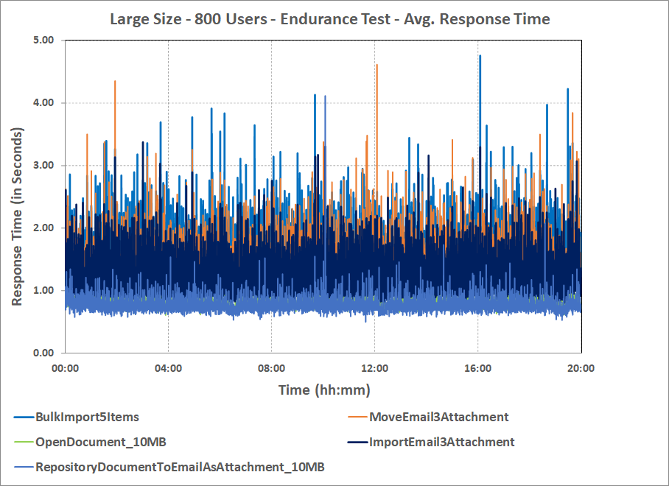

*Figure-10: Large Cloud Size Endurance Load Test - Average Response Time*

**Observations:**

* Overall average response time of all the transactions were within SLA of 2 seconds.

#### Server-Side Metrics

Table-30 contains the POD metrics that were captured during the Load Test.

Table-30: POD Statistics