1. Create a directory called ""my_folder"", navigate into it, and create a file named ""my_file.txt"" with some text. Then, create another file named ""another_file.txt"" with some text. Concatenate the content of ""another_file.txt"" to ""my_file.txt"" and display the updated content. Finally, list all files and directories in the current directory.
2. Create a directory:

Cmd: ***mkdir my_folder***

1. Create file:

* Create empty file

Cmd: ***touch*** my_file.txt

* Create file with content

Cmd: ***echo*** “Hello World” > another_file.txt

1. Display the content of two files:

Cmd: ***cat*** my_file.txt => cat my_file.txt another_file.txt(displays both contents)

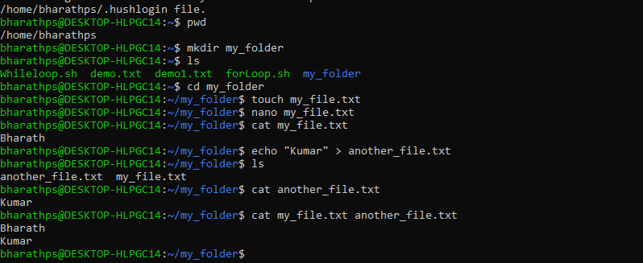

1. Append file contents of second file to first file:

Cmd: **cat** another_file.txt >> my_file.txt(the contents of another_file appended to my_file)

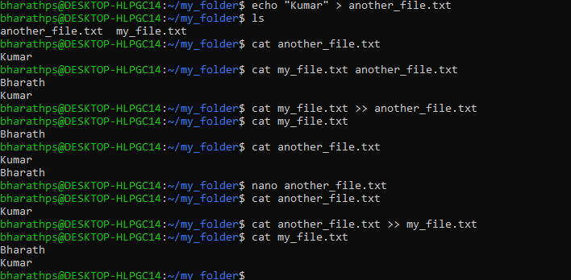

1. Concatenate contents of two files into a third file:

Cmd: **cat** my_file.txt another_file.txt **> merged_file.txt**

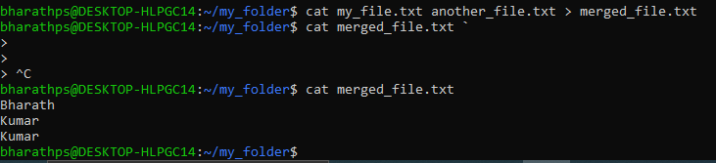

Listing all files inside created directory:

Cmd: ls



1. **Create 20 files with .txt extensions and rename the first 5 files to .yml extension and Print the latest created top 5 files among the total no of files".**
   1. Create 20 .txt file:

Cmd: ***for i in {1..20}; do touch file$i.txt; sleep 1; done***

* 1. Rename first 5 files to .yml file

Cmd: ***for i in {1..5}; do mv file$i.txt file$i.yml; done***

* 1. Print the latest created top 5 files:

Cmd***: ls -lt | head -n 5***

Following is the screenshot of the same:

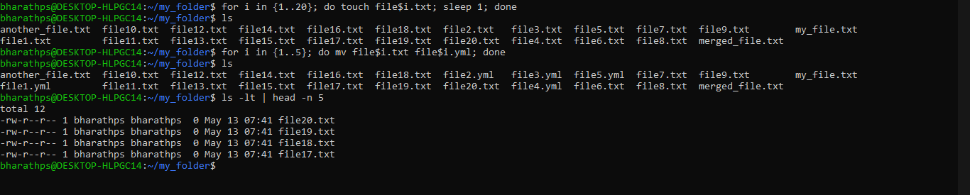

Note: The latest files are file file20.txt to file17.txt because, the **mv** will only rename the file names but does not change the file creation time. Thus these file names.

Its showing only four files bcz (1 total line + 4 files) for the command given.

Additional information:

For Listing newest 5 .txt file:

Cmd: ***ls -lt *.txt | head -n 5***

For Listing newest 5 .yml file:

Cmd: ***ls -lt *.yml | head -n 5***

For listing both combined:

Cmd: ***ls -lt *.txt *.yml 2>/dev/null | head -n 5***

The ***2>/dev/null*** suppresses errors if one of the patterns doesn't match any files (e.g., no .yml files exist yet).

