1.Get me the IP address of a particular domain (guvi.in). How do I find my CPU/memory usage of my server?. Test the connectivity between 2 nodes?

2.I have deployed an application in guvi.com:9000, and logs show my app is running, but I’m unable to view the page. Check whether my port is open or not ?

Get IP Address of a Domain:

Cmd: ***nslookup*** guvi.in

# or

***dig*** guvi.in ***+short***

# or

***host*** guvi.in

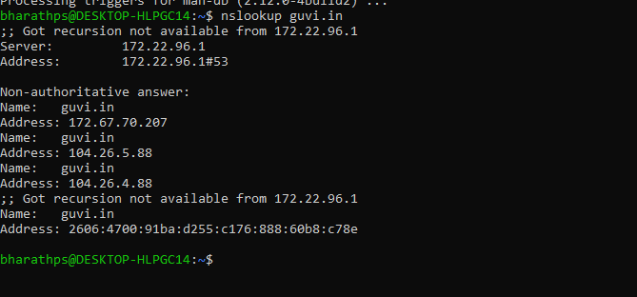

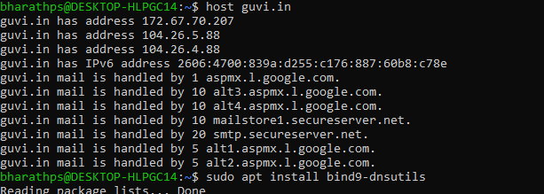

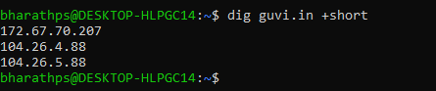

**Find CPU and Memory usage of the server:**

Cmd: **top**

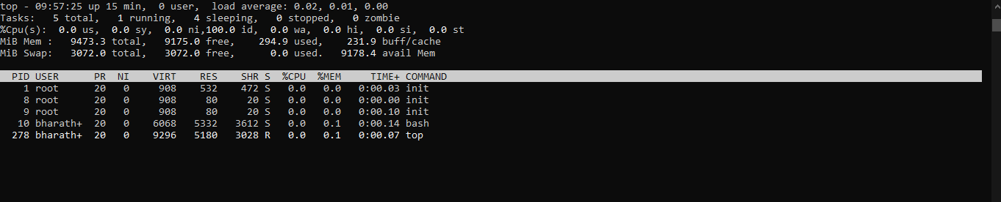

Cmd: **uptime**

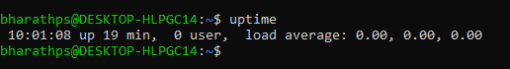

Cmd: **free –h**

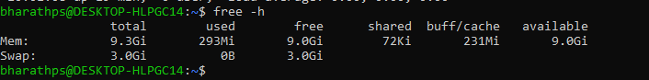

Cmd: **vmstat**

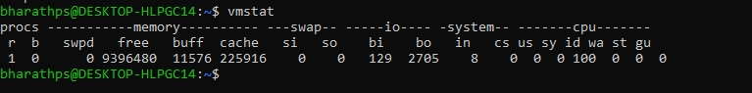

**Check Connectivity between two nodes**

Cmd: **ping** guvi.in

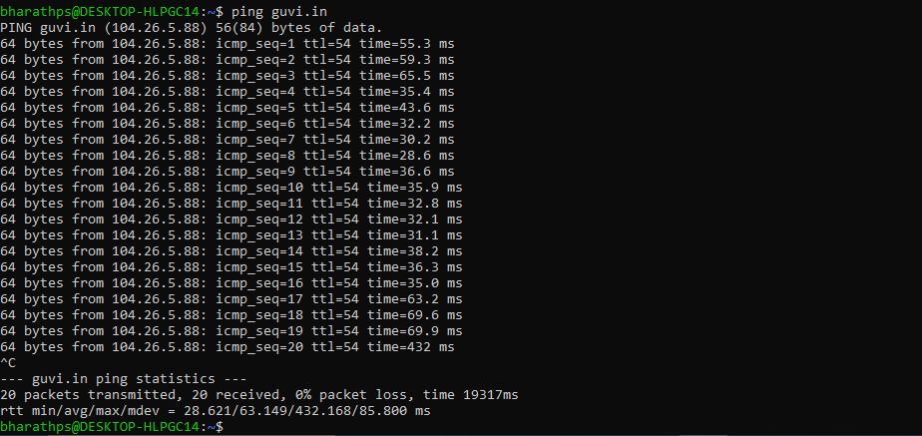

Cmd: **telnet** guvi.in 80(telnet <domainname or IP> <port>)

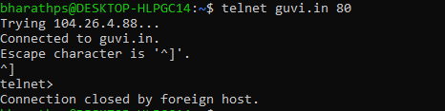

Cmd: **nc** **-zv** guvi.in 80



2.I have deployed an application in guvi.com:9000, and logs show my app is running, but I’m unable to view the page. Check whether my port is open or not ?

Check if port is open and listening:

Cmd: **sudo** **netstat** -tuln | grep :9000(on server) or

***sudo ss -tuln | grep :9000***