Vehicle accident detection

By

Bharath N Raikar

Rachana V

Rachana Pai

Shrreesha S Bhat

Technical Overview

Automatic detection of accidents and reporting is done by using GPS and GSM technology.

Vehicles will be installed with a microcontroller to which sensors such as accelerometer, GSM and GPS module, buzzer, switch will be attached. The accelerometer will sense the vibrations of the vehicle. If the vibrations of the vehicle goes abnormal then it will send the signal along with the position of vehicle to Arduino.  
All the information will be sent by the GSM and GPS module to the person’s emergency contacts and nearest hospitals. The location of the accident will be sent as a google maps link which will be easier to navigate faster.

Technical Overview

This chapter consists of the technical information regarding the components used in this deployed example.

1. Components used:
2. GPS module
3. GSM module
4. Accelerometer
5. Arduino Nano
6. Working
7. Components
8. GPS module:  
   The NEO-6M GPS module is a well-performing complete GPS receiver with a built-in 25 x 25 x 4mm ceramic antenna, which provides a strong satellite search capability. With the power and signal indicators, you can monitor the status of the module.

Features

1)A complete GPS module with an active antenna integrated, and a built-in EEPROM to save configuration parameter data.  
2) Built-in 25 x 25 x 4mm ceramic active antenna provides strong satellite search capability.  
3) Equipped with power and signal indicator lights and data backup battery.  
4) Power supply: 3-5V; Default baud rate: 9600bps.  
5) Interface: RS232 TTL

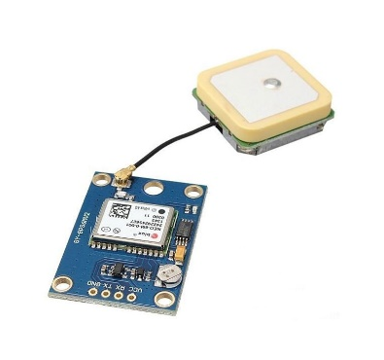

1. GSM module:

SIM800L is a miniature cellular module which allows for GPRS transmission, sending and receiving SMS and making and receiving voice calls. Low cost and small footprint and quad band frequency support make this module perfect solution for any project that require long range connectivity. After connecting power module boots up, searches for cellular network and login automatically. On board LED displays connection state (no network coverage - fast blinking, logged in - slow blinking).

## Specification

* Supply volta0ge: 3.8V - 4.2V
* Recommended supply voltage: 4V
* Power consumption:
  + sleep mode < 2.0mA
  + idle mode < 7.0mA
  + GSM transmission (avg): 350 mA
  + GSM transmission (peek): 2000mA
* Module size: 25 x 23 mm
* Interface: UART (max. 2.8V) and AT commands
* SIM card socket: microSIM (bottom side)
* Supported frequencies: Quad Band (850 / 950 / 1800 /1900 MHz)
* Antenna connector: IPX
* Status signaling: LED
* Working temperature range: -40 do + 85 ° C

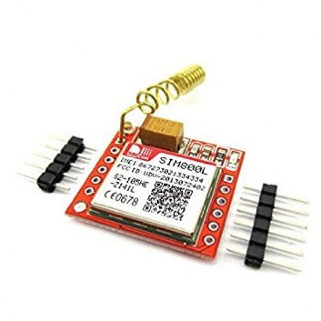

1. Accelerometer (ADX-335):

The **ADXL335** is a triple axis MEMS **accelerometer** with extremely low noise and power consumption - only 320uA! The sensor has a full sensing range of +/-3g

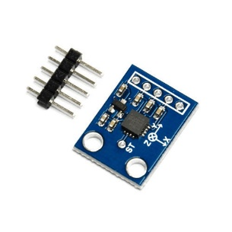

1. Arduino Nano:

The Arduino Nano is a small, complete, and breadboard-friendly board based on the ATmega328P (Arduino Nano 3.x)

Features:

|  |  |
| --- | --- |
| Microcontroller | ATmega328 |
| Architecture | AVR |
| Operating Voltage | 5 V |
| Flash Memory | 32 KB of which 2 KB used by bootloader |
| SRAM | 2 KB |
| Clock Speed | 16 MHz |
| Analog IN Pins | 8 |
| EEPROM | 1 KB |
| DC Current per I/O Pins | 40 mA (I/O Pins) |
| Input Voltage | 7-12 V |
| Digital I/O Pins | 22 (6 of which are PWM) |
| PWM Output | 6 |
| Power Consumption | 19 mA |
| PCB Size | 18 x 45 mm |
| Weight | 7g |
|  |  |

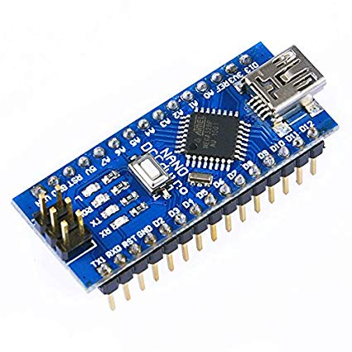

Additional Components

PCB design board to incorporate all the components on one platform.

LCD display for displaying the timer after which the message will be sent.

1. Working

The automatic detection and reporting of accidents are done using GPS and GSM technology. This device consists of a microcontroller, GPS, GSM, Accelerometer, LCD screen. When an accident takes place, the vibrations of the accelerometer are recorded and when the vibrations are very high, a timer of a few seconds starts. If the switch is not pressed before the timer ends, a message consisting of the location of the accident will be sent to the emergency contacts of the person affected, nearest hospitals and the police station.

Vibrations of accelerometer

Very High

Message sent to emergency contacts and hospitals with the location of the accident

GSM AND GPS module activated

switch

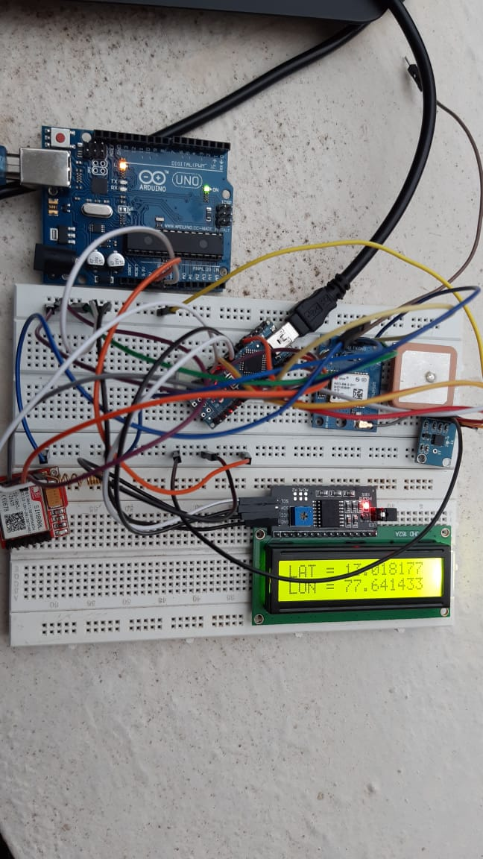

Future Scope

To this model, we can include pressure sensors on certain places of the vehicles and U-slot sensors. The U slot sensor detects the angle of the wheel

The inbuilt sensors already in the vehicles can be used. For example, the sensor used for detecting the airbag is open.

Gyroscope can be used to monitor the amount of leaning angle of vehicles which will be helpful in two wheelers.

The detection can also be measured using the movement of the steering after the accident

More efficiency can be achieved in g-domain than t-domain since we can attain greater accuracy while dealing with higher speeds.