SCHOOL OF COMPUTER SCIENCE ENGINEERING AND INFORMATION SYSTEMS
WINTER SEMESTER 2025-2026
FAT
AGILE DEVELOPMENT PROCESS AND DEVOPS LAB

NAME : P Naveenkumar
REG NO : 23MIS0515
SLOT : L47+ L48
COURSE CODE: ISWE406L
FACULTY : DR. BALA GANESH N

SET-6

Smart Electricity Billing System
Problem statement:
Ensure electricity usage is calculated and billed correctly
Tasks:
1.Develop billing calculation logic
2. Write Junit tests for tariff calculations
3.Implement CI/CD pipeline with automation testing
4.Deploy services on Docker and Kubernetes

App.java
package com.example;

public class App {
public static final int SLAB1_LIMIT = 100;
public static final int SLAB2_LIMIT = 300;
public static final int SLAB3_LIMIT = 500;
public static final double RATE_SLAB1 = 1.50;
public static final double RATE_SLAB2 = 2.50;
public static final double RATE_SLAB3 = 4.00;
public static final double RATE_SLAB4 = 6.00;
public static final double FIXED_METER_CHARGE = 50.00;
public static final double TAX_RATE = 0.05; // 5%

public static int calculateUnitsConsumed(int currentReading, int previousReading) {
if (currentReading < 0 || previousReading < 0) {
throw new IllegalArgumentException("Meter readings cannot be negative.");
}
if (currentReading < previousReading) {
throw new IllegalArgumentException("Current reading cannot be less than previous reading.");
}
return currentReading - previousReading;
}
public static double calculateEnergyCharge(int units) {
if (units < 0) {
throw new IllegalArgumentException("Units consumed cannot be negative.");
}

double charge = 0.0;
int remaining = units;
if (remaining > 0) {
int slabUnits = Math.min(remaining, SLAB1_LIMIT);
charge += slabUnits * RATE_SLAB1;
remaining -= slabUnits;
}
if (remaining > 0) {
int slabUnits = Math.min(remaining, SLAB2_LIMIT - SLAB1_LIMIT);
charge += slabUnits * RATE_SLAB2;
remaining -= slabUnits;
}
if (remaining > 0) {
int slabUnits = Math.min(remaining, SLAB3_LIMIT - SLAB2_LIMIT);
charge += slabUnits * RATE_SLAB3;
remaining -= slabUnits;
}
if (remaining > 0) {
charge += remaining * RATE_SLAB4;
}

return charge;
}

public static double calculateTax(double energyCharge) {
return energyCharge * TAX_RATE;
}
public static double calculateTotalBill(int units) {
double energyCharge = calculateEnergyCharge(units);
double tax = calculateTax(energyCharge);
return energyCharge + tax + FIXED_METER_CHARGE;
}
public static String generateBill(String customerName, int currentReading, int previousReading) {
int units = calculateUnitsConsumed(currentReading, previousReading);
double energyCharge = calculateEnergyCharge(units);
double tax = calculateTax(energyCharge);
double totalBill = calculateTotalBill(units);

StringBuilder sb = new StringBuilder();
sb.append("========================================\n");
sb.append(" ELECTRICITY BILL SUMMARY \n");
sb.append("========================================\n");
sb.append(String.format("Customer Name : %s%n", customerName));
sb.append(String.format("Previous Reading : %d kWh%n", previousReading));
sb.append(String.format("Current Reading : %d kWh%n", currentReading));
sb.append(String.format("Units Consumed : %d units%n", units));
sb.append("----------------------------------------\n");
sb.append(String.format("Energy Charge : ₹%.2f%n", energyCharge));
sb.append(String.format("Tax (5%%) : ₹%.2f%n", tax));
sb.append(String.format("Meter Charge : ₹%.2f%n", FIXED_METER_CHARGE));
sb.append("----------------------------------------\n");
sb.append(String.format("TOTAL AMOUNT DUE : ₹%.2f%n", totalBill));
sb.append("========================================\n");
return sb.toString();
}

public static void main(String[] args) {
System.out.println("Electricity Billing System initialized.\n");

// Example bill generation
String bill = generateBill("Naveen Kumar", 5350, 4900);
System.out.println(bill);
}
}

AppTest.java:
package com.example;

import junit.framework.TestCase;
public class AppTest extends TestCase {
public void testCalculateUnitsConsumed_NormalUsage() {
assertEquals(450, App.calculateUnitsConsumed(5350, 4900));
}

public void testCalculateUnitsConsumed_ZeroUsage() {
assertEquals(0, App.calculateUnitsConsumed(1000, 1000));
}

public void testCalculateUnitsConsumed_SmallUsage() {
assertEquals(1, App.calculateUnitsConsumed(101, 100));
}

public void testCalculateUnitsConsumed_LargeUsage() {
assertEquals(10000, App.calculateUnitsConsumed(20000, 10000));
}

public void testCalculateUnitsConsumed_NegativeCurrentReading() {
try {
App.calculateUnitsConsumed(-100, 50);
fail("Expected IllegalArgumentException for negative current reading");
} catch (IllegalArgumentException e) {
assertEquals("Meter readings cannot be negative.", e.getMessage());
}
}

public void testCalculateUnitsConsumed_NegativePreviousReading() {
try {
App.calculateUnitsConsumed(100, -50);
fail("Expected IllegalArgumentException for negative previous reading");
} catch (IllegalArgumentException e) {
assertEquals("Meter readings cannot be negative.", e.getMessage());
}
}

public void testCalculateUnitsConsumed_CurrentLessThanPrevious() {
try {
App.calculateUnitsConsumed(100, 200);
fail("Expected IllegalArgumentException when current < previous");
} catch (IllegalArgumentException e) {
assertEquals("Current reading cannot be less than previous reading.", e.getMessage());
}
}

public void testEnergyCharge_ZeroUnits() {
assertEquals(0.0, App.calculateEnergyCharge(0), 0.01);
}

public void testEnergyCharge_Slab1_OneUnit() {
assertEquals(1.50, App.calculateEnergyCharge(1), 0.01);
}

public void testEnergyCharge_Slab1_FiftyUnits() {
assertEquals(75.00, App.calculateEnergyCharge(50), 0.01);
}

public void testEnergyCharge_Slab1_BoundaryExact() {
assertEquals(150.00, App.calculateEnergyCharge(100), 0.01);
}

public void testEnergyCharge_Slab2_BoundaryStart() {
assertEquals(152.50, App.calculateEnergyCharge(101), 0.01);
}

public void testEnergyCharge_Slab2_MidRange() {
assertEquals(400.00, App.calculateEnergyCharge(200), 0.01);
}

public void testEnergyCharge_Slab2_BoundaryExact(){
assertEquals(650.00, App.calculateEnergyCharge(300), 0.01);
}
public void testEnergyCharge_Slab3_BoundaryStart() {
assertEquals(654.00, App.calculateEnergyCharge(301), 0.01);
}

public void testEnergyCharge_Slab3_MidRange() {
assertEquals(1050.00, App.calculateEnergyCharge(400), 0.01);
}

public void testEnergyCharge_Slab3_450Units() {
assertEquals(1250.00, App.calculateEnergyCharge(450), 0.01);
}

public void testEnergyCharge_Slab3_BoundaryExact() {
assertEquals(1450.00, App.calculateEnergyCharge(500), 0.01);
}
public void testEnergyCharge_Slab4_BoundaryStart() {
assertEquals(1456.00, App.calculateEnergyCharge(501), 0.01);
}

public void testEnergyCharge_Slab4_LargeUsage() {
// 100 × 1.50 + 200 × 2.50 + 200 × 4.00 + 500 × 6.00
// = 150 + 500 + 800 + 3000 = 4450.00
assertEquals(4450.00, App.calculateEnergyCharge(1000), 0.01);
}

public void testEnergyCharge_NegativeUnits() {
try {
App.calculateEnergyCharge(-10);
fail("Expected IllegalArgumentException for negative units");
} catch (IllegalArgumentException e) {
assertEquals("Units consumed cannot be negative.", e.getMessage());
}
}

public void testTax_ZeroCharge() {
assertEquals(0.0, App.calculateTax(0.0), 0.01);
}

public void testTax_Slab1() {
// Energy charge for 100 units = 150.00, tax = 150 × 0.05 = 7.50
double energyCharge = App.calculateEnergyCharge(100);
assertEquals(7.50, App.calculateTax(energyCharge), 0.01);
}

public void testTax_Slab3() {
// Energy charge for 450 units = 1250.00, tax = 1250 × 0.05 = 62.50
double energyCharge = App.calculateEnergyCharge(450);
assertEquals(62.50, App.calculateTax(energyCharge), 0.01);
}

public void testTax_LargeCharge() {
// Energy charge for 1000 units = 4450.00, tax = 4450 × 0.05 = 222.50
double energyCharge = App.calculateEnergyCharge(1000);
assertEquals(222.50, App.calculateTax(energyCharge), 0.01);
}
public void testTotalBill_ZeroUnits() {
assertEquals(50.00, App.calculateTotalBill(0), 0.01);
}

public void testTotalBill_Slab1Only() {
assertEquals(207.50, App.calculateTotalBill(100), 0.01);
}

public void testTotalBill_Slab2Boundary() {
assertEquals(732.50, App.calculateTotalBill(300), 0.01);
}

public void testTotalBill_Slab3_450Units() {
assertEquals(1362.50, App.calculateTotalBill(450), 0.01);
}

public void testTotalBill_Slab4_1000Units() {
assertEquals(4722.50, App.calculateTotalBill(1000), 0.01);
}
public void testGenerateBill_ContainsCustomerName() {
String bill = App.generateBill("Naveen Kumar", 5350, 4900);
assertTrue(bill.contains("Naveen Kumar"));
}

public void testGenerateBill_ContainsUnitsConsumed() {
String bill = App.generateBill("Test User", 1200, 1000);
assertTrue(bill.contains("200 units"));
}

public void testGenerateBill_ContainsTotalAmount() {
String bill = App.generateBill("Test User", 1100, 1000);
// 100 units → Energy = 150, Tax = 7.50, Meter = 50 → Total = 207.50
assertTrue(bill.contains("207.50"));
}

public void testGenerateBill_ContainsMeterReadings() {
String bill = App.generateBill("Test User", 5000, 4500);
assertTrue(bill.contains("5000"));
assertTrue(bill.contains("4500"));
}
}

POM.XML:
<project xmlns="http://maven.apache.org/POM/4.0.0" xmlns:xsi="http://www.w3.org/2001/XMLSchema-instance"
xsi:schemaLocation="http://maven.apache.org/POM/4.0.0 http://maven.apache.org/maven-v4_0_0.xsd">
<modelVersion>4.0.0</modelVersion>
<groupId>com.example</groupId>
<artifactId>electricity-billing</artifactId>
<packaging>jar</packaging>
<version>1.0-SNAPSHOT</version>
<name>electricity-billing</name>
<url>http://maven.apache.org</url>

<properties>
<maven.compiler.source>17</maven.compiler.source>
<maven.compiler.target>17</maven.compiler.target>
<project.build.sourceEncoding>UTF-8</project.build.sourceEncoding>
</properties>

<dependencies>
<dependency>
<groupId>junit</groupId>
<artifactId>junit</artifactId>
<version>4.13.2</version>
<scope>test</scope>
</dependency>
</dependencies>

<build>
<plugins>
<!-- Compiler plugin -->
<plugin>
<groupId>org.apache.maven.plugins</groupId>
<artifactId>maven-compiler-plugin</artifactId>
<version>3.11.0</version>
<configuration>
<source>17</source>
<target>17</target>
</configuration>
</plugin>

<!-- Surefire plugin for running tests -->
<plugin>
<groupId>org.apache.maven.plugins</groupId>
<artifactId>maven-surefire-plugin</artifactId>
<version>3.1.2</version>
</plugin>

<!-- JAR plugin with main class manifest -->
<plugin>
<groupId>org.apache.maven.plugins</groupId>
<artifactId>maven-jar-plugin</artifactId>
<version>3.3.0</version>
<configuration>
<archive>
<manifest>
<mainClass>com.example.App</mainClass>
</manifest>
</archive>
</configuration>
</plugin>
</plugins>
</build>
</project>

Junit Test:
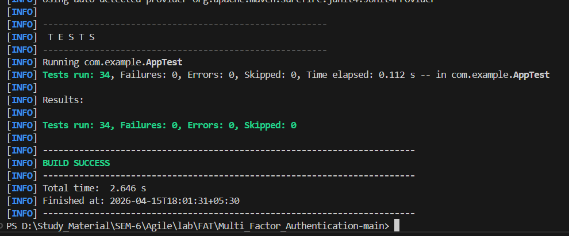
Local Build:
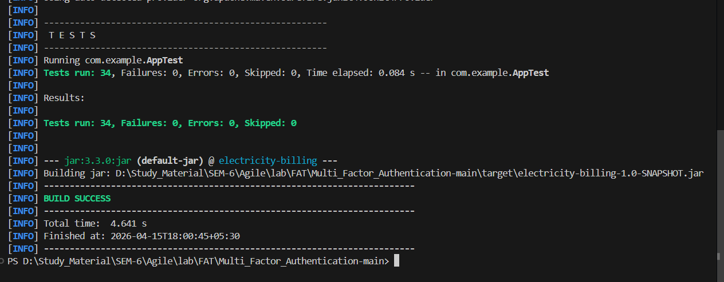

Git repo link : https://github.com/Naveenkumar-0331/electric_bill.git

GitHub init and commit:
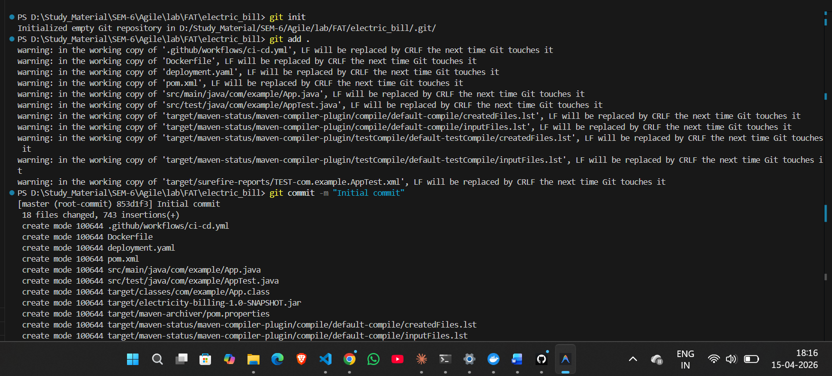
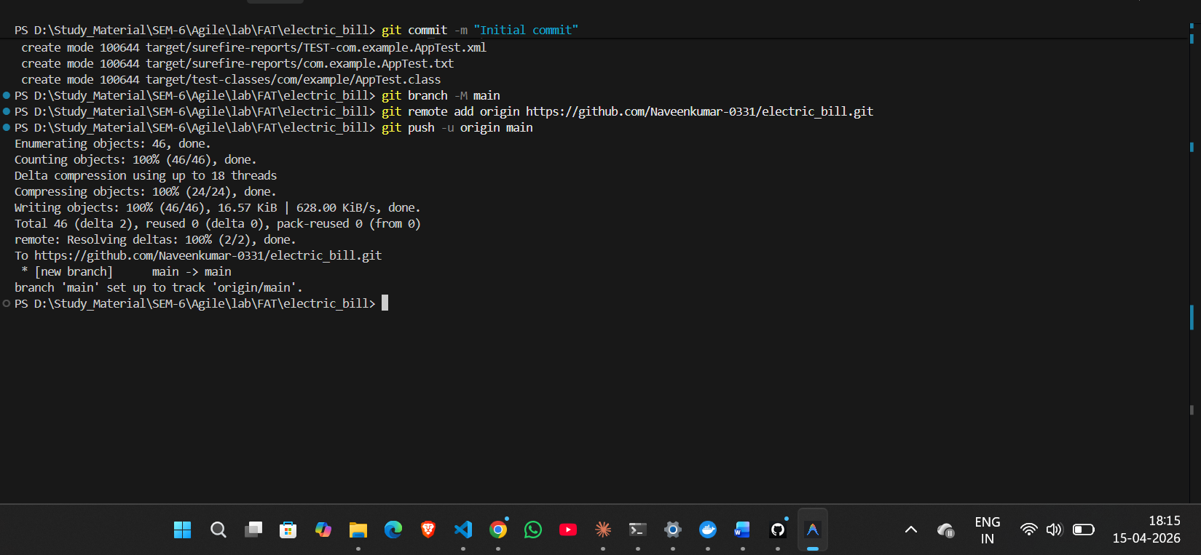

Github repo:
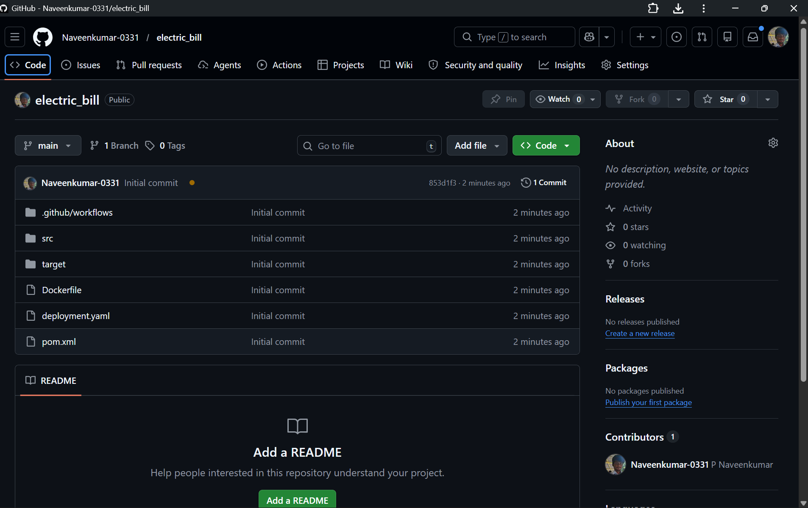

Jenkins:
Pipeline code:
pipeline {
agent any

environment {
DOCKER_IMAGE = "naveen14k/java-test-app:latest"
KUBECONFIG = "C:\\ProgramData\\Jenkins\\.kube\\config"
}
stages {
stage('Clone Repository') {
steps {
git branch: 'main',
url: 'https://github.com/Naveenkumar-0331/electric_bill.git'
}
}
stage('Build & Run Tests') {
steps {
bat 'mvn clean test'
}
post {
always {
junit 'target/surefire-reports/*.xml'
}
}
}
stage('Package Application') {
steps {
bat 'mvn package -DskipTests'
}
}
stage('Build Docker Image') {
steps {
bat "docker build -t %DOCKER_IMAGE% ."
}
}
stage('Push to DockerHub') {
steps {
withCredentials([usernamePassword(
credentialsId: 'docker',
usernameVariable: 'DOCKER_USER',
passwordVariable: 'DOCKER_PASS'
)]) {
bat """
docker login -u %DOCKER_USER% -p %DOCKER_PASS%
docker push %DOCKER_IMAGE%
"""
}
}
}
stage('Deploy to Kubernetes') {
steps {
bat 'kubectl apply -f deployment.yaml --validate=false'
}
}
}
}
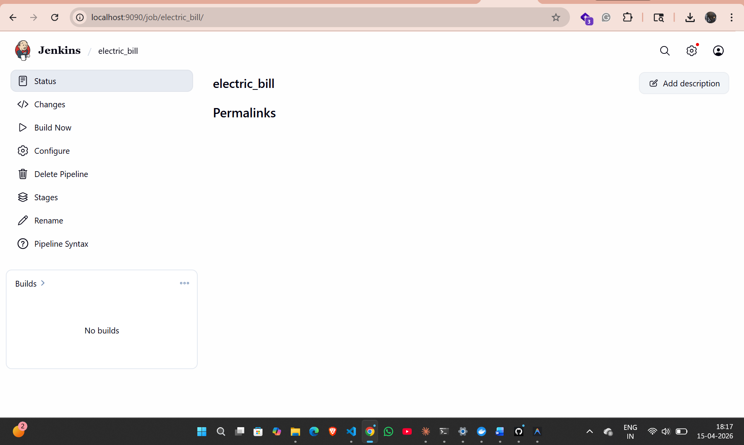

Maven Build in Jenkin:
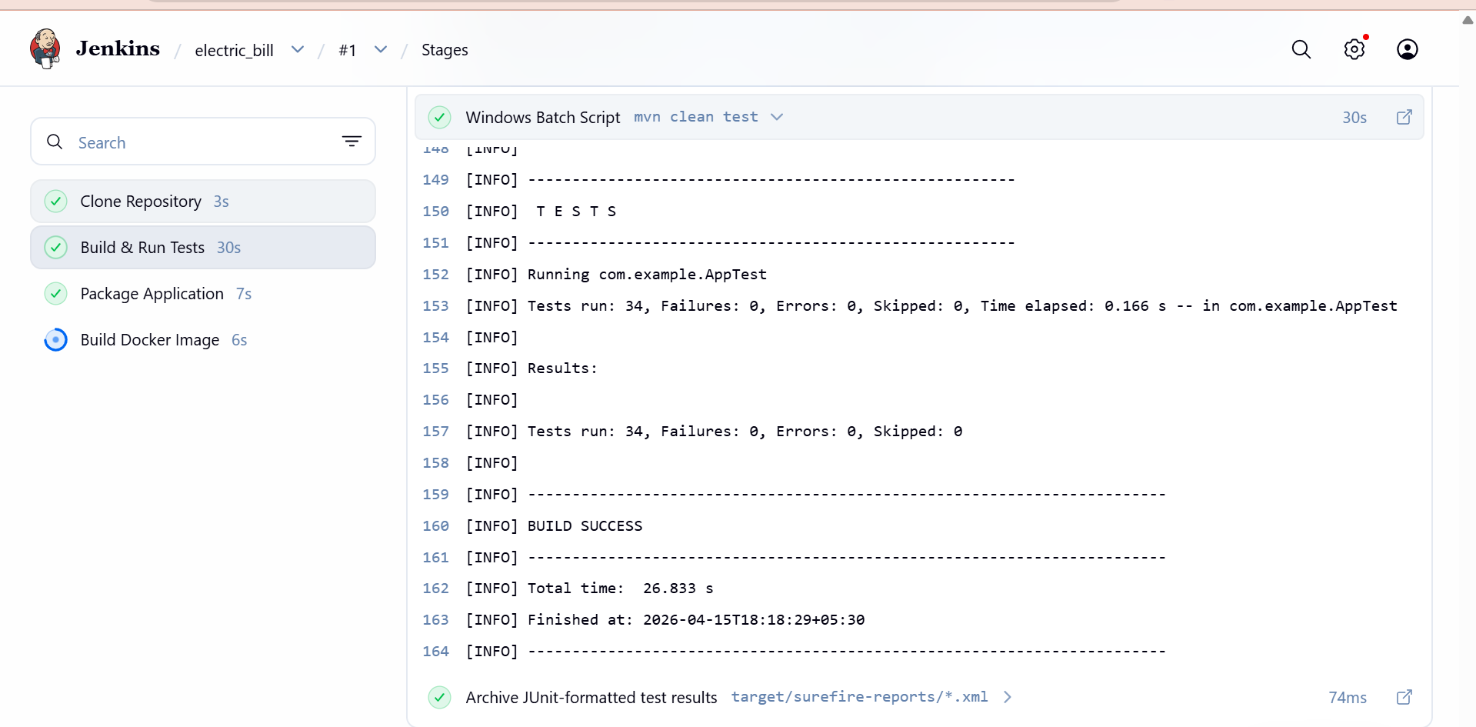

Automation Test in Jenkin:
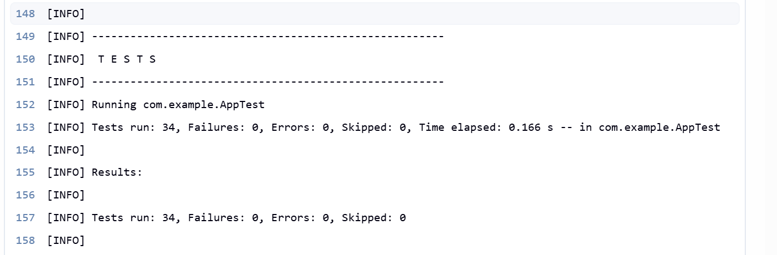

CI/CD pipeline in jenkin:
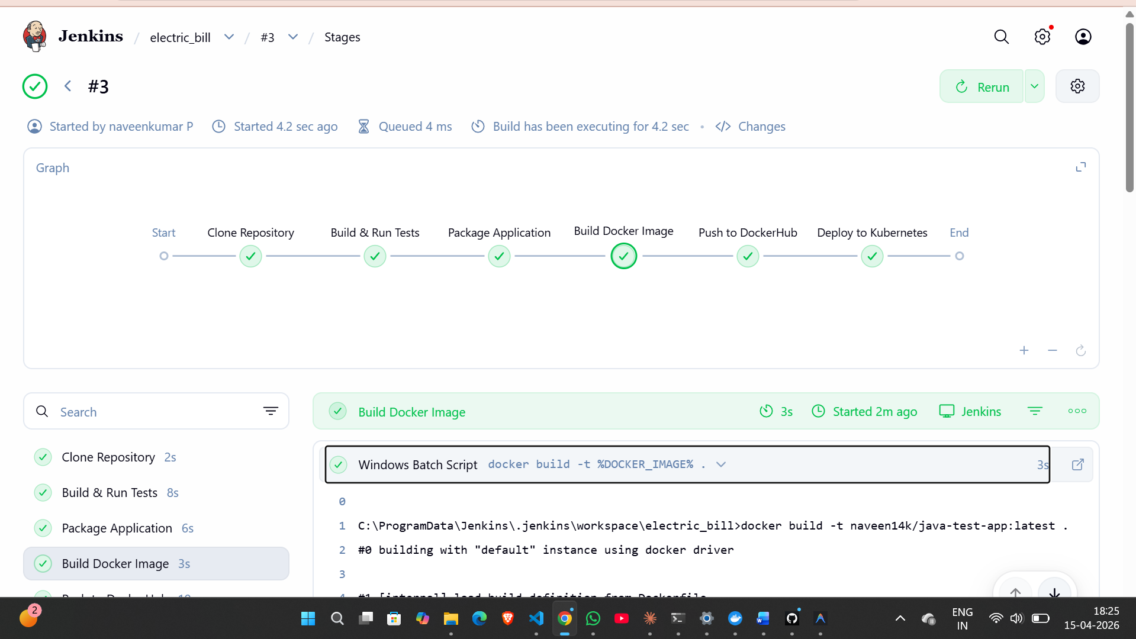

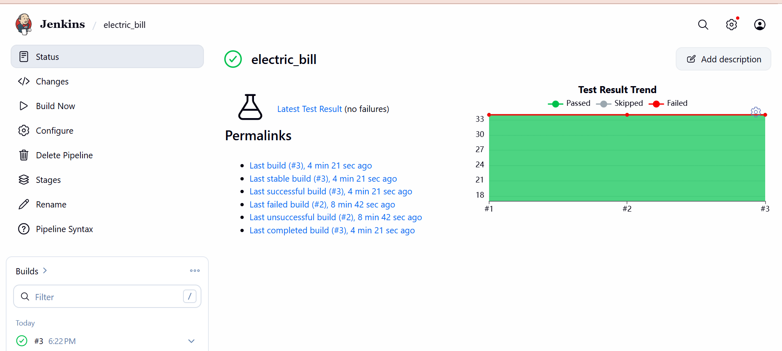

Dockerfile:
# Stage 1: Build the application
FROM maven:3.9-eclipse-temurin-17-alpine AS build
WORKDIR /app
COPY pom.xml .
COPY src ./src
RUN mvn clean package -DskipTests

# Stage 2: Run the application
FROM eclipse-temurin:17-jdk-alpine
WORKDIR /app
COPY --from=build /app/target/electricity-billing-1.0-SNAPSHOT.jar app.jar
EXPOSE 8080
ENTRYPOINT ["java", "-jar", "app.jar"]
Image creation in jenkin:
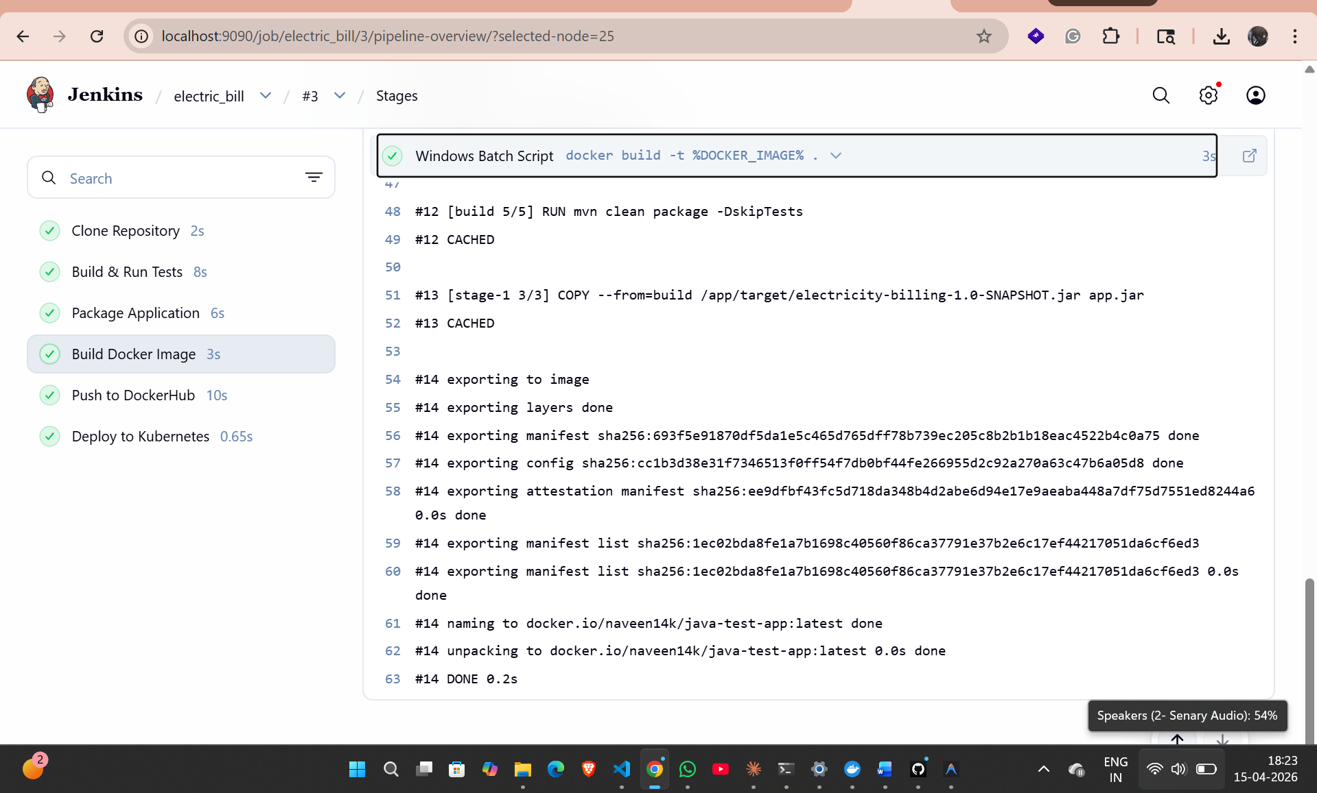

Docker Hub Image:
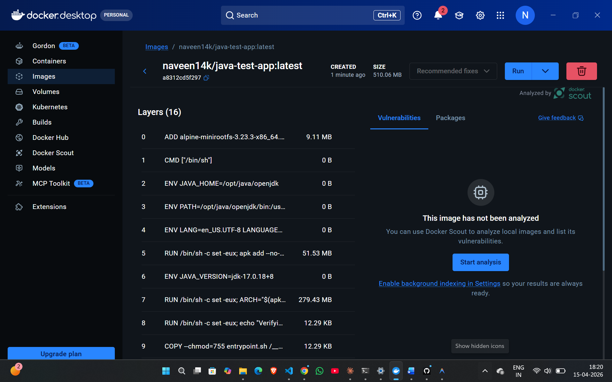

Docker Build:
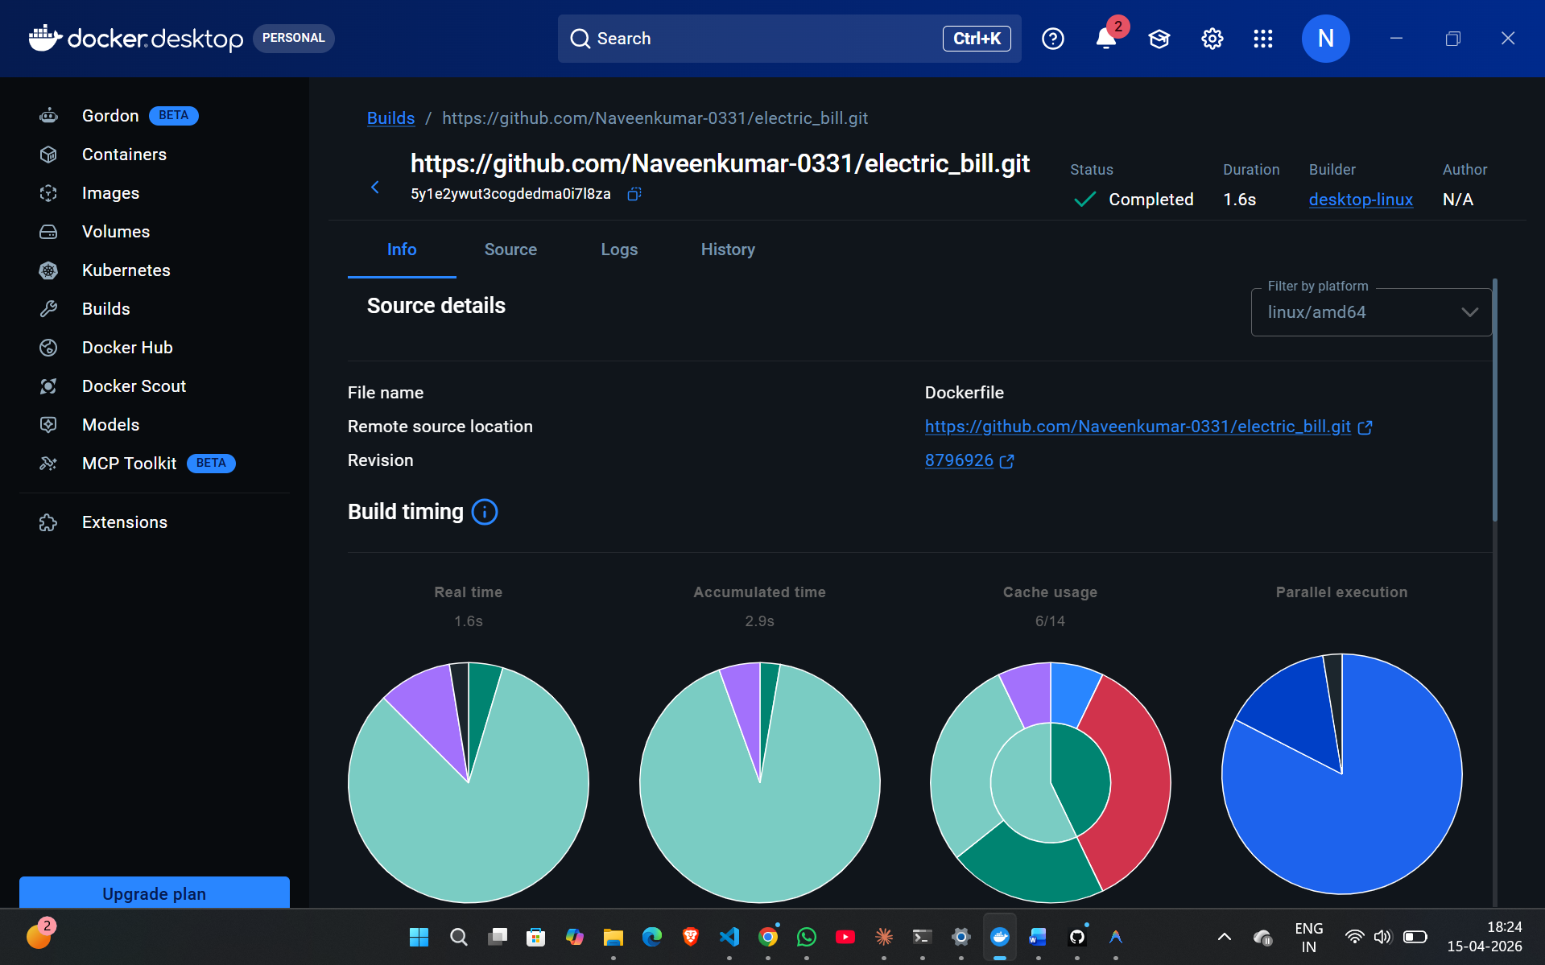

Docker Local Build:
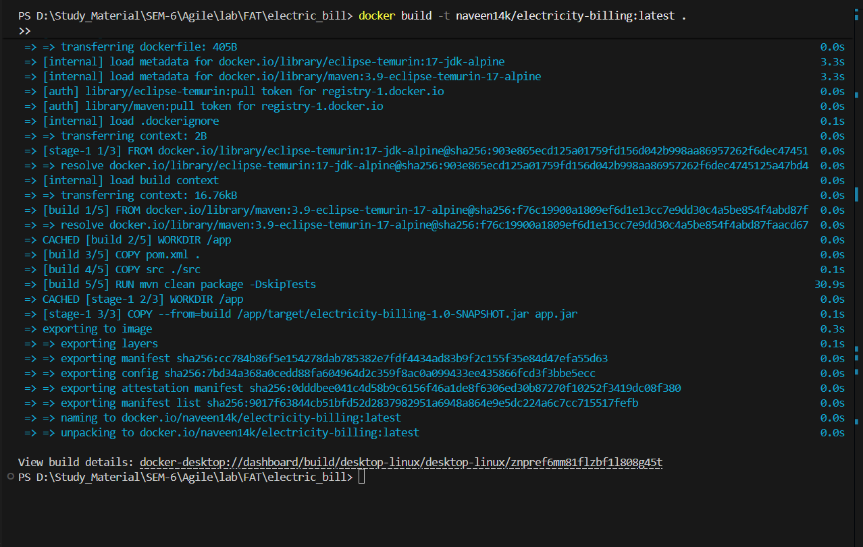
Kubernetes
Deployment.yaml:
apiVersion: apps/v1
kind: Deployment
metadata:
name: electricity-billing-deployment
labels:
app: electricity-billing

spec:
replicas: 2
selector:
matchLabels:
app: electricity-billing

template:
metadata:
labels:
app: electricity-billing

spec:
containers:
- name: electricity-billing
image: naveen14k/electricity-billing:latest
imagePullPolicy: Always

ports:
- containerPort: 8080

resources:
requests:
memory: "256Mi"
cpu: "250m"
limits:
memory: "512Mi"
cpu: "500m"

livenessProbe:
tcpSocket:
port: 8080
initialDelaySeconds: 30
periodSeconds: 10

readinessProbe:
tcpSocket:
port: 8080
initialDelaySeconds: 10
periodSeconds: 5

---
apiVersion: v1
kind: Service
metadata:
name: electricity-billing-service

spec:
type: NodePort
selector:
app: electricity-billing

ports:
- protocol: TCP
port: 80
targetPort: 8080
nodePort: 30009

Kubernetes:
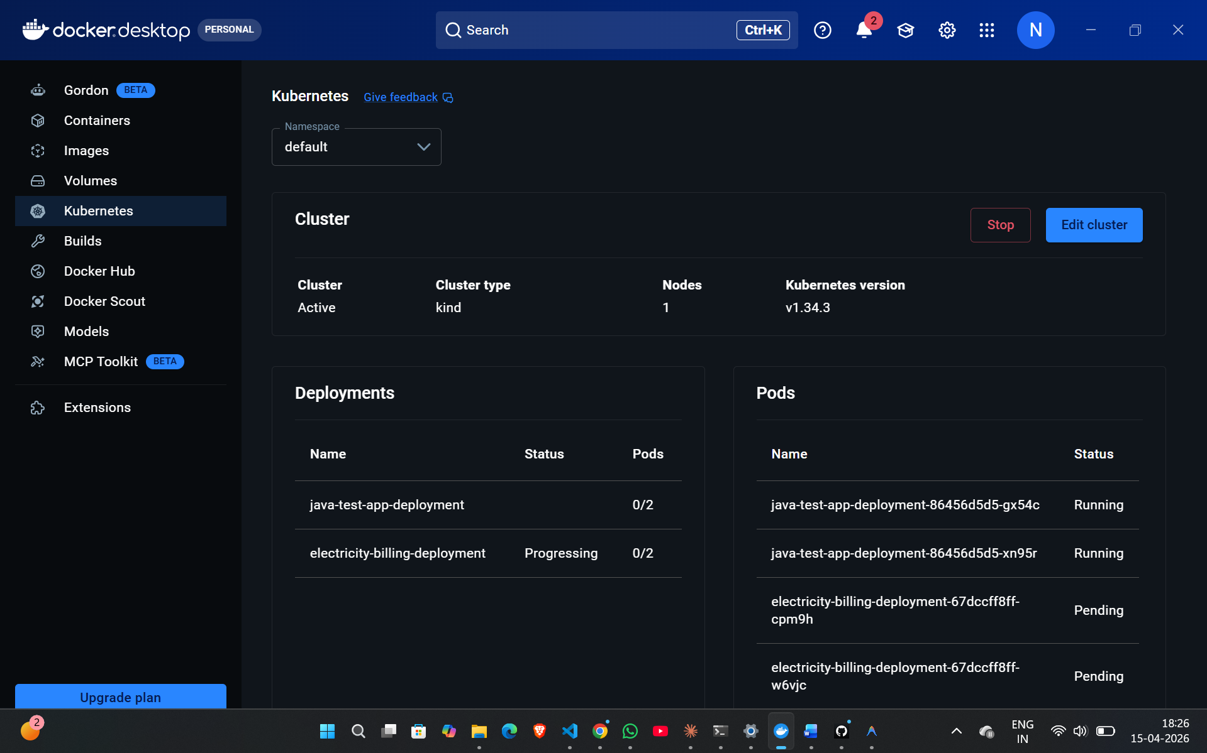
Kubernets Local:
