TeamDetails:
Team 6
Bharath Kumar Eilane
classid-12
Hiresh Bhaskar Jakkala
classid- 17

# Objective:
To create an android app and ionic application with below contents

1)Creating an Application with Two API’s

created an a ionic-1 application using Google maps API’s and FourSquare services.
Login and register
created firebase login and registration page using the following firebase ionic script

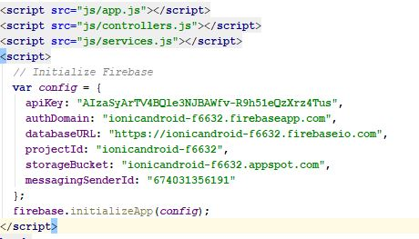

GUI Code for login and Register pages

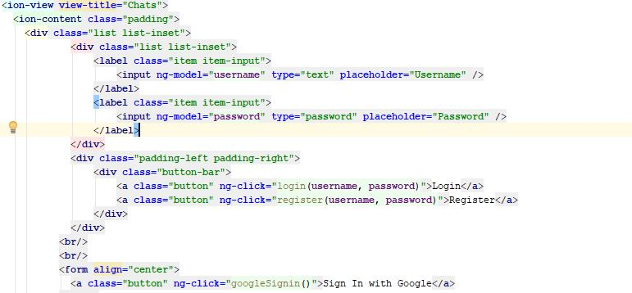

Implementation of four Square Api for searching places for your city

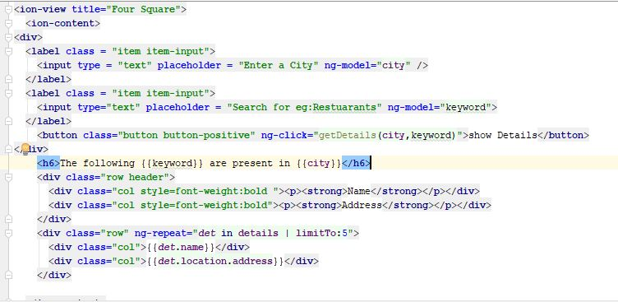
Login UI

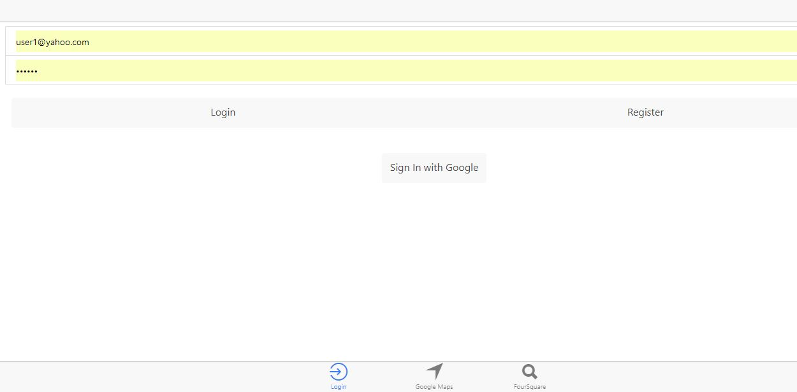

FourSquare ApiUI:
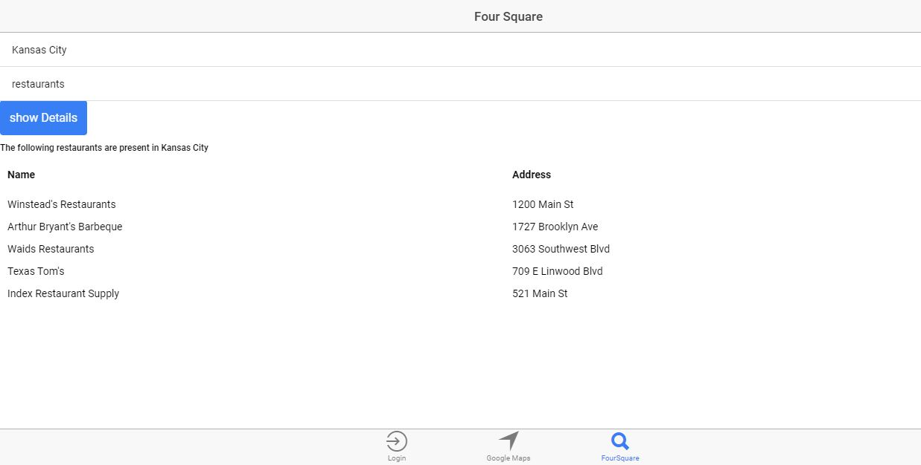
Test Case Runs:

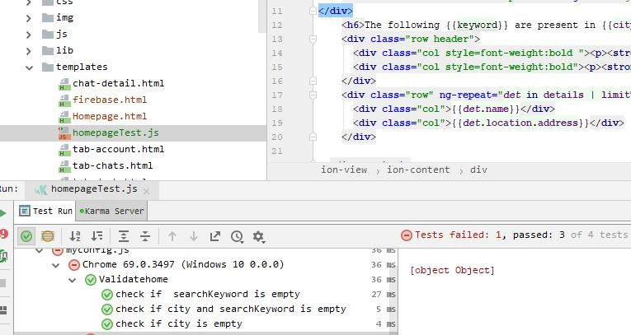

Test Case Code File :

